PROJECT PORTFOLIO 01
Regional Competitiveness &
Spatial Interaction Analysis
A 16-district assessment of northern Bangladesh

Gourab Halder
Urban & Regional Planning Graduate | RUET

Project overview
This project examines how socio-economic conditions, service availability and inter-district connectivity shape regional competitiveness across 16 districts in northern Bangladesh. It combines composite indicators with spatial interaction analysis to identify regional centres, core districts and less-connected hinterlands.

Study area
Rajshahi, Chapainawabganj (listed as Nawabganj in parts of the source report), Natore, Bogura, Joypurhat, Lalmonirhat, Gaibandha, Thakurgaon, Panchagarh, Sirajganj, Pabna, Naogaon, Rangpur, Dinajpur, Nilphamari and Kurigram.
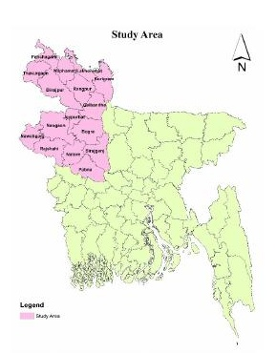
Study area map reproduced from the original group report.

Analytical objectives
- Assess district-level competitiveness using the Regional Competitiveness Index (RCI).
- Identify the regional centre using Marshall’s Centrality Index.
- Estimate inter-district interaction using a population-distance gravity model.
- Combine competitiveness and interaction results to classify districts into functional regional categories.

Data and tools
- Indicators described: population, literacy, employment, education and healthcare facilities, banks and haat/bazars.
- Sources named in the report: BBS, BANBEIS and OpenStreetMap (OSM).
- Tools: Microsoft Excel for calculations and interaction matrices; QGIS for spatial visualization and mapping.

Methods

Regional Competitiveness Index
The report standardizes selected district indicators using Z-scores and calculates an average composite score. The first study describes four indicators: population, employment, literacy rate and healthcare facilities.
RCI = (Z₁ + Z₂ + … + Zₙ) / n
where Z represents the standardized value of an indicator and n is the number of indicators included in the composite score.

Marshall’s Centrality Index
A composite centrality score is calculated from the availability of education, healthcare, banks and markets. The report identifies the district with the highest centrality score as the regional centre.

Gravity model and spatial interaction
Inter-district interaction is estimated using a population-distance relationship:
Iᵢⱼ = (Pᵢ × Pⱼ) / Dᵢⱼ²
where P represents district population and D represents inter-district distance. The interaction matrix was prepared in Excel.

Spatial classification
The report combines RCI and interaction levels to classify districts into Core, Transitional Growth Area, Peripheral and Hinterland groups. QGIS was used to prepare thematic maps and spatial representations.

Key results
- Bogura is reported as the leading district in spatial interaction, accounting for 14.84% of the interaction share shown in the report.
- Panchagarh is reported as the lowest contributor in the interaction chart, at 2.09%.
- Bogura records the highest Marshall’s Centrality Index in the reported table, with a score of 719.5.
- The report states that Bogura has the lowest Nearest Neighbourhood Analysis score (1,489.64), where a lower value is interpreted as better suitability.
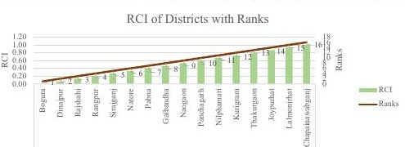
RCI chart reproduced from the source report.
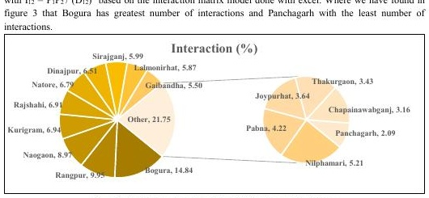
District interaction share from the gravity-model analysis.

Spatial outputs and classification
The source report presents district-level competitiveness and spatial interaction outputs, including maps of the regional pattern and a functional classification of the 16 districts.
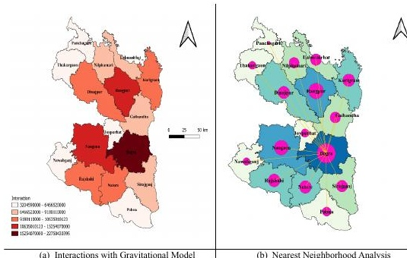
Spatial competitiveness and interaction outputs reproduced from the source report.

Planning relevance
The combined indicators provide a way to discuss regional centres, service concentration and differences in inter-district connectivity. The mapped outputs can support discussion of where regional services and connectivity improvements may be prioritized.

Limitations and verification
The source report contains inconsistent RCI ranking statements and chart/table values. These have not been reconciled or silently altered in this portfolio. District naming also varies in the source (for example, Nawabganj/Chapainawabganj and Jaipurhat/Joypurhat). The original calculation workbook and indicator-level processing should be checked before using the reported rankings for formal decisions.

