PROJECT PORTFOLIO 02
District-level Inequality &
Competitiveness
Theil Index and Regional Competitiveness Index | Northern Bangladesh

Gourab Halder
Urban & Regional Planning Graduate | RUET

Project overview
This project compares socio-economic inequality and regional competitiveness across 16 districts in northern Bangladesh. It uses the Theil Index to assess inequality across selected service and literacy indicators, and the Regional Competitiveness Index (RCI) to compare district-level competitiveness. The two measures are combined to create a four-category district typology.

Study area
Rajshahi, Chapainawabganj, Natore, Bogura, Joypurhat, Lalmonirhat, Gaibandha, Thakurgaon, Panchagarh, Sirajganj, Pabna, Naogaon, Rangpur, Dinajpur, Nilphamari and Kurigram.
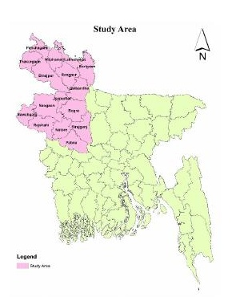
Study area map reproduced from the original group report.

Objectives
- Measure district-level inequality using the Theil Index.
- Compare regional competitiveness using the RCI.
- Classify districts by combining competitiveness and inequality to identify different planning priorities.

Data and tools
- Theil Index variables: education centres, healthcare centres, banks, haat/bazars and literacy rate.
- RCI variables stated in the report: total population, education centres, healthcare centres and literacy rate.
- Sources named: BBS and BANBEIS. Tools: Microsoft Excel and QGIS.

Methods

Theil Index
The Theil Index is used to compare inequality across the selected indicators. The source report calculates indicator-level values and combines the five variables to produce a district-level inequality score. Lower values are interpreted as lower inequality, with zero representing perfect equality in the report’s description.
Theil T = (1/N) × Σ [(yᵢ / ȳ) × ln(yᵢ / ȳ)]
The equation above is transcribed in a readable form from the report. The original calculation workbook should be consulted to verify the aggregation and implementation details.

Regional Competitiveness Index
The RCI is calculated as the average of standardized indicator values. The source describes Z-score standardization followed by normalization for comparison, using four indicators: population, education centres, healthcare centres and literacy rate.
RCI = average of the standardized indicator scores

Combined district classification
The report combines the inequality and competitiveness results to place districts into four analytical categories. This typology is used to compare district conditions and discuss differentiated planning priorities. It is an analytical classification developed for the study, not an official government classification.

Results and spatial outputs
The original report presents district-level indicator results, comparisons of inequality and competitiveness, and maps showing the resulting spatial patterns across the study area.
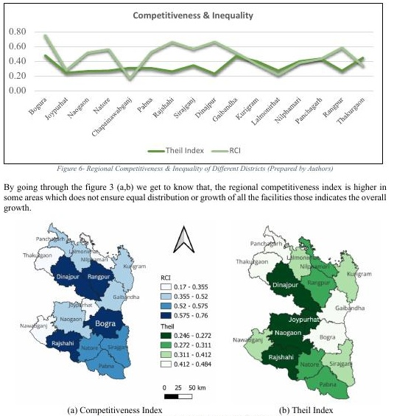
Charts and district-level spatial outputs reproduced from the original group report.

District typology and planning relevance
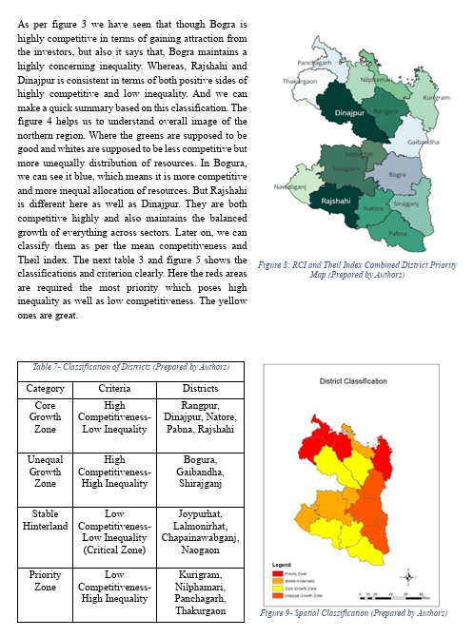
District typology and priority map reproduced from the original group report.
The combined typology offers a way to distinguish districts with different combinations of inequality and competitiveness. It can inform discussion of where service provision, access and regional development interventions may require different priorities.

Limitations and verification
The source report contains a contradiction between the written RCI ranking and the RCI values/ranks in its table. This portfolio does not repeat an unverified district ranking. The report does not document every normalization step or provide the original calculation workbook. The Theil Index aggregation and all district-level calculations should be checked against the source data before formal use.

