**Seminar Report**

**On**

**Railgun**

In partial fulfillment of the requirements for the award of the degree of

Bachelor of Technology in Computer Science & Engineering

Under

Moulana Abul Kalam Azad University of Technology

**Submitted By:**

**GOURAB DEY**

**Department of Computer Science & Engineering**

**Semester VI**

**Roll No: 11900115023**

***email: gourabdey759@gmail.com***

**Y E A R : 2 0 1 8**



**S I L I G U R I I N S T I T U T E O F T E C H N O L O G Y**

**S I L I G U R I, W E S T B E N G A L**

**I N D I A**

**CONTENT**

* **ACKNOWLEDGEMENT 3**
* **INTRODUCTION 4**
* **APPLICATION 5**
* **WEAPENS 6**
* **ADVANTAGE 8**
* **DISADVANTAGE 9**
* **UPCOMING FEATURE 10**
* **REFERENCE 11**

**ACKNOWLEDGEMENT:**

I would like to thank the entire faculty members of Computer Science and Engineering Department for helping and supporting me during my report preparation. This seminar and the associated report would never have been possible without their constant support.

I would like to thank Asst.Prof. Debojyoti Guha Sir specially for guiding me in presenting this report and his constant help and support.

**Railgun**

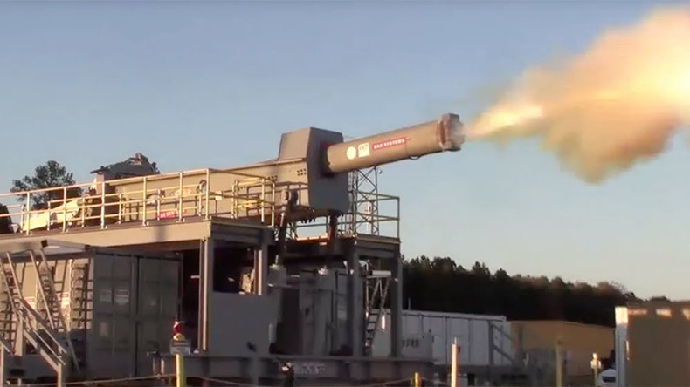**INTRODUCTION:**

A **Railgun** is a device that uses [electromagnetic force](https://en.wikipedia.org/wiki/Electromagnet) to launch high velocity projectiles, by means of a sliding armature that is accelerated along a pair of conductive *rails*. It is typically constructed as a weapon and the projectile normally does not contain explosives, relying on the projectile's high speed to inflict damage. The railgun uses a pair of parallel conductors, or rails, along which a sliding [armature](https://en.wikipedia.org/wiki/Armature_(electrical_engineering)) is accelerated by the electromagnetic effects of a current that flows down one rail, into the armature and then back along the other rail. It is based on principles similar to those of the [homopolar motor](https://en.wikipedia.org/wiki/Homopolar_motor).

As of 2014 railguns were being researched as weapons that use electromagnetic forces to impart a very high [kinetic energy](https://en.wikipedia.org/wiki/Kinetic_energy) to a [projectile](https://en.wikipedia.org/wiki/Projectile) rather than using conventional propellants. While explosive-powered military guns cannot readily achieve a [muzzle velocity](https://en.wikipedia.org/wiki/Muzzle_velocity) of more than about 2 km/s, railguns can readily exceed 3 km/s. For a similar projectile, the range of railguns may exceed that conventional guns. The destructive force of a projectile depends on its kinetic energy at the point of impact and due to the potentially large velocity of a railgun launched projectile their destructive force may be much greater than conventionally launched projectiles of the same size. The absence of explosive propellants or warheads to store and handle, as well as the low cost of projectiles compared to conventional weaponry, come as additional advantages.

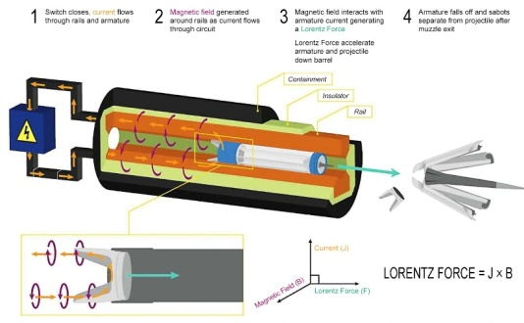**APPLICATION:**

The railgun works by storing power generated from an external source, like a ship, for several seconds. After the weapon is brimming with some 32 megajoules of energy, its capacitors send an electric pulse down two long rails, one negatively charged and one positively charged, generating an electromagnetic field that fires the projectile along the two rails. The 25-pound projectile is a non-explosive bullet filled with tungsten pellets inside an aluminum alloy casing, or sabot, that falls away after the projectile leaves the barrel. The Navy is also developing resistant electronics that go inside the projectile to make it possible to aim the weapon with GPS, technology that could eventually give the EM railgun effective missile-defense capabilities.

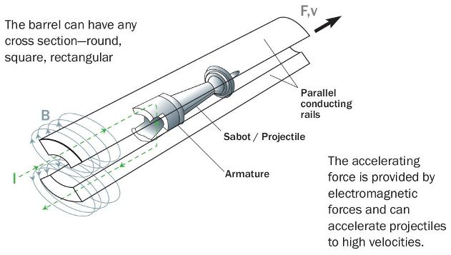

A railgun requires a [pulsed DC](https://en.wikipedia.org/wiki/Pulsed_DC) [power supply](https://en.wikipedia.org/wiki/Power_supply). For potential military applications, railguns are usually of interest because they can achieve much greater muzzle velocities than guns powered by conventional chemical propellants. Increased muzzle velocities with better aerodynamically streamlined projectiles can convey the benefits of increased firing ranges while, in terms of target effects, increased terminal velocities can allow the use of kinetic energy rounds incorporating hit-to-kill guidance, as replacements for [explosive shells](https://en.wikipedia.org/wiki/Explosive_shell). Therefore, typical military railgun designs aim for muzzle velocities in the range of 2000–3500 m/s with muzzle energies of 5–50 [Megajoules](https://en.wikipedia.org/wiki/Megajoule) (MJ). For comparison, 50MJ is equivalent to the kinetic energy of a [school bus](https://en.wikipedia.org/wiki/School_bus) weighing 5 metric tons, travelling at 509 km/h (316 mph). For single loop railguns, these mission requirements require launch currents of a few million [amperes](https://en.wikipedia.org/wiki/Ampere), so a typical railgun power supply might be designed to deliver a launch current of 5 MA for a few milliseconds. As the magnetic field strengths required for such launches will typically be approximately 10 [tesla](https://en.wikipedia.org/wiki/Tesla_(unit)) (100 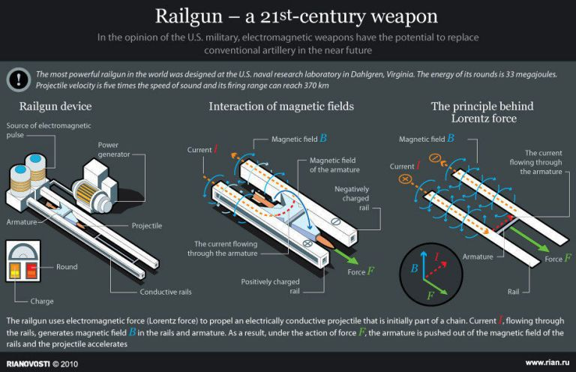[kilogauss](https://en.wikipedia.org/wiki/Kilogauss)), most contemporary railgun designs are effectively "air-cored", i.e., they do not use [ferromagnetic materials](https://en.wikipedia.org/wiki/Ferromagnetic_materials) such as iron to enhance the magnetic flux. However, if the barrel is made of a magnetically permeable material, the magnetic field strength increases due to the increase in permeability . This automatically increases the force.

**WEAPENS:**

Railguns are being researched as weapons with projectiles that do not contain explosives or propellants, but are given extremely high velocities: 2,500 m/s (8,200 ft/s) (approximately [Mach](https://en.wikipedia.org/wiki/Mach_number) 7 at sea level) or more. For comparison, the [M16 rifle](https://en.wikipedia.org/wiki/M16_rifle) has a muzzle speed of 930 m/s (3,050 ft/s), and the [16"/50 caliber Mark 7 gun](https://en.wikipedia.org/wiki/16%22/50_caliber_Mark_7_gun) that armed World War II American battleships has a muzzle speed of 760 m/s (2,490 ft/s)), which because of its much greater projectile mass (up to 2,700 pounds) generated a muzzle energy of 360 MJ and a downrange kinetic impact of energy of over 160 MJ (see also [Project HARP](https://en.wikipedia.org/wiki/Project_HARP)). By firing smaller projectiles at extremely high velocities, railguns may yield kinetic energy impacts equal or superior to the destructive energy of [5"/54 caliber Mark 45 gun](https://en.wikipedia.org/wiki/5%22/54_caliber_Mark_45_gun) Naval guns, (which achieve up to 10MJ at the muzzle), but with much greater range. This decreases ammunition size and weight, allowing more ammunition to be carried and eliminating the hazards of carrying explosives or propellants in a tank or naval weapons platform. Also, by firing more aerodynamically streamlined projectiles at greater velocities, railguns may achieve greater range, less time to target, and at shorter ranges less wind drift, bypassing the physical limitations of conventional firearms: "the limits of gas expansion prohibit launching an unassisted projectile to velocities greater than about 1.5 km/s and ranges of more than 50 miles [80 km] from a practical conventional gun system.

Railguns are being examined for use as [anti-aircraft](https://en.wikipedia.org/wiki/Anti-aircraft) weapons to intercept air threats, particularly [anti-ship cruise missiles](https://en.wikipedia.org/wiki/Anti-ship_missile), in addition to land bombardment. A supersonic [sea-skimming](https://en.wikipedia.org/wiki/Sea-skimming) anti-ship missile can appear over the horizon 20 miles from a warship, leaving a very short reaction time for a ship to intercept it. Even if conventional defense systems react fast enough, they are expensive and only a limited number of large interceptors can be carried. A railgun projectile can reach several times the speed of sound faster than a missile; because of this, it can hit a target, such as a cruise missile, much faster and farther away from the ship. Projectiles are also typically much cheaper and smaller, allowing for many more to be carried (they have no guidance systems, and rely on the railgun to supply their kinetic energy, rather than providing it themselves). The speed, cost, and numerical advantages of railgun systems may allow them to replace several different systems in the current layered defense approach.

**ADVANTAGES:**

The railgun has a much larger possible power than a powder gun

* 1. Currently, we have been able to reach velocities around 9 km/s with the railgun; whereas, the maximum velocity a powder gun can reach is less than 8.5 km/s.It is believed that the railgun can reach up to 140 km/s.
* Since the railgun depends entirely on a massive current, there is no need for fuel or explosives. This is more efficient in three ways:
  1. The risk is greatly reduced for the sailors handling the weapon systems.
  2. The weight of the entire system is reduced.
  3. The smaller size frees up a lot of space, which is crucial on cramped battleships.

**DISADVANTAGES:**

They’re heavy. The electromagnets used are very heavy in order to produce the energy to propel the projectile.

* Power systems. The USN ship-mounted rail gun uses a 25 megawatt power system to fire the gun. Smaller systems are being developed for land deployment via standard military transport vehicles.
* Limited portability. These weapons will need a transport vehicle to move the heavy gun plus its power systems around the battlespace.
* They’re new. New weapons almost always have some teething issues or create their own unique problems.
* Unknown human effects of high-energy EM pulse discharges. How the EM gun will affect the health of sailors hasn’t been intensively studied that I know about.
* The power systems will generate their own “signature” noise that can be identified and targeted from drones or other airborne recon assets.
* Weapons heat may seriously degrade performance. Magnets are less efficient as they get hot and rapid firing in combat conditions could decrease performance. It may be countered with careful application of a non-flammable liquid gas (i.e. nitrogen).

The disadvantages must be weighed against the advantages of the system. EM railguns are safer due to removal of propellants and warhead explosives from the magazines, will be easier to create auto-loading guns, the gun mounts are likely to be much lighter than a 5-inch or 8-inch gun mount. Lower cost, high accuracy and rapid reloading are big naval advantages.

**UPCOMING FEATURE:**

The first is to fire the railgun projectile out of conventional cannons. The Navy discovered in 2012 that they can fire the railgun projectile out of 5-inch powder guns already mounted on many U.S. warships. The [hypervelocity projectile](http://www.onr.navy.mil/~/media/Files/Fact-Sheets/35/Hypervelocity-Projectile-2012B.ashx) has also been tested in 6-inch guns and 155mm Army howitzers. The tungsten round won't leave the powder guns at Mach 6, but it will leave them at Mach 3, twice as fast as conventional rounds, according to Defense One.

The other short-term solution is to develop a railgun that uses less power. An EM railgun that could fire a projectile at 2,500 mph instead of 4,600 mph and hit a target at 50 nautical miles instead of 100 would still be incredibly useful, especially if the Navy could mount the weapon on existing warships. A less powerful railgun still has all the advantages of being cheaper to fire and removing dangerous explosives from a ship.

**REFERENCES:**

* <https://www.youtube.com/watch?v=i737rM6FxqE>
* <https://en.wikipedia.org/wiki/Railgun>
* <https://ndiastorage.blob.core.usgovcloudapi.net/ndia/2014/armaments/WedFox.pdf>
* <https://www.cloudflare.com/docs/railgun/>
* <https://www.cloudflare.com/docs/railgun/installation.html>
* <https://www.google.com/url?sa=t&rct=j&q=&esrc=s&source=web&cd=3&cad=rja&uact=8&ved=0ahUKEwiTxbCO8vbaAhVBRo8KHWCUBc4QFghHMAI&url=http%3A%2F%2Fwww.calvin.edu%2F~pribeiro%2Fcourses%2Fengr302%2FSamples%2FRailgun%2520Paper.doc&usg=AOvVaw3pohLB29I0pf71JT536jC_>