Specs of Code2 on RTX 6000:
- Physics & Numeric: 2D Riemann Problem (Sod Shock Tube) solved using a High-Order MUSCL finite-volume scheme with 3rd-Order SSP-Runge-Kutta (RK3) time-stepping.
- Implementation: Written in Python and dynamically compiled to CUDA using the NVIDIA Warp framework.
- Hardware & Memory: NVIDIA RTX PRO 6000 Blackwell Workstation Edition (95 GB VRAM). Memory layout was explicitly optimized from Array of Structures (AoS) to a Structure-of-Arrays (SoA) paradigm with a highly tuned execution block dimension of 256.
- Extreme Fusion: The final implementation (opti8) uses aggressive “extreme kernel fusion”, where flux computations and RK3 updates are combined into fewer kernels. Intermediate quantities are largely kept in registers, significantly reducing intermediate global memory traffic.
Speedup compared to CPU (and Naive Baseline):
- Absolute Speedup: The optimized GPU solver completes a 33.5 million cell simulation (16384X2048) in ~86.7 seconds. A CPU-based-NumPy implementation is significantly slower (order-of-magnitude difference).
- Algorithmic Scaling : Transitioning from Euler/RK2 (opti4) to RK3 (opti5-8) tripled the mathematical workload per timestep. Despite executing 3x more floating-point operations per step, our final opti8 code optimized the memory pathways so effectively that it still achieved a massive 2.31x speedup in raw execution time over the naive base code on the 8192x1024 grid (dropping from 23.4s to 10.1s), while seamlessly scaling to 33+ million cells.
FLOPS rating:
- Peak Performance: The opti8 code achieved a peak of 85.59 TFLOPS (FP32) on the 4096x512 grid.
- Sustained Large-Grid Performance: On the massive 8192x1024 and 16384x2048 grids, the solver sustained an impressive ~72 to 77 TFLOPS. According to Nsight Compute, this equates to roughly 21% of the theoretical maximum FP32 performance of the entire Blackwell GPU—an exceptionally high yield for a custom high-order CFD solver bound by stencil memory limits.
Nsight highlights:
- Compute-Bound Verification: The profiler indicates that the solver operates in a compute-dominant regime. Streaming Multiprocessor (SM) throughput reached a sustained 77.93%, while DRAM throughput hovered safely at 29.29%. This indicates that memory bottlenecks are significantly reduced and it operates in a compute-dominant region.
- Pipeline Utilization: The Fused Multiply-Add (FMA) pipeline achieved nearly 36% utilization, effectively mapping MUSCL reconstruction and flux calculations to high-throughput hardware instructions.
- Occupancy: Achieved an active warp occupancy of ~48.3%, which aligns with the theoretical hardware limit of (~50%), imposed by high register usage(~ 80 registers per thread).
Best things of my code & project:
- Python-to-CUDA Efficiency: Using Warp, the solver achieved high-performance GPU execution (~85 TFLOPS) while keeping the codebase relatively simple and readable compared to traditional CUDA implementations.
- VRAM Bottleneck Elimination: Transitioning from Array of Structures (AoS) to Structure of Arrays (SoA) layout, along with aggressive kernel fusion of RK3 stages, reduces the global memory traffic and improves cache utilization. Retaining intermediate values in registers increases arithmetic intensity, leading to improved overall performance.
Bottlenecks:
- Register Pressure (Hardware Limit): Nsight Compute reveals that our theoretical occupancy is strictly hard-capped at 50%. This is because the complex RK3/MUSCL mathematics require 80 registers per thread. The GPU physically cannot schedule more than half of its maximum threads at once without spilling to local memory.
- Uncoalesced Memory Strides (Algorithmic Limit): Approximately 13% of our memory accesses are flagged as uncoalesced "excessive sectors." This is an inherent, unavoidable penalty of calculating Y-direction finite-difference fluxes on a 2D memory array, which forces the GPU to read with large, cache-unfriendly linear strides.
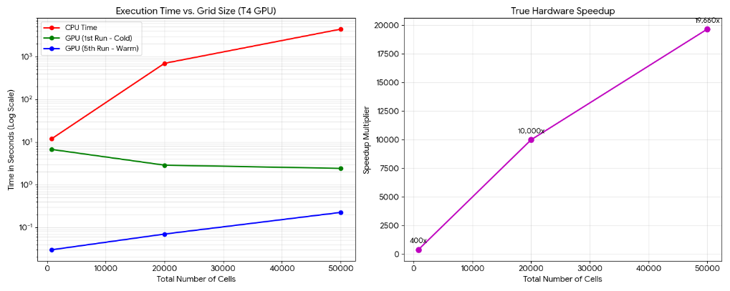
Figure 1 Speed up comparison for GPU and CPU
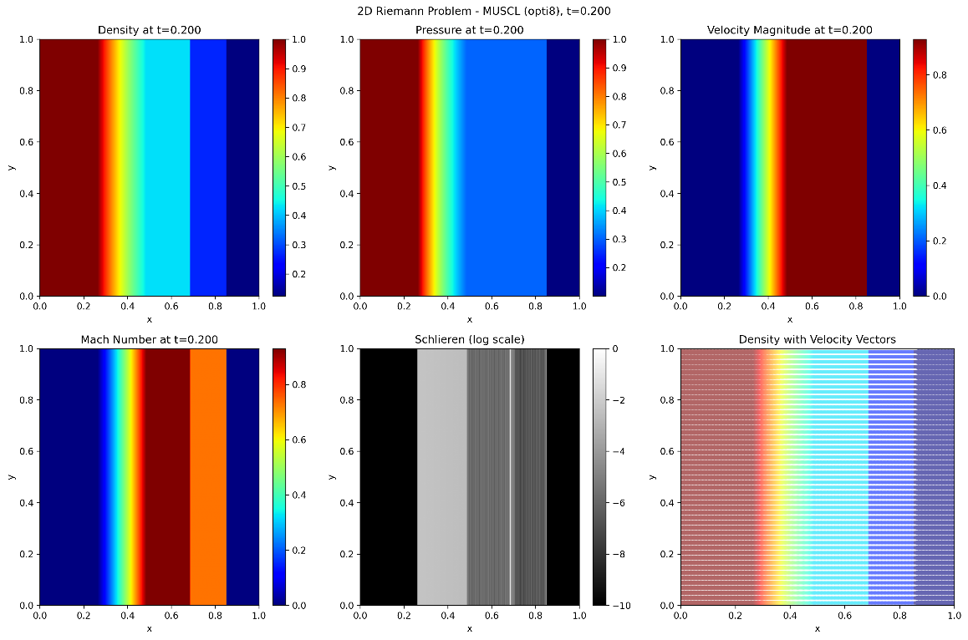
Figure 2 Simulation contour for Density, Pressure, Velocity, Mach number, Schlieren, and Velocity Vectors
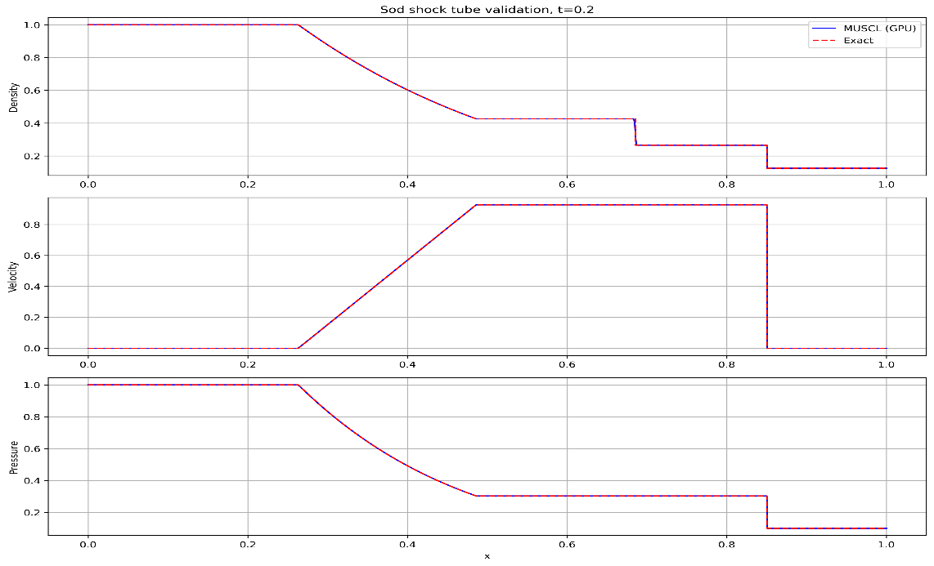
Figure 3 Validation Plots of Simulation data

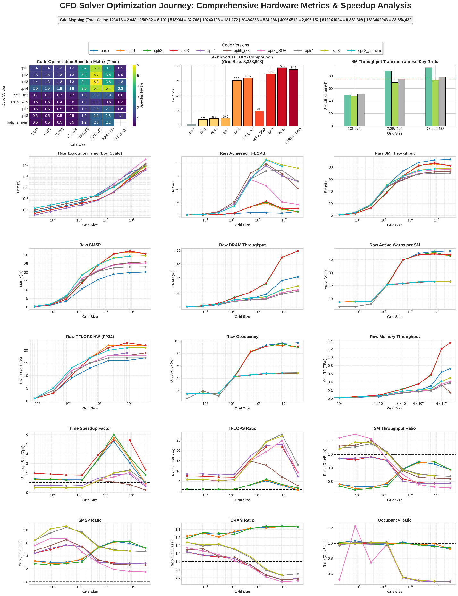
Figure 4 Comprehensive hardware scaling and optimization matrix. Note the logarithmic execution time plot demonstrating perfectly stable scaling up to 33.5 million grid cells, and the transition of SM Throughput crossing the 75% compute-bound threshold in the final opti8 iteration

