Specs of Code2 on RTX 6000:
- Physics & Numeric: 2D Riemann Problem (Sod Shock Tube) solved using a High-Order MUSCL finite-volume scheme with 3rd-Order SSP-Runge-Kutta (RK3) time-stepping.
- Implementation: Written in Python and dynamically compiled to CUDA using the NVIDIA Warp framework.
- Hardware & Memory: NVIDIA RTX PRO 6000 Blackwell Workstation Edition (95 GB VRAM). Memory layout was explicitly optimized from Array of Structures (AoS) to a Structure-of-Arrays (SoA) paradigm with a highly tuned execution block dimension of 256.
- Extreme Fusion: The final implementation (opti8 and opti8_shmem) uses aggressive “extreme kernel fusion”, where flux computations and RK3 updates are combined into fewer kernels. Intermediate quantities are largely kept in registers, significantly reducing intermediate global memory traffic.
Speedup compared to CPU (and Naive Baseline):
- Absolute Speedup: The optimized GPU solver completes a 33.5 million cell simulation (16384X2048) in ~85.338 seconds. A CPU-based-NumPy implementation is significantly slower (order-of-magnitude difference).
- Algorithmic Scaling : Transitioning from Euler/RK2 (opti4) to RK3 (opti5-8) tripled the mathematical workload per timestep. Despite executing 3x more floating-point operations per step, our final opti8 code optimized the memory pathways so effectively that it still achieved a massive 2.31x speedup in raw execution time over the naive base code on the 8192x1024 grid (dropping from 23.4s to 10.1s), while seamlessly scaling to 33+ million cells.
FLOPS rating:
- Peak Performance: The optimized implementations achieve a peak of 85.59 TFLOPS (FP32) on the 4096x512 grid.
- Sustained Large-Grid Performance: On the massive 8192×1024 and 16384×2048 grids, the solver sustains ~72–77 TFLOPS, corresponding to ~20–21% of the theoretical FP32 peak of the GPU—an efficient utilization for a stencil-based CFD solver.
Nsight highlights:
- Compute and Pipeline Efficiency : The solver operates in a compute-dominant regime with SM throughput ~77–78% and DRAM ~29%, indicating reduced memory bottlenecks. The FMA pipeline achieves ~36% utilization, effectively mapping MUSCL reconstruction and flux computations to hardware.
- Occupancy and Memory Behaviour: Active occupancy stabilizes at ~48%, matching the hardware limit (~50%) due to high register usage (~80 registers/thread). The shared-memory variant (opti8_shmem) shows similar SM utilization with slightly improved memory throughput, indicating marginal gains from improved data locality.
Best things of my code & project:
- Python-to-CUDA Efficiency: Using Warp, the solver achieved high-performance GPU execution (~85 TFLOPS) while keeping the codebase relatively simple and readable compared to traditional CUDA implementations.
- VRAM Bottleneck Elimination: Transitioning from Array of Structures (AoS) to Structure of Arrays (SoA) layout, along with aggressive kernel fusion of RK3 stages, reduces the global memory traffic and improves cache utilization. Retaining intermediate values in registers increases arithmetic intensity, leading to improved overall performance.
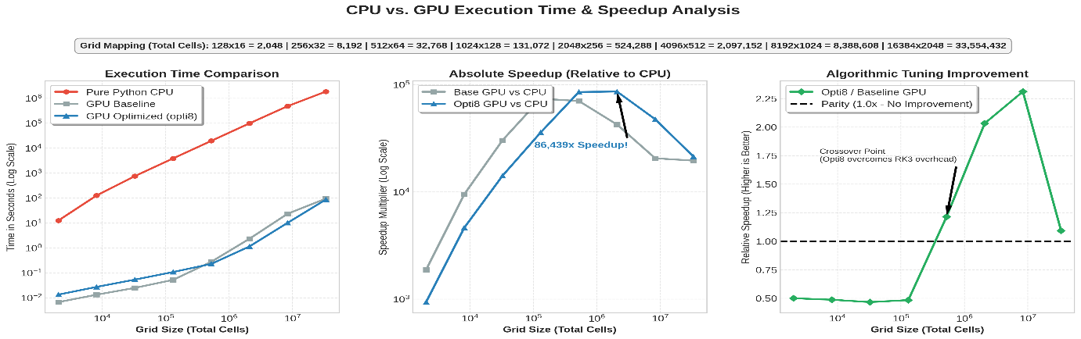
Figure 1 Speed up comparison for GPU and CPU
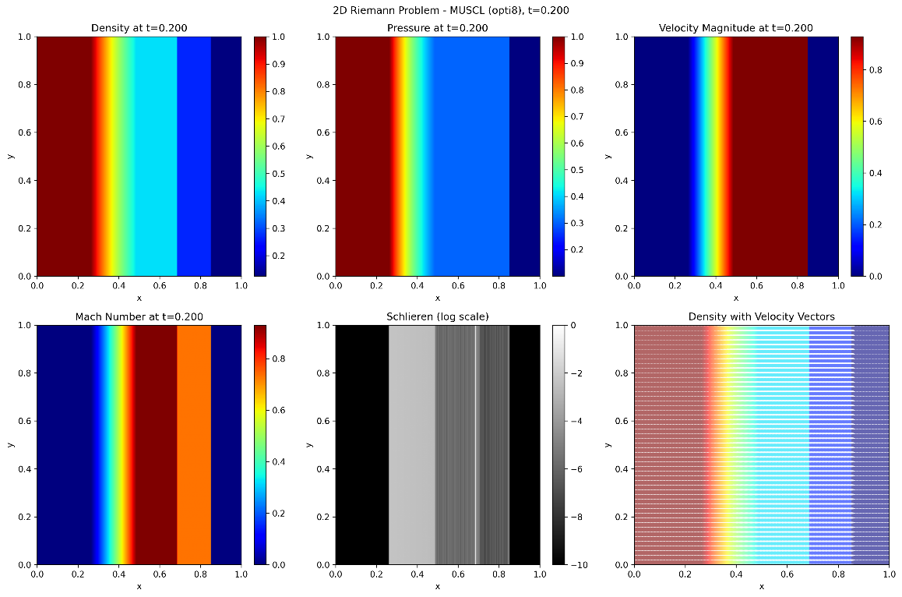
Figure 2 Simulation contour for Density, Pressure, Velocity, Mach number, Schlieren, and Velocity Vectors
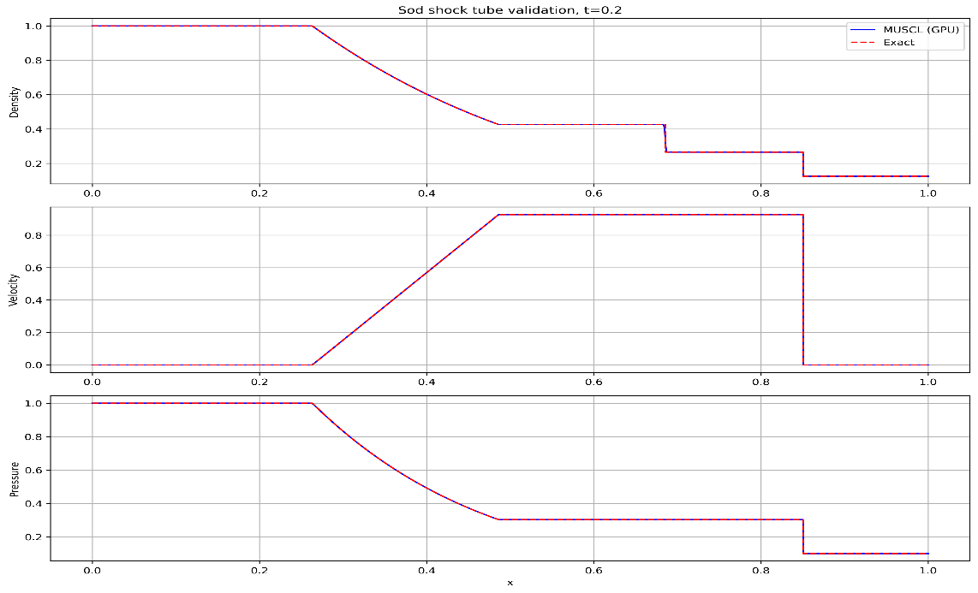
Figure 3 Validation Plots of Simulation data

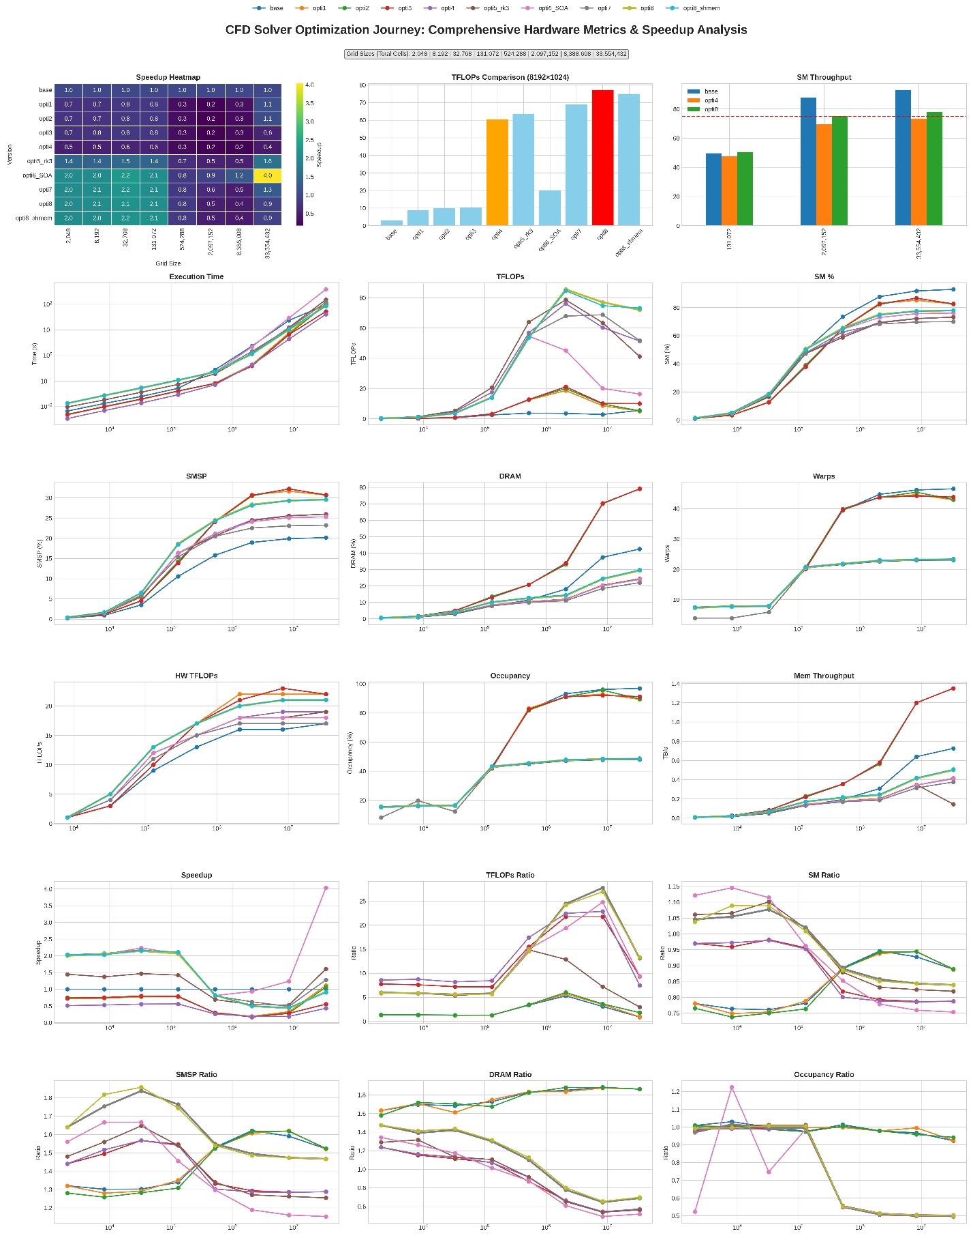
Figure 4 Comprehensive hardware scaling and optimization matrix. Note the logarithmic execution time plot demonstrating perfectly stable scaling up to 33.5 million grid cells, and the transition of SM Throughput crossing the 75% compute-bound threshold in the final opti8 iteration

Bottlenecks:
- Register Pressure (Hardware Limit): Nsight Compute reveals that our theoretical occupancy is strictly hard-capped at 50%. This is because the complex RK3/MUSCL mathematics require 80 registers per thread. The GPU physically cannot schedule more than half of its maximum threads at once without spilling to local memory.
- Uncoalesced Memory Strides (Algorithmic Limit): Approximately 13% of our memory accesses are flagged as uncoalesced "excessive sectors." This is an inherent, unavoidable penalty of calculating Y-direction finite-difference fluxes on a 2D memory array, which forces the GPU to read with large, cache-unfriendly linear strides.

