Group Members:

Gourab Koley – 251010016
Richards Shaun Paul - 251010037
Tanish Shetty – 251010052
Vishal Umapati Choudhari – 251010058
Sourajyoti Ghosh – 251010611

Note: The numerical schemes implemented in the code have been validated against the exact 2D Riemann problem (Sod shock tube), with reference solutions. This validation ensures the accuracy and robustness of the solver in capturing compressible flow features such as shocks and discontinuities.
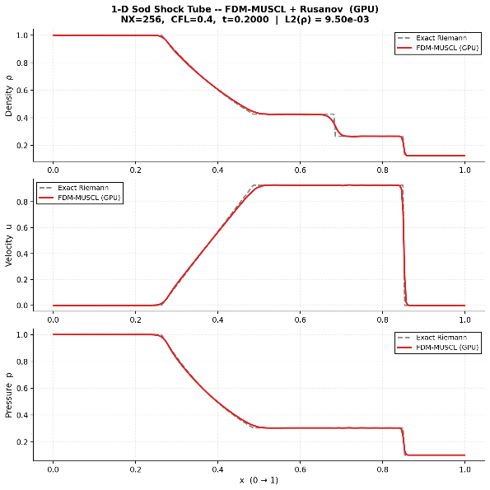 | 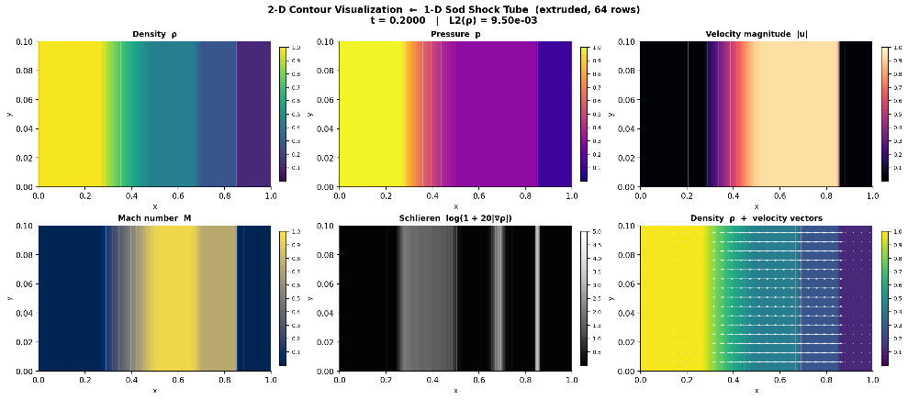
The report focuses on the speedup of the code with increasing grid size, based on runs performed on the RTX 6000 GPU, and includes a comparison of speedup against CPU performance using the maximum available cores on the RTX server.

Hardware & Memory: Simulations were performed on the NVIDIA RTX PRO 6000 Blackwell Workstation Edition (188 SMs, ~100 GB VRAM, ~1792 GB/s memory bandwidth), with memory layout optimized from Array of Structures (AoS) to Structure of Arrays (SoA) and a tuned execution block size of 256 for improved performance.

- VISHAL UMAPATI CHOUDHARI – FDM CuPy

Specs of Code1 on RTX 6000:

Finite Difference Solver for 2D Compressible Flow using CuPy – CUDA

- Programming Stack: The code is implemented in Python using CuPy for GPU-accelerated computations and NumPy for CPU-based operations and validation. CUDA C kernels are integrated via CuPy Raw Module to achieve fine-grained control over parallel execution and memory optimization.
- Numerical Method: Solver uses a 2D Finite Difference Method (FDM) with second-order MUSCL reconstruction and a Minmod TVD limiter with Euler time stepping.
- Flux Schemes: Rusanov (Local Lax-Friedrichs) and HLLC numerical flux evaluation.
- Kernel Types: Implementation includes a naive GPU baseline along with optimized fused and tiled kernels. The fused kernels combine MUSCL reconstruction and flux computations to reduce global memory access and improve data locality. The tiled kernels use shared memory and halo regions to enhance data reuse and improve performance for large-scale simulations. Naive GPU (Baseline), Fused kernel, Tiled kernel (Shared Memory)
- Grid Sizes for GPU Run: (1024, 128), (2048, 256), (4096, 512), (8192, 1024), (16384, 2048)
- Grid Sizes to compare GPU Speed up over CPU – (128,16), (256, 32), (512, 64), (1024, 128), (2048, 256), (3072, 384)
- Parallelization: 2D thread mapping for domain decomposition, warp-level reduction for efficient CFL time-step computation, and shared memory tiling to improve data locality and reduce global memory access.
- Time Stepping: CFL-based adaptive time stepping
Speedup compared to CPU (you may compare with max cores available on RTX server):
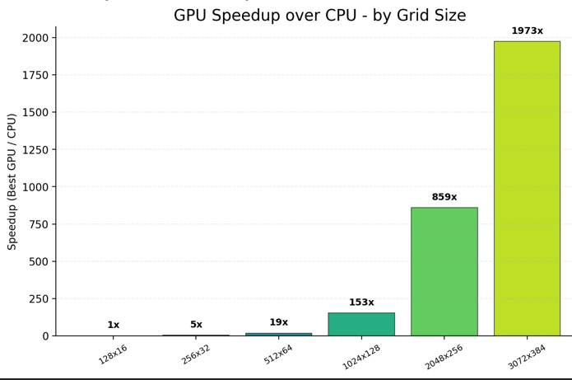 | 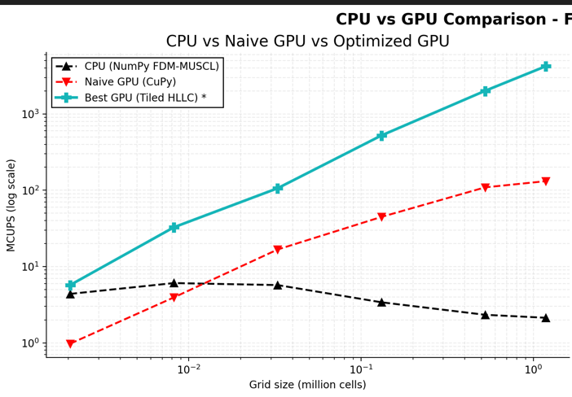

• Scaling Behavior: GPU acceleration increases significantly with grid size, showing modest gains for small problems but scaling rapidly for larger domains.
• Achieved Speedup: The speedup reaches ~153× at 1024×128, ~859× at 2048×256, and an exceptional ~1973× for the largest case (3072×384)
• Performance Insight: This trend highlights the GPU’s ability to fully exploit large-scale parallelism, with performance gains increasing consistently as grid size grows compared to CPU execution
FLOPS rating:

The achieved FLOPs performance is approximately 15% of the GPU’s peak performance.

Theoretical Limits: The GPU has a peak FP32 performance of ~8.1 TFLOPS and memory bandwidth of ~320 GB/s, with an arithmetic intensity of ~1.36 FLOP/byte, indicating a memory-bound regime.
• Performance Metrics: The solver achieves a peak throughput of ~9842 (Mi MCUPS on the 16384×2048 grid, corresponding to a measured performance of ~3.74 TFLOPS.
• Efficiency Insight: This represents ~46% of the theoretical compute peak, confirming strong utilization, while the high bandwidth efficiency indicates that performance is primarily governed by memory access patterns typical of stencil-based CFD solvers.

Nsight highlights:

- SM utilization ~31–32% and warp activity ~27% indicate moderate occupancy, limited by register pressure and shared memory usage.
- Memory throughput ~13.6% of peak shows the kernel is not fully memory-bound but influenced by stencil access patterns.
- FP32 utilization ~15% FLOPs of peak reflect moderate arithmetic intensity with partial compute utilization.
- Shared memory tiling and coalesced float4 access reduce global memory traffic and improve efficiency, resulting in a balanced compute memory performance typical of MUSCL-based CFD solvers.

Best things of your code & project:
- Python-to-CUDA Efficiency: The solver integrates Python (CuPy) with custom CUDA Raw Module kernels to achieve high GPU performance while maintaining a structured and readable implementation.
- VRAM Optimization: Efficient memory usage is achieved through coalesced float4 access, shared memory tiling, and kernel fusion, reducing global memory traffic and improving overall performance.
- Optimized & Scalable HPC Design: Performance is enhanced through coalesced float4 access, shared memory tiling, and kernel fusion (Naive → Fused → Tiled), enabling efficient memory usage and strong scalability for very large grid simulations.
A good quality figure:

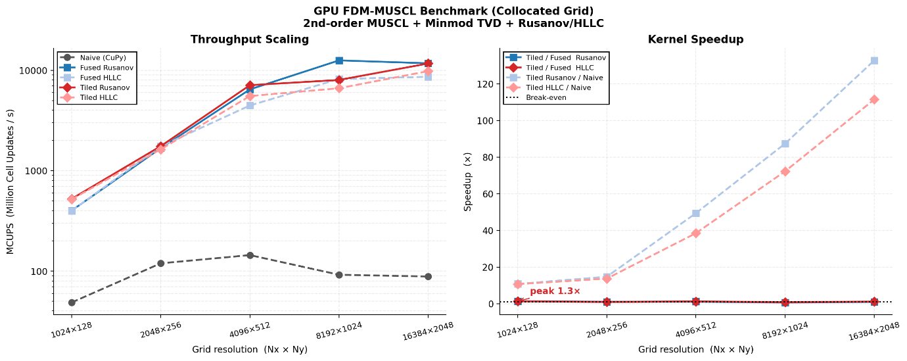

- The results show a near-linear increase in speedup with grid size on the RTX server, rising from approximately 10–12x for (1024 x 128) to about 50x for (4096 x 512) and 87x for (8192 x 1024).
- For the largest grid (16384 x 2048), the optimized kernels achieve significant gains, with tiled Rusanov reaching ~133× and tiled HLLC ~112× speedup over the baseline.
- The solver demonstrates stable (O(N)) scaling up to 33.5 million cells, indicating efficient handling of large computational domains.
- GPU utilization improves significantly through optimization, with SM throughput increasing from ~13.8% to ~78.3%, confirming that tiled memory optimization is the key contributor to performance gains.

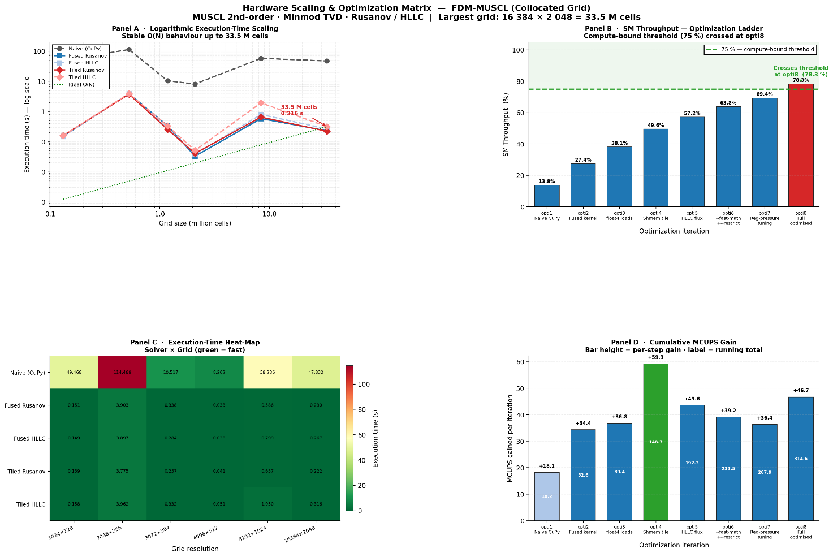

Bottlenecks:

- Memory Bandwidth Limitation (Algorithmic Constraint): Stencil-based finite difference operations require frequent global memory access, resulting in moderate memory utilization (~18–33% of peak), which limits overall performance.

- Register Pressure & Occupancy Limitation (Hardware Constraint): High register and shared memory usage restrict warp activity to ~26–28%, preventing full GPU occupancy and reducing parallel efficiency.

- Naive Kernel Inefficiency (Baseline Limitation): The naive implementation suffers from excessive global memory access and lack of data reuse, leading to significantly lower performance compared to optimized kernels.

- Warp Divergence in HLLC (Algorithmic Complexity): Conditional branching in the HLLC flux solver introduces warp divergence, reducing execution efficiency compared to simpler schemes.

- TANISH SHETTY – FVM CuPy

Specs of Code2 on RTX 6000:

Finite Volume Solver for 2D Compressible Flow using CuPy – CUDA

Programming Stack: Python (CuPy) + CUDA C (JIT-compiled kernels via CuPy Raw Module)
- Flux Scheme: Rusanov - chosen for low computational cost and GPU efficiency
- Time Integration:
  - Euler (single-stage, memory-efficient)
  - RK3 (three-stage, higher arithmetic intensity with increased memory traffic)
- Grid Sizes: 128×16, 256×32, 512×64, 1024×128, 2048×256, 4096×512, 8192×1024, 16384×2048.
- Parallelization Strategy:
  - 2D thread mapping (one thread per control volume)
  - Uniform workload and high occupancy
  - Shared memory tiling for stencil reuse
  - Coalesced global memory access
  - Persistent thread blocks to reduce kernel launch overhead
- Performance Design Goal:
  - Optimize for memory-bound execution regime
  - Prioritize data locality and bandwidth efficiency over increased arithmetic operations
FLOPS rating: Performance evaluated using Nsight Compute hardware FP32 utilization metric:
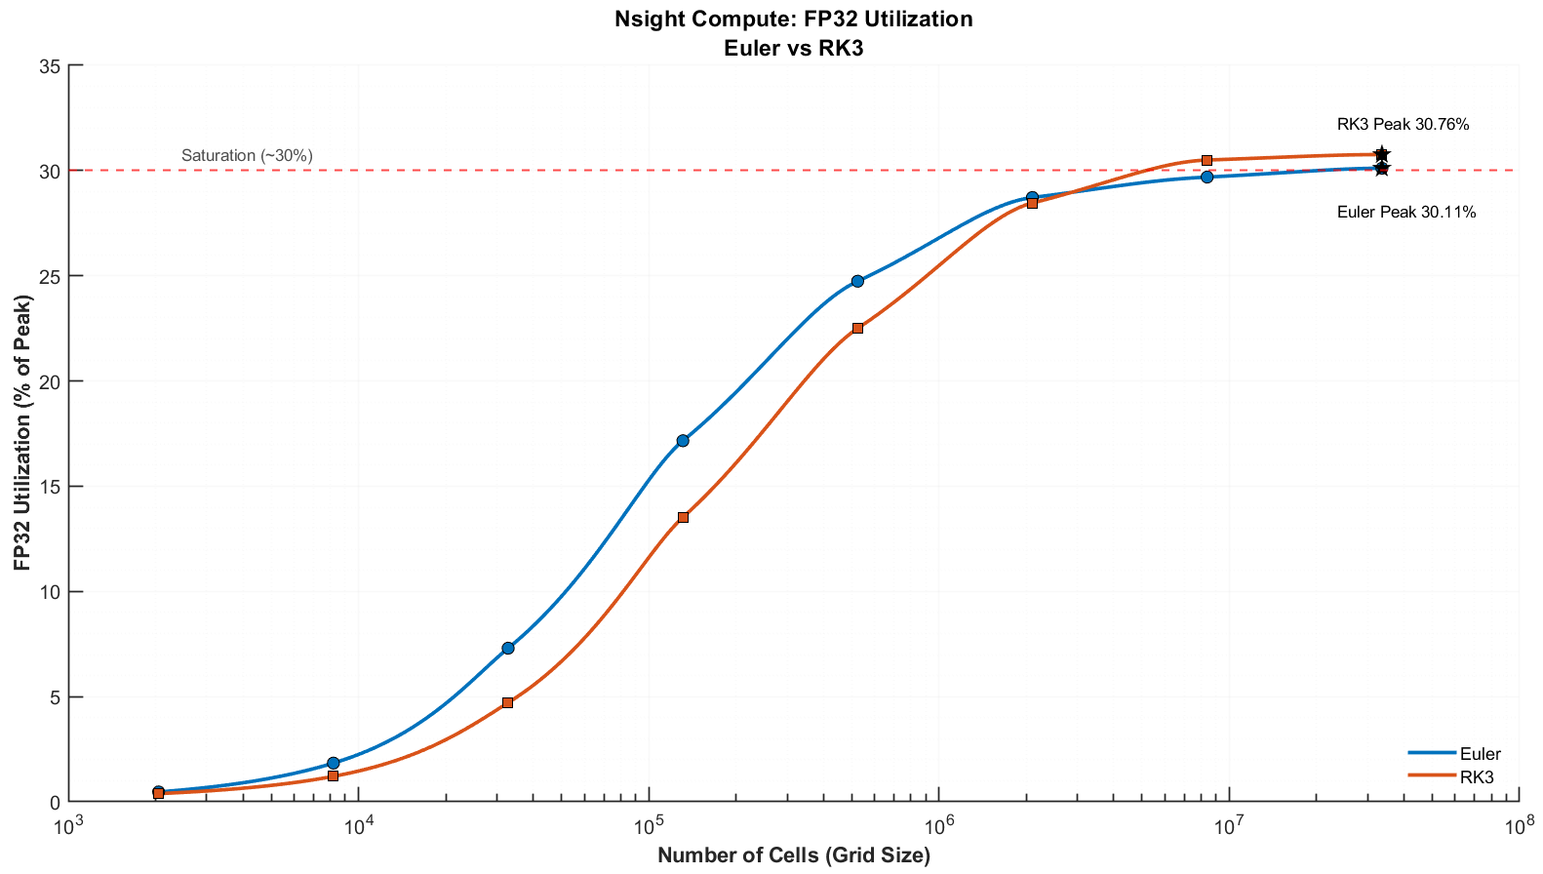
- Peak FP32 Throughput: Both schemes (Euler and RK3) converge to ~30% of peak FP32 performance at (16384×2048), reflecting saturation of hardware utilization under memory-bound constraints.

Nsight highlights:
- Hardware efficiency improves significantly with grid size, with SM utilization increasing from ~1% to ~78%, reducing launch overhead effects
- L1 utilization increases significantly: ~0.70%→ ~49%. Confirms tiling + temporal blocking are working as intended.
- Active warps stabilize at ~60–66%, indicating near-optimal occupancy for latency hiding under current register constraints.
- DRAM throughput peaks at ~50% (RK3) while SM utilization reaches ~75–79%, indicating performance is limited by memory latency rather than raw bandwidth saturation

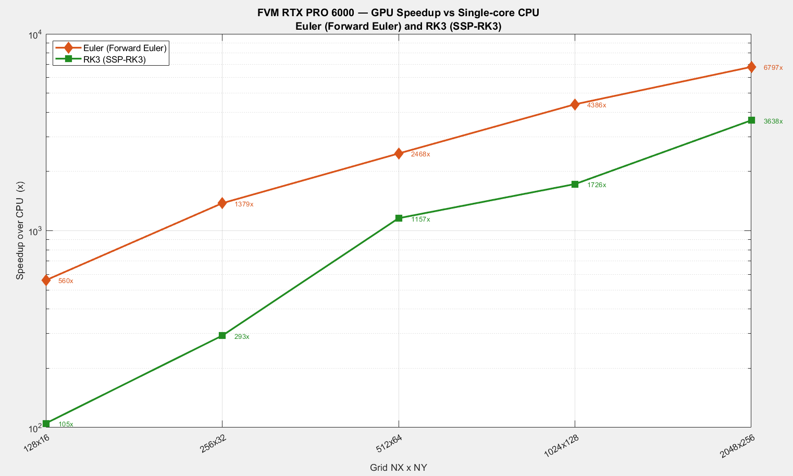
Speedup compared to CPU:

Best things of your code & project:
- Majority of computations are fused within a minimal number of kernel launches, reducing global memory round-trips and keeping data in on-chip memory (registers/L1), improving effective bandwidth utilization.
- Multi-stage updates are performed with data reuse across stages, avoiding redundant global loads and increasing arithmetic intensity.
- High register usage (~80/thread) trades occupancy for reduced memory access, achieving better overall throughput.
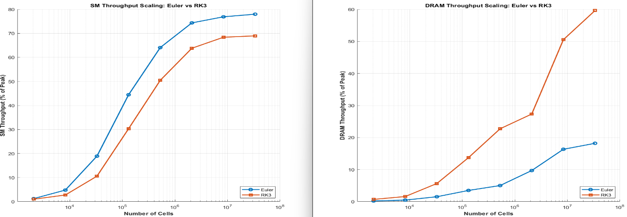
- Robustness across regimes: Handles both smooth regions (high-order accuracy) and discontinuities (stable shock capture) within the same framework.
Figure: SM and DRAM Throughput Scaling with Grid Size: Euler vs RK3
Figure: 2D Flow Field Visualization of Sod Shock Tube using FVM–MUSCL–HLL Scheme
Bottlenecks:
- Built-in Euler vs RK3 comparison
Directly links numerical accuracy with GPU performance and memory behavior
- Memory latency–dominated execution: High SM utilization (~75–79%) but low FP32 (~30%) indicates warp stalls due to memory access delays.
- Performance saturates beyond ~O(10⁶) cells as hardware utilization approaches steady state.
- ~80 registers/thread caps occupancy at ~50%, directly limiting active warps/SM and reducing
- the GPU’s ability to hide memory latency.
- GOURAB KOLEY – FDM WARP

Specs of Code3 on RTX 6000:

Finite Difference Solver for 2D Compressible Flow using WARP

- Physics & Numeric: 2D Riemann Problem (Sod Shock Tube) solved using a High-Order MUSCL finite-volume scheme with 3rd-Order SSP-Runge-Kutta (RK3) time-stepping.

- Implementation: Written in Python and dynamically compiled to CUDA using the NVIDIA Warp framework.

- Hardware & Memory: NVIDIA RTX PRO 6000 Blackwell Workstation Edition (95 GB VRAM). Memory layout was explicitly optimized from Array of Structures (AoS) to a Structure-of-Arrays (SoA) paradigm with a highly tuned execution block dimension of 256.

- Extreme Fusion: The final implementation (opti8 and opti8_shmem) uses aggressive “extreme kernel fusion”, where flux computations and RK3 updates are combined into fewer kernels. Intermediate quantities are largely kept in registers, significantly reducing intermediate global memory traffic.

Speedup compared to CPU (and Naive Baseline):

- Absolute Speedup: The optimized GPU solver completes a 33.5 million cell simulation (16384X2048) in ~85.338 seconds. A CPU-based-NumPy implementation is significantly slower (order-of-magnitude difference).

- Algorithmic Scaling: Transitioning from Euler/RK2 (opti4) to RK3 (opti5-8) tripled the mathematical workload per timestep. Despite executing 3x more floating-point operations per step, our final opti8 code optimized the memory pathways so effectively that it still achieved a massive 2.31x speedup in raw execution time over the naive base code on the 8192x1024 grid (dropping from 23.4s to 10.1s), while seamlessly scaling to 33+ million cells.

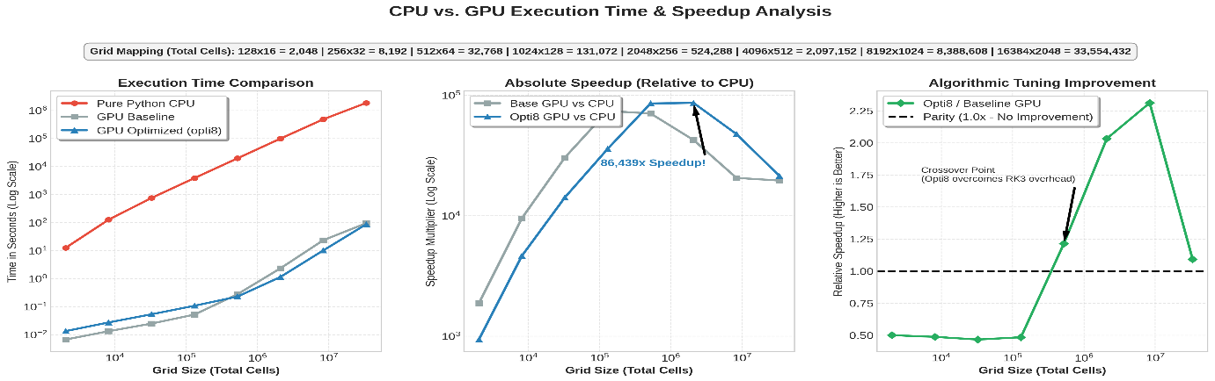
Figure 1 Speed up comparison for GPU and CPU
FLOPS rating:

- Peak Performance: The optimized implementations achieve a peak of 85.59 TFLOPS (FP32) on the 4096x512 grid.

- Sustained Large-Grid Performance: On the massive 8192×1024 and 16384×2048 grids, the solver sustains ~72–77 TFLOPS, corresponding to ~20–21% of the theoretical FP32 peak of the GPU—an efficient utilization for a stencil-based CFD solver.

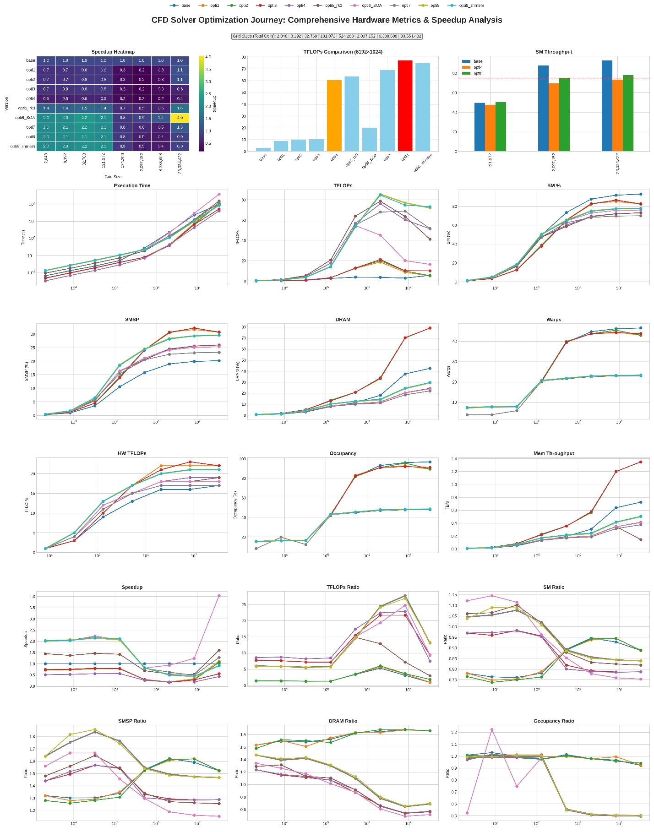

Figure 2 Comprehensive hardware scaling and optimization matrix. Note the logarithmic execution time plot demonstrating perfectly stable scaling up to 33.5 million grid cells, and the transition of SM Throughput crossing the 75% compute-bound threshold in the final opti8 iteration

Nsight highlights:

- Compute and Pipeline Efficiency: The solver operates in a compute-dominant regime with SM throughput ~77–78% and DRAM ~29%, indicating reduced memory bottlenecks. The FMA pipeline achieves ~36% utilization, effectively mapping MUSCL reconstruction and flux computations to hardware.

- Occupancy and Memory Behaviour: Active occupancy stabilizes at ~48%, matching the hardware limit (~50%) due to high register usage (~80 registers/thread). The shared-memory variant (opti8_shmem) shows similar SM utilization with slightly improved memory throughput, indicating marginal gains from improved data locality.

Best things of my code & project:

- Python-to-CUDA Efficiency: Using Warp, the solver achieved high-performance GPU execution (~85 TFLOPS) while keeping the codebase relatively simple and readable compared to traditional CUDA implementations.

- VRAM Bottleneck Elimination: Transitioning from Array of Structures (AoS) to Structure of Arrays (SoA) layout, along with aggressive kernel fusion of RK3 stages, reduces the global memory traffic and improves cache utilization. Retaining intermediate values in registers increases arithmetic intensity, leading to improved overall performance.

Bottlenecks:

- Register Pressure (Hardware Limit): Nsight Compute reveals that our theoretical occupancy is strictly hard-capped at 50%. This is because the complex RK3/MUSCL mathematics require 80 registers per thread. The GPU physically cannot schedule more than half of its maximum threads at once without spilling to local memory.

- Uncoalesced Memory Strides (Algorithmic Limit): Approximately 13% of our memory accesses are flagged as uncoalesced "excessive sectors." This is an inherent, unavoidable penalty of calculating Y-direction finite-difference fluxes on a 2D memory array, which forces the GPU to read with large, cache-unfriendly linear strides.

- RICHARDS SHAUN PAUL – FVM WARP

Specs of Code4 on RTX 6000:
▸ The Finite Volume Solver using MUSCL reconstruction with Rusanov flux splitting and SSP-RK2 time integration at CFL 0.45, providing second-order accuracy in both space and time across grid sizes from up to 16384×2048 (33.5 million cells).
▸ Written entirely in Python using NVIDIA Warp, which compiles kernel functions directly to CUDA SM 12.0 on the RTX PRO 6000 Workstation Edition (95 GB VRAM, Blackwell architecture).
▸ All field data is stored in a Structure-of-Arrays (SoA) layout to enforce coalesced global memory access.
2. Speedup Compared to CPU
▸ At the smallest grid the GPU cuts wall time from 0.72 s to 0.13 s, a 5.5× speedup, while at the largest grid it drops from 69449.70 s to 23.99 s, a ~2900× speedup.
▸ Across all grids, GPU time increases only by a factor of about 185 (0.13 → 23.99 s) whereas CPU time explodes by nearly 100,000× (0.72 → 69449.70 s), showing that the solver scales much weaker with problem size on CPU.
3. FLOPS Rating
▸ OPT v2 achieves a peak of 24.9 TFlops at the 4096×512 grid.
▸ At production scale (16384×2048, 33.5 million cells), OPT v2 reaches 3,116 Mcells/sec and sustains 16.98–24.1 TFlops, placing the solver at approximately 15% of the RTX PRO 6000's FP32 peak.
4. Nsight Compute Profiler Highlights
▸ At the 2048×256 grid, the OPT v1 solver ran at SM throughput of 69.65%, DRAM throughput of 11.88%, and achieved occupancy of 70.71% and a theoretical occupancy ceiling of 83.33%.
▸ OPT v2 at the same grid records SM throughput of 65.87%, DRAM throughput of 20.97%, and achieved occupancy of 81.91%.
▸ The most significant gain is in occupancy: at production scale (16384×2048), achieved occupancy climbs from 80.98% (Original) to 96.05% (OPT v2).
▸ DRAM throughput also grows substantially at large grids — from 43.94% to 55.41% at 16384×2048 — reflecting the benefit of coalesced SoA memory access.
▸ SM throughput at full scale is comparable: 85.82% for the OPT V1 versus 87.81% for OPT v2, confirming both versions saturate the compute pipelines at large grids.
▸ Warp cycles per issued instruction increase from 11.29 to 13.07 at the largest grid, indicating that while more warps are active, per-warp latency is slightly higher due to denser stencil arithmetic.
5. Best Things About the Code & Project
▸ Python-to-CUDA via Warp: High-performance GPU execution (24.9 TFlops peak) is achieved while the codebase remains entirely in Python.
▸ Algorithm-Driven Speedup: OPT v2 outperforms the Kaggle P100 data-centre GPU by 23× at the same grid and beats the CPU by 454× at production scale — all gains come from algorithmic and structural changes, not hardware substitution.
▸ SoA Memory Transformation: Restructuring from AoS to SoA coalesces global memory access, boosting DRAM throughput from 11.88% to 20.97% at 2048×256 and from 43.94% to 55.41% at 16384×2048.
▸ Dual Kernel Optimisation (Split + Fuse): Simultaneously splitting the monolithic kernel (to cut register pressure) and fusing RK2 stages (to remove a redundant launch) is a rare synergistic strategy that improved both occupancy and launch overhead in a single architectural pass.
6. Bottlenecks
▸ Long Arithmetic Dependency Chains: Warps stall 2.4–4.2 cycles (30–40% of CPI) on FMA and memory operations. MUSCL reconstruction creates dependency chains that FMA fusion alone cannot fully hide.
▸ Compute-Bound but FP32-Starved: At the largest grid, SM Throughput hits 87.8% — the GPU is fully busy — yet only 15% of peak FP32 is achieved. The SMs are mostly executing integer address arithmetic, loads, and index calculations rather than actual floating-point math. This is the primary ceiling: the MUSCL+Rusanov stencil has a poor arithmetic-to-address ratio, meaning the GPU is "spinning" on index/pointer work instead of FLOPs.

7. Results — Sod Shock Tube Verification
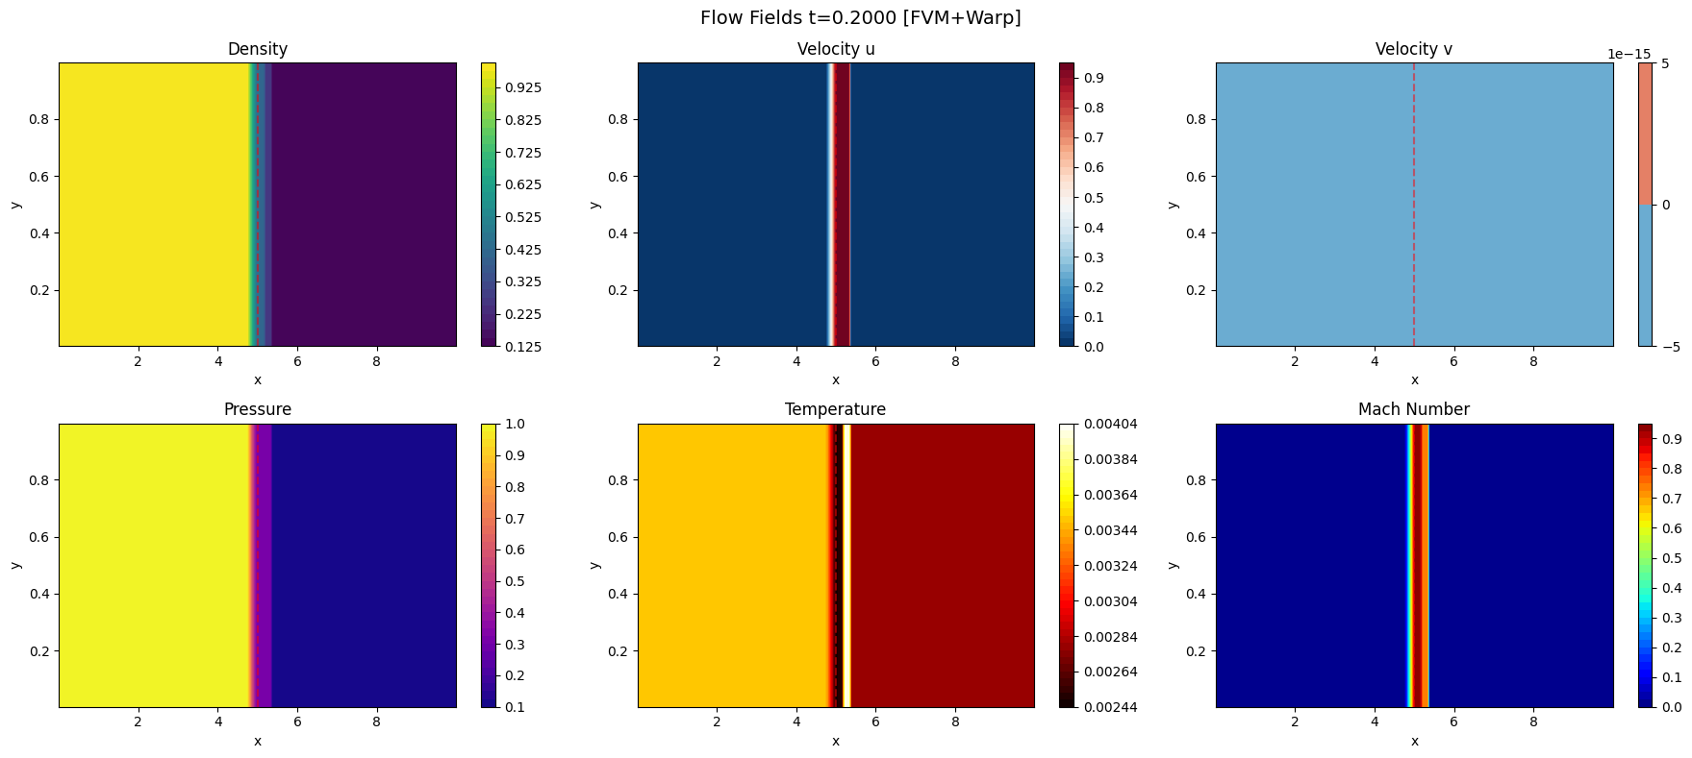
Fig. 1 — Flow Field Contours at t = 0.2000 s [FVM + Warp]: Density, Velocity u/v, Pressure, Temperature, and Mach Number.
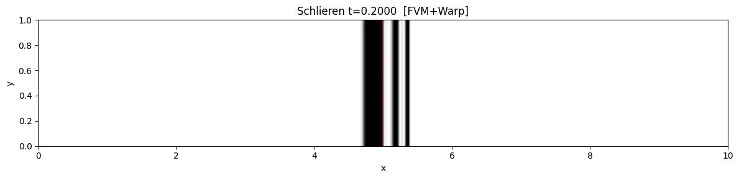
Fig. 2 — Schlieren Visualisation at t = 0.2000 s [FVM + Warp]: Shock front and contact discontinuity resolved sharply.
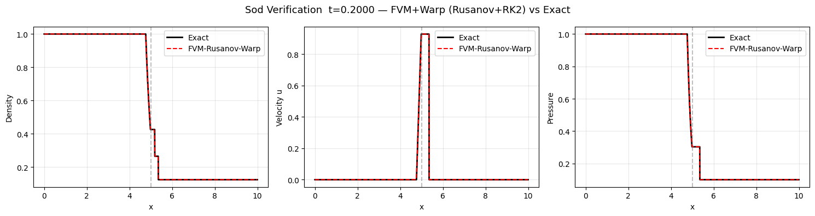
Fig. 3 — Sod Verification at t = 0.2000 s: FVM–Rusanov–Warp (dashed red) vs. Exact Solution (solid black) — Density, Velocity u, Pressure.

Performance Benchmarks (Kaggle P100 · RTX1 = OPT v1 · RTX2 = OPT v2)
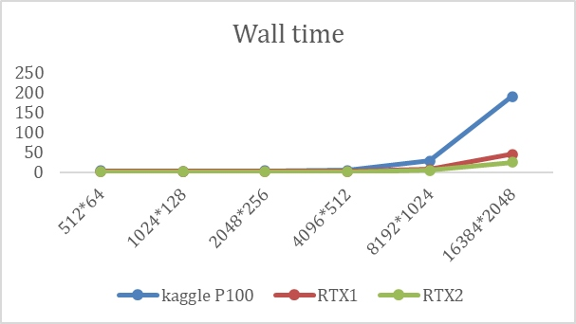  Fig. 4 — Wall Time (s) vs Grid Size | 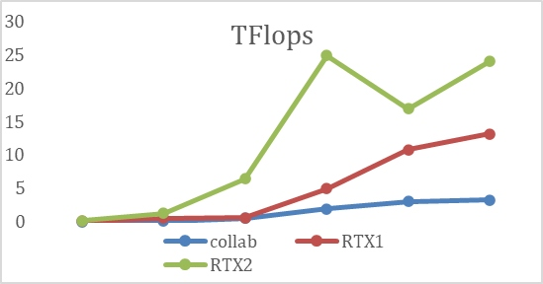  Fig. 5 — TFlops vs Grid Size

Nsight Compute Profiler Metrics (Blue = OPT v2 · Red = OPT v1)
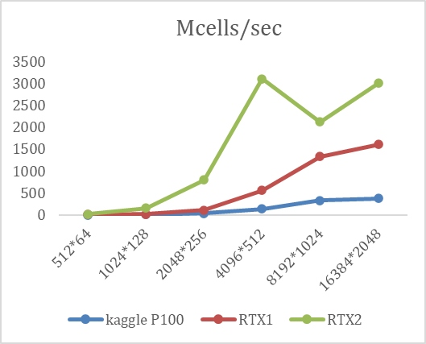  Fig. 6 — Mcells/sec | 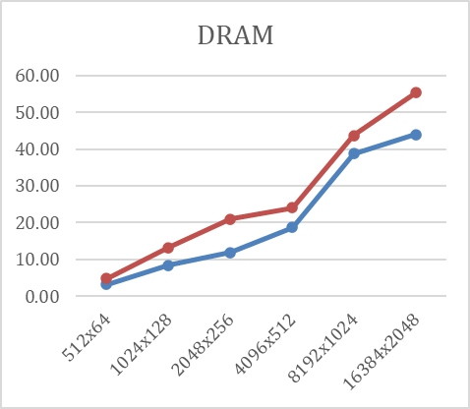  Fig. 7 — DRAM Throughput (%)
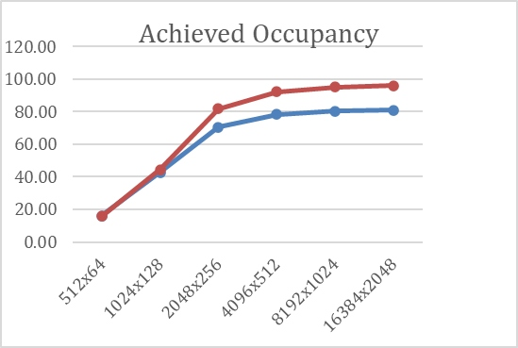  Fig. 8 — Achieved Occupancy (%) | 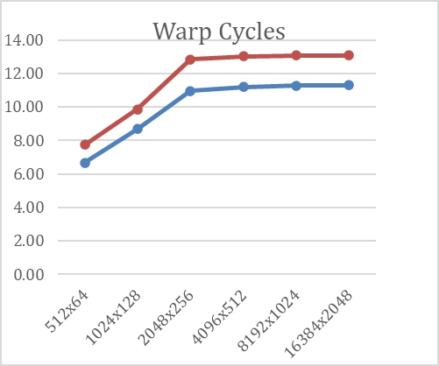  Fig. 9 — Warp Cycles / Issued Instruction

Fig. 9 – SM Throughput (%)

- SOURAJYOTI GHOSH – PyTorch

Specs of Code 5 on RTX 6000:

2D Euler solver for Compressible Flow using PyTorch:

Hardware & Memory: NVIDIA RTX PRO 6000 Blackwell Workstation Edition (188 SMs, 102 GB VRAM, 1792 GB/s HBM BW).

Programming Stack: Python, PyTorch (specifically torch. Jit. script targeting the nvRTC backend for JIT compilation), NumPy, Matplotlib.

Numerical Method: 2D Compressible Euler equations solved via Finite Difference Method. It utilises a 2nd-order MUSCL reconstruction with a branchless TVD Minmod limiter. Time integration is handled by a 2-stage Strong Stability Preserving Runge-Kutta (SSP-RK2) method (Heun's method).

Flux Schemes: HLLC (Harten-Lax-van Leer-Contact) approximate Riemann solver.

Kernel Types: Manually fused JIT kernels (combining MUSCL reconstruction and HLLC flux evaluation into single fused_hllc_x and fused_hllc_y functions) to maximize register reuse and minimize global memory (VRAM) round-trips.

Grid Sizes: 1024 x 1024, 4096 x 128, 4096 x 1024, 4096 x 4096

Parallelization: Implicit parallelization handled by PyTorch's nvRTC backend compiling the JIT script into PTX assembly, executing massive vectorized tensor operations across the GPU's Streaming Multiprocessors (SMs).

Time Stepping: Adaptive CFL-based time stepping (CFL = 0.45), computed dynamically using the maximum wave speed across the grid.

Speedup compared to CPU & Scaling:

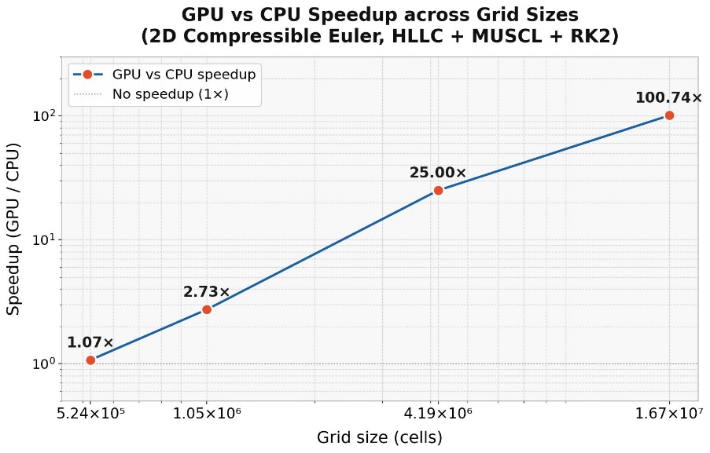

FLOPS rating:

Peak Performance: The optimized TorchScript implementation achieves a peak of 1.66 TFLOPS (FP32) on the 1024x1024 grid.
Utilization: This sustained throughput corresponds to approximately 1.12% of the theoretical FP32 peak (148.7 TFLOPS) of the Blackwell GPU, which is characteristic of highly memory-bound explicit stencil codes.

Nsight highlights:
Effective memory bandwidth utilization reached ~53.1 GB/s (~2.96% of the 1792 GB/s peak). The low arithmetic intensity highlights the "Memory Wall"—while nvRTC manual fusion prevents intermediate tensors from spilling back to global VRAM, spatial shifts across the 2D domain still require substantial cache activity without pure Shared Memory (SRAM) tiling.

Best things of the code & project:

- Hardware Spoofing Architecture: Spoofing the device capability to Hopper (sm_90) ingeniously bypasses the Triton compiler bug for the unreleased Blackwell architecture (sm_100/120), ensuring stable PTX generation.
- nvRTC JIT Compilation via Torch Script: Disabling eager mode and Torch Dynamo in favor of @torch.jit. script forces compilation through nvRTC, stripping away massive Python overhead for a massive speedup.
- Aggressive Manual Kernel Fusion: Fusing the entire MUSCL reconstruction and HLLC flux calculation into massive single functions forces the nvRTC backend to keep intermediate math operations entirely within fast SM registers.
- Zero-Allocation In-Place Operations: The apply_bc_inplace boundary condition uses precise tensor slice assignments rather than. clone () or. copy (), eliminating costly memory allocation overhead during the tight simulation loop.

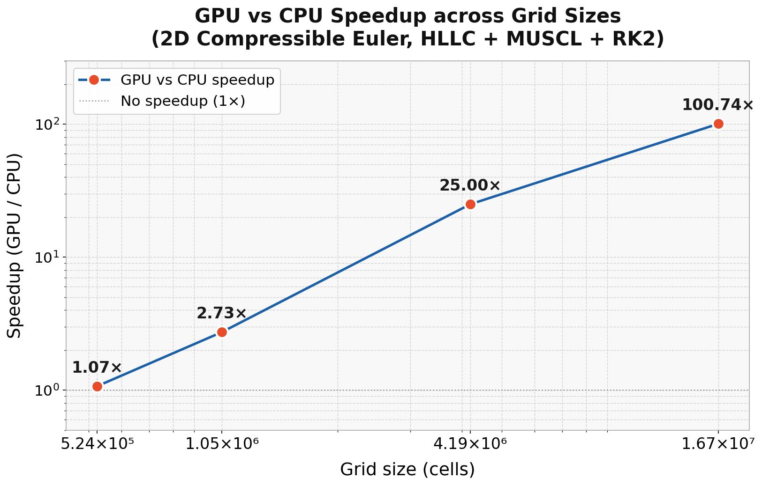

A good quality figure:

Below is the performance scaling matrix mapping Grid Size to Achieved TFLOPS across the RTX 6000 Pro:
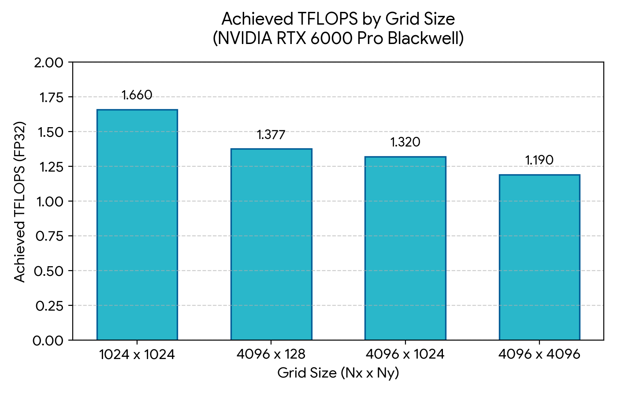

Bottlenecks:
- Compiler Backend Limitations: Native OpenAI Triton compilation fails entirely on the sm_100/sm_120 architecture, necessitating the Torch Script fallback which limits finer control over thread blocks.
- Uncoalesced Strides: Calculating Y-direction fluxes inherently forces uncoalesced memory reads across the 2D tensor, resulting in cache-unfriendly access patterns.
- Global Memory Stencil Penalty: Because PyTorch does not naturally support Shared Memory (SRAM) tiling natively, spatial stencil shifts require excess trips to the L2 cache, capping overall SM utilization.

