The aircraft's stability is the primary determinant of its ability to return to its main route. Aerial vehicles can maintain uniform flight conditions, recover from disturbances, and minimize pilot workload through the use of artificial intelligence and static stability.
Static stability is the ability of a body or aircraft to return to its initial position after it is disturbed. Three are three types of static stability:
- Positive static stability :
In positive static stability the aircraft or the body return to its initial position after small or larger disturbance.
- Neutral static stability :
In neutral stability the aircraft or the body tends to stay at its new altitude after it is disturbed.
- Negative static stability:
In negative stability the aircraft or the body tends to move away from the original position after it is disturbed.
An aircraft's dynamic stability depends mainly on its static stability over time. For example the fighter aircrafts have very less stability in comparison to the commercial or transport aircrafts. There are three types of dynamic stability:
- Positive dynamic stability:
Positive dynamic stability is when the oscillations are tried to dampen out. Each and every time the oscillation factor reduces to return to its original altitude.
- Neutral dynamic stability:
Neutral dynamic stability is the one in which if an aircraft is disturbed, the oscillations never dampens out. Hence there is no correction.
- Negative dynamic stability:
Negative dynamic stability is the one in which if an aircraft is disturbed, the oscillation instead of decreasing, tends to increase and the aircraft becomes uncontrollable.
Talking about the combined effect of degrees of freedom and the stability factors, static stability is mostly dependent on the center of gravity of the aircraft and the neutral point. The neutral point is that point where the pitching moment coefficient is independent of the angle of attack.
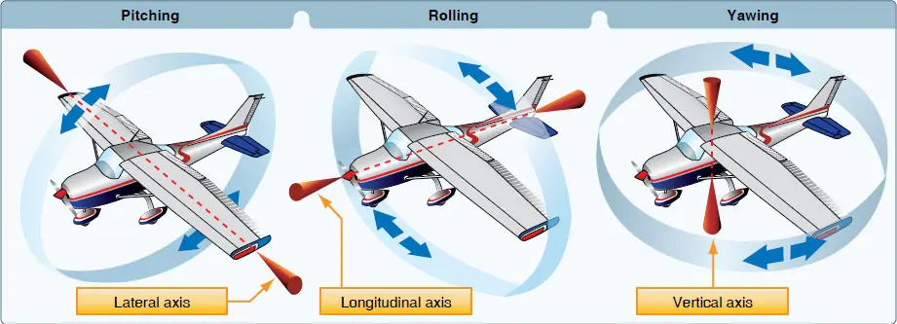
Figure showing stability in conventional aircraft and its degrees of freedom.
In the case of the E-VTOL, the engines are mounted mostly on the flaps of the wings and the pitching moment, rolling and turning moment are mostly performed by the thrust vectoring. The VTOL lacks a vertical stabilizer, so control is mostly performed by the engines. During the take-off and landing phase of the aircraft, the aircraft needs a vertical lift factor without a runway. So, this factor is solved by the engines on the flaps. For take- off and hover, all the flaps( both side of the rear wing and both sides on the front wing) are deflected at right angles to the wings. This makes the engine produce thrust in the upward direction which produces the net forces to lift the aircraft.
Though in conventional or other aircrafts with single engines mounted at the front nose, the cg of the aircraft is mostly situated after the main wings. This makes the main wings less stabilizing. When there is a gust of wind approaching the aircraft creates an angle of attack on the wing, the aerodynamic center located at the quarter chord point of the aircraft causes a moment about the CG of the aircraft, which makes the aircraft pitch up, making the main wing destabilizing. The tail or the horizontal stabilizer are mostly situated at a larger distance from the CG, which a slight deflection of the elevator down would make the aircraft pitch down. This makes the tail a very stabilizing factor of the aircraft.
Through in our case the concept of dihedral wing is used for the front wing, and the concept of anhedral wing is used in the case of the rear wing, in order for the rear wing to eliminate the case of the downwash created by the front wing, which in case affects the rear wing, if it was placed at the same level to the front wing, is kept slightly above. About a height of 1.5 m, in order to compensate for the longitudinal and roll stability of the aircraft. The CG of the aircraft is to be kept at 5.5 meters from the front of the fuselage. These will give a good sense of control to the aircraft. The autopilot would have to perform less calculations to control the aircraft. Keeping the CG location at 5.5 meters from the fuselage provides an unstable wing at the front while a stable wing at the rear of it.
During the operation of vertical take-off the aircraft would use the all engine and use the fan control to control its engine. The moment generated by both the wings are different. The moment on the front wing is greater than the moment generated by the rear wing, which is to be stabilized by the engine control.

Considering the condition of the paramedic and the patients, the roll motion and the directional motion are done by the asymmetric moment of the flaps and also the fan speed. The turning motion in an aircraft or a VTOL is mostly characterized by the radius of the turn, the wing loading criteria and the centrifugal force acting on the aircraft. Supposed to turn left , the aircraft would deflect both its front and rear flaps on the right side of it by some angle (depending on the rate of the turn and the radius of the turn), which in turn would create asymmetric lift distribution, on both the wings. The higher lift on the right side precedes the lift on the right side and thus makes the aircraft turn.
Mostly roll or directional stability is performed by the vertical stability of the tail. But there are some other features which the conventional bomber uses that are part of a tailless aircraft. So mostly, our VTOL is based on the concept of tailless aircraft,(lacking vertical stabilizer or the yaw motion). For the use of rolling moment, some dihedral angles of 2 to 3 degrees are provided to the front wing but the main factor which aids in roll stability is the use of the engines mounted at the flaps which acts as the thrust vectoring control.
The use of the directional stability is mostly performed by the rudder (yaw motion) in an aircraft. But for a tailless aircraft, the wings are bent back at a certain angle, known as the sweep angle. Generally Sweep angles are used mostly in the fighter aircrafts, to reduce the critical mach number of the wing. Thereby reducing the local velocity over the wings and hence the aircraft could travel faster. But in the case of the stability factors, a few degrees of sweep angle provides turn stability. Hence, in our VTOL design, the rear wing is swept back by a few degrees to aid for the turn factor.
Taking about the cruise condition, where in an conventional aircraft, the flaps are retracted back to the normal position and the general elliptical lift distribution takes place over the wing. For the case of our design, similar configuration of flaps are seen and the intake of the engine produces a laminar flow over the wing, making the flow to be smooth and laminar flow above the wing. The high speed flow over the wing cause the low pressure and the high pressure created below the wing generated enough lift to carry the body.
As we have talked about the downwash created by the front wing, and the rear wing being on its wake region. So, a fine adjustment is done, where the rear wing is placed above the rear wing to neglect the downwash. A similar CFD data is analysed below
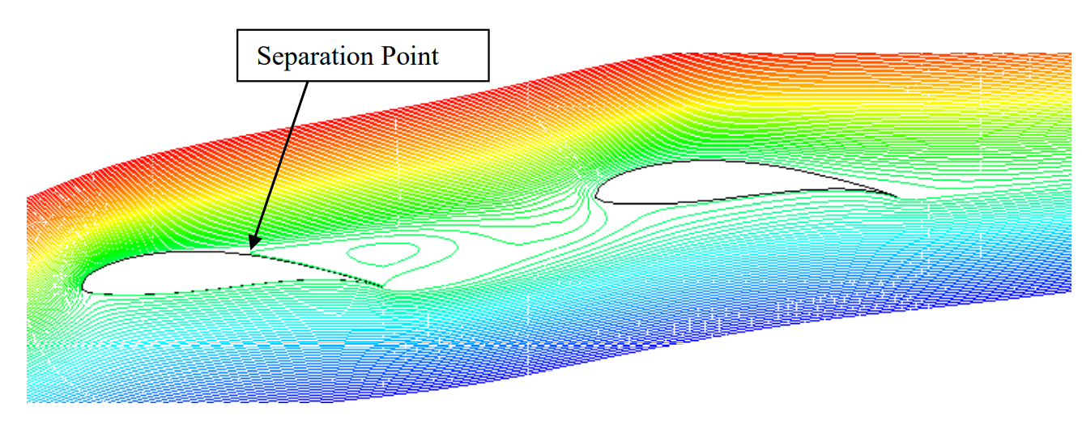
Figure showing the Streamline at the recirculation region attached on the upstream airfoil near stall
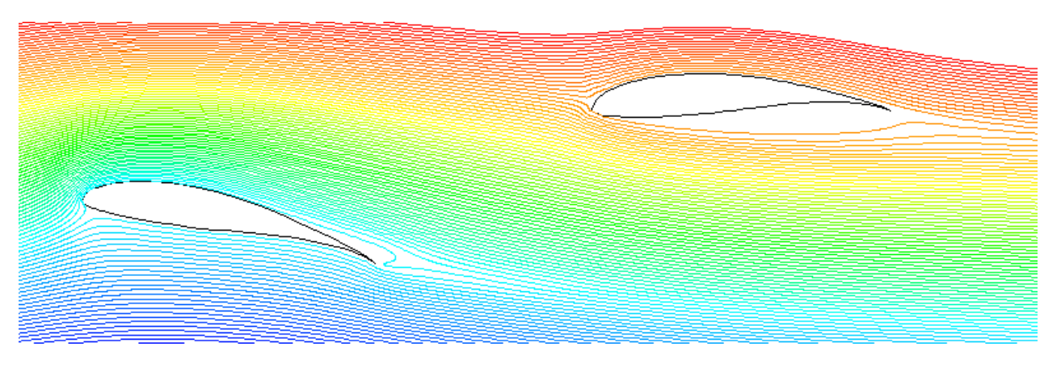
Figure showing the velocity streamline for the tandem configuration
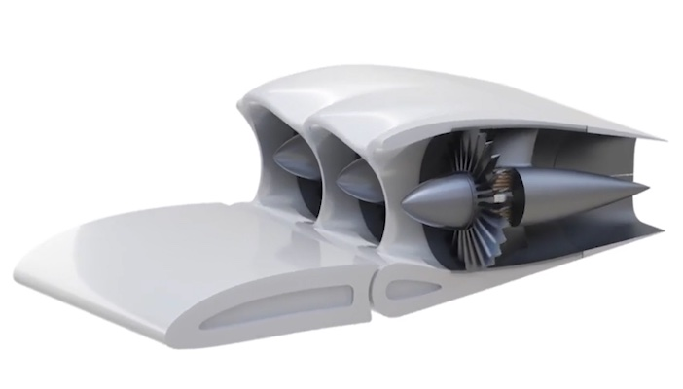
Figure showing the use of the flap control for thrust vectoring
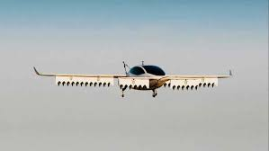
Similar feature used in our aircraft to assist for Vertical take - off and landing.
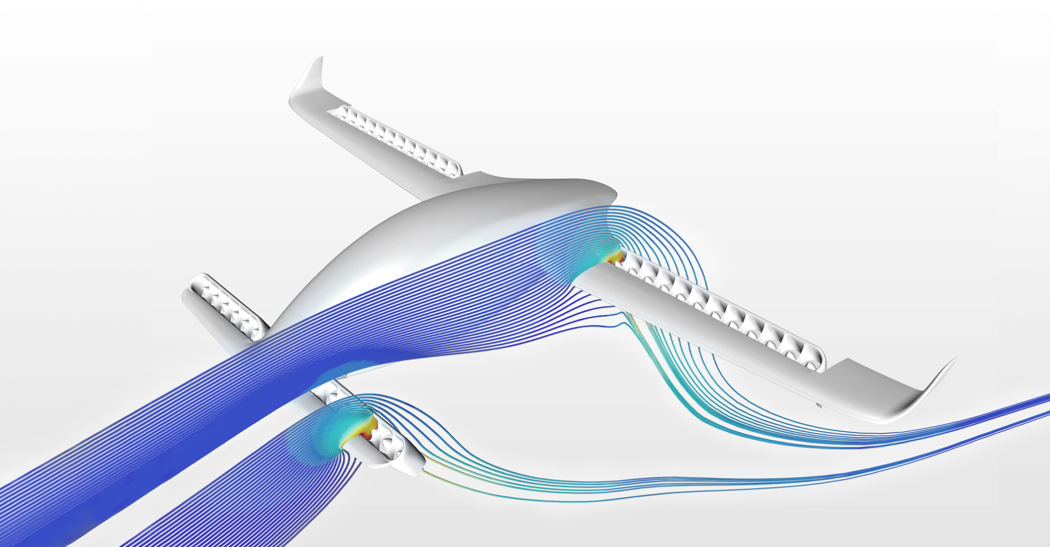
Cfd result depicting similar aircraft using thrust vectoring.

