Given 2D-Diffusion equations is
$$\frac{∂ϕ^{2}}{∂x^{2}}+\frac{∂ϕ^{2}}{∂y^{2}}=0$$Given Boundary conditions are:
- $ϕ=100$at x = 0
- $ϕ=0$at $x=L_{x}$
- Insulated boundaries $(\frac{dϕ}{dy}=0)$ at $y=0$ and $y=L_{y}$
Assuming $L_{x}=1$ and $L_{y}=1$for $0≤ x≤L_{x}$ and $0≤y≤L_{y}$
The spacing in x direction is $∆x$ and the spacing in y direction is $∆y$
Using the FDM (Finite Difference Methods) approach, for 2D, we get the form :
$$\frac{ϕ_{i+1,j}-2ϕ_{i,j}+ϕ_{i-1,j} }{∆x^{2}}+\frac{ϕ_{i,j+1}-2ϕ_{i.j}+ϕ_{i,j-1} }{∆y^{2}}=0$$

Taking $β=\frac{∆x}{∆y }$, so the new equation becomes
$$ϕ_{i+1,j}+ϕ_{i-1,j}+β^{2}\left(ϕ_{i,j+1}+ϕ_{i, j-1}\right)-2\left(1+β^{2}\right)ϕ_{i,j}=0$$
Applying the boundary conditions on the given FDM methods on the say 5X5 nodes,
For Node 1,1 :
$$ϕ_{2,1}+ϕ_{0,1}+ β^{2}\left(ϕ_{1,2}+ϕ_{1,0}\right)-2\left(1+β^{2}\right)ϕ_{1,1}=0$$
As $ϕ_{0,1}=100$ and from the Neumann boundary conditions of $\frac{dϕ}{dy}=0$so stating that $\frac{ϕ_{1,0}-ϕ_{1,2}}{2∆y}=0$. Hence $ϕ_{1,0}=ϕ_{1,2}$. So, the new equation formed is
$$ϕ_{2,1}+100+ β^{2}\left(2ϕ_{1,2}\right)-2\left(1+β^{2}\right)ϕ_{1,1}=0$$
Or,
$$ϕ_{2,1}+ β^{2}\left(2ϕ_{1,2}\right)-2\left(1+β^{2}\right)ϕ_{1,1}=-100$$
Similarly, for Node 2,1:
$$ϕ_{3,1}+ϕ_{1,1}+ β^{2}\left(2ϕ_{2,2}\right)-2\left(1+β^{2}\right)ϕ_{2,1}=0$$
Node 3,1:
$$ϕ_{4,1}+ϕ_{2,1}+ β^{2}\left({2ϕ}_{3,2}\right)-2\left(1+β^{2}\right)ϕ_{3,1}=0$$
Node 1,2:
$$ϕ_{2,2}+ β^{2}\left(ϕ_{1,3}+ ϕ_{1,1}\right)-2\left(1+β^{2}\right)ϕ_{1,3}=-100$$
Node 2,2:
$$ϕ_{3,2}+ϕ_{1,2}+ β^{2}\left(ϕ_{2,1}+ϕ_{2,3}\right)-2\left(1+β^{2}\right)ϕ_{2,2}=0$$
Node 3,2:
$$ϕ_{2,2}+ β^{2}\left(ϕ_{3,1}+ϕ_{3,3}\right)-2\left(1+β^{2}\right)ϕ_{3,2}=0$$
And similarly we , find this for all the unknown nodes equations, now we can put this in matrix format and solve with the linear solvers for $Aϕ=B$
Where A matrix is
$$A=\left[ \begin{matrix}γ & 1 & 0 & 2β^{2} & 0 & 0 & 0 & 0 & 0 \\ 1 & γ & 1 & 0 & 2β^{2} & 0 & 0 & 0 & 0 \\ 0 & 1 & γ & 0 & 0 & 2β^{2} & 0 & 0 & 0 \\ β^{2} & 0 & 0 & γ & 1 & 0 & β^{2} & 0 & 0 \\ 0 & β^{2} & 0 & 1 & γ & 1 & 0 & β^{2} & 0 \\ 0 & 0 & β^{2} & 0 & 1 & γ & 0 & 0 & β^{2} \\ 0 & 0 & 0 & 2β^{2} & 0 & 0 & γ & 1 & 0 \\ 0 & 0 & 0 & 0 & 2β^{2} & 0 & 1 & γ & 1 \\ 0 & 0 & 0 & 0 & 0 & 2β^{2} & 0 & 1 & γ\end{matrix}\right]$$
Where $γ= -2\left(1+β^{2}\right)$
And $B=\left[\begin{matrix}-100 \\ 0 \\ 0 \\ -100 \\ 0 \\ 0 \\ -100 \\ 0 \\ 0\end{matrix}\right]$formed after converting the equations in the matrix format to solve the equations .
I have used PETSc 3.17.5 version , to solve and test the performance of different solvers for different grid points of 5, 10, 20, 40, 80, 100 and 250. The solvers and the preconditioner used are :
- cg
  - none
  - bjacobi
  - asm
  - gamg
- gmres
  - none
  - bjacobi
  - asm
  - gamg
- minres
  - none
  - gamg
- fcg
  - none
  - bjacobi
- Chebyshev
  - None
  - Jacobi

Here I have used different grid points with different sets of solvers to find the comparison
So to visualize the steady-state solution, here are the contours and surface plots for comparison of different grid points with different solvers and preconditioners
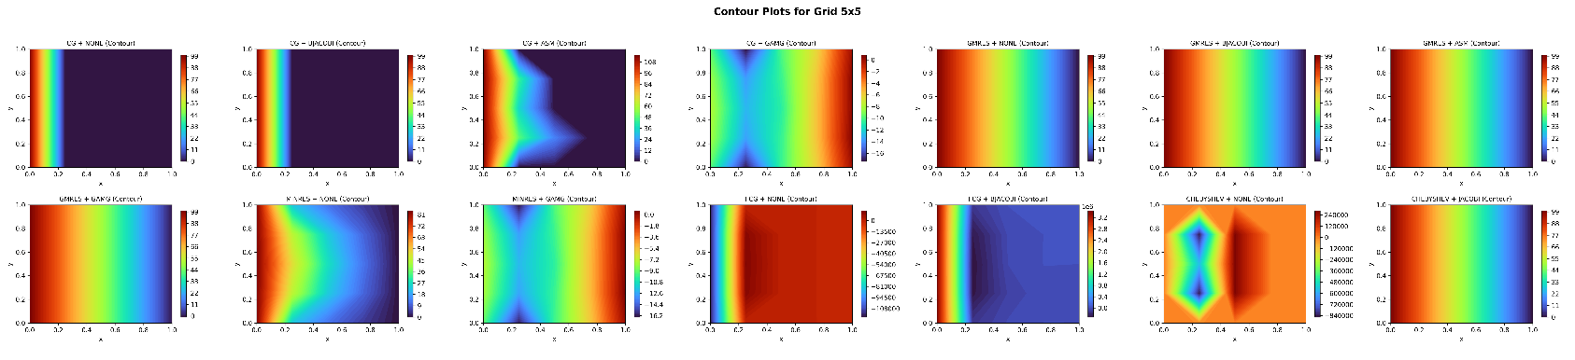
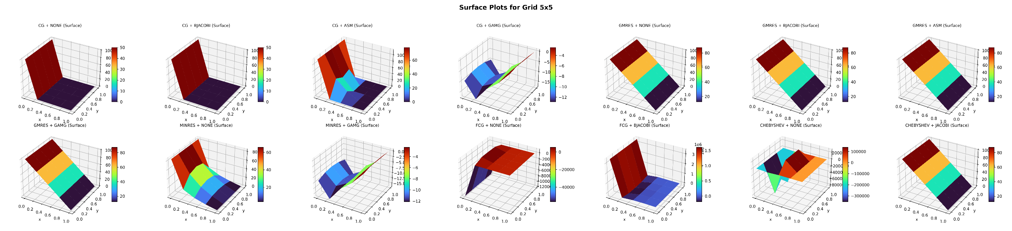
Figure 1 (a) Contour Plot and (b) Surface Plot for 5X5 Grid

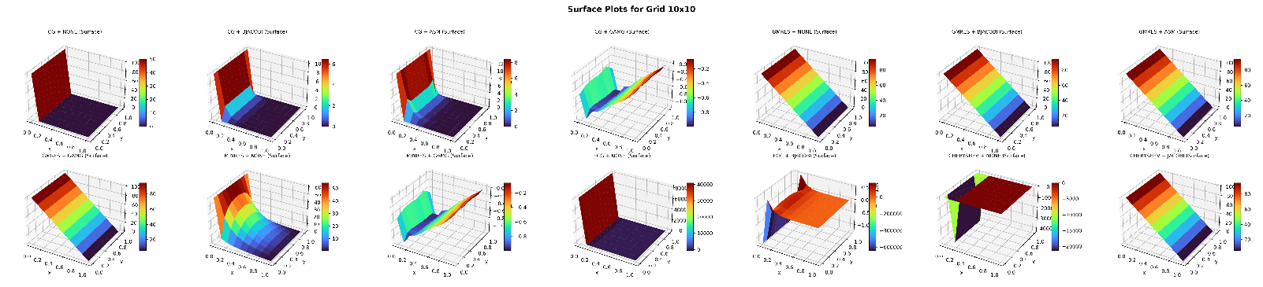
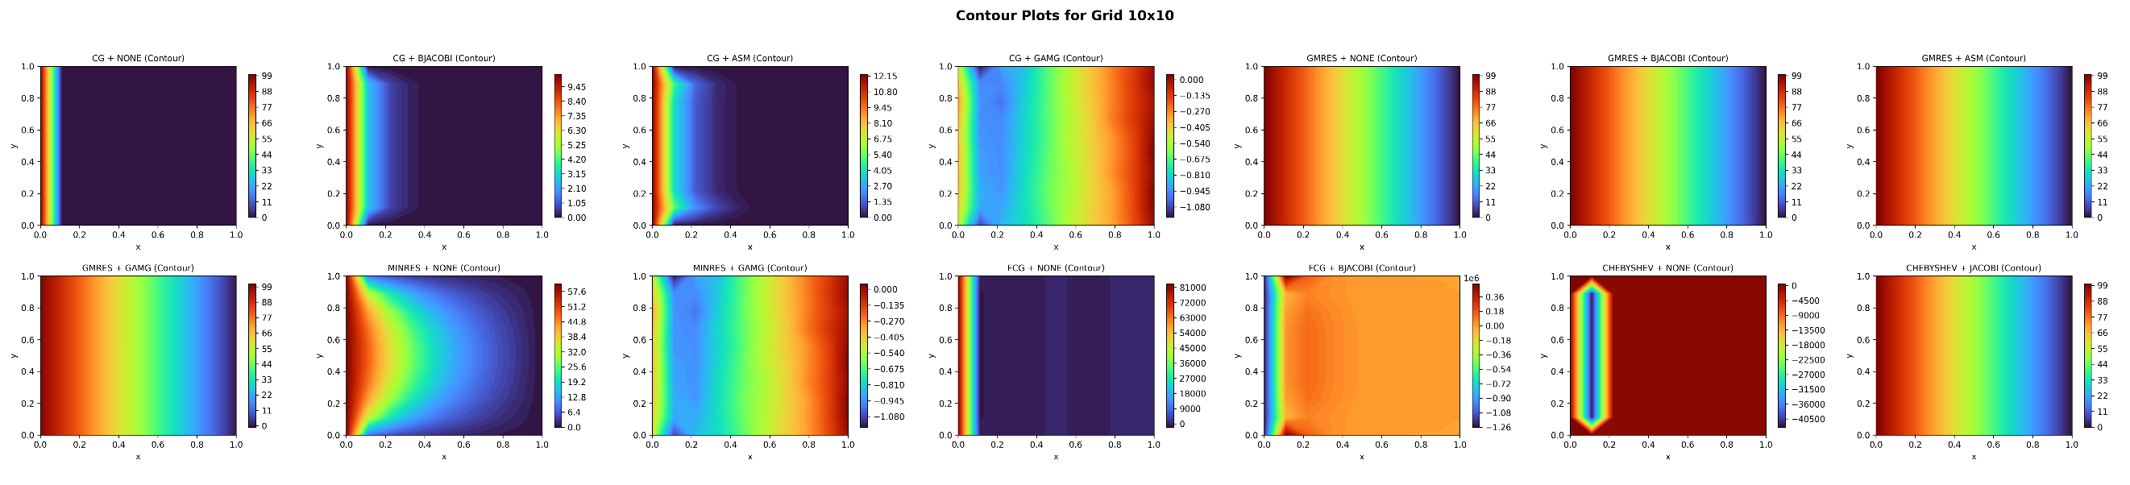
Figure 2 (a) Contour Plot and (b) Surface Plot for 10X10 Grid
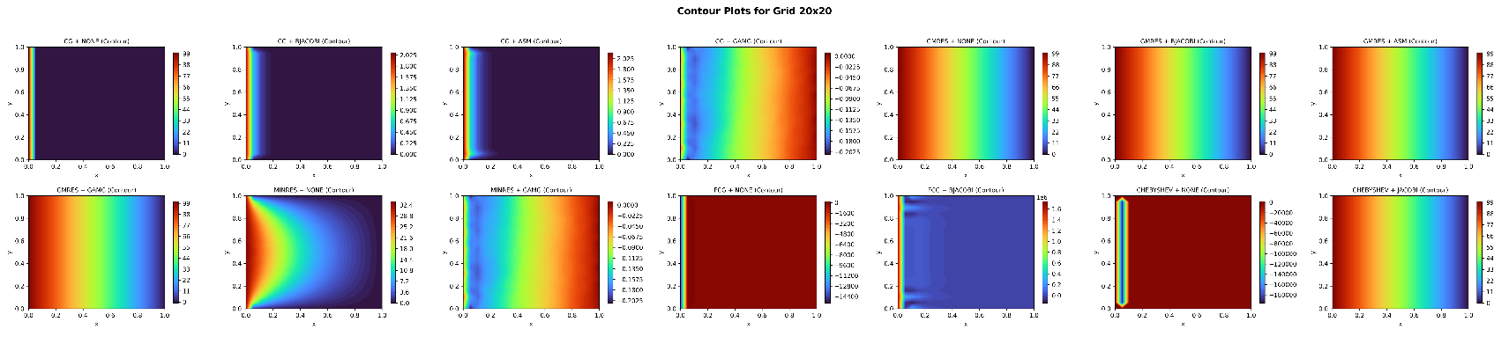
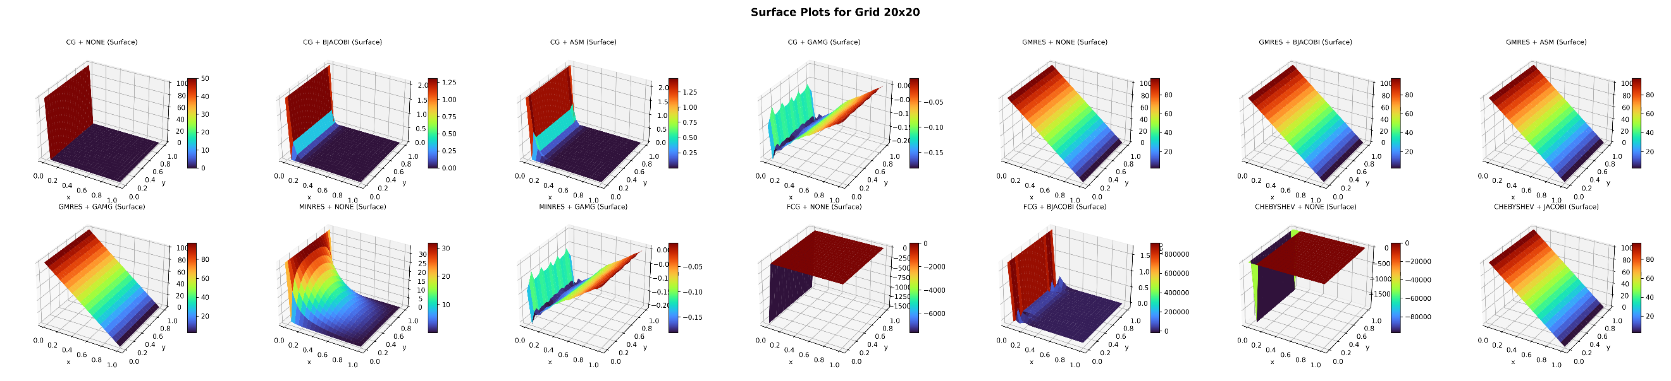
Figure 3 (a) Contour Plot and (b) Surface plot for 20X20 Grid

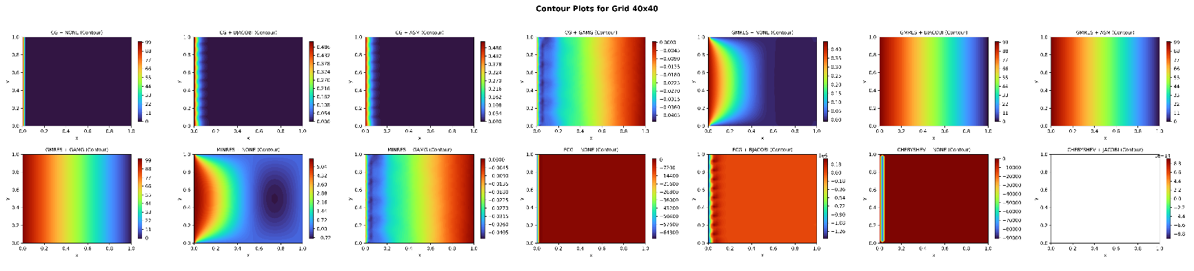
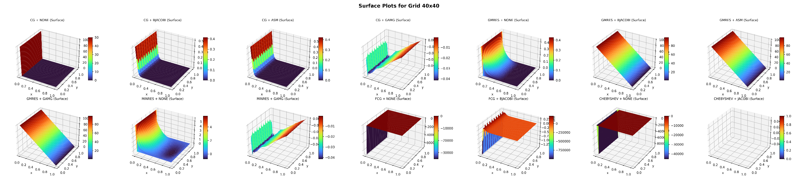
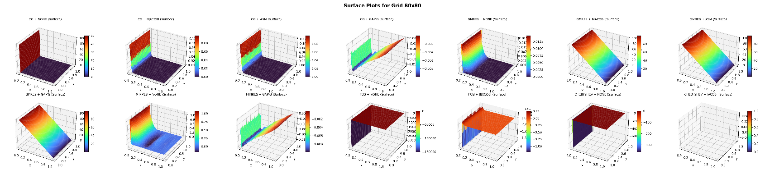
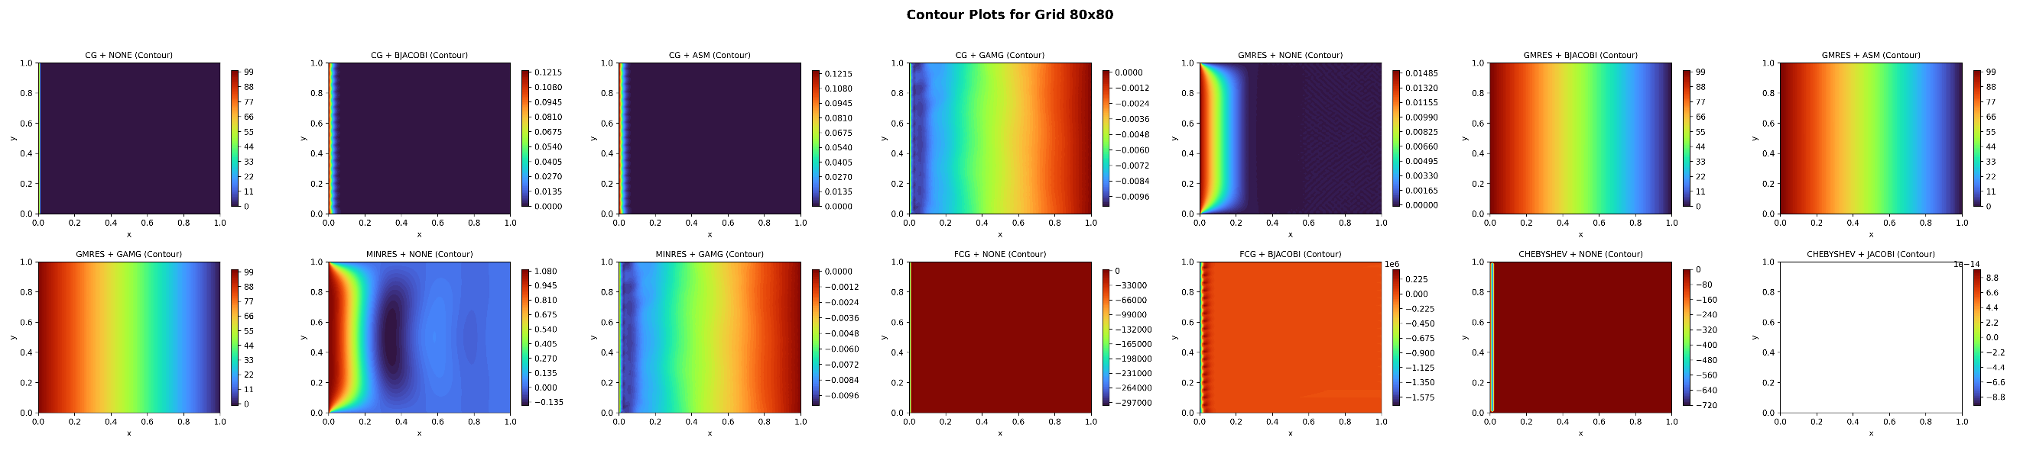
Figure 4(a) Contour Plot and (b)Surface Plot for 40X40 Grid
Figure 5(a) Contour Plot and (b)Surface Plot for 80X80 Grid

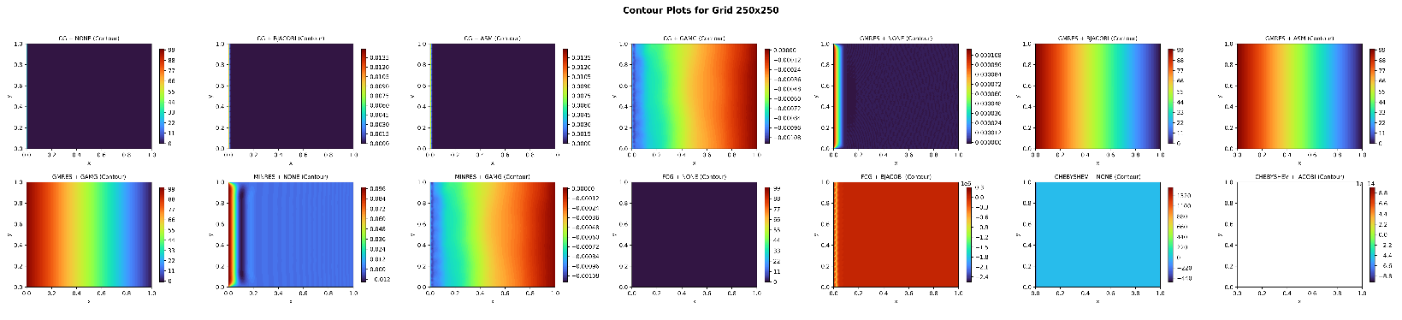
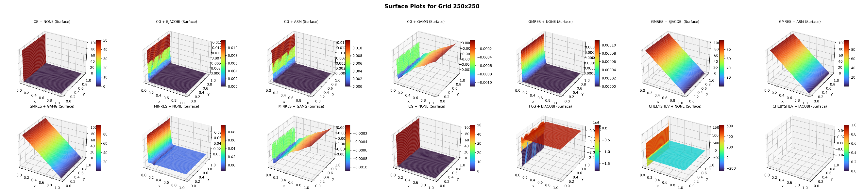
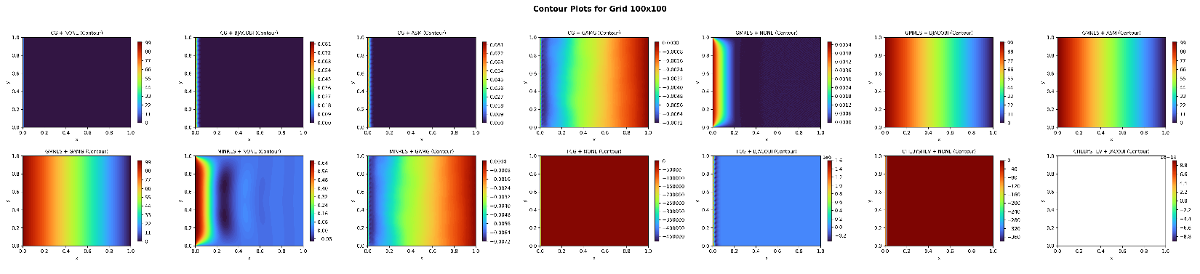
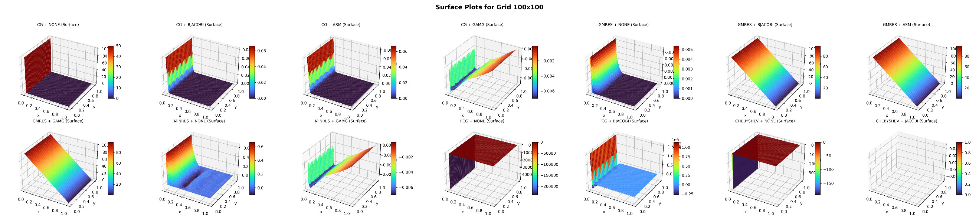
Figure 7(a) Contour Plot and (b)Surface Plot for 250X250 Grid
Figure 6(a) Contour Plot and (b)Surface Plot for 100X100 Grid
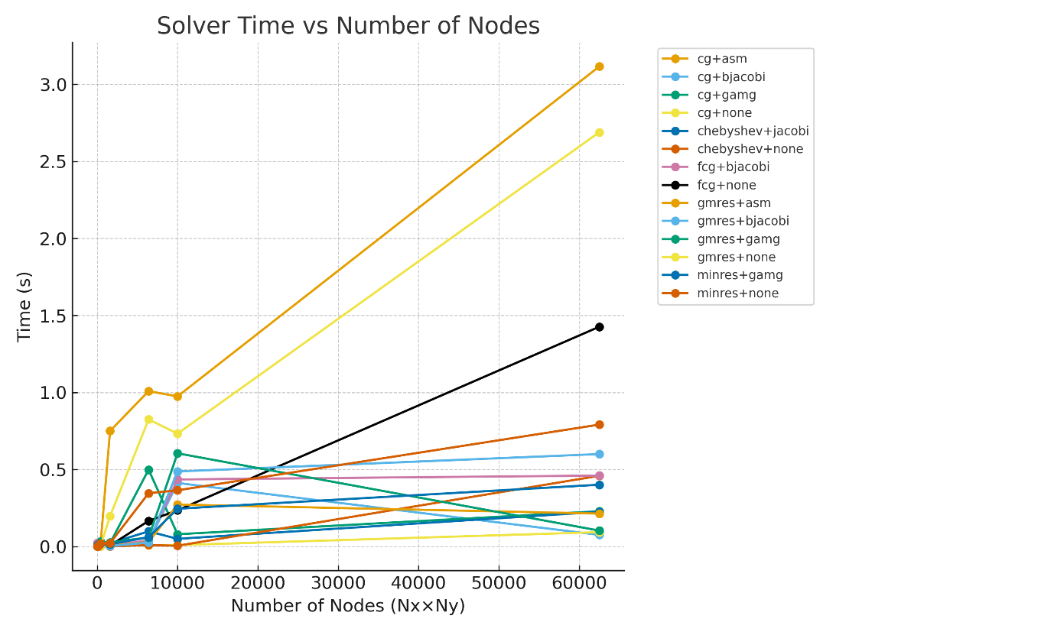
Figure 8 Time vs Nodes plot
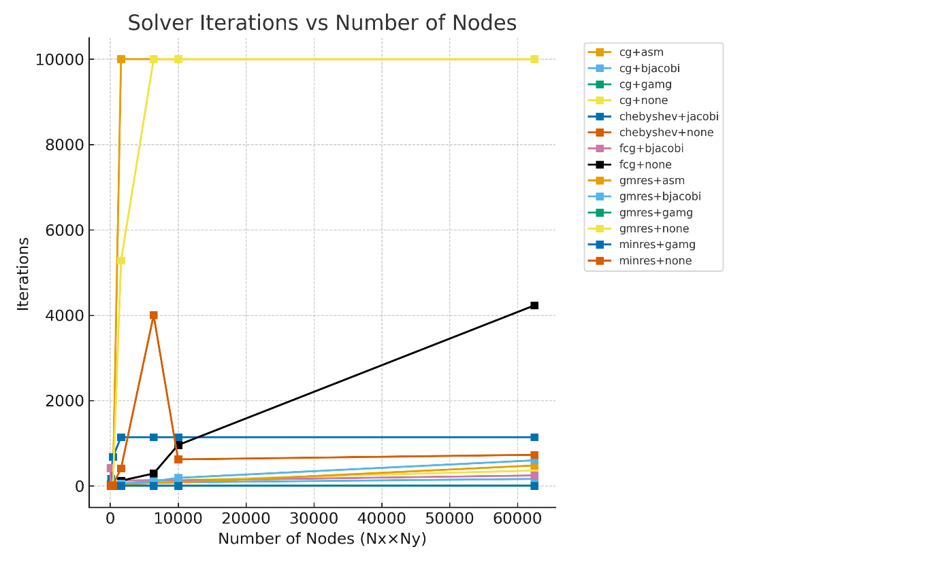
Figure 9 Iteration vs Nodes plot
Conclusion
The solver performance was evaluated for multiple grid resolutions ranging from 5×5 to 500×500, using various iterative solvers and preconditioners available in PETSc.
The convergence behaviour was analysed in terms of iteration count, computational time, and final residual magnitude, along with the physical accuracy of the resulting field.

- GMRES Solver
The Generalized Minimal Residual (GMRES) method exhibited the most consistent and accurate performance across all grid sizes. For every grid level, GMRES achieved low residuals (typically $<{10}^{-2}$) with stable convergence, regardless of the preconditioner. Among preconditioners. ASM and GAMG yielded the fastest convergence , while BJACOBI provided moderate improvement over the unpreconditioned case. The resulting contour and surface plots were physically accurate, showing smooth diffusion from the hot to cold boundaries, thus confirming reliable convergence.

- CG Solver
The Conjugate Gradient (CG) method converged rapidly for coarse grids (5X5, 10X10), but its performance degraded significantly with increasing grid size. For larger systems ($>10X10$), CG failed to reach acceptable residuals and produced unstable or inaccurate field patterns. This behaviour suggests sensitivity to conditioning and a lack of robustness for finer discretization’s, even though CG is theoretically optimal for symmetric positive-definite systems.

- MINRES Solvers
The MINRES solver, when used with preconditioners such as GAMG, appeared to perform efficiently based on low iteration counts and small residuals (<1). However, upon visual inspection of the contour plots, the solutions did not match the expected physical pattern.
This indicates that MINRES likely reached a false convergence, where the residual norm decreased but the computed field remained inaccurate. Hence, it is not reliable for this particular Laplace-type system.

- Chebyshev Solver
The Chebyshev method performed well for lower grid sizes when paired with the Jacobi preconditioner, achieving convergence within a few iterations. However, for higher grid densities, the residual values became undefined (NaN), indicating numerical instability or divergence. This suggests the Chebyshev method is only suitable for small-scale problems or as a smoother in multigrid schemes.

- FCG Solver
The Flexible Conjugate Gradient (FCG) solver exhibited the poorest performance throughout all grid sizes. It either failed to converge or produced unacceptably large residuals, making it unsuitable for steady-state diffusion problems of this type.
Overall, the GMRES solvers with ASM or GAMG preconditioner provided the most stable and physically accurate solutions for the 2D steady-state diffusion equation. It maintained consistent convergence characteristics across all mesh sizes, making it the preferred choice for both accurate and robustness in PETSC-based implementation .

