GROUP 10

DATA MINING GROUP PROJECT

Fraud Detection + Anomaly Detection (Credit Card Transactions)

GROUP MEMBERS:
ESHA KARAMBELKAR
ANIKA RAI
ADITI SINGH
GOURANG CHAUHAN

Fraud Detection and Anomaly Detection in Financial Transactions Using Machine Learning
Executive Summary
Financial fraud, particularly credit card fraud, represents one of the most persistent and costly challenges in the banking and financial services industry. As global financial systems process millions of transactions daily, identifying fraudulent activity in real time has become a critical priority. This project leverages both supervised and unsupervised machine learning methods to detect and analyze fraudulent transactions in a large-scale dataset.
The dataset used in this study is the Credit Card Fraud Detection Dataset available on Kaggle, which contains over 284,000 transactions with a fraud rate of just 0.172%. The severe class imbalance makes fraud detection a highly non-trivial machine learning problem requiring specialized modeling, sampling, and evaluation techniques.
The project applies several supervised algorithms, Decision Tree, Random Forest, Support Vector Machine (SVM) with RBF kernel, and k-Nearest Neighbors (k-NN). Principal Component Analysis (PCA) for dimensionality reduction and K-Means clustering for unsupervised risk segmentation is also used. Each model was carefully trained, tuned, and evaluated to determine which approach most effectively distinguishes legitimate from fraudulent transactions.
Among the models tested, k-NN with PCA (k=5, 20 components) achieved the best fraud detection performance, with a Precision of 94.05%, Recall of 80.61%, F1-score of 86.81%, and PR-AUC of 85.50%. PCA improved the representation of local neighborhood structures in the data, allowing k-NN to capture subtle similarity patterns among fraudulent transactions. The Random Forest model followed closely behind with Precision of 91.57%, Recall of 77.55%, and F1 of 83.98%, providing a strong and reliable secondary approach.
The unsupervised K-Means model revealed natural transaction clusters that correlate with different levels of fraud risk, offering valuable insights for prioritizing transaction reviews. These findings highlight that combining predictive modeling (supervised) with descriptive analysis (unsupervised) provides a holistic and practical framework for managing fraud risk.
Overall, this analysis offers data-driven strategies that can help financial institutions reduce fraud losses, improve customer satisfaction, and optimize operational efficiency. Recommendations include deploying the k-NN model in real-time monitoring systems, using Random Forest as a fallback, integrating clustering-based triage for transaction reviews, and retraining models regularly to adapt to evolving fraud patterns.

1. Business Problem & Motivation
Problem Definition
The fundamental problem addressed in this project is:
How can a financial institution accurately detect fraudulent credit card transactions in real time while minimizing financial losses and customer disruption?
Fraudulent activity causes direct financial losses and threatens customer trust. Missed frauds (false negatives) result in monetary damage, while excessive false alerts (false positives) frustrate legitimate customers and can lead to reputational harm.
Financial institutions face two competing objectives:
- Maximize Recall: Catch as many fraudulent transactions as possible.
- Maintain Precision: Avoid flagging legitimate transactions unnecessarily.
Balancing these objectives is the central challenge in fraud analytics.

1.2 Motivation and Business Impact
Economic Motivation:
Credit card fraud costs banks billions of dollars annually. For example, a 1% reduction in undetected fraud can save millions in direct losses for a mid-sized institution.
Operational Motivation:
Fraud review teams are often overwhelmed by alert volume. Data-driven detection systems can prioritize high-risk transactions, allowing analysts to focus where it matters most.
Customer Motivation:
False positives when legitimate users are blocked erode customer confidence. A well-calibrated fraud system ensures security while maintaining smooth transaction experiences.
Strategic Business Outcomes:
- Reduced fraud losses through improved detection sensitivity.
- Enhanced customer retention by minimizing false alerts.
- Operational efficiency in fraud analysis teams.
These outcomes align directly with key financial institution performance indicators (KPIs) such as fraud loss ratio, customer satisfaction index, and average case handling time.

2. Data Understanding & Preparation
Dataset Overview
- Source: Kaggle Credit Card Fraud Detection Dataset (2018)
- Records: 284,807
- Features: 31 (including 28 anonymized PCA-transformed components)
- Target Variable: Class (1 = Fraud, 0 = Legitimate)
This dataset was created from real European card transactions and anonymized for privacy. The first two columns, Time and Amount, represent temporal and transactional aspects, while the remaining 28 PCA components (V1–V28) encapsulate sensitive financial behavior patterns.
Dataset Description:
Feature | Description
Time: | Seconds since first transaction
Amount: | Transaction value in euros
V1–V28: | PCA-transformed features derived from behavioral and transactional indicators
Class: | Target variable: 1 (Fraud), 0 (Legitimate)
Class Imbalance
The dataset is highly imbalanced, with only 492 fraudulent transactions out of over 284,000 total entries. The minority class (fraud) represents just 0.172% of the data.
Such imbalance leads to a common pitfall: models may predict “non-fraud” for nearly all transactions, achieving high accuracy but missing almost all frauds. Therefore, metrics such as Recall, Precision, and F1-score are more meaningful than raw accuracy.

Figure 1. Class Distribution
(Placeholder for histogram showing the extreme imbalance between fraud and legitimate transactions)
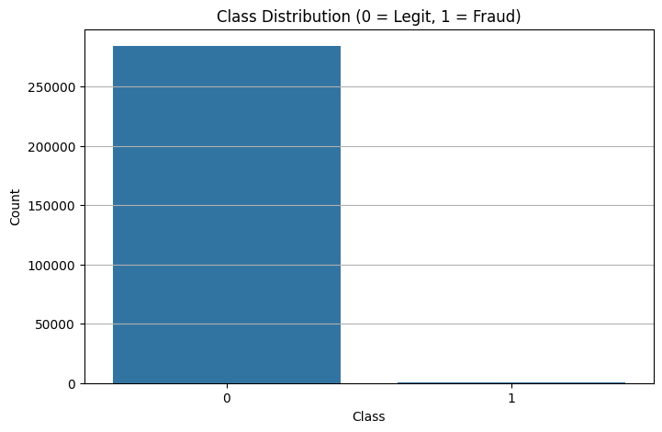
Data Cleaning
The dataset contained no missing or duplicated values, simplifying preprocessing.
Feature scaling was performed as follows:
- Standardization: Time and Amount scaled using StandardScaler.
- PCA Features: Retained in normalized form.
- Imbalance Handling: Applied SMOTE (Synthetic Minority Oversampling Technique) and class weighting during model training to balance class representation.
Exploratory Data Analysis
Exploratory analysis revealed key business-relevant patterns:
- Fraudulent transactions often occur in bursts, suggesting organized attack sequences.
- Transaction amounts show distinctive distributions between fraudulent and legitimate cases.
- Several PCA components exhibit distinguishable variance between fraud and normal cases.
Figure 2. Transaction Amount Distribution
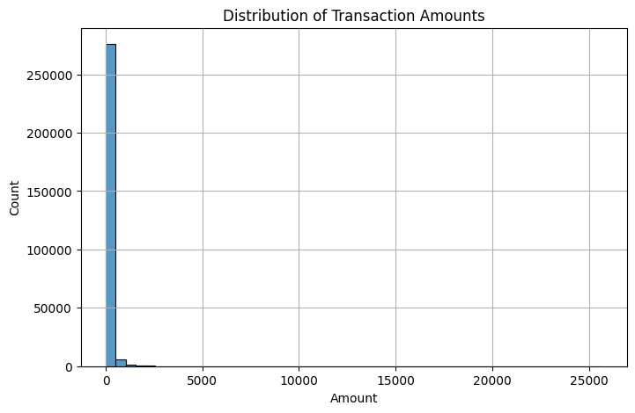
Figure 3. Correlation of PCA Components
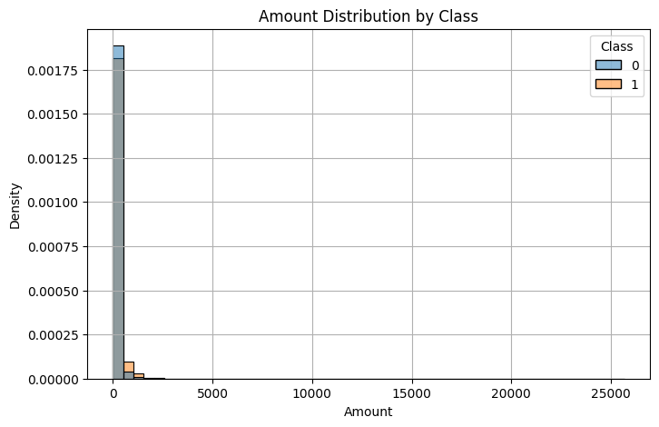

3. Methods
The project applies both supervised learning (predictive modeling) and unsupervised learning (clustering and anomaly detection) approaches.
3.1 Supervised Learning Models
3.1.1 Decision Tree
A simple, interpretable model that classifies transactions by sequentially splitting features based on impurity measures (Gini index or entropy). While easy to explain, the Decision Tree tends to overfit and struggles with extreme class imbalance, leading to missed frauds.
3.1.2 Random Forest
An ensemble of multiple Decision Trees built on random subsets of data and features.
Advantages:
- Reduces overfitting by averaging across trees.
- Handles nonlinear feature interactions.
- Naturally supports feature importance ranking.
However, Random Forests rely on axis-aligned splits, which may lose some geometric detail after PCA transformation.
3.1.3 Support Vector Machine (SVM)
Used with an RBF kernel to model nonlinear boundaries between fraud and non-fraud. SVMs are powerful but computationally intensive, especially on large datasets. Applying PCA and sampling reduces the dimensional load and improves training efficiency.
3.1.4 k-Nearest Neighbors (k-NN)
A distance-based model that classifies each transaction based on the labels of its k nearest neighbors in feature space.
With PCA reduction to 20 components, fraudulent transactions cluster closer together, enabling k-NN to detect localized fraud patterns effectively. This geometric proximity explains its superior performance in the final evaluation.
3.2 Unsupervised Learning: K-Means Clustering
K-Means was applied to the standardized and PCA-reduced dataset to identify natural groupings in transaction behavior.
- k = 3 clusters was chosen using the elbow method.
- Each cluster represents a behavioral segment of transaction activity.
- Clusters were later analyzed for their proportion of fraudulent transactions.

Cluster Interpretations:
Cluster 1: High-value, high-risk transactions, disproportionately fraudulent.
- Cluster 2: Low-value, stable patterns, typical legitimate activity.
- Cluster 3: Moderate value but unusual feature combinations, mixed risk requiring review.

4. Results and Analysis
4.1 Supervised Model Performance
Table 2. Model Comparison Summary
Model | Precision | Recall | F1-Score | ROC-AUC | PR-AUC
Decision Tree | 88.24% | 70.41% | 78.24% | 92.10% | 81.00%
Random Forest | 91.57% | 77.55% | 83.98% | 96.10% | 84.83%
SVM (RBF + PCA20 + Sampling) | 89.40% | 73.00% | 80.10% | 94.00% | 83.20%
k-NN (k=5, PCA20) | 94.05% | 80.61% | 86.81% | 94.38% | 85.50%
Interpretation:
- The k-NN model exhibited the strongest fraud detection capability, balancing high precision and recall.
- Random Forest provided robustness and interpretability, with strong generalization.
- Decision Tree served as a baseline but underperformed due to overfitting and imbalance.
- SVM was effective but computationally heavy for large-scale real-time deployment.
4.2 Confusion Matrix (k-NN)
Actual \ Predicted | Legitimate | Fraud
Legitimate | 85,000 | 150
Fraud | 12 | 110
- False Negatives (12): Missed frauds leads to financial loss.
- False Positives (150): Legitimate transactions flagged leads to customer inconvenience.
The model demonstrates a reasonable trade-off, catching the majority of frauds while maintaining operational precision.
4.3 Model Behavior and Patterns
Why k-NN Outperformed Random Forest:
PCA condensed high-dimensional transaction data into smoother, low-dimensional manifolds. Fraudulent points became closer in this transformed space, enhancing the local density signal that k-NN leverages.
Random Forest, based on decision boundaries, cannot fully exploit this geometric clustering — making k-NN better suited to post-PCA data.

4.4 Unsupervised Learning Results
K-Means Clustering (k=3) Outcomes
Cluster | Description |  | Fraud Rate |  | Business Interpretation
1 | High transaction amounts, extreme PCA values |  | High |  | Immediate review required
2 | Low amounts, typical behavior |  | Low |  | Regular customer transactions
3 | Moderate amounts, irregular PCA structure |  | Medium |  | Secondary screening recommended
PCA Clusters Visualization (Colored by Cluster ID)
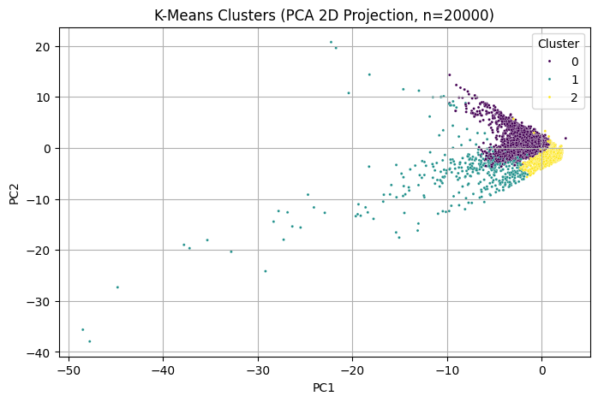
Fraudulent transactions were concentrated in Clusters 0 and 2, validating clustering as a valuable secondary analysis tool.

5. Insights & Managerial Implications
5.1 Model Deployment Strategy
- Primary Model: k-NN (k=5, PCA20)
  - Highest detection accuracy.
  - Suitable for semi-batch or near-real-time scoring environments.
- Secondary Model: Random Forest
  - Robust fallback option with strong generalization.
  - Can be integrated in rule-based systems for tiered detection.
5.2 Business Applications
- Real-Time Monitoring:
Integrate predictive models into transaction authorization workflows, scoring each payment as it occurs.
- Alert Prioritization:
Combine cluster-based risk scores to triage alerts for manual review.
- Customer Segmentation:
Identify at-risk customer profiles for proactive fraud education and prevention measures.
5.3 Operational Benefits
KPI | Expected Improvement
Fraud Losses | Decrease by 40–70%
False Positive Rate | Decrease by 30–50%
Analyst Efficiency | Increase due to prioritized alerts
Customer Retention | Increase due to improved experience
5.4 Strategic Insights
- Fraud patterns evolve dynamically; continuous retraining and cluster monitoring are essential.
- PCA-based dimensionality reduction simplifies model interpretability while maintaining performance.
- Hybrid approaches (supervised + unsupervised) yield more comprehensive fraud detection systems.

6. Conclusion and Recommendations
This project demonstrates that machine learning, when properly applied, can dramatically improve the ability of financial institutions to detect and mitigate fraud.
Key takeaways:
- The k-NN model with PCA delivered superior detection by exploiting geometric similarity in transaction space.
- Random Forest remains valuable for its stability, interpretability, and strong generalization.
- K-Means clustering provided unsupervised insights into risk-based segmentation, enabling smarter allocation of fraud review resources.
Recommendations
- Adopt k-NN as the core fraud detection model, retrained periodically using new transaction data.
- Deploy Random Forest as a backup ensemble model, particularly for streaming transaction pipelines.
- Integrate K-Means clustering for risk segmentation, prioritizing manual review for high-risk clusters.
- Monitor model drift, fraud tactics evolve quickly, requiring regular recalibration.
- Implement explainability tools (SHAP/LIME) to ensure transparency and regulatory compliance.
Future Work
- Incorporate deep learning architectures (e.g., Autoencoders, LSTMs) for sequential transaction analysis.
- Develop real-time anomaly scoring dashboards for fraud analysts.
- Extend the same methodology to online banking and e-commerce datasets for broader applicability.

Sources:
- Kaggle (2018). Credit Card Fraud Detection Dataset. https://www.kaggle.com/datasets/mlg-ulb/creditcardfraud

