Name: Gourav Bangad

Mis: 112003014

Div 1

1. Install Git commands:

Command: sudo apt-get install git

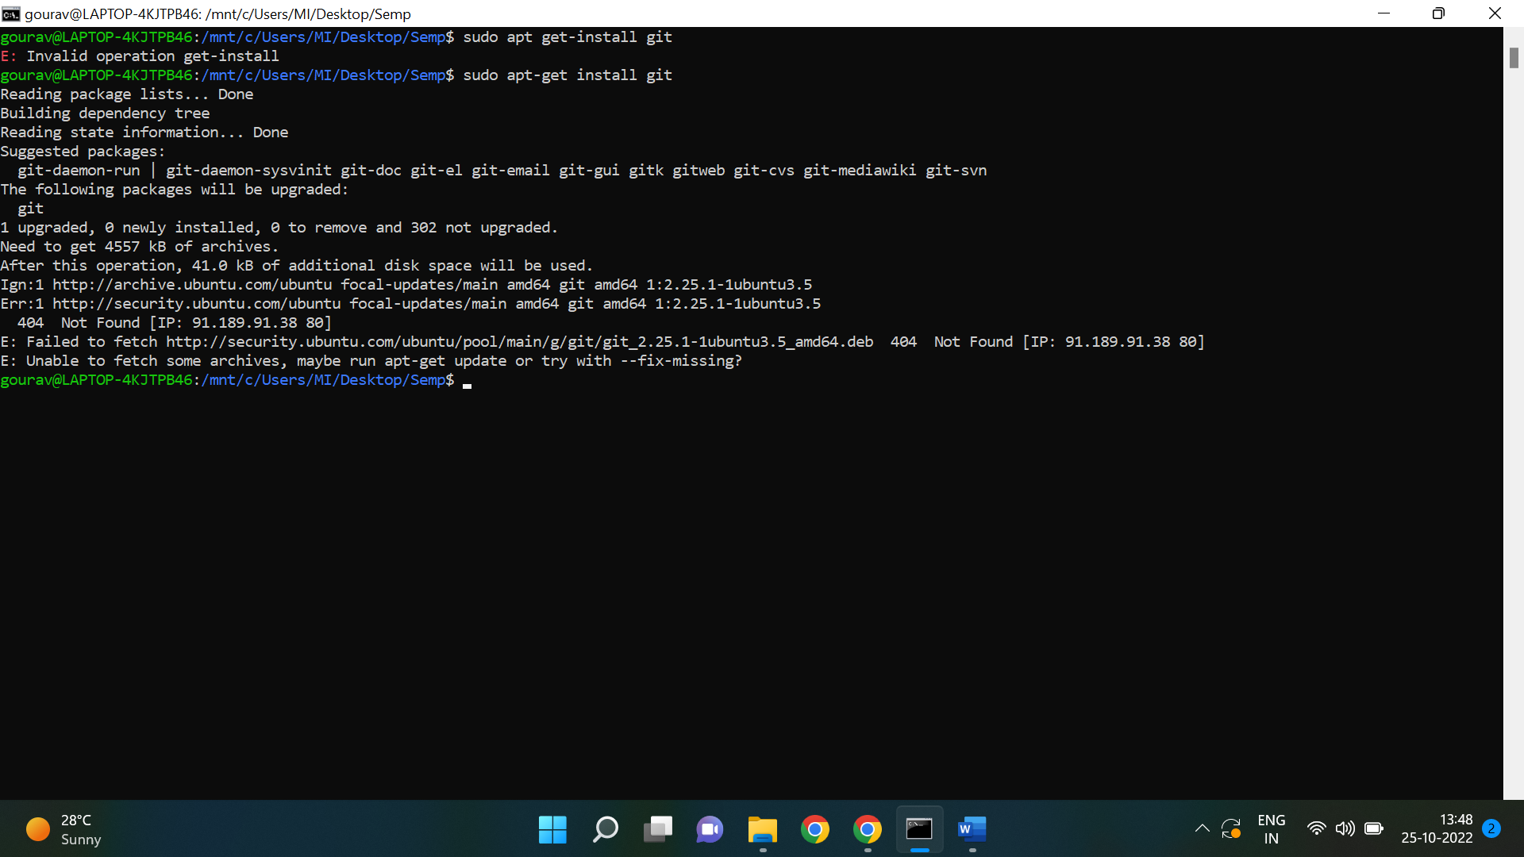

1. Git Config:

