Grad-CAM and Disease Prediction Comparison Report

1. Model Overview
Model | Architecture | Parameters | Test Accuracy | FPS | Latency (ms)
VGG16 | CNN (13 Conv + 3 FC) | 138M | 97.72% | 267.5 | 9.49 ms
ViT-Base | Vision Transformer (Patch16) | 86M | 74.22% | 70.1 | 14.26 ms
Swin-Base | Swin Transformer (Patch4, W7) | 88M | 73.83% | 20.5 | 48.81 ms

2. Grad-CAM and Prediction Comparison

Apple Scab Leaf
VGG16 | ViT-Base | Swin-Base
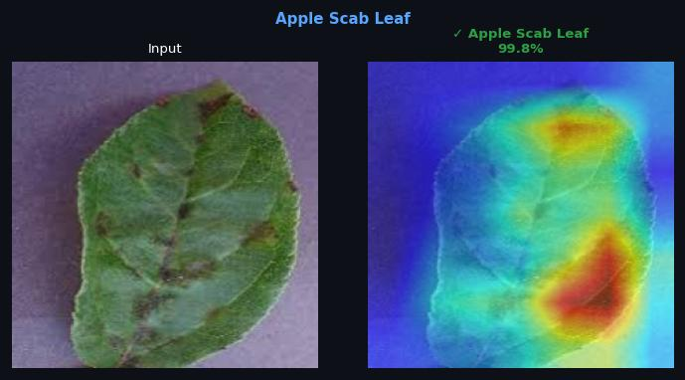  Predicted: Apple Scab Leaf  Confidence: 99.8% | 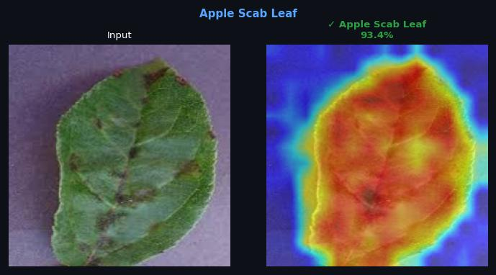  Predicted: Apple Scab Leaf  Confidence: 93.4% | 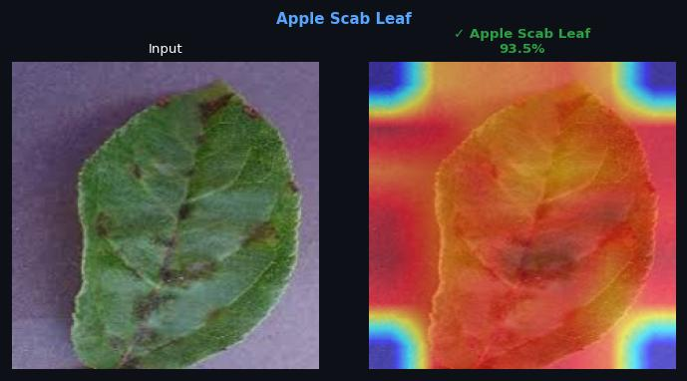  Predicted: Apple Scab Leaf  Confidence: 93.5%

Apple leaf
VGG16 | ViT-Base | Swin-Base
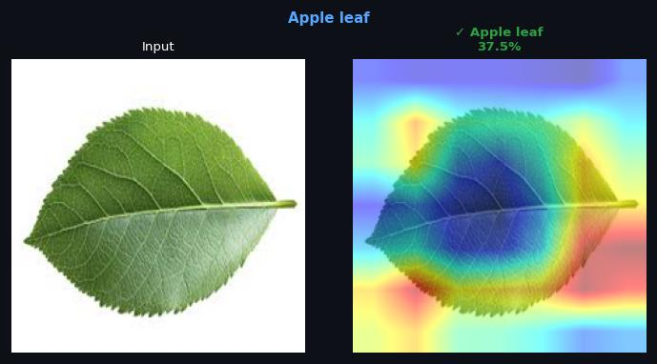  Predicted: Apple leaf  Confidence: 37.5% | 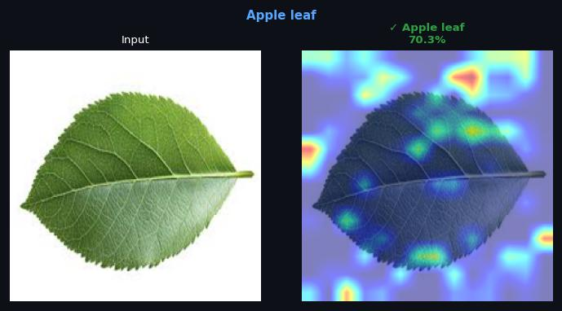  Predicted: Apple leaf  Confidence: 70.3% | 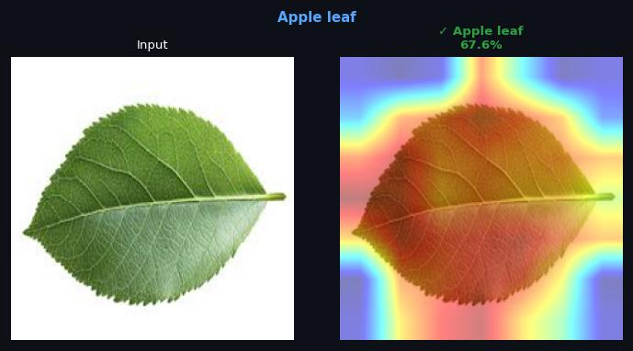  Predicted: Apple leaf  Confidence: 67.6%

Apple rust leaf
VGG16 | ViT-Base | Swin-Base
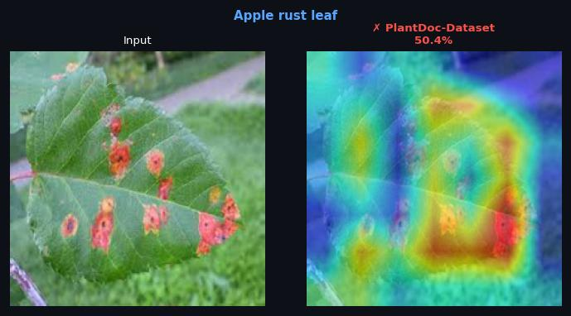  Predicted: PlantDoc-Dataset  Confidence: 50.4% | 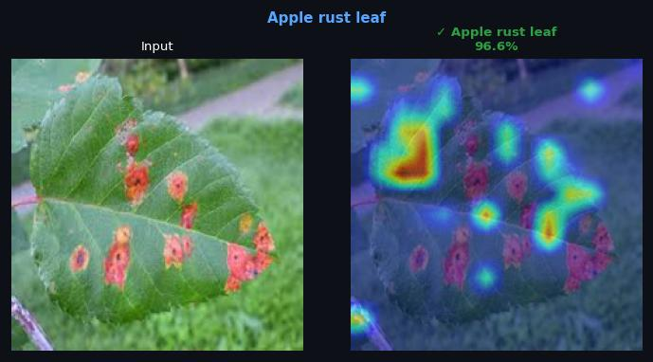  Predicted: Apple rust leaf  Confidence: 96.6% | 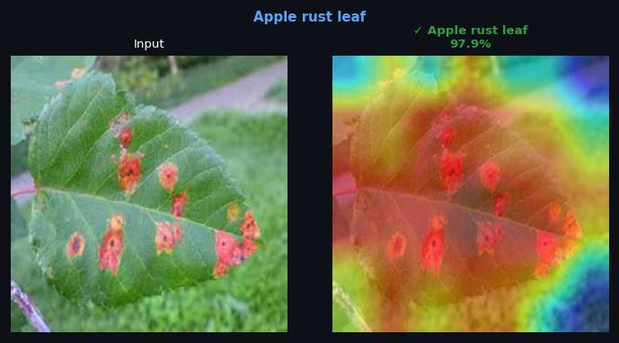  Predicted: Apple rust leaf  Confidence: 97.9%

Bell pepper leaf
VGG16 | ViT-Base | Swin-Base
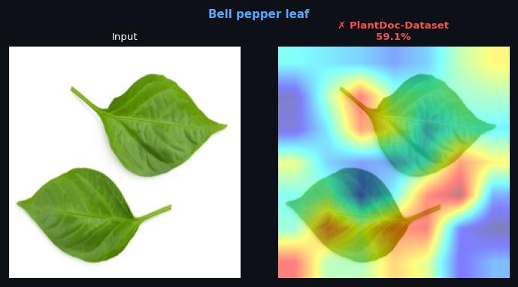  Predicted: N/A  Confidence: N/A | 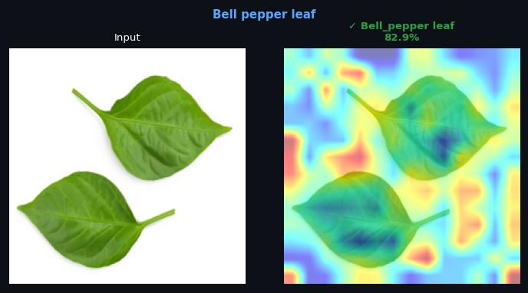  Predicted: N/A  Confidence: N/A | 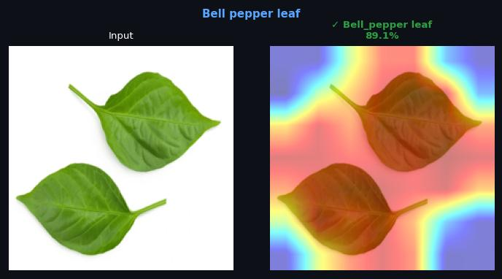  Predicted: N/A  Confidence: N/A

Bell pepper leaf spot
VGG16 | ViT-Base | Swin-Base
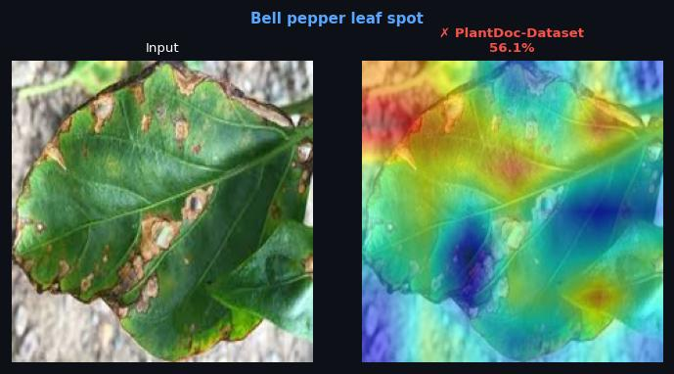  Predicted: PlantDoc-Dataset  Confidence: 56.1% | 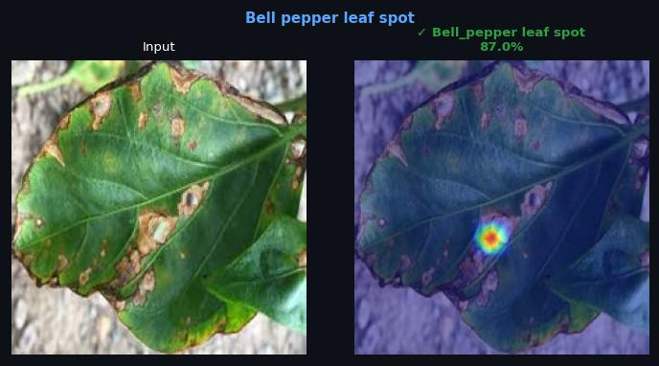  Predicted: Bell_pepper leaf spot  Confidence: 87.0% | 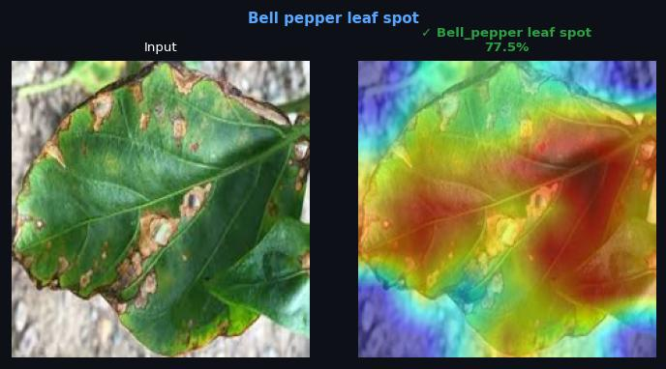  Predicted: Bell_pepper leaf spot  Confidence: 77.5%

Blueberry leaf
VGG16 | ViT-Base | Swin-Base
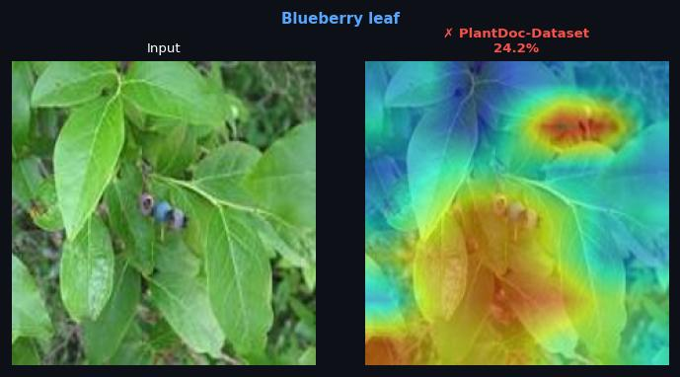  Predicted: PlantDoc-Dataset  Confidence: 24.2% | 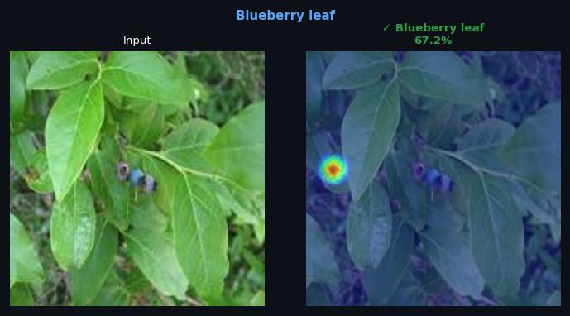  Predicted: Blueberry leaf  Confidence: 67.2% | 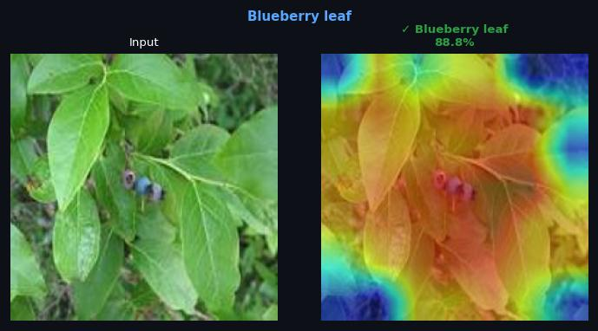  Predicted: Blueberry leaf  Confidence: 88.8%

Cherry leaf
VGG16 | ViT-Base | Swin-Base
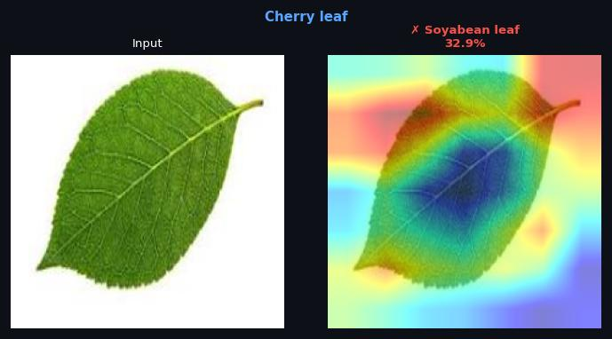  Predicted: Soyabean leaf  Confidence: 32.9% | 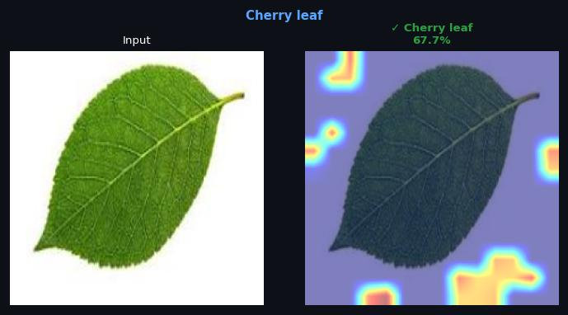  Predicted: Cherry leaf  Confidence: 67.8% | 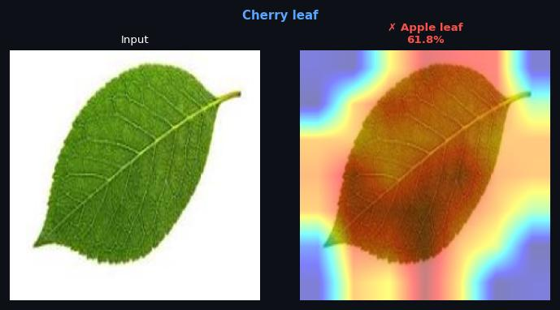  Predicted: Apple leaf  Confidence: 61.8%

Corn Gray leaf spot
VGG16 | ViT-Base | Swin-Base
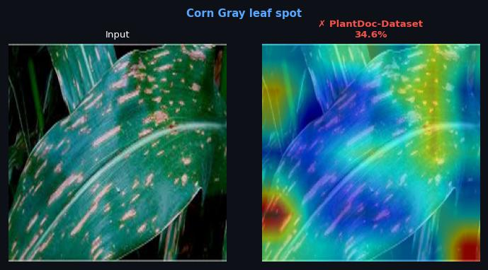  Predicted: PlantDoc-Dataset  Confidence: 34.6% | 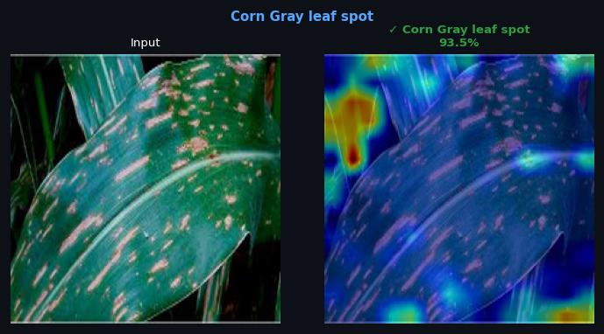  Predicted: Corn Gray leaf spot  Confidence: 93.5% | 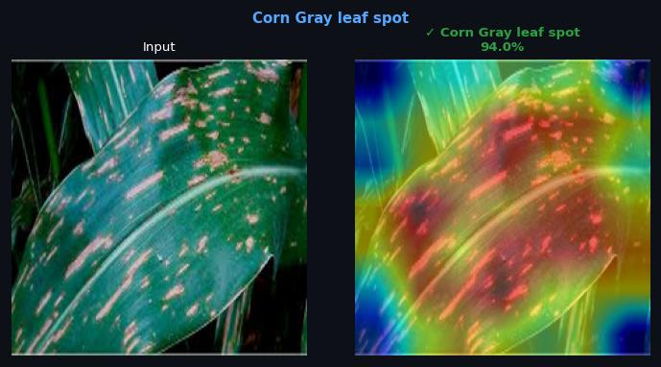  Predicted: Corn Gray leaf spot  Confidence: 94.0%

Corn leaf
VGG16 | ViT-Base | Swin-Base
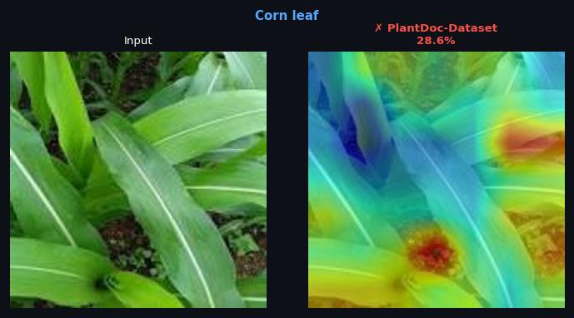  Predicted: PlantDoc-Dataset  Confidence: 28.6% | 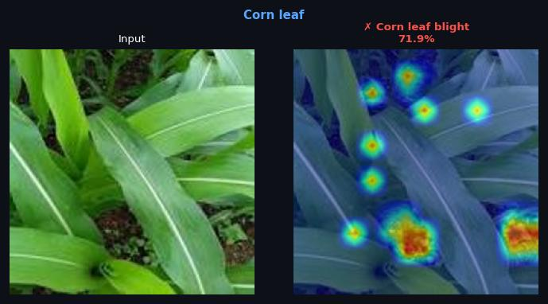  Predicted: Corn leaf blight  Confidence: 71.9% | 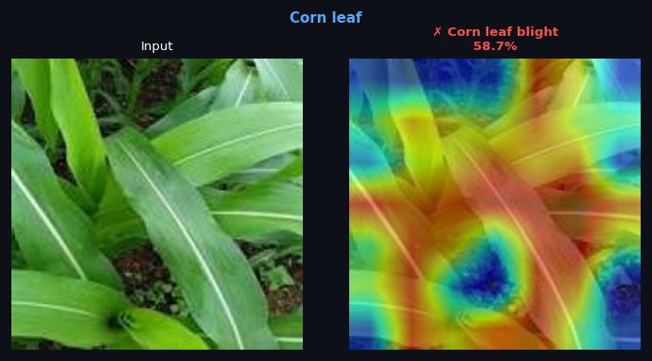  Predicted: Corn leaf blight  Confidence: 58.7%

Corn rust leaf
VGG16 | ViT-Base | Swin-Base
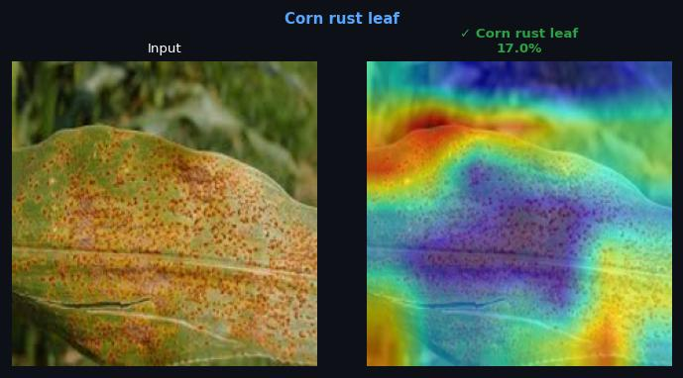  Predicted: Corn rust leaf  Confidence: 17.0% | 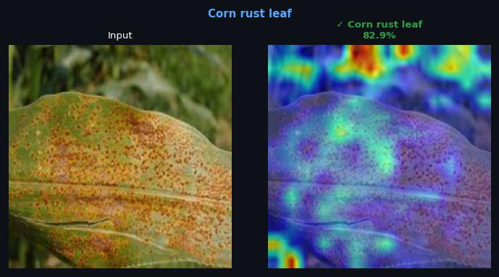  Predicted: Corn rust leaf  Confidence: 82.8% | 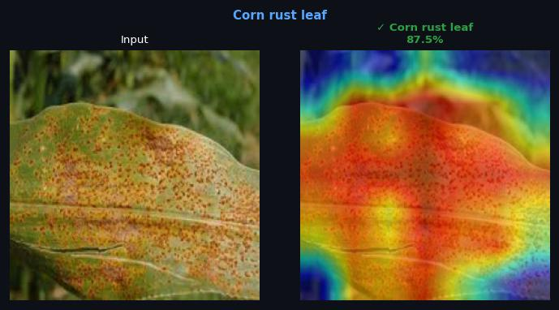  Predicted: Corn rust leaf  Confidence: 87.5%

Orange leaf
VGG16 | ViT-Base | Swin-Base
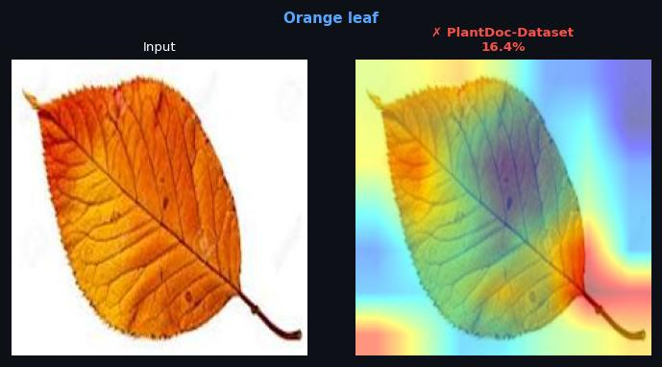  Predicted: PlantDoc-Dataset  Confidence: 16.4% | 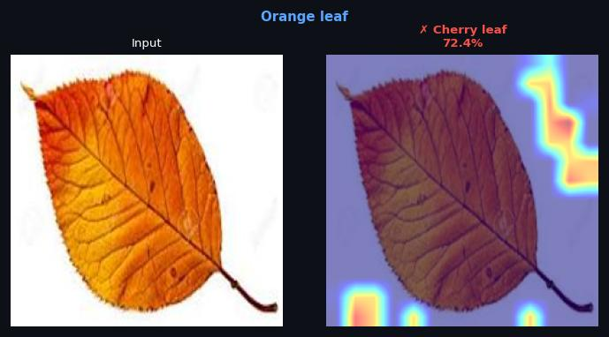  Predicted: Cherry leaf  Confidence: 72.4% | 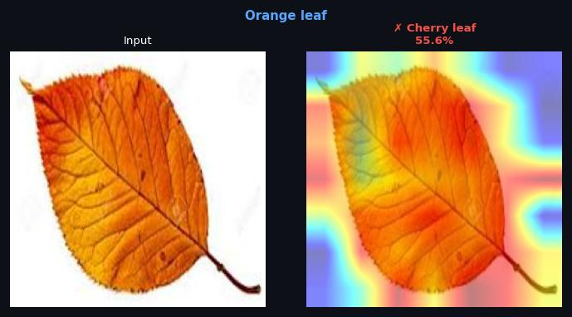  Predicted: Cherry leaf  Confidence: 55.5%

Peach leaf
VGG16 | ViT-Base | Swin-Base
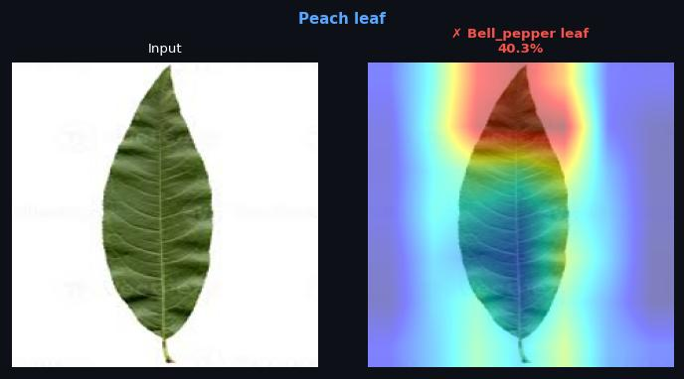  Predicted: Bell_pepper leaf  Confidence: 40.3% | 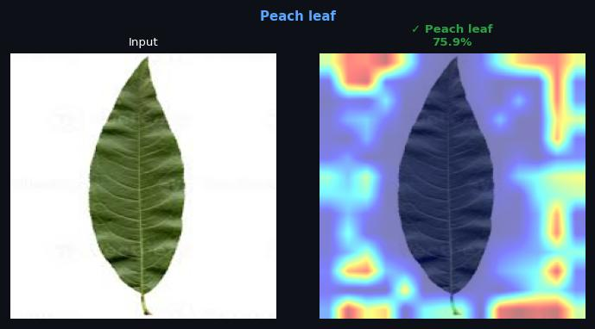  Predicted: Peach leaf  Confidence: 75.9% | 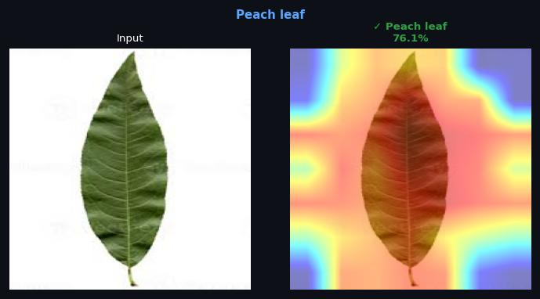  Predicted: Peach leaf  Confidence: 76.1%

Potato leaf
VGG16 | ViT-Base | Swin-Base
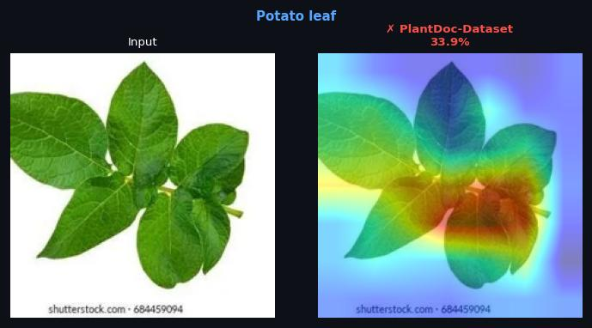  Predicted: N/A  Confidence: N/A | 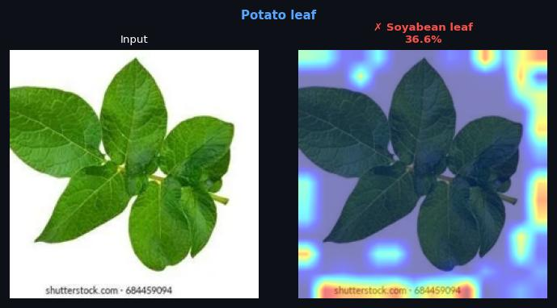  Predicted: N/A  Confidence: N/A | 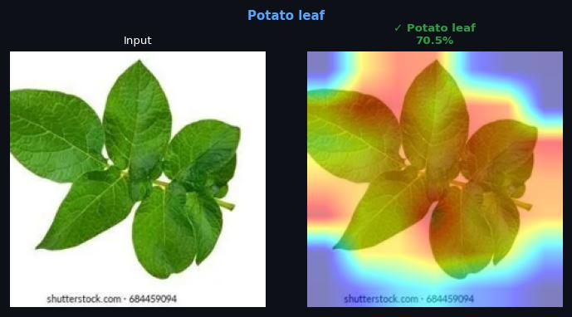  Predicted: N/A  Confidence: N/A

Potato leaf early blight
VGG16 | ViT-Base | Swin-Base
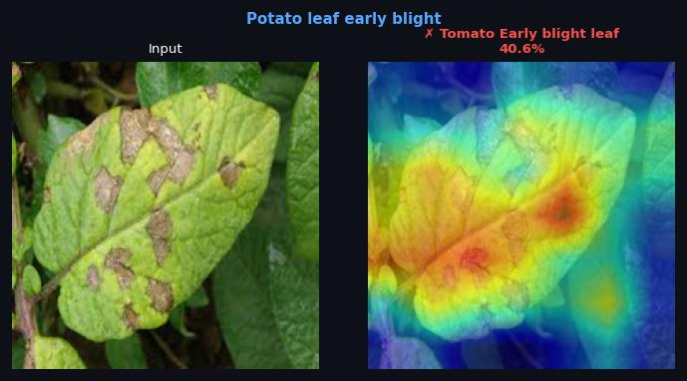  Predicted: Tomato Early blight leaf  Confidence: 40.6% | 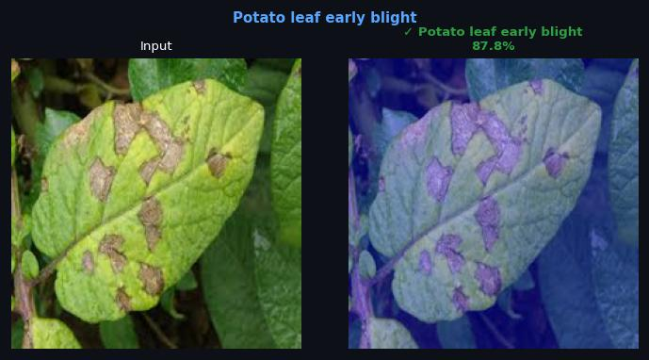  Predicted: Potato leaf early blight  Confidence: 87.8% | 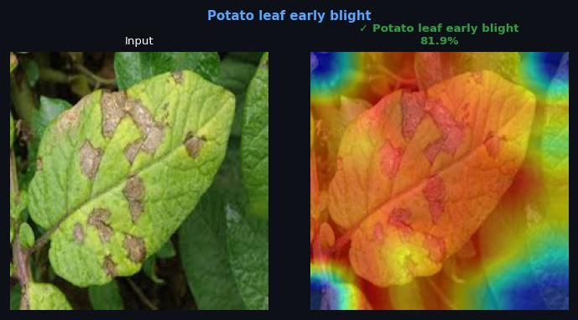  Predicted: Potato leaf early blight  Confidence: 81.9%

Potato leaf late blight
VGG16 | ViT-Base | Swin-Base
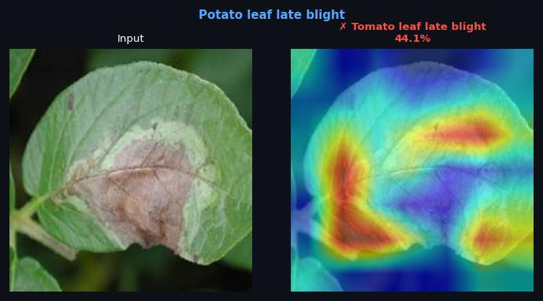  Predicted: Tomato leaf late blight  Confidence: 44.1% | 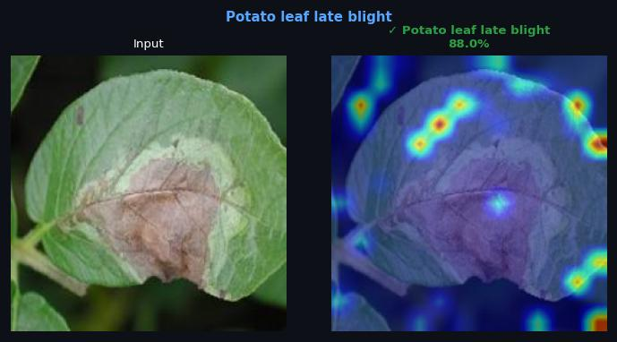  Predicted: Potato leaf late blight  Confidence: 88.0% | 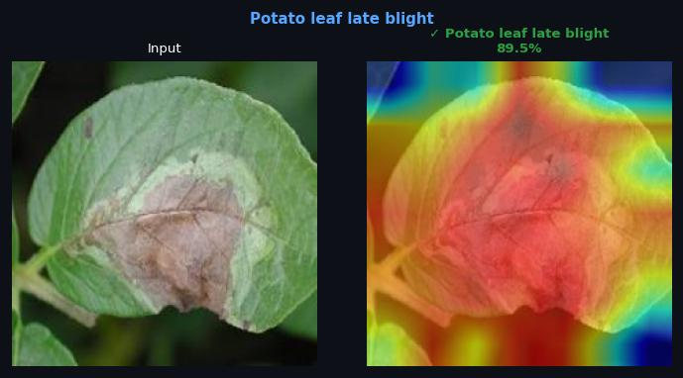  Predicted: Potato leaf late blight  Confidence: 89.5%

Raspberry leaf
VGG16 | ViT-Base | Swin-Base
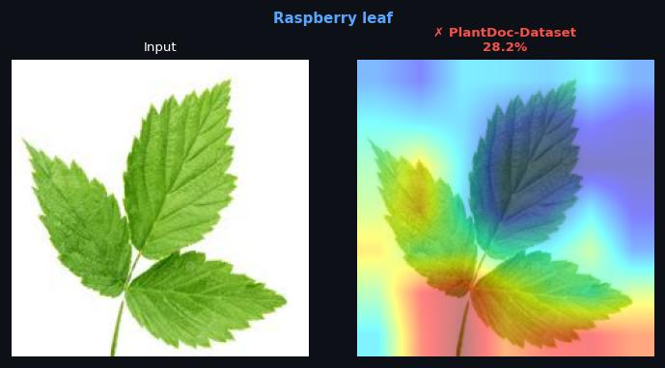  Predicted: PlantDoc-Dataset  Confidence: 28.3% | 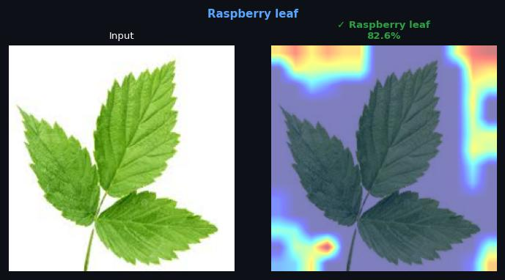  Predicted: Raspberry leaf  Confidence: 82.6% | 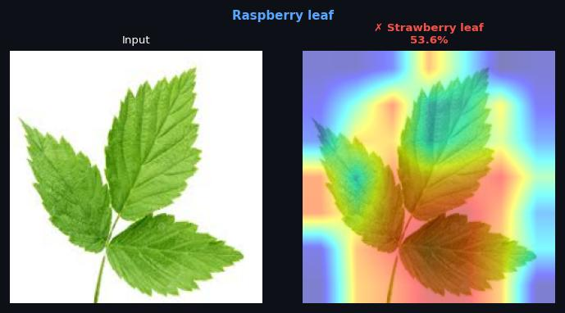  Predicted: Strawberry leaf  Confidence: 53.6%

Soyabean leaf
VGG16 | ViT-Base | Swin-Base
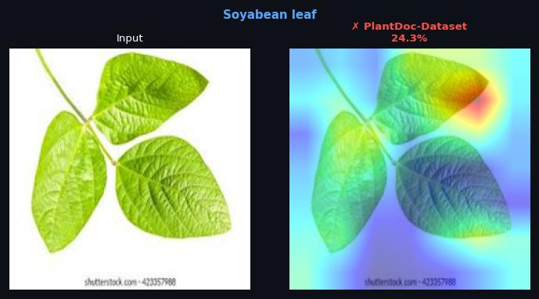  Predicted: PlantDoc-Dataset  Confidence: 24.3% | 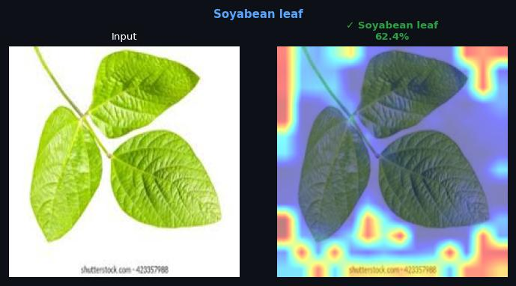  Predicted: Soyabean leaf  Confidence: 62.4% | 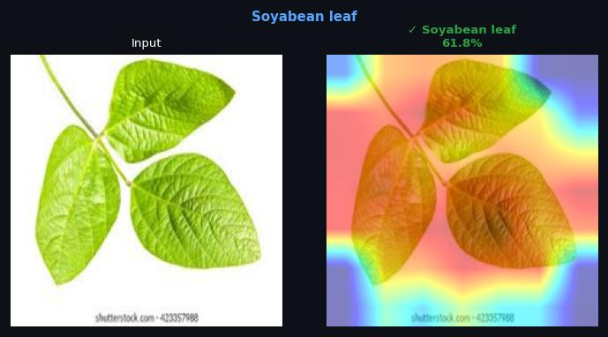  Predicted: Soyabean leaf  Confidence: 61.8%

Squash Powdery mildew leaf
VGG16 | ViT-Base | Swin-Base
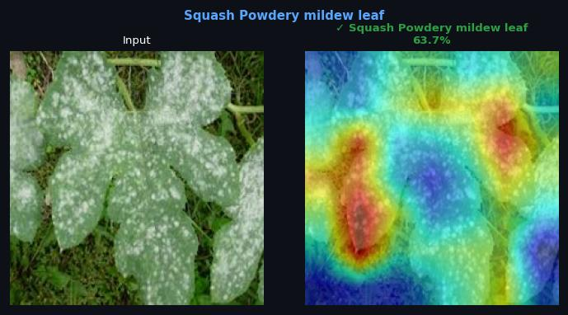  Predicted: Squash Powdery mildew leaf  Confidence: 63.7% | 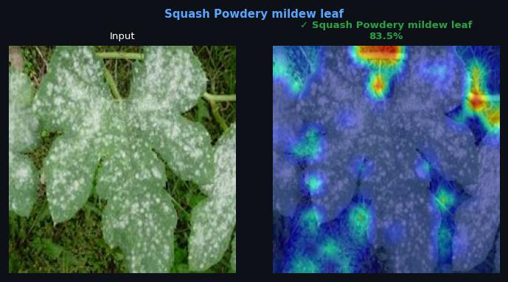  Predicted: Squash Powdery mildew leaf  Confidence: 83.5% | 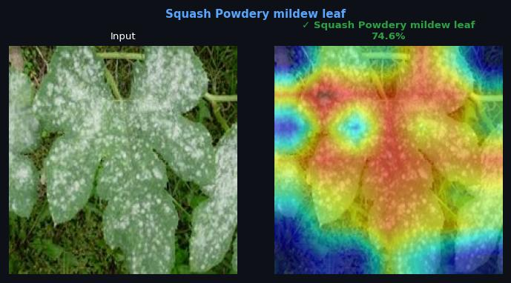  Predicted: Squash Powdery mildew leaf  Confidence: 74.6%

Strawberry leaf
VGG16 | ViT-Base | Swin-Base
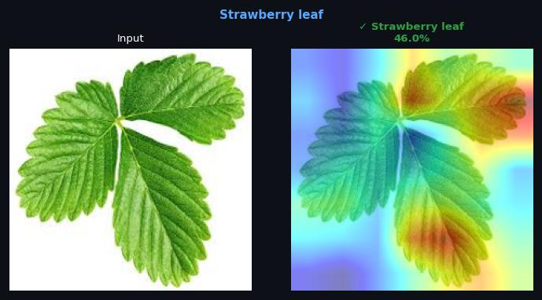  Predicted: Strawberry leaf  Confidence: 46.0% | 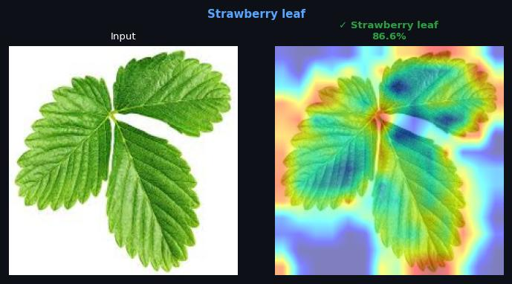  Predicted: Strawberry leaf  Confidence: 86.6% | 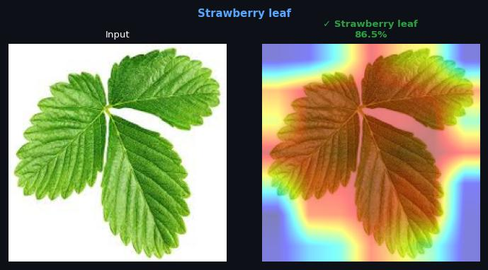  Predicted: Strawberry leaf  Confidence: 86.5%

Tomato Early blight leaf
VGG16 | ViT-Base | Swin-Base
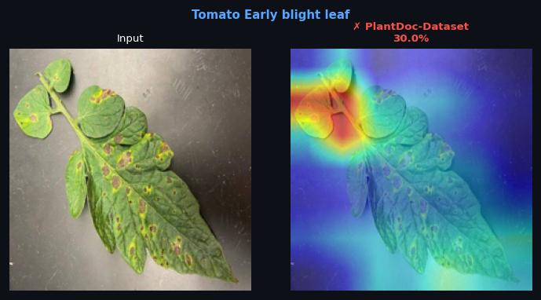  Predicted: PlantDoc-Dataset  Confidence: 30.0% | 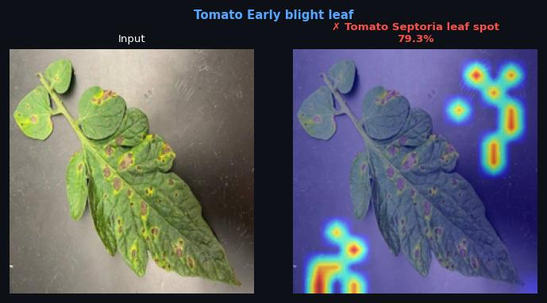  Predicted: Tomato Septoria leaf spot  Confidence: 79.3% | 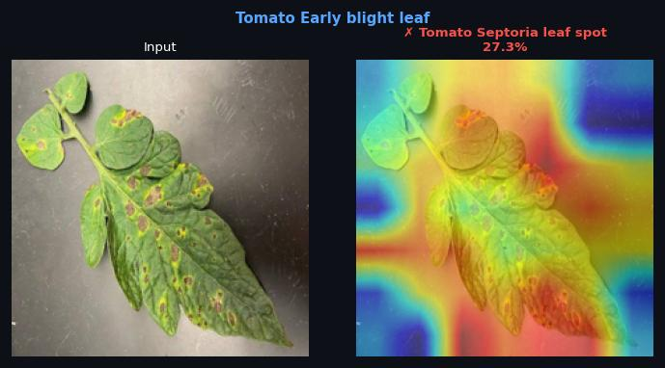  Predicted: Tomato Septoria leaf spot  Confidence: 27.4%

Tomato Septoria leaf spot
VGG16 | ViT-Base | Swin-Base
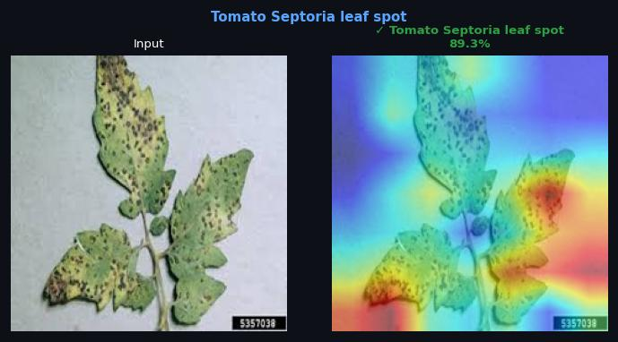  Predicted: Tomato Septoria leaf spot  Confidence: 89.3% | 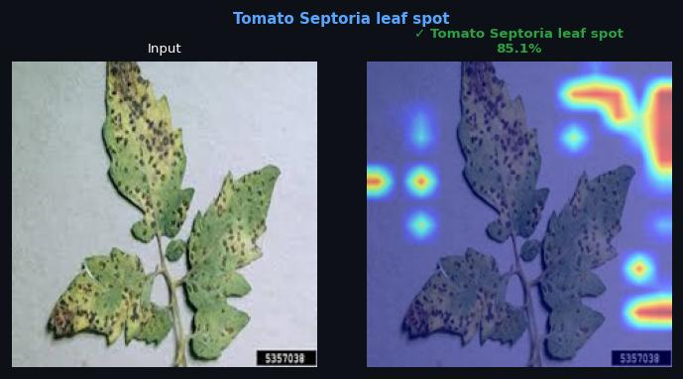  Predicted: Tomato Septoria leaf spot  Confidence: 85.1% | 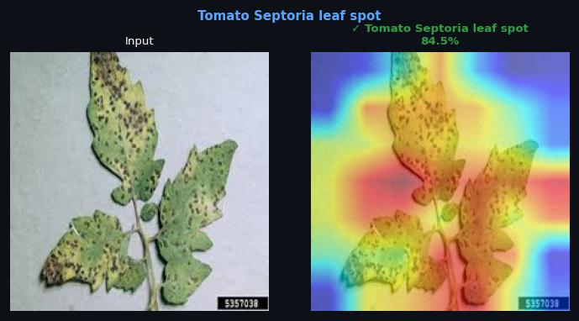  Predicted: Tomato Septoria leaf spot  Confidence: 84.5%

Tomato leaf
VGG16 | ViT-Base | Swin-Base
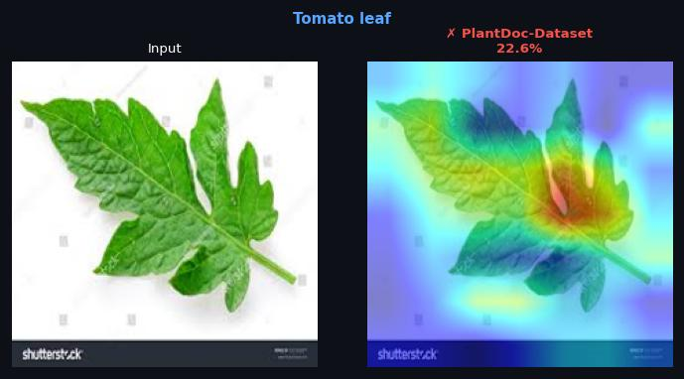  Predicted: PlantDoc-Dataset  Confidence: 22.6% | 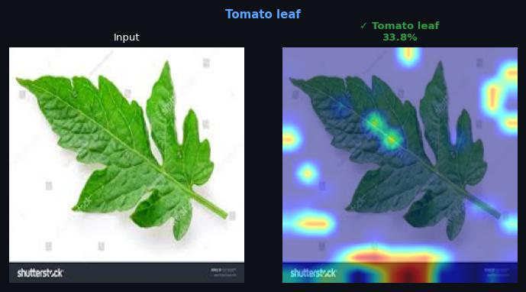  Predicted: Tomato leaf  Confidence: 33.8% | 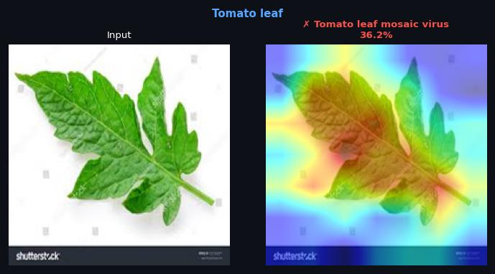  Predicted: Tomato leaf mosaic virus  Confidence: 36.2%

Tomato leaf bacterial spot
VGG16 | ViT-Base | Swin-Base
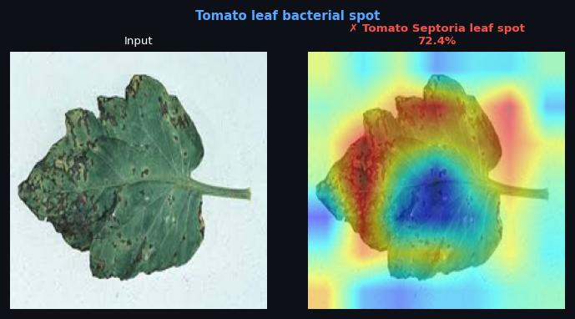  Predicted: Tomato Septoria leaf spot  Confidence: 72.5% | 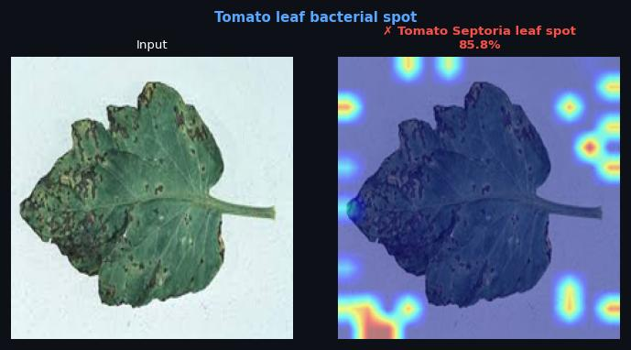  Predicted: Tomato Septoria leaf spot  Confidence: 85.8% | 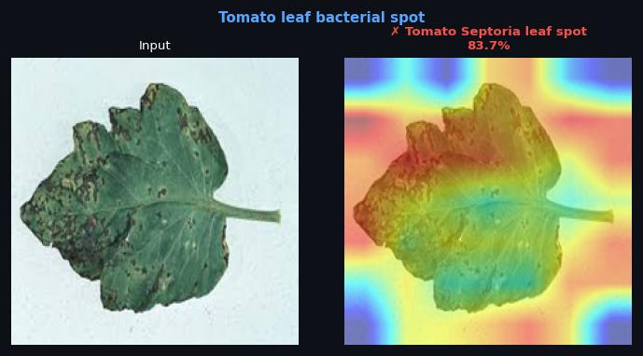  Predicted: Tomato Septoria leaf spot  Confidence: 83.8%

Tomato leaf late blight
VGG16 | ViT-Base | Swin-Base
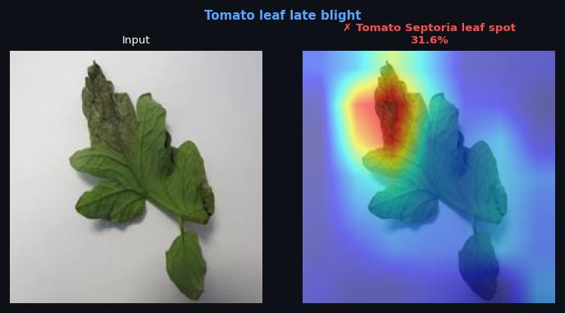  Predicted: Tomato Septoria leaf spot  Confidence: 31.6% | 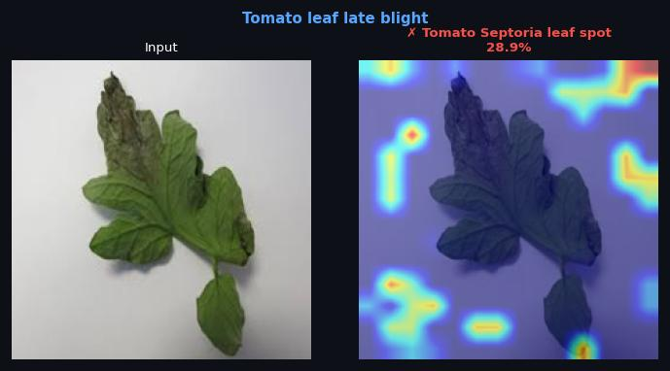  Predicted: Tomato Septoria leaf spot  Confidence: 28.9% | 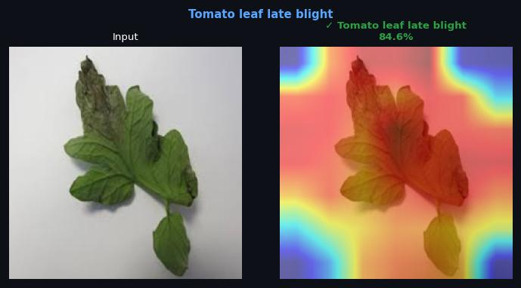  Predicted: Tomato leaf late blight  Confidence: 84.6%

Tomato leaf mosaic virus
VGG16 | ViT-Base | Swin-Base
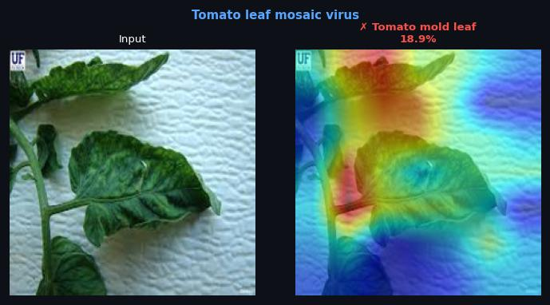  Predicted: Tomato mold leaf  Confidence: 18.9% | 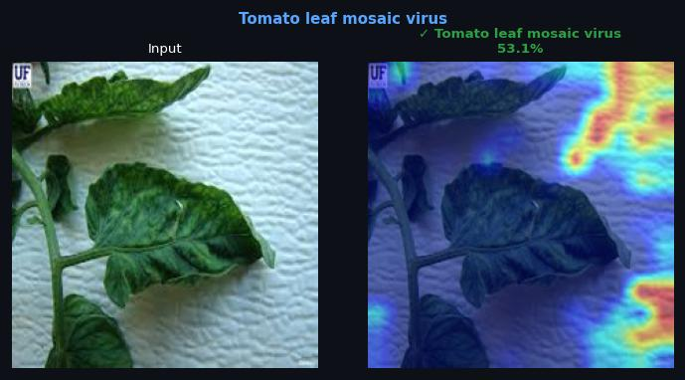  Predicted: Tomato leaf mosaic virus  Confidence: 53.1% | 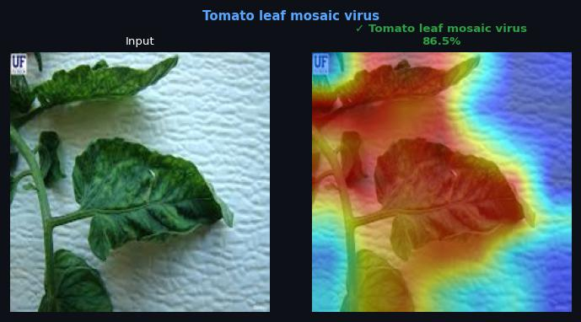  Predicted: Tomato leaf mosaic virus  Confidence: 86.5%

Tomato leaf yellow virus
VGG16 | ViT-Base | Swin-Base
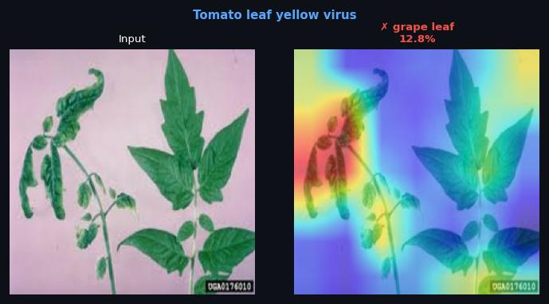  Predicted: grape leaf  Confidence: 12.8% | 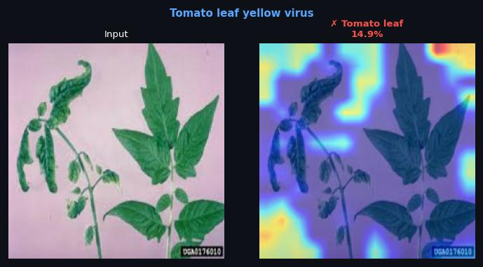  Predicted: Tomato leaf  Confidence: 14.9% | 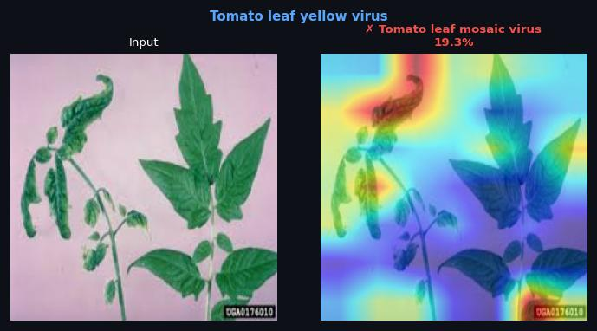  Predicted: Tomato leaf mosaic virus  Confidence: 19.3%

Tomato mold leaf
VGG16 | ViT-Base | Swin-Base
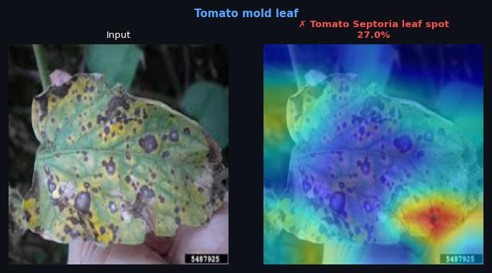  Predicted: Tomato Septoria leaf spot  Confidence: 27.0% | 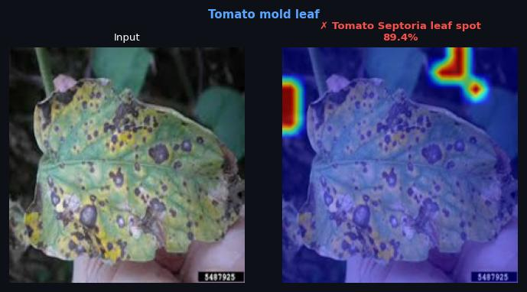  Predicted: Tomato Septoria leaf spot  Confidence: 89.4% | 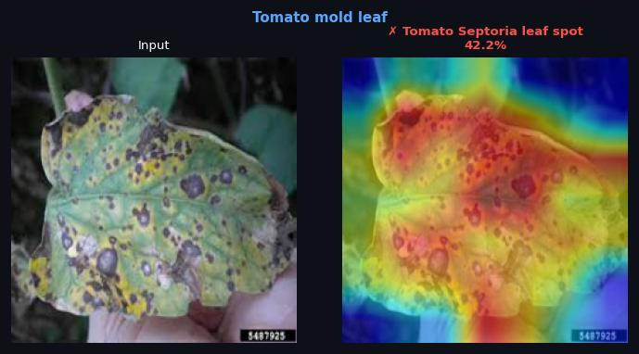  Predicted: Tomato Septoria leaf spot  Confidence: 42.2%

grape leaf black rot
VGG16 | ViT-Base | Swin-Base
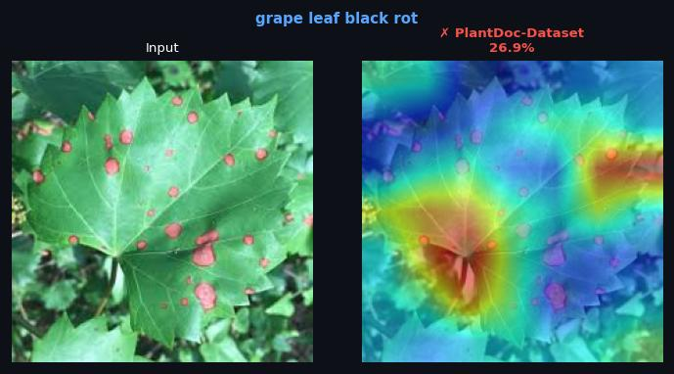  Predicted: PlantDoc-Dataset  Confidence: 26.9% | 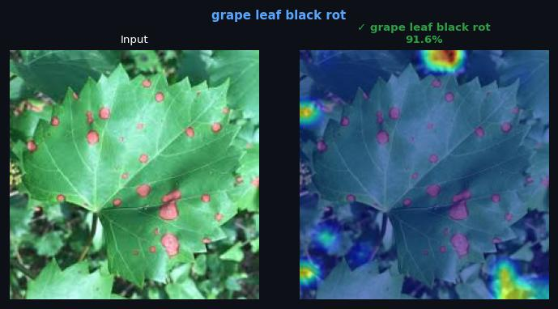  Predicted: grape leaf black rot  Confidence: 91.6% | 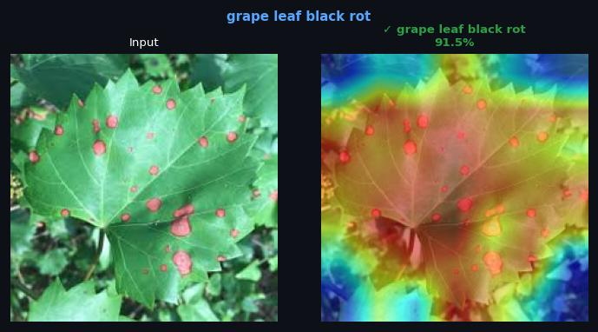  Predicted: grape leaf black rot  Confidence: 91.5%

