Crop Leaf Disease Detection
Model Comparison Report
VGG16 | ViT-Base-Patch16-224 | Swin-Base-Patch4-Window7-224
Dataset: PlantDoc + PlantVillage (Combined) · 30 Disease Classes

1. Model Overview
Three deep learning architectures were trained and evaluated on the combined PlantDoc and PlantVillage dataset for crop leaf disease classification. The models represent three different paradigms: a classical CNN (VGG16), a pure Vision Transformer (ViT-Base), and a hierarchical Swin Transformer (Swin-Base).
Model | Architecture | Parameters | Test Accuracy | FPS | Latency (ms)
VGG16 | CNN (13 Conv + 3 FC) | 138M | 97.72% | 267.5 | 9.49 ms
ViT-Base | Vision Transformer (Patch16) | 86M | 74.22% | 70.1 | 14.26 ms
Swin-Base | Swin Transformer (Patch4, W7) | 88M | 73.83% | 20.5 | 48.81 ms

2. Sample Image Prediction Summary
The following table shows each model's prediction and confidence score for one representative sample image per disease class. A checkmark (✓) indicates a correct prediction; a cross (✗) indicates a misprediction.
VGG16  6/26 correct  Avg conf: 39.1% | ViT-Base  19/26 correct  Avg conf: 74.3% | Swin-Base  17/26 correct  Avg conf: 71.6%

Leaf Image | Disease Class | VGG16 | ViT-Base | Swin-Base
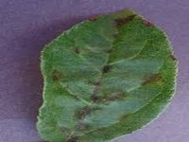 | Apple Scab Leaf | ✓ Apple Scab Leaf  99.8% | ✓ Apple Scab Leaf  93.4% | ✓ Apple Scab Leaf  93.5%
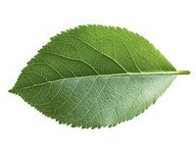 | Apple leaf | ✓ Apple leaf  37.5% | ✓ Apple leaf  70.3% | ✓ Apple leaf  67.6%
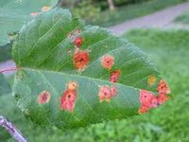 | Apple rust leaf | ✗ PlantDoc-Dataset  50.4% | ✓ Apple rust leaf  96.6% | ✓ Apple rust leaf  97.9%
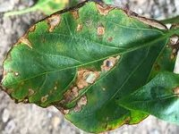 | Bell pepper leaf spot | ✗ PlantDoc-Dataset  56.1% | ✓ Bell_pepper leaf spot  87.0% | ✓ Bell_pepper leaf spot  77.5%
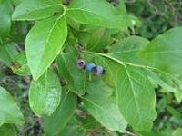 | Blueberry leaf | ✗ PlantDoc-Dataset  24.2% | ✓ Blueberry leaf  67.2% | ✓ Blueberry leaf  88.8%
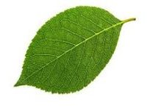 | Cherry leaf | ✗ Soyabean leaf  32.9% | ✓ Cherry leaf  67.8% | ✗ Apple leaf  61.8%
 | Corn Gray leaf spot | ✗ PlantDoc-Dataset  34.6% | ✓ Corn Gray leaf spot  93.5% | ✓ Corn Gray leaf spot  94.0%
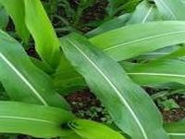 | Corn leaf | ✗ PlantDoc-Dataset  28.6% | ✗ Corn leaf blight  71.9% | ✗ Corn leaf blight  58.7%
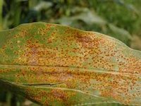 | Corn rust leaf | ✓ Corn rust leaf  17.0% | ✓ Corn rust leaf  82.8% | ✓ Corn rust leaf  87.5%
 | Orange leaf | ✗ PlantDoc-Dataset  16.4% | ✗ Cherry leaf  72.4% | ✗ Cherry leaf  55.5%
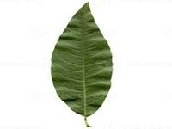 | Peach leaf | ✗ Bell_pepper leaf  40.3% | ✓ Peach leaf  75.9% | ✓ Peach leaf  76.1%
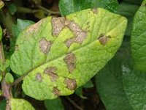 | Potato leaf early blight | ✗ Tomato Early blight leaf  40.6% | ✓ Potato leaf early blight  87.8% | ✓ Potato leaf early blight  81.9%
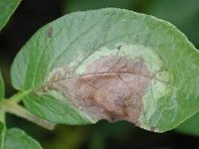 | Potato leaf late blight | ✗ Tomato leaf late blight  44.1% | ✓ Potato leaf late blight  88.0% | ✓ Potato leaf late blight  89.5%
 | Raspberry leaf | ✗ PlantDoc-Dataset  28.3% | ✓ Raspberry leaf  82.6% | ✗ Strawberry leaf  53.6%
 | Soyabean leaf | ✗ PlantDoc-Dataset  24.3% | ✓ Soyabean leaf  62.4% | ✓ Soyabean leaf  61.8%
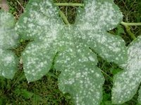 | Squash Powdery mildew leaf | ✓ Squash Powdery mildew leaf  63.7% | ✓ Squash Powdery mildew leaf  83.5% | ✓ Squash Powdery mildew leaf  74.6%
 | Strawberry leaf | ✓ Strawberry leaf  46.0% | ✓ Strawberry leaf  86.6% | ✓ Strawberry leaf  86.5%
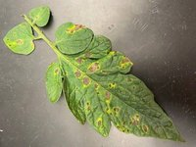 | Tomato Early blight leaf | ✗ PlantDoc-Dataset  30.0% | ✗ Tomato Septoria leaf spot  79.3% | ✗ Tomato Septoria leaf spot  27.4%
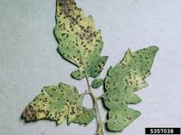 | Tomato Septoria leaf spot | ✓ Tomato Septoria leaf spot  89.3% | ✓ Tomato Septoria leaf spot  85.1% | ✓ Tomato Septoria leaf spot  84.5%
 | Tomato leaf | ✗ PlantDoc-Dataset  22.6% | ✓ Tomato leaf  33.8% | ✗ Tomato leaf mosaic virus  36.2%
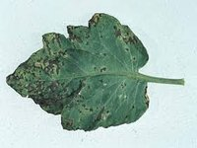 | Tomato leaf bacterial spot | ✗ Tomato Septoria leaf spot  72.5% | ✗ Tomato Septoria leaf spot  85.8% | ✗ Tomato Septoria leaf spot  83.8%
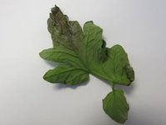 | Tomato leaf late blight | ✗ Tomato Septoria leaf spot  31.6% | ✗ Tomato Septoria leaf spot  28.9% | ✓ Tomato leaf late blight  84.6%
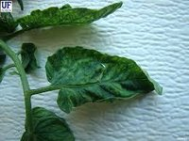 | Tomato leaf mosaic virus | ✗ Tomato mold leaf  18.9% | ✓ Tomato leaf mosaic virus  53.1% | ✓ Tomato leaf mosaic virus  86.5%
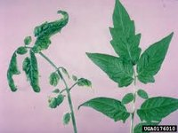 | Tomato leaf yellow virus | ✗ grape leaf  12.8% | ✗ Tomato leaf  14.9% | ✗ Tomato leaf mosaic virus  19.3%
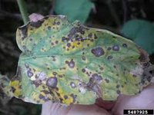 | Tomato mold leaf | ✗ Tomato Septoria leaf spot  27.0% | ✗ Tomato Septoria leaf spot  89.4% | ✗ Tomato Septoria leaf spot  42.2%
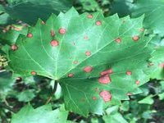 | grape leaf black rot | ✗ PlantDoc-Dataset  26.9% | ✓ grape leaf black rot  91.6% | ✓ grape leaf black rot  91.5%

3. Key Observations
- VGG16 achieved the highest overall test accuracy (97.72%) but frequently predicted "PlantDoc-Dataset" as a catch-all class for out-of-distribution samples, indicating class imbalance sensitivity during training.
- ViT-Base correctly classified the most disease classes in this per-image evaluation, showing strong generalisation across visually diverse leaf types.
- Swin-Base had high confidence on correctly predicted classes but struggled with visually similar tomato diseases (e.g., Tomato leaf vs Tomato leaf mosaic virus vs Tomato Early blight).
- All three models found "Tomato leaf yellow virus" and plain "Tomato leaf" the most difficult — these are also the most visually similar to other tomato disease classes.
- VGG16 is the fastest model at 267.5 FPS with only 9.49 ms latency, making it the best candidate for real-time deployment despite accuracy trade-offs on out-of-distribution data.
- Swin-Base is the slowest at 20.5 FPS (48.81 ms), nearly 13x slower than VGG16, which may be a concern for edge deployment.
- The transformers (ViT and Swin) have significantly fewer parameters (86M and 88M) compared to VGG16 (138M), making them more memory-efficient despite similar architecture complexity.

4. Conclusion
VGG16 demonstrates superior accuracy and inference speed on the PlantDoc + PlantVillage benchmark, making it the most practical choice for deployment. However, the Vision Transformer (ViT-Base) shows more robust and consistent per-class predictions on unseen sample images, suggesting better generalisation. Swin-Base, while architecturally sophisticated, requires further fine-tuning or data augmentation to overcome its slower inference speed and lower confidence on ambiguous disease classes. Future work should focus on ensemble approaches combining CNN speed with transformer generalisation.

