**JAVA-James Gosling -1955**

AWT and Swing are used in Java for creating standalone applications.

Java Applications-> standalone, webapp, enterprise,mobile

Java Platforms_Editions ->SE,EE,ME,FX

**JVM**

A specification where working of Java Virtual Machine is specified. But implementation provider is independent to choose the algorithm. Its implementation has been provided by Oracle and other companies

fn->Memory area,Class file format,Register set,Garbage-collected heap,Fatal error reporting etc.

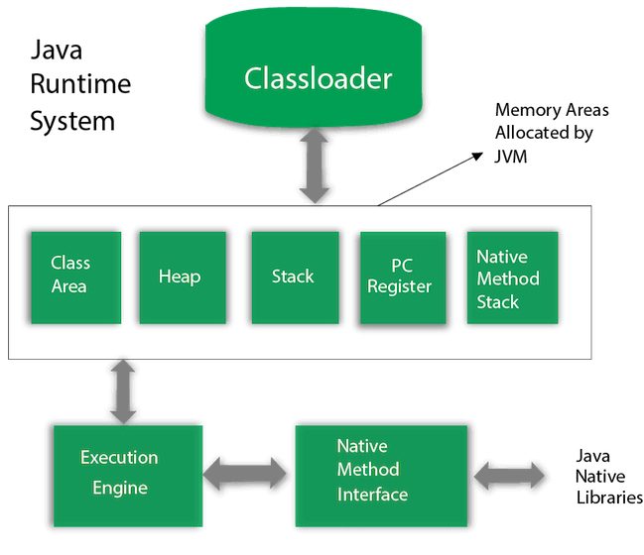

Classloader->**Bootstrap ClassLoader(rt.jar loads java classes),Extension**

**ClassLoader(load installed java lib jars), System/Application ClassLoader(loads class path jars)**

**Rt jar contains core classes like java.lang**

**Java Native Interface->interacts with other languages and OS**

**Execution Engine-> virtual processor, JIT,interpretor**

Class file contains bytecode

Semicolon at the of class defination is optional

Main method cannot be abstract

Valid main class initializations

public static void main(String[] args)

public static void main(String []args)

public static void main(String args[])

public static void main(String... args)

static public void main(String[] args)

public static final void main(String[] args)

final public static void main(String[] args)

final strictfp public static void main(String[] args)   
  
java classes can be saved with different name then file if not public

set path=C:\Program Files\Java\jdk1.6.0_23\bin

JVM, JRE, and JDK are platform dependent

JRE->JVM + libraries liie rt.jar  
jvm can not run independent requires jre or jdk

JDK->jre+devlopment tool to build SE,EE,ME,FX