Design and Implementation of a Database Management System for Cinema Screening and Ticket Booking System
(CineBook)
Submitted by
Gourav Saha | 25WU0101042
Pranav Yeddula | 25WU0102311
Yash Raj | 25WU0102307
Department of Computer Science and Engineering
Course: Database Management Systems
Faculty: Dr. Kiran Mayee Adavala
Academic Year: 2026–2027

Table of Contents
Abstract 3
I. Introduction 4
II. Problem Statement 5
III. Objectives and Scope 6
A. Objectives 6
B. Scope 6
IV. System Requirements 7
A. Software Requirements 7
B. Hardware Requirements 7
V. System Design 8
A. Entity-Relationship Diagram 8
B. Relational Schema 8
C. Normalization 9
D. Data Dictionary 9
E. Keys, Constraints and Indexes 10
VI. Implementation 11
A. Technology Stack 11
B. SQL Commands 11
C. Database Connectivity 11
D. Backend Operations 12
E. Double-Booking Prevention 12
F. Validation and Error Handling 13
G. System Architecture and Data Flow 13
H. User Interface 14
VII. Testing 17
VIII. Conclusion and Future Work 18
Contribution of Team Members 19
Appendix A: Source Code Repository 20
References 21

Abstract
CineBook is a database-driven movie ticket booking system that manages users, movies, cinemas, screens, seats, shows, bookings and payments. Its central goal is to guarantee that a seat can never be sold twice for the same show, even when two users try to book it at almost the same moment. The system uses MySQL 8 as the backend database, Python 3 with Flask for backend processing and database connectivity, and HTML, CSS and JavaScript for the user interface. The relational schema consists of ten tables normalised up to Third Normal Form and protected by primary keys, foreign keys, UNIQUE, NOT NULL, CHECK, DEFAULT and ENUM constraints. Double booking is prevented by combining temporary seat locks of about five minutes, MySQL transactions that follow the ACID properties, row locking with SELECT ... FOR UPDATE, and a UNIQUE constraint on (show_id, seat_id) in the booking_seats table. Indexes on frequently searched columns are examined with the EXPLAIN statement, passwords are stored as salted hashes, and automated Pytest tests cover database functionality, the booking flow and concurrency-related behaviour. Payment is simulated, and the project is an academic prototype that is not claimed to be production-ready. It demonstrates the practical use of DBMS concepts such as database design, normalisation, integrity constraints, joins, indexing, transactions and concurrency control.
Index Terms: Concurrency control, database design, double-booking prevention, MySQL, normalization, relational database, transactions.

I. Introduction
Ticket booking systems handle interconnected information such as movies, cinemas, screens, seat layouts, show timings, customers and payments. This information must be stored in a structured way and kept correct while many customers use the system at the same time. A Database Management System (DBMS) provides this structure through the relational model [1], the SQL language [2] and transaction processing [3].
A seat in a particular show is a scarce, shared resource. It can be sold only once, yet many customers may be viewing the same seat map and several may try to book the same seat within a fraction of a second. If the database is not designed carefully, two customers can both be told that the seat is theirs. This failure, called double booking, damages customer trust and creates refunds and disputes for the cinema. It also cannot be solved reliably by checking availability in application code and writing the booking afterwards, because another request can take the seat between the check and the write [4, 5].
To address this, CineBook was developed as a relational database system in which the rules of the problem are enforced by the database itself. Cinema, screen, seat, movie, show, user, booking and payment data are stored in related tables connected by primary and foreign keys. A Flask application [6] connected to MySQL through mysql-connector-python [7] lets users register, log in, browse movies, choose a show, select seats, book, pay (simulated) and view their bookings through a web interface.

II. Problem Statement
The main problem addressed by this project is the reliable management of seat reservations in a movie ticket booking system. When two users try to book the same seat for the same show at almost the same time, a poorly designed database may confirm both bookings. Without a properly designed schema, the system may also suffer from duplicated data, inconsistent records, half-finished bookings (for example a booking without seats or without a payment record) and slow retrieval of shows and seat availability.
The project therefore aims to design and implement a normalised relational database and a booking process in which seat selection, booking, seat assignment and payment record are completed as one consistent unit, in which the same seat can never be booked twice for a show, and in which users interact with the data through a simple web application.

III. Objectives and Scope

A. Objectives
- To design a normalised relational database (up to 3NF) for movie ticket booking.
- To identify entities and establish relationships between them using primary and foreign keys.
- To apply UNIQUE, NOT NULL, CHECK, DEFAULT and ENUM constraints to keep data valid.
- To prevent double booking using seat locks, transactions, row locking and a UNIQUE constraint.
- To implement the complete booking workflow with Python, Flask and MySQL connectivity.
- To execute JOIN queries and improve query efficiency with indexes verified using EXPLAIN.
- To store passwords securely as salted hashes.
- To test the system using a live demonstration and automated Pytest tests.

B. Scope
The system manages users, movies, cinemas, screens, seats, shows, bookings, temporary seat locks and simulated payments. It supports registration and login, movie browsing, cinema and show selection, seat selection with temporary locking, booking with simulated payment, and a booking-history page. The current sample data contains eight movies.
The current version focuses on database design and concurrency control. Payment is simulated, and no custom lock manager is implemented; the project uses the transaction and row-locking facilities of MySQL. Future versions may include a real payment gateway, stronger authentication and session security, a background clean-up service, notifications, a recommendation system and cloud deployment.

IV. System Requirements

A. Software Requirements
TABLE I. SOFTWARE REQUIREMENTS
Requirement | Technology
Operating System | Any operating system that supports Python 3 and MySQL 8
Database | MySQL 8+ (InnoDB storage engine)
Programming Language | Python 3
Web Framework | Flask
Database Connector | mysql-connector-python
Password Hashing | Werkzeug
Front End | HTML5, CSS3, vanilla JavaScript
Testing | Pytest
Web Browser | Any modern browser with JavaScript enabled

B. Hardware Requirements
TABLE II. RECOMMENDED HARDWARE REQUIREMENTS
Requirement | Recommended
Processor | Any modern dual-core processor
RAM | 4 GB or above
Storage | A few GB of free space for MySQL, Python and project files
Network | Not required to run locally; needed only to install packages

V. System Design

A. Entity-Relationship Diagram
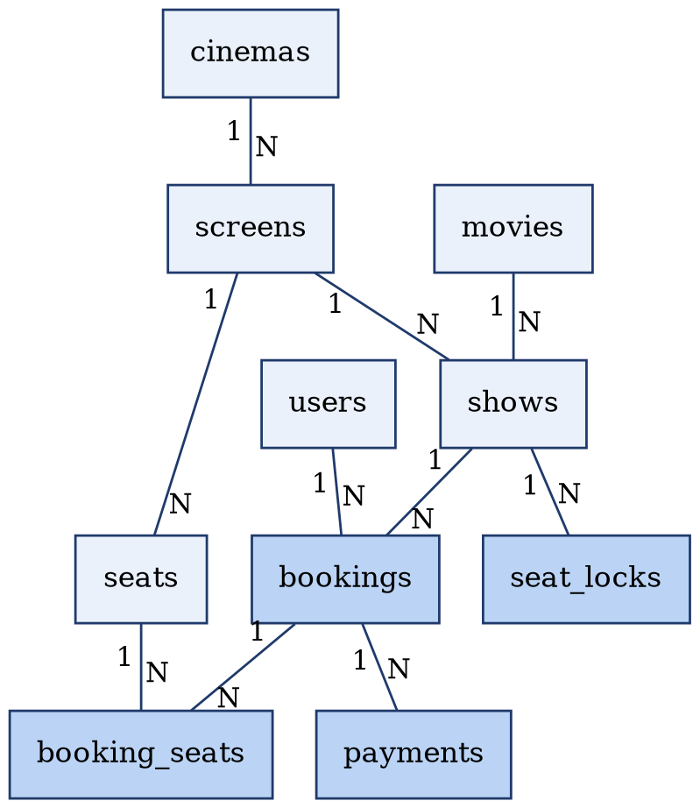
Fig. 1. Entity-Relationship diagram of CineBook (1 = one side, N = many side; darker boxes are booking-related tables).
The ER diagram represents the major entities of the system: Cinema, Screen, Seat, Movie, Show, User, Booking, Booking Seat, Seat Lock and Payment. The key relationships are:
- Cinema – Screen – Seat: A cinema has many screens, and a screen has many seats.
- Movie / Screen – Show: A movie can have many shows, and a screen can host many shows; each show is one movie on one screen at a date and time.
- User – Booking: A user can make many bookings; each booking belongs to one user.
- Show – Booking: A show can have many bookings; each booking is for one show.
- Booking – Booking Seat – Seat: A booking has many booking_seats rows, and a seat can appear in many rows for different shows.
- Show – Seat Lock: A show can have many temporary seat locks.
- Booking – Payment: A booking can have payment records.

B. Relational Schema
The ER model was converted into ten relations. Primary keys (PK) and foreign keys (FK) are noted where applicable.
TABLE III. RELATIONAL SCHEMA
Relation | Attributes | Keys
users | user_id, email, password hash, ... | PK: user_id; email UNIQUE
movies | movie_id, title, ... | PK: movie_id
cinemas | cinema_id, name, ... | PK: cinema_id
screens | screen_id, screen_name, cinema_id, ... | PK: screen_id; FK: cinema_id
seats | seat_id, screen_id, ... | PK: seat_id; FK: screen_id
shows | show_id, movie_id, screen_id, show_date, start_time, ... | PK: show_id; FK: movie_id, screen_id
bookings | booking_id, user_id, show_id, ... | PK: booking_id; FK: user_id, show_id
booking_seats | booking_id, show_id, seat_id | FK: booking_id, show_id, seat_id; UNIQUE (show_id, seat_id)
seat_locks | show_id, seat_id, user_id, expires_at, ... | FK: show_id; temporary hold (about 5 min)
payments | payment_id, booking_id, ... | PK: payment_id; FK: booking_id

C. Normalization
The database was designed using normalization principles [8] to reduce redundancy and improve data consistency.
- First Normal Form (1NF): All attributes hold atomic values and repeating groups are avoided.
- Second Normal Form (2NF): Non-key attributes depend on the complete primary key, so partial dependencies are avoided.
- Third Normal Form (3NF): Non-key attributes depend only on the key, which removes transitive dependencies.
The best example is booking_seats. Storing the seats of a booking as a single value such as A1,A2,A3 would break 1NF because the cell is not atomic. CineBook therefore stores one row per seat, as shown in Table IV, which also allows each seat to be checked, locked and made unique per show.
TABLE IV. UN-NORMALISED AND NORMALISED STORAGE OF BOOKED SEATS
Bad design (violates 1NF) | Correct design (used) | Observation
booking_id | seats  101 | A1,A2,A3 | booking_id | show_id | seat_id  101 | 1 | A1  101 | 1 | A2  101 | 1 | A3 | One atomic value per cell; one row per seat

D. Data Dictionary
Tables V to VII show the data dictionary for the most important tables of the booking process.
TABLE V. BOOKING_SEATS TABLE
Column | Constraint | Description
booking_id | NOT NULL, FOREIGN KEY | Booking to which the seat belongs
show_id | NOT NULL, FOREIGN KEY, part of UNIQUE | Show for which the seat is booked
seat_id | NOT NULL, FOREIGN KEY, part of UNIQUE | Seat that is booked
(show_id, seat_id) | UNIQUE | Same seat cannot be booked twice for the same show
TABLE VI. SHOWS TABLE
Column | Constraint | Description
show_id | PRIMARY KEY | Unique show identifier
movie_id | FOREIGN KEY | Movie being shown
screen_id | FOREIGN KEY | Screen on which the show runs
show_date, start_time | NOT NULL | Date and start time of the show
TABLE VII. SEAT_LOCKS TABLE
Column | Constraint | Description
show_id | FOREIGN KEY | Show for which a seat is temporarily held
expires_at | NOT NULL | Time after which the hold is no longer valid (about 5 minutes)

E. Keys, Constraints and Indexes
Every table has a primary key. Foreign keys give referential integrity, so a booking cannot exist without a real user and show. The email column of users is UNIQUE and acts as a candidate (alternate) key. NOT NULL, CHECK, DEFAULT and ENUM are used where applicable. Indexes are created on the columns used most in searches and joins, as listed in Table VIII. MySQL uses B-tree based indexes [9, 10], so a lookup reads far fewer rows than a full table scan; this is a reduction in the rows read and not an instantaneous lookup.
TABLE VIII. INDEXES USED IN CINEBOOK
Index on | Used by | Benefit
users(email) | Login lookup | Finds a user without scanning all users
shows(movie_id, show_date) | Show listing | Selects the shows of a movie on a date
booking_seats(show_id, seat_id) | Availability check | Fast check of booked seats; supports UNIQUE
seat_locks(show_id, expires_at) | Lock check and expiry | Finds current or expired locks of a show

VI. Implementation

A. Technology Stack
The system uses MySQL 8 (InnoDB) for database management [11], Python 3 and Flask for backend development, mysql-connector-python for database connectivity, Werkzeug for password hashing [12, 13], HTML5, CSS3 and vanilla JavaScript for the user interface, and Pytest for testing [14]. The project is organised into the folders app (routes.py, db.py, templates and static files), database (schema.sql and seed.sql), docs and tests, with run.py, requirements.txt and README.md at the top level.

B. SQL Commands
1) DDL Commands: Data Definition Language commands create the database structure in schema.sql. The most important definition is that of booking_seats (simplified listing):
CREATE TABLE booking_seats (
booking_id INT NOT NULL,
show_id INT NOT NULL,
seat_id INT NOT NULL,
FOREIGN KEY (booking_id) REFERENCES bookings(booking_id),
FOREIGN KEY (show_id) REFERENCES shows(show_id),
FOREIGN KEY (seat_id) REFERENCES seats(seat_id),
UNIQUE (show_id, seat_id) -- same seat, same show: only once
);
2) DML Commands: Data Manipulation Language commands insert sample data from seed.sql and are used by the application to insert, retrieve, update and delete records. The movie details were refreshed with UPDATE statements and not by deleting and re-inserting rows, so movie identifiers and their links to shows and bookings stayed valid.
3) Sample Queries: Because the database is normalised, JOINs bring related information back together. The following queries retrieve the shows of movies and the screen and cinema of each show.
-- Q1: Movie title with show date and time
SELECT m.title, s.show_date, s.start_time
FROM movies m
JOIN shows s ON m.movie_id = s.movie_id;

-- Q2: Show with screen and cinema
SELECT s.start_time, sc.screen_name, c.name
FROM shows s
JOIN screens sc ON s.screen_id = sc.screen_id
JOIN cinemas c ON sc.cinema_id = c.cinema_id;
4) Query Analysis: The EXPLAIN statement is used to inspect how MySQL executes a query [15]. It shows how tables are accessed, which indexes are used and the estimated number of rows, so the effect of the indexes of Table VIII can be checked.

C. Database Connectivity
A database helper module (db.py) establishes communication between the Flask application and MySQL using the mysql-connector-python library. Connection settings are read from an environment file (a .env.example template is provided) and not hard-coded in the source files. Route functions call the helper whenever they need to run a database operation, and the booking route controls COMMIT and ROLLBACK explicitly.

D. Backend Operations
The Flask backend (routes.py) handles the operations of Table IX. Each operation executes SQL statements and commits the required changes to the database.
TABLE IX. BACKEND OPERATIONS OF CINEBOOK
Operation | Purpose | Main tables
Register / Login | Create a user with a hashed password; verify credentials | users
Browse movies and shows | List movies; list shows with cinema and screen using JOINs | movies, shows, screens, cinemas
Select seats | Show the seat map; create temporary seat locks | seats, booking_seats, seat_locks
Confirm booking | Transactional booking with seat check and row locking | bookings, booking_seats
Simulated payment | Record a payment inside the booking transaction | payments
My Bookings | List the bookings of the logged-in user | bookings, booking_seats

E. Double-Booking Prevention
This is the most important feature of the system. Four mechanisms are used together. First, temporary seat locks hold the seats chosen by a user for about five minutes, after which they expire. Second, a MySQL transaction groups all writes of a booking into one unit of work. Third, SELECT ... FOR UPDATE locks the rows being checked, so that conflicting requests are processed one after another [16, 17]. Fourth, the UNIQUE constraint on (show_id, seat_id) is the final protection against duplicate booking records. The booking flow is:
BEGIN
remove / check expired seat locks
check seat availability
SELECT ... FOR UPDATE -- lock the rows being checked
create booking
insert booking_seats -- one row per seat
create payment (simulated)
remove seat locks
COMMIT (any failure -> ROLLBACK)
If User A and User B both pick seat A1 at almost the same time, User A's transaction obtains the row lock, books the seat and commits. User B's transaction waits, then sees that A1 is already taken and is rolled back with a seat-unavailable message (Fig. 2). The approach demonstrates the ACID properties [18]: atomicity (all steps succeed or all roll back), consistency (constraints and foreign keys), isolation (concurrent bookings do not interfere) and durability (a committed booking stays stored). MySQL's transactions and row locking are used, and no custom lock manager is implemented.
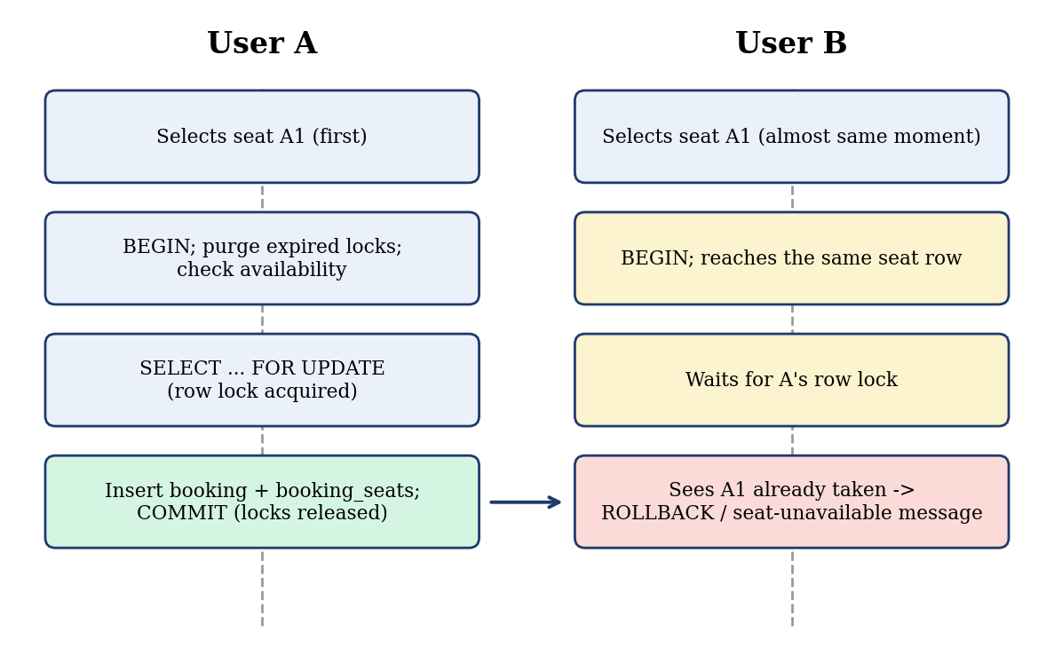
Fig. 2. Two concurrent requests for the same seat.

F. Validation and Error Handling
Validation and exception handling manage invalid database operations. A failed booking step, a violated UNIQUE constraint or a seat taken by another user causes the transaction to be rolled back, so no incomplete booking is left in the database. Registering an email that already exists is rejected because email is UNIQUE, and a booking for a non-existent user or show is rejected by the foreign keys. Passwords are never stored in plain text. These behaviours also show that integrity is enforced by the database itself.

G. System Architecture and Data Flow
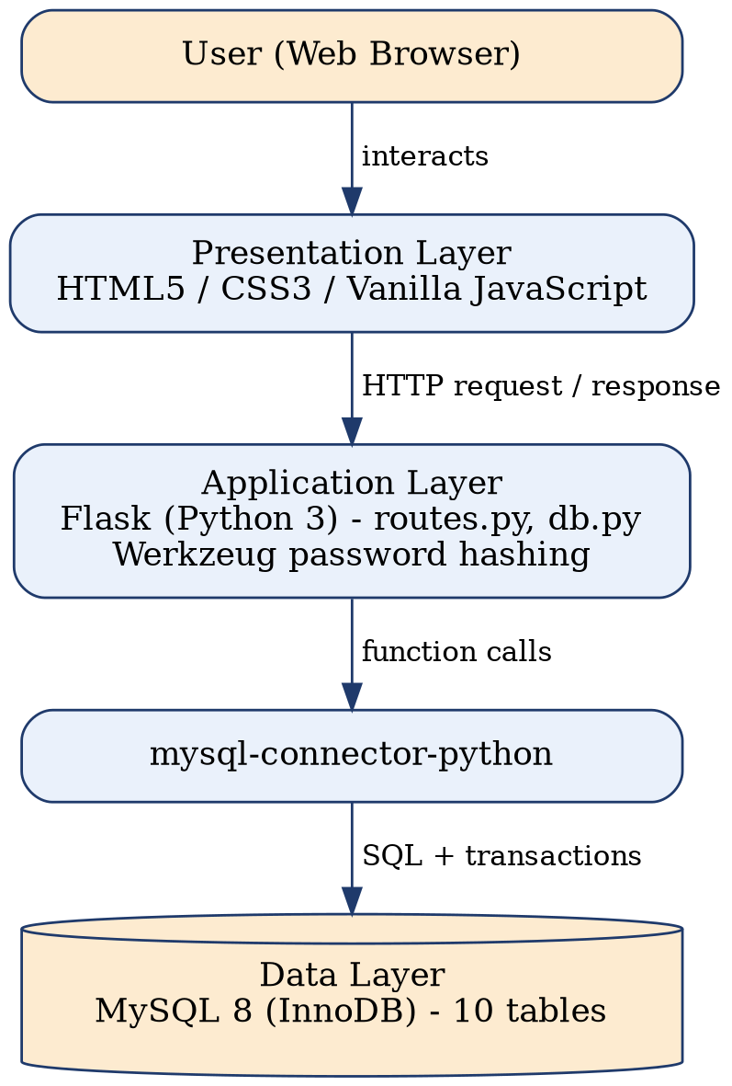
Fig. 3. Overall architecture of CineBook.
When a user performs an operation in the browser, the request is passed to the Flask backend. The backend opens a database connection, executes the corresponding SQL operation and returns the result to the page. The booking process follows the flow of Fig. 4, and the data flow between the user, the processes and the data stores is shown in Fig. 5.
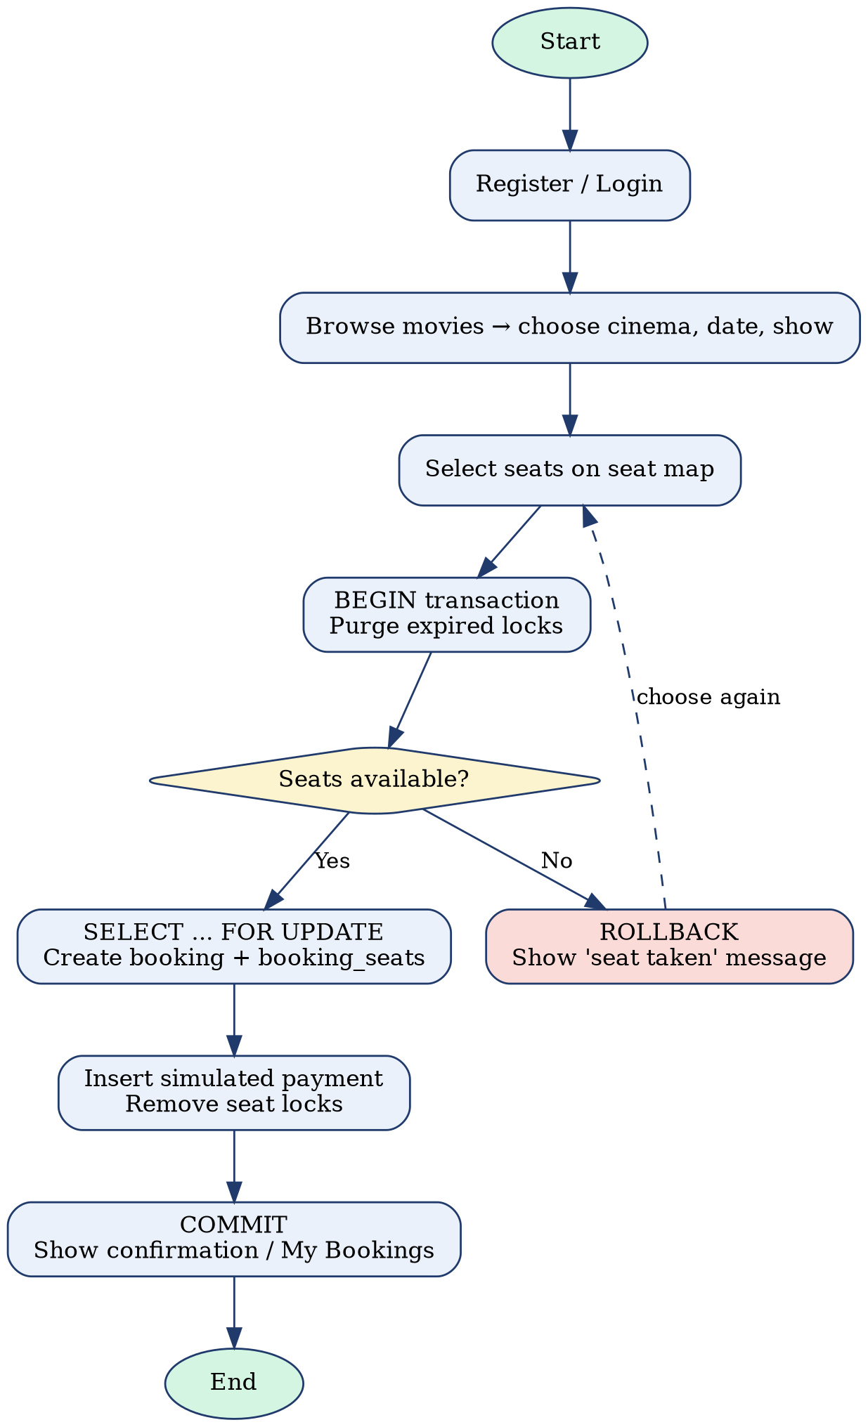
Fig. 4. Flowchart of the seat booking process.
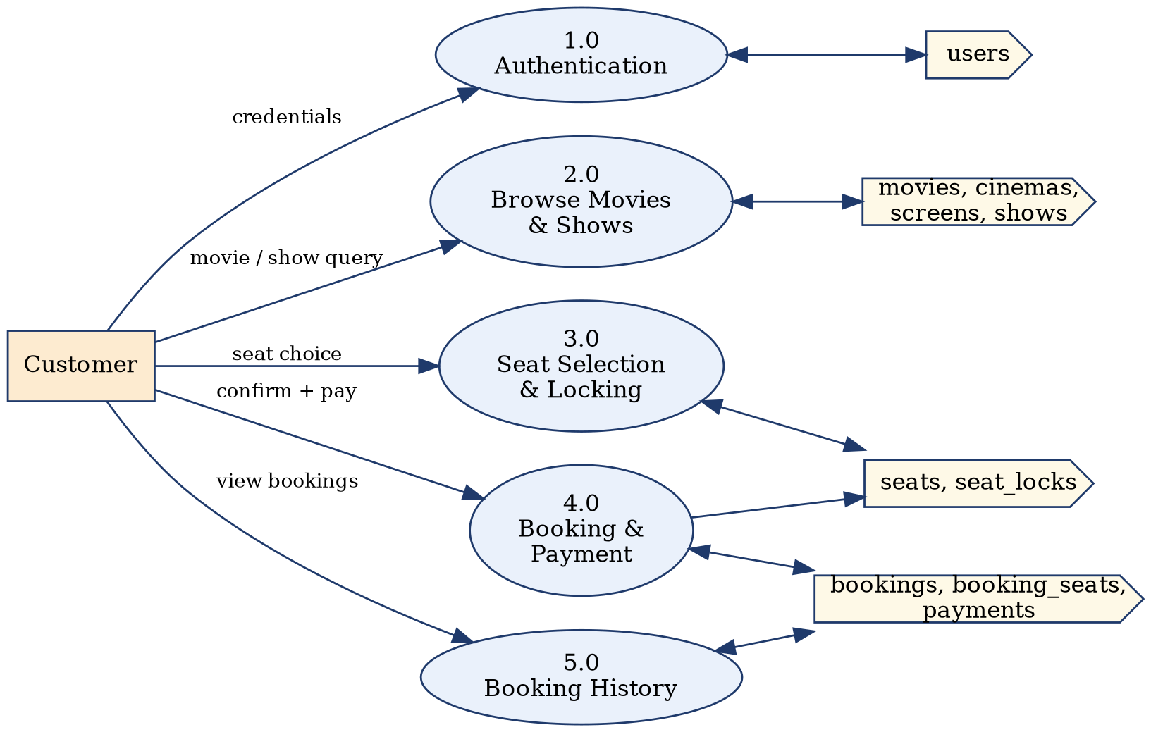
Fig. 5. Data flow diagram of CineBook.

H. User Interface
The web interface provides the following pages:
- Home page: Lists the movies (Fig. 7).
- Show selection: Choose cinema, date and show (Fig. 8).
- Seat map: Select seats; selected seats are temporarily locked (Figs. 6 and 9).
- Confirmation and payment: Confirm the booking with simulated payment (Fig. 10).
- My Bookings: View booking history (Fig. 11).
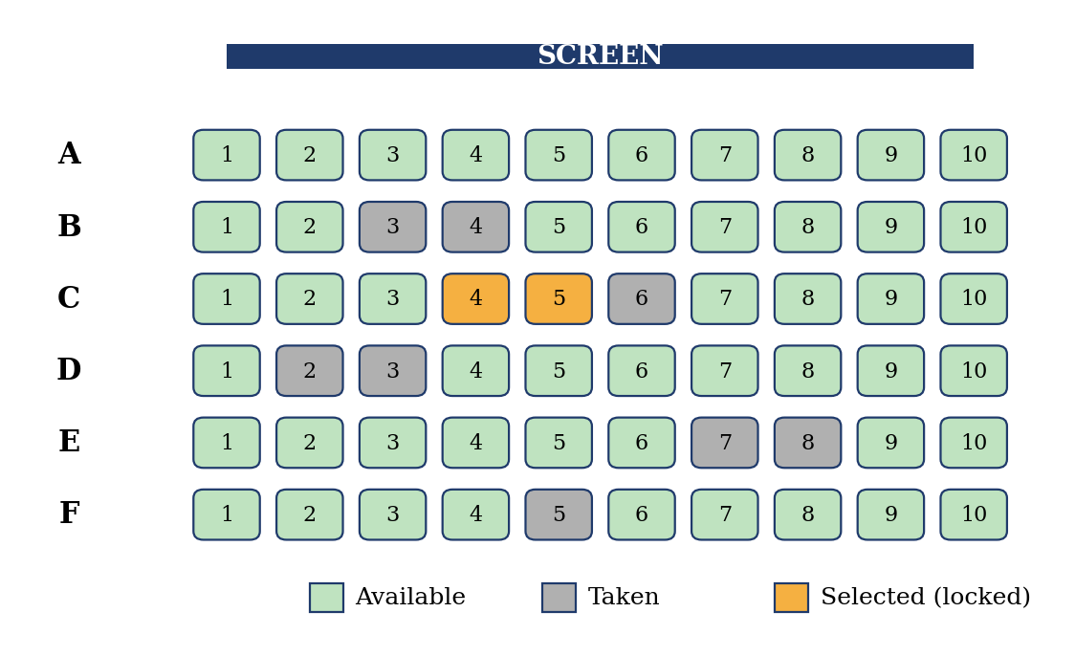
Fig. 6. Illustrative seat map showing available, taken and selected seats.

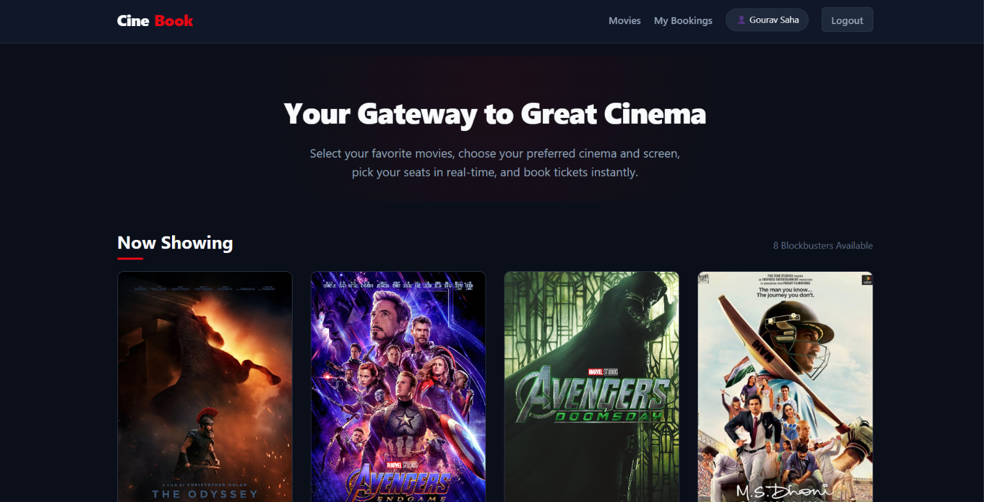
Figure 7: Home page
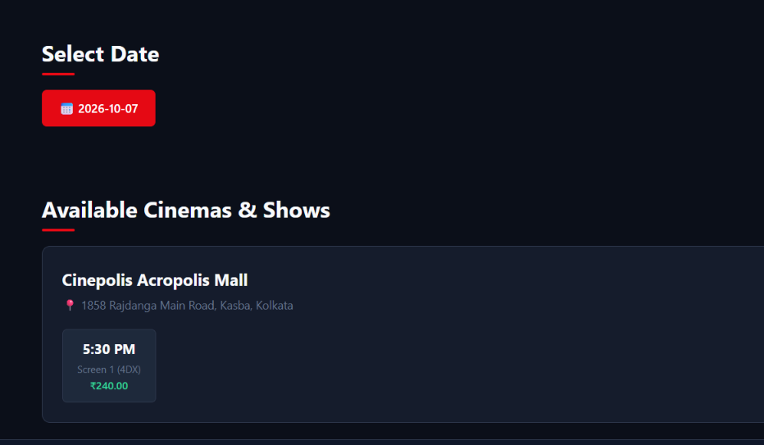
Figure 8: Cinema, date and show selection
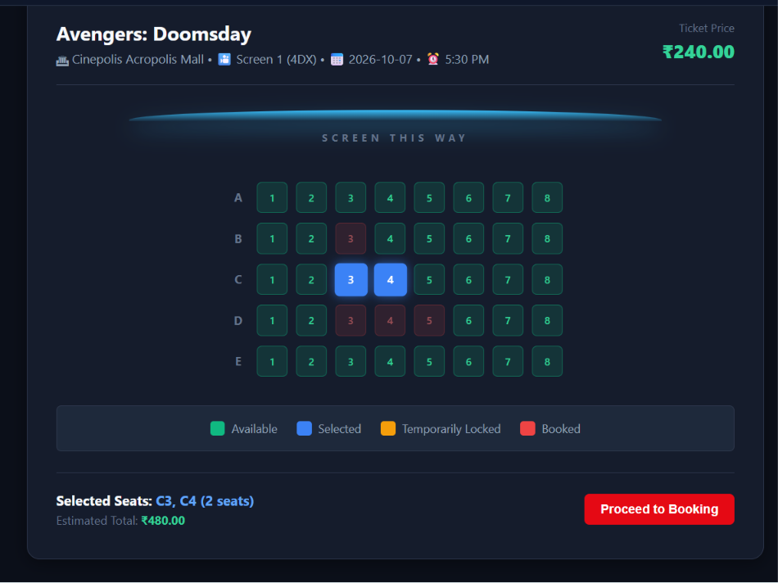
Figure 9: Seat selection
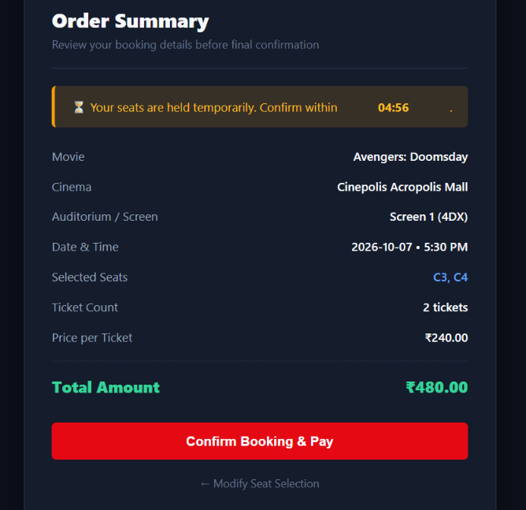
Figure 10: Payment Gateway
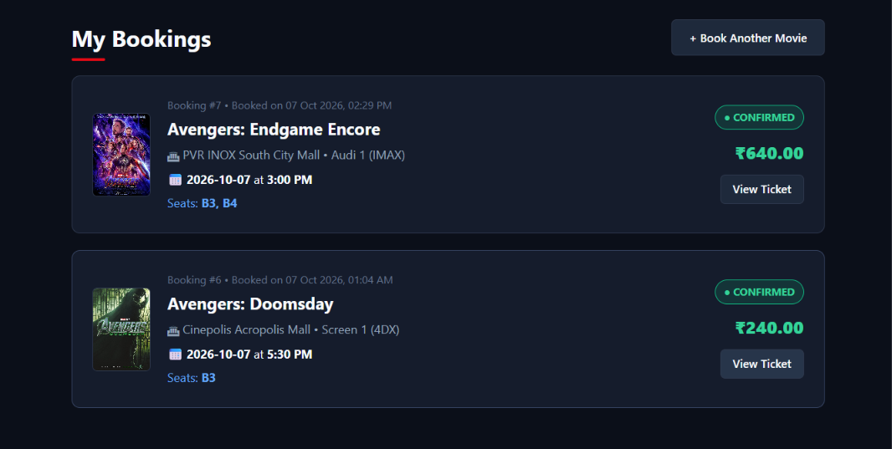
Figure 11: My bookings
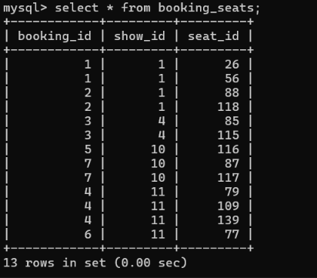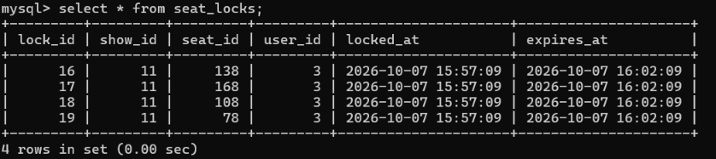
Figure 12: MySQL output of seat_locks and booking_seats

VII. Testing
The system was tested through a live demonstration of the complete booking flow and through automated tests written with Pytest, run with the command python -m pytest tests/ -v. The tests cover database functionality, the booking flow and concurrency-related behaviour. Table X lists the main test cases and the expected result of each.
TABLE X. TEST CASES AND EXPECTED RESULTS
Test case | Input / action | Expected result
Register user | Valid name, email and password | User stored; password saved as hash
Duplicate email | Register an existing email | Rejected by UNIQUE constraint
Login | Valid and invalid credentials | Valid login succeeds; invalid is refused
Browse shows | Open a movie | Shows listed with cinema and screen
Seat lock | Select free seats | Lock row created with an expiry time
Expired lock | Check seats after lock expiry | Seat becomes available again
Book free seats | Confirm booking | Booking, booking_seats and payment rows stored
Same seat twice | Two requests for one seat and show | Only one booking succeeds; the other is rolled back
Payment failure | Failure after booking insert | ROLLBACK; no incomplete booking remains
My Bookings | Open booking history | Only the user's bookings are listed
The test results are read from the Pytest terminal output of the final run.

VIII. Conclusion and Future Work
CineBook demonstrates the practical implementation of database management concepts using MySQL, Python and Flask. It provides structured storage of users, movies, cinemas, screens, seats, shows, bookings and payments, and applies a normalised design, keys and constraints, joins, indexing, transactions, concurrency control, ACID properties and query optimisation. Its layered protection of temporary seat locks, transactions, row locking and a UNIQUE constraint ensures that a seat is not booked twice for the same show. It is an academic project and is not claimed to be production-ready.
Future enhancements include:
- A real payment gateway
- Stronger authentication and session security
- A background clean-up service for expired seat locks
- Cloud and scalable deployment
- Booking notifications
- A recommendation system

Contribution of Team Members
- Gourav Saha (25WU0101042): Database Management: MySQL 8+.
- Pranav Yeddula (25WU0102311): Python 3, Flask.
- Yash Raj (25WU0102307): html, css, vanillajs .

Appendix A: Source Code Repository
The complete source code, database scripts (schema.sql and seed.sql), application modules, tests and related project files are available at: https://github.com/Gourav-aiml/CineBook-DBMS

References
[1] E. F. Codd, “A relational model of data for large shared data banks,” Commun. ACM, vol. 13, no. 6, pp. 377–387, Jun. 1970.
[2] D. D. Chamberlin and R. F. Boyce, “SEQUEL: A structured English query language,” in Proc. ACM SIGFIDET Workshop Data Description, Access and Control, Ann Arbor, MI, USA, 1974, pp. 249–264.
[3] J. Gray and A. Reuter, Transaction Processing: Concepts and Techniques. San Francisco, CA, USA: Morgan Kaufmann, 1993.
[4] H. Berenson, P. Bernstein, J. Gray, J. Melton, E. O’Neil, and P. O’Neil, “A critique of ANSI SQL isolation levels,” in Proc. ACM SIGMOD Int. Conf. Management of Data, San Jose, CA, USA, 1995, pp. 1–10.
[5] M. Kleppmann, Designing Data-Intensive Applications. Sebastopol, CA, USA: O’Reilly Media, 2017.
[6] Pallets Projects, “Flask documentation.” [Online]. Available: https://flask.palletsprojects.com/
[7] Oracle Corporation, “MySQL Connector/Python developer guide.” [Online]. Available: https://dev.mysql.com/doc/connector-python/en/
[8] E. F. Codd, “Further normalization of the data base relational model,” in Data Base Systems, Courant Computer Science Symposia, vol. 6, R. Rustin, Ed. Englewood Cliffs, NJ, USA: Prentice-Hall, 1972, pp. 33–64.
[9] R. Bayer and E. McCreight, “Organization and maintenance of large ordered indexes,” Acta Inform., vol. 1, no. 3, pp. 173–189, 1972.
[10] Oracle Corporation, “MySQL 8.0 reference manual: How MySQL uses indexes.” [Online]. Available: https://dev.mysql.com/doc/refman/8.0/en/mysql-indexes.html
[11] Oracle Corporation, “MySQL 8.0 reference manual: InnoDB and the ACID model.” [Online]. Available: https://dev.mysql.com/doc/refman/8.0/en/mysql-acid.html
[12] Pallets Projects, “Werkzeug documentation.” [Online]. Available: https://werkzeug.palletsprojects.com/
[13] OWASP Foundation, “Password storage cheat sheet.” [Online]. Available: https://cheatsheetseries.owasp.org/cheatsheets/Password_Storage_Cheat_Sheet.html
[14] pytest-dev, “pytest documentation.” [Online]. Available: https://docs.pytest.org/
[15] Oracle Corporation, “MySQL 8.0 reference manual: EXPLAIN statement.” [Online]. Available: https://dev.mysql.com/doc/refman/8.0/en/explain.html
[16] Oracle Corporation, “MySQL 8.0 reference manual: Locking reads.” [Online]. Available: https://dev.mysql.com/doc/refman/8.0/en/innodb-locking-reads.html
[17] K. P. Eswaran, J. N. Gray, R. A. Lorie, and I. L. Traiger, “The notions of consistency and predicate locks in a database system,” Commun. ACM, vol. 19, no. 11, pp. 624–633, Nov. 1976.
[18] T. Haerder and A. Reuter, “Principles of transaction-oriented database recovery,” ACM Comput. Surv., vol. 15, no. 4, pp. 287–317, Dec. 1983.

