WOXSEN UNIVERSITY
SCHOOL OF TECHNOLOGY

OPTIMAL RESOURCE ALLOCATION
USING SIMULATED ANNEALING
“A Case Study in Multi-Drone Task Allocation”
PROJECT-BASED LEARNING REPORT
Foundations of Artificial Intelligence
Course code: 25TU03MJM2 | Semester: III | Academic year: 2026–2027
Submitted by
Gourav Saha - 25WU0101042
Yash Raj - 25WU0102307
Pranav Yeddula - 25WU0102311
Morla Kartik - 25WU0102166
Shwechith Charan - 25WU0102261

Under the guidance of: Dr. N. Steven Raj
October 2026

DECLARATION
We declare that the project report titled “Optimal Resource Allocation Using Simulated Annealing: A Case Study in Multi-Drone Task Allocation” represents our group’s work for the Foundations of Artificial Intelligence course. The report describes the case study shown in our project presentation. We have distinguished observations from design choices and proposals, and we have cited the published sources used for the conceptual background.
Each group member is responsible for reviewing the final submission and confirming that it accurately reflects the implemented project. The faculty guide’s name, signatures, and institutional checks should be completed before submission.
Place: Hyderabad Date: 07/10/2026
Signatures of the candidates:
Gourav Saha - 25WU0101042
Yash Raj - 25WU0102307
Pranav Yeddula - 25WU0102311
Morla Kartik - 25WU0102166
Shwechith Charan - 25WU0102261

CERTIFICATE
This is to certify that the report titled “Optimal Resource Allocation Using Simulated Annealing: A Case Study in Multi-Drone Task Allocation” is submitted by the students listed below as part of the course Foundations of Artificial Intelligence at Woxsen University during the academic year 2026–2027.
Gourav Saha – 25WU0101042
Yash Raj – 25WU0102307
Pranav Yeddula – 25WU0102311
Morla Kartik – 25WU0102166
Shwechith Charan – 25WU0102261
The work was carried out under my guidance, subject to verification and approval by the concerned faculty member.
Faculty guide name and designation: Dr. N. Steven Raj
Faculty signature: Date: 07/10/2026

ACKNOWLEDGEMENT
We would like to thank Dr. N. Steven Raj for helping us connect ideas from class to a working implementation. Building the allocation solver forced us to think beyond a rule that simply sends each task to its nearest resource. We had to decide how to score a whole assignment, how to treat a battery limit that couples one decision to the next, and how to judge whether a better-looking result was actually better.
We also thank our classmates for discussing the project with us and giving feedback on the presentation. Each member of the group contributed to the planning, implementation, explanation, or demonstration of the work. This report brings those parts together in one place.

ABSTRACT
Resource allocation, the assignment of a limited set of resources to a set of tasks so as to optimize a global objective, is one of the most common problem classes in computer science and operations research. Such problems are combinatorial, and their search spaces grow exponentially with size. Exact methods quickly become impractical, and a simple greedy rule often produces poor, unbalanced solutions when assignments share a constraint. This project studies Simulated Annealing (SA), a probabilistic metaheuristic inspired by the annealing of metals, as a general method for constrained resource allocation.
To evaluate the method concretely, we chose a multi-drone task allocation scenario. A fleet of drones must be assigned to geographically distributed task zones so that total travel distance is minimized, subject to a per-drone battery or range cap. The scenario was chosen because it shows clearly why greedy strategies fail: one resource is overloaded while others are underused. It is also easy to visualize and to evaluate numerically.
An SA solver was implemented in Python and compared with a greedy nearest-assignment baseline on the same randomly generated instance of four drones and eight zones. SA uses an initial temperature of 100, geometric cooling by a factor of 0.995, and 1500 iterations. SA reached a final cost of 171.8, while the greedy baseline reached 1164.2, an improvement of about 85.2% on that instance. The submitted figures show the convergence curve, the final assignment, and the cost comparison. They come from a single instance and a single run, so we report the result as a demonstrated effect and propose repeated matched trials for any general claim.
The project helped us see how a cost function, a neighbor move, a cooling schedule, and a coupling constraint fit together. Its main contribution is an understandable teaching example in which each result has a reason that can be inspected, and the same method carries over to other constrained allocation problems.

TABLE OF CONTENTS

CERTIFICATE 3
ACKNOWLEDGEMENT 4
ABSTRACT 5
TABLE OF CONTENTS 6
LIST OF FIGURES 8
LIST OF TABLES 9
1 INTRODUCTION 10
1.1 Background 10
1.2 Motivation and relevance 10
1.3 Scope of the report 11
1.4 Why the comparison with greedy matters 11
1.5 What we learned from the example 11
2 PROBLEM STATEMENT AND OBJECTIVES 13
2.1 Problem definition 13
2.2 Objectives 13
2.3 Constraints and assumptions 13
2.4 Success criteria 14
2.5 Boundaries of the problem 14
3 LITERATURE REVIEW AND BACKGROUND 15
3.1 Resource allocation and combinatorial optimization 15
3.2 Hill climbing and local optima 15
3.3 Simulated annealing and the Metropolis criterion 15
3.4 Cooling schedules and acceptance probability 16
3.5 Related ideas and applications 16
3.6 Comparison of approaches 17
3.7 Research gap for this classroom project 17
4 METHODOLOGY AND SYSTEM DESIGN 19
4.1 Overall architecture 19
4.2 Problem model 19
4.3 Case-study instance generation 20
4.4 Cost function 20
4.5 Simulated annealing solver 21
4.6 Greedy baseline 21
4.7 Worked examples of the cost and acceptance rules 21
4.8 Handling edge cases 22
4.9 Data flow through one iteration 22
4.10 Evaluation design before collecting results 23
4.11 Verification checks for individual modules 23
5 IMPLEMENTATION 24
5.1 Modules and Python environment 24
5.2 Instance setup and state update 24
5.3 Baseline method 24
5.4 Proposed solver 24
5.5 Pseudocode 25
5.6 What the supplied material establishes 25
5.7 Output and interaction 25
5.8 Output figures 26
6 RESULTS AND DISCUSSION 28
6.1 Observed outputs 28
6.2 What the comparison can and cannot show 28
6.3 Proposed test protocol 29
6.4 Limitations 29
6.5 Interpreting the visible example 29
7 CONCLUSION AND FUTURE SCOPE 31
REFERENCES 32
APPENDIX A REPRODUCIBLE EVALUATION PLAN 33
APPENDIX B DESIGN DECISIONS AND QUESTIONS 34
B.1 Questions to settle before implementation review 34
B.2 Boundary between model and real drones 34

LIST OF FIGURES
Figure 1. Total cost of the current SA solution over 1500 iterations
Figure 2. Final assignment found by Simulated Annealing
Figure 3. Final cost of Simulated Annealing and the greedy baseline

LIST OF TABLES
Table 01: Acceptance probability at different temperatures
Table 02: Background sources and their relevance
Table 03: System architecture layers
Table 04: Problem model components
Table 05: Simulated annealing parameters
Table 06: Implementation functions
Table 07: Greedy and Simulated Annealing comparison
Table 08: Suggested evaluation measures
Table 09: Proposed test scenarios

1 INTRODUCTION

1.1 Background
Resource allocation is the task of assigning a limited set of resources to a set of tasks or demands so that some overall measure of cost or efficiency is optimized. The problem appears whenever capacity is finite and demand is not. In cloud computing, virtual machines must be placed on physical servers to balance load and keep latency low. In logistics, delivery vehicles must be matched to customer locations to reduce distance or time. In manufacturing, jobs must be assigned to machines so that the last job finishes as early as possible [4]. The settings differ, but the abstract structure is the same: resources, tasks, a global objective, and constraints that limit which assignments are acceptable.
What makes these problems hard is that the number of possible assignments grows exponentially. If every one of M tasks can be given to any of N resources, there are N^M candidate assignments. For our case study, with four drones and eight zones, that is 4^8 = 65,536 assignments, which is small enough to enumerate. With ten drones and thirty zones the count is 10^30, and exhaustive search is no longer an option. A method that scales has to search intelligently instead of checking everything.
A common shortcut is a greedy heuristic, in which each task is given to whichever resource looks best for it in isolation, such as the nearest one. Greedy rules are simple and fast, but they make every decision without regard to the others. When a constraint couples the assignments, for example a limit on how much work one resource can carry, several tasks may independently choose the same resource and overload it while other resources sit idle. This weakness motivates methods that evaluate an assignment as a whole [1].

1.2 Motivation and relevance
This project studies Simulated Annealing (SA) as a general-purpose method for constrained resource allocation. SA is a stochastic local-search metaheuristic that has been applied to combinatorial optimization since the early 1980s [2], [5]. It needs only two ingredients, a cost function and a way of generating neighboring solutions, and it can accept a temporarily worse solution in order to escape a local optimum. That combination makes it easy to implement and easy to adapt to new problems.
To test the method on something concrete, we chose a multi-drone task allocation scenario. A small fleet of drones must be assigned to task zones scattered over a two-dimensional area. Each zone needs exactly one drone, a drone may serve several zones, and each drone has a battery or range cap. The goal is to minimize total travel distance without breaking any cap. The scenario keeps the essential features of the general problem while staying small enough to implement, plot, and evaluate within the scope of a course project.
The relevance goes beyond the classroom. The same structure describes survey and delivery drones in disaster relief, parcel distribution across a limited fleet in last-mile delivery, and inspection of agricultural land, solar farms, or pipelines by unmanned aircraft. In each case the practical question is the one posed in our presentation: which drone should serve which zone?

1.3 Scope of the report
The report first defines the problem and its objectives. It then reviews the background on resource allocation, local search, and simulated annealing, and explains the design of the solver and of the greedy baseline used for comparison. Later sections describe the Python implementation and discuss the three plots it produces: a cost-versus-iteration curve, the final drone-to-zone assignment, and a bar chart comparing SA with the greedy baseline.
The stated scope is a single, randomly generated problem instance of the drone case study, solved by one SA run and one greedy pass. The material supplied for this report consists of the group presentation, an earlier draft report, and the three output figures. It does not include the source listing or repeated-trial logs. We therefore describe what the figures and reported costs show, and we mark clearly where a statement is a design choice, an estimate derived from the stated parameters, or a proposal for later testing.

1.4 Why the comparison with greedy matters
The greedy baseline is more than a weak opponent. It represents the natural first answer to the problem, and its failure shows precisely why the problem is not trivial. If battery limits did not exist, sending each zone to its nearest drone would minimize total distance and greedy would be optimal. The battery cap makes the cost of an assignment depend on what else the same drone has been given. Once that dependence exists, the problem can no longer be solved one zone at a time.
The comparison is also limited in an important way. Both methods were run on the same instance, which is the fairest possible comparison for that instance, but one instance is not a benchmark. The 85.2% improvement reported later is a measured result for that case. It should not be read as a general guarantee of how much SA improves on greedy. Appendix A describes the repeated, matched trials that would be needed for a broader claim.

1.5 What we learned from the example
At the start, the problem looked like a matching exercise: pair each zone with a drone. Working on it showed that the interesting part is the interaction between assignments. A zone that is cheap to serve on its own may be expensive in context because it pushes a drone past its range. Greedy cannot see this, and SA can, because it always scores a complete assignment.
We also learned that the settings of the algorithm matter as much as the idea. The starting temperature, the cooling rate, the number of iterations, and the size of the penalty each change how the search behaves. Reading the cost curve in Figure 1 gave us a direct view of the transition from broad exploration to fine-tuning that the theory describes. The result is useful when it can be inspected and questioned, not merely because a method with an impressive name produced it.

2 PROBLEM STATEMENT AND OBJECTIVES

2.1 Problem definition
A fleet of drones must service a set of task zones, which may be delivery points, survey sites, or disaster-relief targets. Every zone needs exactly one drone, and a drone may serve several zones or none. The objective is to minimize the total travel distance of the fleet while respecting a per-drone battery or range cap.
The difficulty comes from combining a global objective with a constraint that couples the assignments. Minimizing distance alone is easy, since each zone goes to its nearest drone. Respecting the cap alone is also easy, since zones can be spread evenly. Doing both together requires trading a slightly longer trip for one zone against the feasibility of the whole fleet. Our central question is therefore: how can a fleet of drones be assigned to a set of task zones so that total travel distance is minimized without any drone exceeding its battery limit?

2.2 Objectives
- Formulate the multi-drone allocation problem as a general resource allocation problem with resources, tasks, an objective function, and constraints.
- Represent a problem instance with random two-dimensional drone and zone positions, and an assignment as a mapping from every zone to one drone.
- Define a cost function that adds the total drone-to-zone distance and a penalty for any drone that exceeds its battery cap.
- Implement a Simulated Annealing solver with swap and reassign moves, Metropolis acceptance, and geometric cooling.
- Implement a greedy nearest-drone baseline for comparison on the same instance.
- Visualize the convergence of the search, the final assignment, and the final cost comparison.
- Discuss how far the approach generalizes to other constrained allocation problems, and state the limits of the evidence.

2.3 Constraints and assumptions
The area is a 100 x 100 two-dimensional grid with continuous coordinates, and distances are Euclidean. The cost of serving a zone is the straight-line distance from the assigned drone’s starting position to that zone. Each zone is assigned to exactly one drone, and a drone may receive zero or more zones. The battery or range cap limits the total distance assigned to a single drone. In the reported instance the cap is 80 units.
The cap is modelled as a soft constraint. A violation is not forbidden outright but is charged a penalty of 50 units of cost for each unit of distance beyond the cap. This keeps the search space connected, because the algorithm can pass through infeasible assignments on its way to a feasible one. It also means that feasibility is encouraged by the cost function rather than guaranteed by construction.
The model ignores several real-world details: the order in which a drone visits its zones, the return trip to a base, wind and payload effects, zone-specific time windows, and charging. The cost counts the distance from the drone’s starting position to each assigned zone, not a closed tour. These simplifications keep the problem small enough to analyze, and they define what the results can and cannot say.

2.4 Success criteria
We define success at two levels. At the functional level, the solver should return a complete assignment in which every zone has exactly one drone, the cost curve should settle at a stable plateau rather than oscillate, and the final assignment should keep every drone within its battery cap. These criteria can be checked directly from the cost curve in Figure 1 and the assignment plot in Figure 2.
At the comparative level, SA and the greedy baseline must be evaluated on the same instance with the same cost function, so that the difference in final cost reflects the method and not the data. A fair comparison reports both final costs and states what produced the difference. The comparison should not declare SA superior merely because it is the more sophisticated method.
A third criterion is interpretability. A viewer should be able to understand why SA found a better solution: which drone greedy overloaded, where SA moved the load, and why the penalty made the greedy solution expensive. This links the project to the course’s concern with decision procedures that can be explained as well as run.

2.5 Boundaries of the problem
This project does not solve the full problem of drone fleet management. There is no flight dynamics model, obstacle map, energy model based on payload or weather, or communication between drones. The battery limit is a distance budget. The positions are random draws, not data from a real deployment. The results are produced by simulation, and nothing in the report claims that a physical fleet would achieve the same improvement.
These boundaries let us ask narrow questions that the material can answer: whether SA finds a feasible, low-cost assignment on the case-study instance, how its final cost compares with the greedy baseline on that instance, and why. Broader claims about other instances, larger fleets, or physical systems need repeated trials and further modelling.

3 LITERATURE REVIEW AND BACKGROUND

3.1 Resource allocation and combinatorial optimization
Russell and Norvig treat optimization problems of this kind as search over a space of complete configurations, where each configuration is evaluated by an objective function [1]. In an allocation problem a configuration is an assignment of tasks to resources. The space is discrete and grows exponentially with the number of tasks, which is why classical exact approaches become impractical beyond small instances. Pinedo describes the same structure in scheduling, where jobs are allocated to machines subject to availability and precedence constraints [4].
One classical special case deserves mention. When each task goes to a different resource and the cost of a pairing does not depend on any other pairing, the problem is the linear assignment problem, which the Hungarian method solves exactly in polynomial time [8]. Our case study does not fit that mould. A drone may serve several zones, and the battery penalty makes the cost of one pairing depend on the others. This coupling is what places the problem outside the reach of simple matching and motivates a metaheuristic.

3.2 Hill climbing and local optima
Hill climbing is the simplest local-search method. It starts from some solution, examines a neighboring solution, and moves there only if the move improves the objective. It stops when no neighbor is better [1]. The method is fast and needs little memory, but it is easily trapped. A solution can be better than all of its neighbors without being the best overall, and hill climbing has no way to leave such a local optimum, because leaving requires accepting a worse solution first.
In the drone problem, a local optimum might be an assignment in which moving any single zone to a different drone makes the cost higher, even though a coordinated change of several zones would give a much better plan. Greedy construction and hill climbing both suffer from this limitation, for different reasons: greedy never revisits a decision, and hill climbing never accepts a step backward.

3.3 Simulated annealing and the Metropolis criterion
Simulated Annealing takes its idea from the annealing of metals. A metal is heated and then cooled slowly so that its atoms can settle into a low-energy, ordered structure. Cooling too quickly freezes the material into a disordered, higher-energy state. Kirkpatrick, Gelatt, and Vecchi showed that the same principle can be used to optimize large combinatorial problems [2], and Černý proposed an equivalent approach independently for the travelling salesman problem [5]. The acceptance rule goes back to the Metropolis algorithm, which was devised to simulate the behaviour of a system of particles at a given temperature [3].
SA extends hill climbing with a temperature parameter T. A candidate move that improves the cost is always accepted. A move that worsens the cost by an amount Δcost is accepted with probability P(accept) = exp(−Δcost / T). When T is high, almost any move is accepted and the search explores widely. As T falls according to a cooling schedule, worsening moves become rare and the search behaves more and more like hill climbing, refining a good region [6]. The gradual change from exploration to exploitation is what lets SA escape local optima.

3.4 Cooling schedules and acceptance probability
The cooling schedule controls how quickly the algorithm moves from exploration to refinement. Hajek showed that a sufficiently slow logarithmic schedule guarantees convergence to a global optimum in probability under certain conditions, but such schedules are far too slow for practical use [7]. Practitioners therefore use faster schedules, most often geometric cooling, in which the temperature is multiplied by a constant factor slightly below one at every step [6]. Our solver uses this form, with T0 = 100 and a factor of 0.995.
A worked example shows what the rule does. Suppose a candidate move makes the cost worse by 10 units. At T = 100 it is accepted with probability exp(−0.1) ≈ 0.905, so the search treats it almost like a free move. At T = 10 the probability falls to exp(−1) ≈ 0.368. At T = 1 it is exp(−10) ≈ 0.00005, and the move is effectively never taken. With geometric cooling, the temperature after k iterations is T0 × 0.995^k. For our parameters this gives about 60.6 after 100 iterations, 8.2 after 500, 0.67 after 1000, and 0.054 at the end of 1500. These values follow from the stated parameters and were not logged from the run.
Δcost (worse by) | T = 100 | T = 10 | T = 1
5 | 0.951 | 0.607 | 0.007
10 | 0.905 | 0.368 | 0.00005
20 | 0.819 | 0.135 | 2 x 10^-9
50 | 0.607 | 0.007 | ~ 0

3.5 Related ideas and applications
The structure of our case study recurs in many domains, and SA has a long record in several of them. In chip design, placement tools have used annealing to position circuit components so that wire length is minimized subject to area and routing limits [9]. In scheduling, jobs are assigned to machines to minimize the makespan [4]. In cloud systems, jobs or virtual machines are assigned to servers to reduce latency or energy use while respecting per-server capacity. In logistics, vehicles are assigned to orders under capacity and time-window constraints. Aerial and field robotics, of which our drone scenario is an applied example, includes disaster-relief survey routing, last-mile parcel delivery, and periodic inspection of agricultural, solar, or pipeline infrastructure.
In each of these domains the solver has the same shape: a cost function that captures the objective and the constraints, a neighbor operator suited to the way an assignment is represented, and the Metropolis rule with a cooling schedule. Only the cost function and the neighbor operator change. This is the main reason SA is attractive as a general tool for constrained allocation.
A different direction is quantum annealing. Kadowaki and Nishimori described annealing of the transverse Ising model, in which quantum fluctuations play the role that thermal noise plays in SA [10]. Quantum annealers such as those built by D-Wave target the same class of combinatorial problems. We treat this as future scope, because it needs specialized hardware and a reformulation of the problem.

3.6 Comparison of approaches
Four families of methods are relevant. Exhaustive search is exact and guarantees the optimum, but its cost grows as N^M and it becomes unusable beyond very small instances. Greedy construction is the cheapest approach. It makes one pass over the tasks and gives no protection against coupled constraints. Hill climbing improves a full assignment and can respect coupling, but it stalls at the first local optimum. SA keeps the full-assignment view of hill climbing and adds a controlled way to accept worse moves, at the price of tuning the temperature, cooling rate, and iteration budget, and with no guarantee of optimality within a finite run.
The relationship between SA and greedy in our experiment follows from this comparison. Greedy is equivalent to optimizing each zone alone. It would be optimal if the problem were separable, and it is the penalty term that makes it non-separable. Hill climbing is not part of our experiment, and we do not claim any measured result for it. We cite it only as the method that SA extends.

3.7 Research gap for this classroom project
The sources above explain local search, annealing, cooling schedules, and applications individually. The gap we address is pedagogical and practical. A reader who sees only the final claim that SA beats greedy learns little. We try to show where the gap between the two methods comes from: the coupling constraint, the exploratory phase at high temperature, and the way the penalty is removed as the search settles. The drone scenario makes these effects visible in plots.
We do not claim a new algorithm. SA, the Metropolis rule, geometric cooling, and the greedy baseline are all standard. What the project adds is a compact, inspectable demonstration of why a metaheuristic helps when constraints couple assignments. A stronger literature-based evaluation would compare SA with hill climbing, random restarts, and exact methods on many instances. We did not run that wider experiment, so the literature in this report explains design choices and does not imply a validated advantage over every alternative.
Source | Relevant idea | How used here
Russell and Norvig [1] | Local search and optimization | Hill climbing and SA background
Kirkpatrick et al. [2] | Optimization by annealing | Motivation for the SA solver
Metropolis et al. [3] | Acceptance rule | exp(−Δcost / T) criterion
Pinedo [4] | Scheduling as allocation | Job-to-machine analogy
Černý [5] | Independent annealing proposal | Historical context
van Laarhoven and Aarts [6] | Annealing theory and practice | Geometric cooling
Hajek [7] | Cooling schedule theory | Why practical schedules are faster
Kuhn [8] | Hungarian method | Contrast with coupled allocation
Sechen and Sangiovanni-Vincentelli [9] | Annealing for chip placement | Application example
Kadowaki and Nishimori [10] | Quantum annealing | Future scope

4 METHODOLOGY AND SYSTEM DESIGN

4.1 Overall architecture
The proposed system has four layers. The input layer generates a random problem instance with drone and zone positions. The reasoning layer holds the cost function and the neighbor operator, which together define what a good assignment is and how one assignment can be changed into another. The execution layer runs the annealing loop, applying the Metropolis rule, cooling the temperature, and tracking the best assignment seen. The evaluation layer records the cost history, runs the greedy baseline on the same instance, and produces the plots.
This separation matters because it keeps the question of what is good apart from the question of how to search. The cost function can be changed, for example by altering the cap or the penalty, without touching the solver. The solver can be changed, for example from SA to hill climbing, without touching the cost function. That is also what allows the greedy baseline to be scored fairly with exactly the same cost function as SA.
Layer | Inputs or outputs | Responsibility
Input | Drone positions, zone positions, battery cap | Describe the problem instance
Reasoning | Assignment, cost, neighbor candidates | Score and modify assignments
Execution | Temperature, acceptance decision, best-so-far | Run the annealing loop and track the best
Evaluation | Cost history, SA and greedy costs, plots | Record outcomes and compare methods

4.2 Problem model
In general form, a resource allocation problem has four components: a set of resources R = {r1, ..., rN}; a set of tasks T = {t1, ..., tM}, each of which must be satisfied by exactly one resource while a resource may serve many tasks; an objective function that computes the total cost of an assignment; and constraints that decide which assignments are feasible. The aim is to find an assignment of every task that minimizes the objective while satisfying the constraints.
A candidate solution can be written as a list of length M in which entry j names the drone assigned to zone j. This representation guarantees that every zone is assigned exactly once, so that requirement never has to be checked or repaired. It is also consistent with the two move types used by the solver, which either exchange two entries of the list or change a single entry.
Component | General form | Drone case study
Resources | N resources | N drones (3–4), random start positions
Tasks | M tasks, each served exactly once | M zones (6–8), random positions
Objective | Total cost of the assignment | Total Euclidean drone-to-zone distance
Constraint | Capacity or budget per resource | Battery cap per drone, enforced by a penalty

4.3 Case-study instance generation
An instance is generated by sampling drone starting coordinates and zone coordinates uniformly at random on a 100 x 100 grid. The setup allows 3 to 4 drones and 6 to 8 zones, and the reported run uses 4 drones and 8 zones, as shown by the drone markers D0 to D3 and zone markers Z0 to Z7 in Figure 2. Because each run draws a fresh layout, the algorithm can be tested on varied spatial configurations instead of one fixed map.
The random draw also has a drawback for reporting. Unless the random seed or the coordinates are saved, a layout cannot be reproduced exactly. The supplied material does not record a seed, so the numbers in this report belong to one particular layout that we cannot regenerate on demand. Appendix A lists the information a saved instance should include.

4.4 Cost function
The cost of an assignment A is the sum, over all zones, of the Euclidean distance between the zone and the drone it is assigned to, plus a battery penalty. Writing d(j, A_j) for the distance from zone j to its assigned drone, L_i for the total distance assigned to drone i, and C for the battery cap, the cost is:
cost(A) = sum over zones j of d(j, A_j) + 50 x sum over drones i of max(0, L_i − C)
In the reported run C = 80 and the penalty weight is 50 per unit of overshoot. The penalty is what couples the decisions. Without it, the cost of assigning a zone depends only on that zone and its drone. With it, the cost of giving a zone to a drone also depends on what else the drone already carries, so the problem cannot be solved by considering each zone in isolation.
The size of the weight is a design choice. Distances on a 100 x 100 grid are of the order of tens of units, so one unit of overshoot at a cost of 50 outweighs a typical detour. This makes infeasible assignments strongly unattractive. A random starting assignment can therefore cost over ten thousand units, as the first point of Figure 1 shows, even though the total distance itself is a few hundred.

4.5 Simulated annealing solver
The solver begins from a random assignment of zones to drones. At every iteration it creates a neighboring solution using one of two moves, chosen at random: swapping the drones assigned to two randomly chosen zones, or reassigning one randomly chosen zone to a different, randomly chosen drone. The candidate’s cost is compared with the current cost, and the Metropolis criterion decides whether to accept it. The best solution found over the whole run is stored and returned, so the final answer is never worse than any solution the search visited, even if the current solution wandered upward late in the run.
Parameter | Value | Role
Initial temperature T0 | 100 | Sets early willingness to accept worse moves
Cooling factor | 0.995 per iteration | Geometric reduction of T
Iterations | 1500 | Fixed search budget
Moves | Swap or reassign | Neighbor generation, chosen at random
Battery cap | 80 units per drone | Range limit
Penalty weight | 50 per unit of overshoot | Makes violations costly

4.6 Greedy baseline
As a point of comparison, a greedy nearest-assignment baseline was implemented. For each zone, independently of all other zones, it chooses the drone that is geometrically closest. The method needs no iterative search. It also performs no load balancing: several nearby zones may all choose the same drone, which can then exceed its battery cap while other drones remain lightly loaded.
The baseline is scored with the same cost function as SA, including the battery penalty. This detail matters. Greedy minimizes the distance part of the cost, since every zone gets its closest drone, but it has no mechanism to avoid the penalty part. Its final cost reflects exactly the damage that ignoring the coupling can do.

4.7 Worked examples of the cost and acceptance rules
Two small calculations show how the rules behave. First, the penalty. Suppose a drone has been assigned zones whose distances add up to 90 units, against a cap of 80. The overshoot is 10 units, so the penalty is 10 x 50 = 500. Moving one zone that is 25 units from its drone to another drone that is currently at 40 units, and that is also about 25 units from the zone, brings the first drone to 65 and the second to 65, both under the cap, and removes the entire penalty at a cost of at most a few tens of units of extra distance. A search that can evaluate the whole assignment will find such a move attractive.
Second, the acceptance rule. Suppose the current cost is 300 and a candidate costs 320, so Δcost = +20. Early in the run, at T = 100, the move is accepted with probability exp(−0.2) ≈ 0.82. At T = 10 the probability is exp(−2) ≈ 0.14. At T = 1 it is below 10^-8. The same move is therefore nearly free at the beginning and effectively forbidden at the end. The numbers are illustrative and are not taken from the logged run.
A third calculation is an inference from the reported costs. Greedy gives every zone its nearest drone, so its distance part cannot exceed that of any other assignment. If SA’s final cost of 171.8 contains little or no penalty, greedy’s distance part is at most about 171.8. The remaining 1164.2 − 171.8 = 992.4 or more must then be penalty, which at 50 per unit corresponds to an overshoot of roughly 20 units or more on the overloaded drone. This is an estimate based on an assumption. The run itself did not report the overshoot.

4.8 Handling edge cases
Several situations deserve explicit treatment. If one drone receives all zones, the representation allows it, and the penalty will usually make it unattractive. If a drone receives no zones, its load is zero and no penalty applies, which is acceptable because the problem allows idle drones. If it is impossible to satisfy every cap, for instance because zones are far from all drones, the soft constraint still lets the solver return the least costly assignment, but that answer will contain a penalty. A report built on such a run should say so instead of calling the result feasible.
Ties between candidate costs are another practical case. SA accepts a move with Δcost = 0 under the rule that any non-worsening move is accepted, which lets the search drift across plateaus. Because the run is random, an exact tie-breaking rule is not needed for correctness, but it matters for reproducibility. Saving the random seed would make a run repeatable.

4.9 Data flow through one iteration
At the start of an iteration, the solver holds the current assignment, its cost, the best assignment so far, and the temperature. The neighbor operator produces a candidate by copying the current assignment and applying a swap or a reassignment. The cost function scores the candidate, computing every drone’s load and applying the penalty. The acceptance test compares the two costs, draws a random number if the candidate is worse, and either replaces the current assignment or discards the candidate. The best-so-far record is updated if the current cost is the lowest seen, and the temperature is multiplied by 0.995.
This data flow makes debugging manageable. If costs never fall, inspect the cost function and the neighbor operator before the schedule. If costs fall and then rise, check that the best assignment, not the current one, is returned. If SA and greedy give identical costs, check that the penalty is switched on. Dividing the problem this way avoids treating every unexpected output as a flaw in the idea of annealing itself.

4.10 Evaluation design before collecting results
The reported figures are observations from one run and should be treated as such. A trial that supports a general claim would start from a saved instance, use a documented random seed, run SA for the fixed budget of 1500 iterations, and score both methods with the same cost function. The stopping rule must be the same for every trial. Here it is the fixed iteration count. The cap, the penalty, T0, and the cooling factor must be recorded together with the results.
Metrics should be defined before experiments are run. The final cost is the main measure. Secondary measures are the raw travel distance, the largest battery overshoot of any drone, the number of drones within the cap, and the number of iterations after which the best cost was reached. Because SA is stochastic, several runs per instance, with different seeds, are needed before a mean and spread can be reported.

4.11 Verification checks for individual modules
Before comparing complete runs, each module can be checked on a small hand-designed instance. For the cost function, place one drone and one zone at a known distance and confirm that the cost equals that distance, then lower the cap below that distance and confirm that the penalty equals 50 times the overshoot. For the greedy baseline, create a layout in which the nearest drone to each zone is obvious and confirm that the output matches. For SA, run it on an instance with no binding battery limit and confirm that it reaches, or comes very close to, the greedy cost, since greedy is optimal when the penalty never applies. Finally, set a very low cap and confirm that SA spreads zones across more drones than greedy does. These are proposed checks, not tests documented in the supplied material.

5 IMPLEMENTATION

5.1 Modules and Python environment
The case study was implemented in Python. The core algorithm uses only the standard library for random number generation, distance computation, and the SA and greedy logic. The matplotlib library [11] produces the three plots. The code is organized into a small number of separate functions rather than one monolithic script, as summarized below.
Function | Responsibility
assignment_cost() | Computes total distance for an assignment, including the battery-cap penalty
random_assignment() | Generates a random initial zone-to-drone assignment
neighbor() | Produces a candidate by a swap or a single-zone reassignment
simulated_annealing() | Runs the SA loop and returns the best assignment found
greedy_assignment() | Computes the nearest-drone baseline
main() | Generates the instance, runs both methods, prints results, and saves the three plots

5.2 Instance setup and state update
The setup step draws the drone and zone coordinates and stores them as lists of points. The assignment is a list of drone indices, one per zone. Evaluating an assignment requires only these lists, the cap, and the penalty weight, which means that no hidden state is carried between iterations other than the current assignment, the best assignment, and the temperature.
Keeping the state this small has a practical benefit. A candidate can be created by copying the current list and changing one or two entries, and discarding a rejected candidate costs nothing. The same instance can be passed unchanged to both the SA solver and the greedy baseline, which is what ensures that they are scored on identical data.

5.3 Baseline method
The greedy function loops over the zones and, for each, computes the distance to every drone and keeps the smallest. No information is shared between zones. Its running time is proportional to N x M, and it makes no random choices, so for a given instance it always returns the same assignment. The result is passed to the same cost function as the SA output, so the penalty is applied if some drone ends up over the cap.

5.4 Proposed solver
The SA function receives the instance, the initial temperature, the cooling factor, and the iteration budget. It starts from a random assignment, and at every iteration it proposes a neighbor, evaluates it, applies the Metropolis rule, updates the best solution, and cools. In the reported run these values are T0 = 100, 0.995, and 1500. After the loop, the function returns the best assignment found.
The use of two move types is a design choice that helps the search. A reassignment changes the load on two drones and can quickly relieve an overloaded one. A swap keeps the number of zones per drone unchanged while exchanging which zones each carries, which allows fine adjustment once the loads are roughly balanced. Choosing between them at random gives the search both capabilities without a separate rule.

5.5 Pseudocode
- Generate a random assignment of zones to drones, and set T to T0 = 100.
- Repeat for 1500 iterations:
- Create a candidate from the current assignment by a swap or a reassignment.
- Compute delta = cost(candidate) − cost(current).
- If delta < 0, or a random number is below exp(−delta / T), accept the candidate as the current assignment.
- If the current cost is the lowest seen so far, store it as the best.
- Cool the temperature: T = T x 0.995.
- Return the best assignment found.

5.6 What the supplied material establishes
The supplied material establishes the following. The program takes an instance of four drones and eight zones, solves it with SA using the stated parameters, solves it with greedy, and reports final costs of 171.8 and 1164.2. The cost curve in Figure 1 shows the run starting above 12,000 and settling to a low plateau. The assignment in Figure 2 connects each drone to its assigned zones. The bar chart in Figure 3 reports the two final costs.
The material does not include the source listing, so details such as the exact random generator, the way a drone’s load is computed in code, and the handling of ties are taken from the design description and are not independently verified. We have also not seen results from other random seeds. Where this report explains a design choice, it does so from the description, and where it makes an inference, it says so.

5.7 Output and interaction
The program prints the final costs of both methods and saves three plots. There is no interactive interface. The three figures are intended to be read together. The first shows how the search behaved over time, the second shows what it produced, and the third shows how that compares with the baseline. The presentation uses the same three views in its results slides.

5.8 Output figures
The following figures are the program’s three output plots. They document the behavior of the solver on one instance and do not replace a full source review or a set of repeated trials.
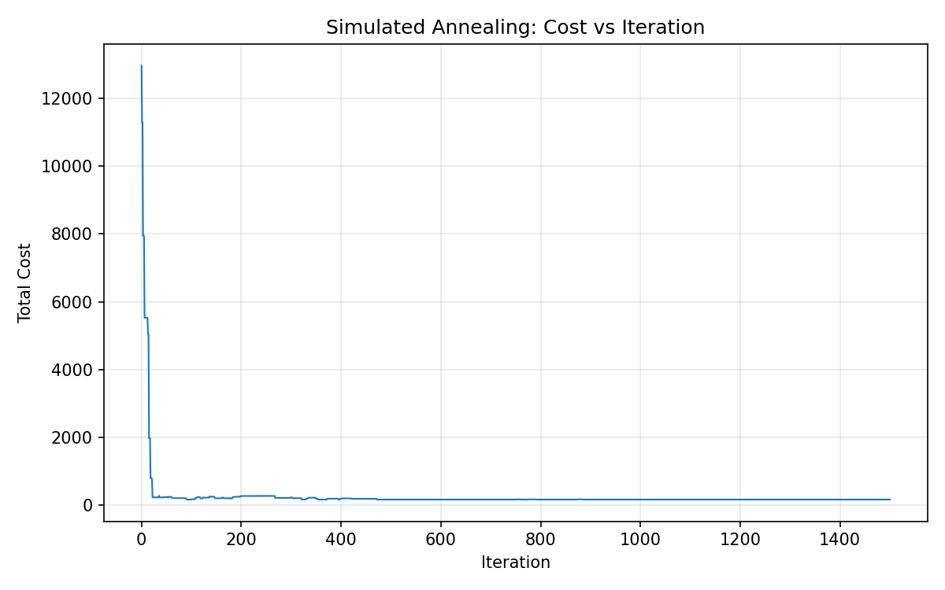
Figure 1: Total cost of the current SA solution over 1500 iterations
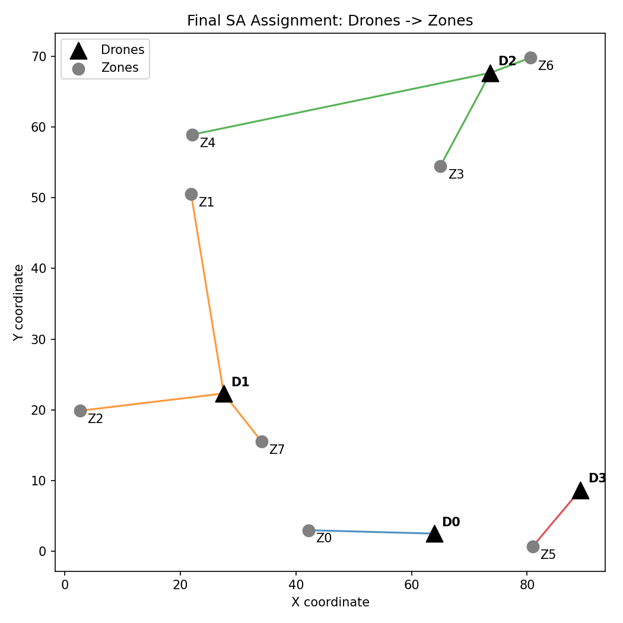
Figure 2: Final assignment found by Simulated Annealing (triangles are drones, circles are zones)
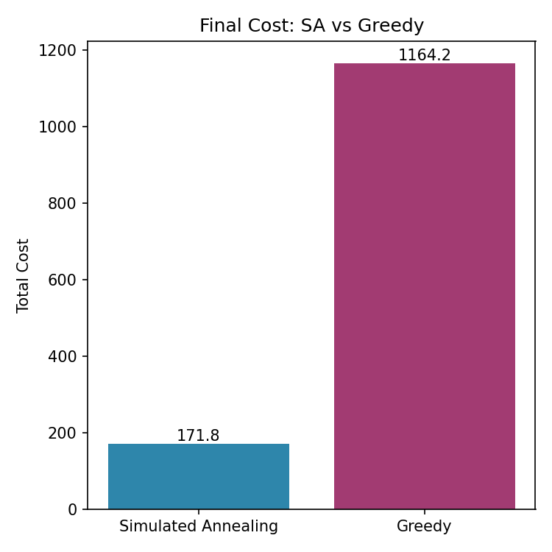
Figure 3: Final cost of Simulated Annealing and the greedy baseline on the same instance

6 RESULTS AND DISCUSSION

6.1 Observed outputs
This section presents the results of running the SA solver and the greedy baseline on the same randomly generated instance, with 4 drones, 8 zones, a battery cap of 80 units, and a penalty weight of 50 per unit of overshoot. Figure 1 shows the cost of the current SA solution over 1500 iterations. The curve starts near 13,000, because the random initial assignment heavily violates the cap on at least one drone. Within the first few dozen iterations, the high temperature allows large jumps, and the cost falls sharply as the search finds assignments that respect the cap. It then flattens into a stable plateau at a low cost.
Figure 2 shows the final assignment. In that plot, D0 serves Z0 and D3 serves Z5, while D1 serves Z1, Z2, and Z7 and D2 serves Z3, Z4, and Z6. Zones are grouped with geometrically nearby drones in a way that keeps each drone’s total flight distance within the cap. No drone is connected to zones spread arbitrarily across the map.
Figure 3 compares the final costs. SA reached 171.8 and greedy reached 1164.2, an improvement of 85.2% for SA. The gap arises because of the penalty. Greedy gave one drone several nearby zones at once, pushed its total distance past the cap, and paid a heavy penalty. SA evaluated the assignment as a whole and moved zones away from the overloaded drone toward a drone with spare range.
Aspect | Greedy nearest assignment | Simulated Annealing
Final cost | 1164.2 | 171.8
Improvement over greedy | Baseline | 85.2%
Battery cap | One drone overloaded, heavy penalty | Every drone kept within its cap
Decision basis | Each zone chosen independently | Whole assignment evaluated
Search effort | Single pass | 1500 iterations

6.2 What the comparison can and cannot show
The strongest conclusion supported by the results is that, on this instance, a method that evaluates the whole assignment avoids a penalty that a zone-by-zone method incurs. This is a useful demonstration of why coupled constraints defeat greedy decisions, and the effect can be traced to a specific cause in the cost function.
The result does not show that SA reaches the global optimum. SA is a heuristic, and a final cost of 171.8 is the best value found in a single run, not a proof of minimality. With only 65,536 possible assignments for this instance, enumeration could confirm the optimum, and that would be a natural check. We did not run it. The result also does not show that an 85.2% improvement will be observed on other instances. On an instance where no drone is overloaded by greedy, the two methods may give similar costs.

6.3 Proposed test protocol
To make a stronger claim, generate many random instances with saved seeds, and run both methods on each. Include cases with a loose cap, a tight cap, clustered zones, and zones spread evenly. For each instance run SA several times with different seeds, because its output is random. Record the same set of measures each time, and report them per instance before averaging.
Measure | Definition | Reason to collect it
Final cost | Distance plus penalty of the returned assignment | Primary comparison measure
Raw distance | Total drone-to-zone distance without penalty | Separates travel from penalty
Maximum overshoot | Largest load above the cap on any drone | Checks feasibility directly
Convergence point | Iteration at which the best cost was first reached | Tests whether 1500 is enough
Run-to-run spread | Range of final costs over repeated SA runs | Shows reliability of the stochastic search

6.4 Limitations
The model is simplified. It counts distance from a starting position to each zone and ignores routing order, return trips, payload, wind, and charging. The reported evidence comes from one instance and one SA run, and the random seed was not recorded. The material supplied does not include the source code or logs from repeated runs, so some implementation details cannot be verified. The penalty weight of 50 and the cap of 80 are design values and were not tuned or tested for sensitivity.
The cost curve shows that SA converged, but it does not show that the cooling schedule is the best possible. A slower schedule or more iterations might reach a lower cost, and a faster one might reach a similar cost sooner. A valuable extension would vary T0, the cooling factor, and the iteration count, and record the effect on the final cost.

6.5 Interpreting the visible example
The final cost of 171.8 has a narrow meaning. It is the lowest cost the SA run found for this layout, scored by the chosen cost function. It is not a percentage of an ideal and not a distance in kilometers. Read from Figure 2, the individual trips range from under ten to about fifty units, and the summed distance is consistent with a cost near 170. No drone appears to have a load above 80, which agrees with the plateau in Figure 1 being free of penalty.
The figure of 1164.2 for greedy has a different character. Most of that value is penalty, as the calculation in Section 4.7 suggests. The comparison therefore measures chiefly the effect of the battery cap, not a difference in raw travel. If the penalty weight were reduced, the gap would shrink, and if the cap were removed, greedy would match or beat SA on distance. That sensitivity is a property of the model and should be stated alongside the headline number.
The most defensible result is therefore this: on the reported instance, SA found a feasible, low-cost assignment and greedy did not, because greedy cannot see the coupling between assignments. Whether SA is the best method for this problem, and by how much it wins on average, remains open until matched trials are run. The distinction between a demonstrated effect and an unmeasured average is central to a credible report.

7 CONCLUSION AND FUTURE SCOPE
This project studied Simulated Annealing as a general-purpose metaheuristic for constrained resource allocation and tested it on a multi-drone task allocation case study. The SA solver, with a simple neighbor move and a geometric cooling schedule, found an assignment that respected the per-drone battery cap and reached a total cost of 171.8, compared with 1164.2 for a greedy nearest-assignment baseline on the same instance, an improvement of about 85.2%. The cost curve showed the expected shift from broad exploration at high temperature to fine-tuning at low temperature.
The main learning outcome was seeing why the coupling between assignments matters. Greedy decisions that look best one at a time can add up to a poor, even infeasible, plan, while a method that scores the whole assignment can rebalance the load. The same structure appears in disaster-relief routing, last-mile delivery, field inspection, cloud load balancing, job scheduling, and chip placement, so the approach carries over to those domains with a change of cost function and neighbor move. Numerical performance claims beyond this instance require matched, repeated trials.
Future work can follow several directions. Quantum annealing, for example on D-Wave hardware, could explore the same assignment landscape through quantum tunneling instead of thermal noise [10]. The framework can be applied to further case studies such as delivery routing and server load balancing. The model can be extended with routing order, return trips, and charging. Finally, the experiment can be repeated over many saved instances, with sensitivity tests on the cap, the penalty, and the cooling schedule, and with an exact enumeration to check how close SA comes to the optimum on small cases.

REFERENCES
[1] S. Russell and P. Norvig, Artificial Intelligence: A Modern Approach, 4th ed. Pearson, 2021. (Local search and optimization: hill climbing and simulated annealing.)
[2] S. Kirkpatrick, C. D. Gelatt, and M. P. Vecchi, “Optimization by Simulated Annealing,” Science, vol. 220, no. 4598, pp. 671–680, 1983.
[3] N. Metropolis, A. W. Rosenbluth, M. N. Rosenbluth, A. H. Teller, and E. Teller, “Equation of State Calculations by Fast Computing Machines,” Journal of Chemical Physics, vol. 21, no. 6, pp. 1087–1092, 1953.
[4] M. L. Pinedo, Scheduling: Theory, Algorithms, and Systems, 5th ed. Springer, 2016.
[5] V. Černý, “Thermodynamical approach to the traveling salesman problem: An efficient simulation algorithm,” Journal of Optimization Theory and Applications, vol. 45, no. 1, pp. 41–51, 1985.
[6] P. J. M. van Laarhoven and E. H. L. Aarts, Simulated Annealing: Theory and Applications. Reidel (Springer), 1987.
[7] B. Hajek, “Cooling schedules for optimal annealing,” Mathematics of Operations Research, vol. 13, no. 2, pp. 311–329, 1988.
[8] H. W. Kuhn, “The Hungarian method for the assignment problem,” Naval Research Logistics Quarterly, vol. 2, no. 1–2, pp. 83–97, 1955.
[9] C. Sechen and A. Sangiovanni-Vincentelli, “The TimberWolf placement and routing package,” IEEE Journal of Solid-State Circuits, vol. 20, no. 2, pp. 510–522, 1985.
[10] T. Kadowaki and H. Nishimori, “Quantum annealing in the transverse Ising model,” Physical Review E, vol. 58, no. 5, pp. 5355–5363, 1998.
[11] J. D. Hunter, “Matplotlib: A 2D graphics environment,” Computing in Science & Engineering, vol. 9, no. 3, pp. 90–95, 2007.
Project material: the group’s presentation (slide deck), earlier draft report, and the three output figures produced by the Python program, October 2026. These are the source for the described method, parameters, and observed results.

APPENDIX A REPRODUCIBLE EVALUATION PLAN
This appendix records a practical way to turn the single reported run into a proper experiment. It describes proposed tests, not tests already completed. A saved instance should include the number of drones and zones, every drone and zone coordinate, the battery cap, the penalty weight, the SA parameters (T0, cooling factor, iteration count), and the random seed. The same saved instance must be supplied to both methods.
Scenario | Controlled instance change | Question to answer
A | Loose cap that no assignment can exceed | Does SA match greedy when the penalty never applies?
B | Cap tight enough that greedy overloads one drone | Does SA rebalance load and avoid the penalty?
C | Zones clustered near one drone | Does SA spread zones to other drones despite longer trips?
D | Zones spread evenly among drones | Do the methods converge to similar assignments?
E | Cap too low for any assignment to satisfy | Is the residual penalty reported honestly?
F | Same instance, ten different SA seeds | How large is the run-to-run spread?

For each scenario, record the final cost of both methods, the raw distance, the largest overshoot, and the iteration at which SA reached its best cost. A fair result table should report each scenario before computing averages. If SA accepts a longer raw distance in order to avoid a penalty, the interpretation should show both numbers, because reporting only one would hide the trade-off.

APPENDIX B DESIGN DECISIONS AND QUESTIONS

B.1 Questions to settle before implementation review
How is the battery limit defined? The model counts the sum of drone-to-zone distances as the load of a drone. A real flight would include the order of visits and the return leg, so the cap should be interpreted as a distance budget, and a different definition would change the cost function.
How was the penalty weight chosen? The value of 50 per unit makes a violation costlier than a typical detour. A smaller value would allow occasional violations in exchange for shorter total distance. The sensitivity of the result to this value has not been tested.
How were T0 and the cooling factor chosen? T0 = 100 and 0.995 are working values. A more careful study would choose T0 from the typical size of a worsening move, and would compare several cooling factors and iteration budgets.
Is the best solution or the final solution returned? The solver returns the best solution seen. This protects against late worsening moves and should be stated whenever results are reported, because returning the final current solution can give a different value.

B.2 Boundary between model and real drones
The simulation uses abstract points and straight-line distances. A real fleet would need position estimation, collision avoidance, wind and payload models, communication, and regulatory constraints. Our report does not claim that the program addresses any of these. The two-dimensional grid is intentionally simple so that the allocation logic can be inspected and explained.
This distinction is useful in a Foundations of AI project. It lets us ask whether the optimization method is sound before adding the engineering challenges of real aircraft. Future development can add those challenges one at a time and compare the resulting behavior with the clean model.

