**NAME: GOURAV KUMAR SHAW**

**ENROLLMENT NO: 2020CSB010**

**SECTION: GX**

**SUBJECT: DBMS Lab**

**ASSIGNMENT NO - 2**

**A.Creation of Tables:**

**Creating DEPT table:**

**Query:**

create table DEPT (

DEPTNO int primary key,

DNAME varchar(15) ,

LOC varchar(10)

);

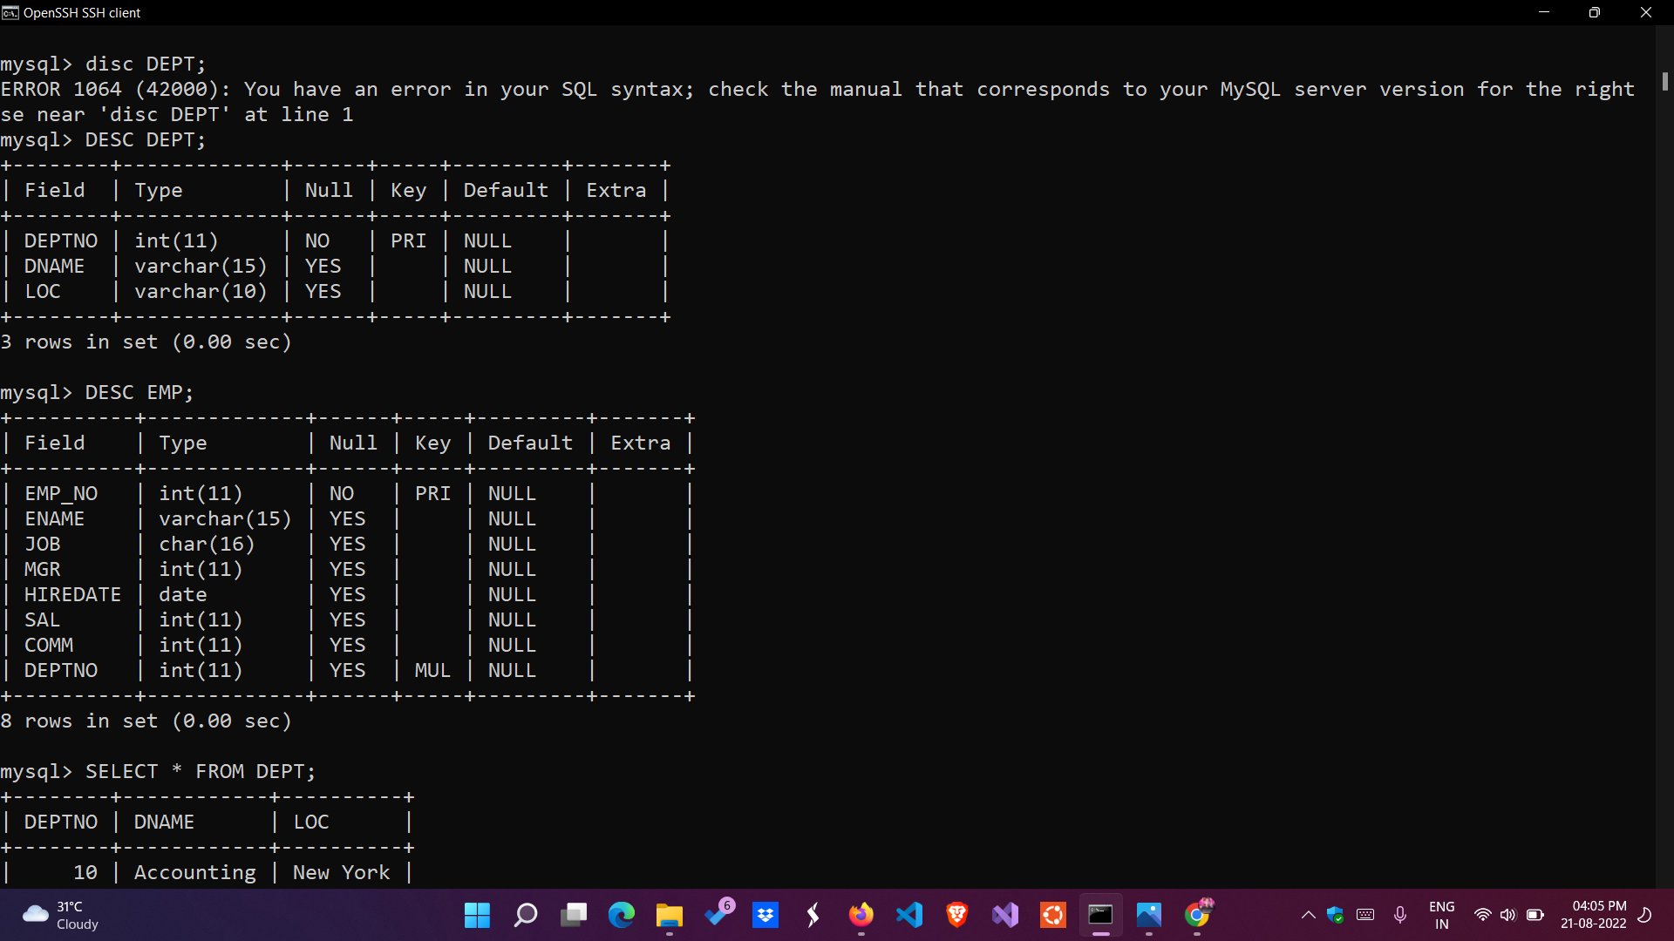

**DEPT table after insertion of values:**

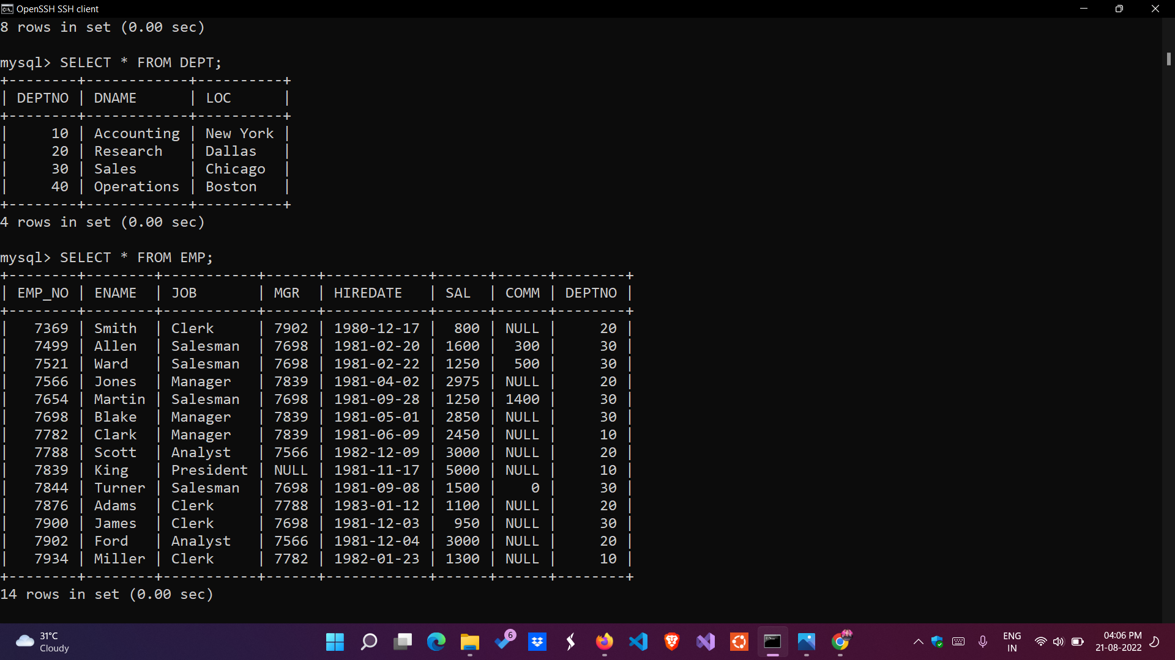

**Creating EMP table :**

**Query:**

create table EMP (

EMP_NO int primary key,

ENAME varchar(15),

JOB char(16),

MGR int references EMP(EMP_NO),

HIREDATE date,

SAL int,

COMM int,

DEPTNO int references DEPT(DEPTNO)

);



**EMP table after insertion of values:**



**B. Queries and their Solutions:**

**a)** List the names of analysts and salesman.

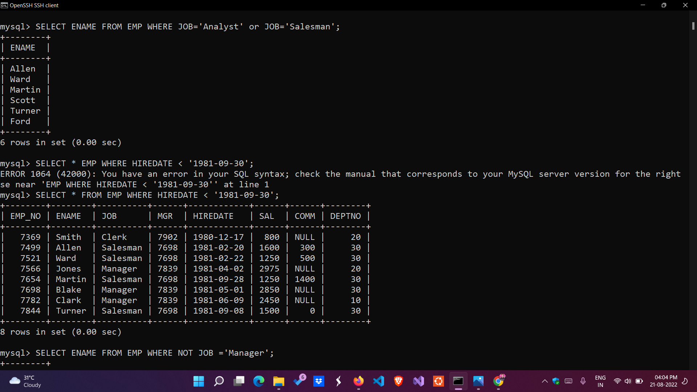

**b)** List details of employees who have joined before 30 Sep 81.



**c)** List names of employees who are not managers.

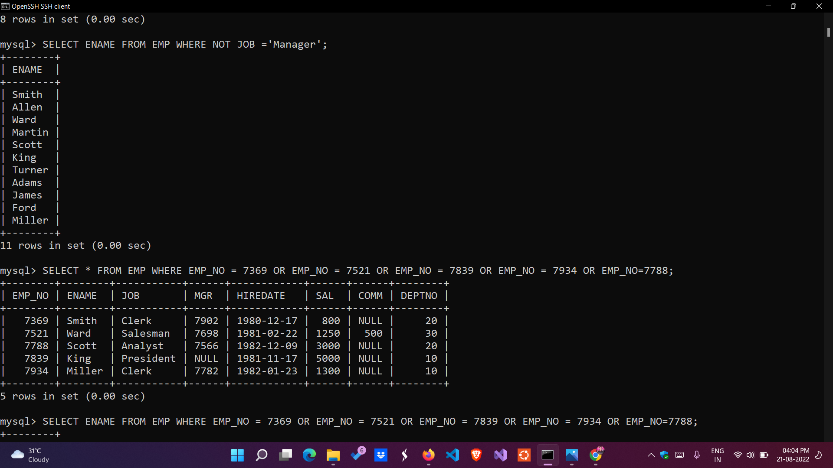

**d)** List the names of employees whose employee numbers are 7369,7521,7839,7934,7788.

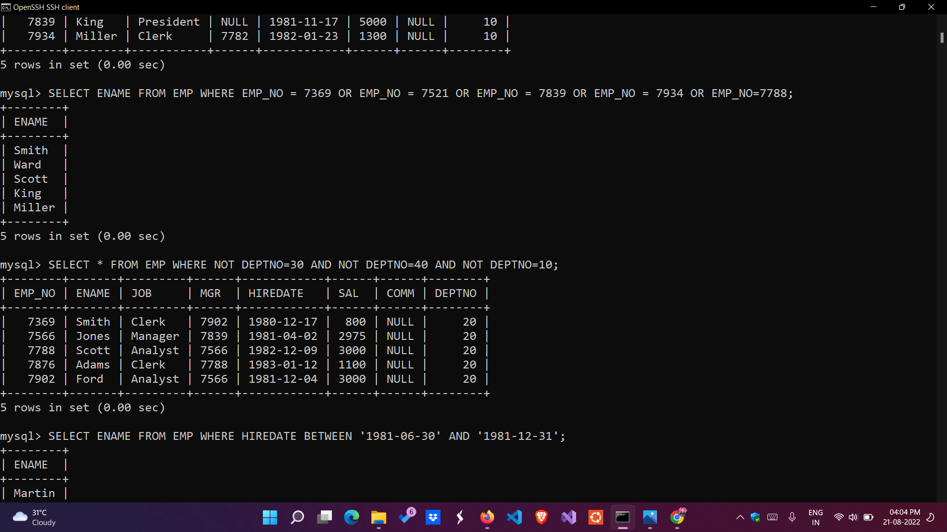

**e)** List employees not belonging to department 30, 40, or 10.



**f)** List employee names for those who have joined between 30 June and 31 Dec. '81.

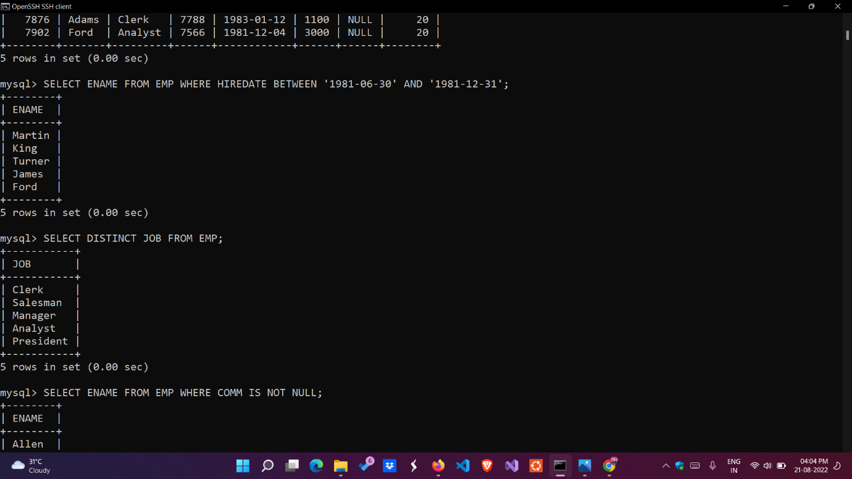

**g)** List the different designations in the company.

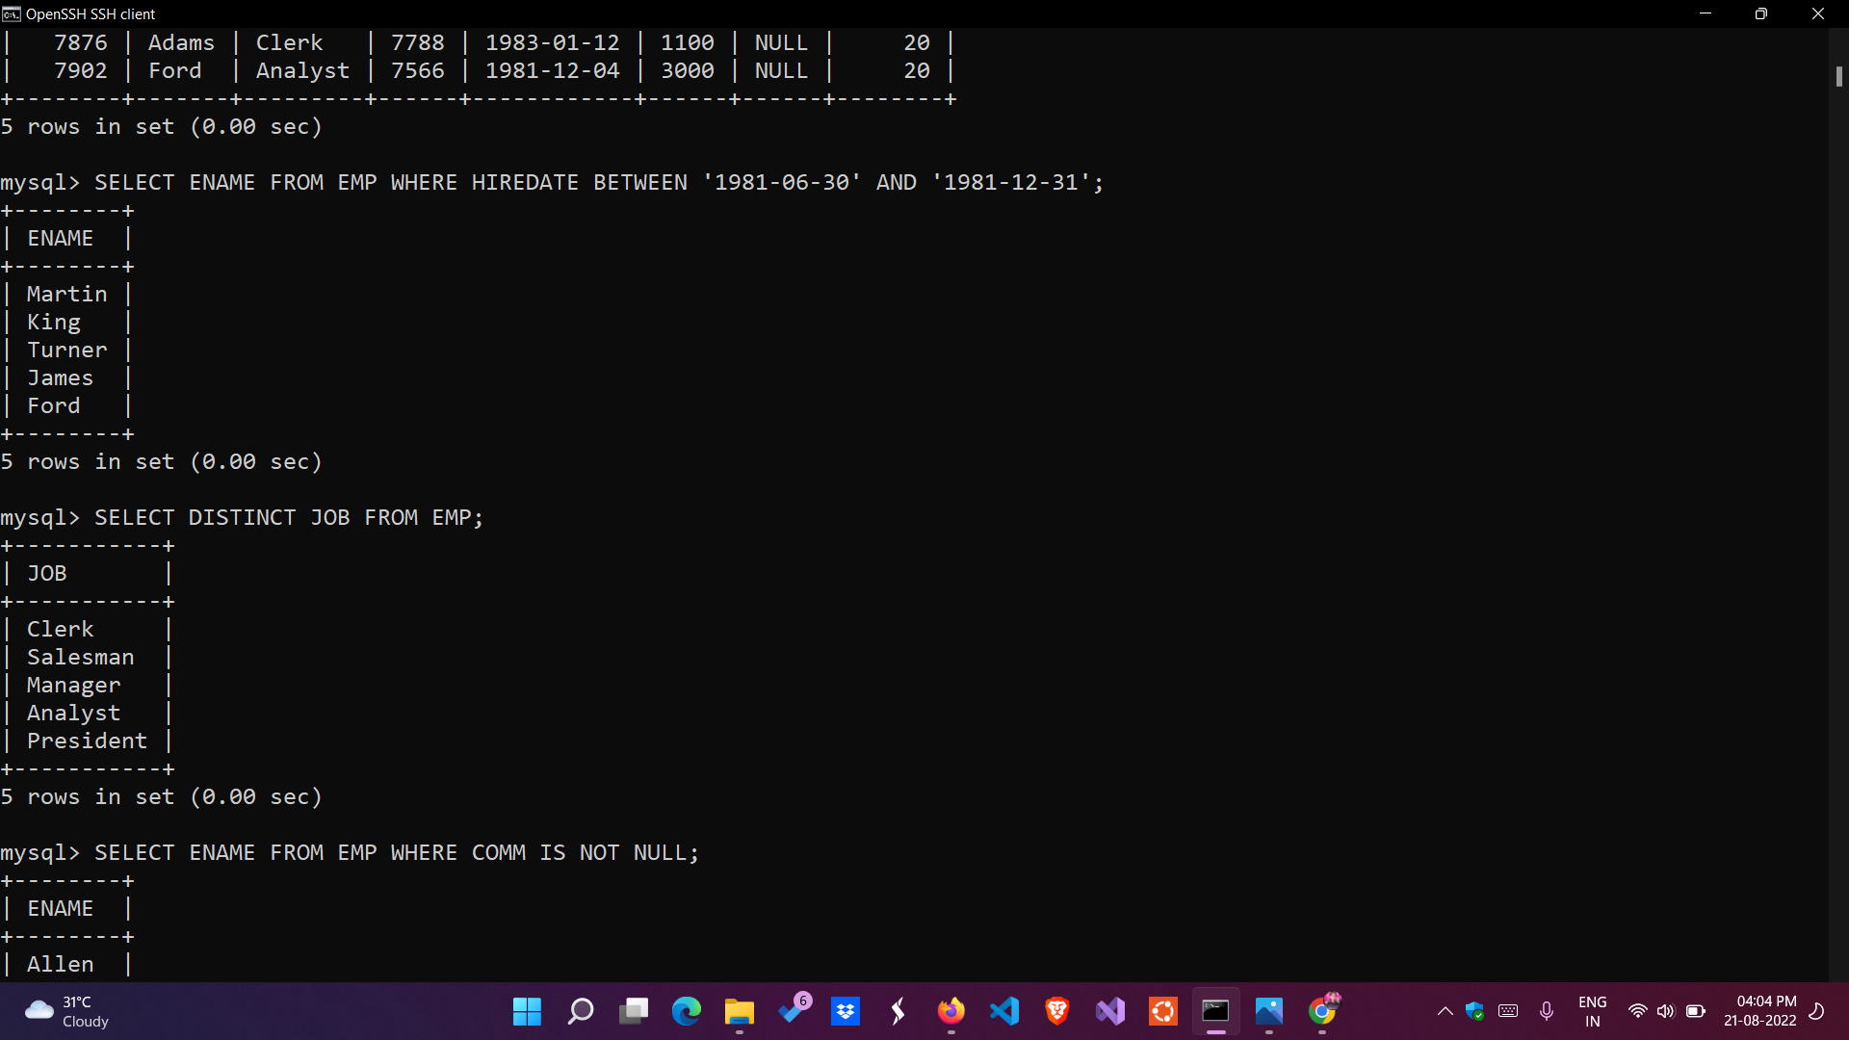

**h)** List the names of employees who are not eligible for commission.

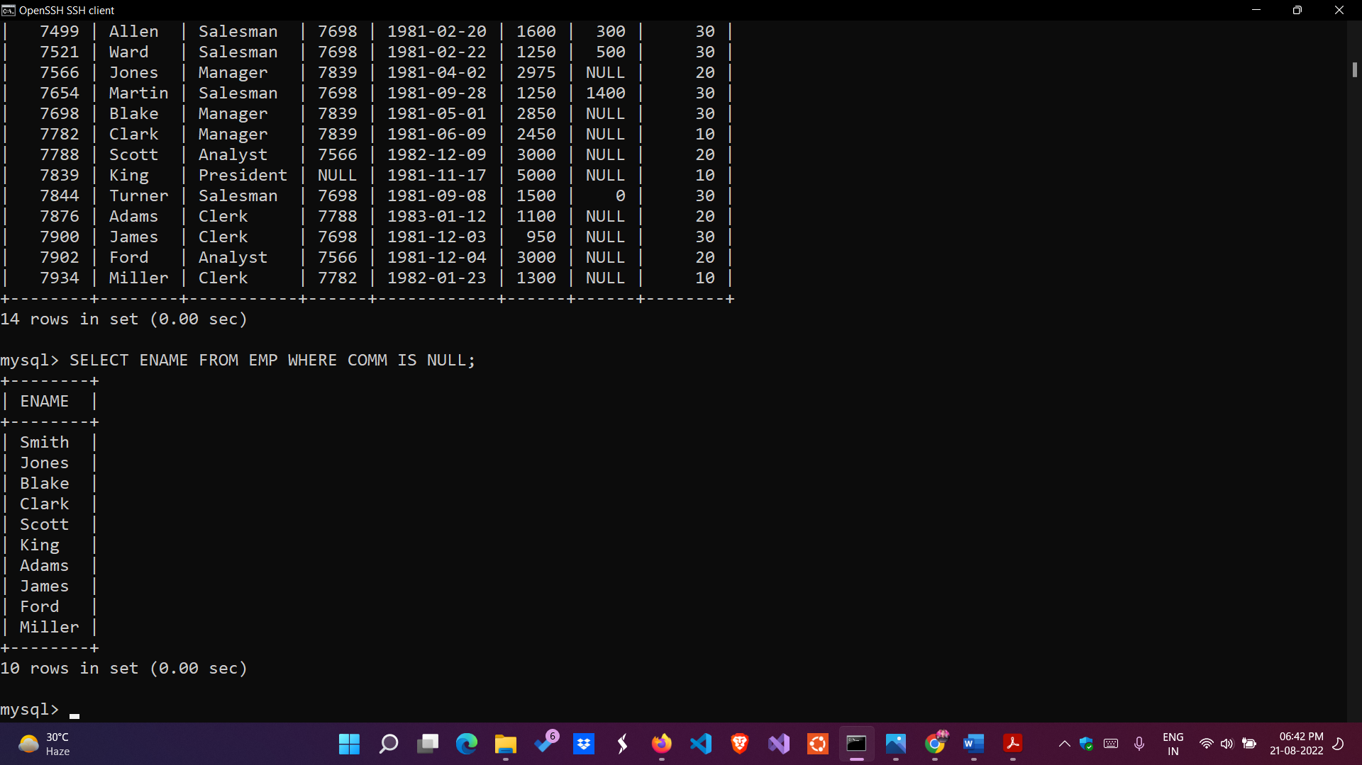

**i)**List the name and designation of the employee who does not report to anybody.

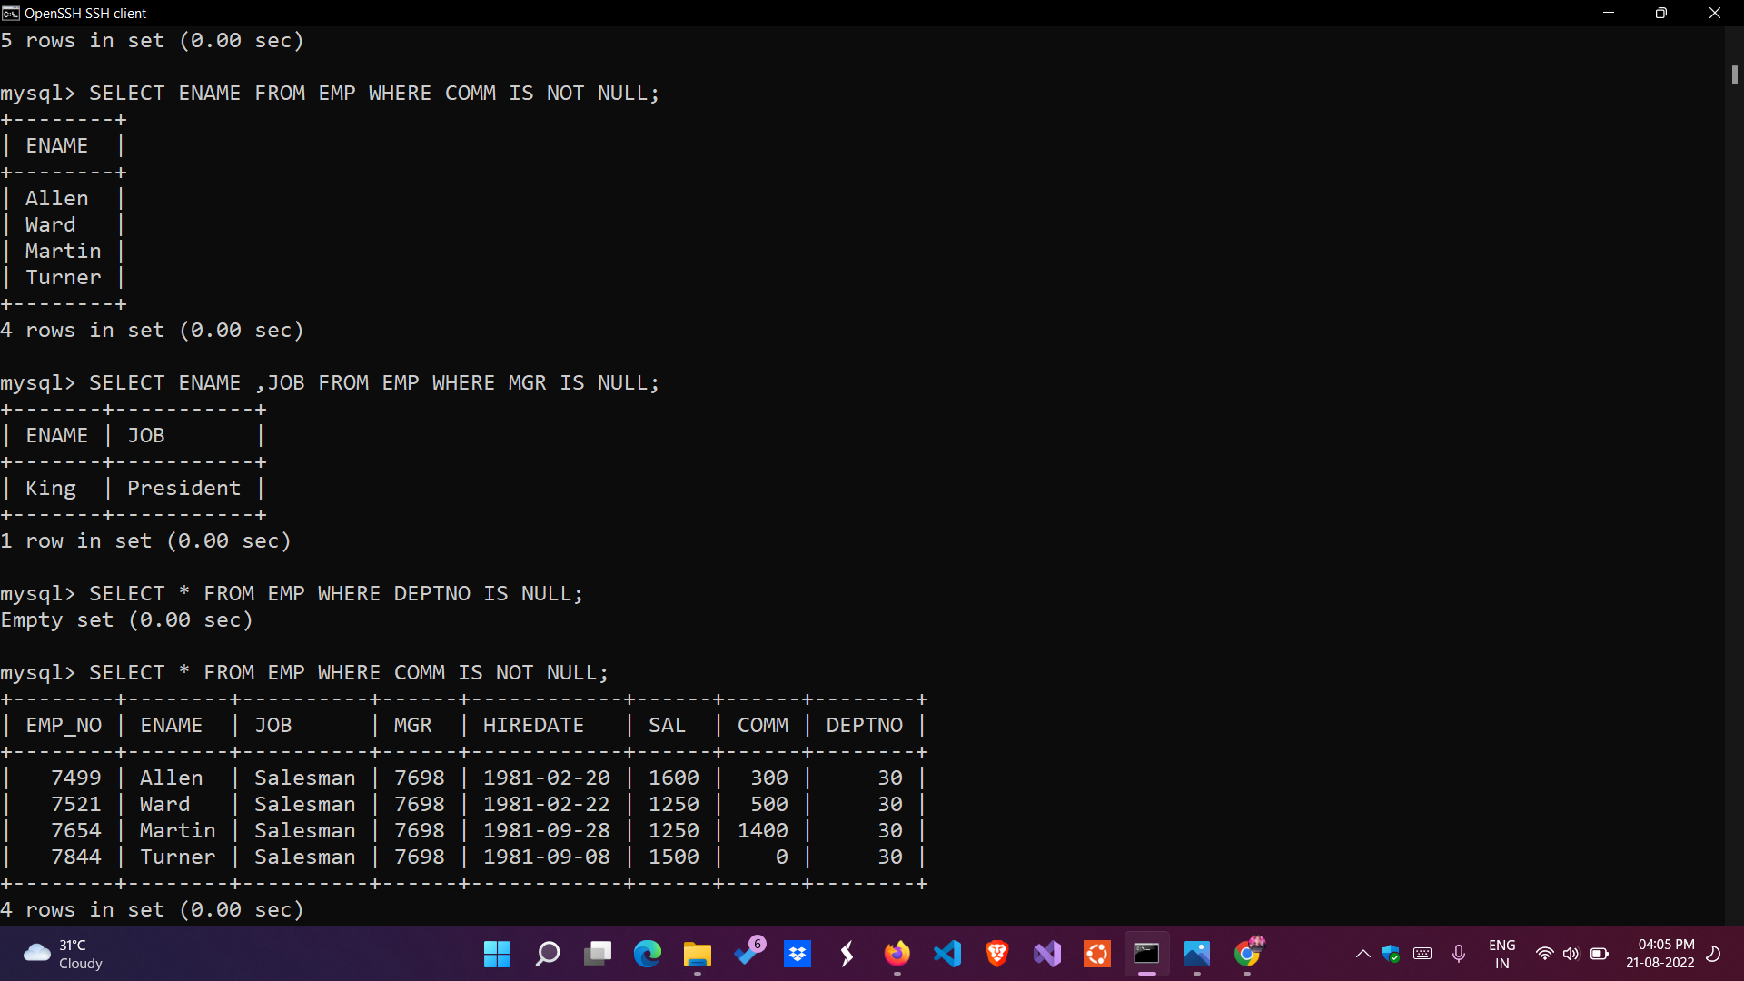

**j)** List the employees not assigned to any department.



**k)** List the employees who are eligible for commission.



**l)** List employees whose names either start or end with "S".

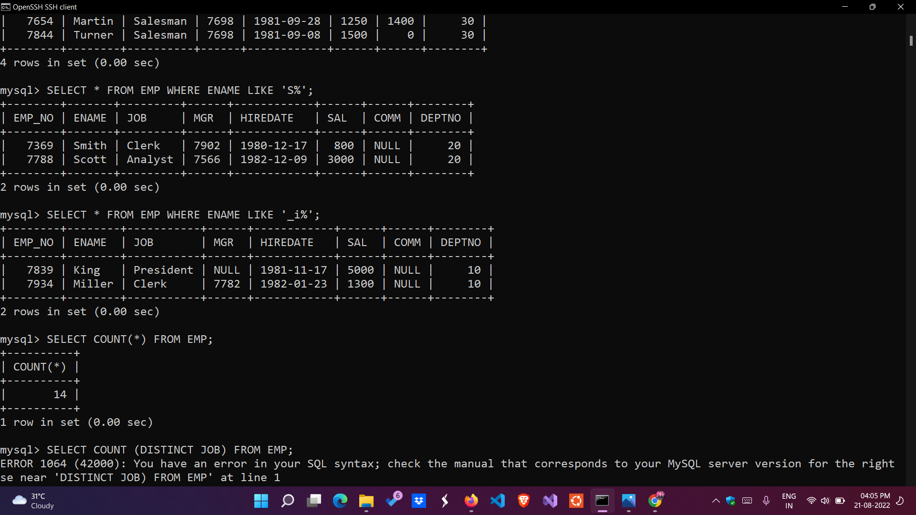

**m)** List names of employees whose names have "i" as the second character.



**n)** List the number of employees working with the company.



**o)** List the number of designations available in the EMP table.

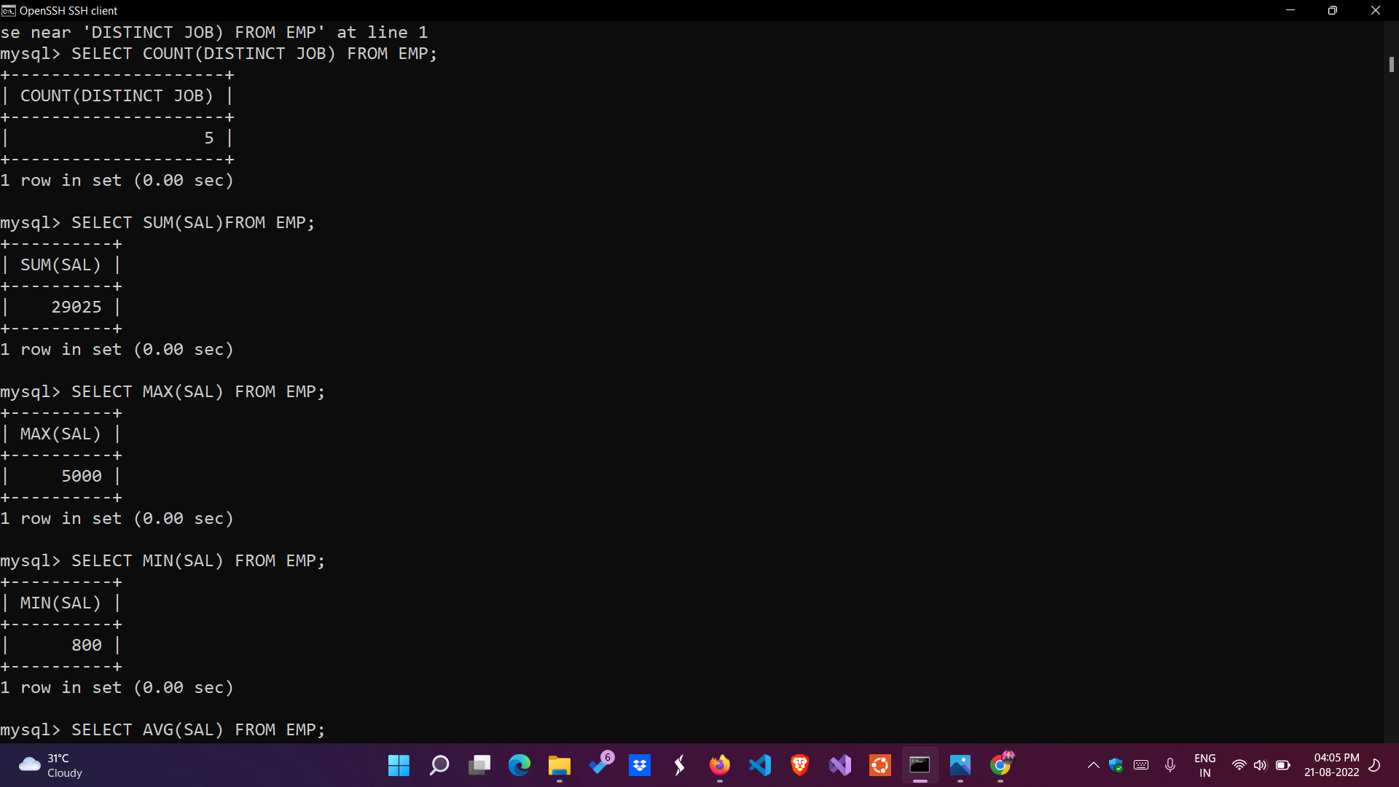

**p)** List the total salaries paid to the employees.

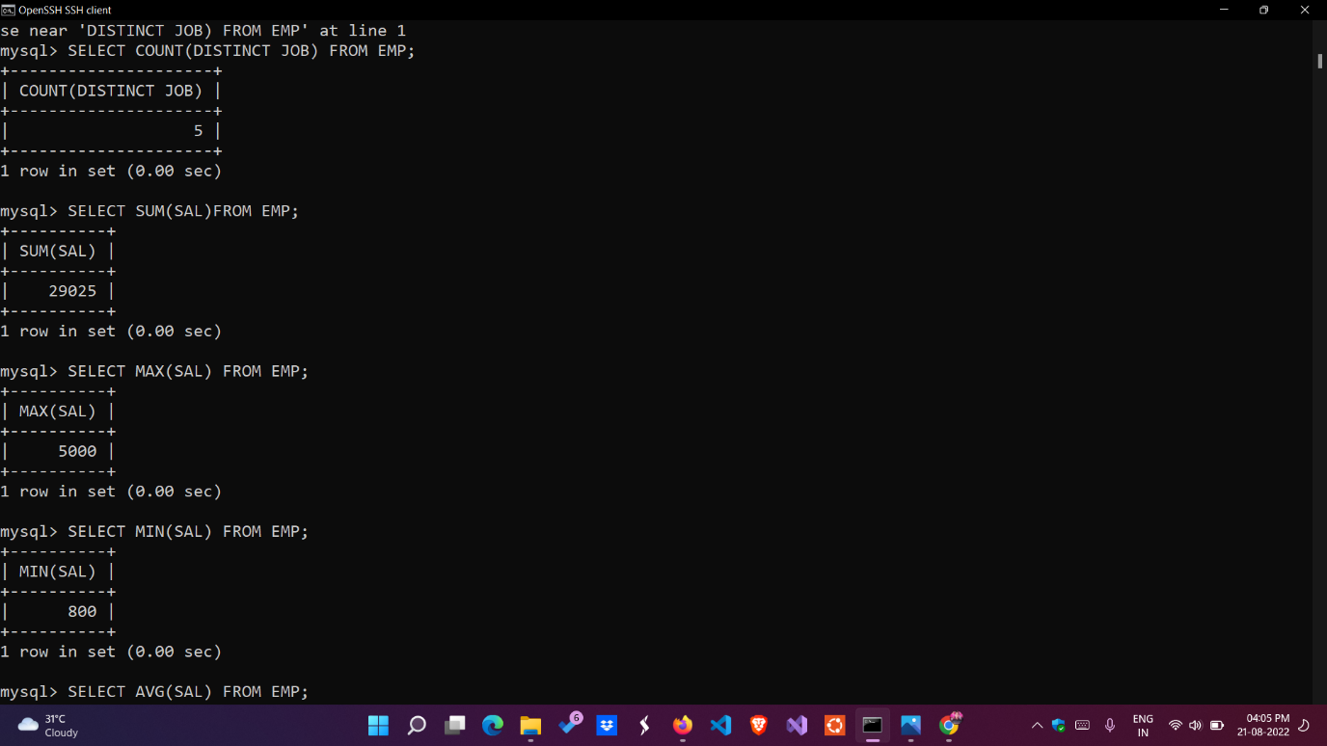

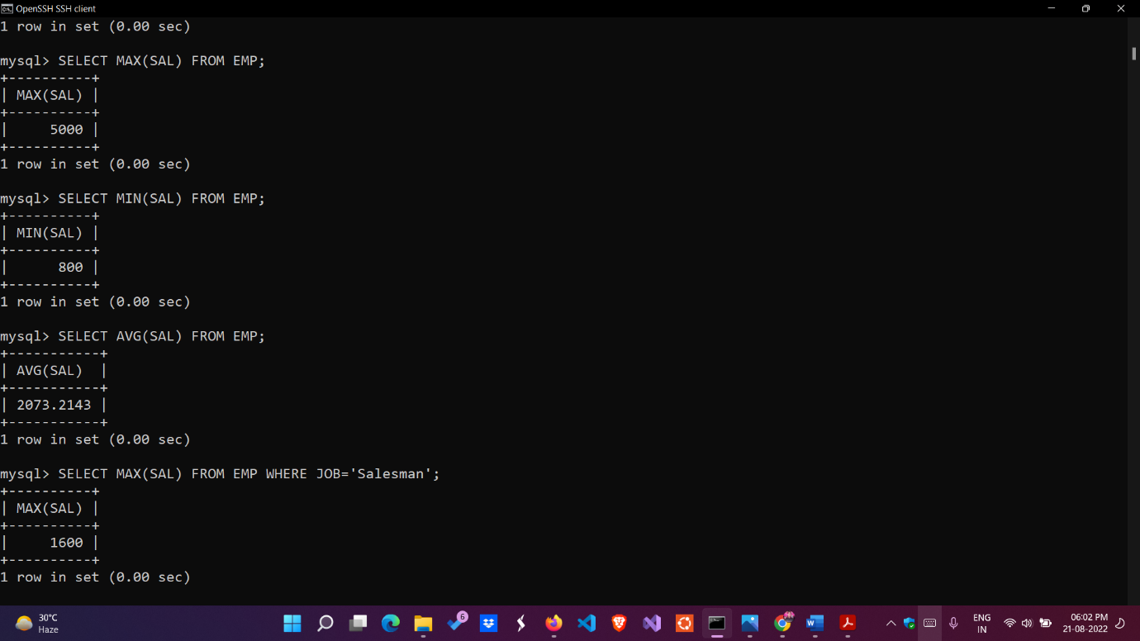**q)** List the maximum, minimum and average salary in the company.

**r)** List the maximum salary paid to a salesman.

