**Name : Gourav Kumar Shaw**

**Enrollment Id. : 2020CSB010**

**Section: Gx**

**Subject : Computer Network lab**

**1. Analyse the packets (across all layers) exchanged with your computer while executing the**

**following commands: (i) ping, (ii) traceroute, (iii) dig, (iv) arp,(v)wget.**

1. 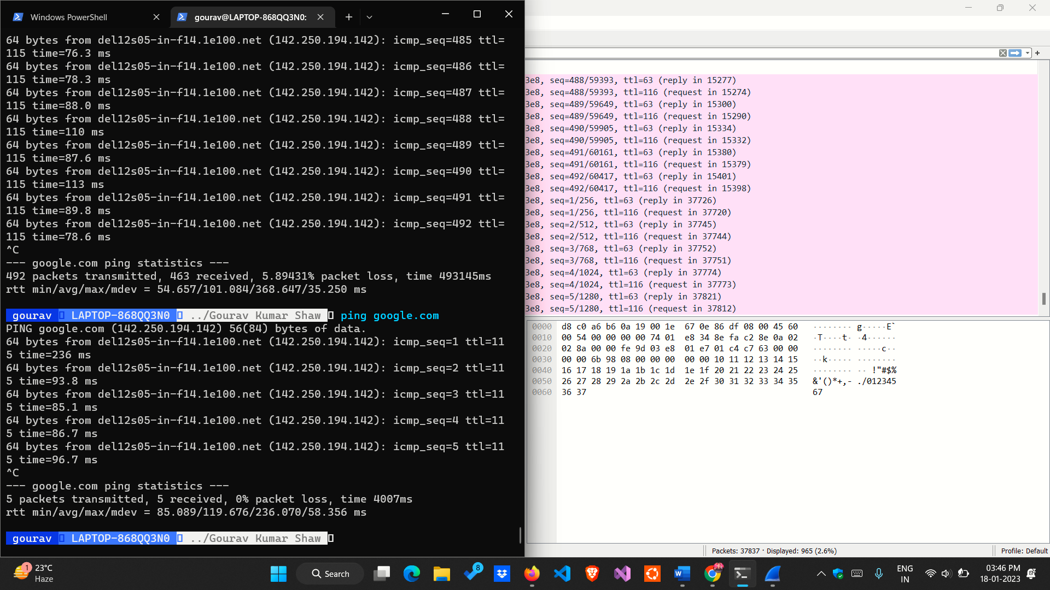Ping

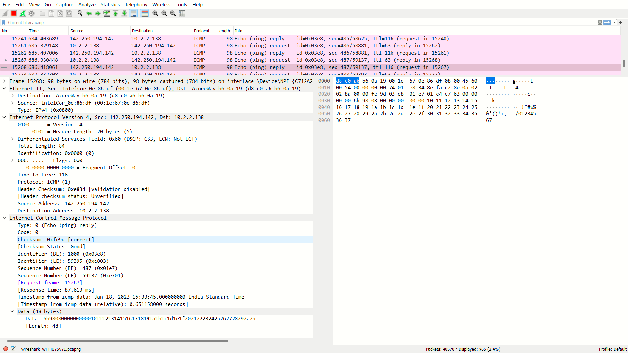

2.traceroute

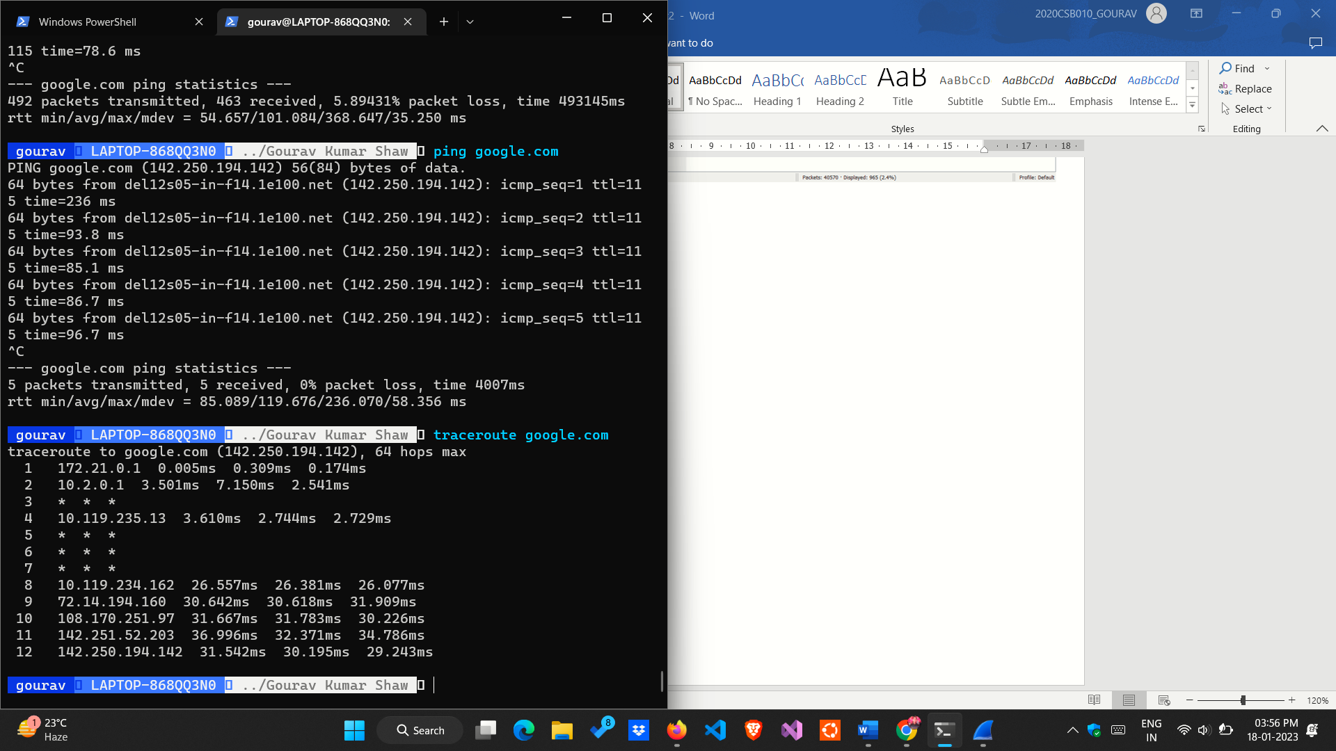

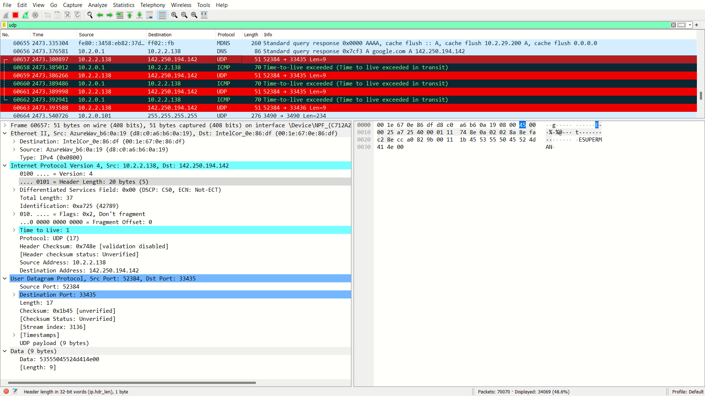

3.dig

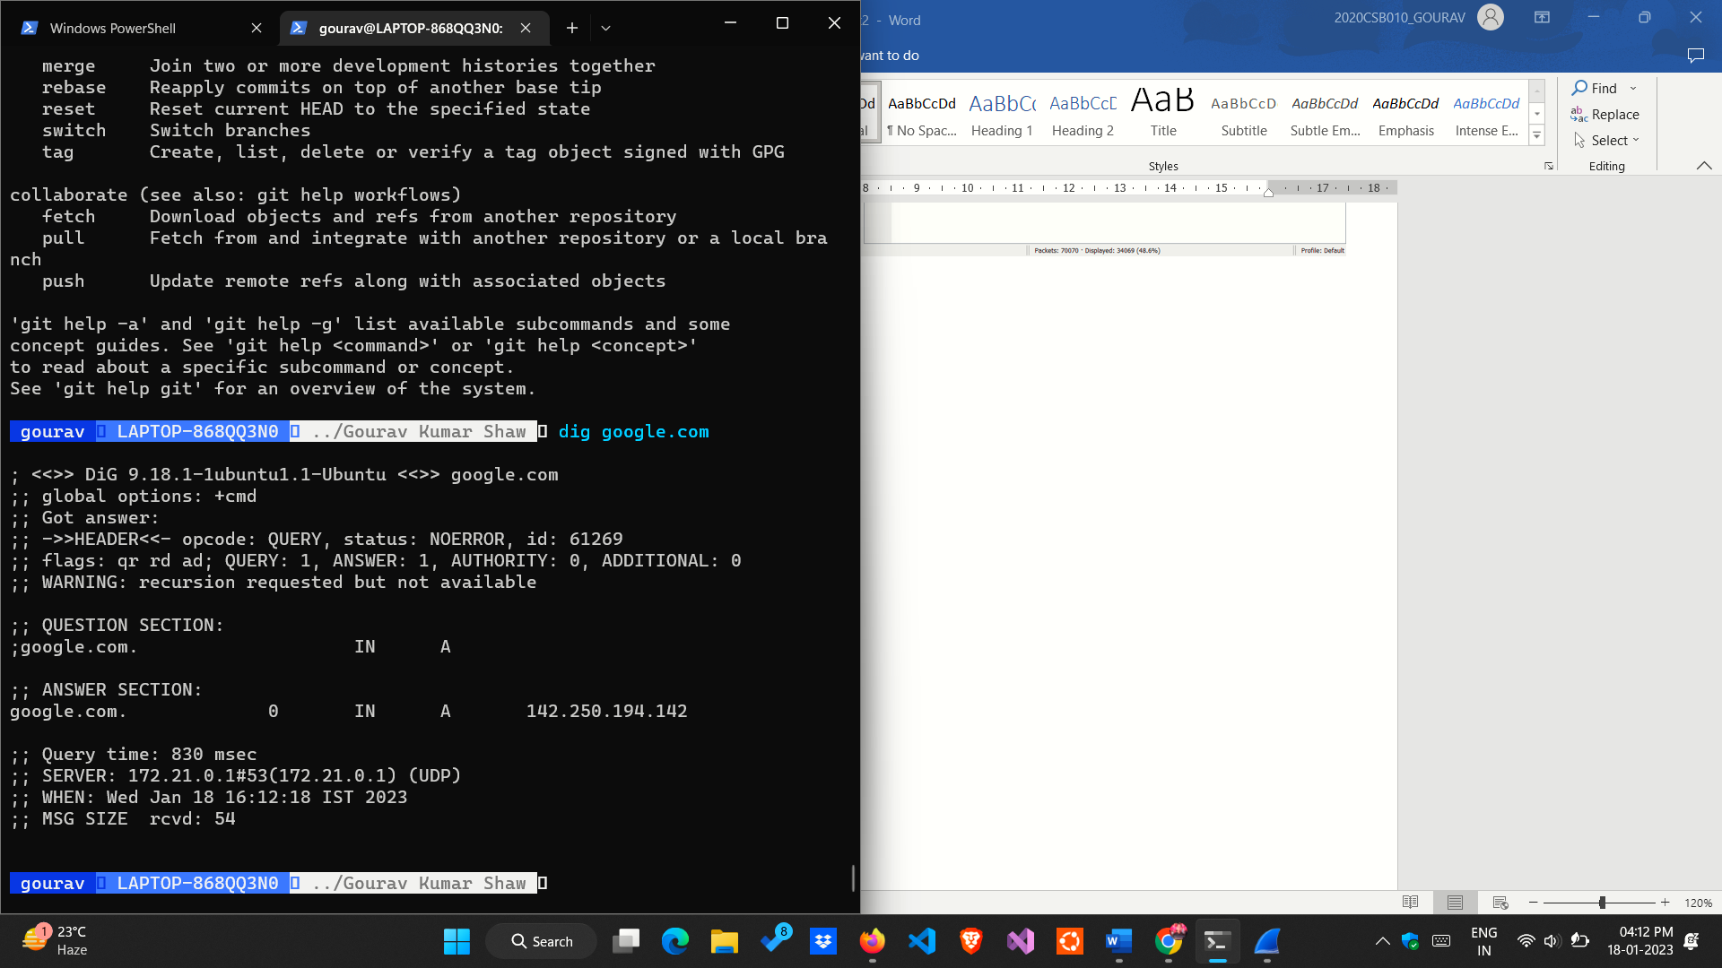

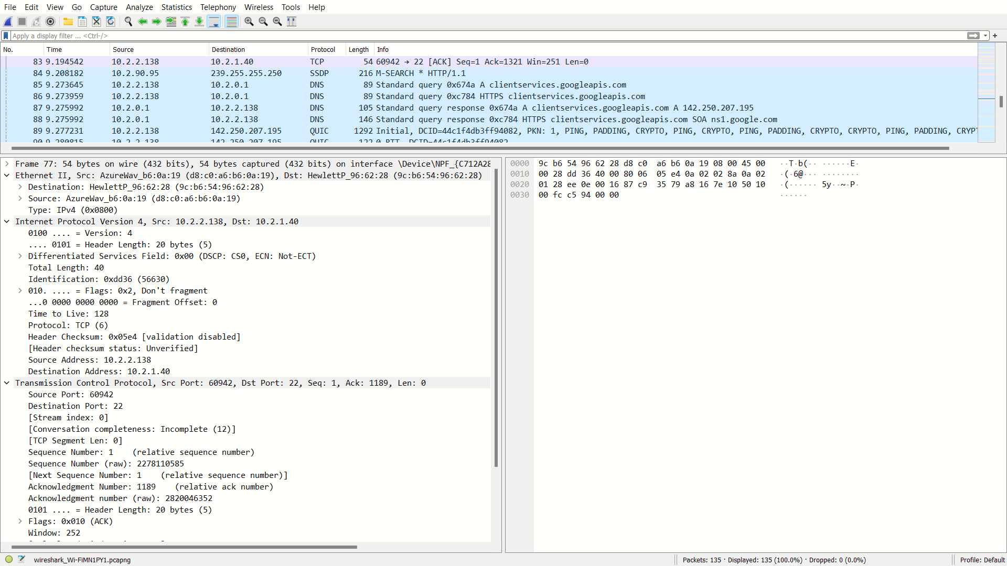

4. arp

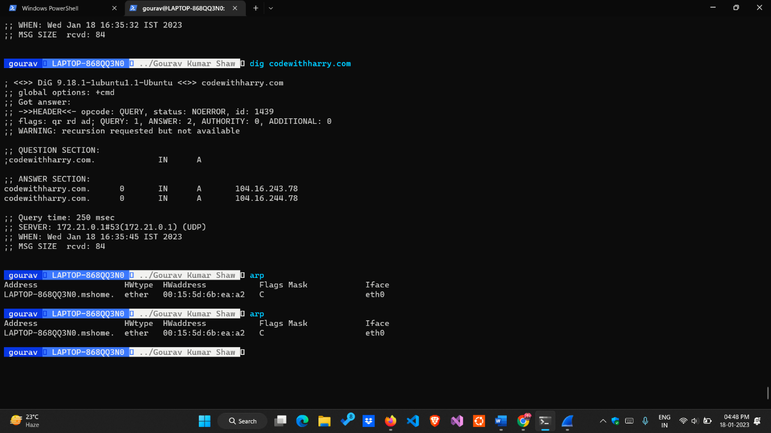

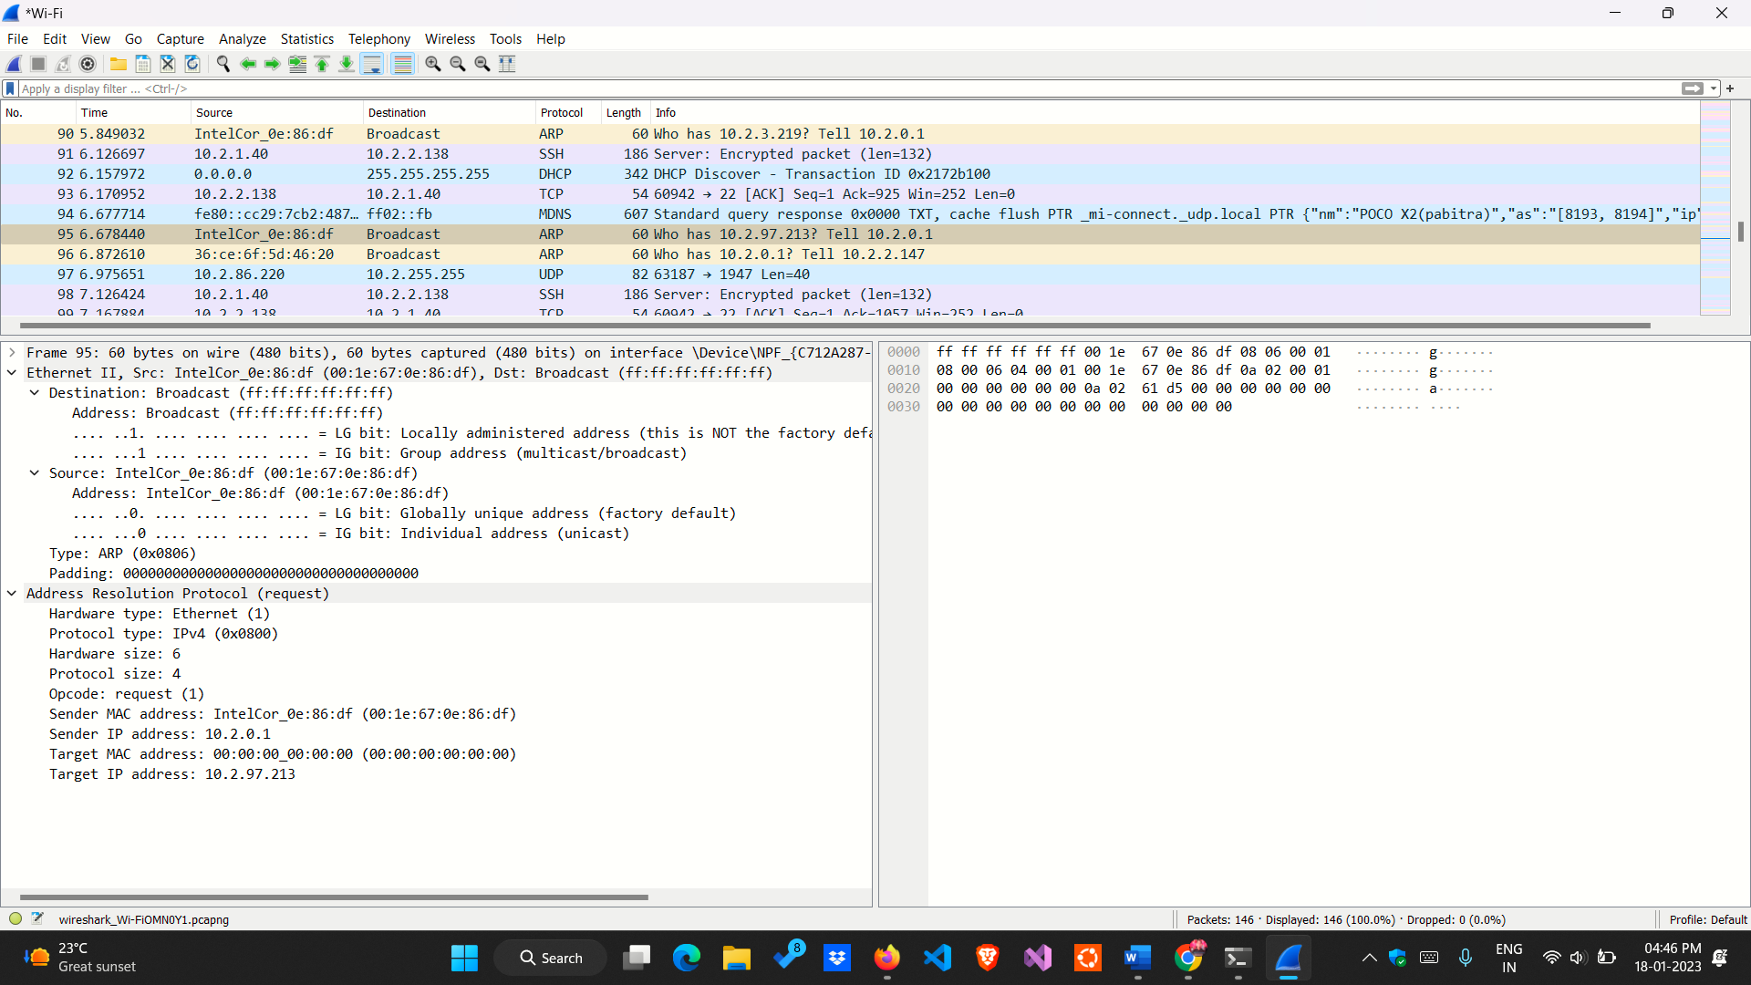

5. wget

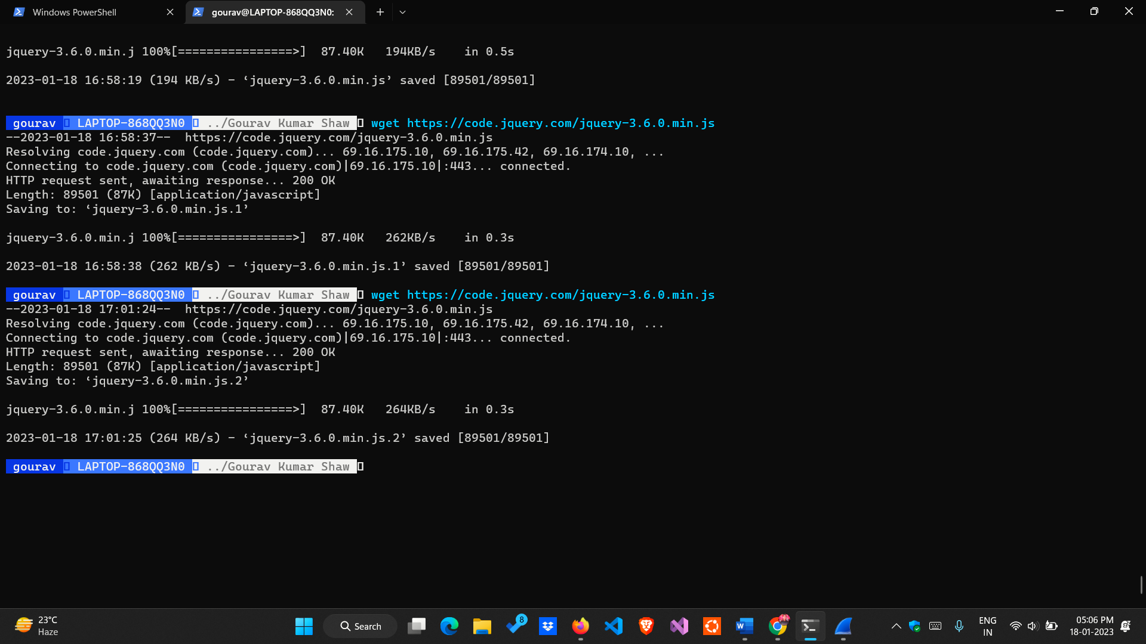

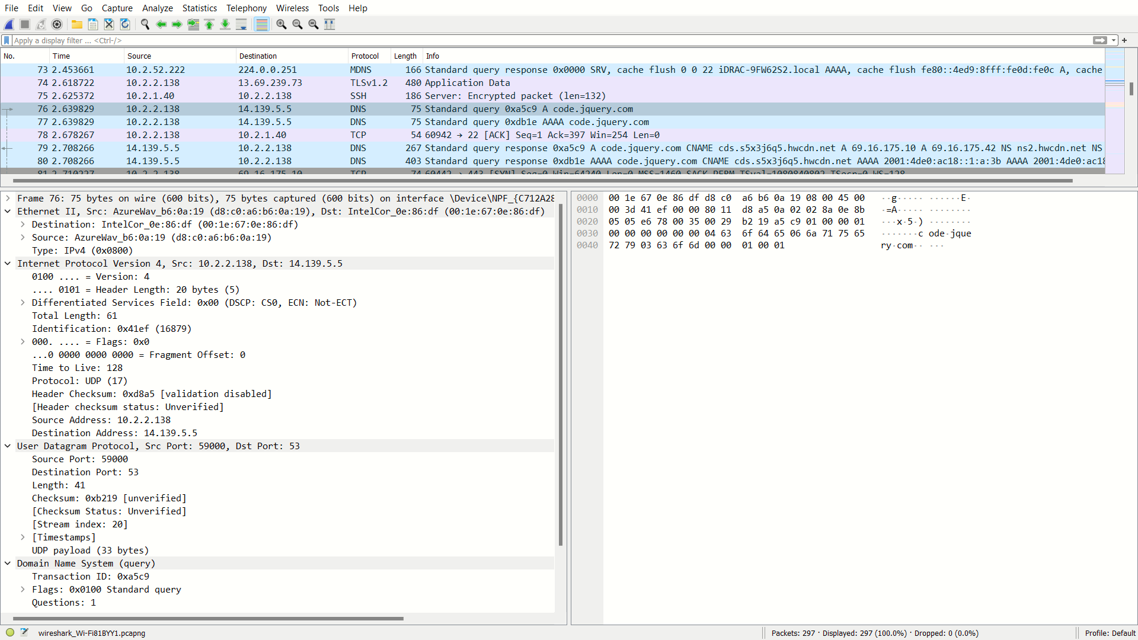

2. Capture the packets while sending/receiving telnet request/response between your

computer and a custom server running the telnet daemon. What is your observation

while analysing the application layer data?

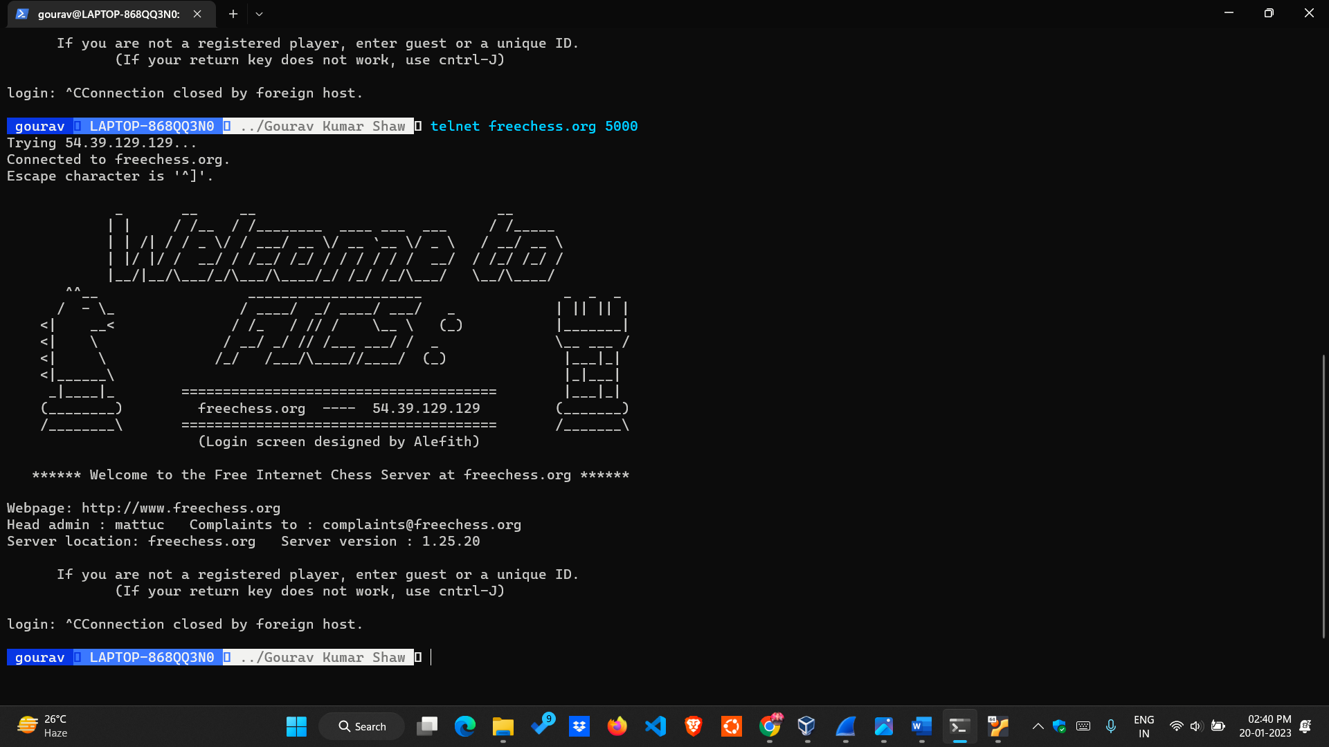

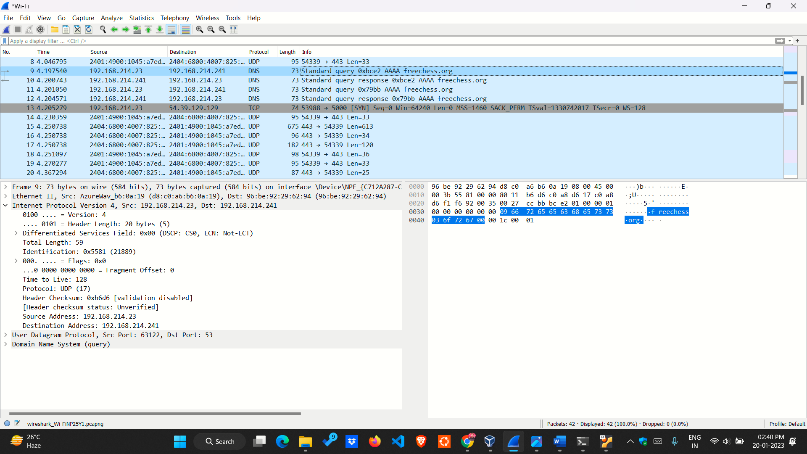

3. Capture the packets while sending/receiving ssh request/response between your

computer and one of the department servers. What is your observation while analysing

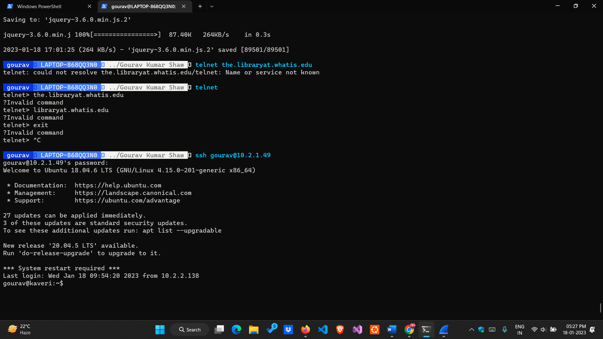the application layer data?

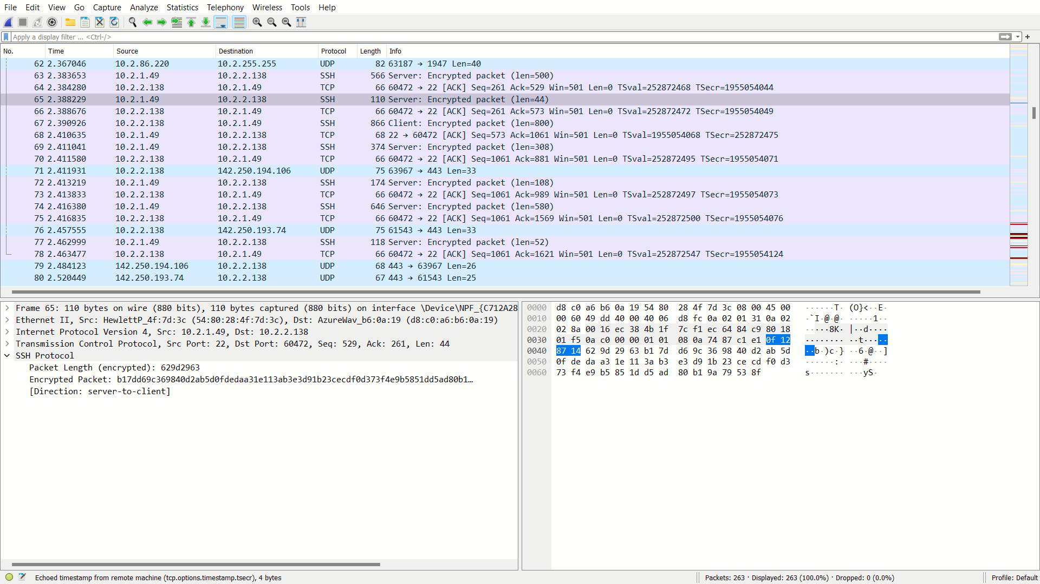

4. Enter the URL: http://gaia.cs.umass.edu/wireshark-labs/INTRO-

wireshark-file1.html and capture packets using Wireshark. After your

browser has displayed the INTRO-wireshark-file1.html page (it is a simple one

line of congratulations), stop Wireshark packet capture.

Answer the following from the captured packets:

a. How long did it take from when the HTTP GET message was sent until the

HTTP OK reply was received?

b. What is the Internet address of the gaia.cs.umass.edu? What is the Internet

address of your computer? Support your answer with an appropriate screenshot

from your computer.

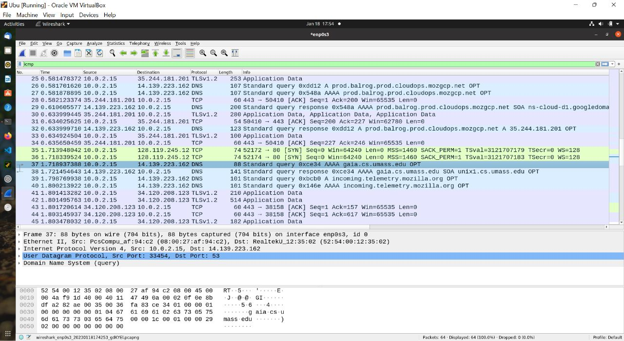

gaia.cs.umass.edu->14.139.223.162

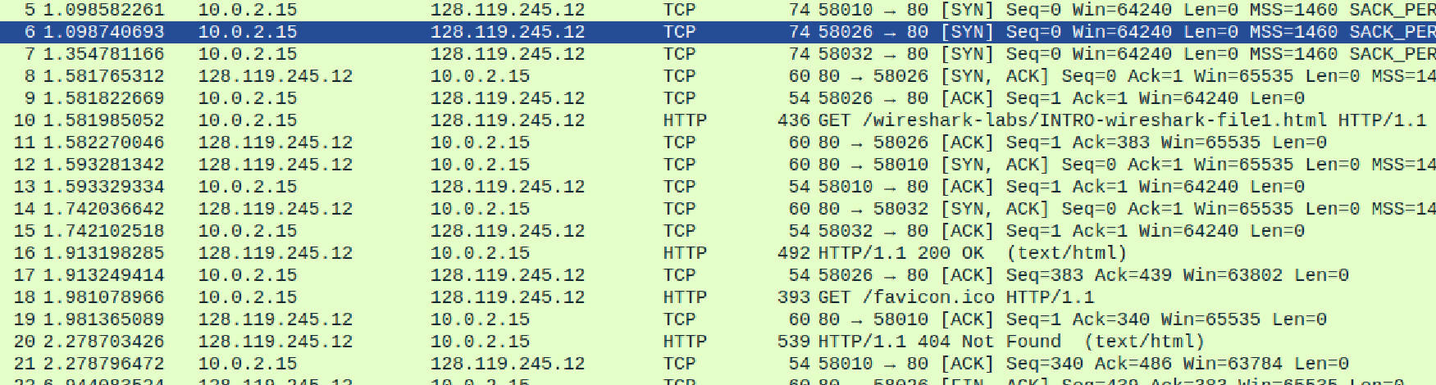

5. Start the Wireshark packet capturing service. Enter the URL:

https://www.gmail.com on your browser and sign-in to your gmail account by

providing credentials (Username/Password).

Answer the following from the captured packets:

a. Is there any difference in the application layer protocol?

b. How it is different from the HTTP data you analysed in the above problem?