**4. Listing variables and examining their values.**

**Code:**

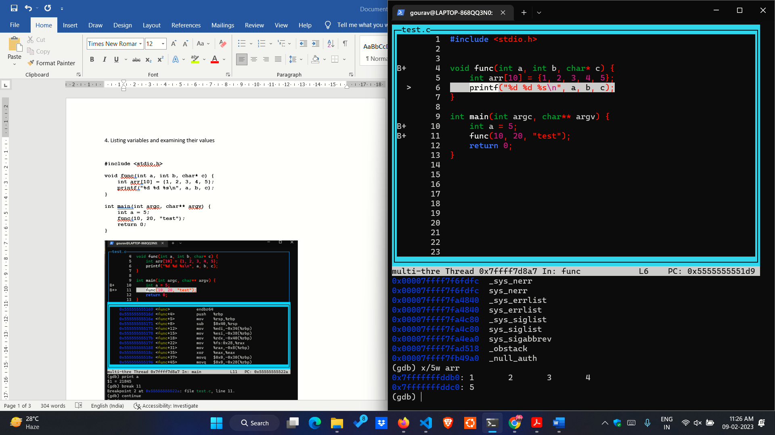

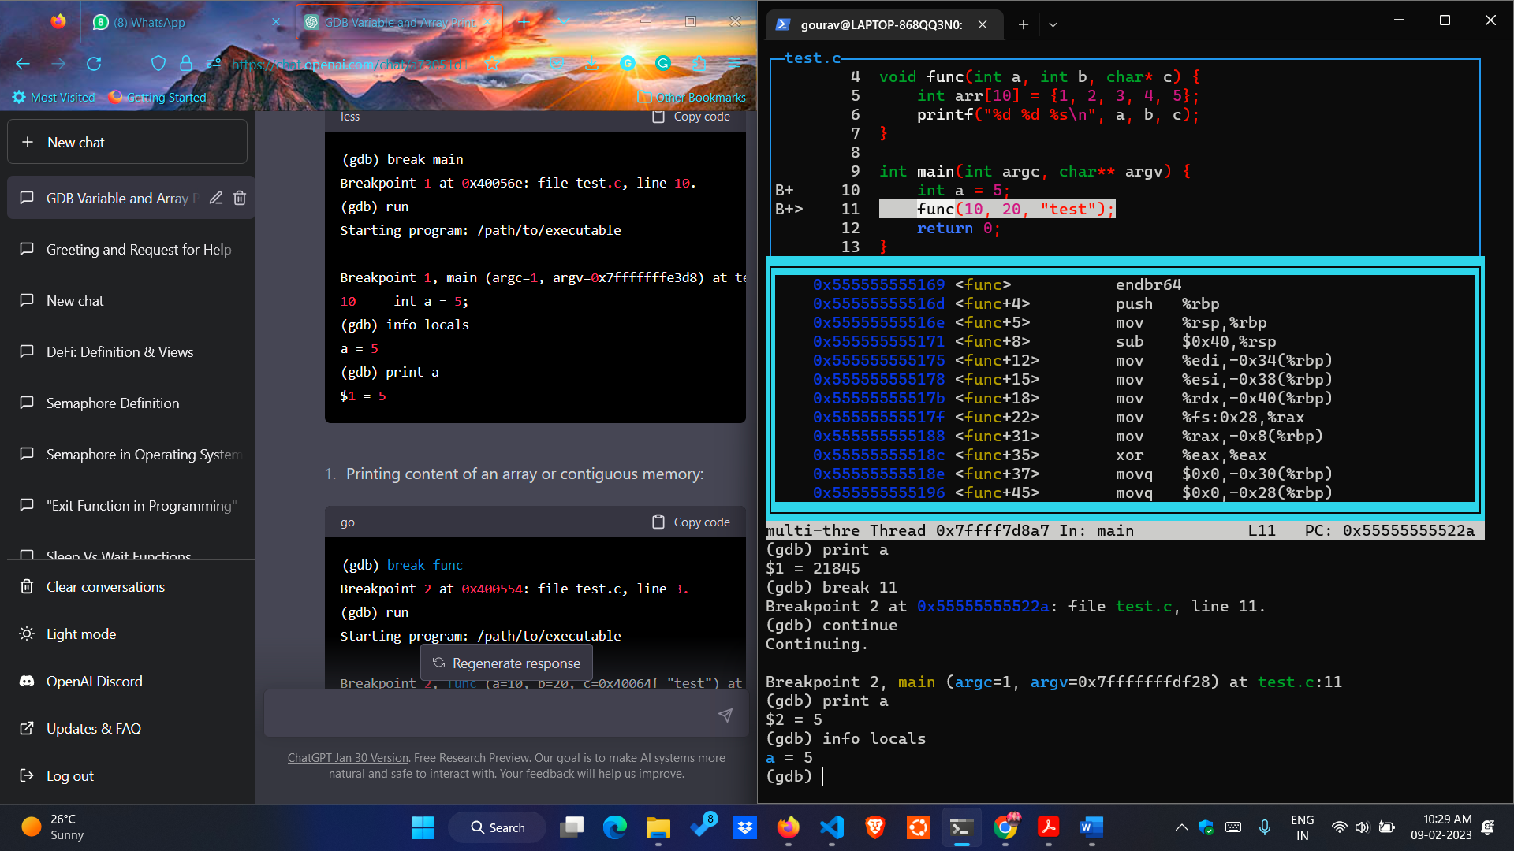

* **info locals**: The **info locals** command is used to display the values of local variables in the current scope. When you are stopped at a breakpoint or when your program is running in the debugger, we can use **info locals** to see the values of all local variables in the current function.
* In this example, **info** **locals** was used to display the value of the local variable a. Here **info locals** gives the output **a=5**.
* **info locals** will only show the values of local variables in the current scope. If we have nested scopes or if we are using function calls, we may need to use the up and down commands to change the current scope and display the values of local variables in other scopes.
* Note that the **info locals** command does not display the information about the function arguments

**5. Printing content of an array or contiguous memory**

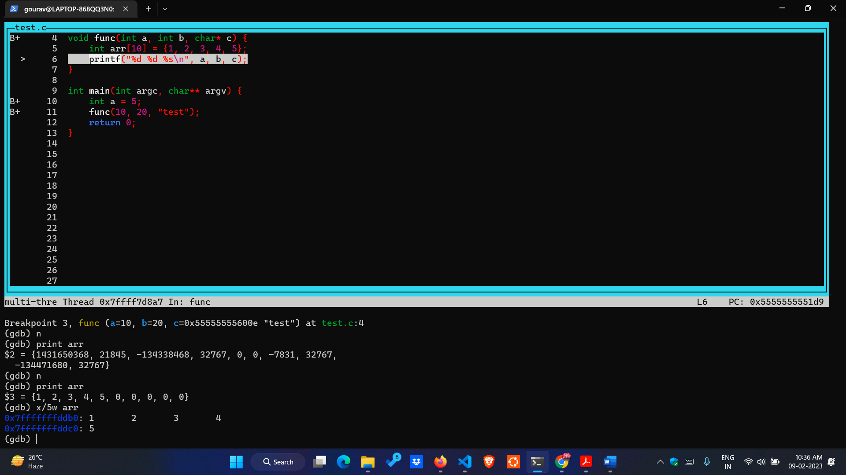

* **x/5w arr**: In GDB, the x command is used to examine memory. The **/5w** in the **x/5w arr** command is a format specifier that tells GDB how to format the output.
* The **/5w** format specifier is used to display 5 memory words in hexadecimal format. A word is typically 4 bytes on most systems, so this command will display the values of 20 bytes of memory.
* The **arr** argument specifies the memory address to start displaying from, which is name of array. In this example, **x/5w arr** was used to display the values of the first 5 elements of the **arr** array. The output shows that the values of the elements are stored in consecutive memory locations, starting from the address :**0x7fffffffddb0.**
* If we gives the command **print arr** then it will gives all the array elements including 0.
* But if we want only particular elements to print then we have to use **x/nw arr** were n is number of element we want to print**.**

**6. Printing function arguments**

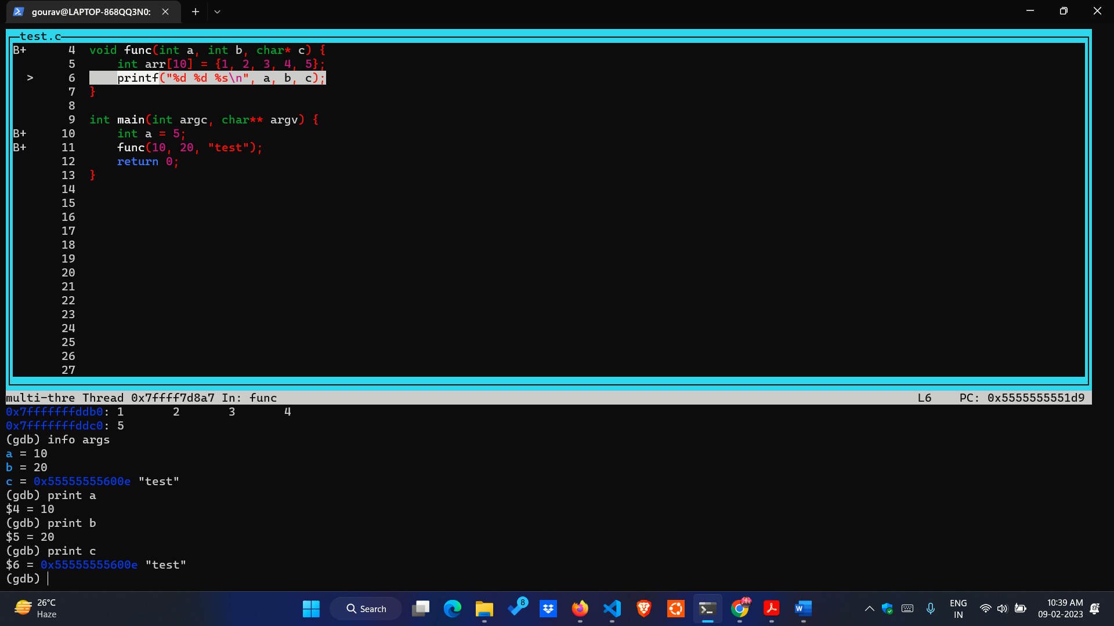

* **info args:** the **info args** command is used to display the arguments of the current function. When we are stopped at a breakpoint or when our program is running in the debugger.
* we can use **info args** to see the values of all arguments passed to the current function.
* **info args** will only show the values of arguments in the current function. If we are calling other functions, we need to set breakpoints in those functions and use **info args** to see the values of arguments passed to those functions.
* Here in our program if we give the command **info args** it gives the values of arguments **a=10, b=20 and c=0x55555555600e “test”.**