2-c)
The worldwide low-code advancement stage market size is extended to develop from USD 13.2 billion out of 2020 to USD 45.5 billion by 2025, at a Compound Annual Growth Rate (CAGR) of 28.1% during this time frame. The expanding need of digitalization and development of agile DevOps practices are expected to enhance the use of low-code development platform market across the globe.

The BFSI(Banking, Financial Services and Insurance) industry requires market services and platform on a large-scale due to the voluminous information produced across these organizations.Organizations have implemented low-code development platform and services to improve the automation in the customer service business functions, as customer service is the core factor responsible for customer acquisition and retention in the BFSI industry. This industry frequently keeps introducing new and improved financial products and
services to enhance its business operations, which makes it attractive for the low-code development platform providers to offer advanced solutions to the industry.

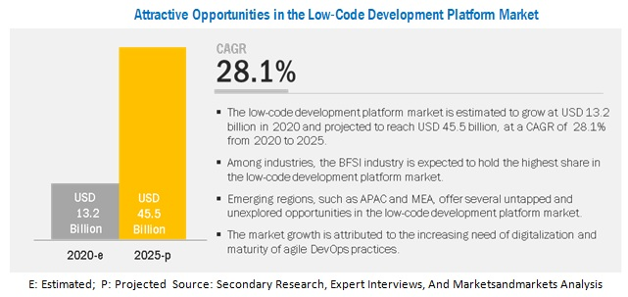

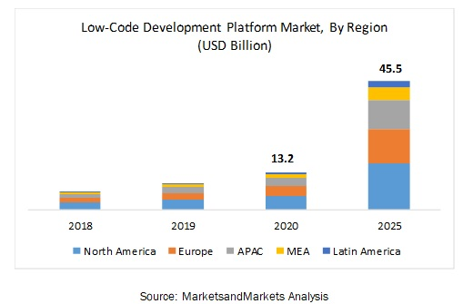
Web application is considered as a face of an organization and by using the low-code development platform organizations can roll out user-defined web-based applications quickly. Instead of writing the programming language for the development of web-based applications, employees with less development experience can also create sophisticated applications. For those who has relevant experience, this platform can ease out the daily work chores and can even help them create more custom web-based applications by integrating already existing digital ecosystems.

Some Recent developments include-
In March 2020, Deloitte and Appian announced a strategic alliance to help modernize mission systems for its clients within commercial, federal civilian, defense, and state and local government agencies.
In March 2020, Appian launched the latest version of the Appian Low-code Automation Platform. The new version delivers material business impact with unified, flexible, and fast enterprise automation.
In February 2020, Salesforce acquired Evergage, a cloud-based personalization and customer data platform.
In February 2020, Microsoft PowerApps announced the public preview for two core canvas apps, which are canvas components and PowerApps component framework.
In January 2020, Appian partnered with Celonis to accelerate digital business process transformation.

5)

NCDPs are applied to fulfill the necessities of organizations that need to automate or digitize measures with cloud-based versatile applications. No-code applications are every now and again made remembering the prerequisites of big business clients, not the same as standard IT and engineer groups.

However, those stages are not uniform by the way they are promoted, but instead vary in their usefulness, mixes, and business use cases. Explicit applications, for example, business mechanization seamlessly coordinate ERP workflows.

This turn in focus is intended to further the advancement of the software development cycle where getting IT teams to work on building business apps may take up excessive resources, funds and time, all of which may be hard to come by in comparison to market demands.

The shift from conventional business software to a lean no-code development methodology may also impact IT leaders and tech departments. According to analysts, the usage of no-code tools may put IT in a more governance-centric and supervisory role rather than dynamic software programming and debugging.
The potential benefits of utilising an NCDP tool is that with web access and practical business intelligence one can become an application developer, which is transformational for enterprise productivity.
On the other hand, IT folks have pointed out that business users inept at debugging code may create further challenges for tech teams, given the sensitivity around cybersecurity and business theft events caused by software bugs. Nevertheless, NCDPs have been anticipated as the next wave in programming and techniques for rapid app development, which could be revolutionary for the software world.
According to analysts, the rise of no-code platforms is similar to the time before the coming of computer operating systems, which impacted personal computing with the help of GUIs. Prior to the current operating systems, computers could only be accessed by technologists and people versed with languages such as DOS.
6)
Today, effective IT requires smart enterprise system management, which increasingly means building a custom-made digital ecosystem. As organizations continue investing in digital transformation technologies, they must consider what apps and platforms will fulfill their specific needs at the lowest cost, with least internal IT resources, and with minimal disruption.
Enterprise applications managers, IT team leads, CIOs, CTOs, and department heads will raise their IT infrastructure to a higher level by adopting platforms that offer low-code and no-code application development.
Low-code/no-code technology enables organizations to overcome the usual obstacles in acquiring enterprise applications and satisfying unique needs. Departments throughout the organization have the potential to develop, test, and use apps without relying on IT.
After alleviating some of this demand, organizations can benefit from greater bandwidth for custom applications, lower costs, faster deployment, and easier transitions from legacy systems to modern applications.
Some companies have already begun to understand the value of low-code technology, but haven’t realized how the addition of no-code tools for business users can heighten those benefits even more. With both, developers can focus on high-value work, while business users enjoy the independence of building and improving apps to serve their own needs.

