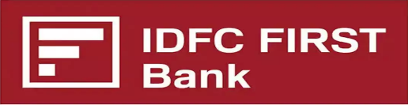

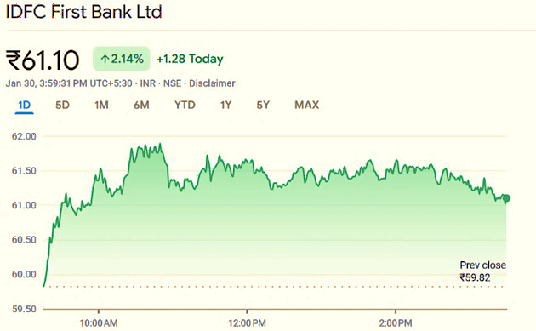
Company Profile
IDFC FIRST Bank, formed in 2018 through the merger of IDFC Bank and Capital First, Headquartered in Mumbai is a retail-focused bank offering a wide range of financial services in India. It emphasizes digital banking, customer-centric solutions, and robust retail expansion. The bank holds strong credit ratings, with ICRA assigning [ICRA]AA+ (Stable), CRISIL rating it AA+/Stable, and CARE Ratings reaffirming CARE AA+; Stable, reflecting its solid financial position, capital adequacy, and growing retail portfolio.

Areas Of Business
Market cap | ₹43,806Cr
P/E | 22.75
Earnings per share | 2.63
Industry P/E | 12.31
Book Value | 51.59
Price to Book | 1.16

IDFC FIRST Bank operates in multiple financial sectors, catering to individuals, businesses, and institutions. Its key areas of business include:
- Retail Banking – Offers savings and current accounts, personal loans, home loans, vehicle loans, and credit cards.

- Corporate Banking – Provides working capital loans, term loans, trade finance, and treasury solutions for large businesses.
Management Overview
Mr. V. Vaidyanathan – Managing Director & CEO
An experienced banking professional, Vaidyanathan has played a key role in transforming IDFC Bank post-merger into IDFC FIRST Bank, focusing on retail banking and digital innovations.

Mr. Sudhir Agarwal – Chief Financial Officer
Oversees the bank's financial operations, including financial reporting, treasury, and capital management.

Mr. Sandeep Batra – Chief Operating Officer
Responsible for streamlining the bank's operations, focusing on efficiency and customer satisfaction.

Mr. Arun Agarwal – Chief Risk Officer
Manages risk strategies and ensures the bank maintains a strong risk management framework.

Mr. Ashish Agarwal – Head of Corporate Banking
Leads corporate banking initiatives, including financing solutions for large businesses and institutional clients.

Mr. R. Mahesh – Head of Retail Banking
Focuses on the retail banking segment, enhancing the customer experience and driving the bank's retail portfolio growth.

- SME & MSME Banking – Supports small and medium enterprises with business loans, overdraft facilities, and digital banking solutions.

- Wholesale Banking – Engages in infrastructure financing, project loans, structured finance, and institutional banking.

- Wealth Management & Private Banking – Offers investment advisory, portfolio management, and high-net-worth (HNW) customer services.

- Digital Banking & FinTech Solutions – Focuses on online banking, UPI, mobile apps, and fintech collaborations to enhance digital payments.

- Rural & Inclusive Banking – Provides microfinance, Agri-loans, and financial inclusion programs for rural customers.

Key Offerings of IDFC FIRST Bank
- Retail Banking
- Corporate & Business Banking
- SME & MSME Banking
- Wealth Management & Investment Services
- Digital & FinTech Solutions
- Rural & Inclusive Banking

Economic Outlook

Asset Quality: Expectation of low NPA ratios and stable asset quality due to prudent risk management strategies.

Sustainable Finance Focus: Increased emphasis on green bonds and ESG investments, in line with broader global trends toward sustainable finance.

MSME Market Share Expansion: Continued growth in the MSME segment, with tailored financing solutions helping to capture a larger market share.

Double-digit growth: Targeted double-digit growth in retail loans and deposits over the next 3-5 years, supported by digital banking initiatives.

Digital User Expansion: Increasing adoption of mobile banking and digital payments, contributing to stronger engagement with customers.
Global growth remains stable at 3.2%-3.3% for 2024-2025, with inflation and interest rates declining, including a 0.5% US Fed rate cut. India’s economy is projected to grow at 7%-7.2% in FY 2025, with Q1 GDP growth at 6.7%, driven by 7.4% private consumption growth and 7.5% investment growth, despite reduced government capital expenditure. Inflation has eased to 3.65%, while the fiscal deficit significantly declined from ₹6.1 lakh crore to ₹2.8 lakh crore. Financial markets are thriving, with record-high stock markets, doubled mutual fund SIP contributions, and 15% bank credit growth.

Outlook of the Banking and Finance sector in India
The banking and finance sector in India is set for robust growth, with digital adoption driving over 80% of Indian adults to use digital payments, and ₹120 trillion processed through UPI in FY 2023-24. Credit growth is projected to rise by 12-15% annually, with 13% of total credit from non-banking financial companies (NBFCs). IDFC FIRST Bank, for instance, holds a strong ICRA AA+ (Stable) and CRISIL AA+/Stable rating, reflecting its financial stability. The sector also continues to attract sustainable investments, raising ₹19,000 crore through green bonds in 2023. However, inflation, interest rate fluctuations, and fintech competition pose ongoing risks.

IDFC’s Role in Industry Development
IDFC FIRST Bank contributes significantly to India’s banking and finance sector growth through digital innovation, financial inclusion, and infrastructure financing. It has been a leader in digital banking, with over 10 million mobile banking users, offering AI-driven solutions and contactless banking. The bank plays a vital role in financial inclusion, with over 450 million Jan Dhan accounts and expanding services to rural areas. It also supports sustainable finance, raising ₹2,000 crore through green bonds, and contributes to infrastructure with financing of large-scale projects. Additionally, IDFC FIRST Bank aids the SME sector, which contributes 30% to India’s GDP, by providing tailored loans.

Outlook and Projections for IDFC Bank
Retail Banking Growth: Projected 12-15% annual growth in retail loan book, driven by an expanding customer base and increased demand for personal loans, home loans, and credit cards.

Digital Transformation: Continued focus on enhancing digital banking and customer experience, leading to increased digital transactions and operational efficiency.

Strong Credit Ratings: With ICRA AA+ (Stable) and CRISIL AA+/Stable ratings, the bank is well-positioned to capitalize on the growing credit demand in both retail and SME sectors.

Financial Analysis

- Income Statement

- Quarterly Snippet
Particulars(in Cr) | DEC 24 | SEP 24 | JUN 24 | MAR 24
Total Income | 11122 | 10684 | 10362 | 9862
Expenses | 9362 | 8707 | 8515 | 8191
Operating Profit(OP) | 1760 | 1977 | 1847 | 1670
Net Profit (PAT) | 340 | 211 | 642 | 731

The Total income saw a surge annually, as well as from Q2, showing positive signs for the company’s growth. The quarterly OP has seen a decline, but the EBIT margin has grown QoQ.

The annual outlook of the income statement is very good for IDFCFIRSTB, showing great growth potential.

- Annual Snippet
Particulars | Mar 24 (₹ in Cr) | Mar23 (₹ in Cr)
Total Income | 36256 | 27195
Total Expenses | 30018 | 22198
Operating Profit | 6238 | 4996
Net Profit (PAT) | 2942 | 2485

Key Financial Ratios

Particulars | Mar24 | Mar23
EPS growth | 8 % | 1.795%
ROCE | 2.19% | 2.19%
Book Value | ₹47.2 | ₹41.4
P/E | 22.75 | 17.53
CASA% | 47.24% | 49.72%
P/B | 1.6 | 1.3
OP ratio | -9.85% | -8.72%
NP ratio | 61.89% | 62.05%

- Balance Sheet Snapshot
Particulars | Mar 24 (₹ in Cr) | Mar23 (₹ in Cr)
Fixed Assets | 2814 | 2272
Loans & Advances | 194592 | 151794
Investments | 74500 | 60913
Liabilities & Borrowings | 63365 | 69564
Reserves & surplus | 25144 | 19192
Deposits | 200570 | 144469

- Assets have grown at a good rate with an increase in loans & advances and a healthy increase in investments made, which is a good sign for a company.
- We can also see an increase in the deposits being made, thus giving the sign of increasing cash deposits being made.

- Cashflow Statement
Particulars | Mar 24 (₹ in Cr) | Mar23 (₹ in Cr)
CF from Operating Activities | 11542 | 3563
CF from Investing Activities | -9886 | -11995
CF from Financing Activities | -2953 | 6509
Net Cashflow | -1297 | -1923

The Net cash flow has seen a slight improvement since the past year and is set to improve in the coming year, the only concern being the personal loan slippages that were reported this Q3.

The positive sign is that the cash flow from the operating activities has increased substantially, showing a jump of 224%

Technical Analysis

- Moving Averages Analysis
100 SMA = ₹66.8 | SELL
50 SMA = ₹63.3 | SELL
20 SMA = ₹61 | BUY
5 SMA = ₹60 | BUY

Major moving averages are signalling a bearish movement because the recent goof Q3 results are resulted in slipping of the prices and currently signalling a potential reversal and preparing for an upward momentum.

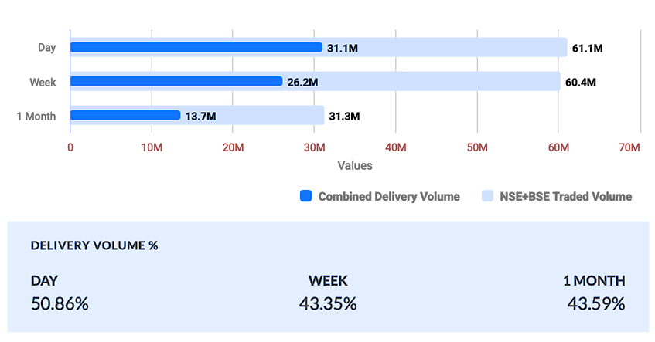
- Volume Analysis
The volumes of deliveries have been increasing as we saw the selloff for the Bad Loan slippage. But we can also see that the majority of transactions have been in delivery which implies that people are finding the stock undervalued and are building positions and utilizing the dip as an opportunity as the stock has a good upside potential from here.

Shareholding Pattern
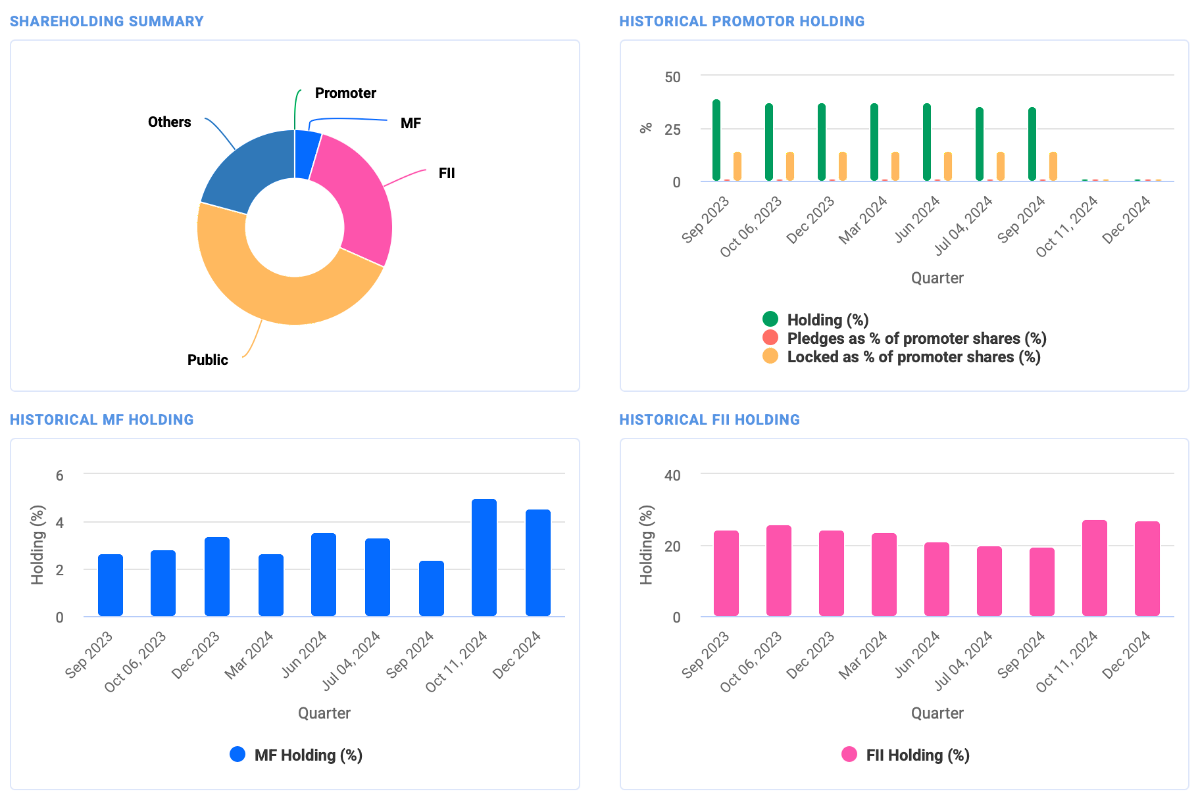
Target for Stock Price Movement
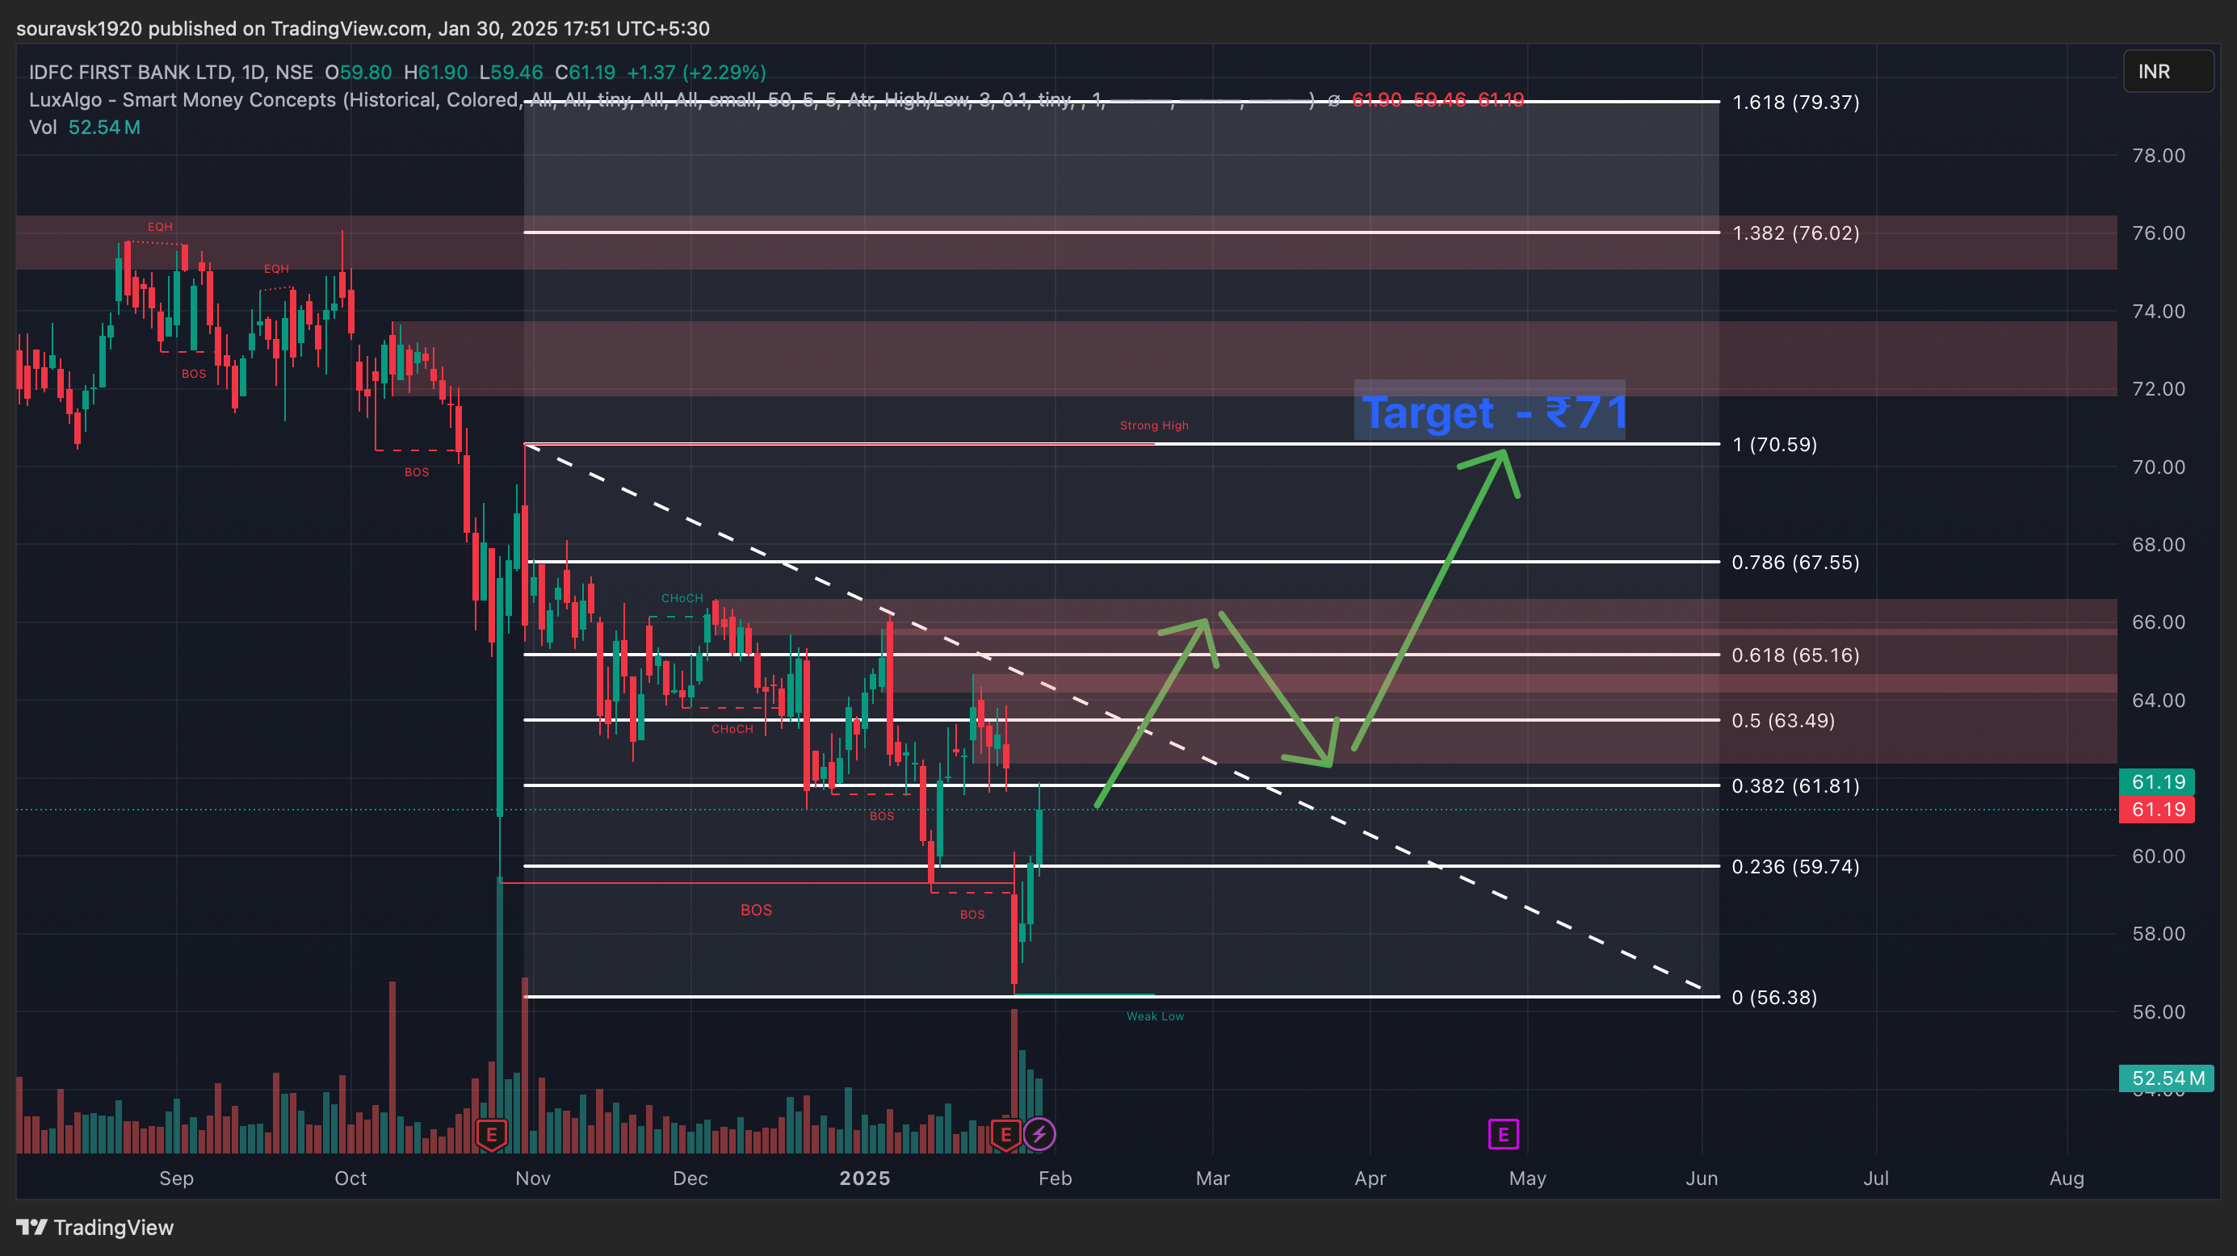

- The Stock slipped 7% on Monday to the level of ₹56 due to the increase in the slippage of personal loans.
- The stock thereafter has shown recovery and looks to be having selling pressure throughout this week, but the RBI monetary policy can ease the selling pressure on the stock by infusing liquidity and increasing the flow of money, which can possibly be a sign of reversal.
- In the short term, while awaiting for the annual earnings in April we can expect the price of the stock to come close to its major resistance of ₹71

If the results are good and there is an improvement in controlling the bad loans then IDFC First Bank has a good upside potential towards the target of ₹85

Target 1 - ₹71 (April - 29)

Target 2 - ₹85 if result turns positive in 29 April 2025

