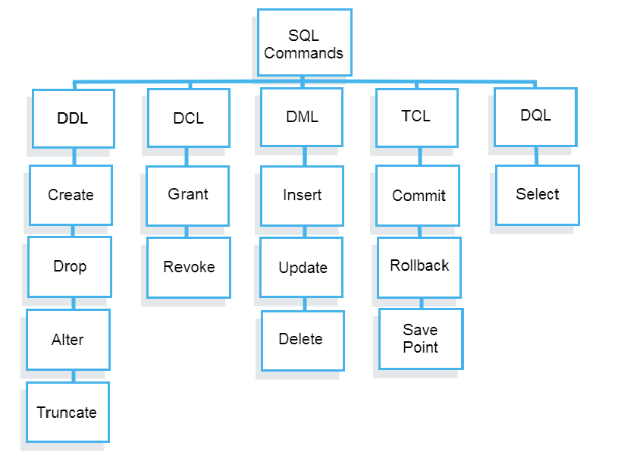

**DQL-**

>Select – print attribute from at table

**Select CustomerName, address from customers**;

-------print only customer name and address column information from “Customer” table

**SELECT DISTINCT Country FROM Customers;**

**------print country column but only unique like if mexico was in double but it returns only one**

**SELECT *column1*,*column2, ...*  
FROM *table_name*  
WHERE *condition***;

Ex- SELECT * FROM Customers  
WHERE Country='Mexico';

-----only print full row where is mexico

**AND, OR, NOT**

SELECT column1, column2, ...  
FROM table_name  
WHERE condition1 AND condition2 AND condition3 ...;

INSERT INTO Customers (CustomerName, ContactName, Address, City, PostalCode, Country)

VALUES ('Cardinal','Tom B. Erichsen','Skagen 21','Stavanger','4006','Norway');

The INSERT INTO statement is used to insert new records in a table.