Team Name: Team SolarCycle
Robust, Solar-Powered Charging Infrastructure for a Shared e-Bike Scheme under Demand Uncertainty
Theme 3 (primary): solar-PV charging-station design · Theme 2 (secondary): managed charge/discharge profiles | Example site: University of Warwick, Coventry (CV4 7AL)
Approach (278 words)
Aim. Design a solar-PV charging hub for a shared e-bike scheme at the University of Warwick (Coventry, CV4 7AL) that stays cost-effective and reliable across every plausible future demand — not merely an average forecast (Theme 3) — while modelling the managed charge/discharge load the hub must serve (Theme 2).
Objectives. (1) Build realistic demand scenarios for the UoW Bikes fleet; (2) size PV, battery storage and charge bays behind a constrained grid connection; (3) quantify the cost and service value of designing for robustness; (4) test whether on-site storage is justified.
Research questions. How should a hub be sized when demand is deeply uncertain? What is the value of robustness versus a conventional average-demand design? At a grid-connected hub, does a battery pay?
Methodology (Figure 1). Low/Medium/High demand scenarios are built from the UoW Bikes shared e-bike data and scaled across a year-on-year growth range into nine probability-weighted scenarios. A smart controller schedules each day's flexible charging across the hub dwell window, following on-site PV and off-peak tariffs. An hourly (8,760 h) energy balance dispatches PV → battery → capped grid → unmet demand under the constrained connection. All 150 candidate designs (PV 5–25 kWp × battery 0–50 kWh × 4–20 bays) are scored against the scenarios, pricing unmet demand as lost service; five decision rules — naive, two-stage stochastic, CVaR, minimax-regret and maximin — map the cost-vs-robustness frontier. Uncertainty is propagated through a 500-sample correlated Monte-Carlo fan and ranked by tornado and variance-based (Sobol) sensitivity; a robustness-of-robustness sweep re-solves across penalty × grid × horizon, and seven outputs are validated against published benchmarks. Real PVGIS solar (Coventry) and National Grid ESO carbon (West Midlands) drive the energy and emissions model.
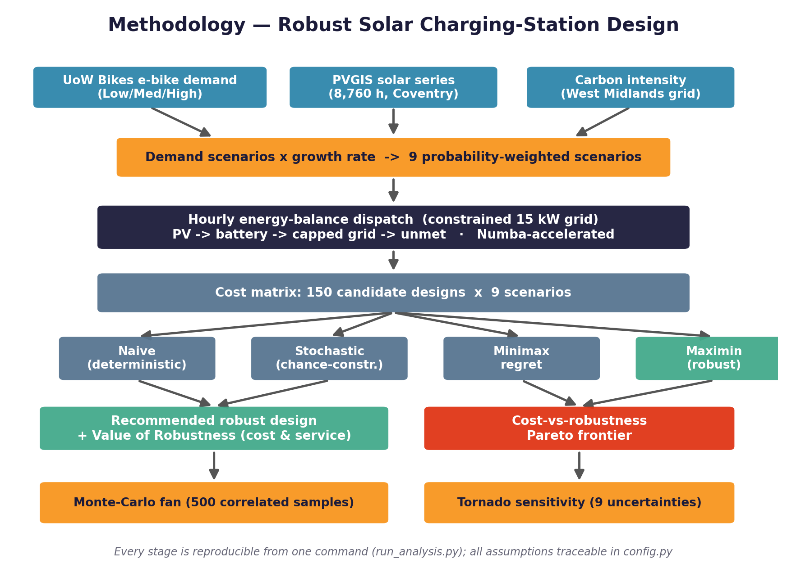
Figure 1 — End-to-end methodology / algorithm flow.
Outcomes (414 words)
Recommended design. The robust optimisation recommends a 15 kWp PV array with 8 smart-managed charge bays and no battery, at a capital cost of approximately £29,400 (Figure 2).
Value of robustness. A conventional design sized to average demand (5 kWp, 4 bays) looks cheap but collapses under the high-demand future: its worst-case annual cost is £56,994 and it serves only 94.1% of charging demand. The robust design caps worst-case cost at £21,472/yr — a 62% (£35,522/yr) reduction — and guarantees 99.4% fleet service in every scenario. Across the Monte-Carlo fan its 95th-percentile cost is £11,261 versus £10,522 for the naive design, more than halving tail risk. We name and quantify this gap as the value of robustness.
Storage boundary — key finding. Because hub charging is flexible, smart charging is the cheapest robustness lever: it flattens the load beneath the grid limit, so at a grid-connected hub a battery never enters any robust solution. Storage becomes essential only when the grid connection falls to ≈9 kW or below — a boundary the robustness sweep locates. The recommendation is therefore solar plus smart-managed bays, not capital-heavy storage (Theme 2).
Robustness of the conclusion. The result is not an artefact of one assumption: the robust design beats the naive design in 100% of 35 penalty × grid-limit combinations, with the value of robustness ranging 2–90% (median 27%) (Figure 3). Seven key outputs — PV yield, grid-carbon intensity, round-trip efficiency, trip distance, solar fraction, LCOE and carbon saving — all fall within published ranges (7/7) (Figure 4).
Sustainability. Operating the recommended hub avoids 3.8 tCO₂/yr (15%) versus grid-only charging at the marginal grid factor, with 15% of demand met directly from on-site solar.
Economic implications. The design uses only commercially available components, sized within manufacturer and industry-benchmark ranges, and reports CAPEX, OPEX, battery-replacement and grid costs. The operator message is direct: pay a modest premium over an average-demand design to remove most downside cost and service risk, and do not buy storage at a connected hub. Demand intensity and year-on-year growth dominate cost variance, so the specification should be revisited as the scheme scales.
Originality & reproducibility. All model code — the dispatch engine, five-rule optimisation, Sobol and robustness analyses and every figure — was written from scratch for this submission. Every numerical assumption carries an inline source; the pipeline is deterministic, regenerates all data and figures from one command, and passes an automated test suite, so any reviewer can reproduce every number.
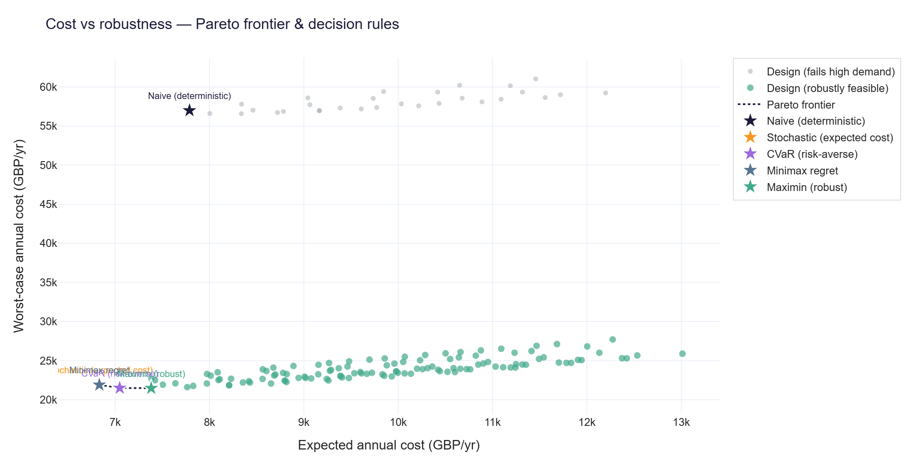
Figure 2 — Cost-vs-robustness Pareto frontier (five decision rules).
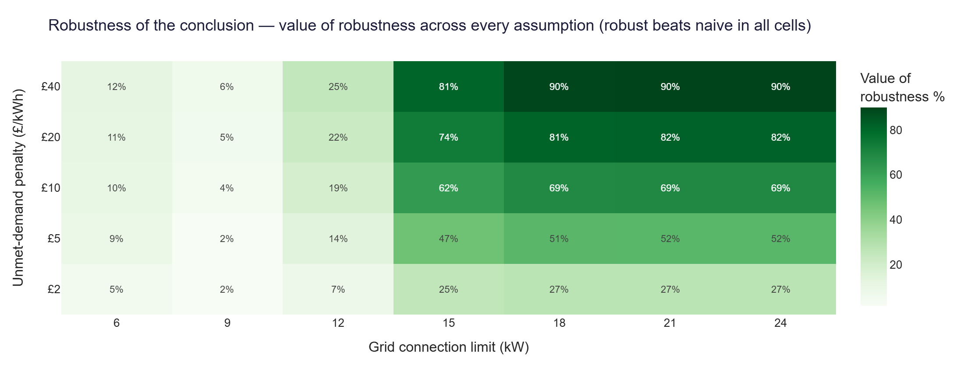 | 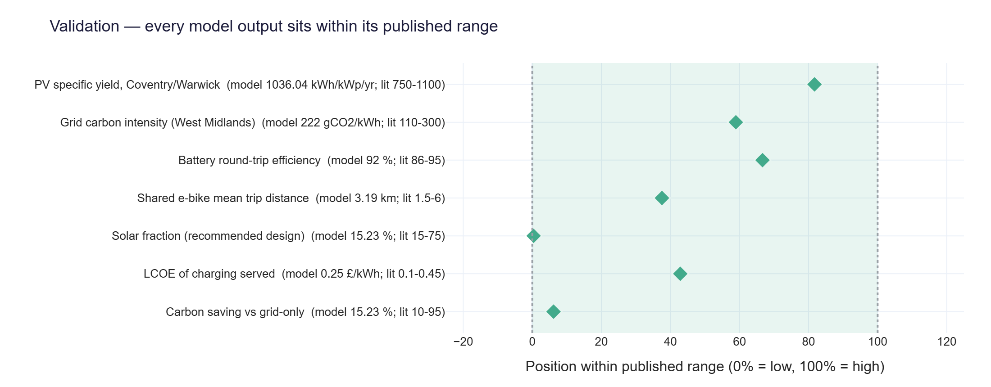
Figure 3 — Robust beats naive across every penalty × grid case. Figure 4 — Validation vs published benchmarks.
Links to GitHub files
GitHub (executable code + README / QuickStart guide): https://github.com/Gourav88502/emicromobility-robust-charging — the README documents the one-command run (“python run_analysis.py”), data sources and how to drop in the official UoW Bikes Data(Sheet1).csv.
References (not counted in the word limit)
[1] Burani, E., Cabri, G., Leoncini, M. (2022). An Algorithm to Predict E-Bike Power Consumption Based on Planned Routes. Electronics, 11(7), 1105.
[2] Ouf, K., Soubra, H., Mazhr, A. (2023). E-Bike Energy Needs Estimation based on Route Characteristics and Rider Behavior. IEEE ICICIS 2023, 345–352.
[3] Corti, F. et al. (2024). A comprehensive review of charging infrastructure for Electric Micromobility Vehicles. Energy Reports, 12, 545–567.
[4] Marie, J.-J. (2023). The Micromobility Revolution Gathers Momentum. Faraday Insights, Issue 16.
[5] Gössling, S. (2020). Integrating e-scooters in urban transportation. Transportation Research Part D, 79, 102230.
[6] Rockafellar, R.T., Uryasev, S. (2000). Optimization of Conditional Value-at-Risk. Journal of Risk, 2(3), 21–41.
[7] Birge, J.R., Louveaux, F. (2011). Introduction to Stochastic Programming, 2nd ed. Springer.
[8] PVGIS (EU JRC) hourly series, University of Warwick (52.3838, −1.5616); National Grid ESO Carbon Intensity API, West Midlands (region 8).
[9] Cost & performance benchmarks: BEIS, IRENA, BloombergNEF, IEA PVPS, Fraunhofer ISE — see REFERENCES.md.

