**Computer Architecture and Organization**

**Project**

**Two-Pass Assembler and Accumulator based CPU**

**Design**



SUBMITTED BY

Gaurav Singhal 2019UCO1571

Mayank Goel 2019UCO1558

Sandeep Jain 2019UCO1522

Nishant Goel 2019UCO1529

**Project Summary**

● Our team has created a two - pass assembler for a micro owen. We defined a basic instruction set required for the functioning and then proceeded with the CPU design, involving the System Bus, Control Unit.

● In the end, we programmed a two - pass assembler , which converts Assembly code of the micro owen into machine code, which can be then stored in the memory, and accessed byte by byte.

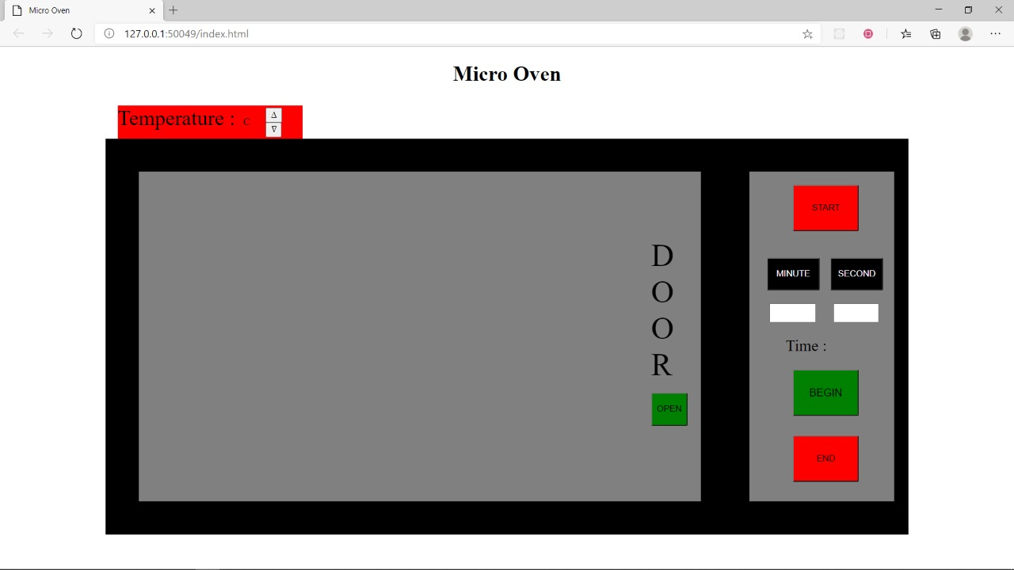

**DESCRIPTION:**

Assembly language is a low-level programming language which is converted into machine code with the help of an assembler program. We have designed a **Two -Pass Assembler** which translates the assembly program into its equivalent binary code and stores it in the memory. The CPU hence can access these instructions from the memory and process them to produce the desired output.

**Language used to code the assembler**: C++

**MEMORY:**

The size of the memory is **128* 16** bits. Memory is **byte addressable**.

**CPU Design**

**Address bus**: 7 bits

**Data bus**: 16 bits

**Flags**:

**Zero flag:** This flag is set if the data in accumulator is zero, else clear.

**Carry flag**: this flag is set if there is a carry bit

**Sign flag**: this flag is set if the value in AC is negative.

**Overflow flag**: this flag is set if the value in AC is overflowing

**Instructions:**

**Size**: 16 bit

**Operations**: 20 distinct operations

**INSTRUCTION FORMAT**

* Size of each instruction is 16 bits.
* First 2 bits are always 00.
* 3rd Bit is use for determining the type of instruction as Memory reference or Non-memory reference.
* 4th bit is used for determining the mode of instruction as direct or indirect
* Next 5 bits are reserved for operation code.
* Remaining bits are reserved for address.

**16-Bit Instruction Format**

|  |  |  |  |  |
| --- | --- | --- | --- | --- |
| 00 | MRI or Non-MRI (1- bit) | Mode Bit (1-bit) | Opcode(5-bit) | Address(7-bit) |

**INSTRUCTION SET**

|  |  |  |  |  |  |
| --- | --- | --- | --- | --- | --- |
| **Sno** | **mnemonic** | **opcode** | **Register Transfer Language**  **(RTL)** | **Function** | **Example** |
| 1 | ldan | 00001 | AC<- M[xxxxxxx] | Load AC with data present at given address from memory | ldan ads |
| 2 | cman | 00010 | AC<- AC’ | Complement the value stored at AC | cman |
| 3 | incn | 00011 | AC<- AC +1 | Increment the value stored in AC by 1 | incn |
| 4 | addn | 00100 | AC <- AC+M[xxxxxxx] | Add value stored at AC with data given by given address | addn ptr I |
| 5 | stan | 00101 | M[xxxxxxx]<-AC | Store value given by AC at the given address in memory | stan ptr |
| 6 | bunn | 00110 | PC<-AR | Branch unconditionally | bunn 15 |
| 7 | clan | 00111 | AC <-0 | Set data present in AC to 0 | clan |
| 8 | iszn | 01000 | DR<-M[AR],DR<-DR+1,M[AR]<-DR,if(DR=0) then PC<-PC+1 | Increment and skip if zero | iszn ptr |
| 9 | andn | 01001 | AC <-( AC&M[xxxxxxx]) | Logical and operation between AC and the value present at given address | andn x |
| 10 | orn | 01010 | AC <-( AC|M[xxxxxxx]) | Perform bitwise OR | orn x |
| 11 | xorn | 01011 | AC <-( AC^M[xxxxxxx]) | Perform bitwise xor operation on AC with value stored at given address | xorn x |
| 12 | setn | 01100 | AC <-( AC&(1<<(M[xxxxxxx]-1))) | Set the ith bit in AC to 1 (Zero-based indexing) | setn i |
| 13 | lsln | 01101 |  | Logical left shift the value stored in AC | lsln |
| 14 | lsrn | 01110 |  | Logical right shift the value stored in AC | lsrn |
| 15 | asln | 01111 |  | Arithmetic left shift the value stored in AC | asln |
| 16 | asrn | 10000 |  | Arithmetic right shift the value stored in AC | asrn |
| 17 | csln | 10001 |  | Circular left shift the value stored in AC | csln |
| 18 | csrn | 10010 |  | Circular right shift the value stored in AC | csrn |
| 19 | subn | 10011 | AC<- AC-M[xxxxxxx] | Subtract value stored at given address from AC | subn ptr |
| 20 | decn | 10100 | AC<- AC-1 | Decrement the value stored at AC by 1 | Decn |
| 21 | dech | 10101 | AC=-10 | Set accumulator to -10 |  |
| 22 | inch | 10110 | AC=10 | Set accumulator to 10 |  |
| 23 | addmin | 10111 | AC=60 | Set accumulator to 60 |  |
| 24 | addsec | 11000 | AC=1 | Set accumulator to 1 |  |
| 25 | addN ptr | 11001 | M[ptr]🡨M[ptr]+AC | ADD accumulator |  |
| 26 | door I/o | 11010 | Check oven | Check oven door is open |  |
| 27 | begin | 11011 |  | Signal for execution of heating till time specified |  |

**Pseudo-Instructions:**

* hlt
* org
* end

**Internal processor register:**

**Program counter**: 7 bits

**Address register**: 7 bits

**Instruction register**: 5 bits

**Data register**: 16 bits

**Types of Instructions:**

* **Memory Reference Instructions**

These instructions refer to memory address as an operand. The other operand is always accumulator.

* **Non-Memory Reference Instructions**

These instructions does not require any address location for retrieval of data , they do not operate with memory .

**Addressing Modes:**

* **Direct Addressing Mode**

Address part of the instruction contains the address of the operand.

* **Indirect Addressing Mode**

Address part of the instruction contains the address of the address where operand is stored.

**How does the assembler works?**

1. Assembler performs its action in two phases.
2. In first pass, Assembler retrieves all the data from symbolic addresses and prepares an address symbol table in the memory.
3. In second pass , Assembler converts each instruction line by line into its binary equivalent and replaces symbols with their equivalent data from address symbol table.
4. Assembler stops converting on reaching halt condition.

**What does your assembler returns?**

Our assembler returns the memory of size 128*16 having the instruction in machine level language that can be fed to the CPU of above mentioned specifications.

At each step our assembler shows the content of each register used in CPU design.

So, user can check the step by step execution of the instructions of the assembly program.

There is a separate space where complete Equivalent binary code is shown for the given

Assembly Program.

**USER INTERFACE :-**

For creating user interface we have used Qt software that uses C++ library to integrate our code with an interface to emulate the working of cpu.

Inbuilt C++ library is provided by the Qt company which enabled us to display the output on a new screen.

This development environment at the same time created an equivalent application of the assembler.

For references for Qt , visit Qt documentation here: <https://doc.qt.io/>

**SAMPLE RUN:-**

**For oven:**

org 10

door 0

ldan tim

stan ctr

ldan hea

stan ptr

clan

addmin

addN ctr

clan

addmin

addN ctr

clan

addmin

addN ctr

clan

addmin

addN ctr

clan

addsec

addN ctr

clan

addsec

addN ctr

clan

addsec

addN ctr

clan

inch

addN ptr

clan

inch

addN ptr

clan

dech

addN ptr

clan

dech

addN ptr

clan

dech

addN ptr

clan

begin

hlt

hea, dec 100

ptr, hex 0

tim, dec 0

ctr, hex 1

end



