IPL DATA ANALYSIS

Internship Project Report
Bharat Cares × IBM Collaboration

Prepared by
Gourav Solanke
B.Tech Computer Science & Engineering
Pimpri Chinchwad University, Pune

Project Domain: Data Analytics / Data Science
Analysis Period in Dataset: 2008–2026

1. Executive Summary
This internship project presents an end-to-end exploratory data analysis of IPL match-level data. The work was developed in the context of an internship with Bharat Cares in collaboration with IBM. The analysis uses Python-based data analytics to understand season patterns, team participation and performance, toss decisions, venues, match-result types, winning margins, Player of the Match awards, and scoring trends.
The uploaded notebook contains 1,243 IPL match records across 19 seasons from 2008 through 2026 and 31 original columns. The notebook performs data-quality checks, preserves meaningful missing match-number values, standardizes historical team names, creates analytical features, performs exploratory analysis, and concludes with an interactive/dashboard-oriented visualization.
The project is descriptive and observational. Relationships such as toss decision versus match outcome are reported as associations in the dataset and are not interpreted as proof of causation.

2. Internship and Project Context
Item | Details
Project Type | Internship Project
Organization | Bharat Cares
Collaboration | IBM
Project Title | IPL Data Analysis
Domain | Data Analytics / Data Science
Author | Gourav Solanke
Program | B.Tech Computer Science & Engineering
University | Pimpri Chinchwad University, Pune
Development Environment | Google Colab

3. Problem Statement
IPL match datasets contain a large amount of information about seasons, teams, tosses, scores, venues, players and match outcomes. When this information is stored in raw tabular form, it is difficult to identify meaningful patterns directly. The problem addressed by this project is to transform the raw IPL match data into a clean, validated and analytically useful dataset, then use exploratory data analysis and visualization to identify observable patterns in IPL matches.

3.1 Problem Explanation
- Raw match data contains multiple data types and historical naming variations.
- Missing values need to be investigated before analysis rather than automatically deleted.
- Historical franchise name changes can cause one franchise to appear as multiple teams.
- Different match-result measures such as runs and wickets should be analyzed separately.
- Toss decisions, match outcomes, scoring, venues and player awards require different analytical views.
- The final results need to be communicated through clear visualizations and a dashboard.

4. Project Objectives
- Understand the structure and quality of the IPL dataset.
- Perform systematic data cleaning and validation.
- Preserve meaningful missing match-number values.
- Standardize historical team names.
- Create useful analytical features.
- Analyze season-wise match and scoring patterns.
- Analyze team participation, wins and win percentages.
- Study toss decisions and their observed relationship with match outcomes.
- Analyze venue distribution.
- Study winning margins by runs and wickets.
- Analyze Player of the Match awards.
- Build a consolidated IPL analysis dashboard.

5. Dataset Description
Dataset Property | Value
Rows | 1,243 matches
Original Columns | 31
Seasons | 19
Season Range | 2008–2026
Duplicate Rows | 0
Missing match_number | 74
Missing winner | 25
Missing player_of_match | 9
Standardized Teams | 15
Venues | 60

The original notebook reports 1,243 rows and 31 columns. The major fields include event_name, season, match_number, date, city, venue, team1, team2, toss_winner, toss_decision, team1_runs, team2_runs, winner, result_type, win_by_runs, win_by_wickets, player_of_match, match_type and related match-official information.

6. Data Cleaning and Validation

6.1 Missing Values
Column | Missing Values | Handling
match_number | 74 | Preserved intentionally
winner | 25 | Handled as no recorded winner for analytical purposes
player_of_match | 9 | Handled as not awarded for analysis

The notebook specifically preserves the 74 missing match_number values. These values are meaningful in the dataset because they represent playoff/knockout matches and therefore were not treated as ordinary missing data.

6.2 Duplicate Check
The notebook reports 0 duplicate rows.

6.3 Team Name Standardization
Historical Name | Standardized Name
Royal Challengers Bangalore | Royal Challengers Bengaluru
Rising Pune Supergiants | Rising Pune Supergiant
Kings XI Punjab | Punjab Kings
Delhi Daredevils | Delhi Capitals

This step prevents historical naming variations from being counted as separate teams during team-level analysis.

7. Project Methodology
- Load the IPL dataset into a pandas DataFrame.
- Inspect dimensions, columns, data types and missing values.
- Check duplicates and important categorical values.
- Clean date and text fields.
- Handle missing winner and Player of the Match values.
- Create match-stage, season and match-result features.
- Standardize historical team names.
- Recalculate team and toss-related analyses after standardization.
- Perform exploratory analysis using tables and visualizations.
- Build an interactive dashboard and summarize key statistical findings.

8. Feature Engineering
Feature | Purpose
season_year | Represents the IPL season as an analysis field
match_stage | Separates League and Playoff / Knockout records
result_category | Categorizes wins by runs, wickets or other/no result
toss_match_same | Compares toss winner and match winner
win_margin | Stores the relevant numerical winning margin
margin_type | Identifies Runs, Wickets or No Margin
total_match_runs | Sum of both teams' recorded runs

9. Exploratory Data Analysis

9.1 Season-wise Match Analysis
The notebook analyzes the number of matches by season and visualizes the season trend. The dataset covers 19 seasons from 2008 to 2026.
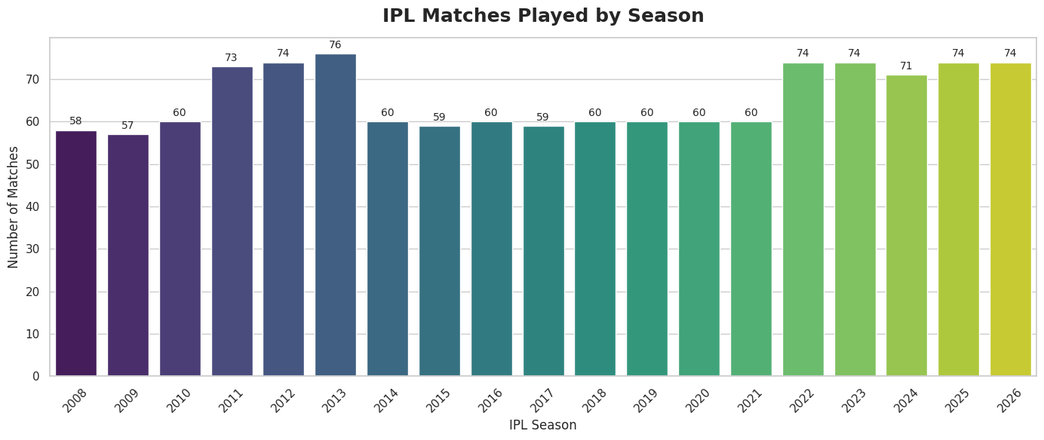
Figure 1. Season-wise IPL match visualization from the uploaded notebook.

9.2 Team Participation and Performance
After standardizing historical names, the notebook reports 15 standardized teams and 2,486 team appearances, corresponding to two team appearances per match.
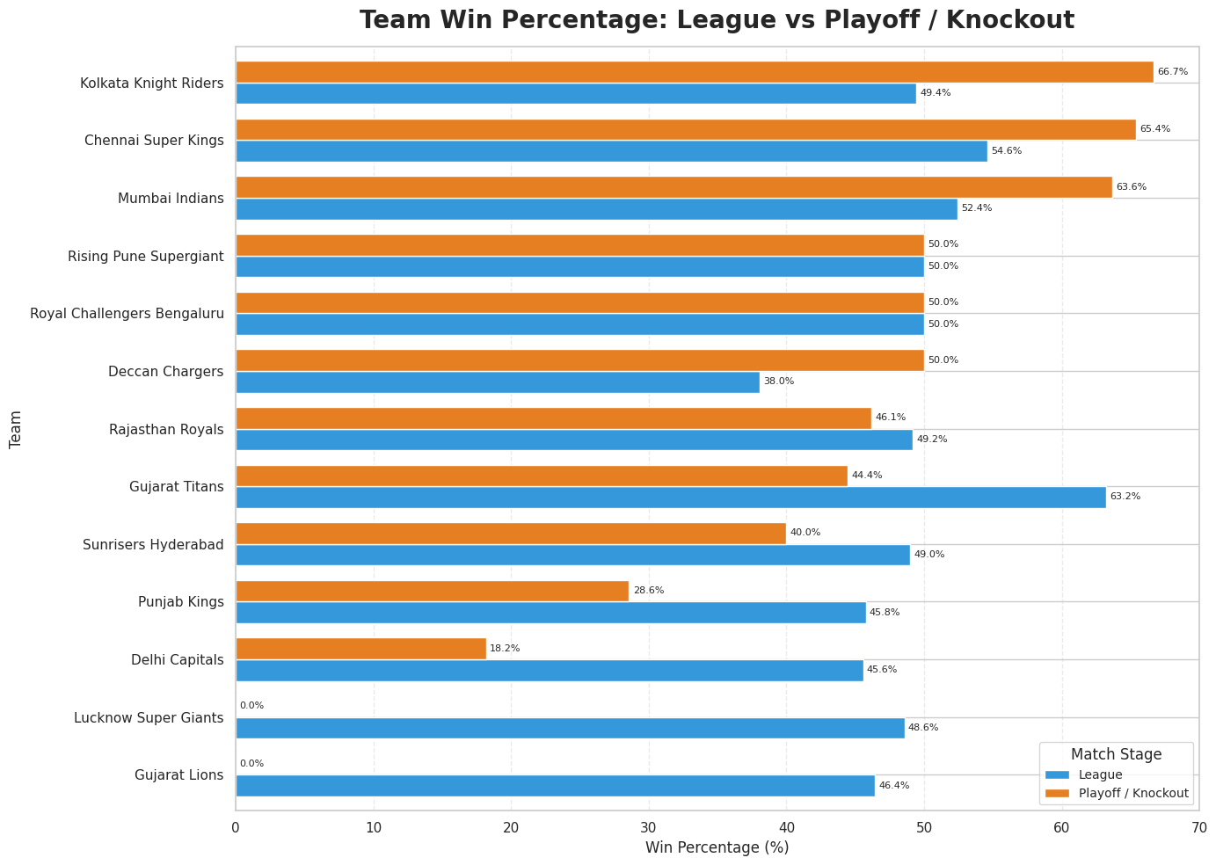
Figure 2. Team performance by match stage.
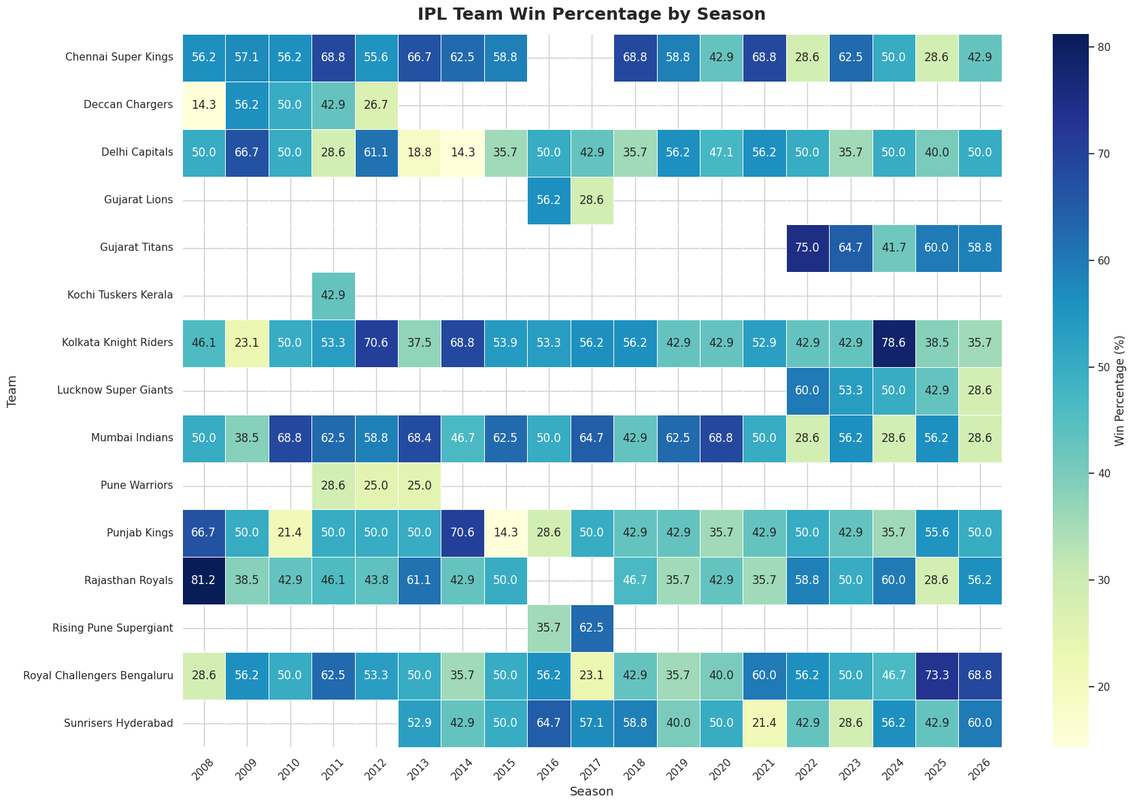
Figure 3. Season-wise team win-percentage heatmap.

9.3 Team Wins
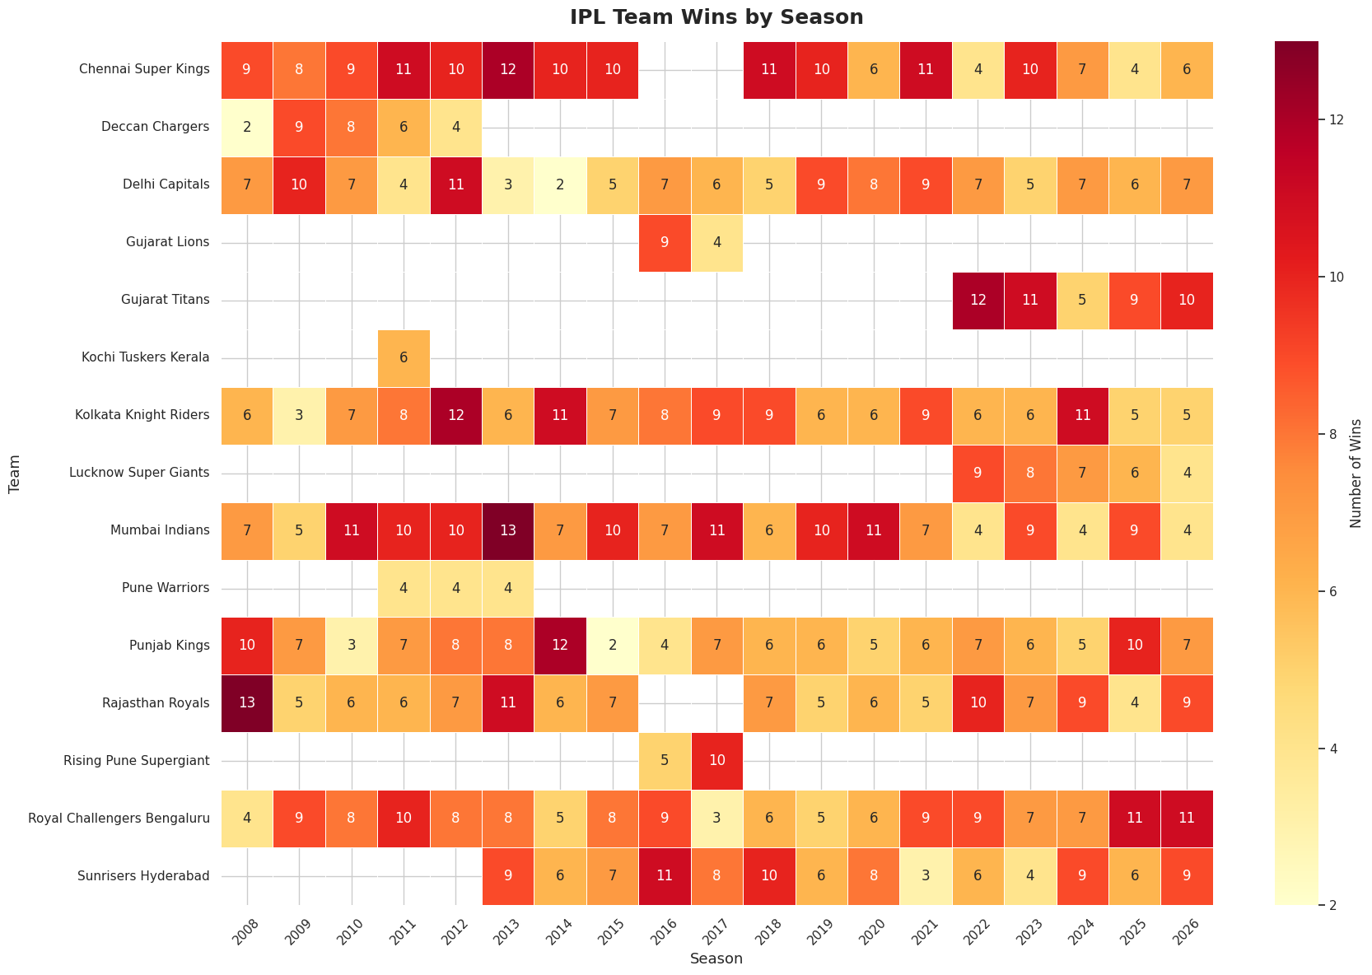
Figure 4. Season-wise team wins heatmap.

9.4 Match Result Types
Result Type | Matches | Percentage
Win by Wickets | 660 | 53.10%
Win by Runs | 558 | 44.89%
Other / No Result | 25 | 2.01%

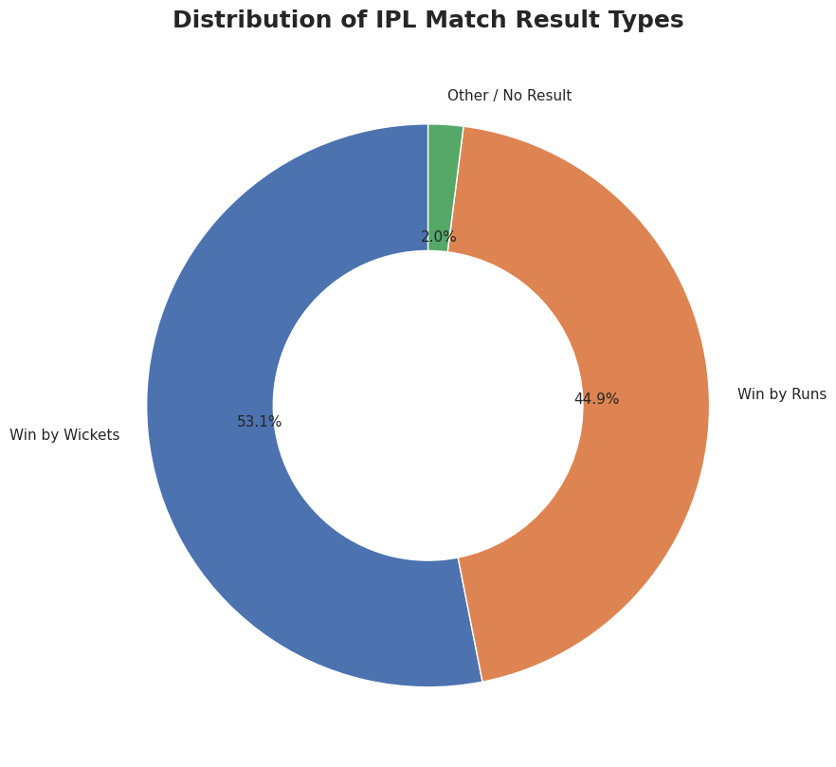
Figure 5. Distribution of IPL match result types.

9.5 Winning Margin Analysis
Margin Type | Matches | Average | Median | Minimum | Maximum
Runs | 558 | 31.04 | 23 | 1 | 146
Wickets | 660 | 6.17 | 6 | 1 | 10

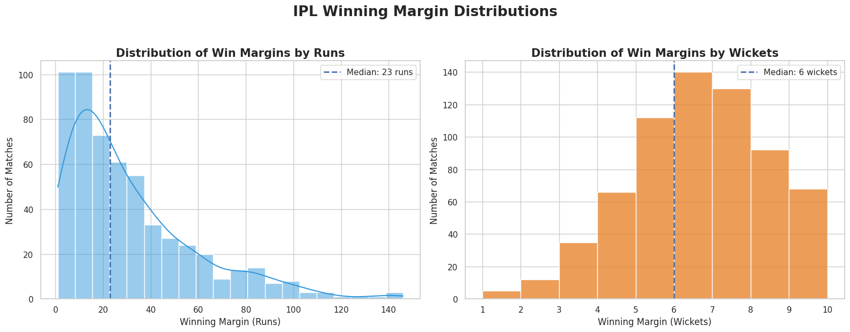
Figure 6. Distribution of winning margins.

9.6 Player of the Match Analysis
Player | Awards
AB de Villiers | 25
V Kohli | 22
CH Gayle | 22
RG Sharma | 21
SP Narine | 18
DA Warner | 18
MS Dhoni | 18
RA Jadeja | 17
KL Rahul | 17
SR Watson | 16

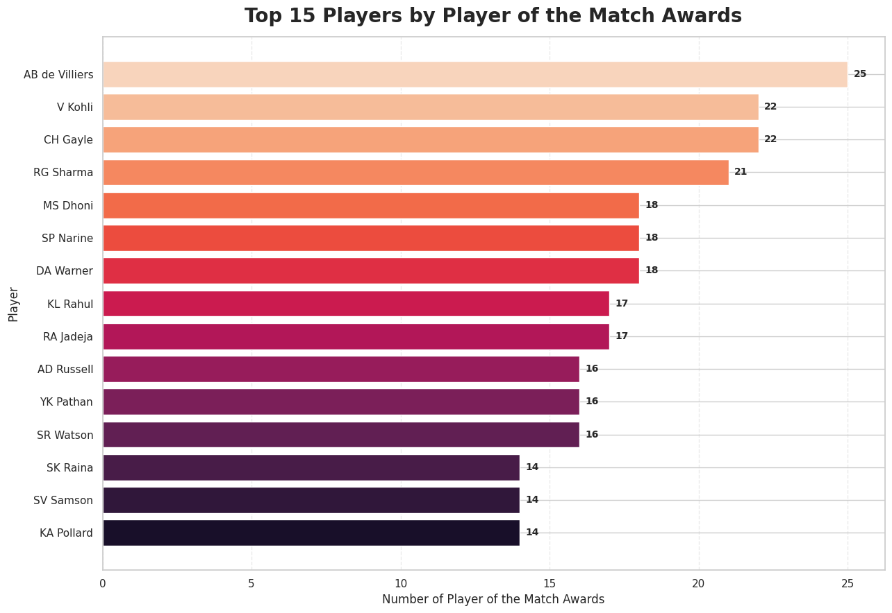
Figure 7. Top Player of the Match award counts from the notebook.

9.7 Playoff / Knockout Analysis
The notebook identifies 74 Playoff / Knockout matches based on the meaningful missing match_number values. The available event_name value for these records is 'Indian Premier League'; the dataset does not directly provide a separate Final/Qualifier/Eliminator label in the inspected event_name output, so the report does not infer those specific stages.

Match Stage | Result Category | Matches
League | Other / No Result | 25
League | Win by Runs | 522
League | Win by Wickets | 622
Playoff / Knockout | Win by Runs | 36
Playoff / Knockout | Win by Wickets | 38

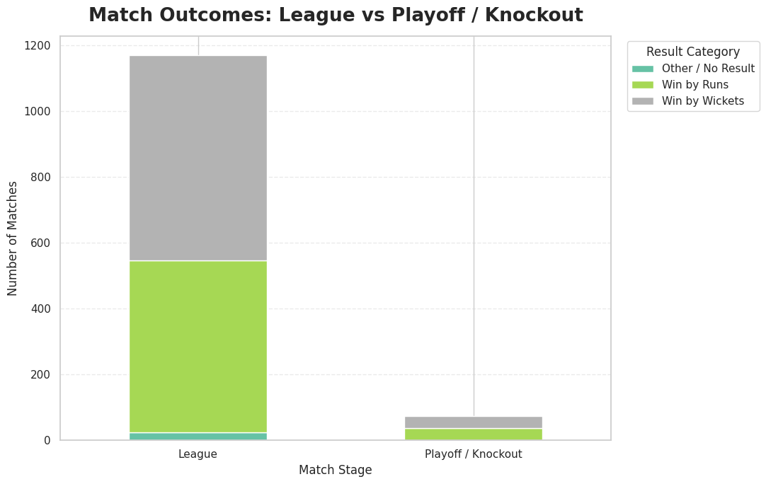
Figure 8. Match outcomes by match stage.

9.8 Venue Analysis
Venue | Matches
Eden Gardens | 77
Wankhede Stadium | 73
M Chinnaswamy Stadium | 65
Feroz Shah Kotla | 60
Wankhede Stadium, Mumbai | 59
Rajiv Gandhi International Stadium, Uppal | 49
MA Chidambaram Stadium, Chepauk | 48
Sawai Mansingh Stadium | 47
Dubai International Cricket Stadium | 46
MA Chidambaram Stadium, Chepauk, Chennai | 41

The notebook reports 60 unique venue strings. Some venue names occur in historical and location-qualified forms, such as Wankhede Stadium and Wankhede Stadium, Mumbai. This is a potential future data-standardization opportunity.
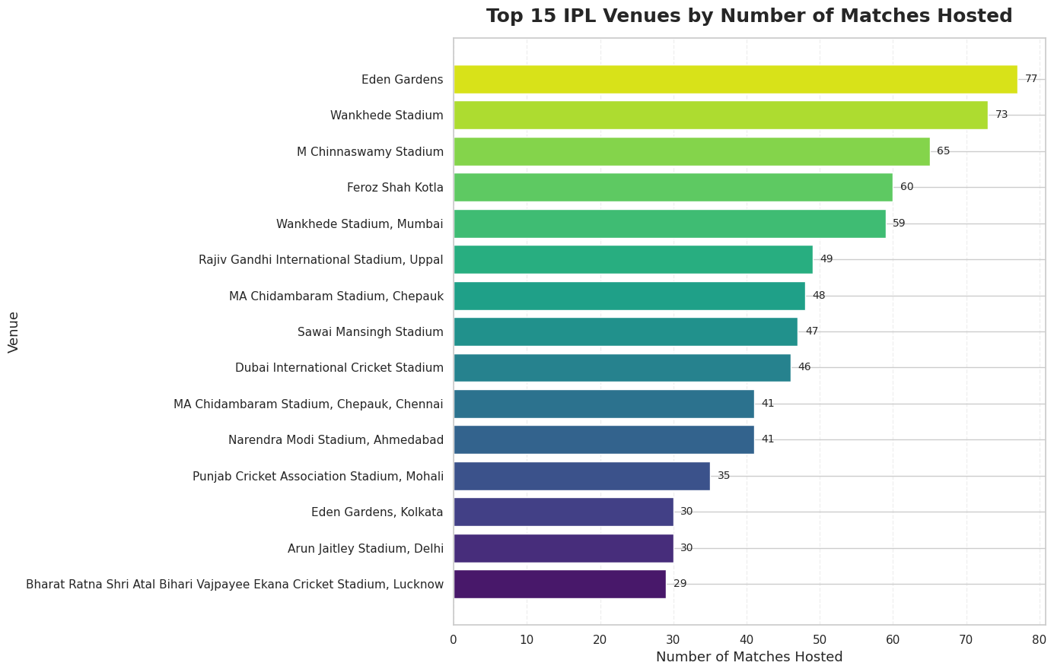
Figure 9. Top IPL venues by matches hosted.

9.9 Toss Analysis
Toss Decision | Matches | Toss Winner Wins | Toss Winner Losses | Win %
Bat | 408 | 185 | 223 | 45.34%
Field | 810 | 443 | 367 | 54.69%

The notebook observes that the toss-winning team won 45.34% of matches when it chose to bat and 54.69% when it chose to field. These are observed associations in this dataset and should not be interpreted as causal effects.
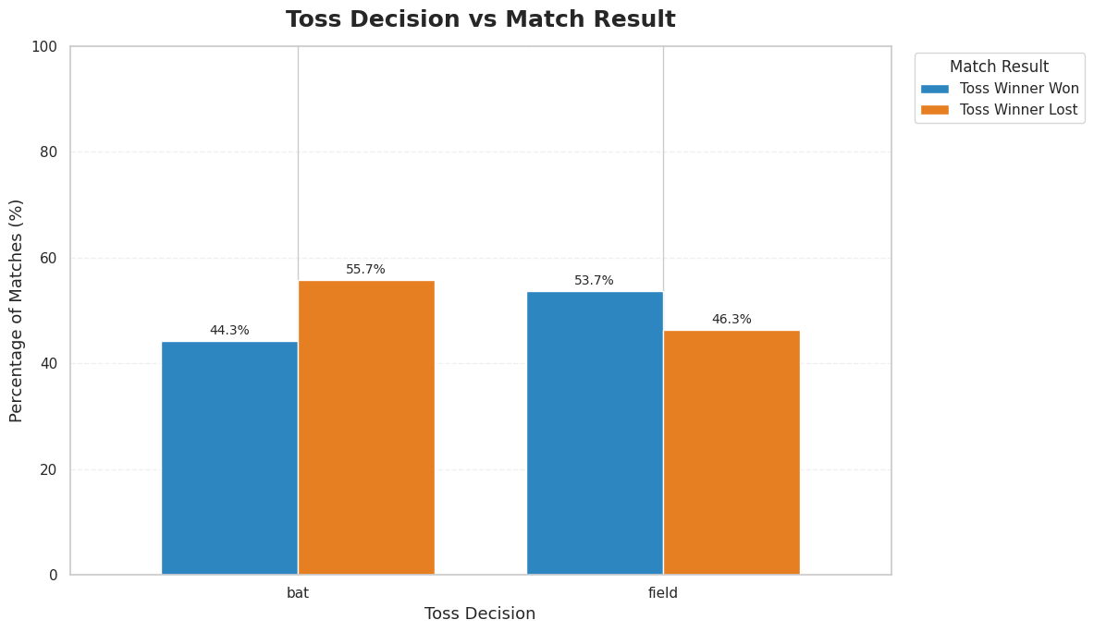
Figure 10. Toss decision versus match result.

9.10 Season-wise Scoring Trends
Season | Matches | Total Runs | Average Runs/Match
2008 | 58 | 17,937 | 309.26
2010 | 60 | 18,883 | 314.72
2014 | 60 | 18,931 | 315.52
2018 | 60 | 19,901 | 331.68
2022 | 74 | 24,395 | 329.66
2023 | 74 | 25,688 | 347.14
2024 | 71 | 25,971 | 365.79
2025 | 74 | 26,527 | 358.47
2026 | 74 | 27,455 | 371.01

Across the notebook's season-level calculations, average runs per match range from 286.89 in 2009 to 371.01 in 2026. Total runs should be interpreted together with the number of matches in each season.
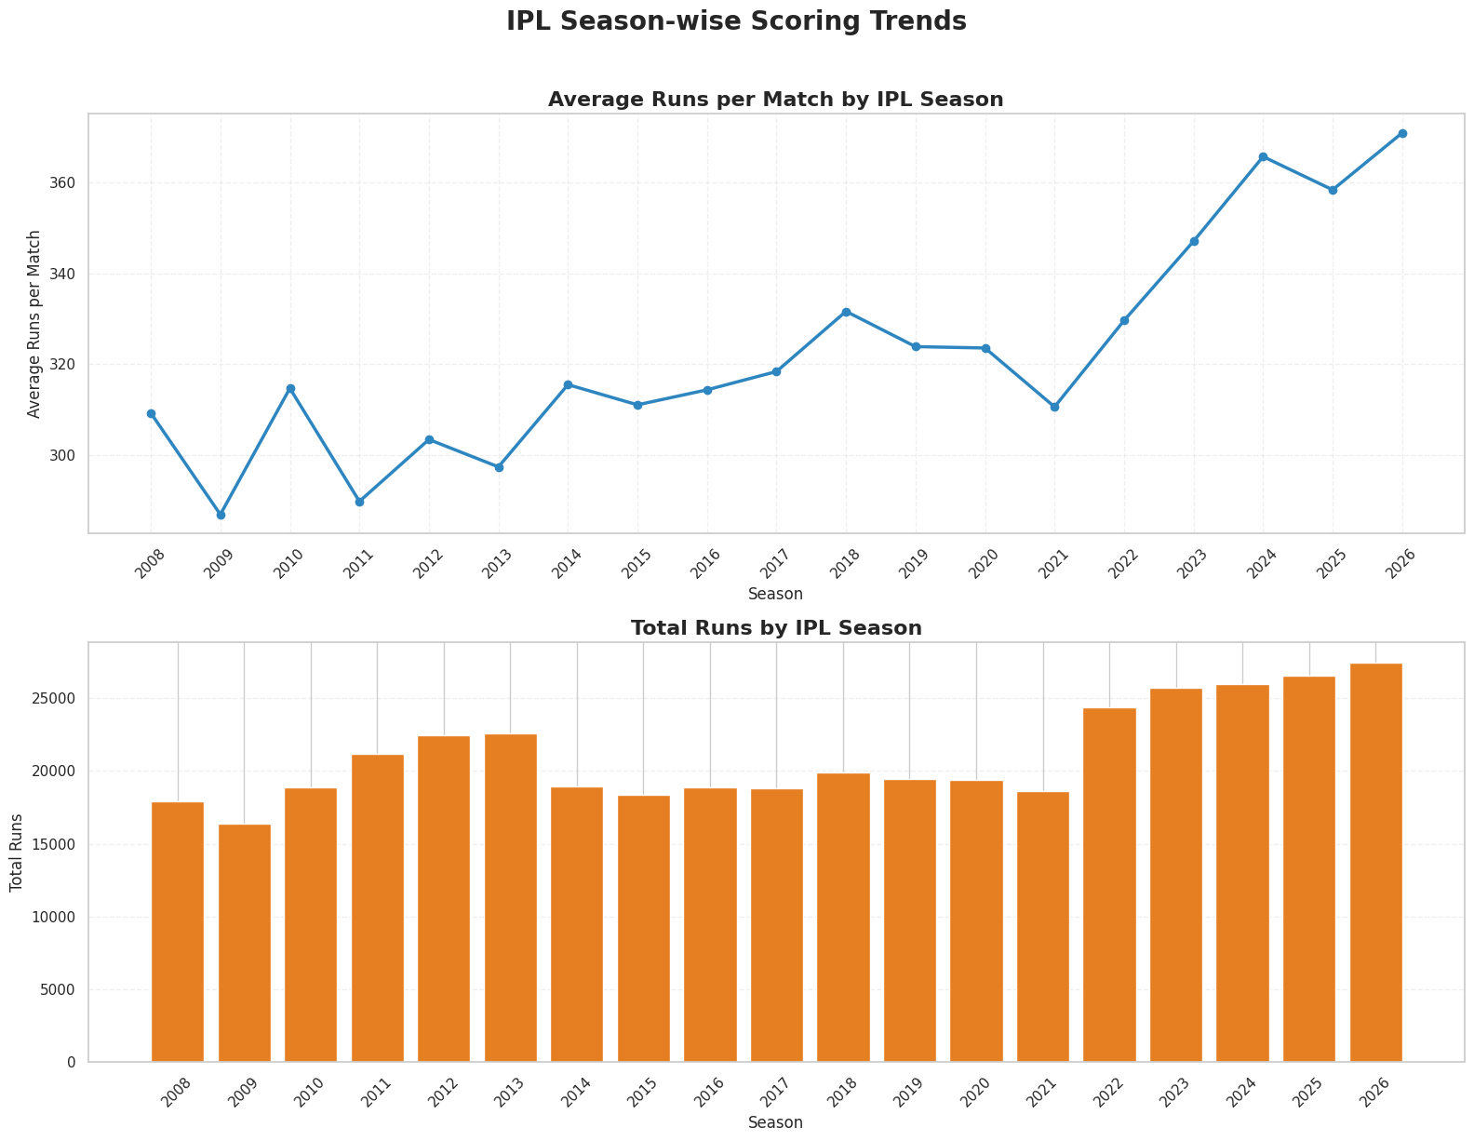
Figure 11. Season-wise scoring visualization.

9.11 Team-wise Scoring
Team | Matches | Total Runs | Average Runs/Match
Gujarat Titans | 77 | 13,743 | 178.48
Lucknow Super Giants | 72 | 12,754 | 177.14
Sunrisers Hyderabad | 211 | 34,640 | 164.17
Punjab Kings | 278 | 45,573 | 163.93
Chennai Super Kings | 266 | 43,600 | 163.91
Mumbai Indians | 291 | 47,641 | 163.71
Royal Challengers Bengaluru | 286 | 46,332 | 162.00

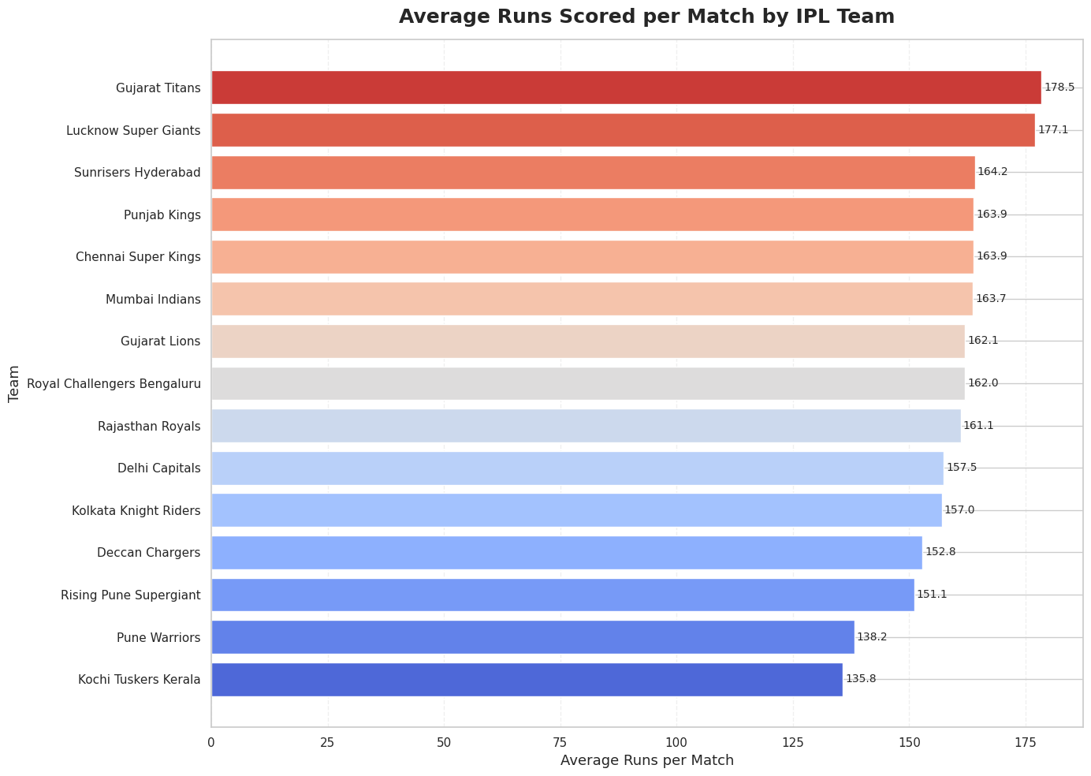
Figure 12. Team-wise average scoring visualization.

10. Key Statistical Summary
Metric | Notebook Result
Total Matches | 1,243
Total Seasons | 19
Standardized Teams | 15
Venue Strings | 60
Most Used Venue | Eden Gardens — 77 matches
Most Common Result Type | Win by Wickets — 660 matches
Overall Average Runs/Match | 323.2
Toss Winner Match Win % | 50.52%
Most Player of the Match Awards | AB de Villiers — 25
Highest Average Team Runs/Match | Gujarat Titans — 178.48

11. Final Interactive / Analytical Dashboard
The final notebook includes a dashboard combining season trends, team performance, toss analysis, result types, Player of the Match awards, venue analysis, winning-margin distributions and team scoring.
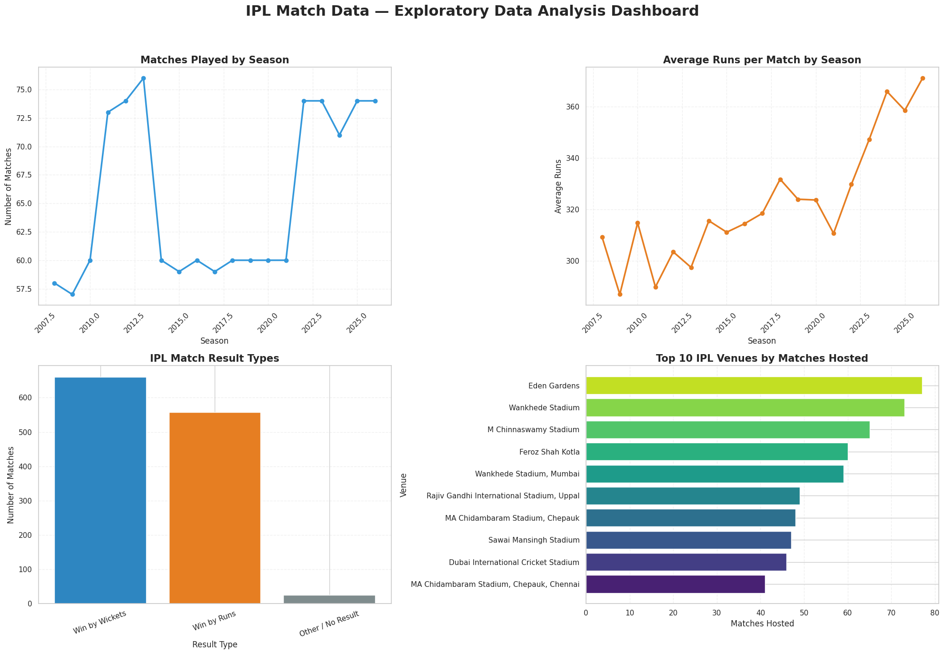
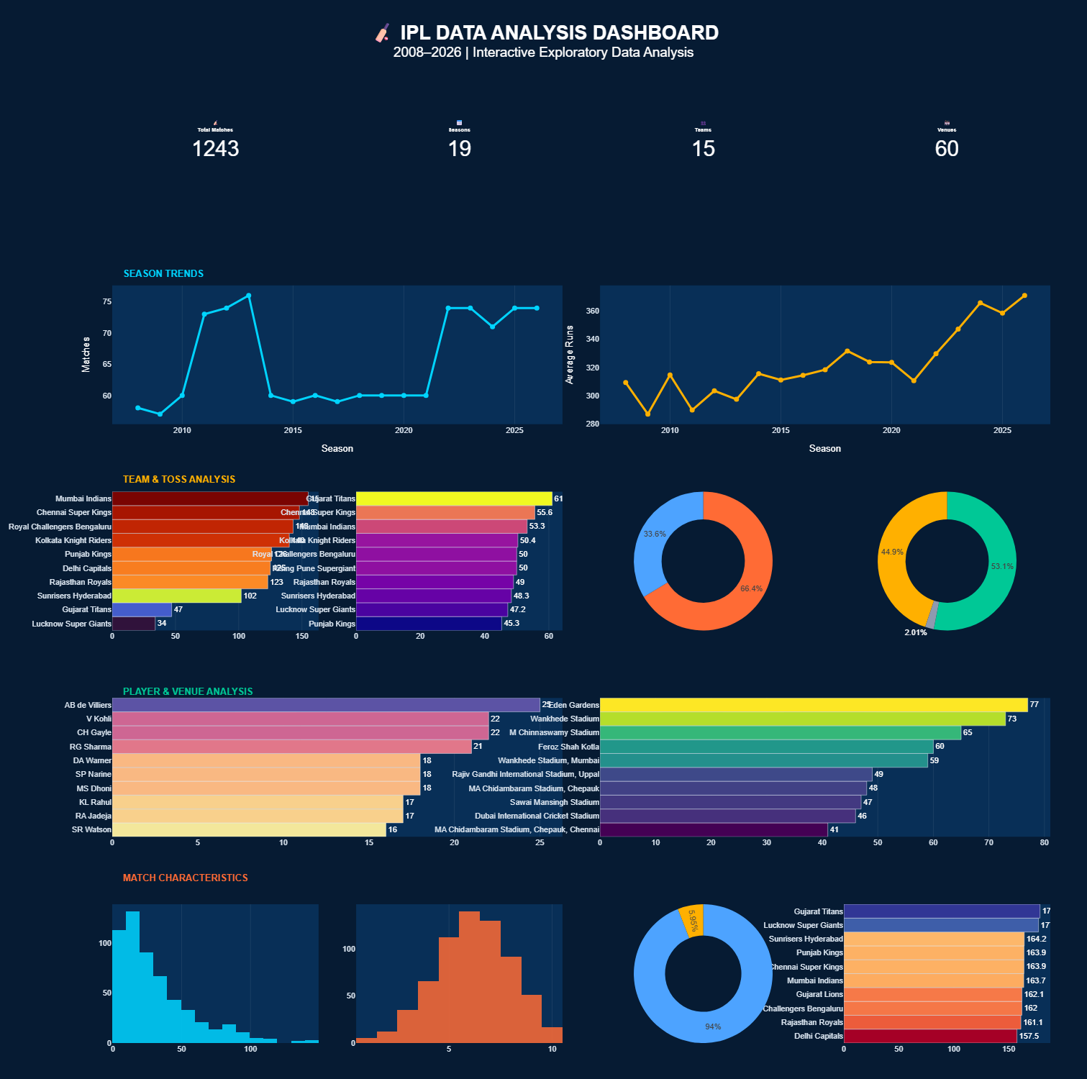

Figure 13. Final IPL EDA dashboard from the uploaded notebook.

12. Observations and Insights

12.1 Direct Observations
- The dataset contains 1,243 match records across 19 seasons from 2008 to 2026.
- No duplicate rows were identified in the notebook's duplicate check.
- There are 74 missing match_number values, and these were intentionally preserved as Playoff / Knockout records.
- After historical team-name standardization, the notebook reports 15 standardized teams.
- Win by wickets accounts for 660 matches (53.10%), while win by runs accounts for 558 matches (44.89%).
- There are 25 matches categorized as Other / No Result (2.01%).
- AB de Villiers has 25 Player of the Match awards in the notebook's award-frequency analysis.
- Eden Gardens is the most frequent venue string in the dataset with 77 matches.
- The toss-winning team won 50.52% of matches overall in the notebook's toss comparison.
- Average runs per match are 371.01 in the 2026 season according to the notebook's season scoring table.

12.2 Interpretation
The analysis shows that IPL match outcomes contain substantial variation across seasons, teams, venues and result types. The scoring analysis also shows variation in average runs per match across seasons. Team-name standardization is important because historical franchise names otherwise fragment team-level statistics. Similarly, venue strings show historical naming variation that could be standardized further in a future version.

13. Limitations
- The analysis is descriptive and does not establish causal relationships.
- Some venue names appear as separate strings even when they refer to the same physical venue.
- The Playoff / Knockout classification is based on meaningful missing match_number values; specific playoff sub-stages are not inferred.
- Team win percentages can be sensitive to the number of matches played.
- Player of the Match award counts do not represent complete player performance.
- Historical scoring comparisons may be affected by changes in match schedules, playing conditions and dataset composition.
- The notebook focuses primarily on match-level data rather than ball-by-ball player performance.

14. Future Scope
- Standardize venue names and create venue-level canonical identifiers.
- Perform ball-by-ball analysis for powerplay, middle overs and death overs.
- Analyze player batting and bowling performance.
- Study strike rate, economy rate and boundary patterns.
- Develop team-vs-team head-to-head analysis.
- Perform venue-specific team performance analysis.
- Build predictive models for match outcomes.
- Develop player performance prediction models.
- Add advanced statistical hypothesis testing.
- Publish the dashboard through a web-based analytics platform.

15. Conclusion
This internship project demonstrates a complete Python-based data analytics workflow on IPL match data. The uploaded notebook successfully moves from dataset inspection and quality checks to cleaning, feature engineering, exploratory analysis, visualization and dashboard-style reporting. The analysis identifies observable patterns in team participation, match outcomes, toss decisions, venues, winning margins, Player of the Match awards and scoring trends.
The project also demonstrates the importance of data-quality decisions. Meaningful missing match numbers were preserved, historical team names were standardized, duplicate records were checked, and descriptive findings were separated from causal claims. These practices improve the reliability and interpretability of the resulting analysis.

16. Technology Stack
Category | Technology
Programming | Python
Data Analysis | Pandas, NumPy
Visualization | Matplotlib, Seaborn, Plotly
Development | Google Colab
Data Preparation | Google Sheets / CSV
Version Control | Git / GitHub

17. References / Project Resources
- Uploaded IPL Data Analysis Google Colab notebook: Gourav_Solanke_IPL2008_26_Data_Analysis.ipynb
- IPL match dataset used in the uploaded notebook.
- Python documentation and package documentation for Pandas, NumPy, Matplotlib, Seaborn and Plotly.

