DIGITAL LOAN ORIGINATION SYSTEM
Process Flow Diagram

Project | Digital Loan Origination System (LOS)
Document Version | 1.1
Author | Gourav (Business Analyst)
Status | Approved

Revision History
Version | Date | Author | Description
1.0 | 14-Jul-2026 | Gourav | Initial swimlane diagram
1.1 | 16-Jul-2026 | Gourav | Redrawn diagram to fix overlapping decision nodes and crossed arrows in the Loan Officer and System lanes

Swimlane Diagram
The diagram below illustrates the end-to-end loan application process across the four participants: Applicant, System (LOS), Credit Bureau, and Loan Officer.
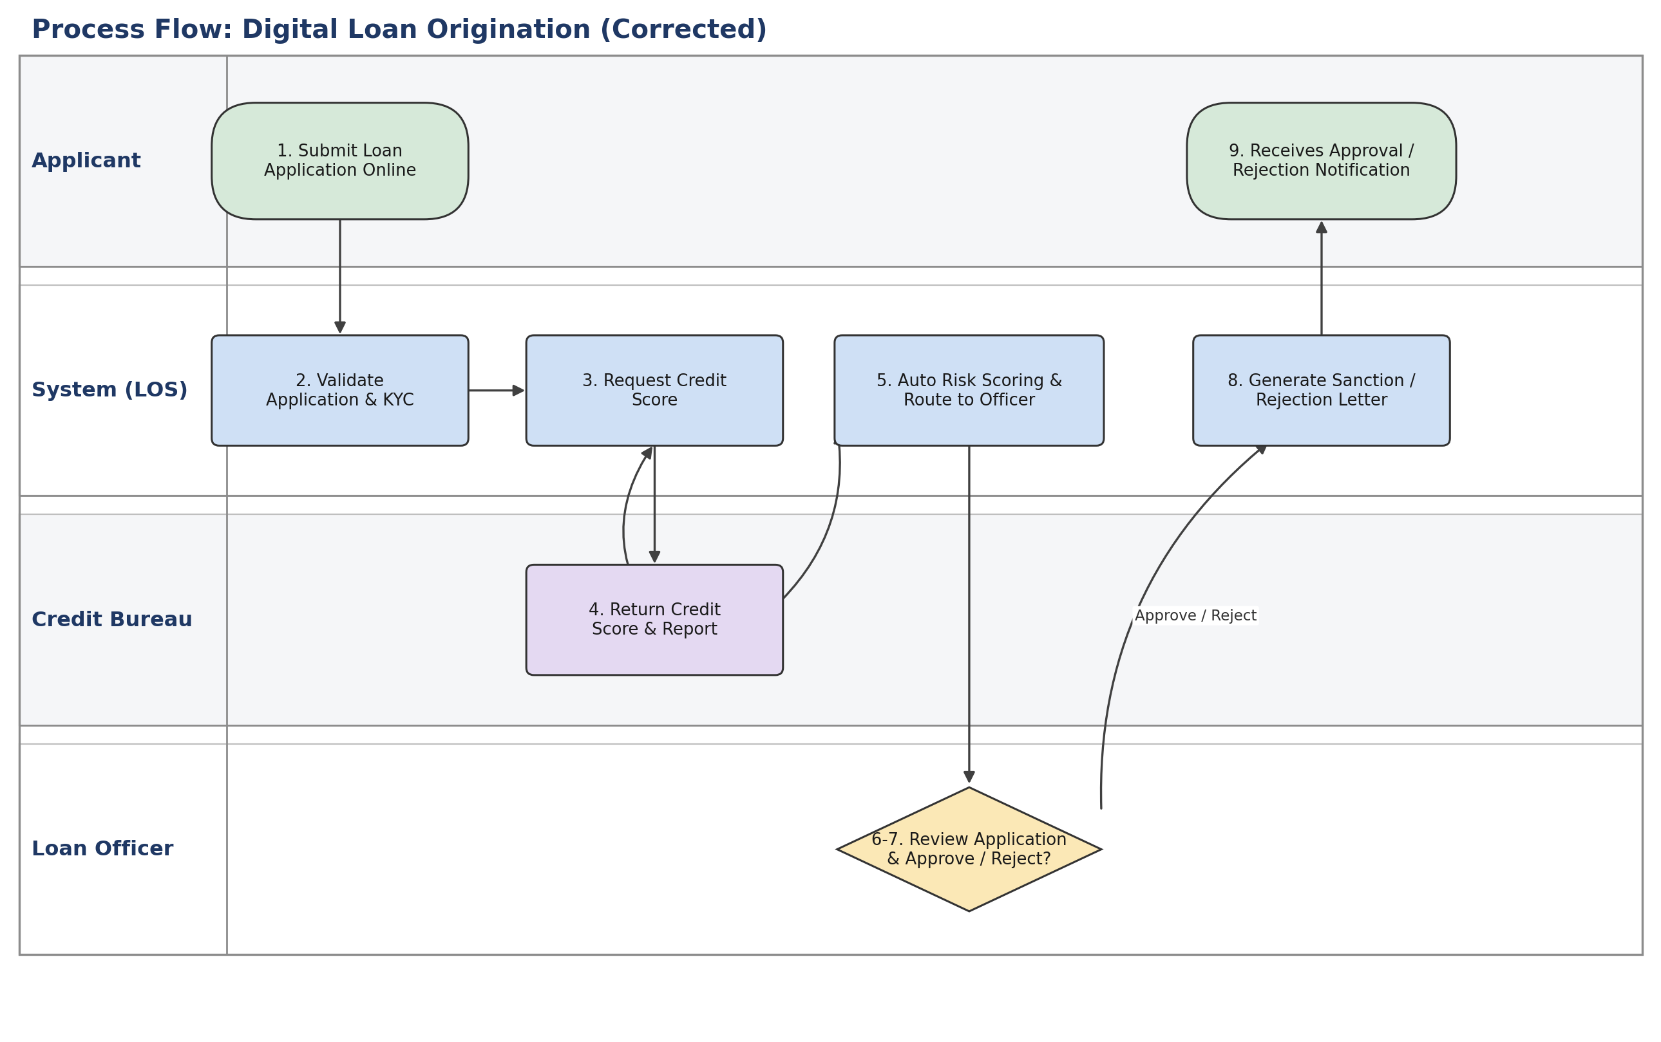

Step Description
Step | Actor | Action
1 | Applicant | Submits the loan application online
2 | System | Validates the application and KYC documents
3 | System | Requests the credit score from the Credit Bureau
4 | Credit Bureau | Returns the credit score and report
5 | System | Runs auto risk scoring and routes the application to a loan officer
6 | Loan Officer | Reviews the application and risk report
7 | Loan Officer | Approves or rejects the application
8 | System | Generates a sanction or rejection letter and notifies the applicant
9 | Applicant | Receives the approval/rejection notification

