DIGITAL LOAN ORIGINATION SYSTEM
Wireframe / Mockup
Document

Project | Digital Loan Origination System (LOS)
Document Version | 1.1
Author | Gourav (Business Analyst)
Status | Approved

Revision History
Version | Date | Author | Description
1.0 | 14-Jul-2026 | Gourav | Initial wireframe
1.1 | 16-Jul-2026 | Gourav | Corrected annotation #3 to resolve inconsistency between the mockup and the functional flow

Screen: Loan Application — Step 2: Loan Details
Tool Used: Low-fidelity wireframe (layout reference only, not final UI).
The wireframe below represents the layout and key UI elements of the loan application screen. It is intentionally low-fidelity — colors, fonts, and spacing will be finalized by the UI/UX team during high-fidelity design.
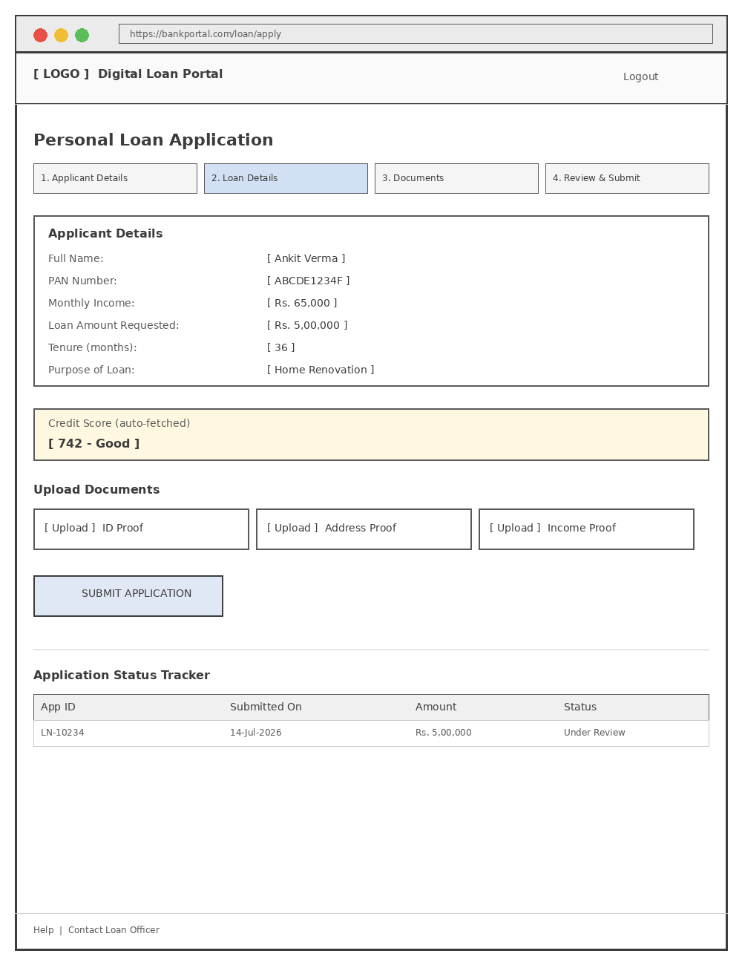

Annotations
# | Element | Notes
1 | Step indicator | Shows the applicant's progress through the 4-step application flow.
2 | Applicant Details panel | Editable fields; PAN validated on blur.
3 | Credit Score panel | Illustrative only on this mockup. Per FR-02.1 the credit score is fetched automatically only after the application is submitted (Step 4), so this panel must not appear — and must not be populated — during Steps 1–3 of the live build.
4 | Document upload cards | Drag-and-drop or click to upload; shows file name once uploaded.
5 | Submit Application button | Disabled until all mandatory fields and documents are complete.
6 | Application Status Tracker | Shown after submission; updates in real time as the application moves through review.
Gap identified during documentation review: the original mockup displayed the Credit Score panel on the same screen as the Loan Details step, which contradicts the functional flow (credit score is only available after submission). Annotation #3 above has been corrected; the high-fidelity design team should confirm the Credit Score panel is removed from Steps 1–3 and only surfaced on the post-submission Status Tracker.

