We have two solutions.

* First solution

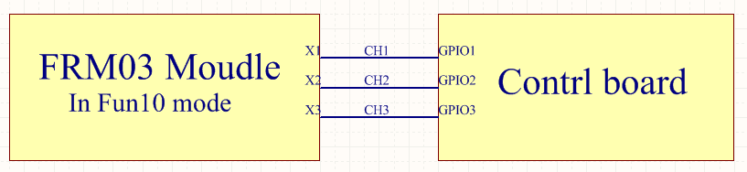

Figure 1 Adding an additional control board

Let's make the FRM03 module work in mode 10. A control board with three input and output ports is connected to X1, X2 and X3 modules. At the same time, this additional control board can set the time length of the specified output channel level, and there are cooperative rules among the three output ports as follows.



Figure 2 Work cycle

1. In 0 to 10 seconds, K1 opens, K2 closes, and K3 closes.
2. In 10 to 20 seconds, K1 closes, K2 opens, and K3 closes.
3. In 20 to 30 seconds, K1 closes, K2 closes, and K3 opens
4. Repeat step 1 to cycle indefinitely over such a period.

**Notes : When the GPIO of the control board is 1, the corresponding K is ON.**

**For this control board, customers can implement it by themselves, or we can help procurement, if the implementation is not found, we suggest to come to us to provide solutions.**

* **Second Solution**



Customized solutions, including user interface, power supply, driver interface and so on, of course, need further communication and negotiation, development, debugging, sample preparation, sample delivery.

If the customer needs to customize, please give us more details, we will have a solution, and then out of the circuit schematic, PCB wiring, software debugging, sample testing, sample validation.