NLP MINI PROJECT REPORT

TENDERIQ: INTELLIGENT TENDER ANALYSIS
Using Natural Language Processing for Tender Information Extraction
Submitted in partial fulfillment of the requirements for
Natural Language Processing (NLP)

Submitted By
Kunal Pandey TEB236
Bhoomika Singh TEB252
Gouri Vastava TEB259
Suraj Yadav TEB263

Submitted To:
Prof. Shobha Lolge

Department of Computer Engineering
Lokmanya Tilak College of Engineering
Academic Year: 2026–27

Abstract
TENDERIQ is a web-based Natural Language Processing project developed to reduce the effort required to review lengthy tender documents. The system accepts tender information in PDF, TXT, or pasted-text form, extracts the textual content, and applies rule-based NLP techniques such as regular-expression pattern matching, keyword matching, and section-based parsing. Important information including tender title, reference number, issuing organization, eligibility criteria, financial requirements, important dates, mandatory documents, disqualification conditions, and risk alerts is extracted and presented in a structured dashboard. The project also generates an executive summary from relevant descriptive sentences and provides a downloadable JSON representation of the analysis. The implementation uses Python, Flask, PyMuPDF, NLTK-related project dependencies, HTML/CSS templates, and rule-based extraction logic. The project demonstrates how practical NLP techniques can convert unstructured procurement text into structured information that is easier to review.

3. Introduction

3.1 Background
Tender and procurement documents contain large amounts of information distributed across different sections. A bidder may need to identify eligibility conditions, financial obligations, deadlines, mandatory documents, and disqualification clauses before deciding whether to participate. Manual reading of long documents can be time-consuming and important conditions may be overlooked.

3.2 Problem Statement
The project addresses the problem of extracting important tender information from semi-structured PDF or text documents. The objective is not to replace the complete tender document, but to provide a quick structured view of important requirements and possible risks.

3.3 Objectives
- Accept tender information through PDF, TXT, or pasted text.
- Extract text from uploaded documents.
- Identify important tender fields using NLP-based rules and regular expressions.
- Organize extracted information into meaningful categories.
- Generate risk alerts for non-compliance and financial requirements.
- Generate a short executive summary from relevant tender statements.
- Display results through a simple web dashboard and allow JSON download.

3.4 Scope
The current scope is focused on English tender documents with recognizable headings, keywords, and textual patterns. The implementation is rule-based and is intended as a practical NLP demonstration. It is not a general-purpose semantic understanding system.

4. Literature Review
Natural Language Processing has been widely used for converting unstructured text into machine-readable information. Classical information extraction approaches use lexical patterns, dictionaries, regular expressions, and rule-based systems. These approaches are useful when the target documents have predictable headings and terminology, as is common in forms and structured business documents.

4.1 Related Work 1 – Rule-Based Information Extraction
Rule-based information extraction identifies predefined entities or fields using linguistic patterns and domain-specific rules. For tender documents, patterns such as “Reference No”, “Eligibility Requirements”, “EMD”, and “Submission Deadline” can be used to locate useful information.

4.2 Related Work 2 – Natural Language Toolkit
NLTK provides Python-based facilities for text processing and experimentation, including tokenization, stemming, tagging, and corpus handling. The project uses the Python NLP ecosystem and follows the practical rule-based approach rather than training a machine-learning model.

4.3 Related Work 3 – Document Text Extraction
PDF text extraction libraries allow downstream NLP methods to operate on the textual content of documents. In this project, PyMuPDF is used to extract text from PDF files before the information extraction stage.

4.4 Research / Implementation Gap
A generic NLP pipeline may extract text but does not necessarily present the information in a form useful for tender review. TENDERIQ focuses on a domain-specific information extraction layer that organizes procurement information into practical categories such as eligibility, finance, dates, documents, and alerts.

5. Methodology

5.1 System Workflow

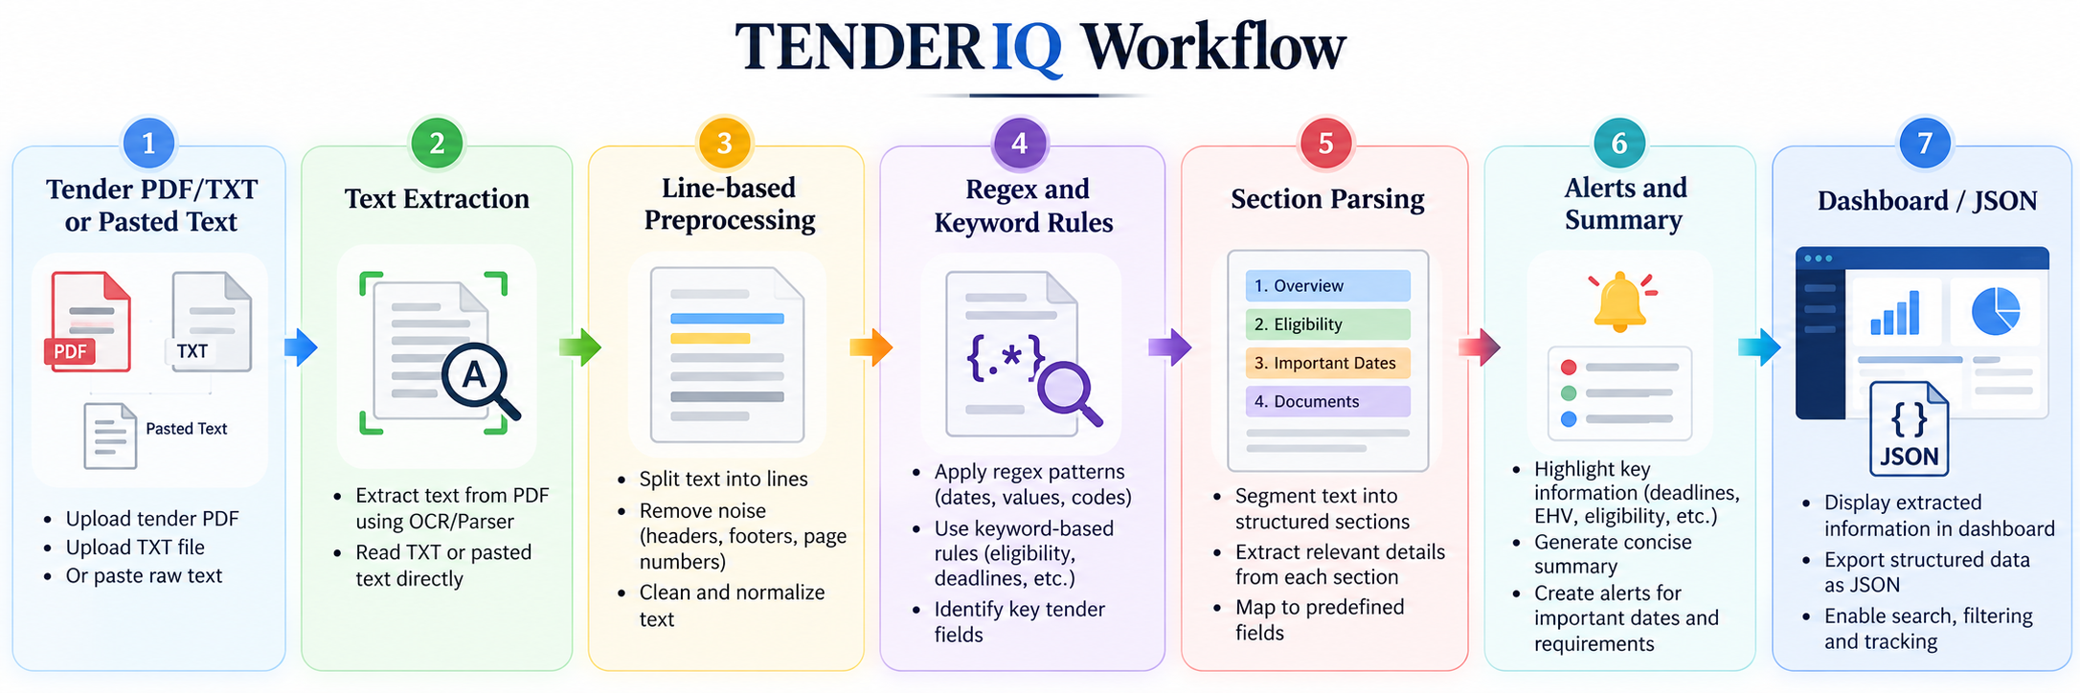

5.2 Input Layer
The Flask application provides an analysis form. A user can paste tender text, upload a TXT file, or upload a PDF file. The application limits accepted uploaded extensions to PDF and TXT and stores uploaded files temporarily for processing.

5.3 Text Extraction and Preprocessing
For PDF input, the preprocessing module uses PyMuPDF to read the pages and combine their textual content. TXT files are read using UTF-8 encoding. The extracted text is then split into non-empty, stripped lines. This line representation is used by the rule-based extraction pipeline.

5.4 Overview Extraction
Regular expressions search for patterns associated with the tender title, reference number, and issuing organization. For example, title patterns include “Tender Title”, “Title”, and “Subject”, while reference patterns include “Tender Reference Number”, “Ref No”, and related variants.

5.5 Section-Based Extraction
The extraction engine maintains a current section while scanning the document line by line. When it encounters words related to eligibility, financial requirements, mandatory documents, or disqualification, subsequent lines are assigned to the corresponding category until another section begins.

5.6 Date Extraction
Lines containing keywords such as date, deadline, submission, opening, and schedule are collected as potentially important dates. This provides a quick list of publication, submission, and opening information when such phrases occur in the source document.

5.7 Financial and Eligibility Fallback Rules
If an explicit section is not found, fallback keyword rules are used. Eligibility fallback terms include phrases such as “must be”, “must possess”, “turnover”, and “experience”. Financial fallback terms include “INR”, “EMD”, “fee”, “payment”, and “deposit”.

5.8 Risk Alerts
The system creates a Risk Warning when disqualification information or blacklisting language is detected. It creates a Financial Alert when EMD or deposit-related information is detected. These alerts are intended to draw attention to potentially important tender conditions.

5.9 Executive Summary
The summary module selects relatively long lines containing terms related to objectives, scope, procurement, supply, installation, requirements, projects, or infrastructure. Up to a small number of relevant sentences are combined to form an executive summary. This is extractive and rule-based.

5.10 Output Structure
The extraction function returns a structured object containing overview information, eligibility, financial requirements, dates, mandatory documents, disqualification information, alerts, keywords, and summary text. The Flask layer sends this structure to the results template and also saves a JSON file.
6. Implementation & Results

6.1 Tools and Technologies
Component | Technology | Purpose
Backend | Python + Flask | Web routing, forms, file handling and result rendering
PDF Processing | PyMuPDF | Extract text from PDF documents
NLP Logic | Python regex + keyword/rule-based parsing | Information extraction and alerts
Frontend | HTML/CSS templates | Input form and result dashboard
Data Output | JSON | Downloadable structured analysis
Dependencies | Flask, NLTK, PyMuPDF, Werkzeug | Project runtime and NLP/document processing support

6.2 Input Interface
The analysis interface allows the user to paste tender text or upload a PDF/TXT document before starting extraction.
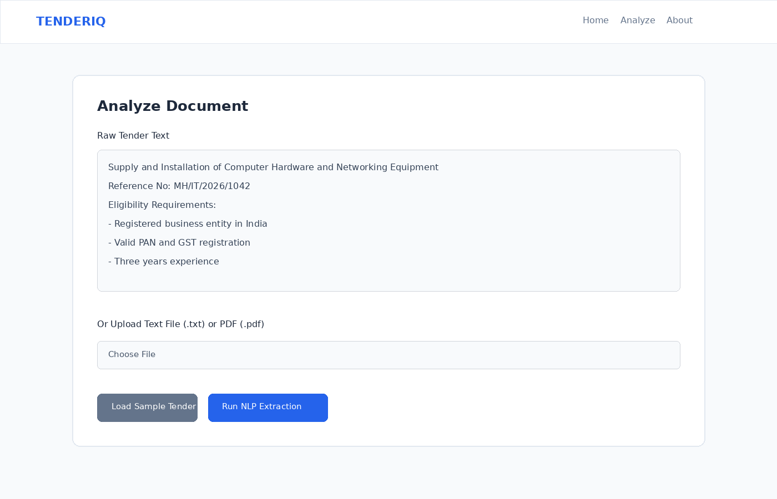
Figure 1. TENDERIQ document analysis input interface (sample project output).

6.3 Sample Processing
For the sample test document, the system identified the tender title as “Construction and Improvement of Internal Roads”, the reference number as “PWD/MH/2026/2085”, and the issuing organization as “Public Works Department, Maharashtra”. It also detected eligibility criteria, financial requirements, dates, mandatory documents, and risk alerts.

6.4 Output Dashboard
The extracted information is displayed in separate dashboard sections so that a user can review important conditions without scanning the entire document.
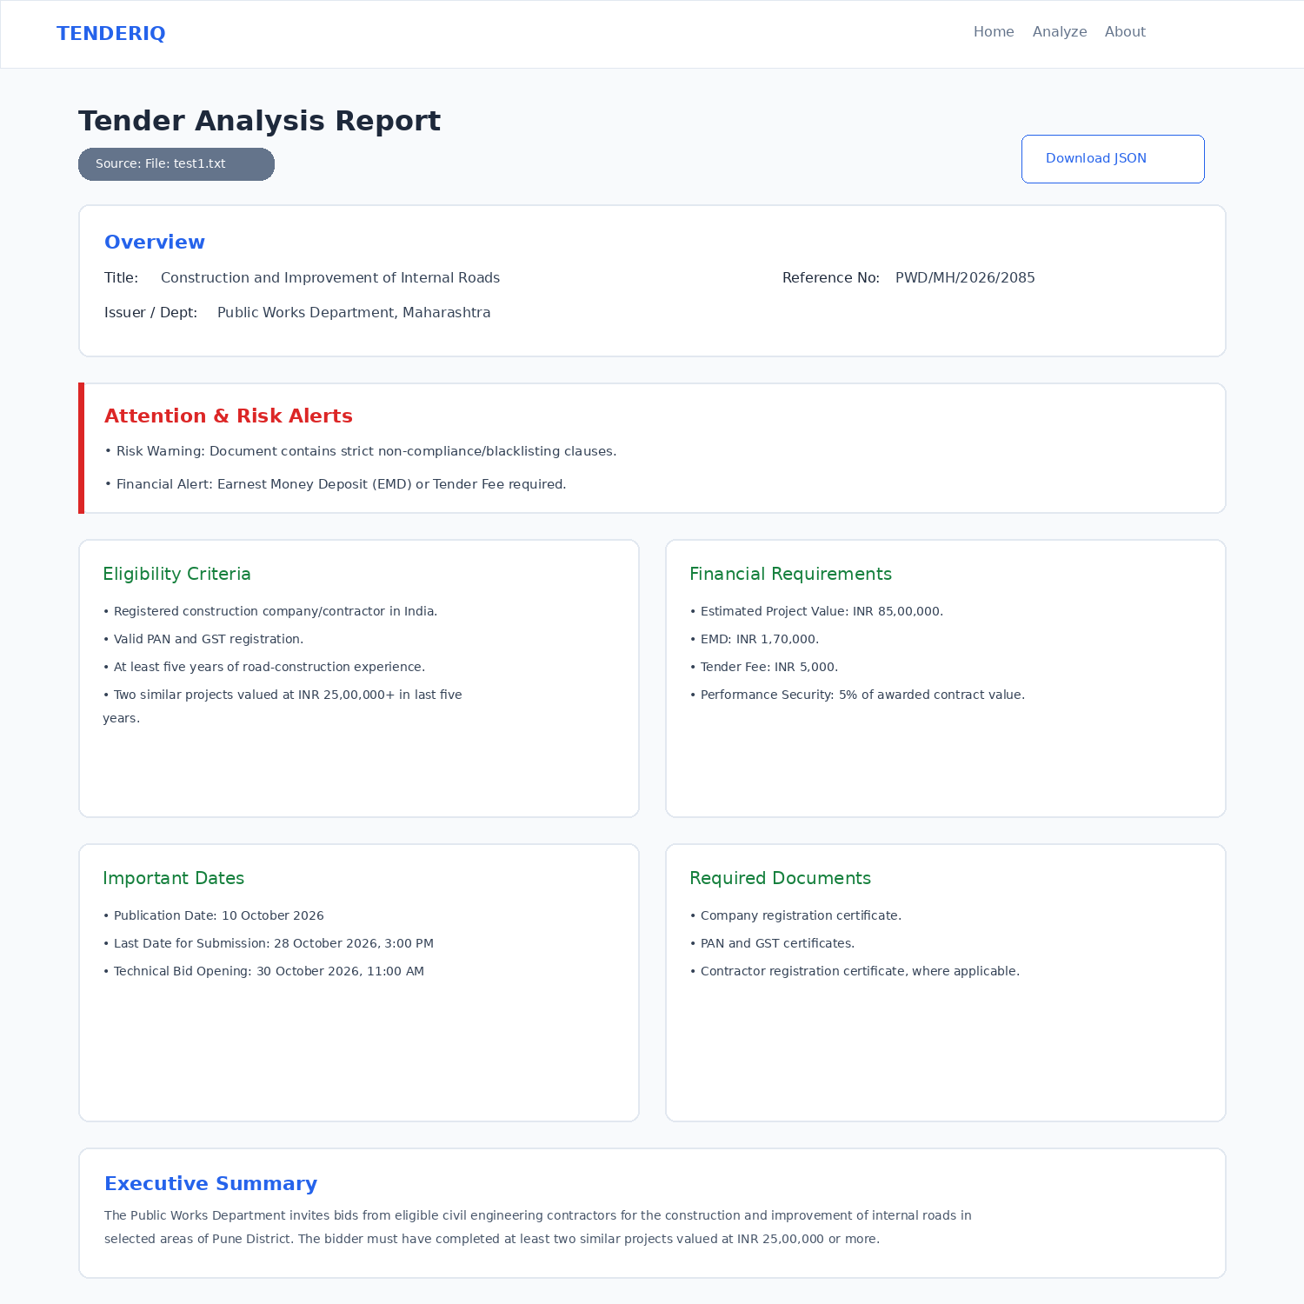
Figure 2. TENDERIQ extracted-result dashboard showing overview, alerts, eligibility, financial requirements, dates, documents and summary.

6.5 Observed Results
- Tender metadata such as title, reference number, and issuing organization can be extracted from matching labels.
- Eligibility and financial clauses are grouped using section headings and fallback keywords.
- Important date-related lines are collected for quick review.
- Mandatory document and disqualification sections are extracted when recognizable headings are present.
- Risk alerts are generated when blacklisting/disqualification or EMD/deposit language is detected.
- An executive summary is produced from relevant descriptive sentences.
- The complete extraction result can be stored and downloaded in JSON format.

6.6 Limitations Observed
The current implementation depends on recognizable English headings and keywords. Because it is rule-based, unusual wording, scanned-image PDFs, or documents with substantially different structures may reduce extraction quality. The current implementation does not use a trained machine-learning classifier, transformer model, semantic embedding model, or a general question-answering model.

7. Conclusion
TENDERIQ demonstrates a practical application of Natural Language Processing for domain-specific document analysis. The project converts tender documents into text and applies regular-expression, keyword, and section-based rules to extract useful information. The resulting dashboard provides a structured view of tender metadata, eligibility, financial requirements, dates, documents, disqualification conditions, risk alerts, and an executive summary. The project shows that even a lightweight rule-based NLP pipeline can reduce the effort needed for initial tender review.

8. Future Scope
- Use Named Entity Recognition (NER) to identify organizations, dates, amounts, locations, and other entities more robustly.
- Add machine-learning or transformer-based information extraction for documents with varied wording.
- Add OCR support for scanned PDF documents.
- Use semantic similarity or embeddings to retrieve relevant tender clauses.
- Add a question-answering interface so users can ask questions such as “What is the submission deadline?”
- Support multilingual tender documents.
- Improve date normalization and validation.
- Add confidence scores for extracted fields.
- Improve table extraction for tender documents containing tabular schedules and financial data.
- Add user history and secure persistent storage if deployed for multiple users.

9. References
1. Bird, S., Klein, E., & Loper, E. Natural Language Processing with Python: Analyzing Text with the Natural Language Toolkit. O’Reilly Media.
2. Jurafsky, D., & Martin, J. H. Speech and Language Processing. Pearson / draft online editions.
3. NLTK Documentation – Natural Language Toolkit, Python NLP toolkit.
4. PyMuPDF Documentation – Python library for PDF processing and text extraction.
5. Flask Documentation – Python web framework used for the project backend.
6. Python Documentation – Regular expression operations (re module).
7. TENDERIQ project source code and sample tender data supplied for the NLP mini-project.

10. Appendix

10.1 Important Code Logic
The main Flask analysis route accepts an uploaded file or pasted text and then calls the NLP extraction function. The core extraction function scans the text line by line and uses regular-expression patterns and section rules to construct the output object.
# Main NLP processing call
extraction_result = extract_information(raw_text)
# Simplified extraction idea
lines = [line.strip() for line in text.split("\n") if line.strip()]
# Example: detect a tender title
title_match = re.search(
r'(?:Tender Title|Title|Subject)\s*[:\-]\s*(.+)',
text,
re.IGNORECASE
)

10.2 Sample Output Fields
- overview: title, reference, issuing organization and summary
- eligibility: extracted eligibility conditions
- financial: extracted financial requirements
- dates: detected date-related lines
- mandatory_docs: required document lines
- disqualification: extracted disqualification/condition lines
- alerts: generated risk and financial alerts
- summary: executive summary text

