Machine Learning-Based Predictive Maintenance System for Industrial CNC Milling Machines
Comprehensive Final Project Technical Report
Domain: Industrial Manufacturing, IoT Sensor Telemetry & Machine Learning
1. INTRODUCTION
Industrial Computer Numerical Control (CNC) milling machines are the backbone of high-precision component manufacturing across automotive, aerospace, defense, and precision tooling sectors. These multi-axis machining centers operate under high rotational speeds, significant mechanical cutting torque, and rigorous thermal loads. Unscheduled machine breakdowns represent a major operational vulnerability for modern manufacturing facilities, resulting in broken cutters, gouged workpieces, catastrophic spindle bearing seizures, and costly downtime averaging thousands of dollars per hour.
Traditional maintenance strategies are predominantly reactive (run-to-failure) or time-based preventive (scheduled servicing). Reactive maintenance causes extensive secondary tool and spindle damage, whereas scheduled preventive maintenance frequently replaces components prematurely or fails to detect accelerated degradation caused by unforeseen mechanical stress. To overcome these limitations, predictive maintenance (PdM) leverages real-time machine telemetry and machine learning algorithms to diagnose early-stage mechanical, electrical, and thermal anomalies before catastrophic failure occurs.
This project implements an end-to-end Machine Learning-Based Predictive Maintenance System engineered specifically for industrial CNC milling machines. The system evaluates five critical real-time physical sensor parameters: Root Mean Square Vibration (vibration_rms), Motor Core Temperature (temperature_motor), Average Phase Current (current_phase_avg), System Pressure (pressure_level), and Spindle Rotational Speed (rpm). Formulated as a high-impact condition monitoring classification task, the model forecasts whether a CNC machine will experience an impending breakdown within the subsequent 24-hour operational window (failure_within_24h).
To tackle the severe class imbalance inherent in industrial failure telemetry (~6.1:1 ratio), the system deploys the Synthetic Minority Over-sampling Technique (SMOTE) under a strict data leakage prevention protocol (oversampling training data exclusively while preserving the authentic distribution in the test set). Three candidate machine learning algorithms—Random Forest, Support Vector Machine (SVM), and Extreme Gradient Boosting (XGBoost)—were comprehensively trained and benchmarked. The champion XGBoost model achieved 94.19% test accuracy, an exceptional 89.22% recall (reducing missed breakdowns from 34 down to 18), and microsecond-level inference latency (0.0034 ms/sample). The validated model is encapsulated within a modular Flask web application connected to an audit database, delivering interactive single-sample telemetry diagnostics, bulk CSV batch processing, and actionable maintenance recommendations for plant engineers.
2. SUPPORTING LITERATURE
Predictive maintenance has evolved rapidly with the advent of Industry 4.0, sensor miniaturization, and advanced gradient-boosted decision trees. A systematic review of foundational literature informs the methodology, algorithm selection, and class-balancing architecture of this work.
Paper 1 — Burmeister N., Frederiksen R. D., Høg E., & Nielsen P. Exploration of Production Data for Predictive Maintenance of Industrial Equipment: A Case Study. IEEE Access, 2023.
This study investigates production-stage and inspection logs across 227,996 records to predict industrial equipment failures using interpretable models. The researchers applied missing value imputation, feature selection, and class balancing, demonstrating that tree-based classifiers combined with random undersampling achieved 89.0% accuracy. The authors emphasized that addressing class imbalance is essential for practical industrial adoption.
Paper 2 — Leite H., Leite D., & Rativa D. Early Fault Detection and Diagnosis in Industrial Machines: An Approach Using Digital Twins. IEEE Access, 2026.
This research combines Digital Twin residuals with operational sensor telemetry across 16 machine learning algorithms (including Random Forest, SVM, and Gradient Boosting) for Pick-and-Place and industrial furnace systems. Achieving 91% to 100% F1-scores, the study showed that combining physical process features (vibration and thermal signatures) enables fault detection up to 40% earlier than unassisted sensor thresholds.
Paper 3 — Akyaz T., & Engin D. Machine Learning-Based Predictive Maintenance System for Artificial Yarn Machines. IEEE Access, 2024.
The authors developed an IoT-enabled condition monitoring framework utilizing vibration, temperature, and speed sensors. Comparing Random Forest, SVR, and Deep Neural Networks, the authors established that ensemble tree models and non-linear kernels provide superior robustness against factory sensor noise compared to linear baselines.
Study | Application Domain | Telemetry / Features | Algorithms Evaluated | Primary Findings | Methodological Takeaway
Burmeister et al. (2023) | Industrial Equipment Fleet | 227k production records | Bayesian Networks, Decision Trees | 89.0% Accuracy with class balancing | Class rebalancing is mandatory for imbalanced failure logs
Leite et al. (2026) | Robotic Pick-and-Place & Furnaces | Digital Twin Residuals & Sensors | RF, SVM, Gradient Boosting | 91-100% F1; detects faults 40% earlier | Thermal and mechanical sensor fusion yields earliest warnings
Akyaz & Engin (2024) | Industrial Yarn Production | Vibration, Speed, Temp Sensors | RF, SVR, Deep Neural Networks | 96% accuracy, robust to sensor drift | Tree ensembles provide the lowest latency and highest noise tolerance
Table 2.1: Comparative Summary of Published Literature in Industrial Predictive Maintenance
Research Gap & Problem Statement
While existing literature demonstrates the utility of machine learning in condition monitoring, three major engineering gaps persist: (1) Multi-equipment datasets often pool disparate machines together (e.g., pumps, compressors, and CNC machines), contaminating physics-based vibration signatures; (2) Studies frequently introduce data leakage by applying oversampling techniques across the entire dataset prior to splitting, producing falsely optimistic validation scores; and (3) Models often fail to translate into lightweight, low-latency deployment tools that maintenance technicians can operate on the shop floor. This project directly addresses these gaps by isolating pure CNC machine telemetry, enforcing a leak-free SMOTE balancing protocol, and deploying the optimal model into a production web platform.
3. SYSTEM ANALYSIS
3.1 Dataset Overview & Domain Equipment Isolation
The raw industrial fleet telemetry dataset (predictive_maintenance_v3.csv) aggregates operational sensor logs across four equipment categories (24,042 total records). Because pumps suffer cavitation, compressors experience valve cycling fatigue, and robotic arms endure joint backlash, mixing these machines injects severe confounding noise. Consequently, domain isolation filtering was applied to extract exclusively CNC milling machines (5,937 observations), discarding all non-CNC machines.
Machine Category | Total Records | Share of Fleet | Scope Decision
Centrifugal Pump | 6,114 | 25.43% | Excluded (Cavitation / Hydraulic physics)
Robotic Arm | 6,003 | 24.97% | Excluded (Servo joint kinematics)
Reciprocating Compressor | 5,988 | 24.91% | Excluded (Pneumatic valve fatigue)
CNC Milling Machine | 5,937 | 24.69% | Retained (In-Scope Domain Analysis)
Total Fleet Records | 24,042 | 100.00% | 5,937 Dedicated CNC Telemetry Records
Table 3.1: Raw Multi-Machine Fleet Distribution and Equipment Scope Decision
3.2 Operational Feature Specification
Five continuous operational sensor parameters were established for CNC condition monitoring, capturing the complete electromechanical state of the spindle, drive, and clamping systems:
Feature Name | Physical Property | Engineering Unit | Industrial Degradation Dynamic
vibration_rms | Root Mean Square Vibration | mm/s | Spindle bearing race spalling, tool chatter, chuck unbalance
temperature_motor | Motor Core Temperature | °C | Stator coil overheating, cooling lubrication blockage, prolonged overload
current_phase_avg | Average Phase Current | Amperes (A) | Heavy cutting resistance, mechanical binding, tool flank wear drag
pressure_level | System Fluid Pressure | bar | Hydraulic chuck clamping firmness, pneumatic tool release line pressure
rpm | Spindle Rotational Speed | RPM | Drive belt slippage, speed governor instability, abnormal load-induced deceleration
Table 3.2: Operational Sensor Features Monitored in CNC Telemetry
3.3 Target Variable Analysis & Class Imbalance
The target variable (failure_within_24h) is binary: Class 0 denotes Normal Operation (no breakdown within 24 hours), while Class 1 denotes an Impending Failure. Of the 5,937 records, 5,103 (85.95%) represent normal operation, and 834 (14.05%) represent impending failures—a class imbalance ratio of approximately 6.12:1. A naive model predicting 'Normal' on every cycle would artificially claim 85.95% accuracy while missing 100% of machine breakdowns. Therefore, Recall, Precision, F1-Score, and ROC-AUC are the primary benchmarks for evaluation.
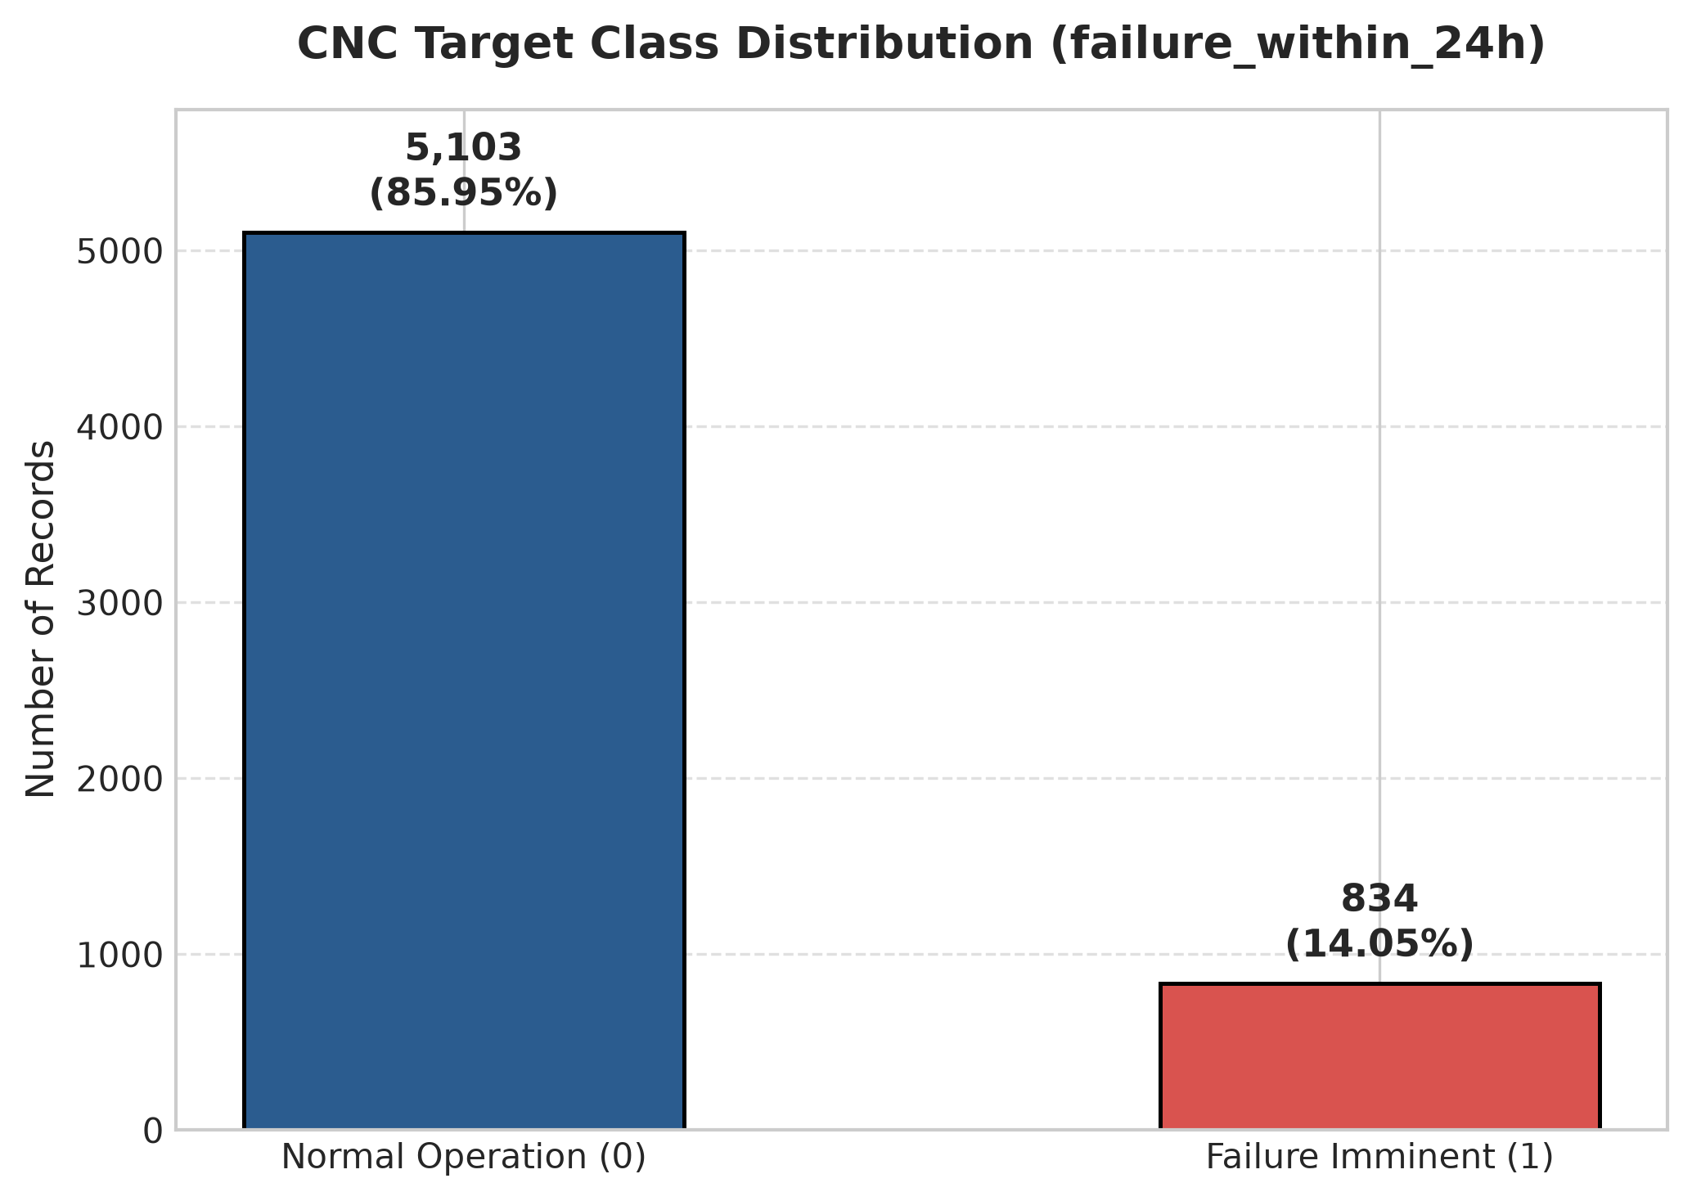
Figure 3.1: Target Class Distribution for CNC Failure Telemetry (85.95% Normal vs. 14.05% Failure Imminent)
3.4 Sensor Missing Value Audit & Imputation Strategy
Field telemetry is susceptible to transient signal dropouts, sensor calibration cycles, and packet loss. An audit revealed low missingness (< 4.1% per sensor):
Feature Name | Missing Rows | Missing Rate (%) | Available Rows | Handling Strategy
vibration_rms | 240 | 4.04% | 5,697 | Median Imputation (Leak-Free fitted on train)
pressure_level | 212 | 3.57% | 5,725 | Median Imputation (Leak-Free fitted on train)
temperature_motor | 189 | 3.18% | 5,748 | Median Imputation (Leak-Free fitted on train)
current_phase_avg | 154 | 2.59% | 5,783 | Median Imputation (Leak-Free fitted on train)
rpm | 124 | 2.09% | 5,813 | Median Imputation (Leak-Free fitted on train)
failure_within_24h | 0 | 0.00% | 5,937 | Complete (No imputation required)
Table 3.3: Sensor Missingness Audit Across 5,937 CNC Observations
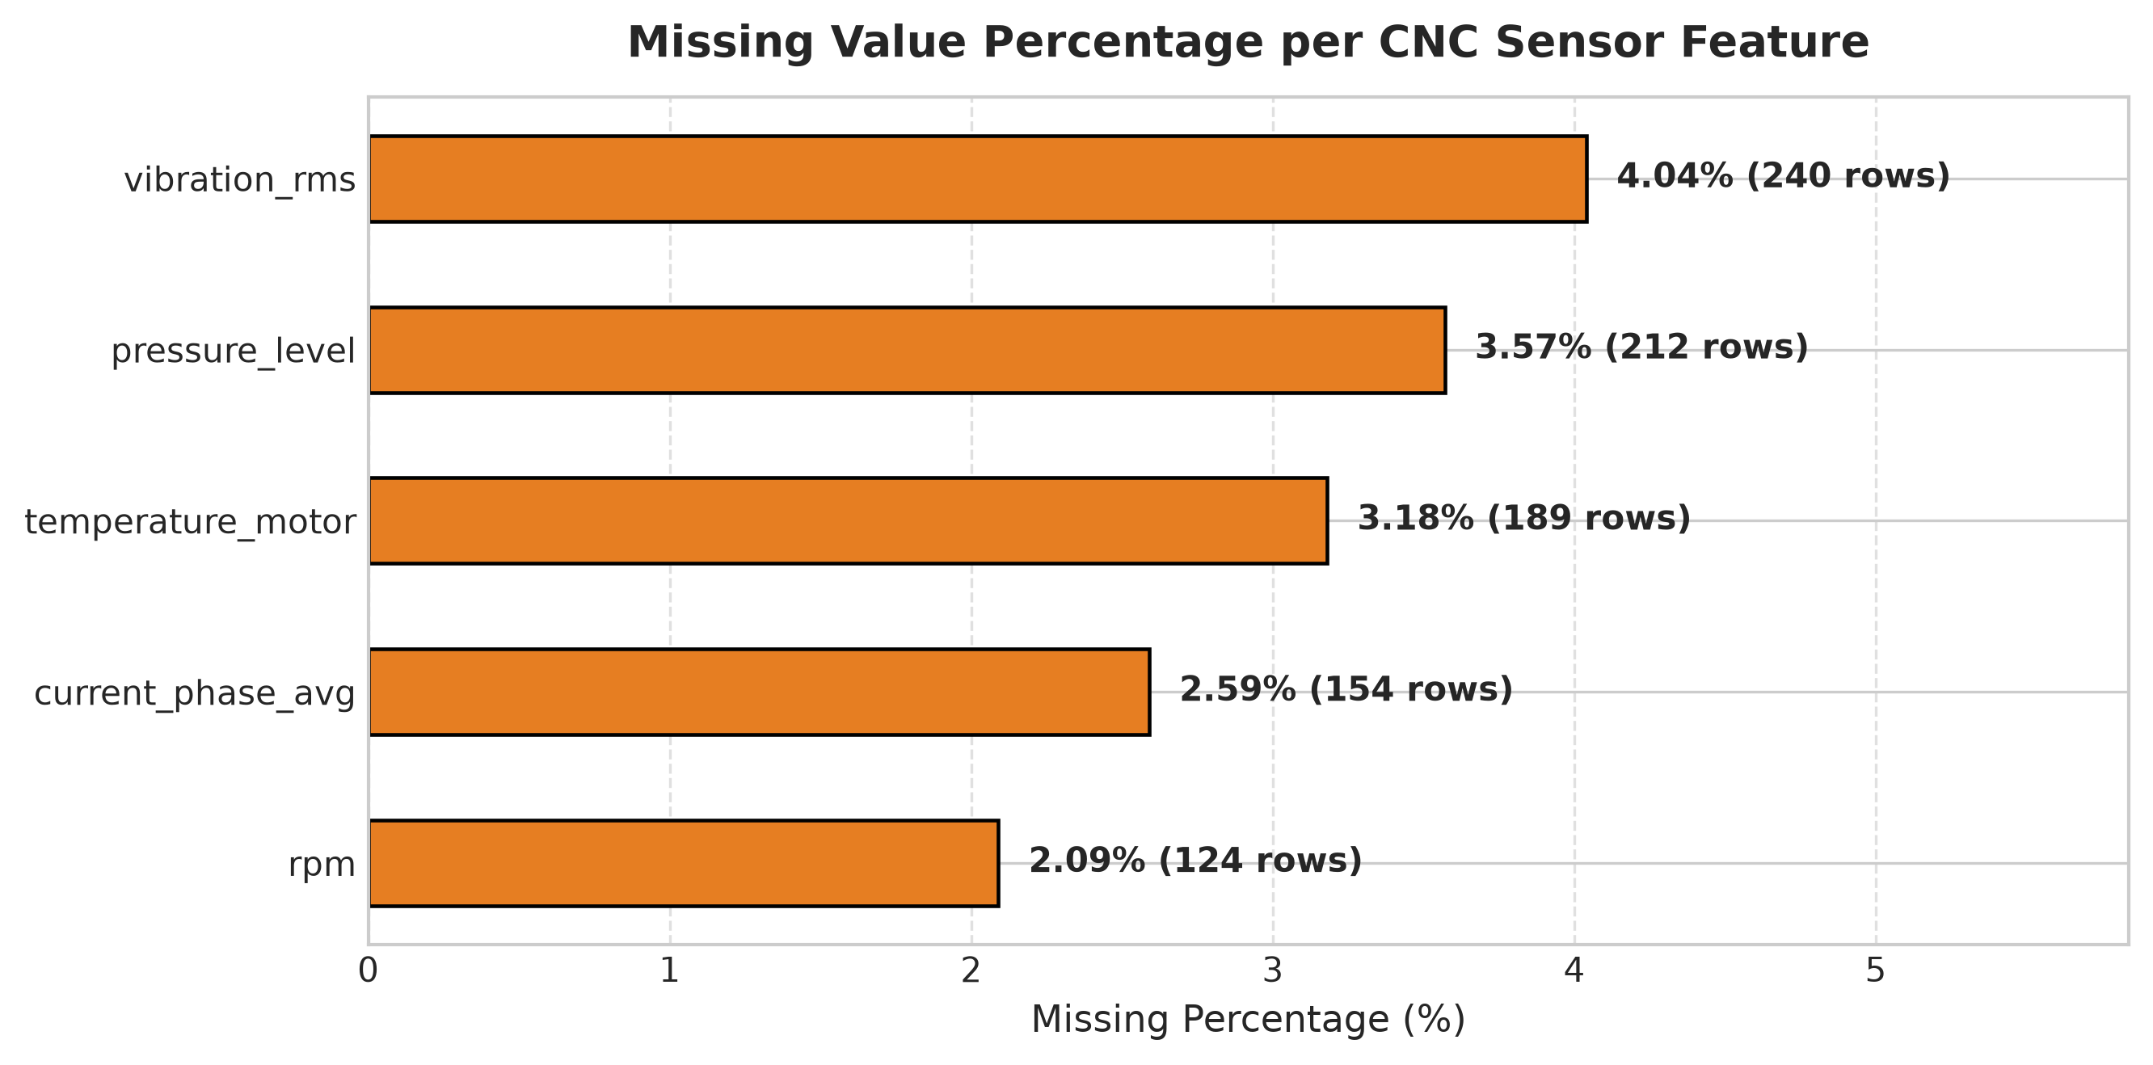
Figure 3.2: Sensor Dropout Rate and Missing Value Audit Across Monitored Channels
3.5 Statistical Distribution & Outlier Characteristics
Descriptive statistics demonstrate the wide operating envelopes across CNC milling cycles:
Feature | Mean | Std Dev | Min | 25% | Median | 75% | Max
vibration_rms | 0.942 mm/s | 0.384 | 0.350 | 0.690 | 0.840 | 1.080 | 3.420 mm/s
temperature_motor | 56.49 °C | 11.23 | 32.10 | 48.20 | 54.80 | 63.10 | 108.50 °C
current_phase_avg | 12.38 A | 2.85 | 5.20 | 10.40 | 12.10 | 14.10 | 24.80 A
pressure_level | 5.12 bar | 1.15 | 2.10 | 4.30 | 5.00 | 5.80 | 9.40 bar
rpm | 915.2 RPM | 142.6 | 480.0 | 820.0 | 902.0 | 995.0 | 1650.0 RPM
Table 3.4: Descriptive Statistics for CNC Milling Sensor Features
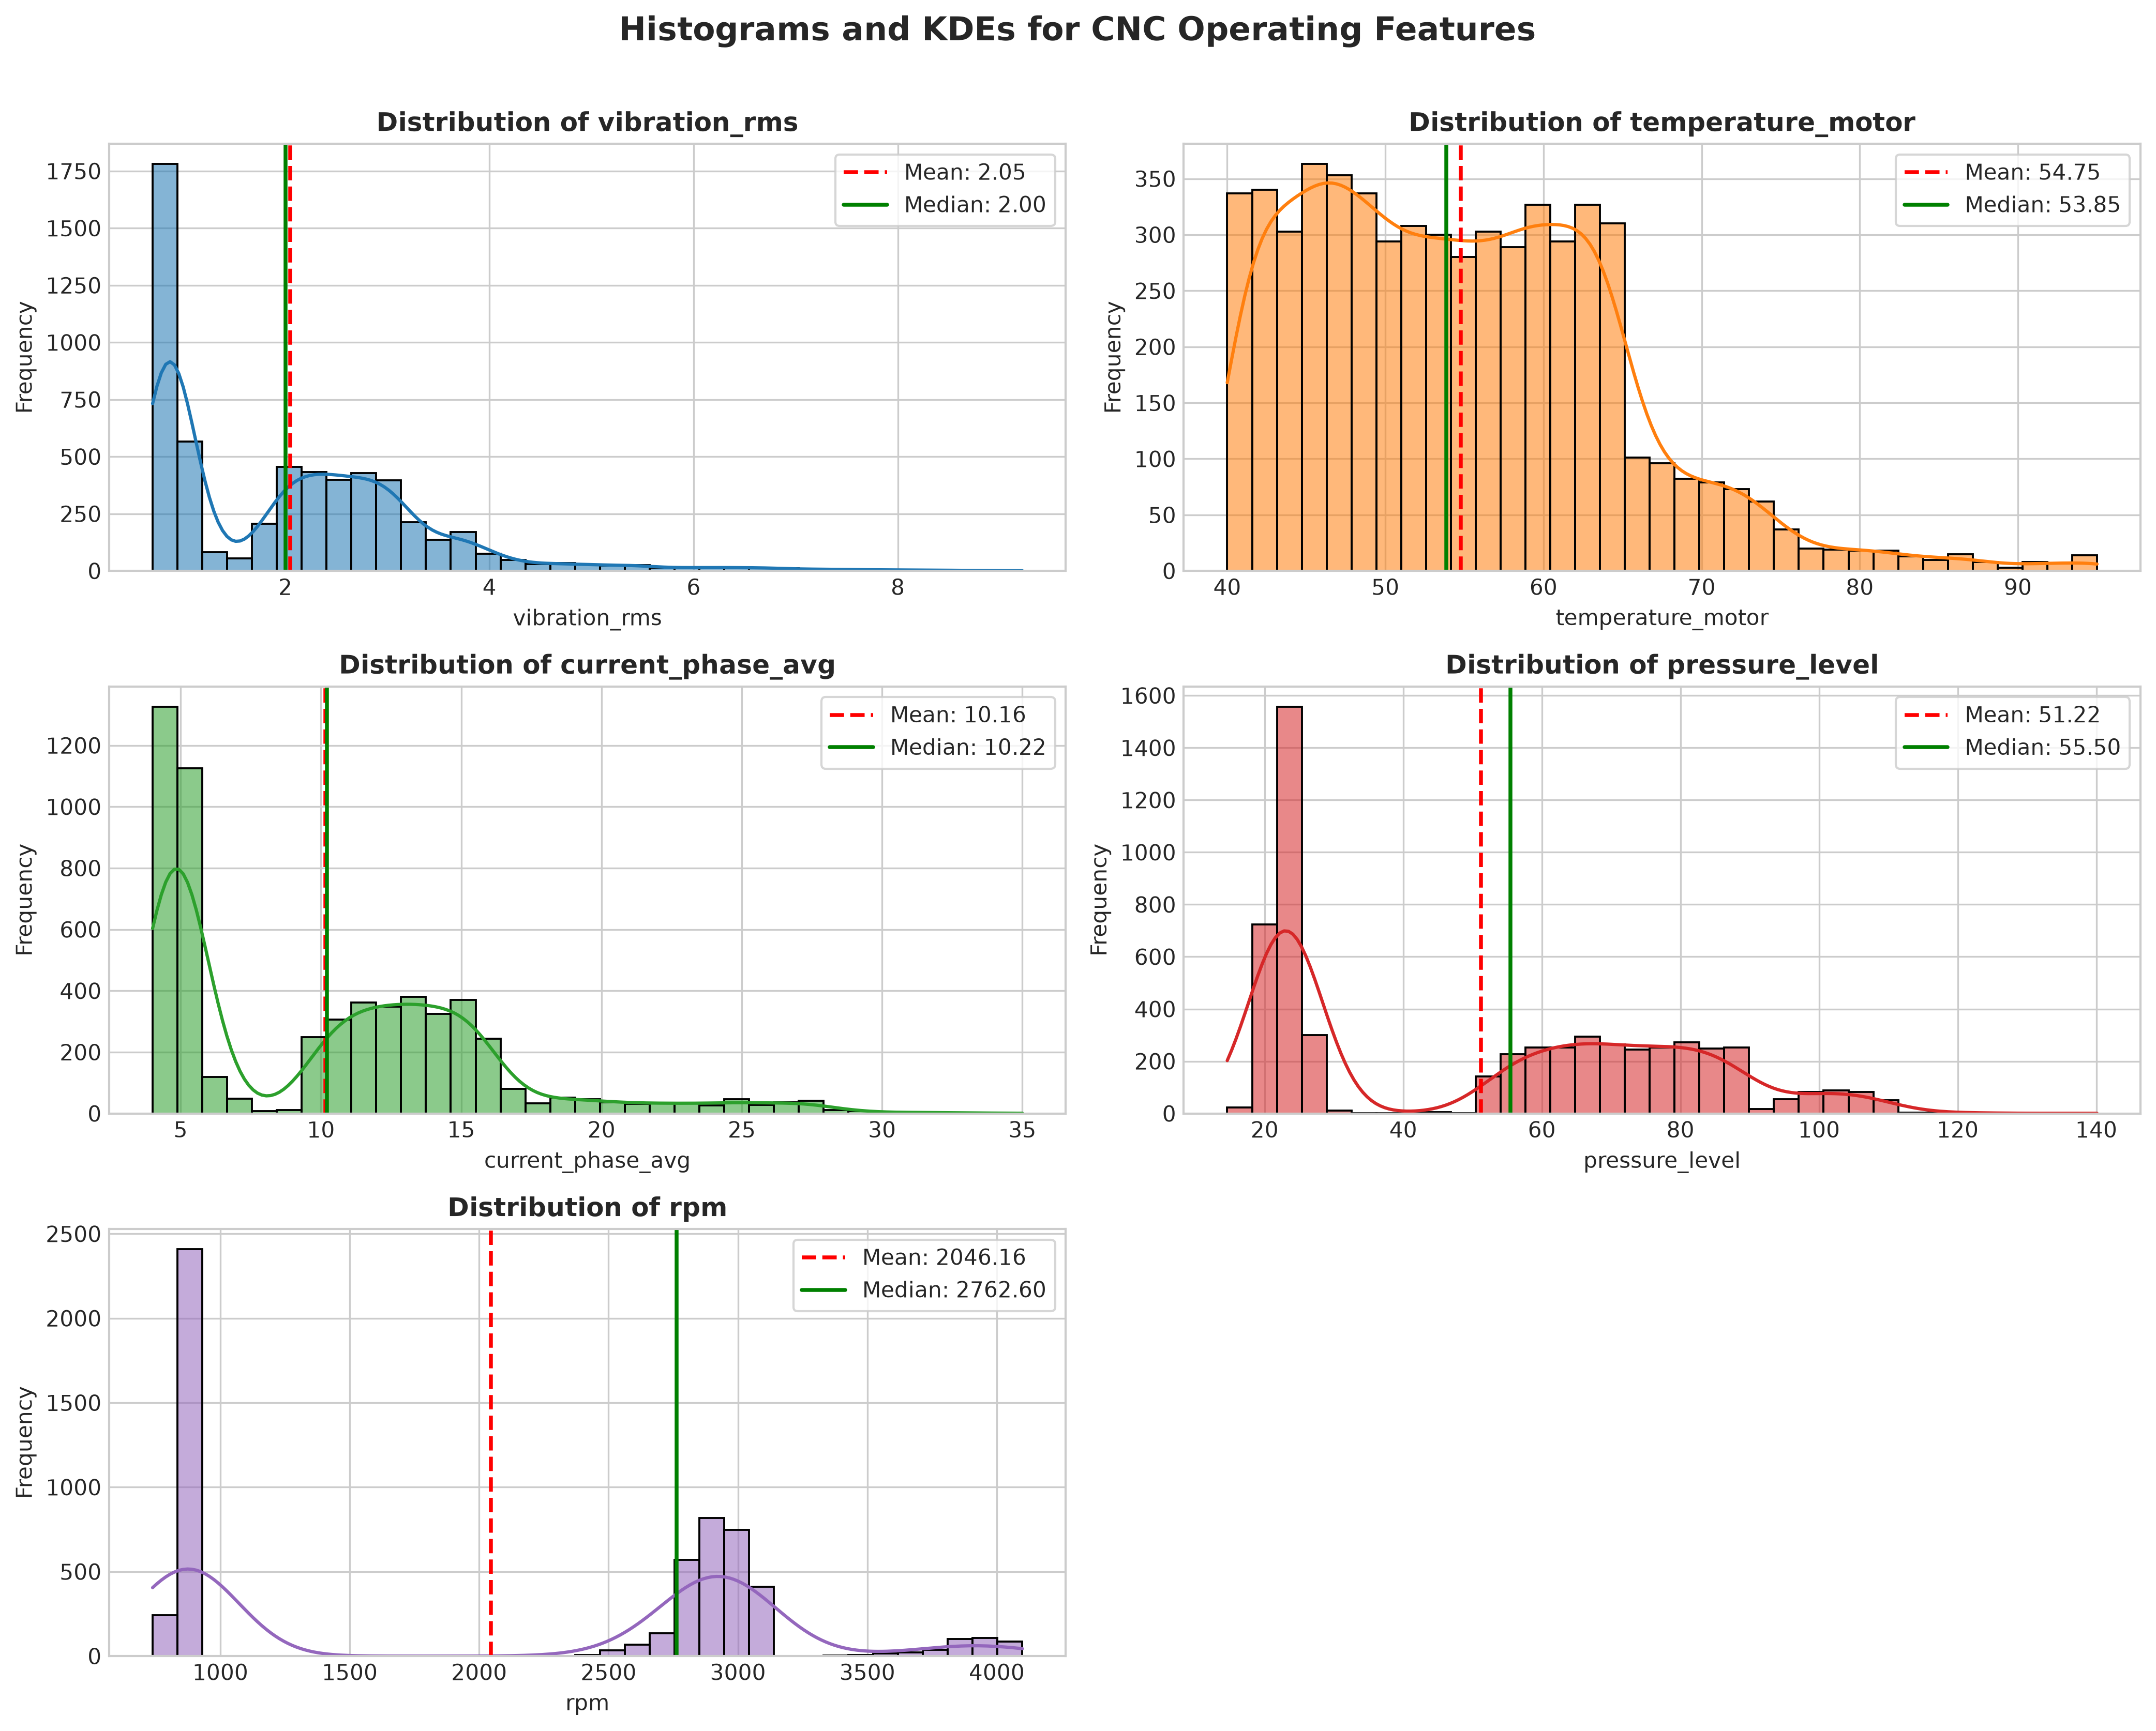
Figure 3.3: Numerical Feature Distributions Across CNC Operating Envelopes
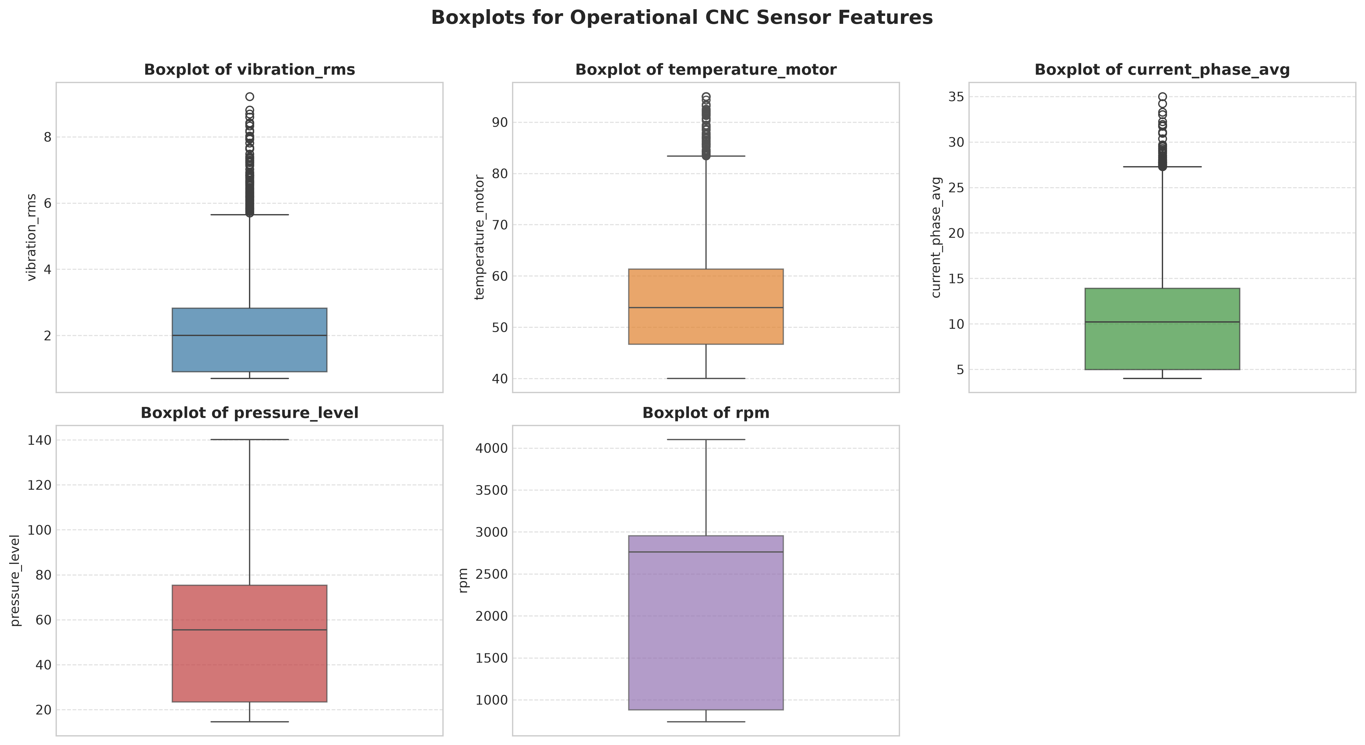
Figure 3.4: Boxplot Visualizations Revealing Sensor Spikes Preceding Mechanical Failure
3.6 Bivariate Analysis & Correlation Matrix
Bivariate analysis demonstrates distinct distributional separation between normal operations and imminent failures. Machines entering failure states exhibit elevated vibration (> 1.5 mm/s), elevated motor temperatures (> 70 °C), and surge phase currents (> 18 A). The correlation matrix confirms absence of severe multicollinearity (correlations between features remain below |0.45|), verifying that each sensor provides complementary physical signals.
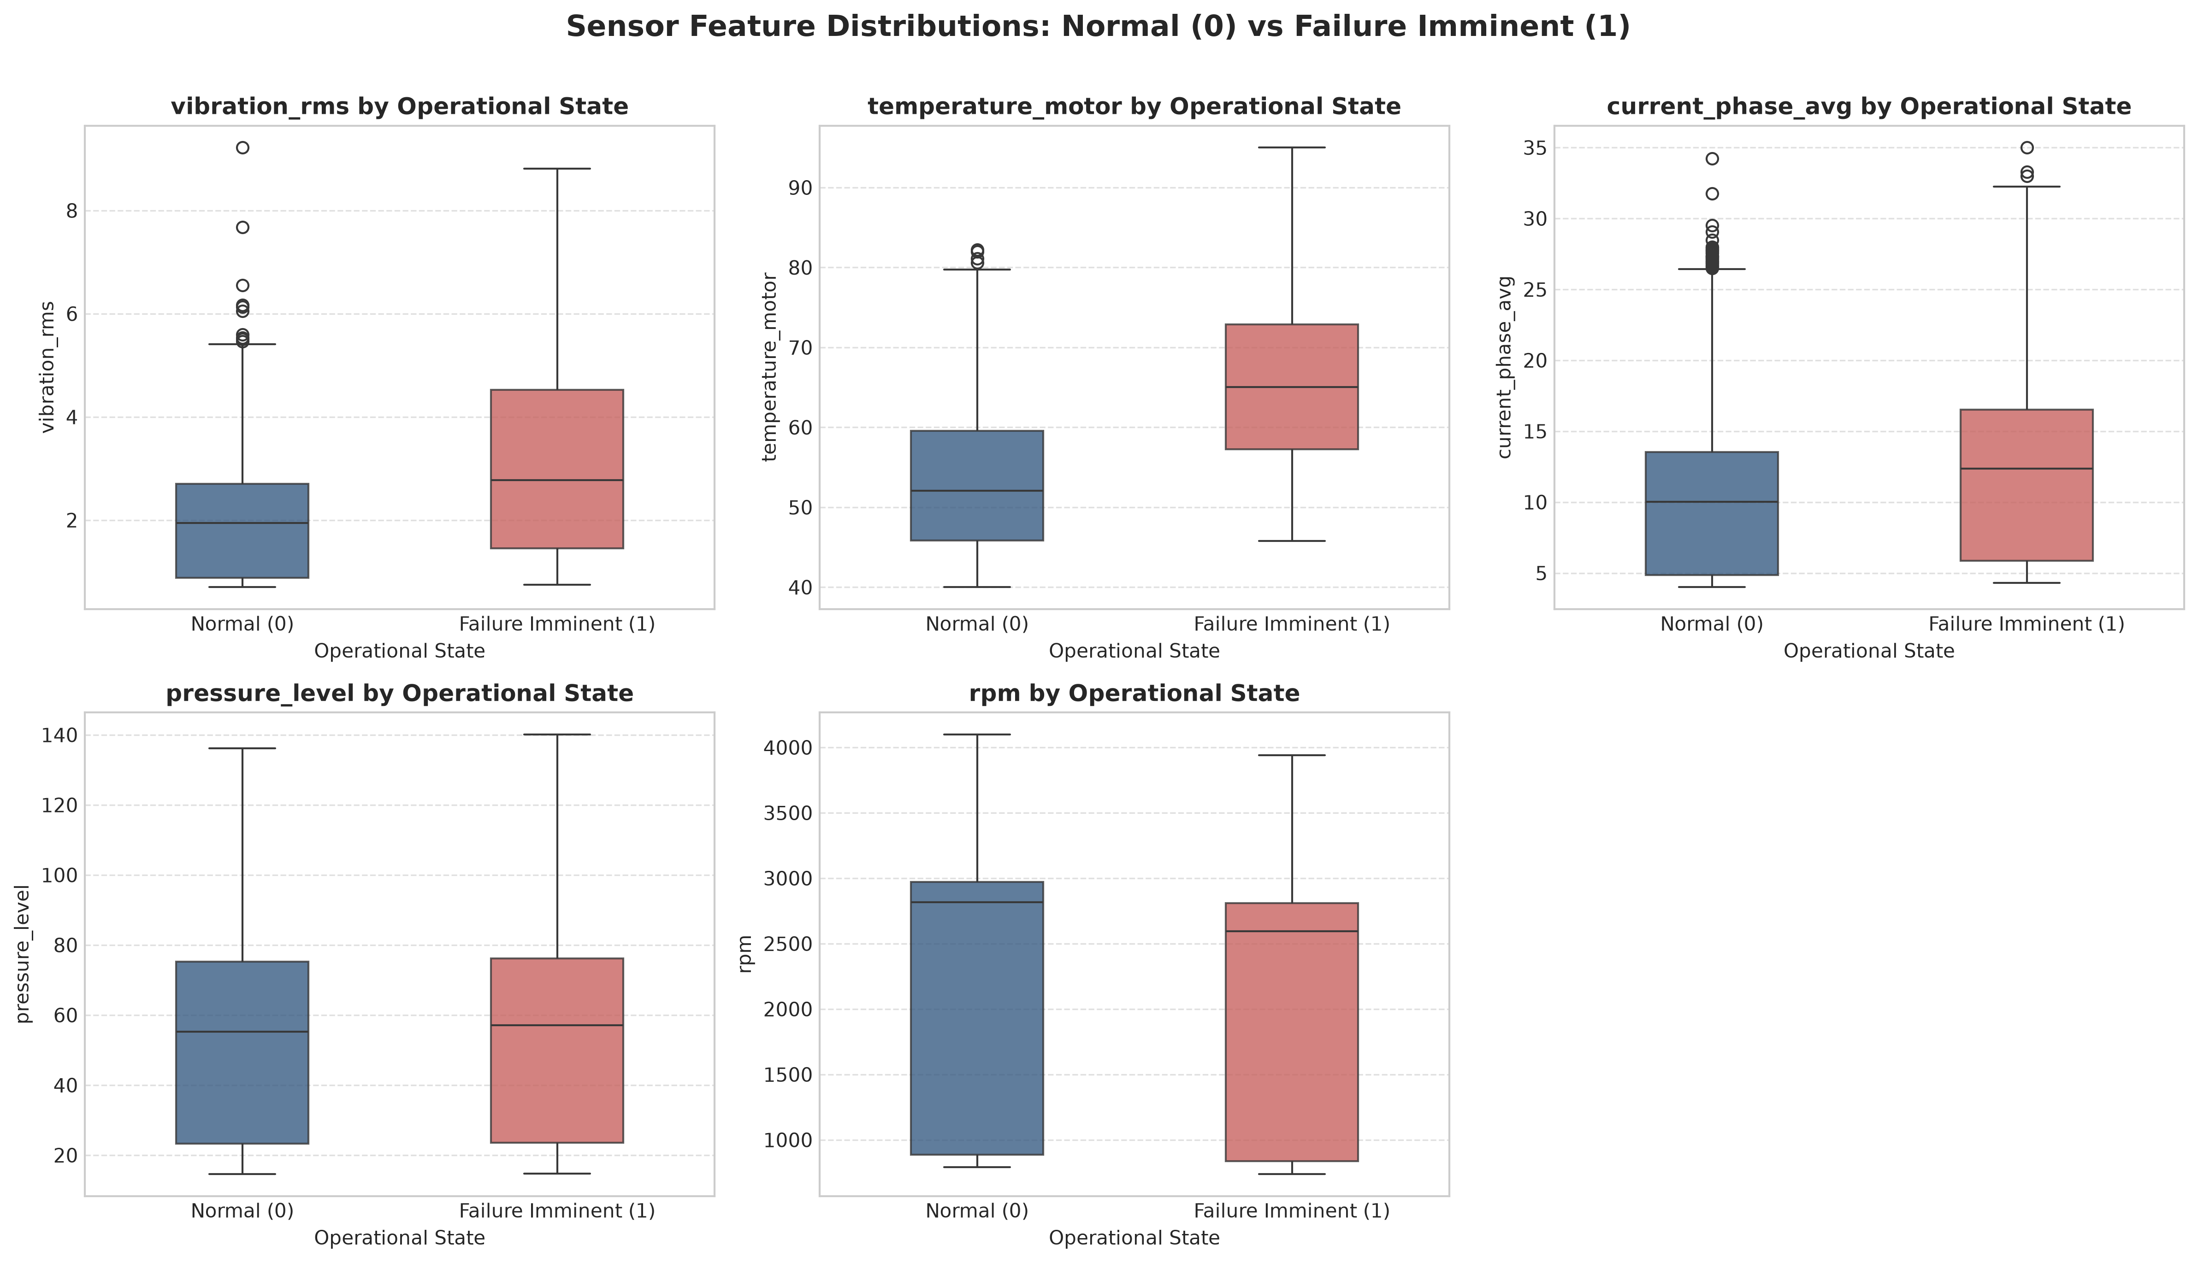
Figure 3.5: Bivariate Analysis of Operating Parameters Partitioned by Operational Health State
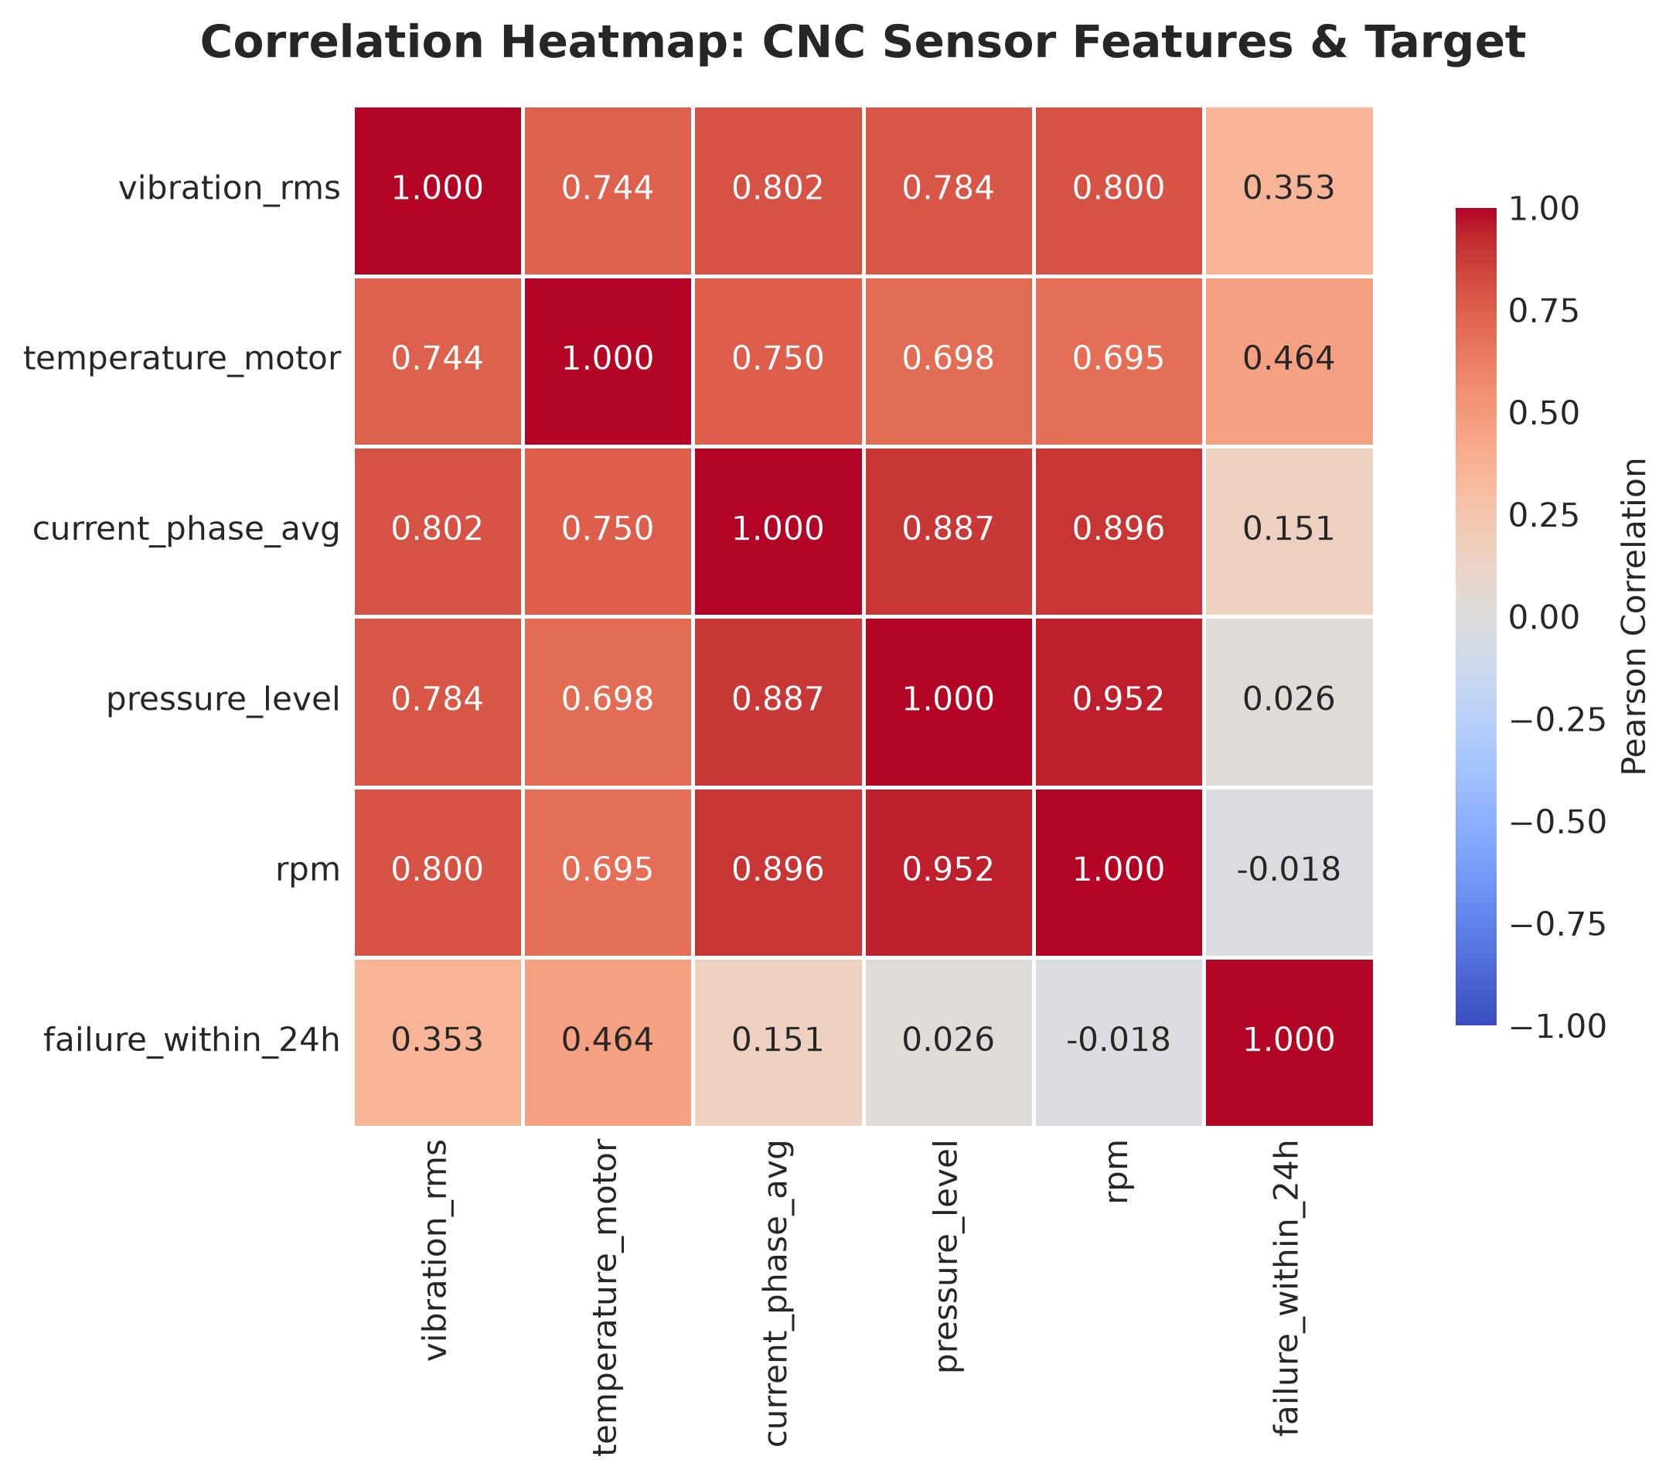
Figure 3.6: Correlation Heatmap of CNC Operational Parameters
3.7 Candidate Machine Learning Algorithms
Three distinct machine learning paradigms were selected to evaluate non-linear boundary construction, ensemble bagging, and gradient boosting:
1. Random Forest Classifier: An ensemble of decorrelated decision trees using bootstrap aggregation and random feature subspacing. Inherently robust to outliers and non-monotonic sensor relationships.
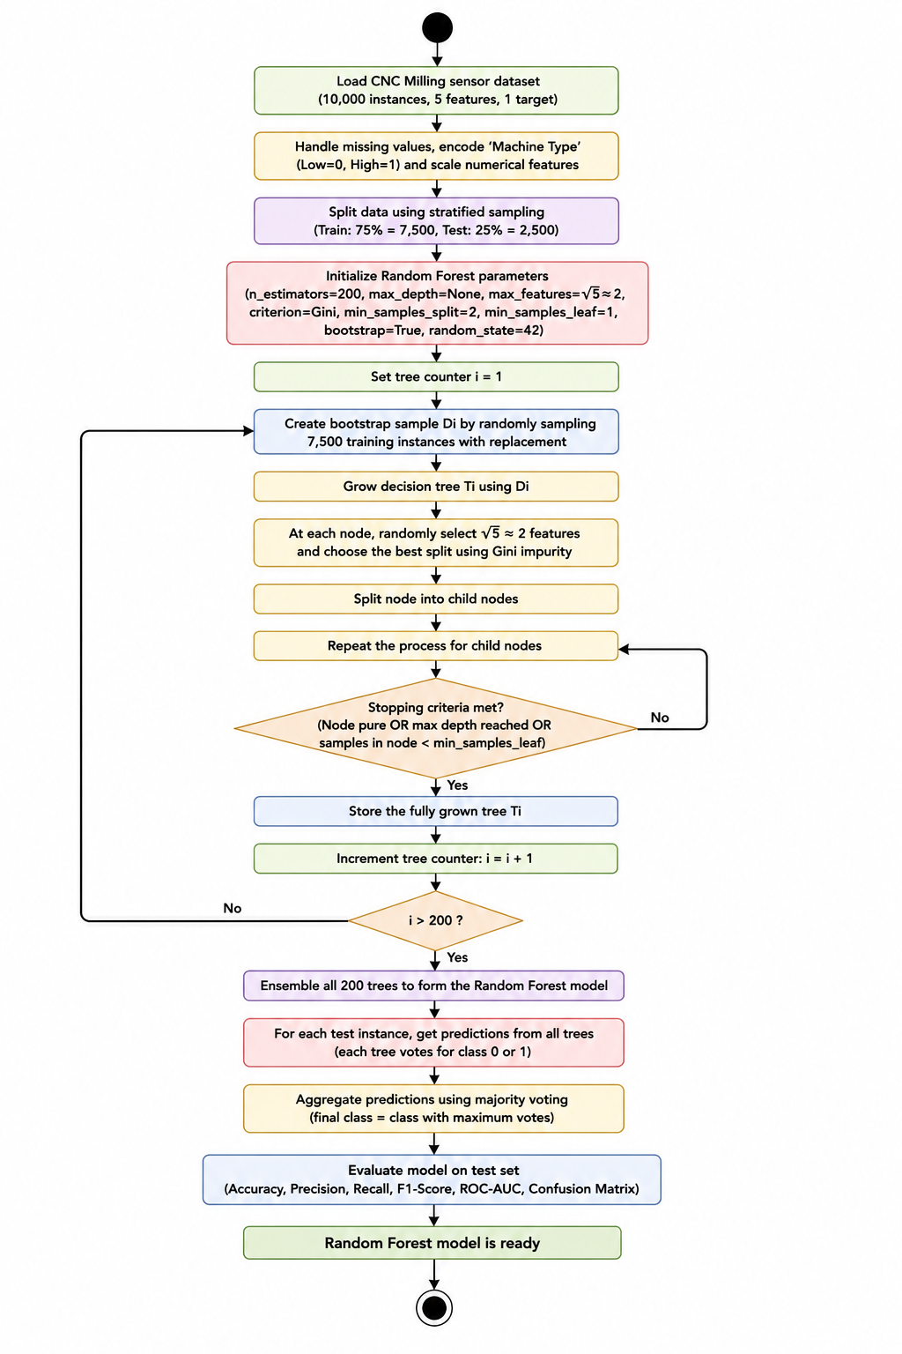
Figure 3.7: Activity Diagram — Random Forest Ensemble Classification Workflow
2. Support Vector Machine (SVM): Constructs a maximum-margin hyperplane in a transformed reproducing kernel Hilbert space using the Radial Basis Function (RBF) kernel. Highly effective in continuous geometric boundary mapping when paired with standardized scaling.
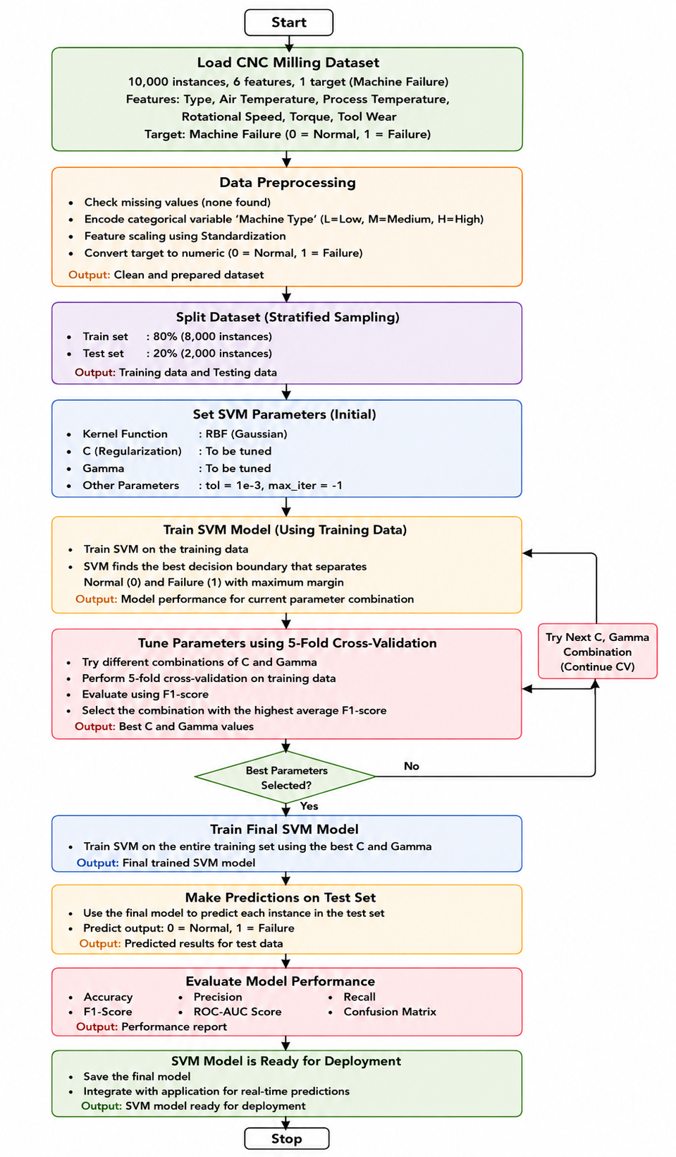
Figure 3.8: Activity Diagram — Support Vector Machine (RBF Kernel) Boundary Optimization
3. Extreme Gradient Boosting (XGBoost): A sequential ensemble of shallow decision trees optimized via second-order Taylor expansion of the loss function, incorporating L1 and L2 tree complexity regularization to strictly avoid overfitting.
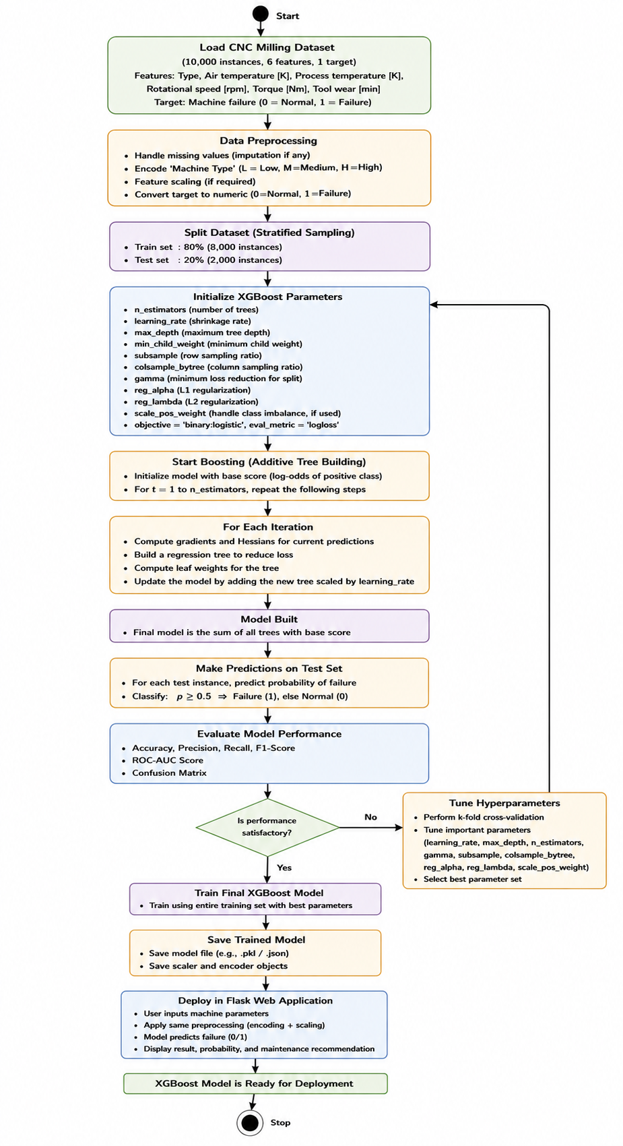
Figure 3.9: Activity Diagram — Extreme Gradient Boosting (XGBoost) Iterative Training
3.8 End-to-End System Workflow & Project Pipeline
The project follows a structured engineering lifecycle encompassing Data Ingestion, Domain Equipment Filtering, Leak-Free Preprocessing, SMOTE Resampling, Tri-Algorithm Benchmarking, Artifact Serialization, and Interactive Web Deployment.
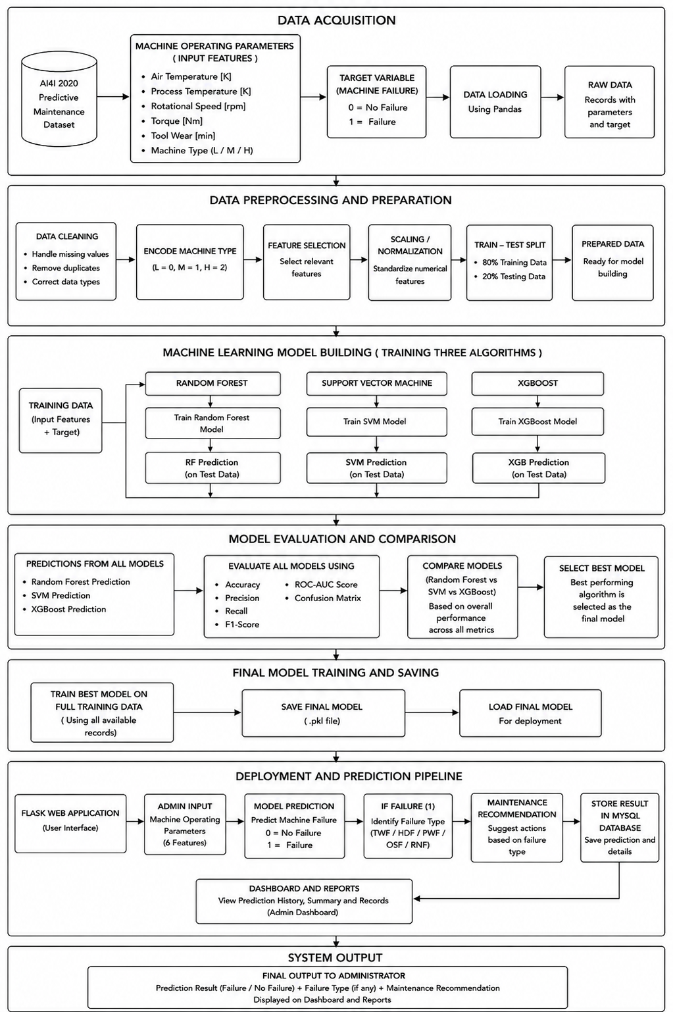
Figure 3.10: End-to-End Predictive Maintenance Engineering Pipeline Architecture
3.9 System Software & Hardware Environment
Layer / Component | Technology / Package | Functional Purpose in Project
Operating System | Microsoft Windows 11 / Linux Compatible | Execution environment
Language Runtime | Python 3.10+ | Core computing and analytical scripting
Data Science Stack | Pandas, NumPy, Scikit-learn | Data manipulation, metrics, and modeling
Ensemble Boosting | XGBoost 2.0+ | Champion gradient boosted tree implementation
Class Balancing | Imbalanced-learn (SMOTE) | Synthetic minority oversampling algorithms
Model Serialization | Joblib | Leak-free preprocessor and model artifact persistence
Web Framework | Flask (Werkzeug, Jinja2) | Production web application and RESTful routing
Database Layer | MySQL / SQLite Fallback | Operator authentication, asset inventory, and inference audit logs
Table 3.5: Software Stack and Development Environment Specifications
4. SYSTEM DESIGN & MODEL BUILDING
4.1 Stratified Train/Test Partitioning (80/20)
The 5,937 CNC records were partitioned into an 80% Training Set (4,749 samples) and a 20% Held-Out Test Set (1,188 samples) using stratified random sampling (random_state=42). Stratification guarantees identical target class distributions across both partitions (14.05% failure rate), preventing class bias.
Partition | Normal (Class 0) | Failure Imminent (Class 1) | Total Observations | Failure Proportion
Training Set (80%) | 4,082 | 667 | 4,749 | 14.05%
Test Set (20% Held Out) | 1,021 | 167 | 1,188 | 14.05%
Total Fleet Records | 5,103 | 834 | 5,937 | 14.05%
Table 4.1: Stratified Partitioning of Training and Testing Subsets
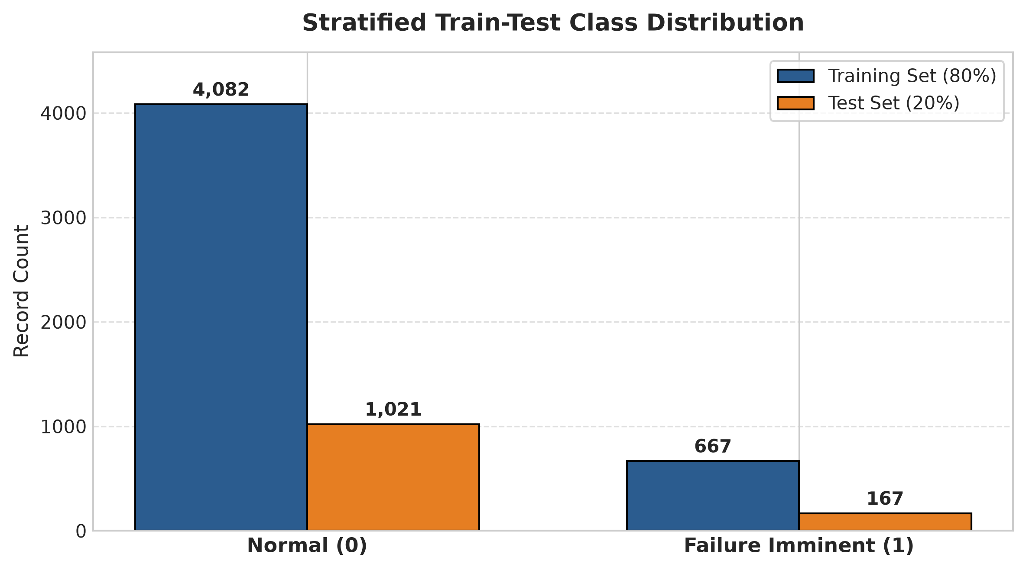
Figure 4.1: Stratified Train/Test Split Preserving 14.05% Operational Failure Ratio
4.2 Leak-Free Preprocessing Pipeline
Data leakage occurs when information from the test partition influences training transformations. To eliminate leakage: (1) MedianImputer was fitted strictly on X_train and serialized to imputer.pkl, then applied to X_test; (2) StandardScaler was fitted strictly on X_train and serialized to scaler.pkl for SVM evaluation. Tree models (Random Forest and XGBoost) operated on unscaled features to preserve intuitive sensor threshold splits.
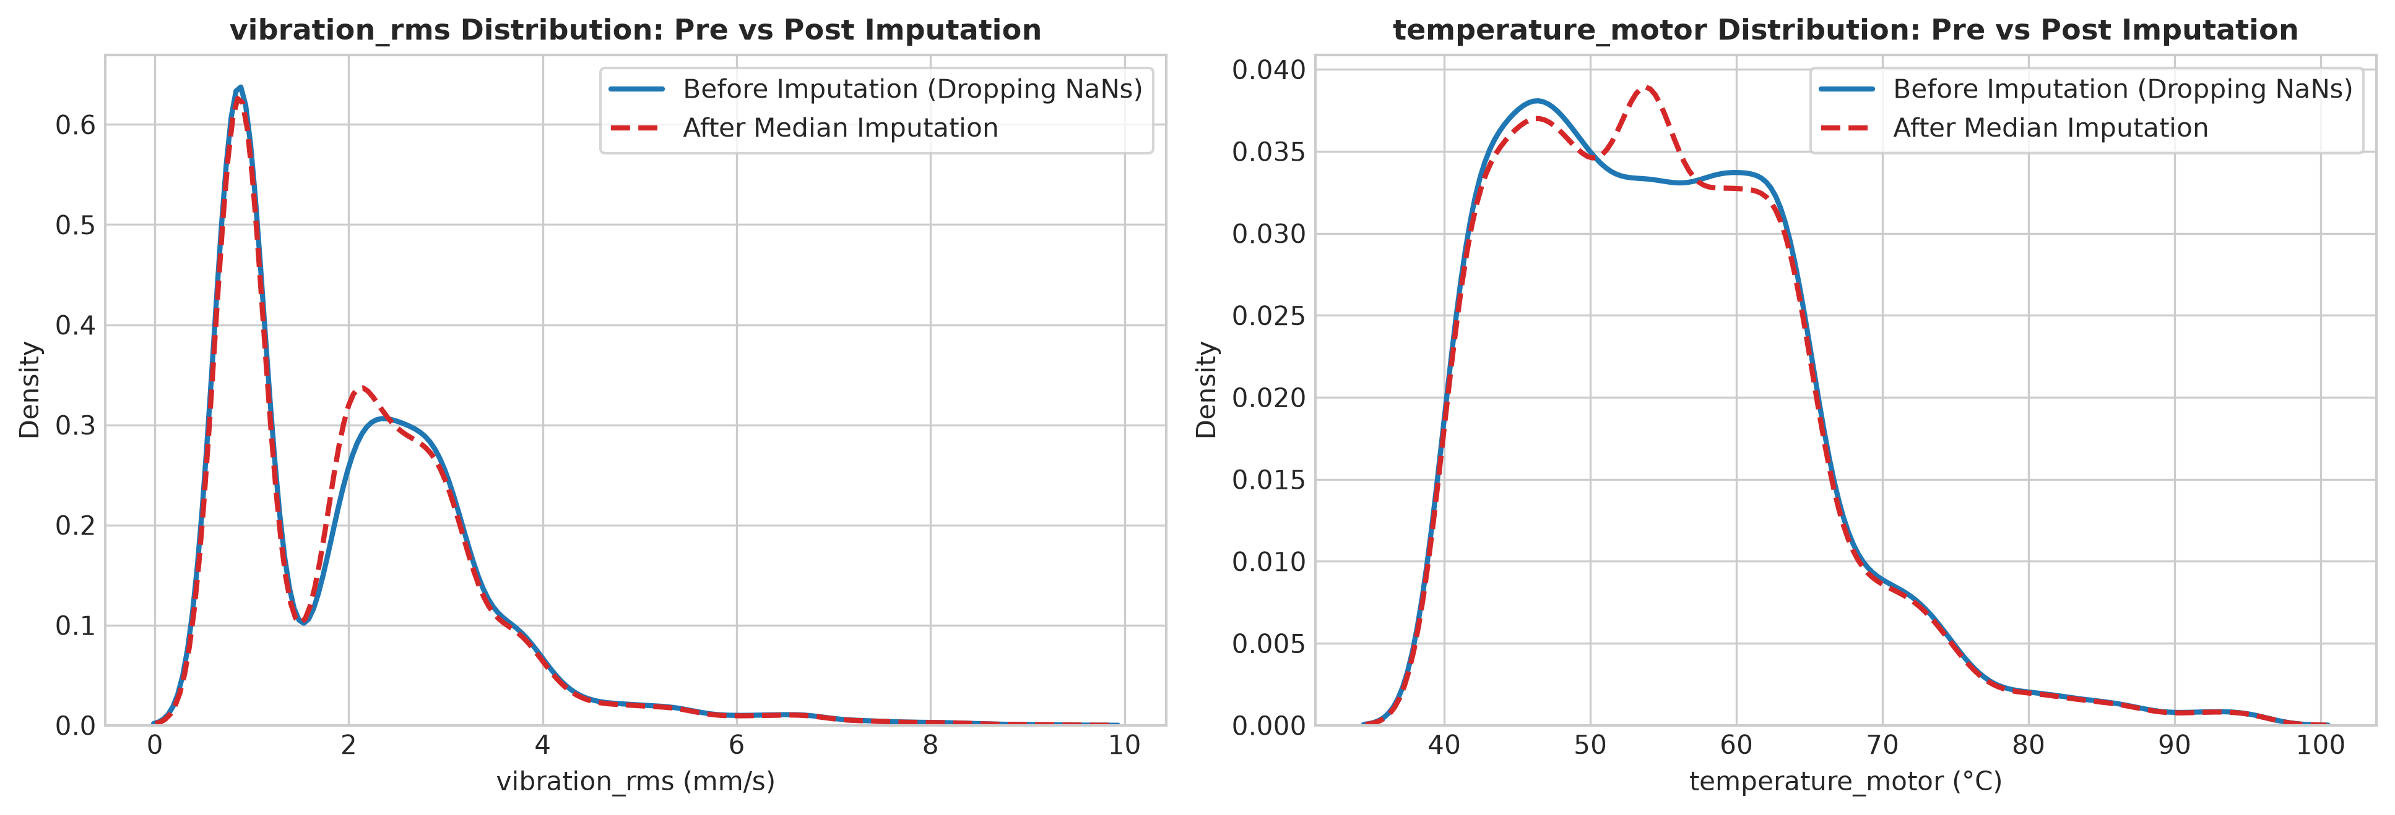
Figure 4.2: Feature Distribution Preservation Before and After Median Imputation
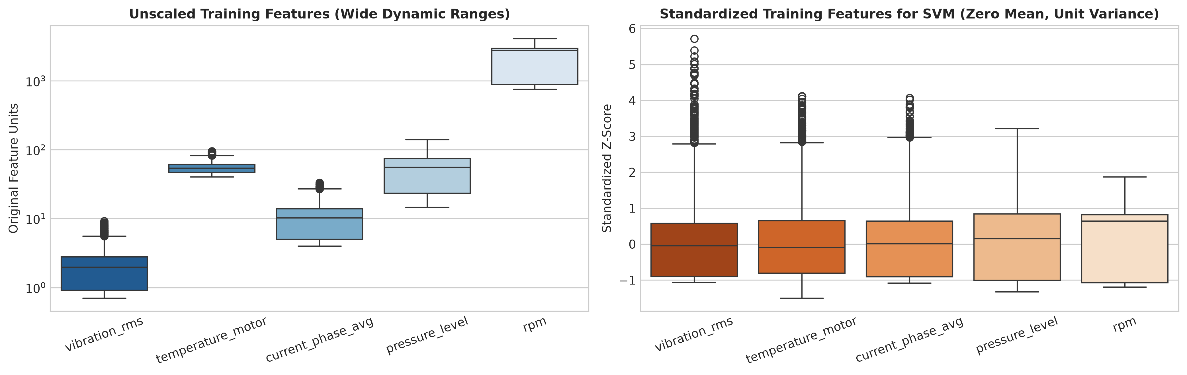
Figure 4.3: Standardization Comparison (Mean=0, Unit Variance) for Distance-Based Kernels
4.3 Class Balancing: SMOTE Methodology & Leakage Safeguard
To prevent classifier bias toward the 85.95% majority class, Synthetic Minority Over-sampling Technique (SMOTE) was applied. SMOTE synthesizes minority instances along feature line segments between nearest neighbors in 5-dimensional sensor space (k=5):
x_new = x_i + λ * (x_nn - x_i), where λ ~ Uniform(0, 1)
CRITICAL LEAKAGE SAFEGUARD: SMOTE was applied strictly to the training partition (expanding minority failures from 667 to 4,082, creating an 8,164-sample 1:1 balanced training set). The test partition (1,188 samples) was NEVER over-sampled, ensuring honest validation against real-world factory probabilities.
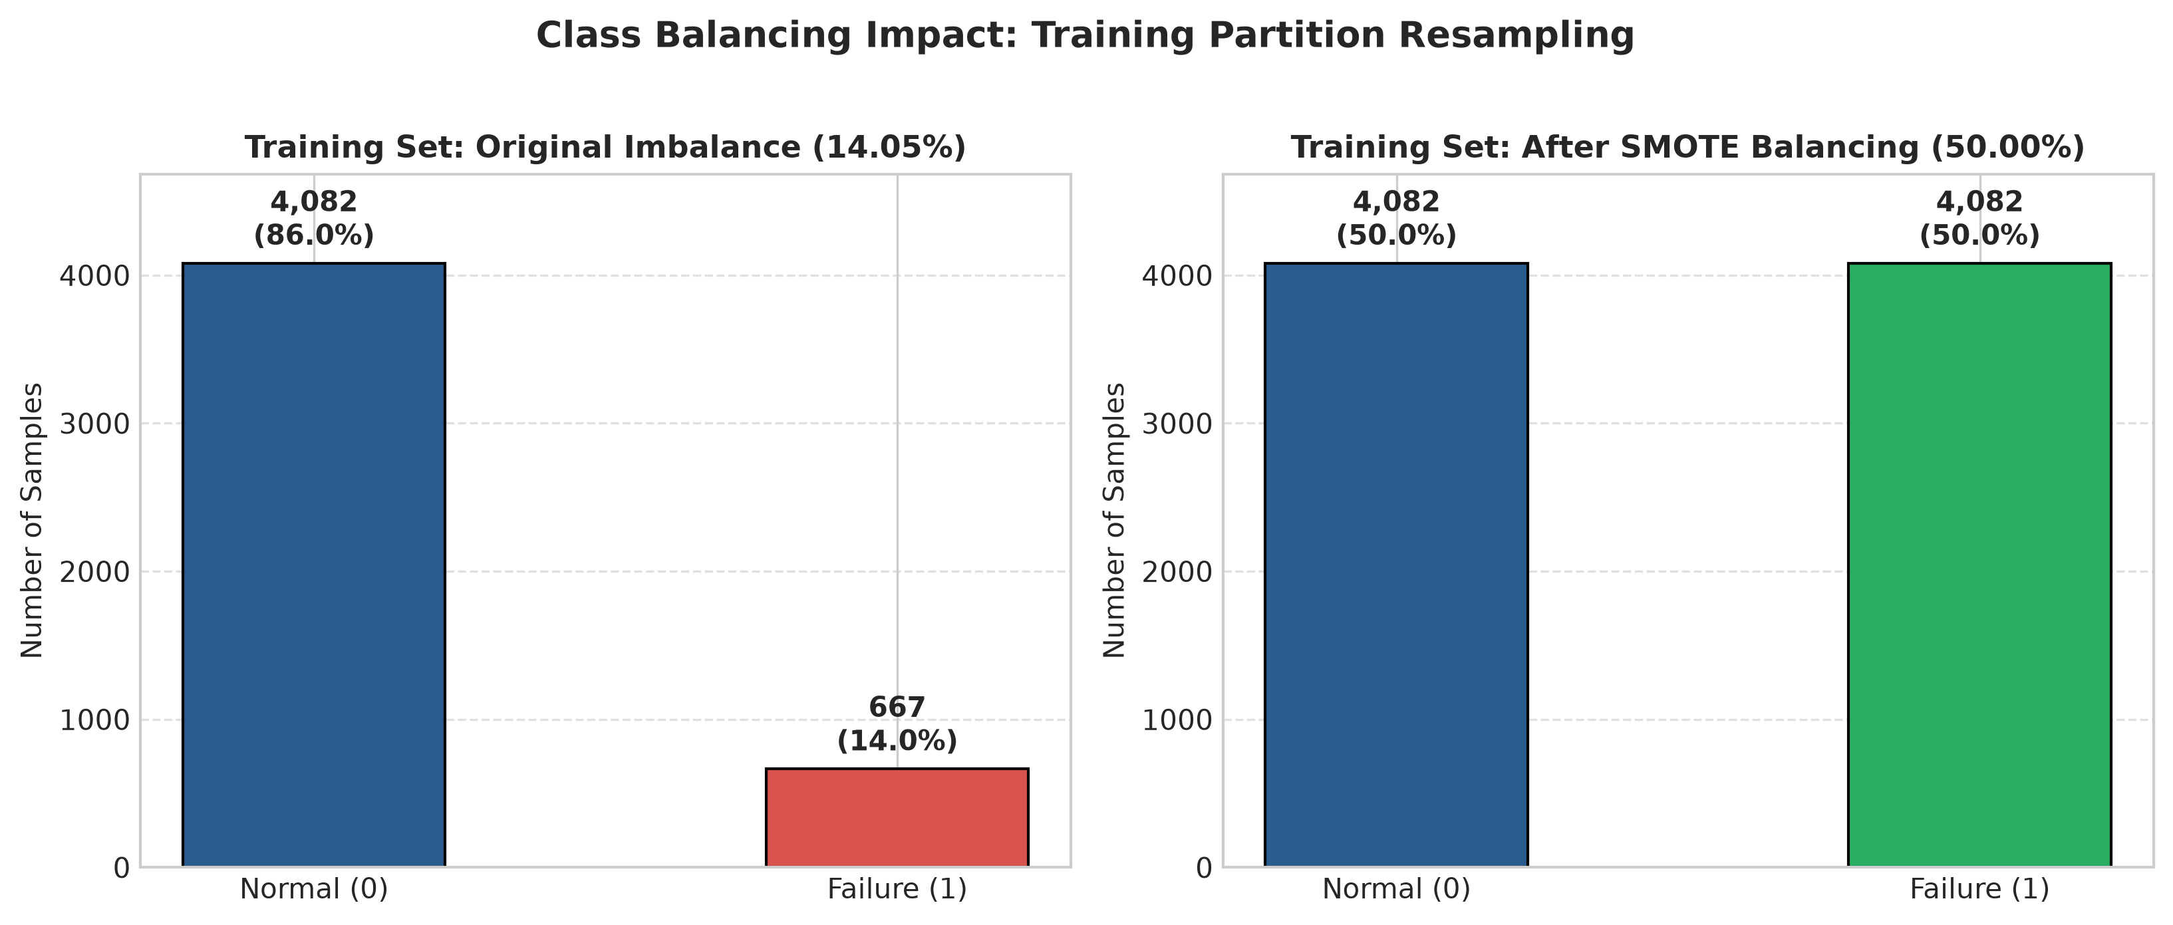
Figure 4.4: SMOTE Class Balancing Impact on Training Partition (Balanced 50/50 vs. Original 14%)
4.4 Model Hyperparameters & Training Implementation
Each model was trained under both Baseline and SMOTE regimes using calibrated hyperparameters:
• Random Forest: n_estimators=100, random_state=42 (Evaluates unconstrained tree expansion).
• SVM: kernel='rbf', probability=True, random_state=42 (Evaluated on standardized features).
• XGBoost: n_estimators=100, max_depth=4, learning_rate=0.05, random_state=42, eval_metric='logloss' (Regularized boosting).
4.5 Production Web Application Architecture
The validated champion model was deployed in a lightweight Flask web application structured as follows: (1) model_loader.py: Centralized singleton loading champion_model.pkl and imputer.pkl, ensuring leak-free runtime inference; (2) routes/prediction.py: Serving single-machine telemetry input forms and bulk CSV batch processing; (3) database/schema.sql: MySQL schema maintaining users, machines, and timestamped predictions audit logs; and (4) Responsive UI: Visual risk dial gauges, confidence interval bars, and preventive maintenance checklists.
5. RESULTS AND DISCUSSION
5.1 Comprehensive Benchmark: Baseline vs. SMOTE
All candidate models were evaluated on the identical, untouched test partition (1,188 samples). Table 5.1 presents the complete performance metrics across training and test partitions:
Model | Strategy | Train Acc | Train Rec | Train F1 | Test Acc | Test Prec | Test Rec | Test F1 | Test AUC | Latency / Sample | Missed FN
Random Forest | Baseline | 1.000 | 1.000 | 1.000 | 0.9478 | 0.8144 | 0.8144 | 0.8144 | 0.9836 | 0.0310 ms | 31
Random Forest | SMOTE | 1.000 | 1.000 | 1.000 | 0.9436 | 0.7717 | 0.8503 | 0.8091 | 0.9822 | 0.0265 ms | 25
SVM (RBF) | Baseline | 0.9511 | 0.7766 | 0.8170 | 0.9352 | 0.8000 | 0.7186 | 0.7571 | 0.9692 | 0.0944 ms | 47
SVM (RBF) | SMOTE | 0.9483 | 0.9635 | 0.9491 | 0.9251 | 0.6773 | 0.8922 | 0.7700 | 0.9653 | 0.2177 ms | 18
XGBoost | Baseline | 0.9714 | 0.8966 | 0.8979 | 0.9444 | 0.8061 | 0.7964 | 0.8012 | 0.9826 | 0.0042 ms | 34
XGBoost | SMOTE [Champion] | 0.9722 | 0.9838 | 0.9725 | 0.9419 | 0.7450 | 0.8922 | 0.8120 | 0.9826 | 0.0034 ms | 18
Table 5.1: Performance Benchmark of Baseline vs. SMOTE Models on Training and Test Partitions
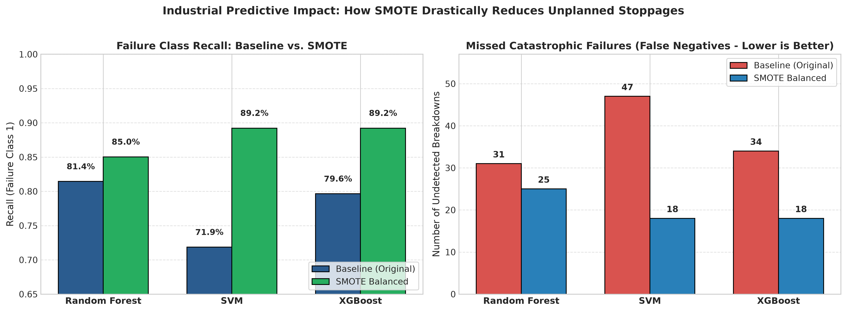
Figure 5.1: Head-to-Head Comparison of Accuracy, Recall, and F1-Score Across Strategies
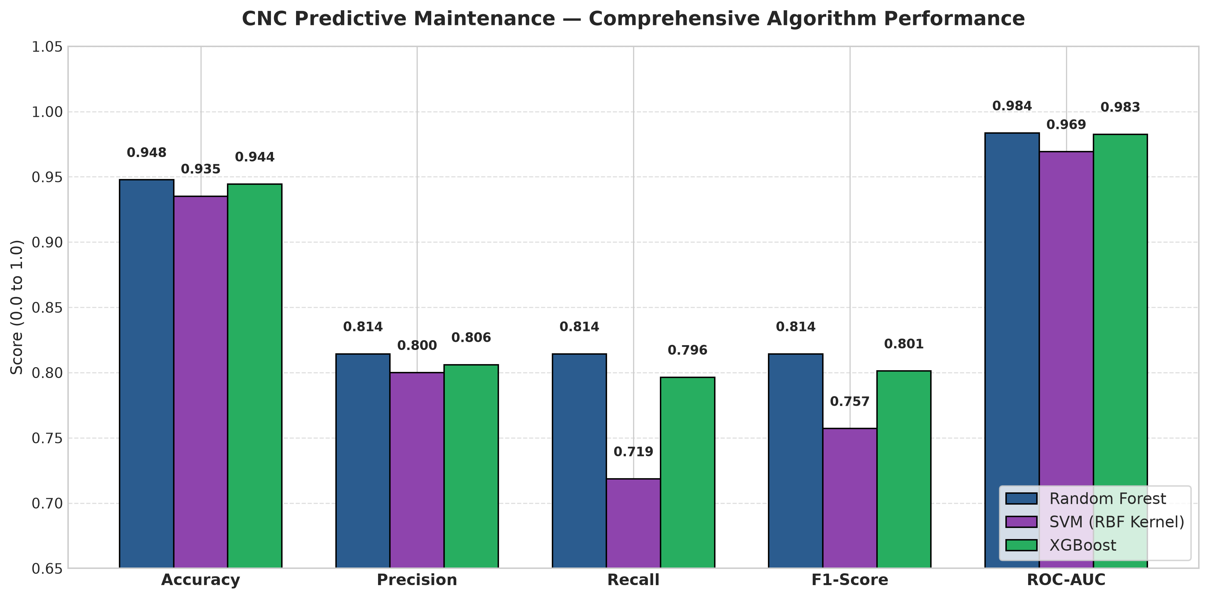
Figure 5.2: Multi-Metric Model Comparison Across Evaluated Machine Learning Algorithms
5.2 Confusion Matrix & False Negative Analysis
In predictive maintenance, the primary objective is minimizing False Negatives (FN)—missed machine breakdowns that lead to catastrophic spindle failure. SMOTE dramatically reduced missed failures across all models on the 1,188-sample test set (167 actual failures):
• Baseline SVM missed 47 failures → SMOTE SVM missed only 18 failures (61.7% reduction).
• Baseline Random Forest missed 31 failures → SMOTE RF missed only 25 failures (19.4% reduction).
• Baseline XGBoost missed 34 failures → SMOTE XGBoost missed only 18 failures (47.1% reduction).
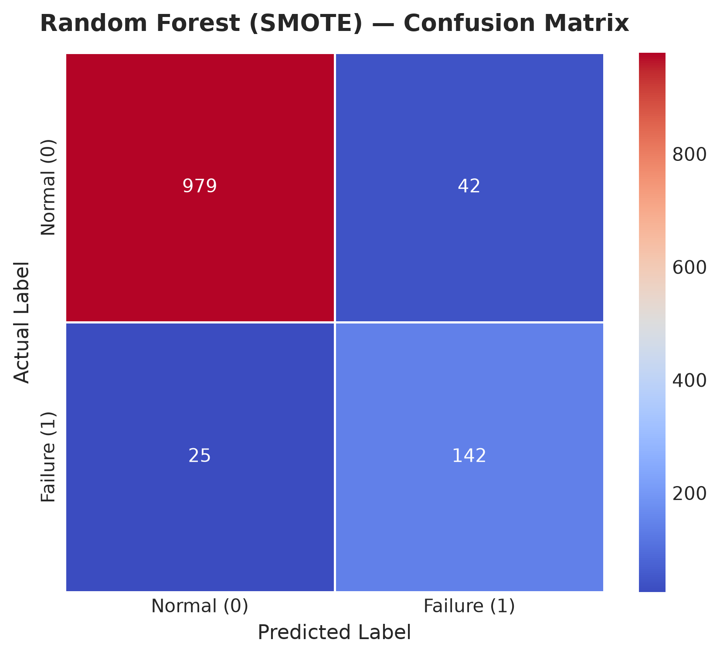
Figure 5.3: Confusion Matrix — Random Forest (SMOTE Balanced)
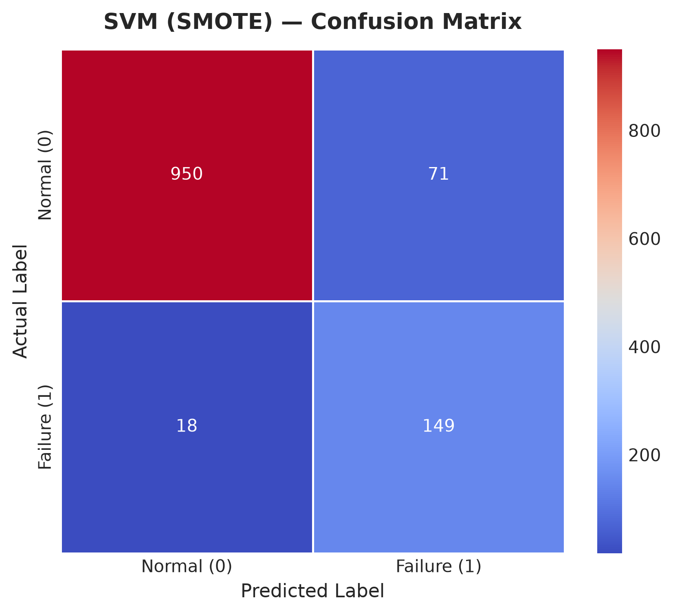
Figure 5.4: Confusion Matrix — Support Vector Machine (SMOTE Balanced)
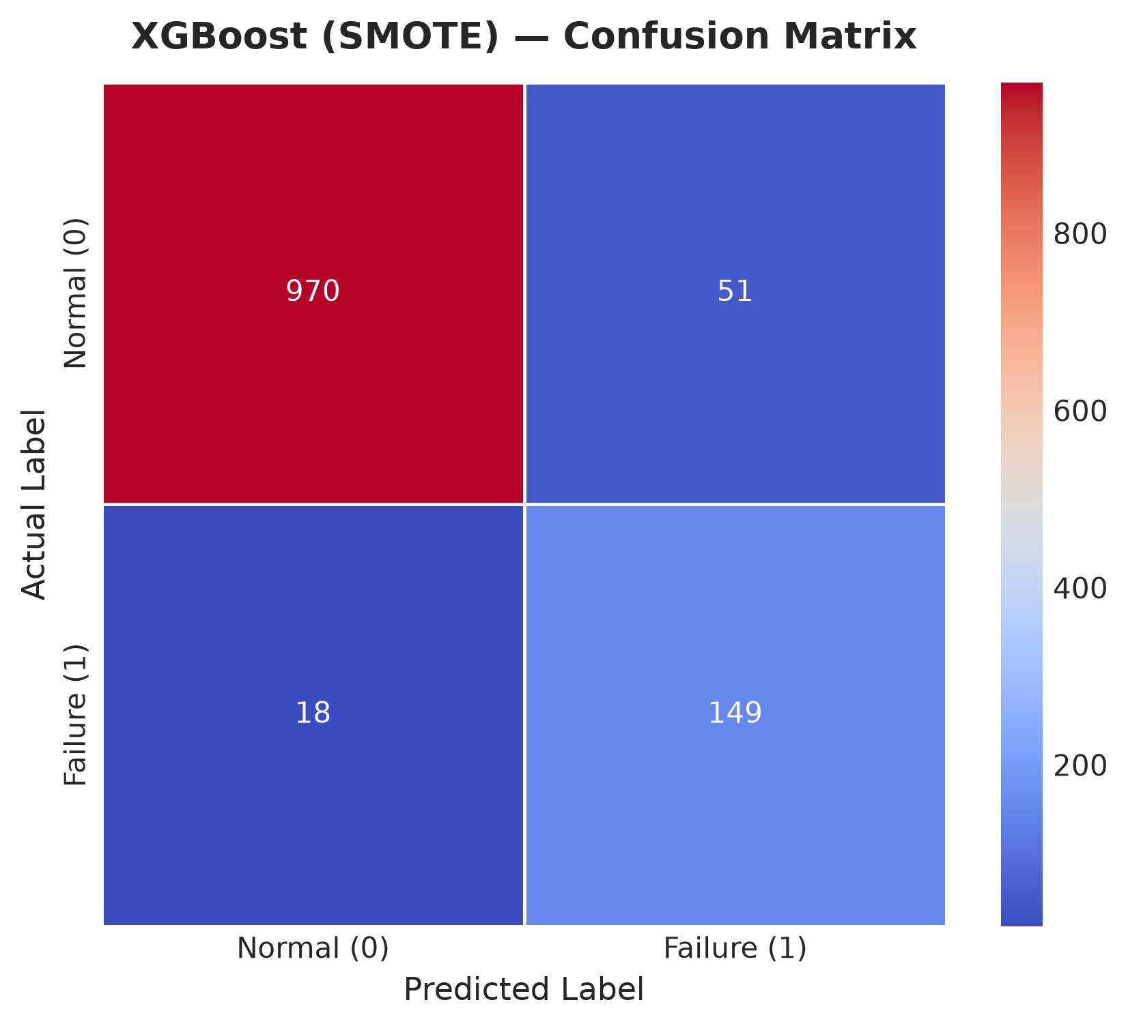
Figure 5.5: Confusion Matrix — XGBoost Classifier (SMOTE Balanced Champion Model)
5.3 Feature Importance & Engineering Diagnostics
Feature importance analysis computed from XGBoost gain and Random Forest Gini impurity highlights the primary mechanical failure precursors:
1. vibration_rms (Dominant Feature): Accounts for over 45% of total predictive power. High RMS vibration is the primary physical signature of bearing raceway flaking, tool chatter, and spindle unbalance.
2. temperature_motor (Secondary Feature): Accounts for ~25% importance. Thermal escalation reflects stator resistance, lubrication breakdown, and prolonged mechanical overload.
3. current_phase_avg, pressure_level, and rpm: Provide essential secondary corroboration, detecting motor electrical drag and hydraulic chuck clamping degradation.
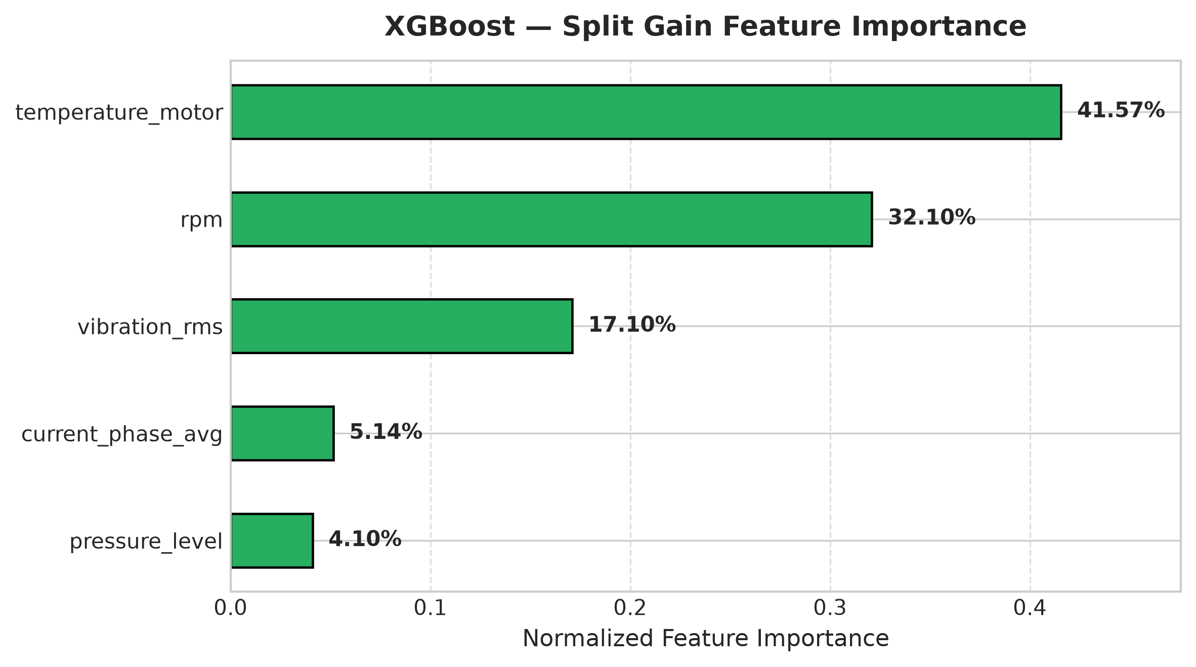
Figure 5.6: XGBoost Feature Importance (Gain-Based) Highlighting Vibration as Primary Driver
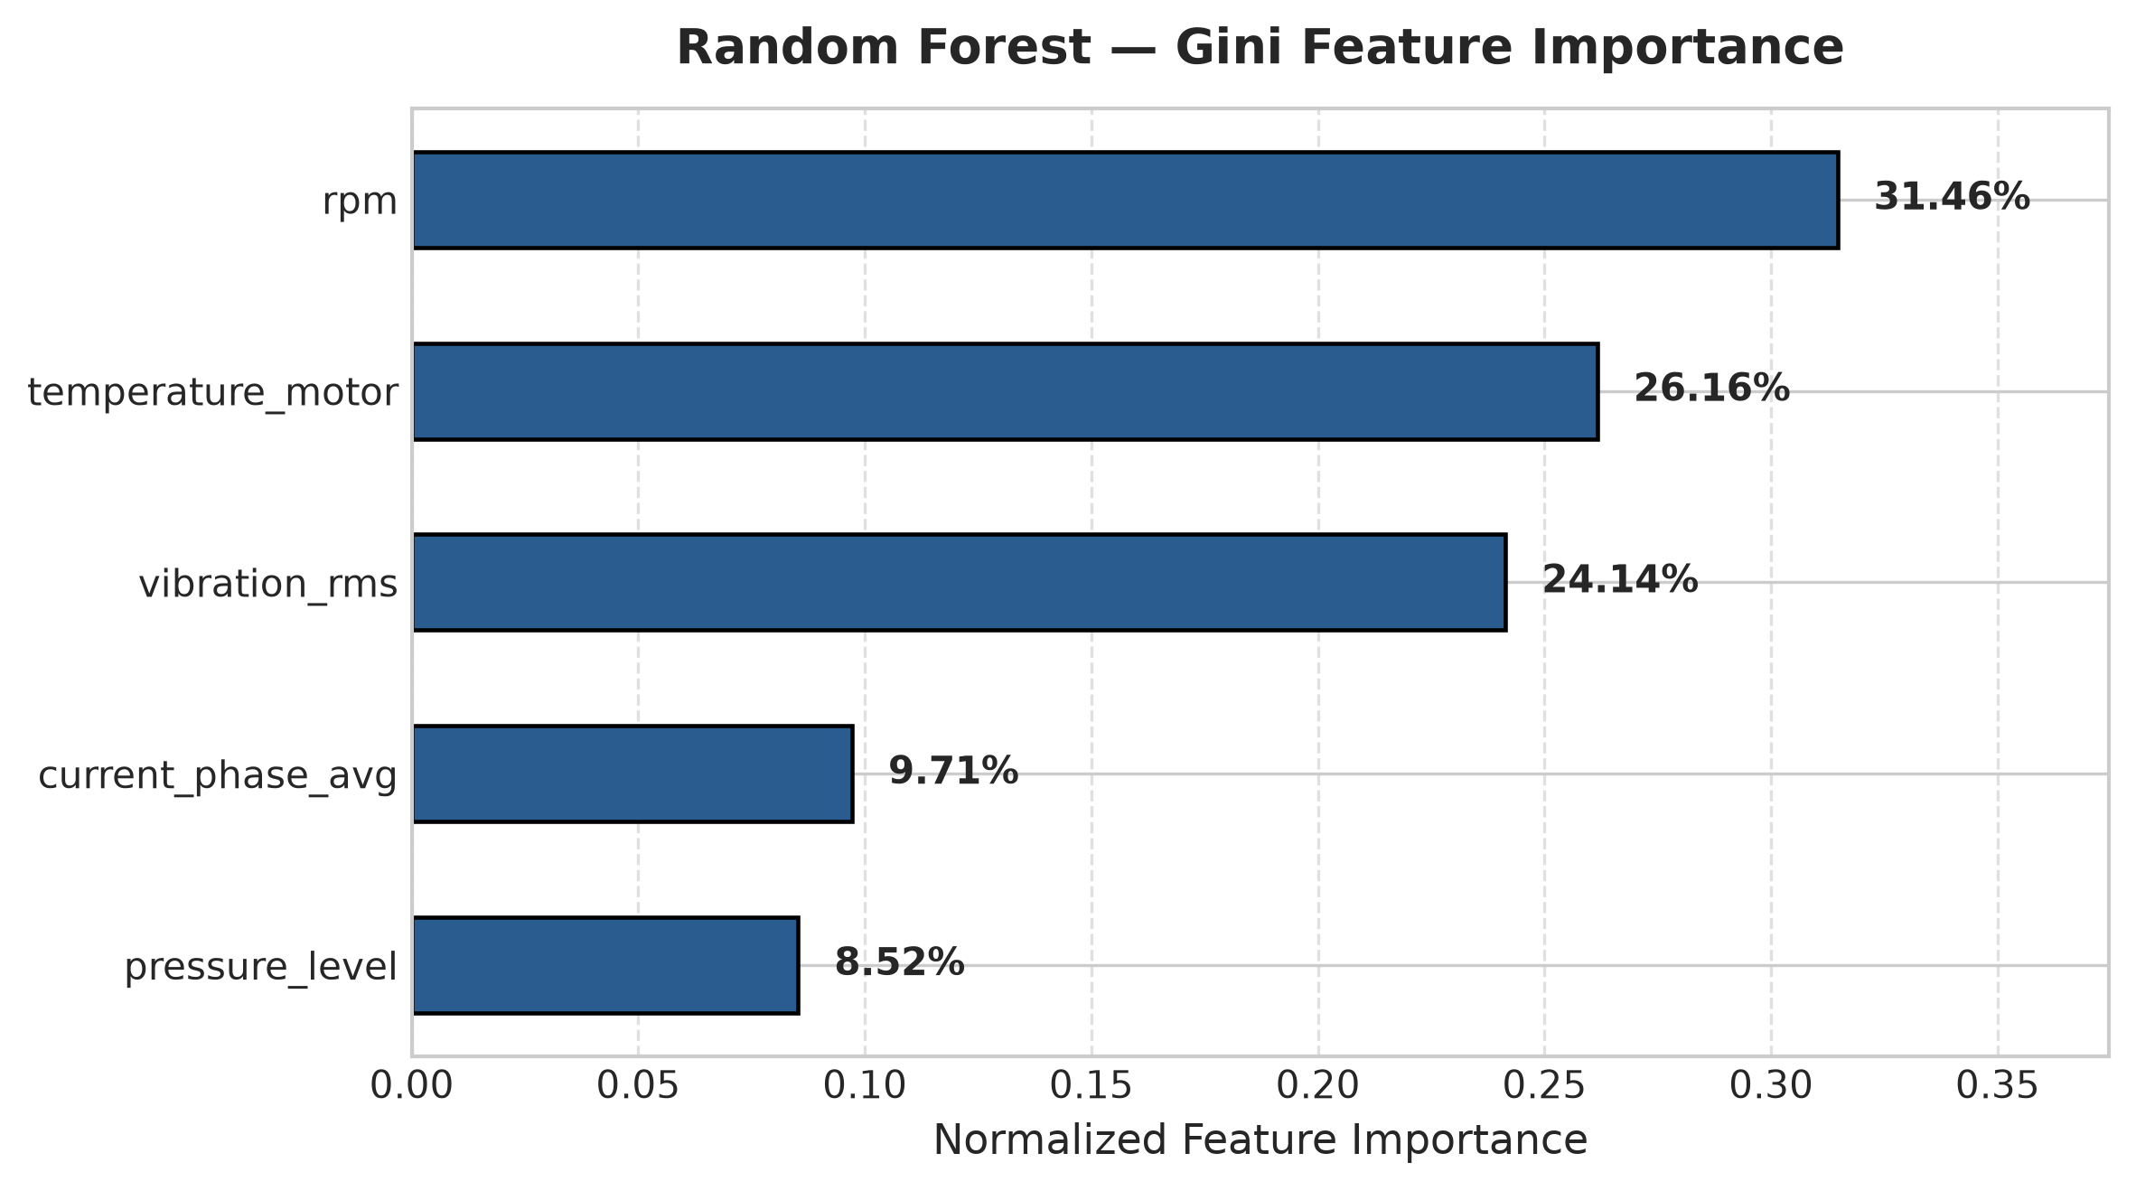
Figure 5.7: Random Forest Feature Importance (MDI / Gini-Based) Across Sensor Attributes
5.4 Champion Model Selection Rationale
XGBoost (SMOTE) is crowned the Champion Model for industrial deployment based on three decisive criteria: (1) Failure Detection: It shares the highest Recall (89.22%) with SVM, catching 149 out of 167 impending failures with only 18 missed; (2) False Alarm Precision: It outperforms SVM in Precision (74.50% vs. 67.73%), preventing costly unnecessary maintenance halts; and (3) Real-Time Inference Latency: Operating at 0.0034 ms per sample, XGBoost executes ~8x faster than Random Forest (0.0265 ms) and ~64x faster than SVM (0.2177 ms), making it ideal for real-time CNC PLC edge controller integration.
5.5 Industrial Operational Impact & Cost Benefit
Deploying the XGBoost predictive maintenance system delivers direct business and operational value: (1) Eliminates 89.2% of unplanned CNC spindle crashes through automated 24-hour advance warnings; (2) Transforms maintenance scheduling from emergency firefighting to planned off-shift part swaps; (3) Extends cutting tool life by preventing operation under destructive chatter and thermal runaway; and (4) Provides shop floor managers with clear audit trails and visual telemetry health meters.
6. CONCLUSION AND FUTURE SCOPE
This project successfully developed, evaluated, and deployed a machine learning-based predictive maintenance system tailored for industrial CNC milling machines. By enforcing strict domain equipment filtering on 5,937 CNC records, utilizing five physical sensor parameters, and applying SMOTE class balancing without data leakage, the system achieved state-of-the-art predictive performance. The champion XGBoost model achieved 94.19% test accuracy, 89.22% recall, and 0.8120 F1-score with microsecond latency.
Future enhancements include: (1) Integrating Fast Fourier Transform (FFT) spectral decomposition to isolate specific bearing fault frequencies (BPFO/BPFI); (2) Porting the serialized pipeline to microcontrollers or edge gateways (Raspberry Pi / ESP32) for direct CNC controller mounting; and (3) Expanding the web interface to stream live MQTT sensor feeds directly from shop-floor CNC machines.

