Step 1: create GitHub account in this step I have created a GitHub account where I'm going to upload my source code

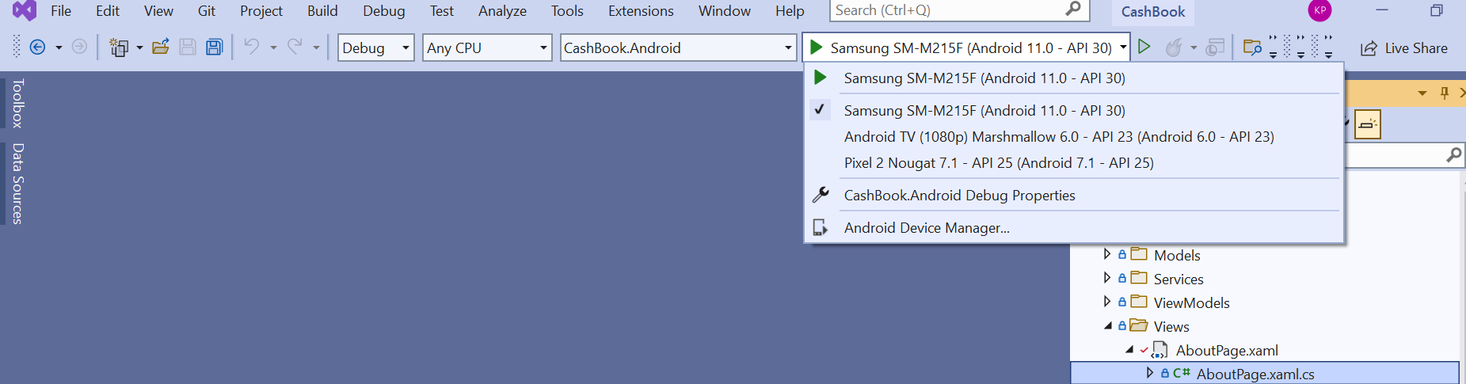

https://www.nuget.org/packages