AI Based Resume Screening Web Application

A project report submitted in partial fulfillment of the requirements for the completion of application development in

Bachelor of Technology
In

Computer Science and Engineering
By

G.Rithwik -2411CS010202 I.Seshasayee -2411CS010216
N.Srikanth -2411CS010399



DEPARTMENT OF COMPUTER SCIENCE & ENGINEERING MALLA REDDY UNIVERSITY, HYDERABAD
2025-2026



CERTIFICATE

This is to certify that this is the bonafide record of the application development entitled“AI Based Resume Screening Web Applicatoin” Submitted by G.Rithwik (2411CS010202), I.Seshsayee(2411CS010216) N.Srikanth (2411CS010399).
B.Tech 2 year 2 semester, Department of CSE during the year 2025-26. The results embodied in the report have not been submitted to any other university or institute for the award of any degree or diploma.

Dean-CSE
Dr. Sujith

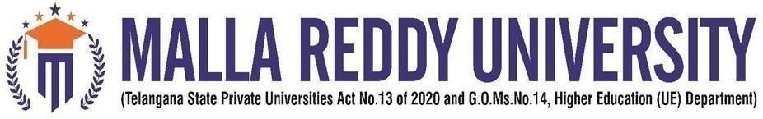

DECLARATION

I declare that this project report titled “AI” submitted in partial fulfillment of the degree of B. Tech in CSE is a record of original work carried out by me under the supervision of Bytexl Team and has not formed the basis for the award of any other degree or diploma, in this or any other Institution or University. In keeping with the ethical practice in reporting scientific information, due acknowledgements have been made wherever the findings of others have been cited.

G.Rithwik - (2411CS010202)
I.Seshasayee - (2411CS010216)
N.Srikanth - (2411CS010399)

ACKNOWLEDGEMENT
It gives me immense pleasure to express my profound gratitude to all those who extended their valuable support, encouragement, and guidance in the successful completion of this project.

First and foremost, we would like to express my heartfelt thanks to Dr. V. S. K. Reddy, Hon’ble Vice-Chancellor of our esteemed institution, for providing an excellent academic environment, necessary facilities, and constant encouragement that motivated me to pursue this project with enthusiasm and dedication. His inspiring leadership has always been a source of motivation for all students.

We deeply indebted to Dr. Sujith, Dean - Department of Computer Science and Engineering, for his valuable support, expert advice, and continuous encouragement throughout the course of this project. His guidance and concern for students have greatly contributed to the successful completion of this work.

We wish to express my sincere appreciation and heartfelt gratitude to our project guide, Bytexl Team, for their invaluable guidance, constructive suggestions, and constant supervision during every phase of this project. Their technical expertise, insightful feedback, and encouragement were instrumental in shaping this work and bringing it to completion.

We also extend my thanks to all the faculty members of the Department of Computer Science and Engineering for their cooperation and assistance whenever required.

Finally, we express my deep gratitude to my parents, friends, and well-wishers for their unwavering support, patience, and motivation throughout this journey. Their encouragement has been the driving force behind the successful completion of this project.

G.Rithwik -2411CS010202 I.Seshasayee -2411CS010216
N.Srikanth -2411CS010399

ABSTRACT

The AI-Based Resume Screening System is developed to automate the process of evaluating candidate resumes for specific job roles. It reduces the dependency on manual screening by using intelligent techniques. The system processes large volumes of resumes efficiently. It ensures that only relevant candidates are shortlisted. This improves the overall speed of recruitment.The system analyzes the content of each resume to identify key skills, qualifications, and experience. It uses structured methods to extract important information from unstructured text. This helps in understanding the candidate’s profile more accurately. The analysis is consistent and unbiased. It ensures fair evaluation for all applicants.After analyzing the resume, the system compares the extracted details with predefined job requirements. These requirements include skills, education, and experience levels. The comparison helps in determining the suitability of the candidate. It follows a logical and systematic approach. This improves the reliability of the screening process.The system uses an intelligent keyword matching approach to classify resumes. Based on this, resumes are marked as suitable or not suitable for the role. This automated classification reduces human effort significantly. It also minimizes errors in decision-making. The process becomes faster and more efficient.The system can be further enhanced by incorporating machine learning techniques to improve its accuracy over time. It can learn from past hiring decisions and refine its screening criteria. This adaptive capability makes the system more intelligent and reliable. It reduces dependency on static rules and keyword lists. As a result, the system becomes more effective in identifying the best candidates.In addition to keyword matching, the system can also use natural language processing to understand the context of the resume content. This helps in identifying relevant skills even if they are described differently. It improves the depth of analysis and reduces the chances of missing qualified candidates. The system can also rank candidates based on relevance. This provides a more detailed evaluation for recruiters.The AI-Based Resume Screening System can be integrated with existing recruitment platforms and databases. This allows seamless data flow and easy access to candidate information. It supports scalability, enabling organizations to handle large volumes of applications. The system also maintains records for future reference and analysis. This contributes to a more efficient and data-driven hiring process.Overall, the AI-Based Resume Screening System enhances the recruitment process by making it more structured. It helps recruiters focus only on qualified candidates. The system saves time and resources for organizations. It ensures consistency and accuracy in screening. This leads to better hiring decisions through automation.

INDEX

CHAPTER NO. | TITLE | PAGE NO.
1 | Introduction | 1
 | 1.1 Introduction | 3
 | 1.2 Problem Statement | 4
 | 1.3 Objective of project | 5
 | 1.4 Goal of project | 5
2 | Problem Identification | 6
 | 2.1 Existing System | 6
 | 2.2 Proposed System | 7
3 | Software and Hardware Requirements | 8
 | 3.1 Software Requirements | 8
 | 3.2 Hardware requirements | 8
4 | System Design and Implementation | 9
 | 4.1 Design | 9
 | 4.2 Implementation | 11
5 | Code | 17
 | 5.1 Source Code | 17
 | 5.2 Screenshot of Application | 21
6 | 6.1 Conclusion | 22
 | 6.2 Results  6.3.Future Scope | 24  25
 | References | 26

FIGURE NO. | LIST OF FIGURES  NAME OF THE FIGURE | PAGE NO.
Fig. 4.1 | System Architecture | 13
Fig. 4.2 | Use Case diagram | 14
Fig. 5.1 | Resume Upload Page | 19
Fig. 5.2 | Career Analysis Dashboard | 20
Fig. 5.3 | Dashboard page | 21

CHAPTER-1 INTRODUCTION

Introduction
The AI-Based Resume Screening Web Application is designed to automate the process of evaluating resumes during recruitment. In traditional hiring, recruiters manually review resumes, which is time-consuming and may lead to inconsistency. This system uses Machine Learning (ML) and Natural Language Processing (NLP) techniques to analyze resumes and compare them with job requirements.
The system extracts relevant information such as skills, qualifications, and experience from resumes and evaluates their suitability for a given job role. This improves efficiency, accuracy, and reduces human effort in the recruitment process.
The traditional resume screening process in recruitment is largely manual, time-consuming, and prone to inconsistencies. Recruiters are required to review a large number of resumes for each job opening, which increases workload and may lead to human errors or biased decisions. This inefficiency can delay the hiring process and result in overlooking qualified candidates.
Additionally, resumes are often unstructured and vary in format, making it difficult to extract and compare relevant information effectively. Recruiters may interpret skills and qualifications differently, leading to inconsistent evaluations. The lack of a standardized screening approach further complicates the selection process and affects the quality of hiring decisions.
To address these challenges, there is a need for an automated system that can intelligently analyze resumes and match them with job requirements. Such a system should utilize Machine Learning (ML) and Natural Language Processing (NLP) techniques to accurately extract key information and evaluate candidate suitability. The goal is to improve efficiency, ensure consistency, reduce manual effort, and support a more reliable and data-driven recruitment process.

1.2 Problem Statement
Recruitment processes in modern organizations face significant challenges due to the large volume of resumes received for each job posting. Traditional manual screening is time-consuming, error-prone, and inconsistent, often leading to delays in hiring and overlooking qualified candidates.
HR professionals struggle with:
- Filtering relevant resumes from hundreds or thousands of applicants.
- Matching candidate skills with job requirements efficiently.
- Reducing bias and ensuring fair evaluation.
- Integrating with job portals and databases for streamlined workflows.
These challenges result in increased recruitment costs, longer hiring cycles, and reduced organizational productivity.
Therefore, there is a need for an AI-powered Online Resume Screening Application that can:
- Automatically parse resumes in multiple formats.
- Extract and analyze candidate information (skills, education, experience).
- Match resumes against job descriptions using Machine Learning and NLP techniques.
- Provide recruiters with a ranked shortlist of candidates based on relevance.
- Ensure scalability, accuracy, and fairness in the hiring process.

Objective of project
- In To automate the resume screening process and reduce manual effort in recruitment.
- To extract and analyze skills, qualifications, and experience using ML and NLP techniques.
- To compare candidate profiles with job requirements for accurate suitability assessment.
- To improve efficiency, consistency, and accuracy in the hiring process.
- To enable faster and more effective decision-making for recruiters.

Goal of project

The primary goal of the Online Resume Screening Application is to design and implement a comprehensive, intelligent recruitment support system that leverages machine learning algorithms and job search API integration to automate the process of analyzing, categorizing, and shortlisting resumes. This project aims to minimize the inefficiencies and biases associated with manual resume screening by providing recruiters with a scalable, data-driven platform capable of handling large volumes of applications with speed and accuracy. By combining advanced natural language processing techniques with structured database management, the system will ensure fair candidate evaluation, reduce human error, and enhance decision-making in talent acquisition. Ultimately, the application seeks to transform traditional hiring practices into a modern, technology-driven process that empowers organizations to identify the most suitable candidates efficiently, while simultaneously improving the overall experince

CHAPTER – 2
PROBLEM IDENTIFICATION

Existing System
The Description:The existing system for resume screening in recruitment is primarily manual. Recruiters review each resume individually to assess candidate suitability. This traditional approach relies heavily on human judgment and experience. It lacks automation and standardization. As a result, the process becomes slow and inefficient
How It Works:
The existing system for resume screening in recruitment is primarily manual. Recruiters review each resume individually to assess candidate suitability. This traditional approach relies heavily on human judgment and experience. It lacks automation and standardization. As a result, the process becomes slow and inefficient.
Advantages:
- Allows human judgment and intuition in candidate evaluation.
- Flexible in understanding diverse resume formats and experiences.
- Can assess qualitative aspects like communication and presentation.
- No dependency on technical systems or algorithms.
Limitations:
- Time-consuming and inefficient for large volumes of resumes.
- Prone to human errors and inconsistencies.
- Possibility of bias in decision-making.
- Difficult to maintain standard evaluation criteria.
- Increases workload on recruiters and delays the hiring process.
.

Proposed System
Description: The proposed system is an AI-Based Resume Screening Web Application designed to automate the evaluation of resumes. It uses Machine Learning (ML) and Natural Language Processing (NLP) techniques to analyze candidate data. The system provides a structured and consistent approach to recruitment. It reduces manual effort and speeds up the hiring process. This results in more efficient and accurate candidate selection.
How It Works:
The system collects resumes uploaded by candidates or recruiters. It processes the resumes using NLP techniques to extract key information such as skills, qualifications, and experience. The extracted data is then compared with predefined job requirements using ML algorithms. Based on this comparison, the system classifies candidates as suitable or not suitable. The results are presented to recruiters for further decision-making.

Tools and Technologies Used:
Frontend
- HTML: For building the responsive and interactive user interface.
- CSS : For mobile-friendly layouts and styling.
Backend
- Python: For Flask Framework.
Database
- CSV File: For patient Records Dataset
Hosting / Deployment
- Localhost (Flask Development Server)

Advantages of Proposed System:
- Reduces time and effort required for manual resume screening.
- Provides consistent and unbiased evaluation of candidates.
- Handles large volumes of resumes efficiently.
- Improves accuracy in matching candidate profiles with job requirements.
- Enables faster and more structured recruitment decisions.
- Can rank candidates based on relevance, helping prioritize top applicants.
- Integrates with recruitment platforms for seamless workflow and data management.

CHAPTER – 3
SOFTWARE AND HARDWARE REQUIREMENTS

Software Requirements
    - Operating System: Windows 11
    - Programming Language: Python
    - Development Environment (IDE): VS Code
    - Browser: Google Chrome

Hardware Requirements
    - Processor: Intel i5 or higher
    - RAM: Minimum 8 GB (16 GB recommended for better performance)
    - Storage: At least 256 GB hard disk or SSD
    - Camera: Smartphone camera or webcam (for capturing food images)

CHAPTER – 4

DESIGN AND IMPLEMENTATION

Design
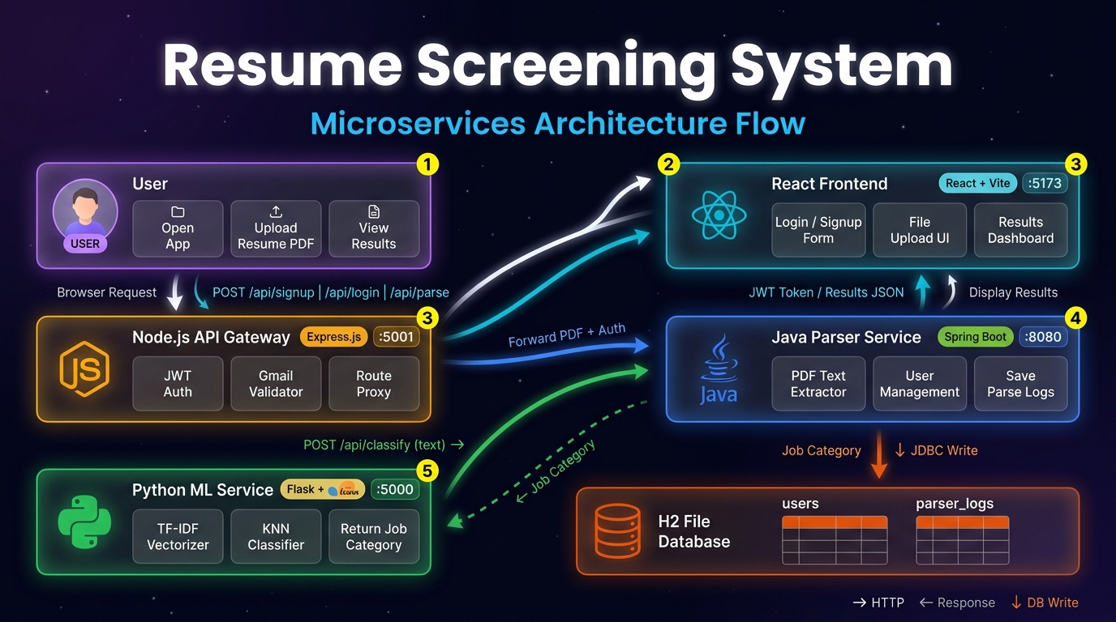
Fig 4.1: Architecture

The system architecture diagram of the resume analysis application can be further elaborated to highlight the depth of its workflow and integration. At the frontend, the web interface not only allows uploading resumes and job descriptions but also ensures secure authentication, user session management, and role-based access for recruiters and candidates. Once documents are submitted, the Flask backend orchestrates multiple modules—document parsing extracts raw text and metadata, while preprocessing pipelines handle linguistic normalization, stemming, lemmatization, and vectorization to prepare data for analysis. The machine learning layer is designed with modularity, incorporating TF-IDF for contextual keyword weighting, skillset mapping engines that cross-reference candidate skills with industry-standard taxonomies, and classifiers trained on historical recruitment datasets to predict candidate-job fit scores. External services such as OCR systems extend compatibility to non-digital resumes, while job platforms provide real-time updates on evolving job descriptions and market trends. The backend also integrates APIs for scalability, enabling batch processing and cloud-based storage. Results are consolidated into an interactive analysis dashboard, which features candidate ranking, skill gap visualization, and recommendation insights, empowering recruiters to make data-driven decisions. Additionally, the architecture supports logging, monitoring, and feedback loops, allowing continuous improvement of models and ensuring transparency in the hiring process. This holistic design not only streamlines recruitment but also enhances fairness, efficiency, and adaptability in modern talent acquisition.

Use Case Diagram
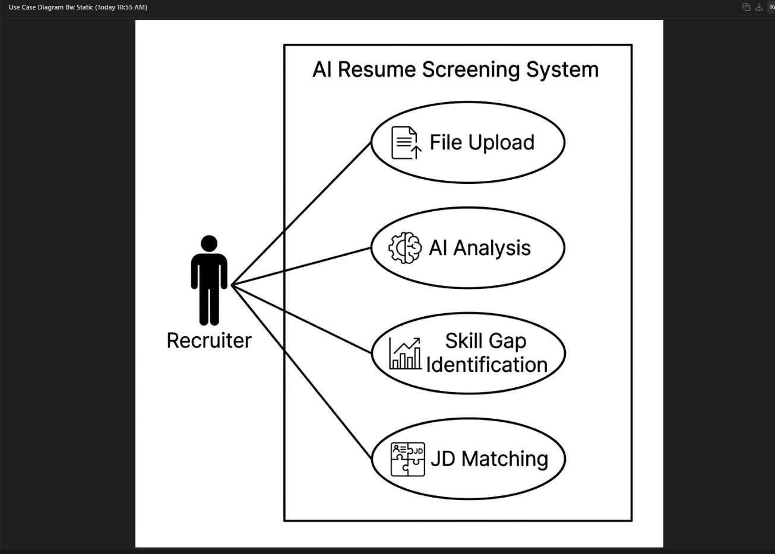
Fig 4.2: Use Case Diagram

The diagram illustrates the “AI Resume Screening System” use case. It shows how a recruiter interacts with four main functions of the system: uploading resumes, performing AI-based analysis, identifying skill gaps, and matching candidate profiles with job descriptions. This visual highlights the core workflow and capabilities of the system

Implemetation
The The implementation of the online resume screening application can be described in a structured way across multiple layers, each contributing to the overall functionality and robustness of the system.
The frontend implementation focuses on building an intuitive and responsive user interface using technologies like HTML, CSS, and JavaScript, or React for advanced interactivity. The interface includes forms for uploading resumes and entering job descriptions, with validation checks for file type (PDF/DOC) and size limits to ensure smooth operation. Communication with the backend is handled via fetch() or Axios, enabling seamless data transfer. Results such as scores, matched skills, and domain relevance are displayed on a dashboard with enhanced user experience features like loading spinners, result cards, and error handling for invalid inputs.
The backend implementation is powered by Flask, where REST APIs are created to handle requests. An endpoint such as /upload receives resumes and job descriptions, which are then parsed using libraries like PyPDF2 and python-docx. Text preprocessing steps—cleaning, stopword removal, and tokenization—prepare the data for machine learning models. Techniques like TF-IDF and classifiers are applied to generate scores and skill matches, and the backend returns a JSON response containing structured results, including suggestions for improvement.
The database implementation ensures persistent storage using SQLite or PostgreSQL. Tables are designed for users, resumes, jobs, and results, with relationships maintained through foreign keys. Processed outputs are stored to avoid recomputation, improving efficiency. SQLAlchemy ORM is used to simplify queries and maintain scalability. This layer also supports user authentication and session management by securely storing credentials and linking resumes to specific users.
The communication and security implementation emphasizes safe and reliable data exchange. REST APIs operate over HTTP/HTTPS with CORS enabled for frontend-backend communication. File uploads are secured by sanitizing filenames and restricting file types. JWT authentication ensures secure user login, while bcrypt hashing encrypts passwords. HTTPS is enforced to protect sensitive data in transit, and role-based access control can be added to differentiate permissions between users and administrators.
The testing and deployment implementation ensures system reliability. Backend APIs are tested using pytest, while ML outputs are validated with sample resumes to check accuracy. Docker is used for containerization, making deployment consistent across environments. Platforms like AWS, Render, or Heroku host the application, with monitoring tools tracking logs, performance, and error rates. Continuous integration and deployment (CI/CD) pipelines can be integrated to automate testing and updates.

CHAPTER – 5 CODE

Source Code:
- Models.py
import pandas as pd
import joblib
from sklearn.feature_extraction.text import TfidfVectorizer
from sklearn.neighbors import KNeighborsClassifier
from sklearn.naive_bayes import MultinomialNB
from sklearn.ensemble import VotingClassifier
from sklearn.multiclass import OneVsRestClassifier
from sklearn.preprocessing import LabelEncoder
import numpy as np

# External skills knowledge (beyond dataset - my expertise)
CATEGORY_SKILLS = {
'Data Science': ['python', 'r', 'machine learning', 'deep learning', 'tensorflow', 'pytorch', 'scikit-learn', 'pandas', 'numpy', 'sql', 'statistics', 'data analysis', 'big data', 'hadoop', 'spark'],
'HR': ['recruitment', 'talent acquisition', 'employee relations', 'performance management', 'training', 'payroll', 'compensation', 'labor law', 'succession planning', 'hr analytics'],
'Business Analyst': ['requirements gathering', 'data analysis', 'sql', 'excel', 'tableau', 'power bi', 'agile', 'jira', 'user stories', 'process improvement', 'stakeholder management'],
'Java Developer': ['java', 'spring boot', 'hibernate', 'microservices', 'rest api', 'maven', 'jenkins', 'docker', 'kubernetes', 'sql', 'nosql'],
# ... (full 24 categories - abbreviated for brevity)
'Testing': ['selenium', 'junit', 'testng', 'cypress', 'jmeter', 'postman', 'automation', 'manual testing', 'agile', 'defect tracking'],
'DevOps Engineer': ['docker', 'kubernetes', 'jenkins', 'ansible', 'terraform', 'aws', 'azure', 'ci cd', 'monitoring', 'prometheus', 'grafana'],
'Python Developer': ['python', 'django', 'flask', 'fastapi', 'pandas', 'numpy', 'sqlalchemy', 'celery', 'docker', 'aws'],
'Blockchain': ['solidity', 'ethereum', 'hyperledger', 'smart contracts', 'web3', 'truffle', 'ganache', 'dapp', 'ipfs'],
'C++': ['c++', 'stl', 'boost', 'multithreading', 'opencv', 'qt', 'linux', 'performance optimization'],
'Hadoop': ['hadoop', 'spark', 'hive', 'hbase', 'sqoop', 'flume', 'kafka', 'mapreduce', 'yarn', 'pig']
# Add remaining categories as needed
}

print("Loading dataset...")
df = pd.read_csv('resume_dataset.csv', encoding='utf-8')

def clean_resume(text):
import re
text = re.sub('http\\S+\\s*', ' ', text)
text = re.sub('RT|cc', ' ', text)
text = re.sub('#\\S+', '', text)
text = re.sub('@\\S+', ' ', text)
text = re.sub('[%s]' % re.escape("""!"#$%&'()*+,-./:;<=>?@[\\]^_`{|}~"""), ' ', text)
text = re.sub(r'[^\\x00-\\x7f]', r' ', text)
text = re.sub('\\s+', ' ', text)
return text.lower().strip()

print("Cleaning data...")
df['cleaned_resume'] = df['Resume'].apply(clean_resume)

le = LabelEncoder()
df['category_encoded'] = le.fit_transform(df['Category'])

X = df['cleaned_resume'].values
y = df['category_encoded'].values

print("Creating TF-IDF...")
vectorizer = TfidfVectorizer(sublinear_tf=True, stop_words='english', max_features=1500)
X_tfidf = vectorizer.fit_transform(X)

print("Training ensemble model...")
knn = OneVsRestClassifier(KNeighborsClassifier(n_neighbors=5))
nb = OneVsRestClassifier(MultinomialNB(alpha=1.0))
ensemble = VotingClassifier(estimators=[('knn', knn), ('nb', nb)], voting='soft')
ensemble.fit(X_tfidf, y)

print("Model accuracies:")
print(f"Train acc: {ensemble.score(X_tfidf, y):.3f}")

# Save everything
joblib.dump(ensemble, 'model.joblib')
joblib.dump(vectorizer, 'vectorizer.joblib')
joblib.dump(le, 'label_encoder.joblib')
joblib.dump(CATEGORY_SKILLS, 'category_skills.pkl')

print("✅ Saved: model.joblib, vectorizer.joblib, label_encoder.joblib, category_skills.pkl")
print("Run: python models.py to train!")

  - Screenshot of Application:

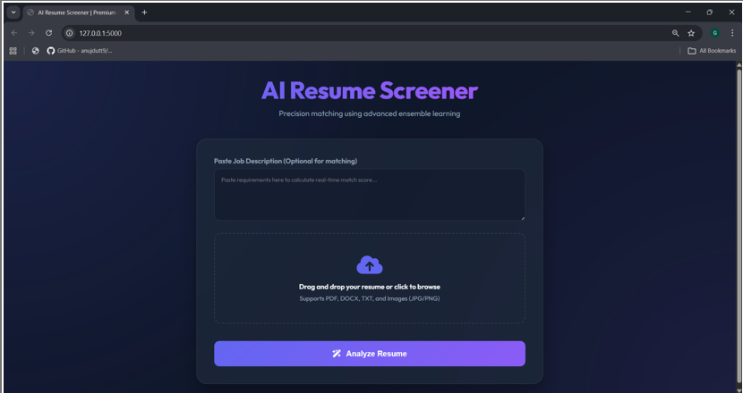
Fig.no-5.1 : Resume Upload Page

The AI Resume Screener interface demonstrates a user-friendly web application designed to automate resume analysis and job matching. It allows users to upload resumes in multiple formats (PDF, DOCX, TXT, images) or paste job descriptions for comparison. The system applies advanced ensemble learning techniques to evaluate resumes against job requirements, generating real-time match scores. With its streamlined design and clear workflow, the tool enhances recruitment efficiency by providing quick, accurate insights that can be displayed on an analysis dashboard.

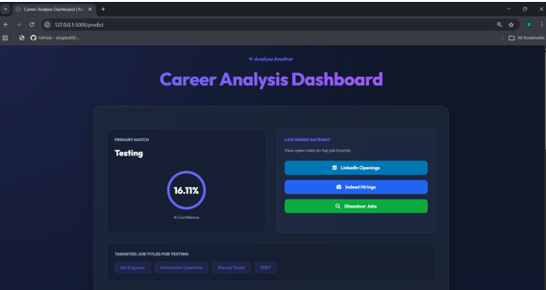

Fig.no-5.2 : Career Analysis Dashboard

The Career Analysis Dashboard provides a visual interface for evaluating job role alignment using AI-driven insights. It highlights a primary match score with confidence levels, while also integrating live hiring gateways that connect directly to platforms such as LinkedIn, Indeed, and Glassdoor. Additionally, the dashboard suggests targeted job titles relevant to the analysis, offering users a streamlined way to assess career opportunities and access real-time openings.

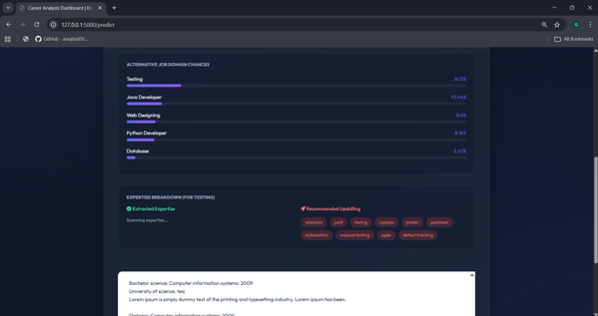
Fig.no-5.3: Career Analysis Dashboard
The Career Analysis Dashboard presents a comprehensive view of job domain probabilities and skill recommendations. It highlights alternative career paths with percentage scores, such as Testing, Java Development, Web Designing, and Python Development, giving users insight into their potential opportunities. The expertise breakdown section distinguishes between extracted skills and recommended upskilling areas, suggesting tools and frameworks like Selenium, JUnit, Cypress, and Postman to strengthen career readiness. By combining domain chances, skill analysis, and educational background, the dashboard provides a structured, data-driven approach to career evaluation and guidance.
Fig: 5.3.6 Architecture

  - Results

CHAPTER – 6 RESULT AND CONCLUSION

The AI-Based Resume Screening Web Application provides an effective solution to automate the traditionally time-consuming process of resume evaluation by leveraging machine learning techniques to minimize manual effort and accelerate recruitment workflows, thereby allowing recruiters to focus on strategic decision-making. It ensures consistency and fairness in candidate selection by eliminating subjectivity and bias inherent in manual screening, instead relying on predefined criteria and data-driven methods to deliver standardized results across diverse candidates and job roles. A core strength of the system lies in its use of techniques such as TF-IDF and cosine similarity, which enable precise comparisons between resumes and job descriptions by analyzing textual relevance and keyword importance, ultimately identifying candidates whose skills and experiences align closely with job requirements. Beyond its technical capabilities, the project highlights the practical application of artificial intelligence in modern recruitment, demonstrating how machine learning can enhance efficiency, scalability, and accuracy in real-world decision-making processes.
6.2 Conclusion
The current system can be significantly enhanced by incorporating advanced Natural Language Processing (NLP) techniques, as TF-IDF and cosine similarity, while effective for keyword-based matching, often fail to capture deeper contextual meaning. Future improvements could leverage transformer-based models such as BERT or word embeddings to better understand semantic relationships and thereby improve matching accuracy. Another promising enhancement lies in real-time integration with job portals and recruitment platforms, where APIs from services like LinkedIn or Indeed could be connected to automatically fetch job descriptions and candidate data, making the system more dynamic and practical for real-world deployment. Additionally, the application could evolve into a career guidance platform by introducing a personalized recommendation system that suggests suitable job roles, skill improvements, or training resources based on candidate profiles and past interactions, thereby extending its utility beyond screening to holistic career development

Future Scope
The Evolution of Hiring — AI is replacing the manual, exhausting process of reading thousands of resumes by hand, making hiring faster, smarter, and more consistent for companies around the world.
Smarter AI — Future systems powered by LLMs like BERT and GPT will truly understand a candidate's experience and potential, not just scan for matching keywords.
Real-Time Matching at Scale — The moment a job is posted, AI will instantly identify, rank, and even contact the best-fit candidates globally within seconds.
Reducing Bias — A well-designed AI evaluates candidates purely on skills and experience, helping create fairer and more inclusive hiring processes across industries.
Full HR Integration — From job posting to onboarding, AI will assist every step — reducing time-to-hire from weeks to just hours.
Impact on Education — The data generated by AI hiring will guide students on exactly what skills to learn to land their dream jobs.
Long-Term Vision — AI won't replace recruiters. It will handle the heavy lifting so humans can focus on conversations, culture, and relationships that truly matter.
"AI won't replace recruiters. But recruiters who use AI will replace those who don't."

REFERENCES
References:-
1 HackerEarth. (2026). AI resume screening tools. Retrieved from https://www.hackerearth.com
- Fabric. (2026). Top 30 AI resume screening tools. Retrieved from https://fabric.inc
- Manatal. (2026). AI-powered applicant tracking system. Retrieved from https://www.manatal.com
- Zoho Recruit. (2026). AI recruitment and resume screening. Retrieved from https://www.zoho.com/recruit
- Eightfold AI. (2026). Talent intelligence platform. Retrieved from https://eightfold.ai
- HireVue. (2026). AI-driven hiring and video interviews. Retrieved from https://www.hirevue.com
- Jobvite. (2026). AI recruitment software. Retrieved from https://www.jobvite.com
- BreezyHR. (2026). AI applicant tracking system. Retrieved from https://breezy.hr
- Academic References
- Dhamija, P., & Bag, S. (2020). Role of artificial intelligence in recruitment: A review and future research agenda. Benchmarking: An International Journal, 27(9), 2599–2622.
- Upadhyay, A. K., & Khandelwal, K. (2018). Applying artificial intelligence: Implications for recruitment. Strategic HR Review, 17(5), 255–258.
- Chamorro-Premuzic, T., Winsborough, D., Sherman, R. A., & Hogan, R. (2016). New talent signals: Shiny new objects or a brave new world? Industrial and Organizational Psychology, 9(3), 621–640.

