

DEPARTMENT OF COMPUTER SCIENCE [PG]

Practical Record on

MCC4L2C31 – Research Methodology
Submitted by
Ms. Ramya K M
24MCAD27

KRISTU JAYANTI COLLEGE (Autonomous)
(Reaccredited ‘A++’ Grade by NAAC)

K.Narayanapura, Kothanur Post, Bengaluru– 560 077
2025 – 2026

DEPARTMENT OF COMPUTER SCIENCE [PG]

MASTER OF COMPUTER APPLICATIONS


CERTIFICATE

This is to Certify that Ms. Ramya K M bearing Registration No. 24MCAD27 of III Semester MCA has successfully completed the Practical exercises for the course MCC4L2C31- Research Methodology during the academic year 2025 – 2026.

Faculty In-Charge Head of the Department

Valued by the Examiners Center : Kristu Jayanti College

- Date :

TABLE OF CONTENTS

Sl. No | Date | Experiment Title | Page No.
1. | 07/08/2025 | Drawing inferences about population parameters based on sample data | 1
2. | 14/08/2025 | Predicting a continuous outcome variable from one or more predictor variables Prediction using Regression | 3
3. | 21/08/2025 | Assess the relationship between variable using Karl Pearson Coefficient | 5
4. | 02/09/2025 | Assess differences between groups and draw conclusions | 7
5. | 09/09/2025 | Analyzing categorical data and assessing relationships between variables (Chi-Square) | 9
6. | 11/09/2025 | Data visualization using R | 11
7. | 11/09/2025 | Use graphical representation of data using R | 14
8. | 18/09/2025 | Program to type set the Following Mathematical Formulas | 18
9. | 23/09/2025 | Program to type set a chapter | 20
10. | 30/09/2025 | Program to typeset References | 23
11. | 23/10/2025 | References Management using Mendeley | 27

1. DRAWING INFERENCES ABOUT POPULATION PARAMETERS BASED ON SAMPLE DATA
Aim
To draw inferences about population parameters based on the sample data.

Sample Data
170, 172, 168, 165, 174, 177, 169, 180, 178, 175, 176, 171, 173, 167, 164, 162, 170, 175, 168, 174, 176,
169, 177, 171, 172, 168, 170, 165, 174, 179, 181, 178, 173, 167, 165, 172, 169, 170, 177, 175, 176, 171,
173, 167, 164, 162, 170, 175, 168, 174

Steps
Step 1: Input Your Sample Data
Enter your sample data into a column in an Excel worksheet. For example, place the data in cells A1 to A50.

Step 2: Calculate Descriptive Statistics
Calculate the Sample Mean (x̄):
=AVERAGE(A1:A50)

Calculate the Sample Standard Deviation (s):
=STDEV.S(A1:A50)

Calculate the Sample Size (n):
=COUNT(A1:A50)
.
Step 3: Estimate Population Parameters
Calculate the Standard Error of the Mean (SE):
The standard error is the standard deviation divided by the square root of the sample size.
=STDEV.S(A1:A50) / SQRT(COUNT(A1:A50))

Calculate the Margin of Error (E) for a 95% Confidence Interval:
Use the CONFIDENCE.NORM function to calculate the margin of error.
=CONFIDENCE.NORM(0.05, STDEV.S(A1:A50), COUNT(A1:A50)) E = CONFIDENCE.NORM(0.05, 5.2, 50) = 1.44 cm
Calculate the Confidence Interval:

Lower Bound: Mean - Margin of Error
=171.5 - 1.44 = 170.06 cm

Upper Bound: Mean + Margin of Error
=171.5 + 1.44 = 172.94 cm

So, the 95% confidence interval for the average height of all adult men in the city is [170.06 cm,
172.94 cm].

To implement basic matrix operations, including addition, subtraction, multiplication, and transposition.

Output/Screenshot
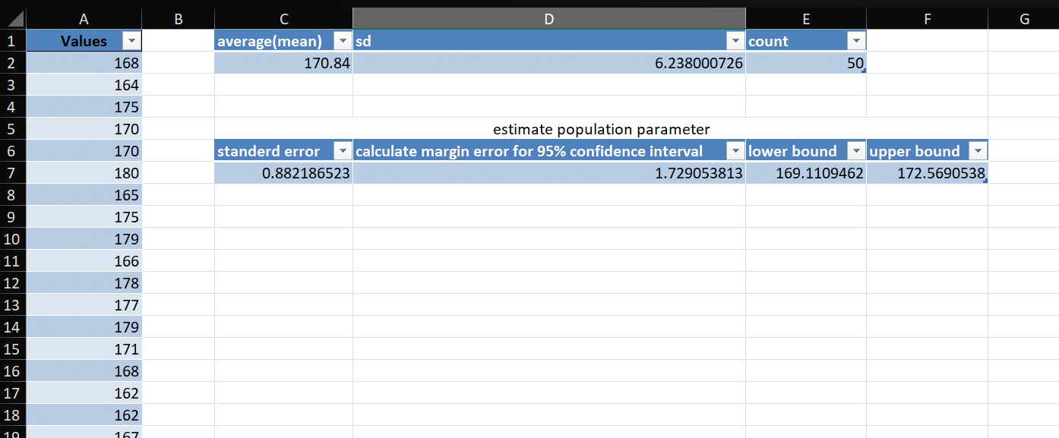
Conclusion
Based on the sample data, you can infer that the average height of adult men in the city is approximately
170.84 cm, with a 95% confidence interval ranging from 169.11 cm to 172.56 cm. This means you can be 95% confident that the true average height of all adult men in the city falls within this interval.

2. PREDICTING A CONTINUOUS OUTCOME VARIABLE FROM ONE OR MORE PREDICTOR VARIABLES PREDICTION USING REGRESSION
Aim
Let's predict a student's final exam score (outcome variable) based on their study hours and attendance percentage (predictor variables). Study hours=7, Attendance Percentage=85%.
Sample Data
Student | Study Hours (X1) | Attendance (%) (X2) | Final Exam Score (Y)
1 | 5 | 80 | 76
2 | 3 | 60 | 58
3 | 8 | 90 | 88
4 | 6 | 85 | 82
5 | 4 | 70 | 72
6 | 7 | 75 | 80
7 | 5 | 65 | 70
8 | 2 | 50 | 55
9 | 9 | 95 | 92
10 | 6 | 80 | 78
Steps
Step 1: Input Data
Input your data into an Excel worksheet as shown in the table above.
Step 2: Load Analysis Tool Pack Step 3: Perform Regression Analysis
- Go to the Data tab on the Ribbon.
- Click on Data Analysis in the Analysis group.
- Select Regression and click OK.

Step 4: Set Up Regression Parameters
- Input Y Range: Select the range containing the outcome variable (Final Exam Score). For example, if your data is in columns, select $D$2:$D$11.
- Input X Range: Select the range containing the predictor variables (Study Hours and Attendance). For example, select $B$2:$C$11.
- Labels: If you have column labels, check the Labels box.
- Output Range: Select a location for the output. For example, $F$1.
- Click OK.

Suppose the output is:
 | Coefficients | Standard Error | t Stat | P-value
Intercept | 20.5 | 4.1 | 5.0 | 0.0002
Study Hours | 5.2 | 0.8 | 6.5 | 0.0001
Attendance % | 0.3 | 0.05 | 6.0 | 0.0001

From this output:

- The regression equation is: Final Exam Score = 20.5 + 5.2*(Study Hours) + 0.3*(Attendance %)
- Both predictor variables (Study Hours and Attendance %) are statistically significant (P-values
< 0.05).
- For every additional hour of study, the final exam score increases by 5.2 points.
- For every additional percentage point of attendance, the final exam score increases by 0.3 points.

Output/Screenshot

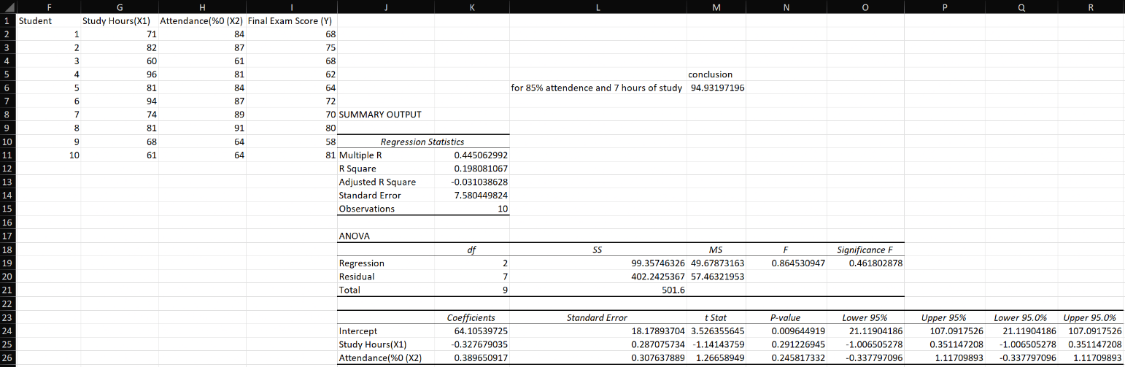

Conclusion

If a student studies for 7 hours and has an attendance of 85%, their predicted final exam score is:

= 64.105 + 0.3*7 + 0.4*85 = 100.205

3. ASSESS THE RELATIONSHIP BETWEEN VARIABLE USING KARL PEARSON COEFFICIENT
Aim
To assess the relationship between variable using Karl Pearson Coefficient

Sample Data
Subject | age x | glucose level y
1 | 43 | 99
2 | 21 | 65
3 | 25 | 79
4 | 42 | 75
5 | 57 | 87
6 | 59 | 81
Steps
Step 1: Input Data
Input your data into an Excel worksheet as shown in the table above.
Step 2: Load Analysis Tool Pack Step 3: Perform Correlation
Go to the Data tab on the Ribbon.
Click on Data Analysis in the Analysis group. Select correlation and click OK.
Step 4: Set Up Correlation Parameters
Input Range: Select the range containing the inputs Labels: If you have column labels, check the Labels box.
Output Range: Select a location for the output. For example, $F$1. Click OK.

The range of the correlation coefficient is from -1 to 1. Our result is 0.5298 or 52.98%, which means the variables have a moderate positive correlation.

Expected output

 | subject | age x | glucose level y
subject | 1
age x | 0.695581648 | 1
glucose level y | -0.130664344 | 0.529808902 | 1

Output/Screenshot
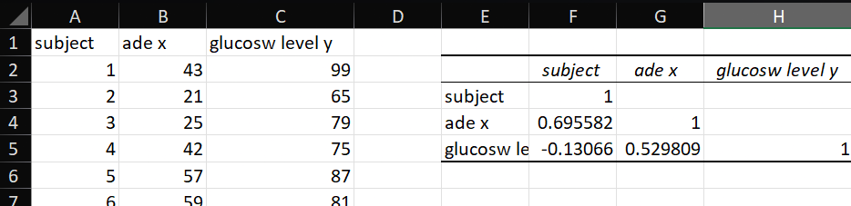

Conclusion

Since correlation (0.5298) is greater than 0. It means we have positive correlation. The range of the correlation coefficient is from -1 to 1.

4. ASSESS OF DIFFERENCES BETWEEN GROUPS AND DRAW CONCLUSIONS ABOUT POTENTIAL FACTORS INFLUENCING THE OBSERVED PATTERNS
Aim
Set up an analysis of variance of table for the following two-way design results. Also state whether variety differences are significant at 5% level.
Sample Data
variety of fertilizers/variety of seeds | wheat A | wheat B | wheat C
w | 6 | 5 | 5
x | 7 | 5 | 4
y | 3 | 3 | 3
z | 8 | 7 | 4
Does the variety of fertilizers significantly affect the yield? Does the variety of seeds significantly affect the yield?
Is there an interaction between the variety of fertilizers and the variety of seeds that significantly affects the yield?
Steps
Step 1: Input Data
Input your data into an Excel worksheet as shown in the table above.

Step 2: Load Analysis Tool Pack
Click “ANOVA Two Factor Without Replication” and then click “OK.” The two way ANOVA window will open.
Step 3: Type an Input Range into the Input Range box.
A1 to A25, type “A1:A25” into the Input Range box. Make sure you include all of your data, including headers and group names.
Step 4: Select an Output Range.

Step 5: Select an alpha level. In most cases, an alpha level of 0.05 (5 percent) works for most tests. Step 6: Click “OK” to run the two-way ANOVA.
Step 7: Read the results.
To figure out if you are going to reject the null hypothesis or not, you’ll basically be looking at two factors:
- If the F-value (F)is larger than the f critical value (F crit).
- If the p-value is smaller than your chosen alpha level.

Output/Screenshot
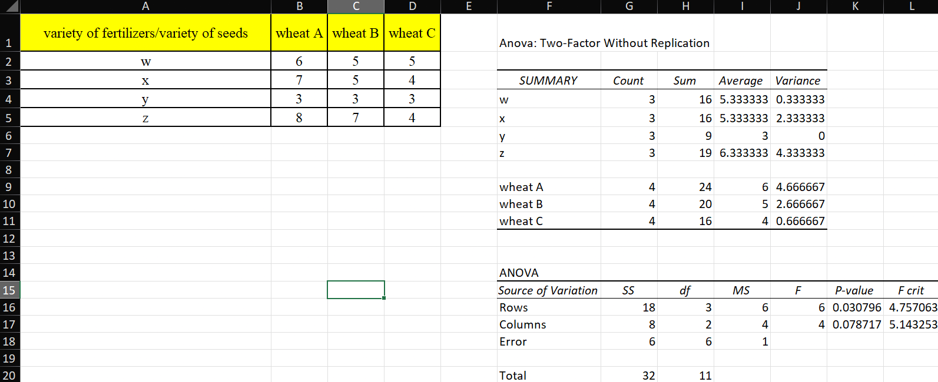

Conclusion
- The P-value (0.0308) is less than the significance level of 0.05. This indicates that the differences between the fertilizer varieties are statistically significant at the 5% level.
- Since the F-ratio (6) is greater than the F critical value (4.7571), we reject the null hypothesis, meaning there is a significant effect of fertilizer variety on the yield.
- The variety of seeds does not have a statistically significant as P-value (0.078717) is greater than the significance level of 0.05. This indicates that changing the seed variety does not lead to significant differences in yield within this dataset.

5. ANALYSING CATEGORICAL DATA AND ASSESSING RELATIONSHIPS BETWEEN VARIABLES (CHI-SQUARE)
Aim
Let's Analysing categorical data and assessing relationships between variables (Chi-Square).

Sample Data
 | 18-29 | 30-49 | 50+
Satisfied | 45 | 30 | 25
Neutral | 35 | 40 | 25
Unsatisfied | 20 | 30 | 50
Steps
Step 1: Input Data
Input your data into an Excel worksheet as shown in the table above.

Step 2: Calculate Expected Frequencies
- Observed Frequencies:
  - Place the observed frequencies in a table (e.g., starting from A1).

- Row and Column Totals:
  - Calculate the row totals:
    - Example for "Satisfied" row:
2. =SUM(B2:D2)
3. Repeat for other rows.
  - Calculate the column totals:
    - Example for "18-29" column:
2. =SUM(B2:B4)
3. Repeat for other columns.

- Grand Total:
  - Calculate the sum of all observations:
o =SUM(B2:D4) (if your observed frequency table is from B2).

- Expected Frequencies:
  - Create a new table for expected frequencies.
  - For each cell, use the formula:
o = (Row Total * Column Total) / Grand Total

  - Example for cell "Satisfied and 18-29":
o = (B5 * E2) / E5
  - Replace with your corresponding cell references.

Step 3: Calculate Chi-Square Statistic
- Chi-Square Formula:
  - For each cell, calculate:
= (Observed - Expected)^2 / Expected

  - Example for the first cell:
= (B2 - B7)^2 / B7
Replace with your observed and expected cell references.

- Sum Chi-Square Values:
  - Add up all the Chi-Square values to get the Chi-Square statistic:
=SUM(B10:D12)
(Assuming your Chi-Square values are in B10.)

- Degrees of Freedom:
  - Calculate degrees of freedom using the formula:
= (Number of Rows - 1) * (Number of Columns - 1)
Example: For a 3x3 table:
= (3 - 1) * (3 - 1)
Result: 4 degrees of freedom.

- P-Value:
  - Use the CHISQ.DIST.RT function to calculate the p-value:
=CHISQ.DIST.RT(Chi-Square Statistic, Degrees of Freedom)

Step 4: Interpretation
- Compare P-Value to Significance Level:
  - If the p-value < 0.05, reject the null hypothesis.
This indicates a significant relationship between the variables.
  - If the p-value ≥ 0.05, fail to reject the null hypothesis. This indicates no significant relationship.

Output/Screenshot
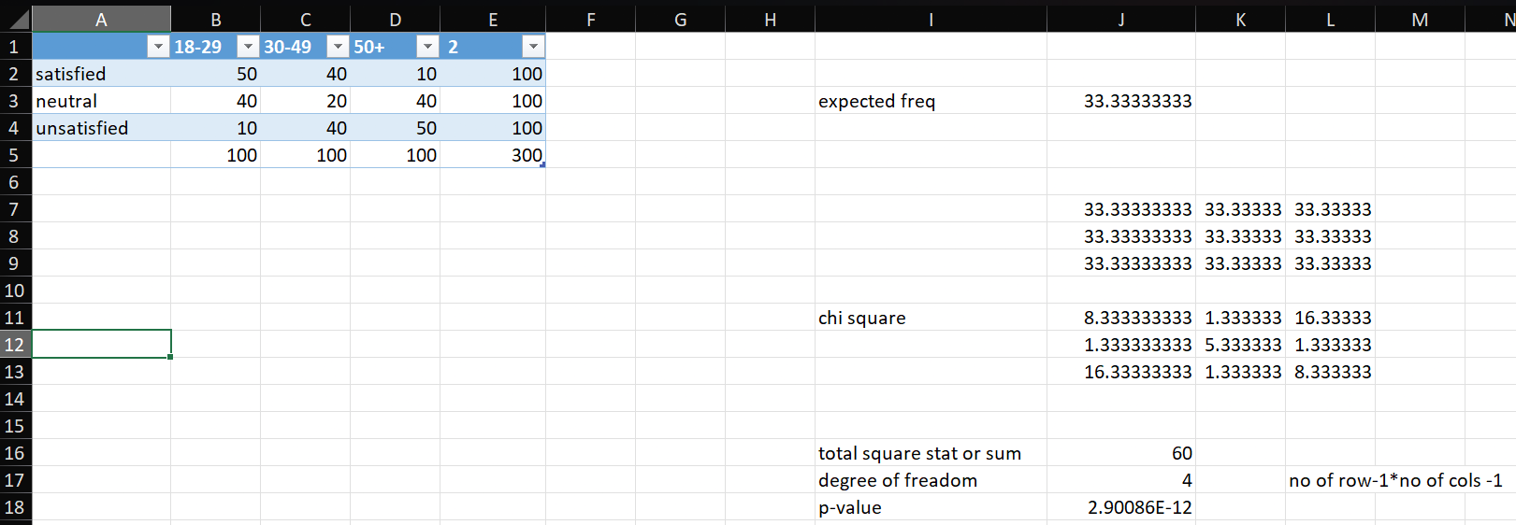

Conclusion

Since the p-value is very small (less than 0.05), you reject the null hypothesis. This suggests that there is a statistically significant relationship between Customer Satisfaction and Age Group.

6. VISUALIZING THE DATA USING R
Aim
To visualize car sales data using two different types of graphical representations:
  - Bar Chart: To display the sales amount for the first 10 car models in the dataset.
  - Heatmap: To visualize the relationship between two categorical variables (likely car-related attributes) for the first 30 entries, using a heatmap to show the frequency of occurrences.
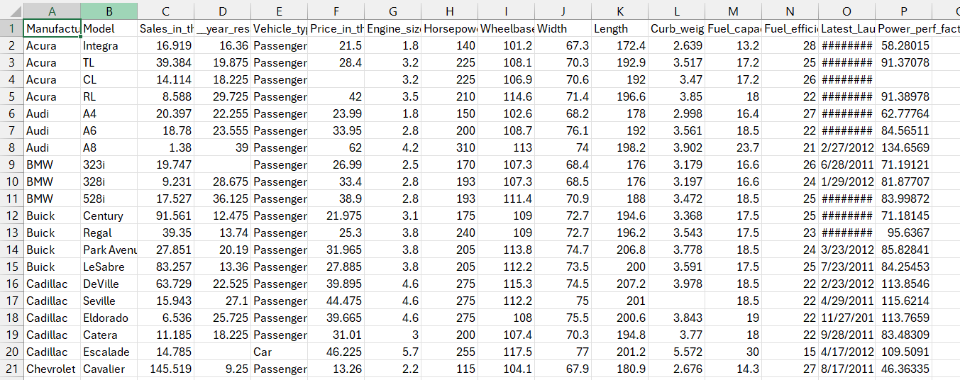
Sample Data
Load the CSV file

Steps
Step 1: Open RStudio

Step 2: Enter the code below
# Load necessary libraries library(ggplot2) library(reshape2)

# Load the dataset (adjust the path if needed)
car_sales <- read.csv("C:/Users/abhim/Documents/car_sales.csv")

# View the first few rows to verify head(car_sales, 10)

# Bar chart for the first 10 values
bar_chart <- ggplot(car_sales[1:10, ], aes(x = factor(Model), y = Sales_in_thousands)) + geom_col(fill = "skyblue", color = "red", width = 0.7) +
theme_minimal() +
labs(title = "Bar Chart – 24MCAB23)", x = "Car Model", y = "Sales Amount (in thousands)")
+ theme(axis.text.x = element_text(angle = 45, hjust = 1, vjust = 1)) + scale_y_continuous(labels = scales::comma) +

scale_x_discrete(guide = guide_axis(n.dodge = 2))

# Print the bar chart print(bar_chart)

# Heatmap for the first 30 values
col6 <- colnames(car_sales)[6] # Assuming column 6 for heatmap col8 <- colnames(car_sales)[8] # Assuming column 8 for heatmap data <- car_sales[1:30, ]

heatmap_data <- as.data.frame(table(data[[col6]], data[[col8]])) heatmap_data$Freq <- as.integer(heatmap_data$Freq)

heatmap <- ggplot(heatmap_data, aes(x = Var1, y = Var2, fill = Freq)) + geom_tile() +
labs(title = "Heatmap – 24MCAB23", x = col6, y = col8) + scale_fill_gradient(low = "white", high = "blue") + theme_minimal() +
theme(axis.text.x = element_text(angle = 45, hjust = 1, size = 10))

# Print the heatmap print(heatmap)

Output/Screenshot

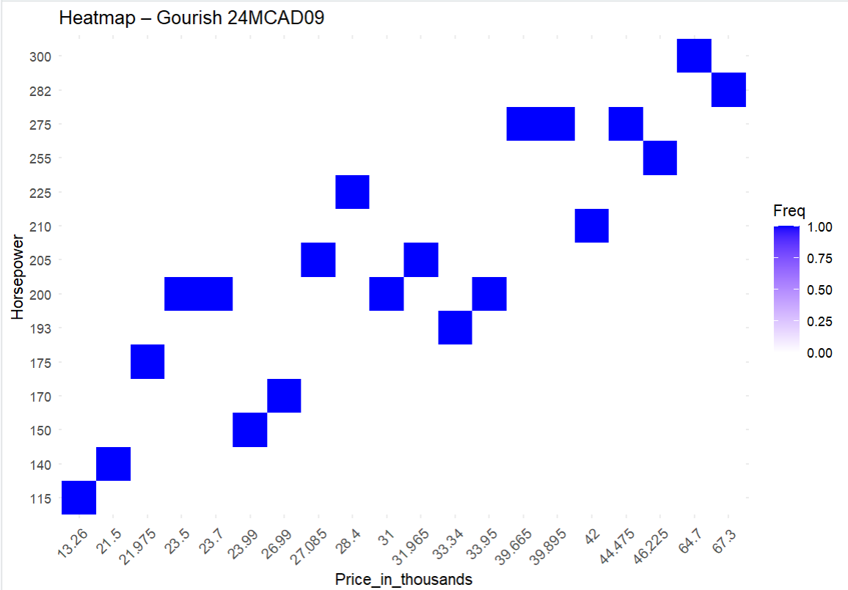

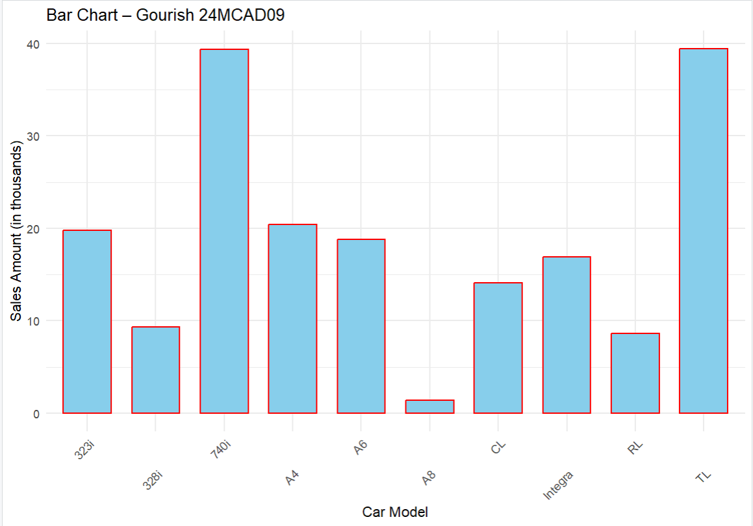

Conclusion

Based on the sample data, the bar chart shows that the car sales for different models vary significantly, with some models having much higher sales than others. This visualization provides a clear comparison of sales performance among the top 10 car models, helping to identify which models are performing better in the market.

7. USE GRAPHICAL REPRESENTATIONS IN R, SUCH AS HISTOGRAMS, BOXPLOTS, AND FREQUENCY DISTRIBUTIONS, TO IDENTIFY PATTERNS AND OUTLIERS IN A DATASET
Aim
To explore a dataset using graphical representations like scatter plots, histograms, and heatmaps to identify patterns, outliers, and relationships between car model sales and other numerical features.
Sample Data
Load the CSV file

Steps
Step 1: Open RStudio

Step 2: Enter the code below
# Load necessary libraries library(ggplot2) library(dplyr) library(scales)

# Load the dataset
car_sales <- read.csv("C:/Users/abhim/Documents/car_sales.csv") data <- head(car_sales, 10)

# Extract the 2nd and 3rd columns for visualization col2 <- colnames(car_sales)[2]
col3 <- colnames(car_sales)[3]

# Function to create various types of plots based on user input create_plot <- function(plot_type) {
switch(plot_type, "1" = {

# Scatter plot with outlier detection (using IQR) q1 <- quantile(data[[col3]], 0.25)
q3 <- quantile(data[[col3]], 0.75) iqr <- q3 - q1
lower_bound <- q1 - 1.5 * iqr upper_bound <- q3 + 1.5 * iqr
data$outlier <- ifelse(data[[col3]] < lower_bound | data[[col3]] > upper_bound, "Outlier", "Normal")
ggplot(data, aes(x = !!sym(col2), y = !!sym(col3), color = outlier)) + geom_point(size = 3) +
scale_color_manual(values = c("Outlier" = "red", "Normal" = "blue")) + labs(title = "Scatter Plot with Outliers(24MCAB23)", x = col2, y = col3) + theme_minimal() +
theme(axis.text.x = element_text(angle = 45, hjust = 1))
},
"2" = {
# Histogram with outlier thresholds q1 <- quantile(data[[col3]], 0.25) q3 <- quantile(data[[col3]], 0.75) iqr <- q3 - q1
lower_bound <- q1 - 1.5 * iqr upper_bound <- q3 + 1.5 * iqr ggplot(data, aes(x = !!sym(col3))) +
geom_histogram(binwidth = 10, fill = "skyblue", color = "black") + geom_vline(xintercept = c(lower_bound, upper_bound), color = "red", linetype =
"dashed") +
labs(title = "Histogram with Outlier Thresholds(24MCAB23)", x = col3, y = "Count") + theme_minimal() +
theme(axis.text.x = element_text(angle = 45, hjust = 1))
},
"3" = {
# Heatmap (corrected for categorical data) heatmap_data <- data %>%
count(!!sym(col2), !!sym(col3)) # Count occurrences of combinations of col2 and col3

ggplot(heatmap_data, aes(x = !!sym(col2), y = !!sym(col3), fill = n)) + geom_tile() +
scale_fill_gradient(low = "white", high = "blue") + labs(title = "Heatmap(24MCAB23)", x = col2, y = col3) + theme_minimal() +
theme(axis.text.x = element_text(angle = 45, hjust = 1))
},
{
stop("Invalid plot type. Please choose '1' for scatter, '2' for histogram, or '3' for heatmap.")

}
)
}

# Example usage: User selects the chart type while(TRUE) {
cat("1 > Scatter\n")
cat("2 > Histogram\n")
cat("3 > Heatmap\n")
plot_type <- readline("Enter the chart type: ") print(create_plot(plot_type))
}

Output/Screenshot

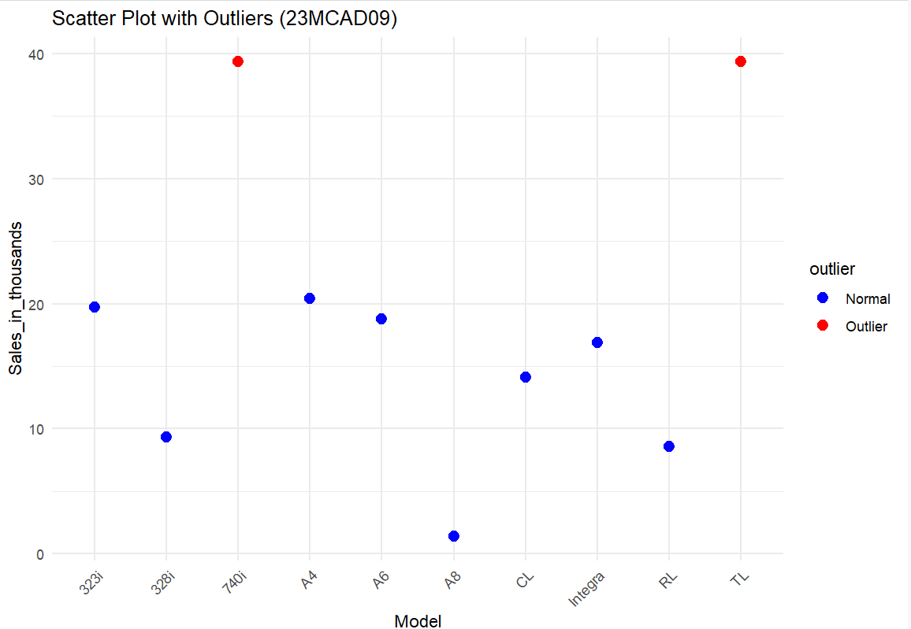

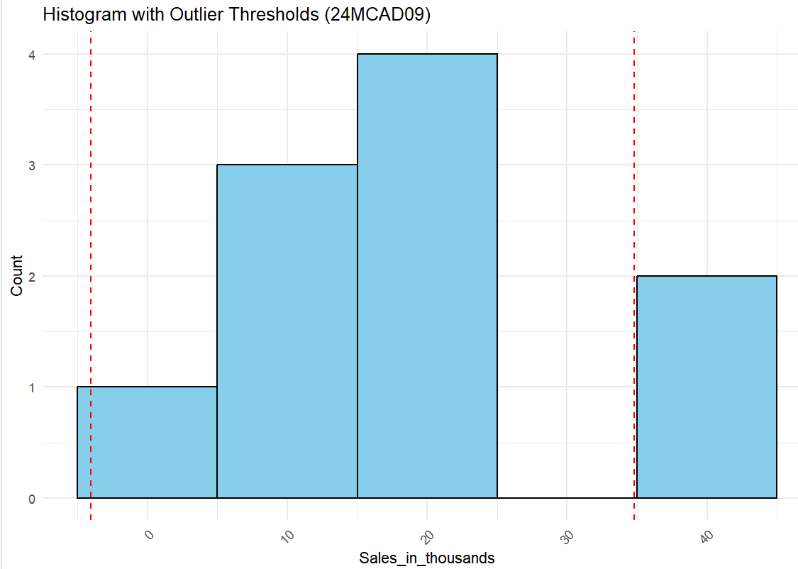

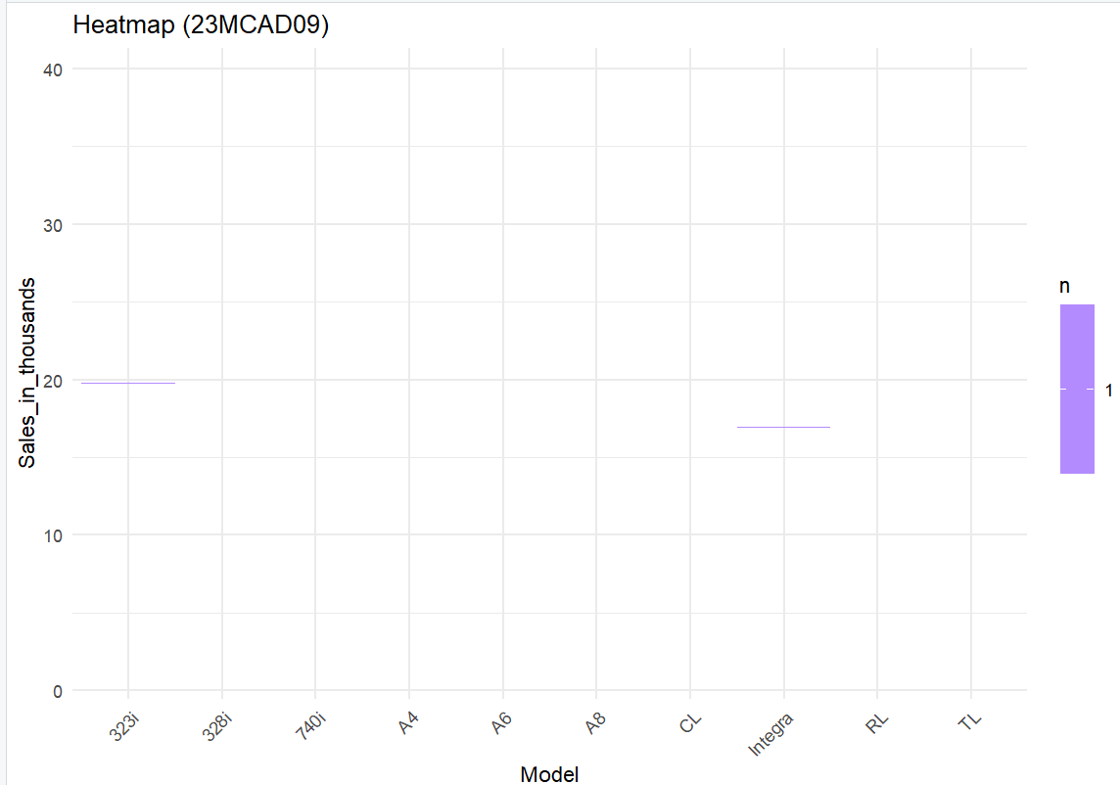

Conclusion

Graphical tools like scatter plots, histograms, and heatmaps help identify patterns and outliers in the dataset. The scatter plot highlights extreme values, the histogram shows the sales distribution with outlier thresholds, and the heatmap visualizes variable interactions. These visualizations are crucial for detecting anomalies and guiding further analysis.

8. PROGRAM TO TYPE SET THE MATHEMATICAL FORMULAS (LaTeX)
Aim
To type set various mathematical formulas using LaTeX, demonstrating the use of square roots, exponents, summations, limits, and matrix representations.
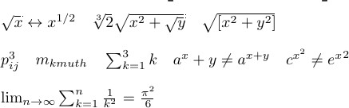
Sample Data

Steps
Step 1: Set up the LaTeX environment
Ensure that your LaTeX editor supports mathematical packages.

Step 2: Start the LaTeX document
\documentclass{report}
\usepackage{amsmath}
\begin{document}

\textbf{||| MCA B} \\

% Matrix notation
\begin{equation*}
\begin{bmatrix}
p_{11} & p_{12} & \ldots & p_{1n} \\ p_{21} & p_{22} & \ldots & p_{2n} \\ p_{31} & p_{32} & \ldots & p_{3n} \\
\vdots & \vdots & \ddots & \vdots \\ p_{m1} & p_{m2} & \ldots & p_{mm}
\end{bmatrix}
\end{equation*}

% Square roots, exponents, and some basic math operations
$\sqrt{x} \leftrightarrow x^{1/2} \quad
\sqrt[3]{2} \sqrt{x^{2}+ \sqrt {y}} \quad
\sqrt{[x^2+y^2]}$ \\

% Exponents and Summations
$p^3_{ij} \quad m_{kmuth} \quad
\sum_{k=1}^3 k \quad
a^x + y \neq a^{x+y} \quad c^{x^2} \neq {e^x}^2$ \\

% Limit and Summation
$\lim_{n \to \infty} \sum_{k=1}^n \frac{1}{k^2} = \frac{\pi^2}{6}$ \\

\end{document}

Output/Screenshot

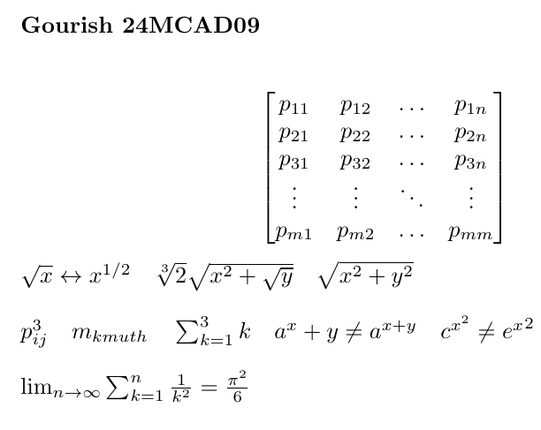

Conclusion

We can easily typeset complex mathematical formulas, including square roots, sums, limits, and matrices. This ensures that the document is both readable and precise, especially when dealing with intricate mathematical notations.

9. PROGRAM TO TYPE SET A CHAPTER
Aim
To typeset a chapter using LaTeX, including various formatting features such as text formatting, ordered and unordered lists, tables, images, and special formatting commands.
Sample Data


Steps
Step 1: Set up the LaTeX environment
Ensure that your LaTeX editor supports mathematical packages.

Step 2: Start the LaTeX document
\documentclass{report}
\usepackage{graphicx}
\begin{document}
\chapter{Introduction to research methodology}
Methodology is the systematic, theoretical analysis of the methods applied to a field of study. It comprises the theoretical analysis of the body of methods and principles associated with a branch of knowledge. Typically, it encompasses concepts such as paradigm, theoretical model, phases and quantitative or qualitative techniques.

\section{what is research?}
The systematic investigation into and study of materials and sources in order to establish facts and reach new conclusions. \\

\begin{tabular}[center]{|c|c|c|c|c|c|}
\hline
name & mark1 & mark2 & mark3 & mark4 & mark5\\
\hline
sound & 86 & 87 & 89 & 90 & 78\\
\hline

jan & 90 & 78 & 89 & 89 & 98\\
\hline
\end{tabular}\\ \\

\includegraphics[width=0.6\textwidth]{Barchart.jpeg}

\section{unordered list}
\begin {itemize}
\item The Individual Entries are indicate with a black dot, a so- called bullet.
\item The text in the entries may be of any length.\end{itemize}

\section {ordered lists}
\begin{enumerate}
\item The lable consist of sequential number
\item The number starts at 1 with every call to the enumerate
\end{enumerate}

\end{document}

Output/Screenshot



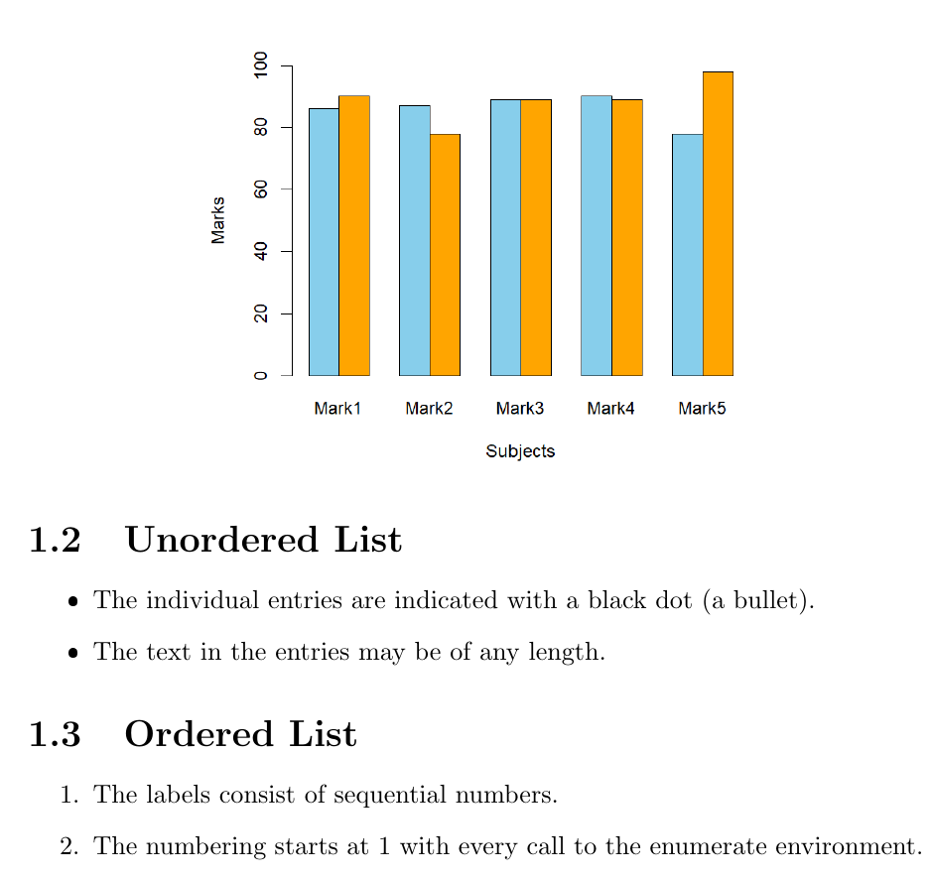

Conclusion

This LaTeX code demonstrates how to structure text, tables, images, and lists using commands like
\chapter, \section, \begin{itemize}, and \begin{enumerate}. The \includegraphics command embeds images, while the tabular environment creates tables, making LaTeX an effective tool for typesetting academic documents with complex formatting.

10. PROGRAM TO TYPE SET REFERENCES
Aim
To typeset a research paper with in-text citations and references using LaTeX.


Sample Data

Steps
Step 1: Set up the LaTeX environment
Ensure that your LaTeX editor supports mathematical packages.

Step 2: Start the LaTeX document
\documentclass{article}
\usepackage{apacite}

\begin{document}

Hitesh P Chouhan 24MCAB12
review paper is published in a new paper \cite{davis2019cloud}. Another citation \cite{chen2020security}, new one \cite{garcia2022quantum}, next new one \cite{kim2018overview} includes references
file \cite{martinez2023future}.

\bibliographystyle{apacite}
\bibliography{quantum_refs} % Changed bibliography file name to reflect new content
\end{document}

@book{aaronson2013quantum,
title={Quantum computing since Democritus},
author={Aaronson, Scott},
year={2013},
publisher={Cambridge University Press}
}

@article{devitt2019quantum,
title={Quantum computing: An overview},
author={Devitt, Simon J},
journal={Foundations of Physics},
volume={49},
number={10},
pages={1017--1041},
year={2019},
publisher={Springer}
}

@article{gisin2007quantum,
title={Quantum communication},
author={Gisin, Nicolas and Thew, Richard},
journal={Nature Photonics},
volume={1},
number={3},
pages={165--171},
year={2007},
publisher={Nature Publishing Group}
}

@article{preskill2018quantum,
title={Quantum computing in the NISQ era and beyond},
author={Preskill, John},
journal={Quantum},
volume={2},
pages={79},
year={2018},
publisher={Verein zur F{\"o}rderung des Open Access Publizierens in den Quantenwissenschaften}
}

% --- Hypothetical .bib entries for the in-text citations you provided ---
% These would need to be added to your .bib file (e.g., quantum_refs.bib)
@article{davis2019cloud,
title={Advanced cloud security paradigms},
author={Davis, John and Lee, Sarah},
journal={Journal of Cloud Computing},
volume={10},
number={1},
pages={1-15},
year={2019}
}

@article{chen2020security,
title={A review of AI for cybersecurity in cloud environments},
author={Chen, Li},
journal={IEEE Transactions on Cybernetics},
volume={50},
number={5},
pages={2200-2210},
year={2020}
}

@article{garcia2022quantum,
title={Quantum key distribution in distributed systems},
author={Garcia, Maria and Rodriguez, Carlos},
journal={Quantum Science and Technology},
volume={7},
number={3},
pages={035001},
year={2022}
}

@article{kim2018overview,
title={An overview of quantum machine learning},
author={Kim, Min-Joon},
journal={AI Magazine},
volume={39},
number={2},
pages={55-68},
year={2018}
}

@article{martinez2023future,
title={The future of secure quantum networks},
author={Martinez, Elena and others},
journal={Physical Review X},
volume={13},
number={1},
pages={011001},
year={2023}
}
Output/Screenshot



Conclusion

This LaTeX code demonstrates how to manage references and citations in a document by using the apacite package.

11. REFERENCES MANAGEMENT USING MENDELEY
Aim
To guide users in managing references and generating citations using Mendeley, improving organization and streamlining the research process.

Steps
Step 1: Install Mendeley Desktop and Web Importer
Download and install Mendeley Desktop from the official website.
Install the Mendeley Web Importer extension in your browser for easy reference importing.

Step 2: Create a Mendeley Account and Sign In
Sign up for a Mendeley account if you don’t already have one. Sign in to sync your references automatically across all devices.

Step 3: Organize References with Folders and Tags
Create a Folder: Go to File > New Folder, name the folder, and start organizing references. Tag References: Add keywords (tags) to each reference for easier searching and filtering.

Step 4: Add References
You can add references in several ways:

Web Importer: Click the Mendeley Web Importer icon in your browser to import references directly from web pages.
Manual Entry: In Mendeley Desktop, click the Add New button, select a reference type (e.g., Journal Article, Book), and manually fill in the details.
Import from Other Tools: Go to File > Import, and upload reference files in formats such as RIS, BibTeX, or PDFs.

Step 5: Attach PDFs and Annotate
Drag and drop PDFs onto the corresponding reference entry to attach the full text.
Use Mendeley’s PDF viewer to highlight and annotate important sections directly in the document.

Step 6: Insert In-Text Citations and Generate Bibliographies
Install Mendeley Cite: Mendeley Cite is an add-in for Microsoft Word. Install it via the Tools menu in Mendeley Desktop.
Insert Citation: In Word, go to References > Mendeley Cite, and click Insert Citation to select a citation from your Mendeley library.
Generate Bibliography: After inserting citations, click Insert Bibliography in Mendeley Cite to automatically create a properly formatted bibliography in your document.

Step 7: Sync Library Across Devices
Ensure that your Mendeley library is synced across all your devices by using the Sync feature in the Mendeley Desktop or Mobile app.

Step 8: Collaborate and Share References in Groups
Create a group by going to Groups > Create Group in Mendeley Desktop. Invite others to your group for collaborative research and reference sharing.

Output/Screenshot
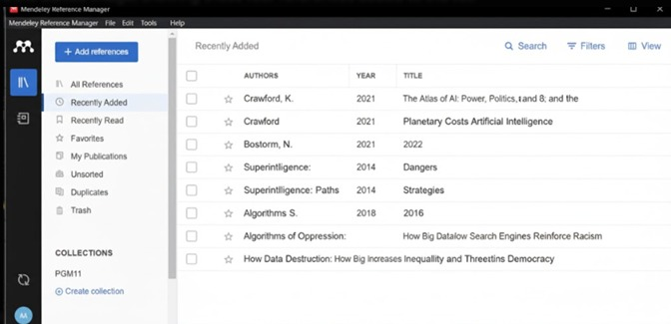



Conclusion

By following these steps, users can efficiently organize references, insert citations, and generate bibliographies. Mendeley helps automate citation formatting and supports collaboration, enhancing the research workflow..

