1. Write a program to perform Basic Matrix Operations.
Date:01/08/2025
Aim:
To develop a Python program to perform basic Matrix operations.

Source Code:
def get_matrix(rows, cols):
matrix = []
print(f"Enter the elements of a {rows}x{cols} matrix, row by row:")
for i in range(rows):
while True:
try:
row_input = input(f"Row {i + 1}: ")
row = list(map(float, row_input.split()))
if len(row) != cols:
raise ValueError("Number of elements in the row does not match the specified number of columns.")
matrix.append(row)
break
except ValueError as e:
print(f"Error: {e}. Please try again.")
return matrix

def print_matrix(matrix):
for row in matrix:
print(" ".join(map(str, row)))

def add_matrices(A, B):
if len(A) != len(B) or len(A[0]) != len(B[0]):
raise ValueError("Matrices must have the same dimensions for addition.")

result = []
for i in range(len(A)):
result_row = [A[i][j] + B[i][j] for j in range(len(A[0]))]
result.append(result_row)
return result

def sub_matrices(A, B):
if len(A) != len(B) or len(A[0]) != len(B[0]):
raise ValueError("Matrices must have the same dimensions for subtraction.")

result = []
for i in range(len(A)):
result_row = [A[i][j] - B[i][j] for j in range(len(A[0]))]
result.append(result_row)
return result

def multiple_matrices(A, B):
if len(A[0]) != len(B):
raise ValueError("Number of columns in matrix A must be equal to the number of rows in matrix B for multiplication.")

result = [[0 for _ in range(len(B[0]))] for _ in range(len(A))]

for i in range(len(A)):
for j in range(len(B[0])):
for k in range(len(B)):
result[i][j] += A[i][k] * B[k][j]
return result

def transpose_matrix(matrix):
rows = len(matrix)
cols = len(matrix[0])

transposed = [[0 for _ in range(rows)] for _ in range(cols)]

for i in range(rows):
for j in range(cols):
transposed[j][i] = matrix[i][j]
return transposed

def main():
try:
rows_A = int(input("Enter number of rows for Matrix A: "))
cols_A = int(input("Enter number of columns for Matrix A: "))
print("Matrix A:")
matrix_A = get_matrix(rows_A, cols_A)

rows_B = int(input("Enter number of rows for Matrix B: "))
cols_B = int(input("Enter number of columns for Matrix B: "))
print("Matrix B:")
matrix_B = get_matrix(rows_B, cols_B)

print("\nMatrix A:")
print_matrix(matrix_A)
print("\nMatrix B:")
print_matrix(matrix_B)

if rows_A == rows_B and cols_A == cols_B:
result_Add = add_matrices(matrix_A, matrix_B)
print("\nMatrix Addition Result:")
print_matrix(result_Add)
else:
print("Matrix addition is not possible with different dimensions.")

if rows_A == rows_B and cols_A == cols_B:
result_Sub = sub_matrices(matrix_A, matrix_B)
print("\nMatrix Subtraction Result:")
print_matrix(result_Sub)
else:
print("Matrix subtraction is not possible with different dimensions.")

if cols_A == rows_B:
result_Mult = multiple_matrices(matrix_A, matrix_B)
print("\nMatrix Multiplication Result:")
print_matrix(result_Mult)
else:
print("Matrix multiplication is not possible with these dimensions.")

print("\nTranspose of Matrix A:")
result_Transpose_A = transpose_matrix(matrix_A)
print_matrix(result_Transpose_A)

print("\nTranspose of Matrix B:")
result_Transpose_B = transpose_matrix(matrix_B)
print_matrix(result_Transpose_B)

except ValueError as e:
print(f"Error: {e}")

if __name__ == "__main__":
main()

Output:

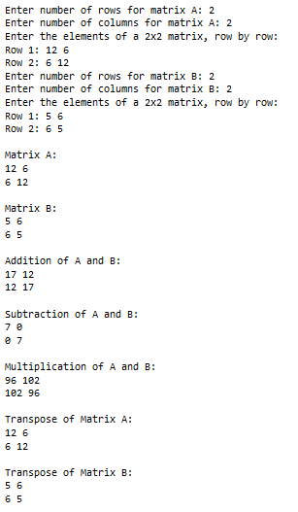

2. Write a program to implement the basic Arithmetic operations of a set and dictionary datatypes
Date:08/08/2025
Aim:
To develop a Python program to implement basic Arithmetic Operations on Set and Dictionary.

Source Code:
def dictionary_operations():
d = {} # Initialize an empty dictionary

while True:
print("\nDictionary Operations Menu:")
print("1. Add/Update Key-Value Pair")
print("2. Remove Key-Value Pair")
print("3. Display All Values")
print("4. Check if Key Exists")
print("5. Exit")

choice = input("Enter your choice (1-5): ")

if choice == '1':
key = input("Enter key: ")
value = input("Enter value: ")
d[key] = value
print(f"Key-Value pair ({key}: {value}) added/updated.")

elif choice == '2':
key = input("Enter key to remove: ")
if key in d:
del d[key]
print(f"Key '{key}' removed.")
else:
print(f"Key '{key}' not found.")
elif choice == '3':
print("Entire dictionary contents:")
for k,v in d.items():
print(f"{k}:{v}")

elif choice == '4':
key = input("Enter key to access value: ")
if key in d:
print(f"Value for key '{key}': {d[key]}")
else:
print(f"Key '{key}' not found.")

elif choice == '5':
print("Exiting the program.")
break

else:
print("Invalid choice. Please enter a number between 1 and 5.")

def set_operations():
s= set()
while True:
print("Set Operations")
print("1. Add Element")
print("2. Remove Element")
print("3. Display Set")
print("4. Check if Element Exist")
print("5. Exit")
choice=input("Enter your Choice")
if choice=='1':
element = input("Enter the element to add")
s.add(element)
print(f"Added element:{element}")
elif choice =='2':
element=input("Enter the element to remove")
if element in s:
s.remove(element)
print(f"Removed element {element} successfully")
else:
print("Element not found")
elif choice =='3':
print("Current set Contents")
print(s)
elif choice=='4':
element=input("Enter the Element to check")
if element in s:
print(f"Element '{element}' exists in the set")
else:
print("Element not found")
elif choice=='5':
break
else:
print("Invalid choice, Please try Again")
def main():
while True:
print("\n Main Menu")
print("1. Dictionary Operations")
print("2. Set Operations")
print("3. Exit")
choice=input("Enter your Choice")
if choice=='1':
dictionary_operations()
elif choice=='2':
set_operations()
elif choice=='3':
print("Exiting...")
break
else:
print("Invalid choice, please try again")
if __name__=="__main__":
main()

Output:

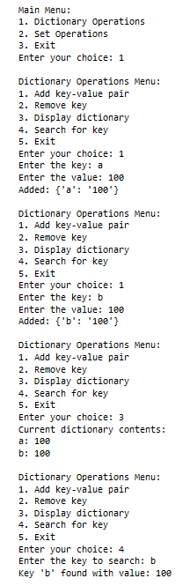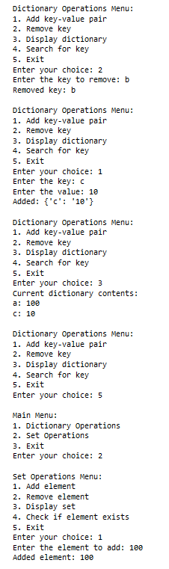

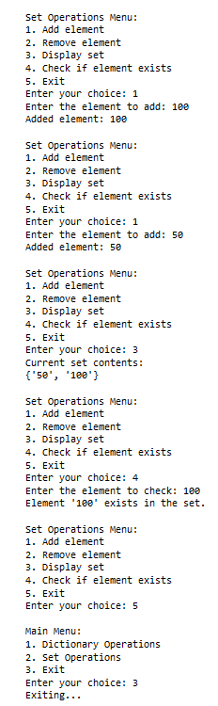

3. Program to implement Regular Expressions in Python
Date:19/08/2025
Aim:
To develop a Python program to implement Regular Expressions..

Source Code:
import re
def validate_email(email):
pattern = r'^[a-zA-Z0-9._%+-]+@[a-zA-Z0-9.-]+\.[a-zA-Z]{2,}$'
return re.match(pattern,email) is not None
def validate_phone_number(phone_number):
pattern=r'^\+?[1-9]\d{1,14}$'
return re.match(pattern,phone_number) is not None
def validate_password(password):
pattern = r'^(?=.*[a-z])(?=.*\d)[A-Za-z\d]{8,}$'
return re.match(pattern,password) is not None
def main():
print("Welcome to the user validation program !")
email = input("Enter your email:")
if validate_email(email):
print("Email is valid")
else:
print("invalid email")
phone_number=input("Enter your Phone Number:")
if validate_phone_number(phone_number):
print("phone number is valid ")
else:
print("invalid phone number")
password = input("Enter your password")
if validate_password(password):
print("Password is valid")
else:
print("password is invalid ")
if __name__ == "__main__":
main()

Output:

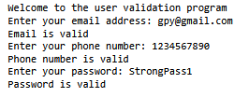

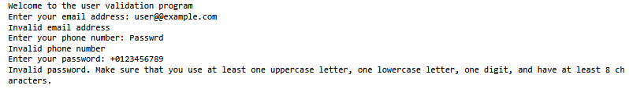

4. Python program to perform file handling.
Date:22/08/2025
Source Code:

def write_to_file(filename):
with open(filename, 'w') as file:
print("Enter text to write to the file. Type 'exit' on a new line to finish.")
while True:
line = input()
if line.lower() == 'exit':
break
file.write(line + '\n')
print(f"Data written to '{filename}'")
def read_from_file(filename):
try:
with open(filename, 'r') as file:
content = file.read()
print("\nFile content: ")
print(content)
except FileNotFoundError:
print("Error. The file '{filename}' doesn't exist")
def append_to_file(filename):
with open(filename, 'a') as file:
print("Enter text to append to the file. Type 'exit' on a new line to finish.")
while True:
line = input()
if line.lower() == 'exit':
break
file.write(line + '\n')
print(f"Data appended to '{filename}'")
def read_lines_from_file(filename):
try:
with open(filename, 'r') as file:
lines = file.readlines()
print("\nLines in File:")
for line in lines:
print(line.strip())
except FileNotFoundError:
print(f"Error. The file '{filename}' doesn't exist")
def main():
while True:
print("\nFile Operations Menu:")
print("1. Write to a file")
print("2. Read from a file")
print("3. Append to a file")
print("4. Read lines from a file")
print("5. Exit")
choice = input("Enter your choice (1-5): ")
if choice == '1':
filename = input("Enter the filename to write to: ")
write_to_file(filename)
elif choice == '2':
filename = input("Enter filename to read from: ")
read_from_file(filename)
elif choice == '3':
filename = input("Enter filename to append to: ")
append_to_file(filename)
elif choice == '4':
filename = input("Enter filename to read lines from:")
read_lines_from_file(filename)
elif choice == '5':
print("Exiting...")
break
else:
print("Invalid choice. Please enter a number between 1 and 5.")
if __name__ == "__main__":
main()

Output:

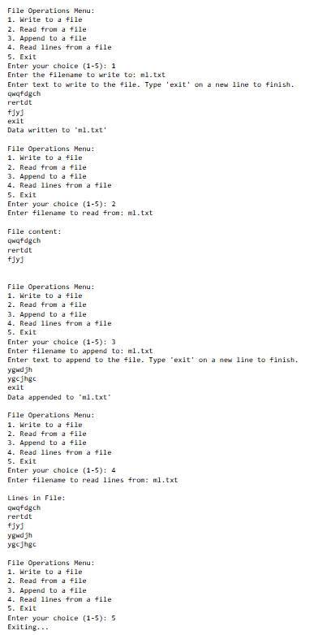

5. Program to store the details of students using data frame and perform primary operations.
Date:26/08/2025
Aim:
To develop a Python program to use data frame to store details of students and perform primary operations.

Source Code:
import Pandas as pd

# Function to create an initial DataFrame
def create_dataframe():
data = {
'StudentID': [1, 2, 3],
'Name': ['Alice', 'Bob', 'Charlie'],
'Age': [20, 21, 22],
'Major': ['Physics', 'Mathematics', 'Computer Science']
}
return pd.DataFrame(data)

# Function to add a new student
def add_student(df, student):
df = df.append(student, ignore_index=True)
return df

# Function to update a student's details
def update_student(df, student_id, field, new_value):
df.loc[df['StudentID'] == student_id, field] = new_value
return df

# Function to delete a student by StudentID
def delete_student(df, student_id):
df = df[df['StudentID'] != student_id]
return df

# Function to save DataFrame to CSV
def save_to_csv(df, filename):
df.to_csv(filename, index=False)

# Function to load DataFrame from CSV
def load_from_csv(filename):
return pd.read_csv(filename)

# Function to sort students by Age
def sort_by_age(df):
return df.sort_values(by='Age')

# Function to filter students by Major
def filter_by_major(df, major):
return df[df['Major'] == major]

# Main operations
def main():
# Create DataFrame
df = create_dataframe()
print("Initial DataFrame:")
print(df)

# Add a new student
new_student = {
'StudentID': 4,
'Name': 'Diana',
'Age': 23,
'Major': 'Biology'
}
df = add_student(df, new_student)
print("\nDataFrame after adding a new student:")
print(df)

# Update an existing student's details
df = update_student(df, 2, 'Major', 'Statistics')
print("\nDataFrame after updating Bob's major:")
print(df)

# Sort by Age
sorted_df = sort_by_age(df)
print("\nDataFrame sorted by Age:")
print(sorted_df)

# Filter by Major
filtered_df = filter_by_major(df, 'Computer Science')
print("\nStudents with Major 'Computer Science':")
print(filtered_df)

# Save to CSV
save_to_csv(df, 'students.csv')
print("\nDataFrame saved to 'students.csv'.")

# Load from CSV
df_loaded = load_from_csv('students.csv')
print("\nDataFrame loaded from 'students.csv':")
print(df_loaded)

# Delete a student
df = delete_student(df, 3)
print("\nDataFrame after deleting student with StudentID 3:")
print(df)

if __name__ == "__main__":
main()

Output:

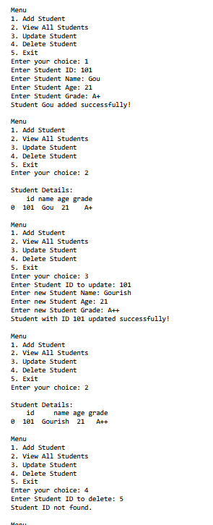

6. Write a Python program to implement pre-processing techniques.

Date:16/09/2025
Aim:
To develop a Python program to implement Pre-processing techniques.

Source Code:
import pandas as pd
from sklearn.model_selection import train_test_split
from sklearn.preprocessing import StandardScaler, LabelEncoder
from sklearn.impute import SimpleImputer
# Load the dataset
data = pd.read_csv("dataset.csv")
print("Original data:")
print(data.head())
# Separate numeric and categorical columns
numeric_columns = data.select_dtypes (include=['float64', 'int64']).columns
categorical_columns = data.select_dtypes (include=['object']).columns
# Handle missing values for numeric columns
numeric_imputer = SimpleImputer(strategy='mean')
data[numeric_columns] = numeric_imputer.fit_transform(data[numeric_columns])
# Handle missing values for categorical columns
categorical_imputer = SimpleImputer(strategy='most_frequent')
data[categorical_columns] = categorical_imputer.fit_transform(data[categorical_columns])
# Encode categorical variables
label_encoders = {}
for column in categorical_columns:
le = LabelEncoder()
data[column] = le.fit_transform(data[column])
label_encoders[column] = le
# Scale numeric features
scaler = StandardScaler()
data[numeric_columns] = scaler.fit_transform(data[numeric_columns])
# Split the data into features and target variable
X = data.drop('target', axis=1)
y = data['target']
# Split the data into training and test sets
X_train, X_test, y_train, y_test = train_test_split(X, y, test_size=0.2, random_state=42)
print("\nPre-processed data:")
print(X_train.head())
print(y_train.head())

Output:

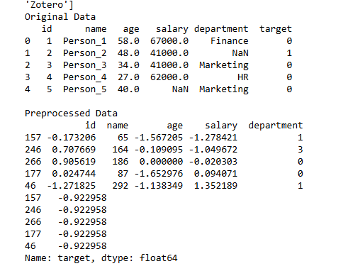

7. Write a program to implement a decision tree algorithm.
Date:23/09/2025
Aim:
To develop a Python program to implement a decision tree algorithm using the following dataset and predict whether it is possible to play golf or not.

Source Code:
import pandas as pd
from sklearn.datasets import load_iris
from sklearn.model_selection import train_test_split
from sklearn.tree import DecisionTreeClassifier, plot_tree
import matplotlib.pyplot as plt
iris=load_iris()
X=iris.data
y=iris.target
X_train, X_test, y_train, y_test= train_test_split(X, y, test_size=0.2, random_state=42)
model=DecisionTreeClassifier()
model.fit(X_train, y_train)
plot_tree(model, filled=True)
plt.show()
Output:

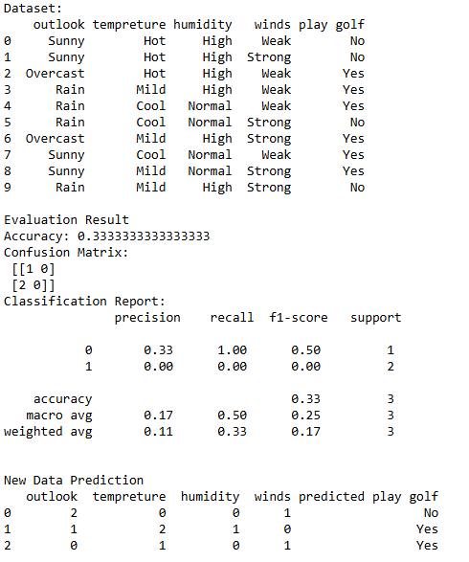

8. Write a Python program to implement the Naive Bayes Algorithm.
Date:23/09/2025
Aim:
To develop a Python program to implement the Naive Bayes Algorithm on the Iris Dataset.

Source Code:

import pandas as pd
from sklearn.model_selection import train_test_split
from sklearn.naive_bayes import GaussianNB
from sklearn.metrics import accuracy_score,classification_report,confusion_matrix

iris_df = pd.read_csv("C:/Users/KJC Staff/Desktop/23MCAA51/iris.csv")
X = iris_df.iloc[:,:-1].values
y = iris_df['class'].values

print("Iris Dataset")
print(iris_df.head())

X_train,X_test,y_train,y_test=train_test_split(X,y,test_size=0.3,random_state=42)

model = GaussianNB()

model.fit(X_train,y_train)

y_pred = model.predict(X_test)

accuracy = accuracy_score(y_test, y_pred)
conf_matrix = confusion_matrix(y_test, y_pred)
class_report = classification_report(y_test, y_pred)

print("\n Evaluation result")
print("accuracy_score:",accuracy)
print("confusion_matrix:",conf_matrix )
print("classification_report:", class_report)

Output:

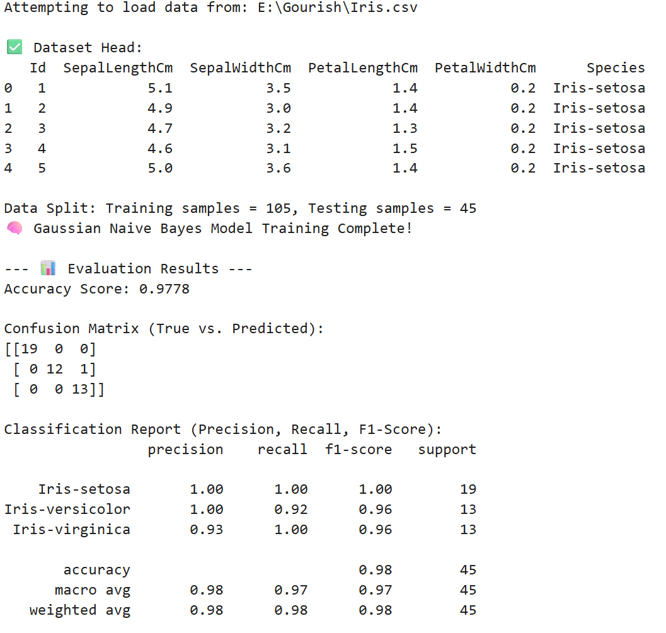

9. Write a Python program to implement Artificial Neural Networks.
Date:17/10/2025
Aim:
To develop a program to implement Artificial Neural networks using Tensorflow

Source Code:
import pandas as pd
import numpy as np
from sklearn.model_selection import train_test_split
from sklearn.preprocessing import StandardScaler
from tensorflow.keras.models import Sequential
from tensorflow.keras.layers import Dense
from tensorflow.keras.utils import to_categorical

# Load the Iris dataset
iris_df = pd.read_csv("C:/Users/KJC Staff/Desktop/23MCAA51/iris.csv")

# Prepare features and labels
X = iris_df.iloc[:, :-1].values
y = iris_df['class'].values

# Encode labels as one-hot
y = pd.factorize(y)[0] # Convert string labels to integers
y = to_categorical(y)

# Split the dataset into training and testing sets
X_train, X_test, y_train, y_test = train_test_split(X, y, test_size=0.2, random_state=42)

# Standardize the features
scaler = StandardScaler()
X_train = scaler.fit_transform(X_train)
X_test = scaler.transform(X_test)

# Create the ANN model
model = Sequential()
model.add(Dense(10, input_dim=4, activation='relu')) # First hidden layer
model.add(Dense(8, activation='relu')) # Second hidden layer
model.add(Dense(3, activation='softmax')) # Output layer

# Compile the model
model.compile(loss='categorical_crossentropy', optimizer='adam', metrics=['accuracy'])

# Train the model
model.fit(X_train, y_train, epochs=100, batch_size=5, verbose=1)

# Evaluate the model
accuracy = model.evaluate(X_test, y_test, verbose=0)[1]
print(f"\nAccuracy on test set: {accuracy:.2f}")

# Make predictions
predictions = model.predict(X_test)
predicted_classes = np.argmax(predictions, axis=1)
actual_classes = np.argmax(y_test, axis=1)

print("\nPredicted classes:", predicted_classes)
print("Actual classes:", actual_classes)

Output:

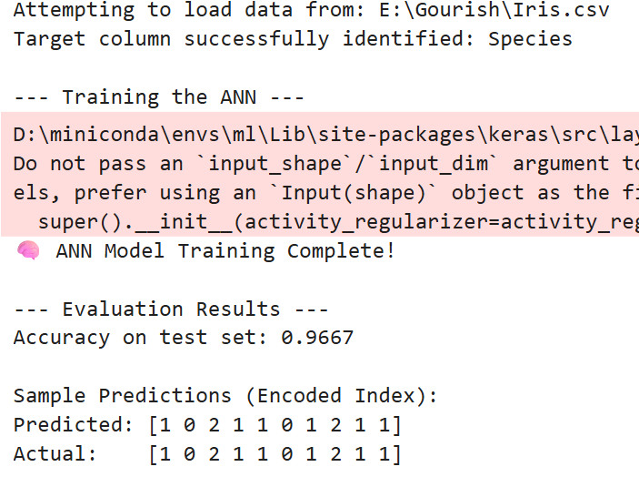

10. Write a Python program to perform Linear Regression.
Date:24/10/2025
Aim:
To develop a Python program to perform Linear Regression.

Source Code:

import numpy as np
import matplotlib.pyplot as plt
from sklearn.linear_model import LinearRegression
#Sample Data
X=np.array([1,2,3,4,5]).reshape(-1,1)
y=np.array([1,3,2,5,4])
#Create and fit the model
linear_model = LinearRegression()
linear_model.fit(X,y)
#Predictions
y_pred=linear_model.predict(X)
#Plot
plt.scatter(X,y,color='blue')
plt.plot(X,y_pred,color='red')
plt.title("Linear Regression")
plt.xlabel('X')
plt.ylabel('y')
plt.show()

Output:
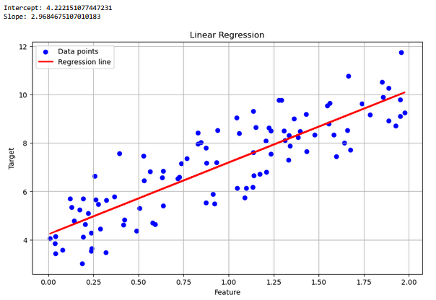

11. Write a Python program to implement K-Means Clustering Algorithm.
Date:24/10/2025
Aim:
To develop a program to implement K-Means Clustering Algorithm using seaborn.

Source Code:

import numpy as np
import pandas as pd
import matplotlib.pyplot as plt
import seaborn as sns
from sklearn.cluster import KMeans
import os
os.environ["OMP_NUM_THREADS"] = "1"
# Data setup
data = {
'Point': ['A', 'B', 'C', 'D', 'E', 'F', 'G', 'H', 'I', 'J'],
'X': [1, 1.5, 3, 5, 3.5, 4.5, 3.8, 9, 8, 9.5],
'Y': [2, 1.8, 4, 7, 5, 5, 6, 10, 8, 9]
}

df = pd.DataFrame(data)

# KMeans clustering
X = df[['X', 'Y']]
kmeans = KMeans(n_clusters=3, n_init=10, random_state=0) # Set n_init explicitly
df['Cluster'] = kmeans.fit_predict(X)

# Plotting
Centroids = kmeans.cluster_centers_
plt.figure(figsize=(8, 6))

# Scatter plot with cluster labels
sns.scatterplot(x='X', y='Y', hue='Cluster', data=df, palette='viridis', s=100)
plt.scatter(Centroids[:, 0], Centroids[:, 1], s=300, c='red', label='Centroids', marker='x')

# Annotating points
for i in range(len(df)):
plt.text(df['X'][i] + 0.1, df['Y'][i] + 0.1, df['Point'][i], fontsize=12)

# Title and labels
plt.title("KMeans Clustering")
plt.xlabel('X-Coordinate')
plt.ylabel('Y-Coordinate')
plt.legend(title='Clusters') # Add title to legend
plt.grid(True)
plt.show()

Output:

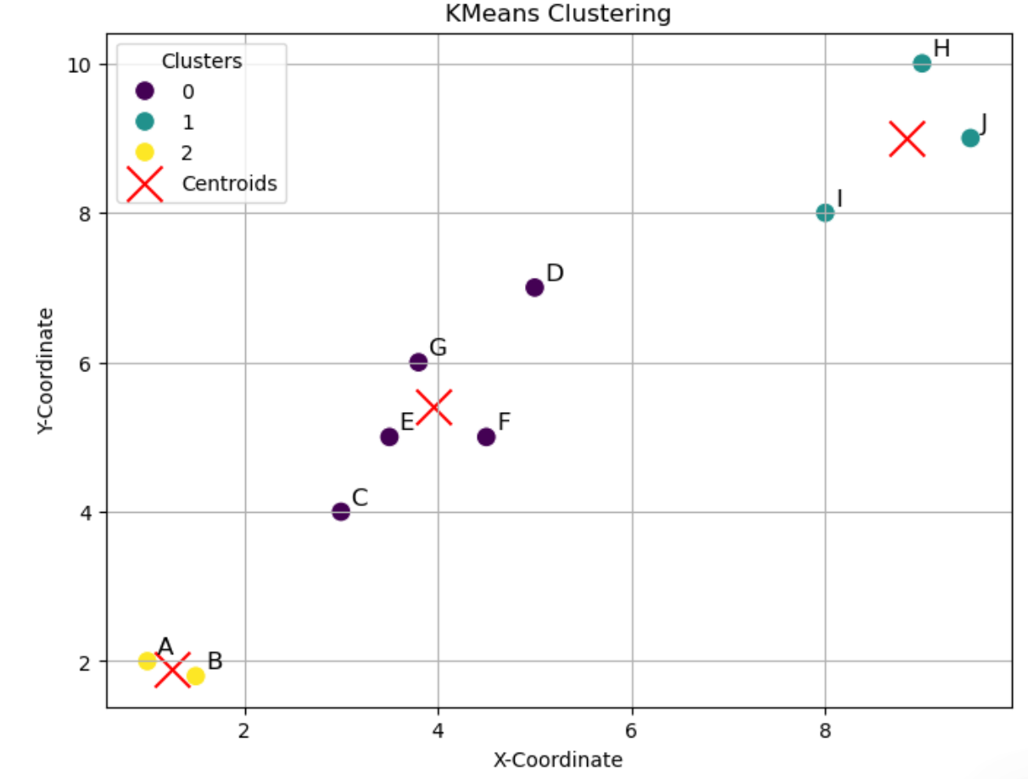

12. Write a Python program to implement Dimensionality Reduction Techniques.
Date:31/10/2025
Aim:
To develop a program to implement dimensionality reduction techniques..

Source Code:

import pandas as pd
from sklearn.decomposition import PCA
import matplotlib.pyplot as plt
from sklearn.preprocessing import LabelEncoder

df=pd.read_csv("iris.csv")
X=df.iloc[:,:-1]
y=df.iloc[:,-1]
label_encoder=LabelEncoder()
y_encoder=label_encoder.fit_transform(y)
pca=PCA(n_components=2)
X_pca=pca.fit_transform(X)

plt.scatter(X_pca[:,0], X_pca[:,1], c=y_encoder, cmap='viridis', edgecolors='k')
plt.xlabel('PC1')
plt.ylabel('PCA2')
plt.title('PCA : 2D Prediction')
plt.show()

Output:
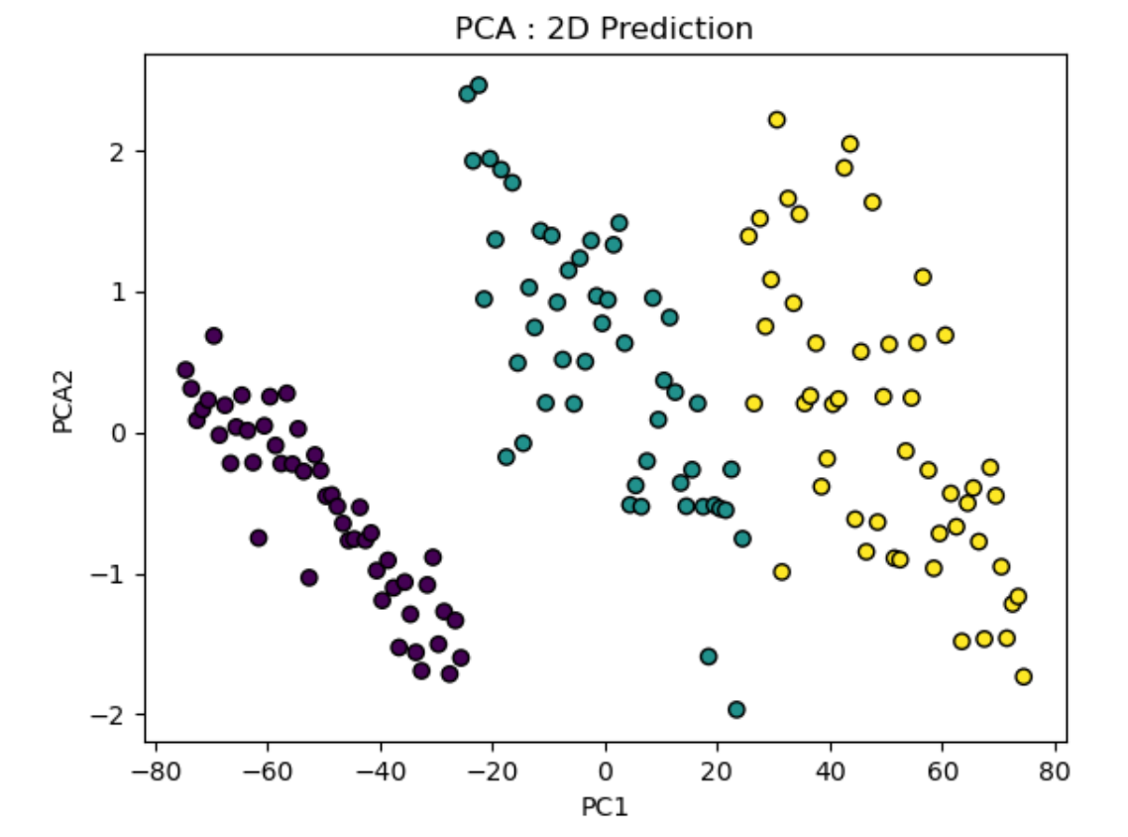

13. Write a Python program visualise data using 2D and 3D plots.
Date:31/10/2025
Aim:
To develop a program to Visualise data using 2D and 3D plots.

Source Code:
import numpy as np
import matplotlib.pyplot as plt
from mpl_toolkits.mplot3d import Axes3D

x=np.linspace(-5,5,100)
y=np.sin(x)

plt.figure(figsize=(8,6))
plt.plot(x,y,label="sin(x)",color='b')
plt.title("2D plot of sin(x)")
plt.xlabel("X-Axis")
plt.ylabel("Y-Axis")
plt.legend()
plt.grid(True)
plt.show()

x_3d=np.linspace(-5,5,100)
y_3d=np.linspace(-5,5,100)
x_3d,y_3d=np.meshgrid(x_3d,y_3d)
z_3d=np.sin(np.sqrt(x_3d**2+y_3d**2))
fig=plt.figure(figsize=(10,7))
ax=fig.add_subplot(111,projection='3d')
ax.plot_surface(x_3d,y_3d,z_3d,cmap='viridis')
ax.set_title("3D Plot of Sin(sqrt(x^2+y^2))")
ax.set_xlabel("X-Axis")
ax.set_ylabel("Y-Axis")
ax.set_zlabel("Z-Axis")
plt.show()

Output:
