ASSIGNMENT – 3
Name: R. S. S. GOURISHWAR
H.NO:2303A52045
Batch: 32
Question
- Given the following jobs with execution times, calculate waiting time and turnaround time using FCFS scheduling:
Ans-
Jobs: J1=5, J2=3, J3=2
FCFS Scheduling
Jobs: J1 = 5, J2 = 3, J3 = 2
Execution Order
J1 → J2 → J3
Gantt Chart 0 5 8 10 | J1 | J2 | J3 |
Waiting Time (WT)
J1 = 0
J2 = 5
J3 = 8
Turnaround Time (TAT = WT + Burst Time)
J1 = 5
J2 = 8
J3 = 10

2. Apply SJF scheduling for the following jobs and find the average waiting time:
Jobs: J1=8, J2=4, J3=2, J4=1
2.SJF Scheduling (Non-Preemptive)

Jobs: J1=8, J2=4, J3=2, J4=1
Execution Order (Shortest first)
J4 → J3 → J2 → J1
Waiting Time
J4 = 0
J3 = 1
J2 = 3
J1 = 7
Average Waiting Time
0+1+3+7=2.75 ​
3. Implement Round Robin scheduling with a time quantum of 2 units for:
Jobs: J1=5, J2=3, J3=1
Ans:
Time Quantum = 2
Jobs: J1=5, J2=3, J3=1
Execution Steps
J1(2) → J2(2) → J3(1) → J1(2) → J2(1) → J1(1)
Gantt Chart
0 2 4 5 7 8 9
Waiting Time
J1 = 4
J2 = 5
J3 = 4
4. Compare FCFS and SJF scheduling for the same set of jobs and justify which is better.
FCFS |  | SJF

Average WT | Higher | Lower

Simplicity | Very simple | Moderate

Starvation | No | Possible

Poor Performance |  | Better
5. Given job arrival times and priorities, determine the execution order.
Priority Scheduling (Execution Order)
Rule: Lower number = higher priority
Example:
Job | Priority
J1 | 3
J2 | 1
J3 | 2
Execution Order
J2 → J3 → J1

6. Write a Python program to implement FCFS job scheduling.
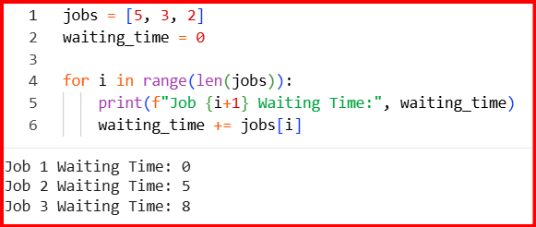
7. Write a Python program for SJF scheduling.
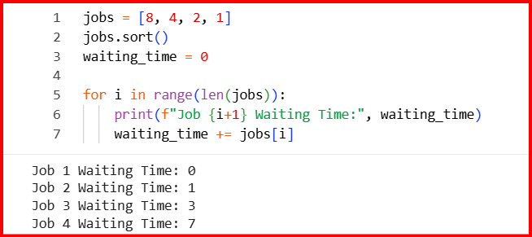
8. Implement Round Robin scheduling using Python.
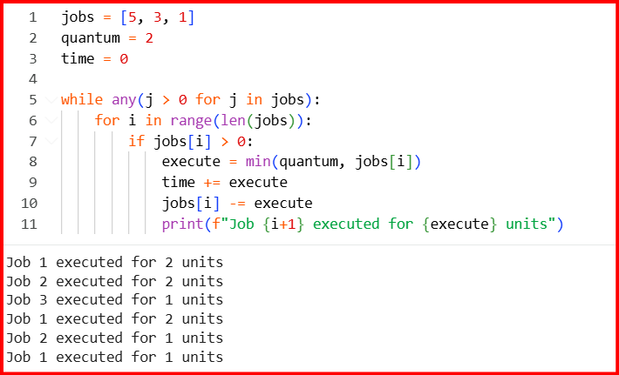
9. Write a Python script to simulate priority scheduling.
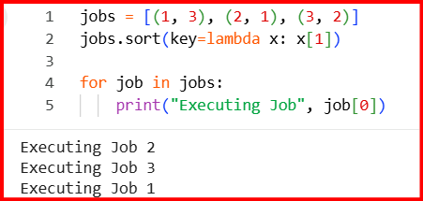
10. Write a Python program to calculate average waiting time.
