AI Assisted Coding

ASSIGNMENT 6.3

Name: R.S.S.GOURISHWAR
HT No: 2303A52045
Batch: 32

Question 1: Loops – Automorphic Numbers in a Range

Task 1:
Prompt AI to generate a function that displays all Automorphic numbers between 1 and 1000 using a for loop.
Instructions:
- Get AI-generated code to list Automorphic numbers using a for loop.
- Analyze the correctness and efficiency of the generated logic.
- Ask AI to regenerate using a while loop and compare both implementations.
Expected Output:
Correct implementation that lists Automorphic numbers using both loop types, with explanation.

Prompt:
generate automorphic numbers function within range 1 to 1000 using for loop and while loop and compare their execution time

Code:
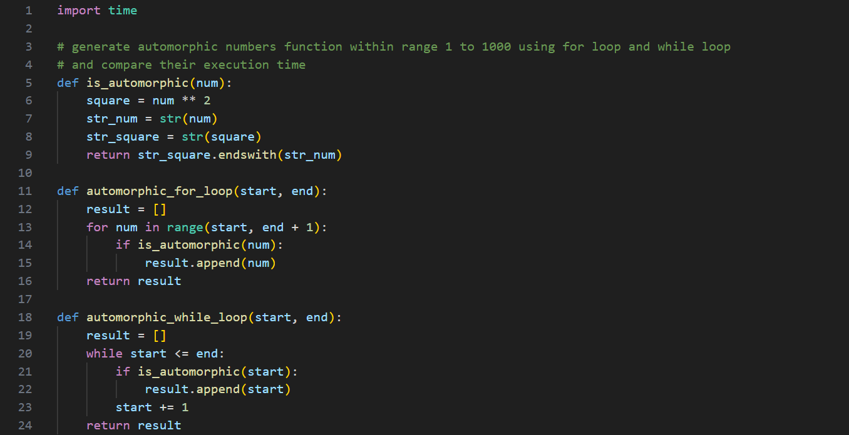
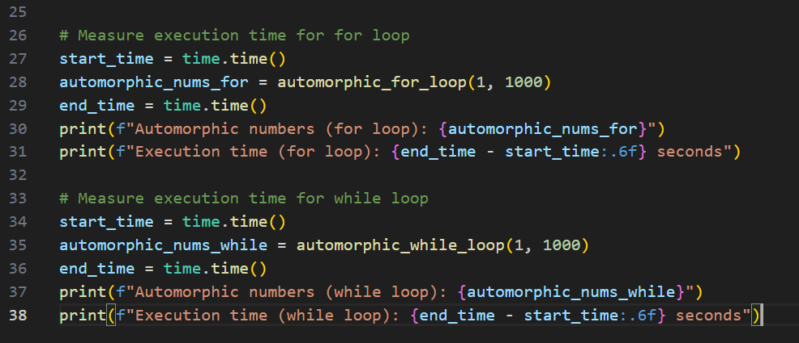

Output(O/P)
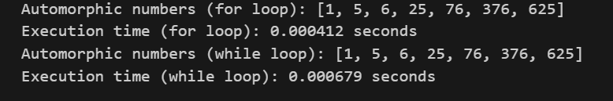

Explanation:
For Loop Is Better if the values range is known, Else While Loop is Prefered, For This Case Where Values are Stored in List, Time Taken for (For Loop) is Less Than (While Loop).

Question 2: Conditional Statements – Online Shopping Feedback Classification

Task 2:
Ask AI to write nested if-elif-else conditions to classify online shopping feedback as Positive, Neutral, or Negative based on a numerical rating (1–5).
Instructions:
- Generate initial code using nested if-elif-else.
- Analyze correctness and readability.
- Ask AI to rewrite using dictionary-based or match-case structure.
Expected Output #2:
Feedback classification function with explanation and an alternative approach

Prompt:
generate python code with nested if-elif-else conditions to classify online shopping feedback as Positive, Neutral, or Negative based on a numerical rating (1–5). Code Should be correct, efficient, and readable
include an alternative approach using dictionary-based or match-case structure.

Code:
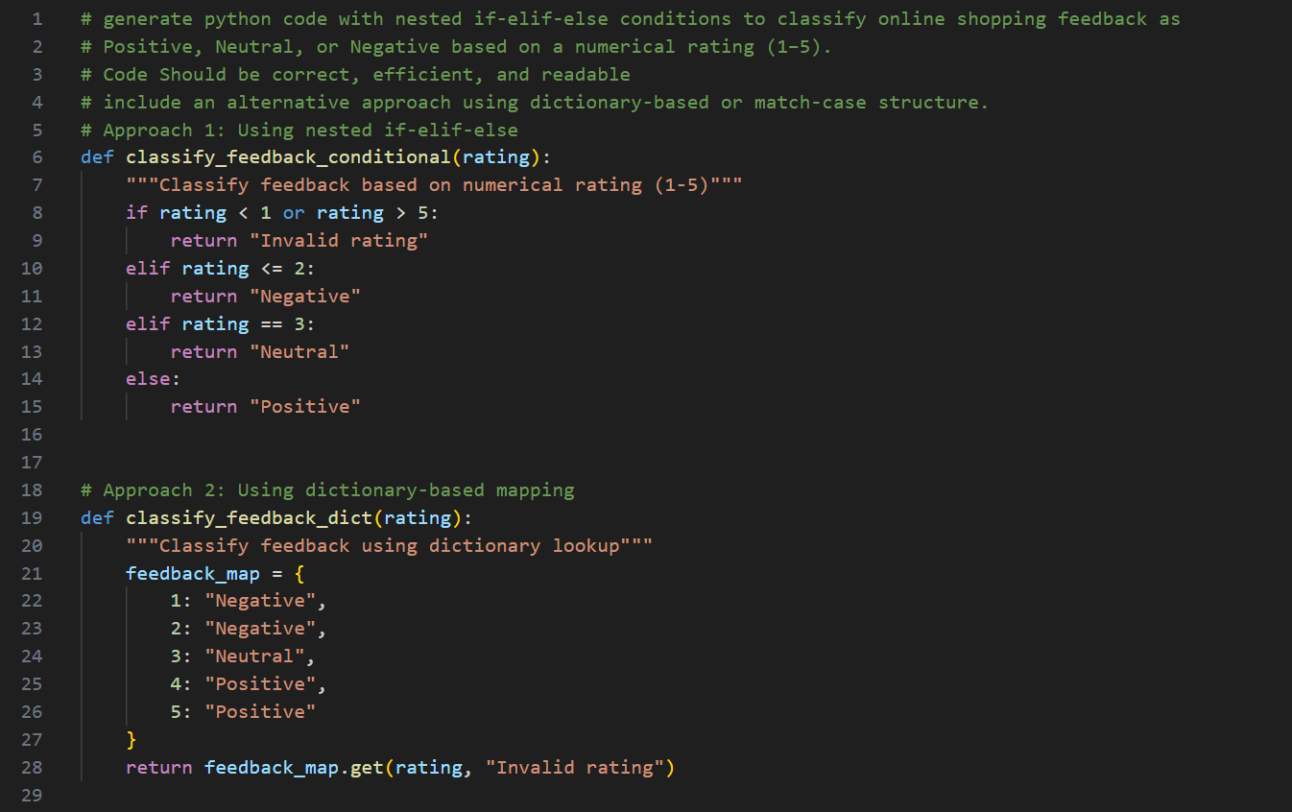
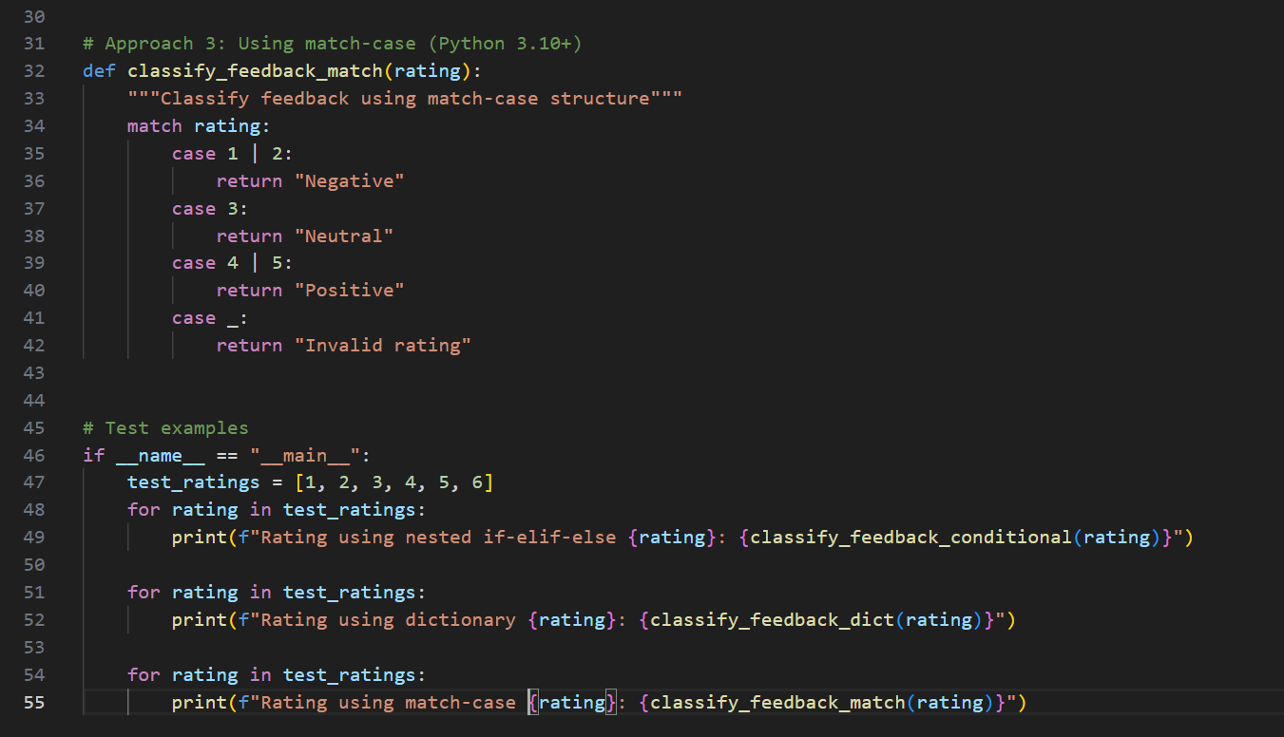

Output(O/P)
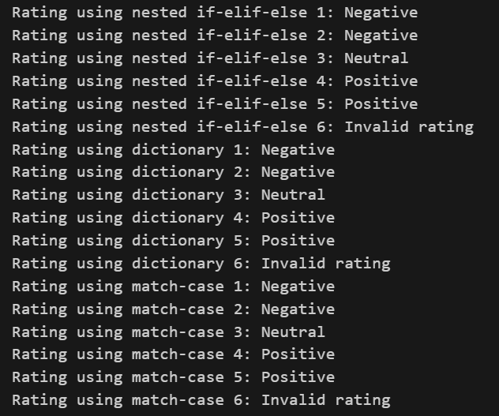

Explanation:
The nested if-elif-else structure correctly classifies ratings from one to five into Negative, Neutral, and Positive categories. The alternative approach using dictionary based mapping or match case improves readability and scalability. It avoids deep nesting and makes the code easier to modify if new categories are added.
Both approaches are correct, but the dictionary or match case is more easy to read.

Question 3: Statistical operations

Task 3:
Define a function named statistical_operations(tuple_num) that performs the following statistical operations on a tuple of numbers:
- Minimum, Maximum
- Mean, Median, Mode
- Variance, Standard Deviation
While writing the function, observe the code suggestions provided by GitHub Copilot.Make decisions to accept, reject, or modify the suggestions based on their relevance and correctness

Prompt:
Define a function named statistical_operations(tuple_num)
that performs the following statistical operations on a tuple of numbers
Minimum, Maximum
Mean, Median, Mode
Variance, Standard Deviation

Code:
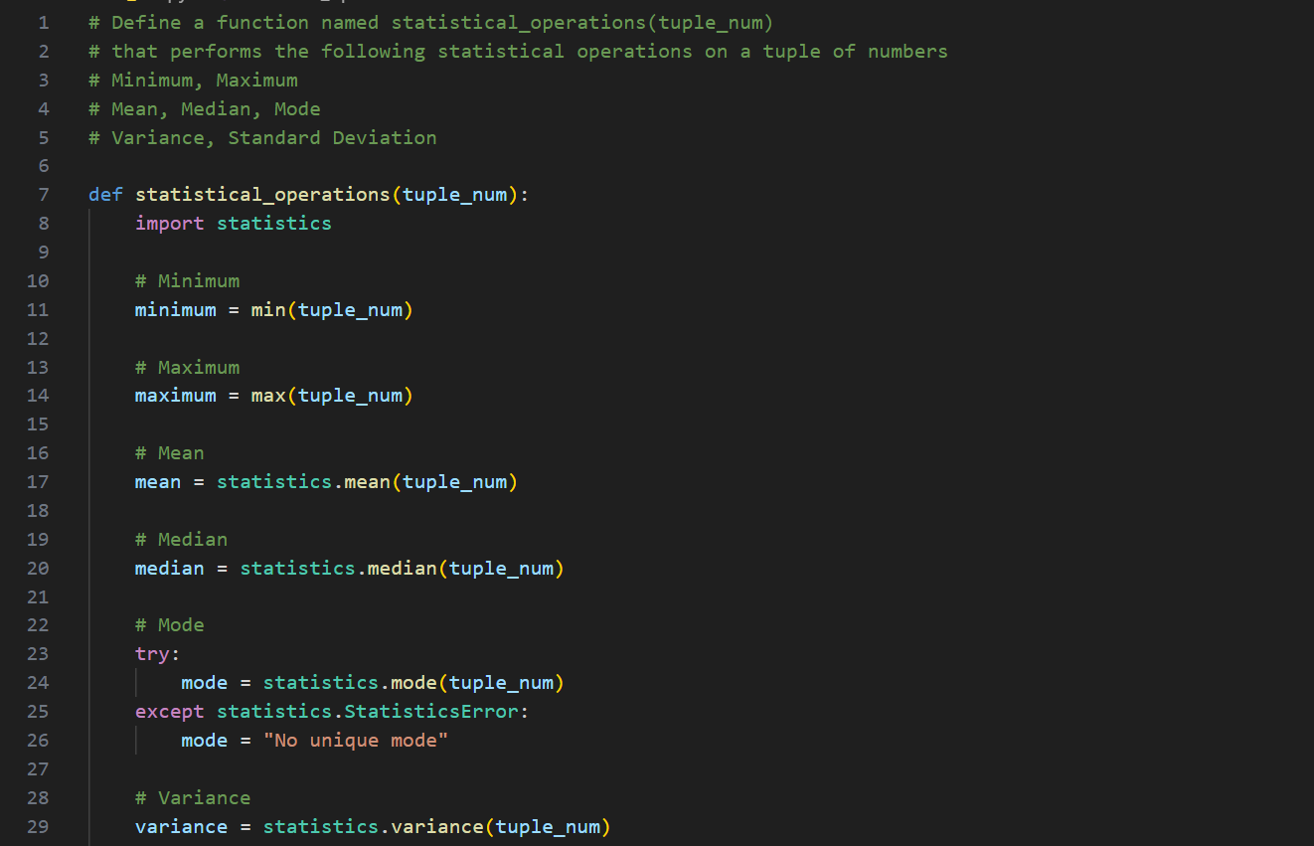
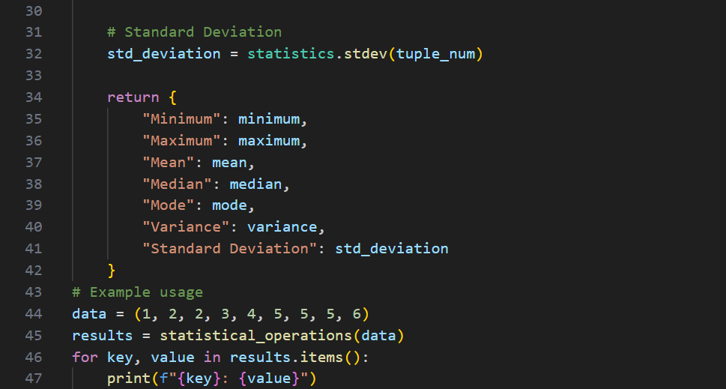

Output(O/P)
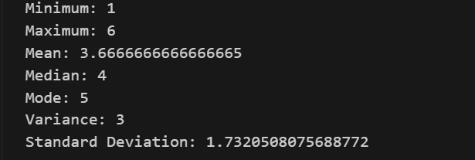

Explanation:
The function calculates minimum, maximum, mean, median, mode, variance, and standard deviation using built in and mathematical logic. Each statistical measure is computed step by step for accuracy. While writing the function, AI code suggestions were reviewed carefully. Only relevant and correct suggestions were accepted. Unnecessary or incorrect suggestions were modified to maintain correctness and clarity. The function works correctly for numerical tuples and produces accurate statistical results.

Question 4: Teacher Profile

Task 4:
Prompt: Create a class Teacher with attributes teacher_id, name, subject, and experience. Add a method to display teacher details.
Expected Output: Class with initializer, method, and object creation

Prompt:
Create a class called Teacher with attributes teacher_id, name, subject, and experience & Add a method to display teacher details.

Code:
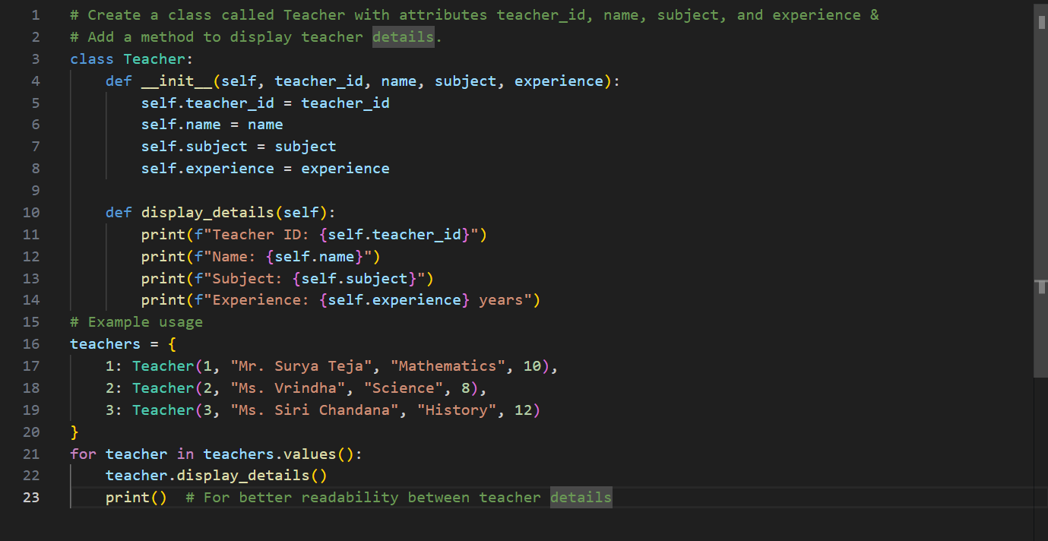

Output(O/P)
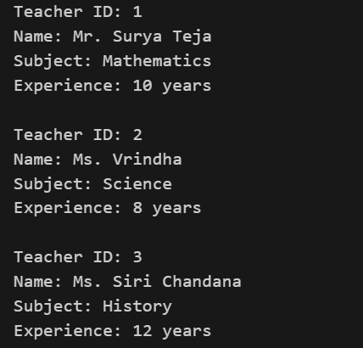

Explanation:
The Teacher class is created with attributes teacher_id, name, subject, and experience. The constructor initializes these values when an object is created. A display method is added to print teacher details in a readable format. Object creation demonstrates how class and methods work together. This implementation follows object oriented programming principles correctly.

Question 5: Zero-Shot Prompting with Conditional Validation

Task 5:
Use zero-shot prompting to instruct an AI tool to generate a function that validates an Indian mobile number.
Requirements:
The function must ensure the mobile number:
Starts with 6, 7, 8, or 9
Contains exactly 10 digits
Expected Output
A valid Python function that performs all required validations without using any input-output examples in the prompt.

Prompt:
generate a function that validates an Indian mobile number.
The function must ensure the mobile number:
Starts with 6, 7, 8, or 9
Contains exactly 10 digits

Code:
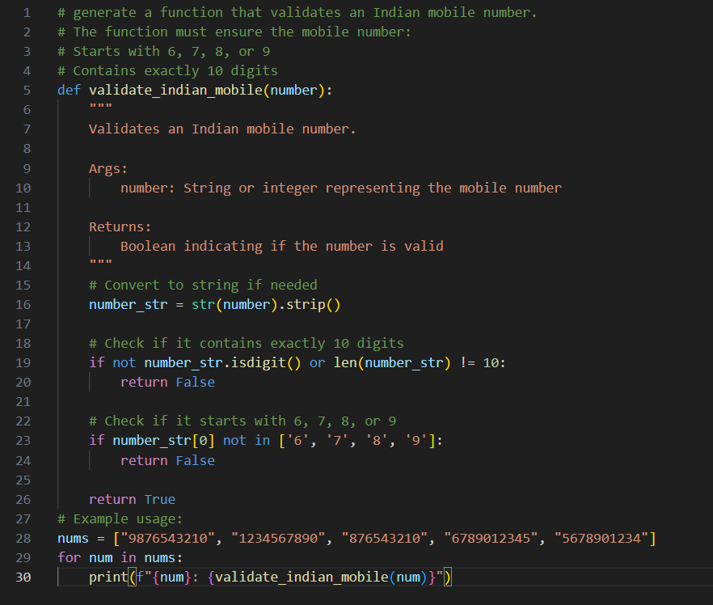

Output(O/P)
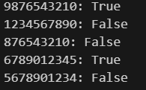

Explanation:
The AI generated function validates an Indian mobile number by checking its length and starting digit. It ensures the number contains exactly ten digits and starts with six, seven, eight, or nine.
Zero shot prompting is used, meaning no examples were provided in the prompt. Despite this, the function correctly implements all validation rules. The solution is efficient and suitable for real world input validation.

Question 6: Loops – Armstrong Numbers in a Range

Task 6:
Write a function using AI that finds all Armstrong numbers in a user specified range (e.g., 1 to 1000).
Instructions:
- Use a for loop and digit power logic.
- Validate correctness by checking known Armstrong numbers (153, 370, etc.).
- Ask AI to regenerate an optimized version (using list comprehensions).
Expected Output #7:
- Python program listing Armstrong numbers in the range.
- Optimized version with explanation.

Prompt:
Write a function that finds all Armstrong numbers in a user specified range, Use a for loop and digit power logic, Validate correctness by checking known Armstrong numbers like 153, 370, write another function which is optimized using list comprehensions.

Code:
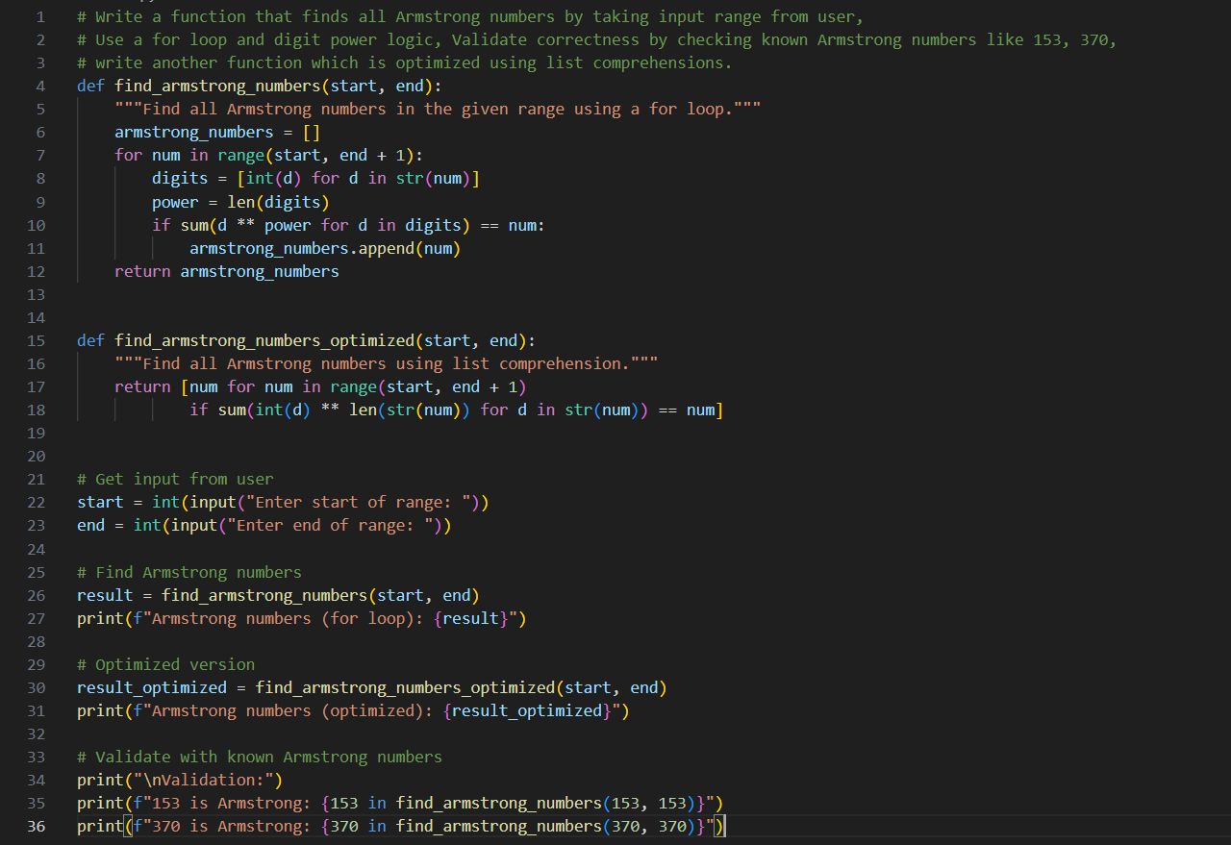

Output(O/P)
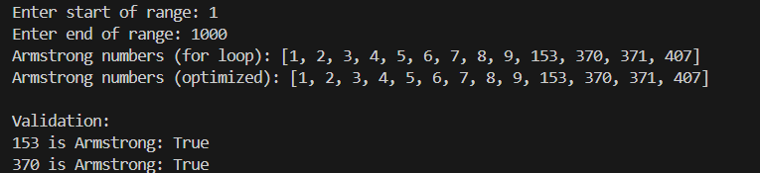

Explanation:
The initial function uses a for loop and digit power logic to identify Armstrong numbers within a given range. It correctly validates known Armstrong numbers such as 153, 370. The optimized version uses list comprehension, reducing code length and improving readability. Both versions are correct, but the optimized version is faster.

Question 7: Loops – Happy Numbers in a Range

Task 7:
Generate a function using AI that displays all Happy Numbers within a user-specified range (e.g., 1 to 500).
Instructions:
- Implement the logic using a loop: repeatedly replace a number with the sum of the squares of its digits until the result is either 1 (Happy Number) or enters a cycle (Not Happy).
- Validate correctness by checking known Happy Numbers (e.g., 1, 7, 10, 13, 19, 23, 28…).
Ask AI to regenerate an optimized version (e.g., by using a set to detect cycles instead of infinite loops).
Expected Output #8:
- Python program that prints all Happy Numbers within a range.
- Optimized version using cycle detection with explanation.

Prompt:
Generate a function that displays all Happy Numbers within a given input given by the user
Implement the logic using a loop: repeatedly replace a number with the sum of the squares of its digits until the result is
either 1 (Happy Number) or enters a cycle (Not Happy).
Validate correctness by checking known Happy Numbers (e.g., 1, 7, 10, 13, 19, 23, 28…).
Generate an another optimized function by using a set to detect cycles instead of infinite loops
compare both functions for performance.

Code:
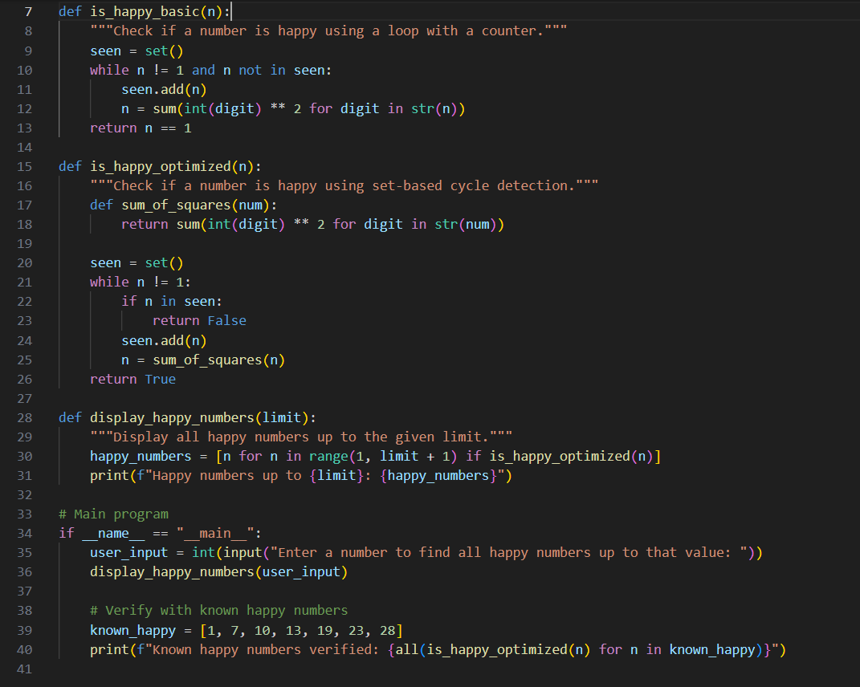

Output(O/P)
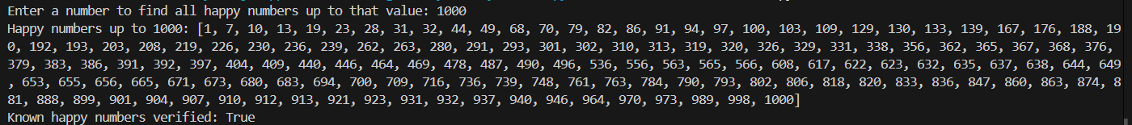

Explanation:

The function repeatedly replaces a number with the sum of the squares of its digits until it becomes one or enters a cycle. Known Happy numbers like one, seven, ten, and nineteen are correctly identified. The optimized version uses a set to track previously seen values. This prevents infinite loops and improves performance. Using a set for cycle detection is more efficient and reliable.

Question 8: Loops – Strong Numbers in a Range

Task 8:
Generate a function using AI that displays all Strong Numbers (sum of factorial of digits equals the number, e.g., 145 = 1!+4!+5!) within a given range.
Instructions:
- Use loops to extract digits and calculate factorials.
- Validate with examples (1, 2, 145).
- Ask AI to regenerate an optimized version (precompute digit factorials).
Expected Output #9:
- Python program that lists Strong Numbers.
- Optimized version with explanation.

Prompt:
Generate a function that displays all Strong Numbers within the given range given by the user, Use loops to extract digits and calculate factorials, Validate with examples (1, 2, 145), write another function optimized version using precomputed digit factorials.

Code:
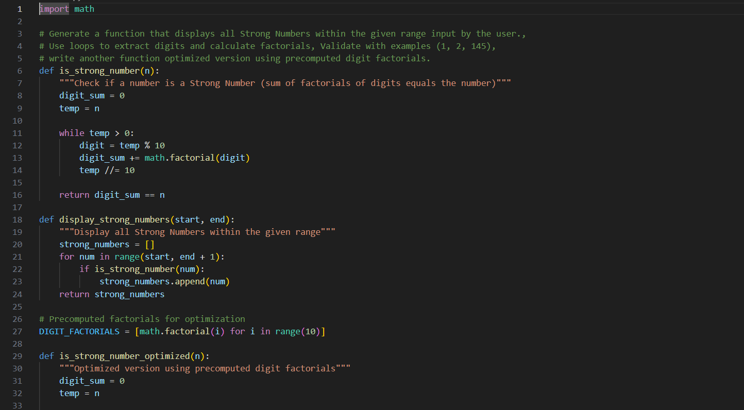
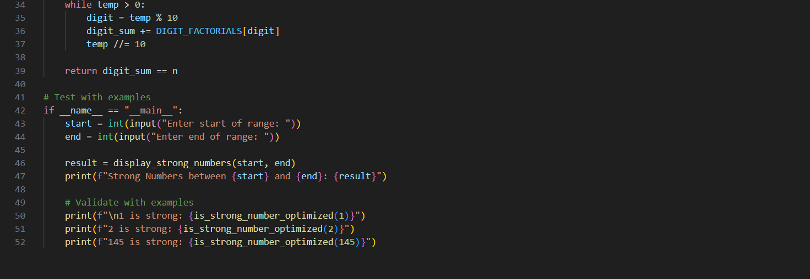

Output(O/P)
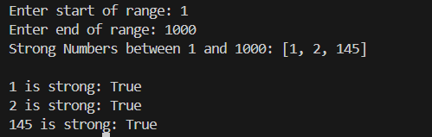

Explanation:

The function checks whether a number is equal to the sum of factorials of its digits. It correctly identifies Strong numbers such as 1, 2 and145. The optimized version precomputes factorials of digits from zero to nine. This avoids repeated calculations and improves execution speed. Both versions produce correct output, with the optimized version being more efficient.

Question 9: Few-Shot Prompting for Nested Dictionary Extraction

Task 9:
Objective Use few-shot prompting (2–3 examples) to instruct the AI to create a function that parses a nested dictionary representing student information.
Requirements
The function should extract and return:
- Full Name
- Branch
- SGPA
Expected Output:
A reusable Python function that correctly navigates and extracts values from nested dictionaries based on the provided examples

Prompt:
Create a Python function that takes a nested dictionary representing student information and extracts:
Full Name, Branch, SGPA
The function should correctly navigate nested dictionaries.
Example 1:
{
"personal": {
"name": { "first": "Surya", "last": "Teja" }
},
"academic": {
"branch": "CSE",
"grades": { "sgpa": 8.0 }
}
}
Output: ("Surya Teja","CSE",8.0)

Example 2:
{
"personal": {
"name": { "first": "Ramu", "last": "Sharma" }
},
"academic": {
"branch": "ECE",
"grades": { "sgpa": 8.6 }
}
}
Output: ("Ananya Sharma", "ECE", 8.6)

Code:
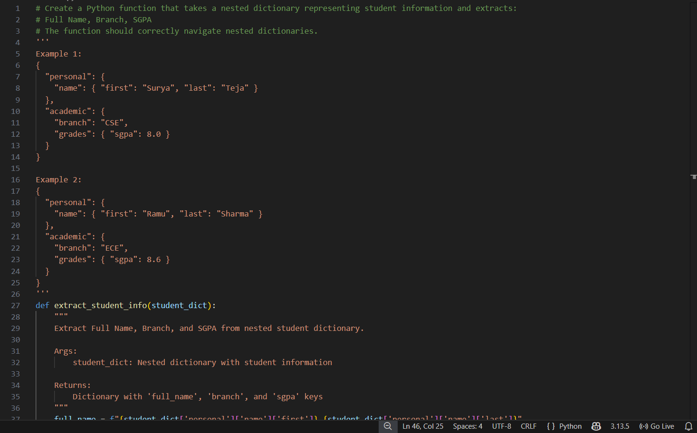
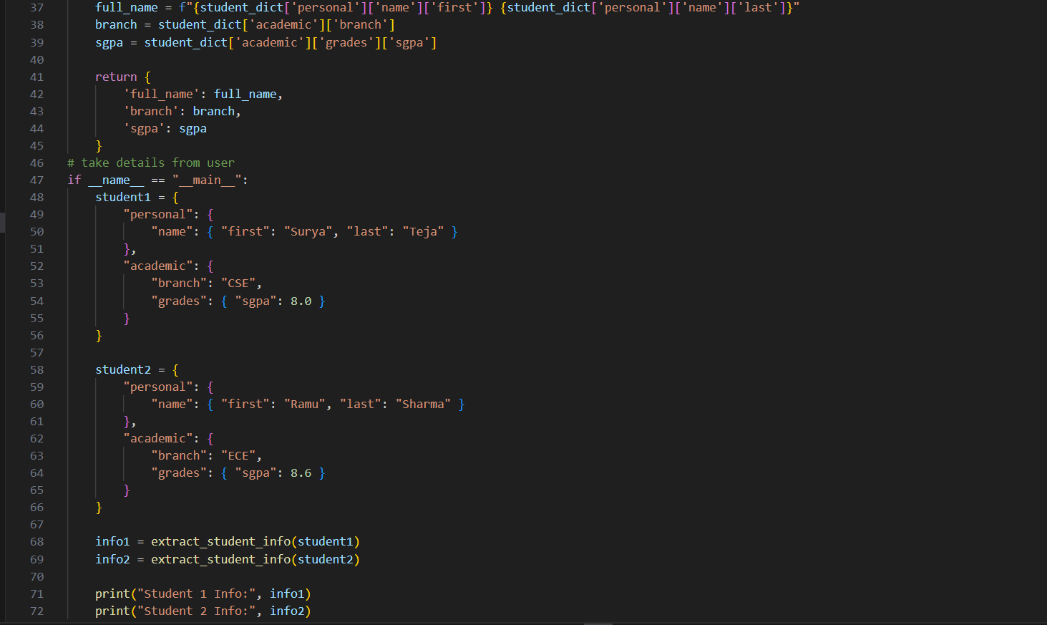

Output(O/P)
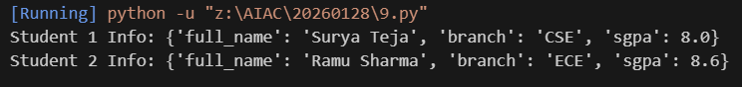

Explanation:
Few shot prompting is used by providing multiple input output examples. Based on these examples, the AI generates a reusable function that navigates nested dictionaries.The function successfully extracts Full Name, Branch, and SGPA from different student data structures. This demonstrates how few shot prompting helps AI learn patterns and apply them correctly.

Question 10: Loops – Perfect Numbers in a Range

Task 10:
Generate a function using AI that displays all Perfect Numbers within a user-specified range (e.g., 1 to 1000).
Instructions:
A Perfect Number is a positive integer equal to the sum of its proper divisors (excluding itself).
Example: 6 = 1 + 2 + 3, 28 = 1 + 2 + 4 + 7 + 14.
Use a for loop to find divisors of each number in the range.
Validate correctness with known Perfect Numbers (6, 28, 496…).
Ask AI to regenerate an optimized version (using divisor check only up to √n).

Prompt:
Generate a Python function that prints all Perfect Numbers in a user given range (for example 1 to 1000).
Requirements:
Use a for loop to find divisors
Validate output using known perfect numbers (6, 28, 496)
Write an another optimized function that checks divisors only up to √n

Code:
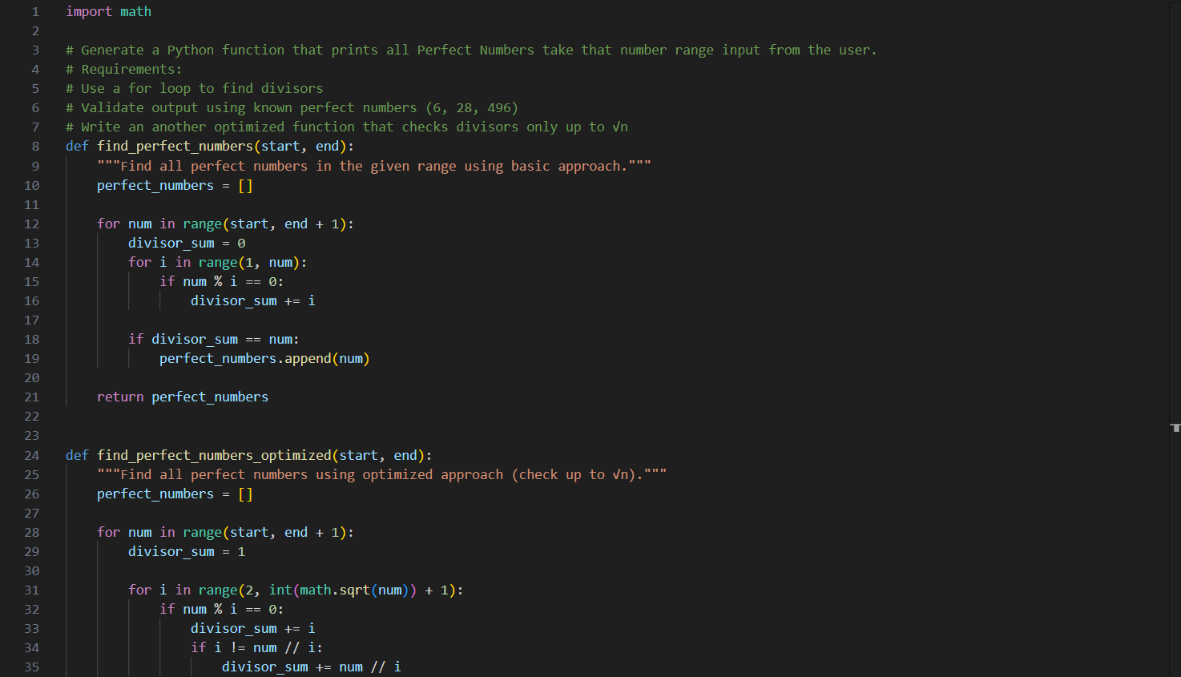
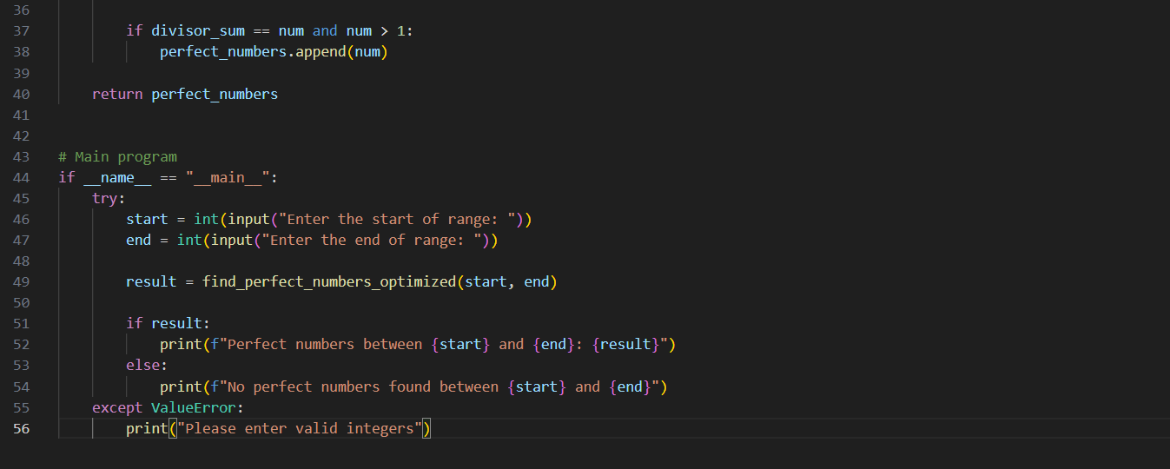

Output(O/P)
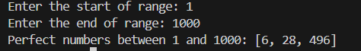

Explanation:
The initial function checks each number in the given range and finds its proper divisors using a for loop. If the sum of divisors equals the number, it is identified as a Perfect number. Known Perfect numbers like 6, 28 & 496 are correctly validated. The optimized version checks divisors only up to the square root of the number, significantly reducing computation time. This makes the optimized solution faster and more efficient for large ranges.

