SCHOOL OF COMPUTER SCIENCE AND ARTIFICIAL INTELLIGENCE |  |  |  |  | DEPARTMENT OF COMPUTER SCIENCE ENGINEERING
Program Name: B. Tech |  |  |  | Assignment Type: Lab |  |  | Academic Year: 2025-26
Course Coordinator Name |  |  |  | Dr. Jagjit Singh Dhatterwal
Instructor(s) Name |  |  |  | Dr. Jagjit Singh Dhatterwal
Course Code |  |  | 23CS201PE401 | Course Title |  | Blockchain Engineering
Year/Sem |  |  | III/II | Regulation |  | R25
Date and Day  of Assignment |  |  | 27-01-2026 | Time(s) |  | 9:00AM to 11:00AM
Duration |  |  | 2 Hours | Applicable to  Batches |  | (23CSBTB19, 23CSBTB20 23CSBTB21, 23CSBTB22 23CSBTB23, 23CSBTB24 23CSBTB25, 23CSBTB26)
Assignment Number: 03/12
 | Q. No. | Question |  |  |  |  |  | Expected Time  to complete
 | 1 | Objective  To develop and deploy a standards-compliant ERC-20 token smart contract using Solidity for the Ethereum network.  Requirements  - Install VS Code  - Install Solidity extension in VS Code  - Use Remix Ethereum IDE (online) or Hardhat (optional)  - Basic understanding of blockchain and Ethereum  - MetaMask wallet (for deployment testing)  Practical Implementation  Step 1: Development Environment Setup  - Install VS Code  Step 2: Create ERC20 Smart Contract  Create a Solidity smart contract that:  - Defines token name, symbol, decimals, and total supply  - Allows token transfer between accounts  - Maintains balances using mappings  - Emits events for transparency  Step 3: Solidity Code (ERC20Token.sol)  // SPDX-License-Identifier: MIT  pragma solidity ^0.8.0;  /*  Simple ERC20 Token Implementation  */  contract MyERC20Token {  // Token details  string public name = "MyToken";  string public symbol = "MTK";  uint8 public decimals = 18;  uint public totalSupply;  // Mapping to store balances  mapping(address => uint) public balanceOf;  // Event to log transfers  event Transfer(address indexed from, address indexed to, uint value);  // Constructor runs once during deployment  constructor(uint initialSupply) {  totalSupply = initialSupply * (10 ** uint(decimals));  balanceOf[msg.sender] = totalSupply;  }  // Transfer function  function transfer(address to, uint value) public returns (bool success) {  require(balanceOf[msg.sender] >= value, "Insufficient balance");  balanceOf[msg.sender] -= value;  balanceOf[to] += value;  emit Transfer(msg.sender, to, value);  return true;  }  }  Step 4: Explanation of Logic  - mapping(address => uint) stores token balances  - constructor() assigns total supply to deployer  - transfer() moves tokens between accounts  - require() ensures sender has enough balance  - emit Transfer() logs transactions on blockchain  Step 5: Deployment  - Compile the contract using Solidity Compiler  - Deploy using Remix VM (London) or MetaMask  - Provide initial supply during deployment (e.g., 1000)

Code :

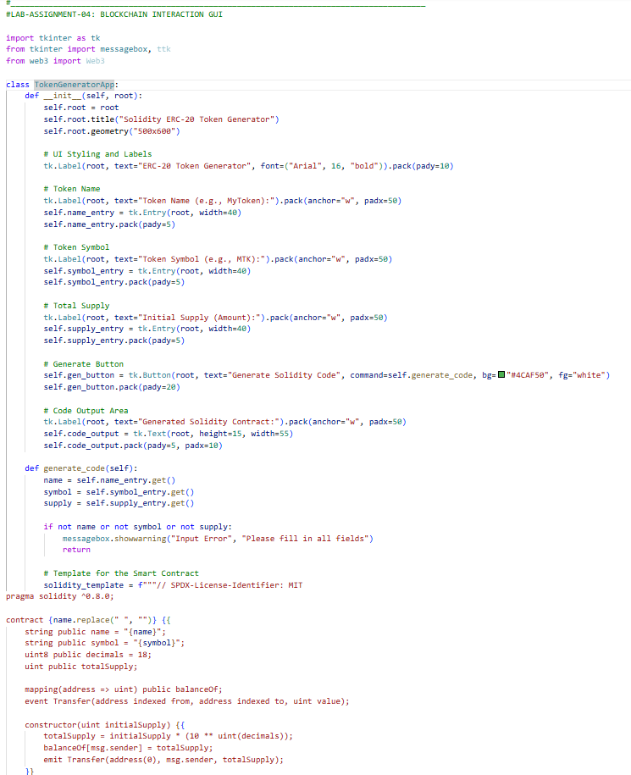
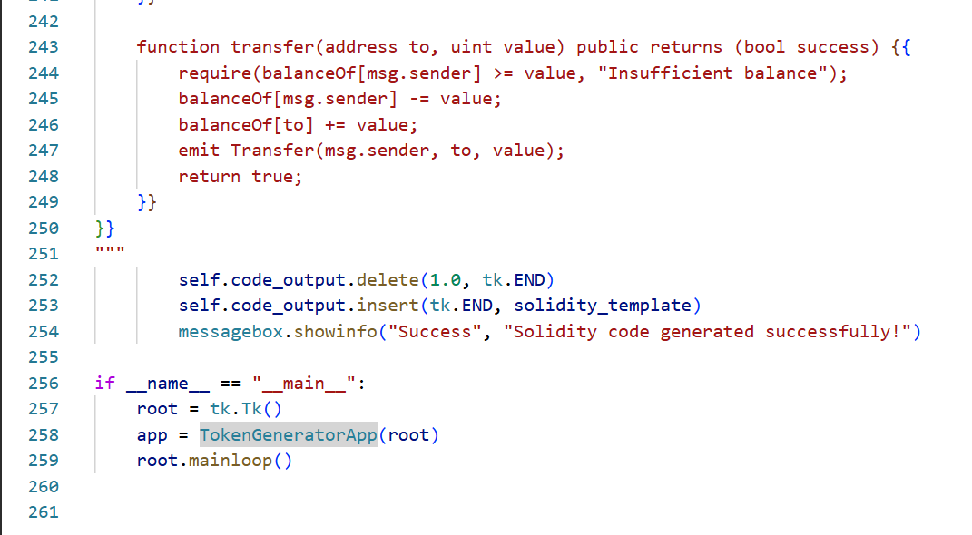

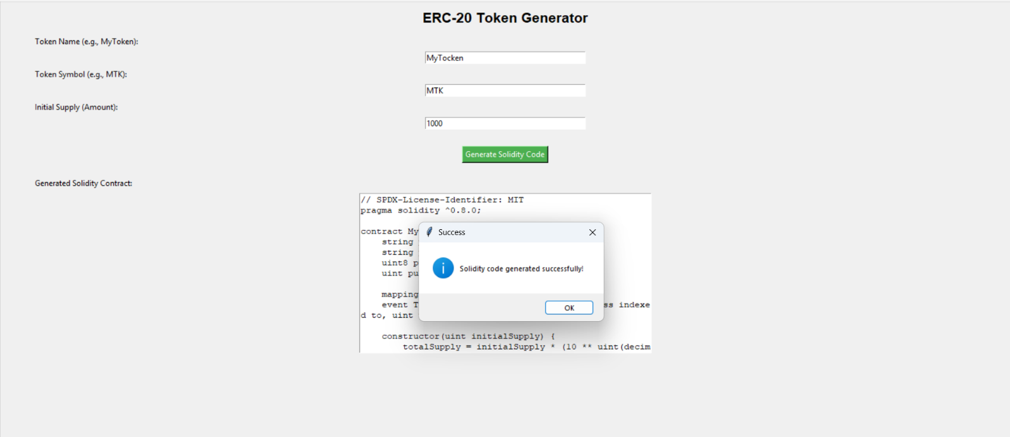
Output:

