 |  |  |  |  | 
Objective:

To study blockchain interaction using Python and Web3 through wallet balance checking and transaction simulation.
1 |  | Requirements:  - Install Python 3.x  - Set up VS Code with Python extension  - Install required Python libraries:  - pip install web3  - Use a test blockchain network (Ethereum Sepolia / Ganache local blockchain)  - Basic understanding of blockchain wallets and private keys
Practical Description:

Step 1: Environment Setup

- Install Python and VS Code
- Install Web3.py library

- Create a Python file named wallet_interaction.py
Step 2: Wallet and Blockchain Interaction Script

Create a Python script that:

- Connects to a blockchain network
- Loads a wallet using a private key
- Fetches wallet address
- Checks wallet balance
- Demonstrates transaction preparation (without real funds)

Code Input:

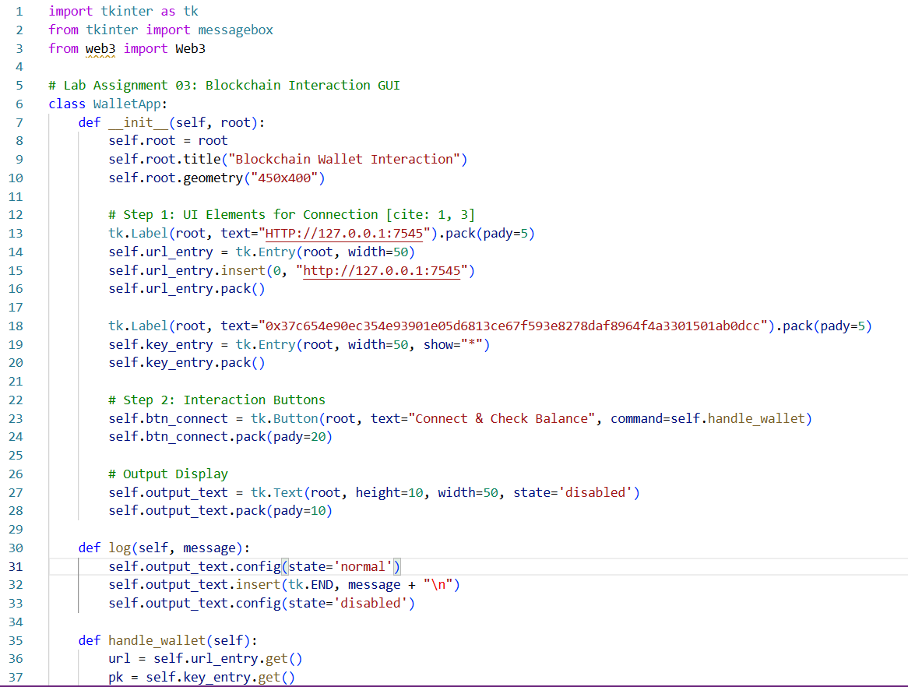

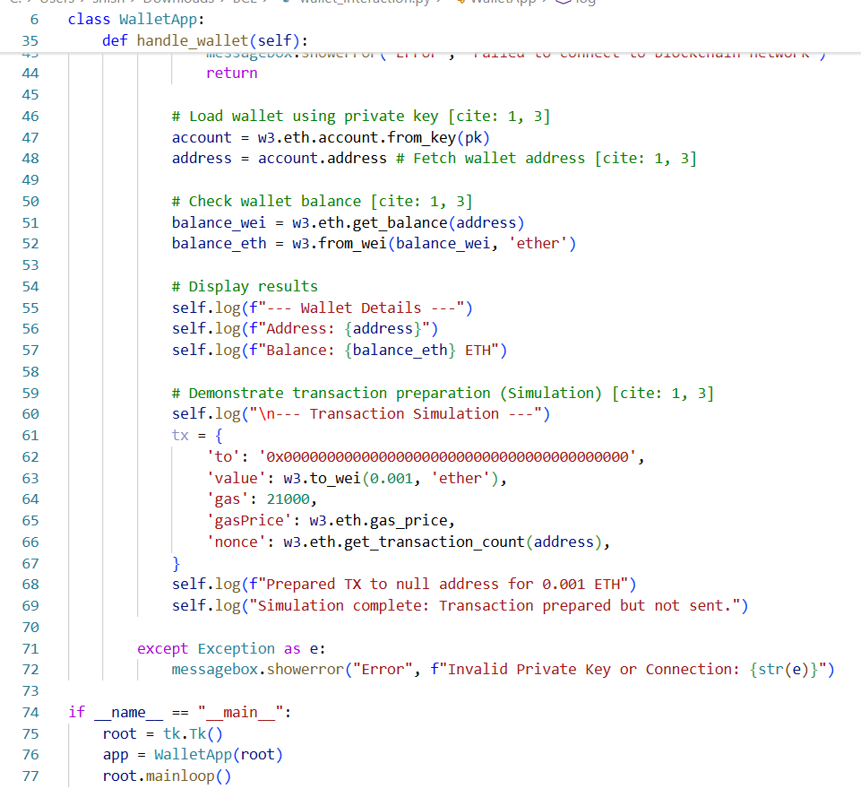

CODE OUTPUT:

