Output:

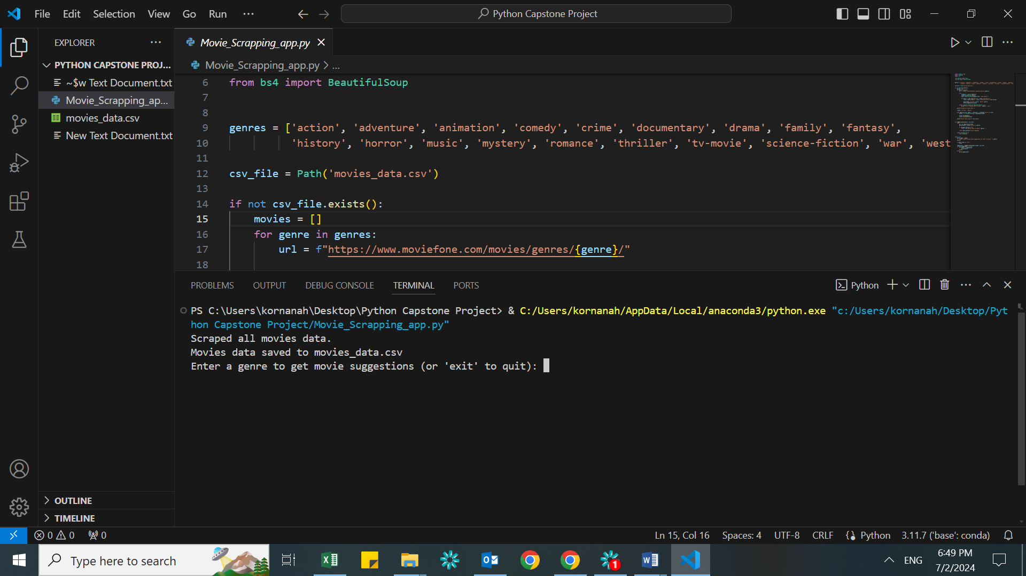

From the above SC we can see the complete data of Movies with Genre is extracted from website and saved in movies_data to the left . Next, we have to enter Genre.

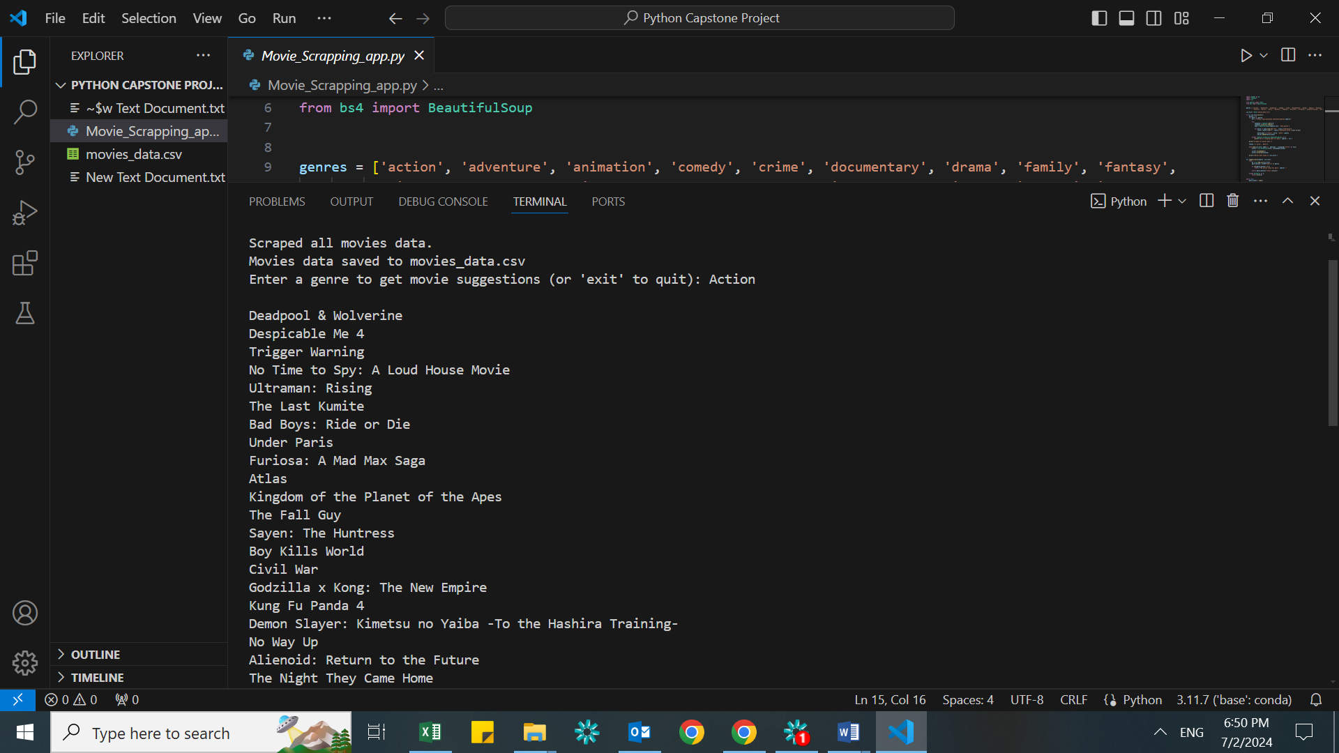

Once the Genre is entered you will get list of movies that come under that Genre.