III Software and Sim to Real Framework

A Software Architecture
The framework compares two closed-loop systems driven by the same joint-angle references (Fig. 1). The Raspberry Pi executes the hardware controller of (1) at a nominal 200 Hz and logs the targets, encoder angles, and timing. For the reported comparisons, the replay adapter holds each logged target until the next reference timestamp. The first encoder sample initializes each simulated joint angle, with zero initial velocity and belt deflection. Subsequent simulation feedback comes from the simulated state.
The simulated PID updates every 5 ms, and its current command is held between updates. The actuator and belt model supplies joint torque at each 0.5 ms MuJoCo step. The step replays use one-joint fixtures. For assembled tracking, separate knee and ankle PID and drivetrain states drive a single coupled, fixed-base leg model. Both replay configurations reuse the hardware gains reported in Section II-C. The step replays differentiate joint-angle error, while the assembled tracking replays use actuator-side finite differences for the derivative feedback.
For each joint, the comparison interpolates simulated angles at the encoder sample times reconstructed from the recorded intervals. The simulation-to-hardware residual is the simulated angle minus the encoder angle on this unshifted time grid. The software also accepts timestamped samples through a read-only HTTP interface for live monitoring.
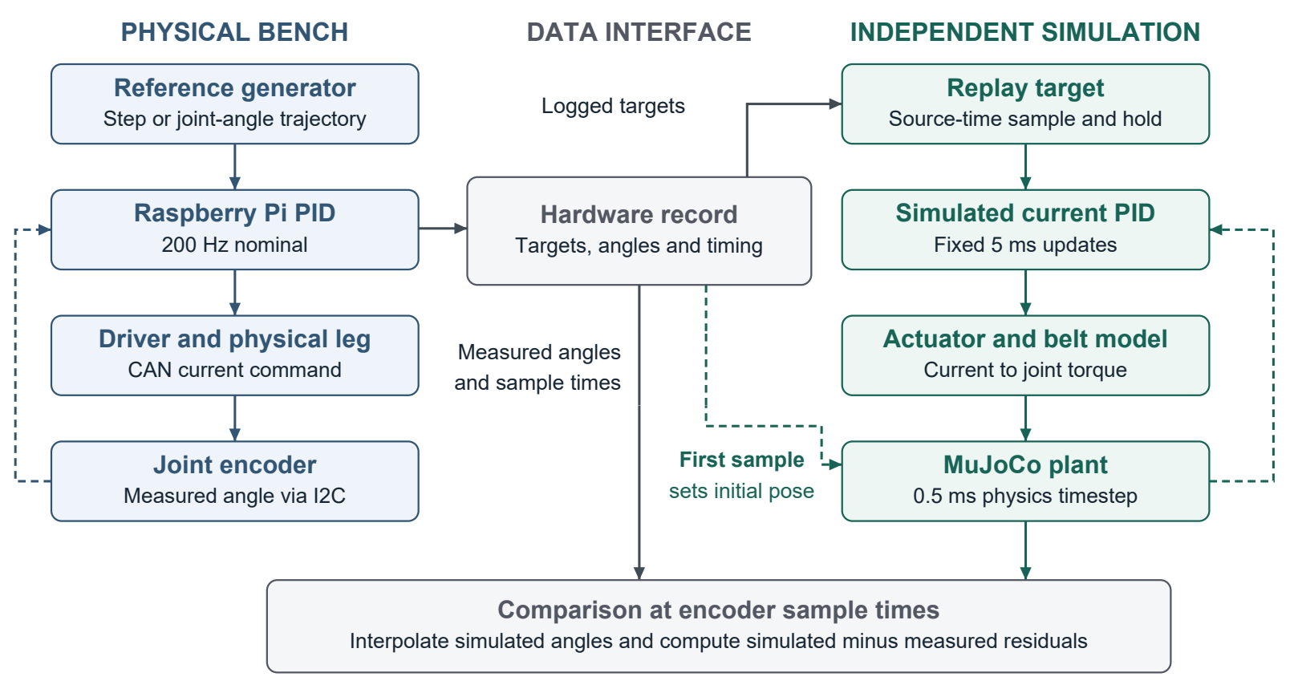
Fig. 1. Software architecture for recorded benchtop comparisons. Dashed arrows show feedback within each loop and the one-time initialization from the encoder record.

