Aws-Ecommerce-Project.
STEP 1 : Create a vpc with 2 AZ’s , 8 subnets(2 public , 6 private(2 for frontend, 2 for backend , 2 for database)).
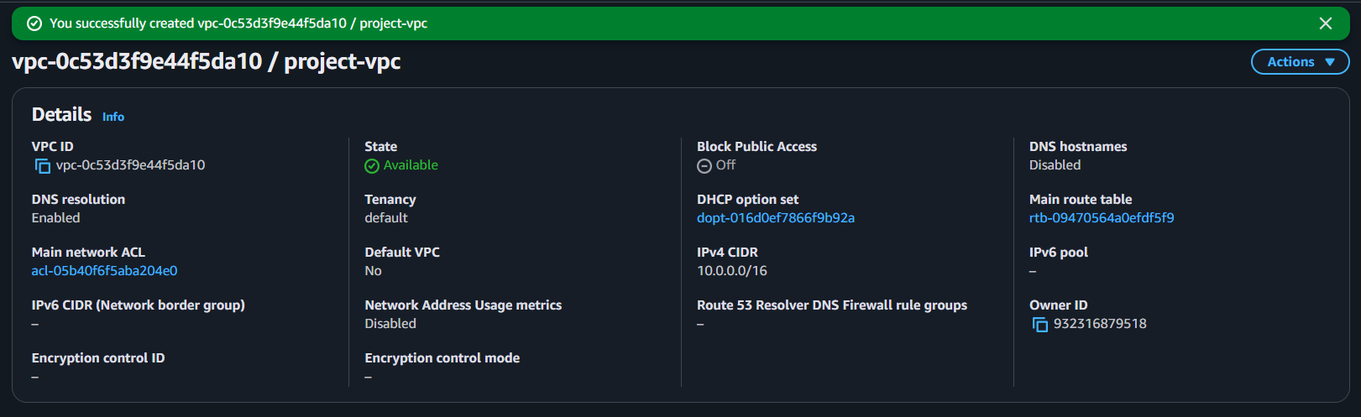

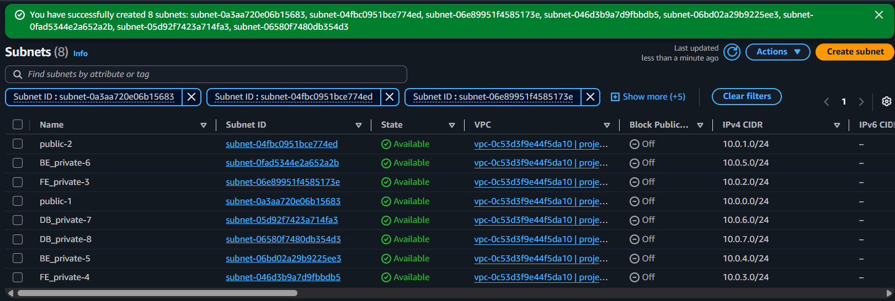

STEP 2 : Create internet gateway and attach to vpc.
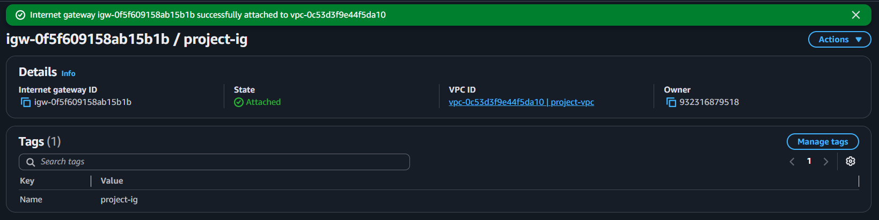

STEP 3 : Create a public route table , attach it to internet gateway and public subnets.
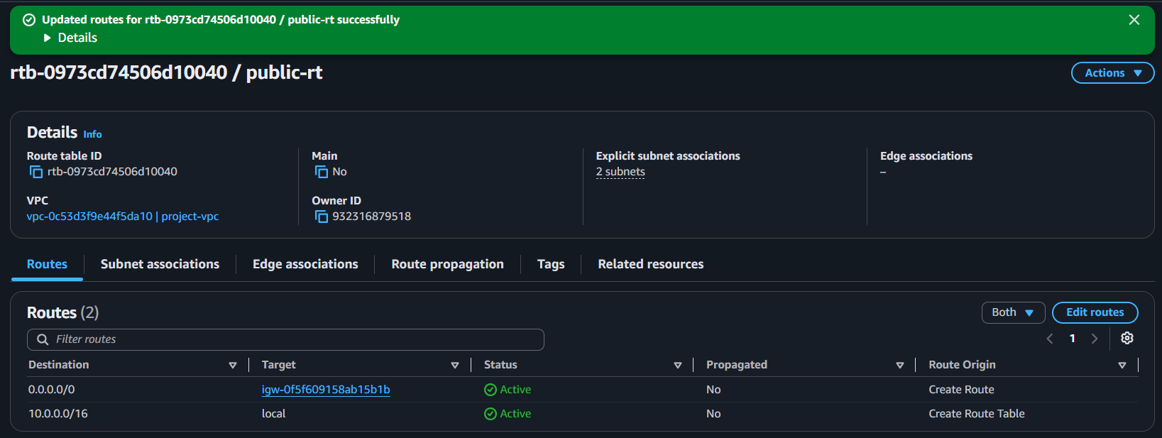
STEP 4 : Create NAT gateway.
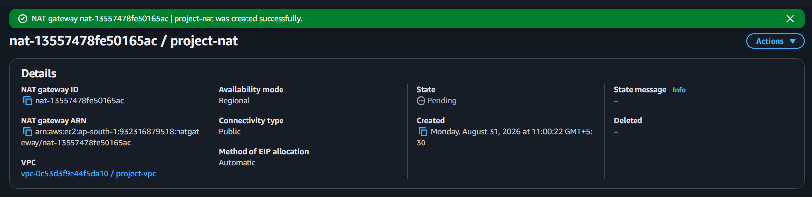

STEP 5 : Create private rt for front end and attach it to frontend subnets and nat.
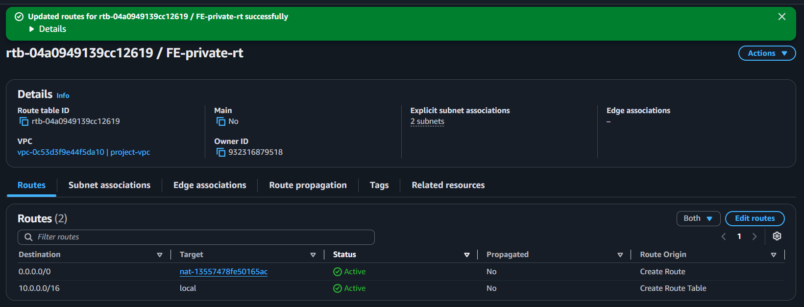

STEP 6 : Create private rt for backend and attach it to backend subnets and nat.
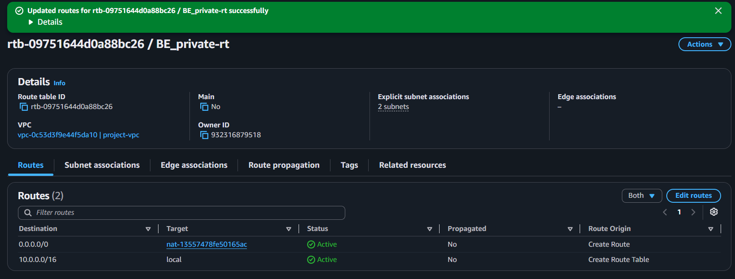

STEP 7 : Create DB_private-rt and attach it to the local vpc.
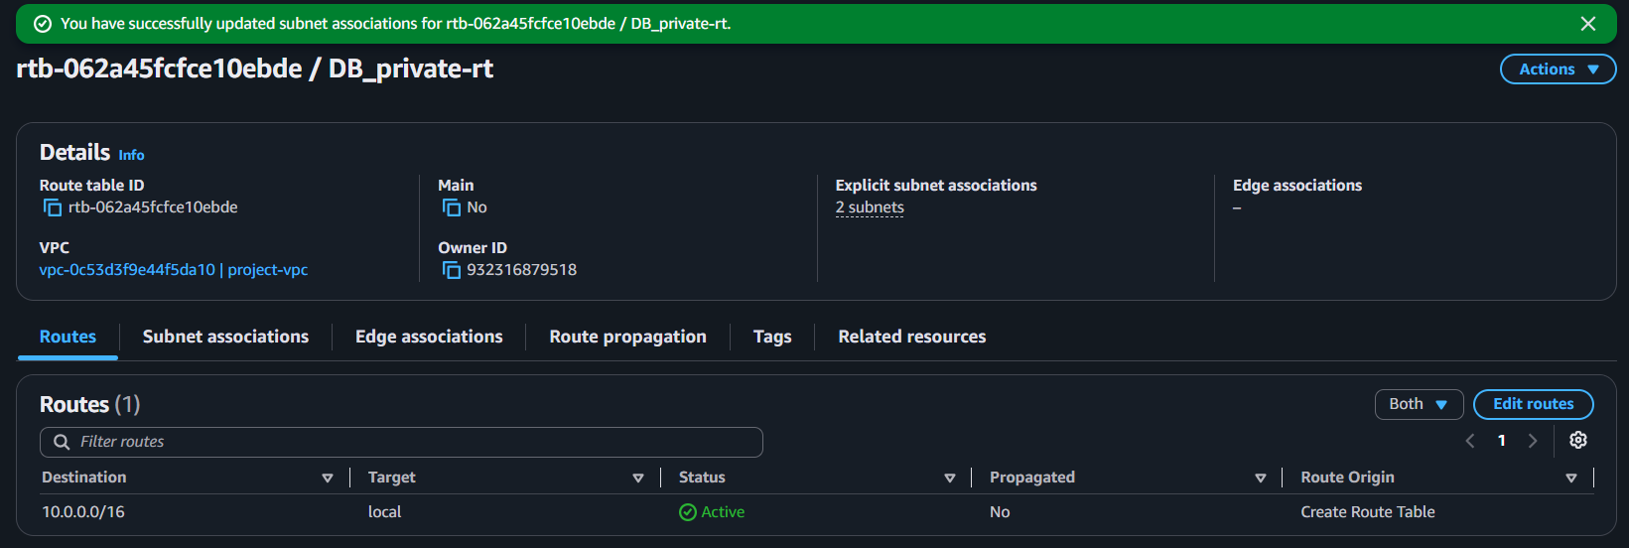

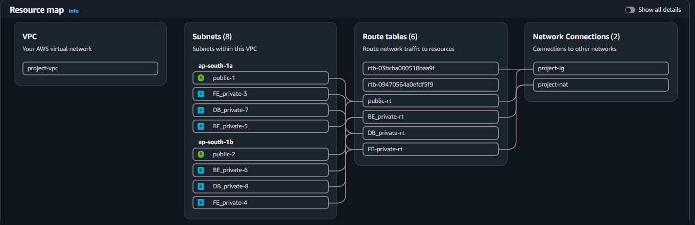

STEP 8 : SECURITY GROUPS.
- Public_alb-sg (80 , 443 -anywhere)
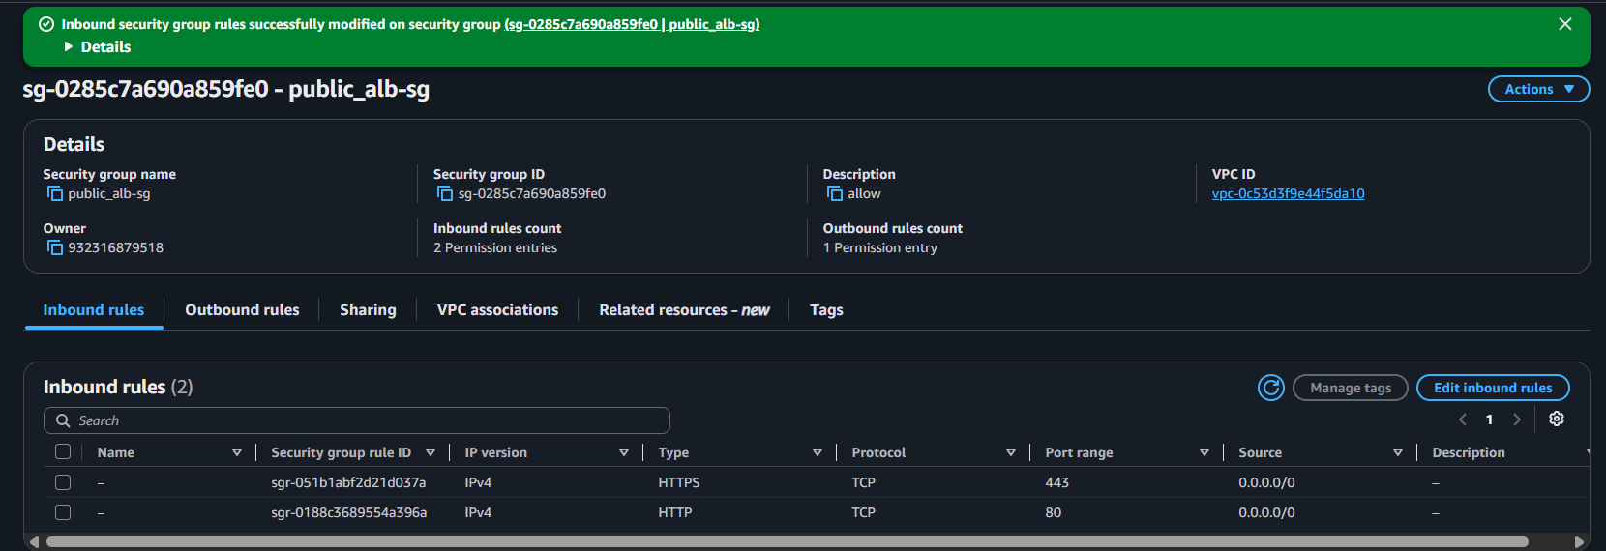

- Frontend_sg (80public_alb-sg)
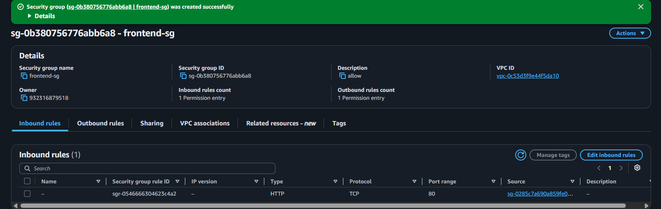

- Internal_alb-sg ( 5000frontend-sg)
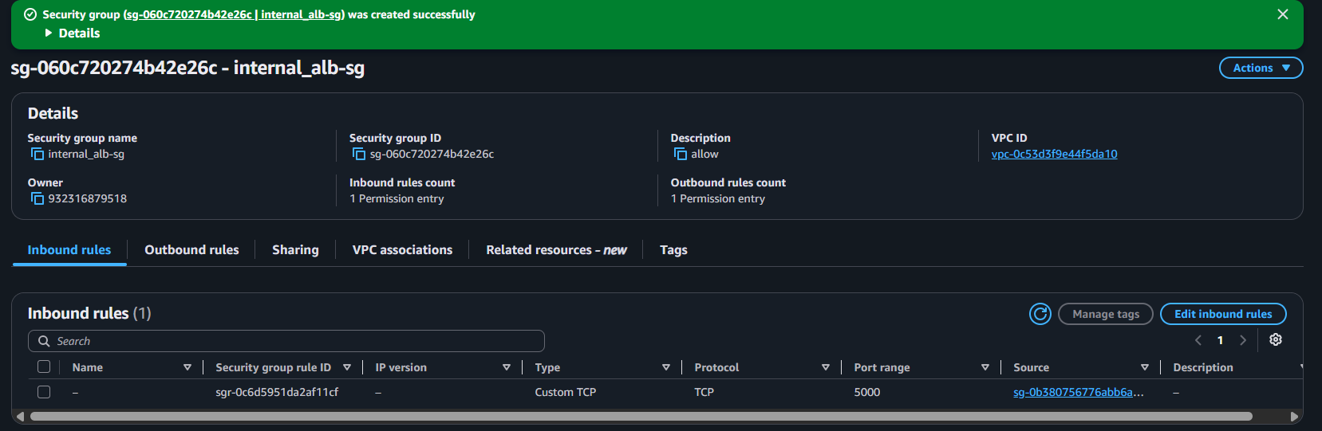

- Backend-sg (5000internal_alb-sg) 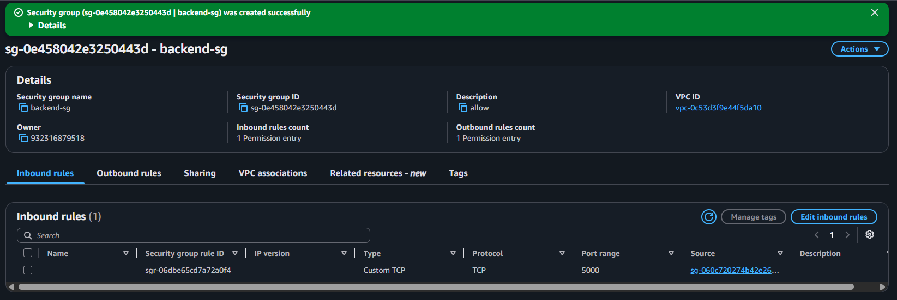
- Db-sg (3036backend-sg) 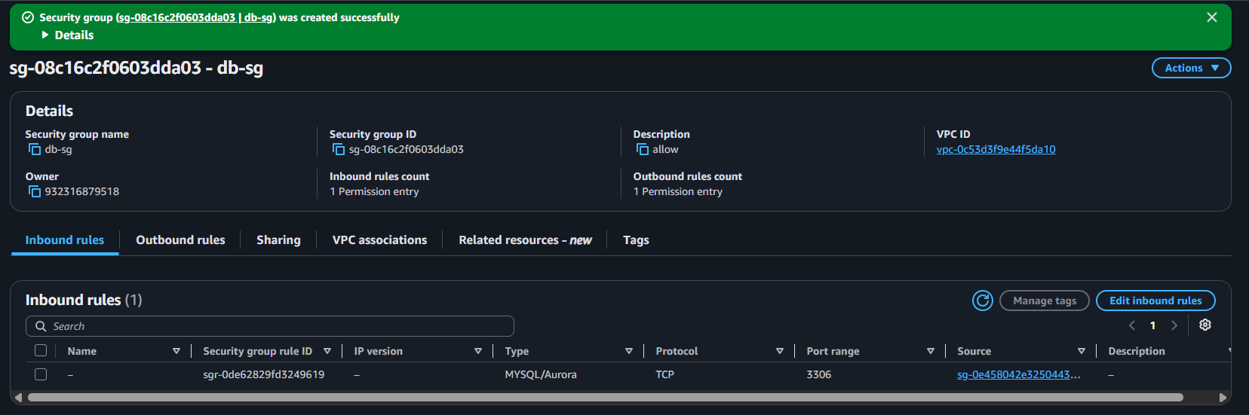

STEP 9 : Create database subnet group.
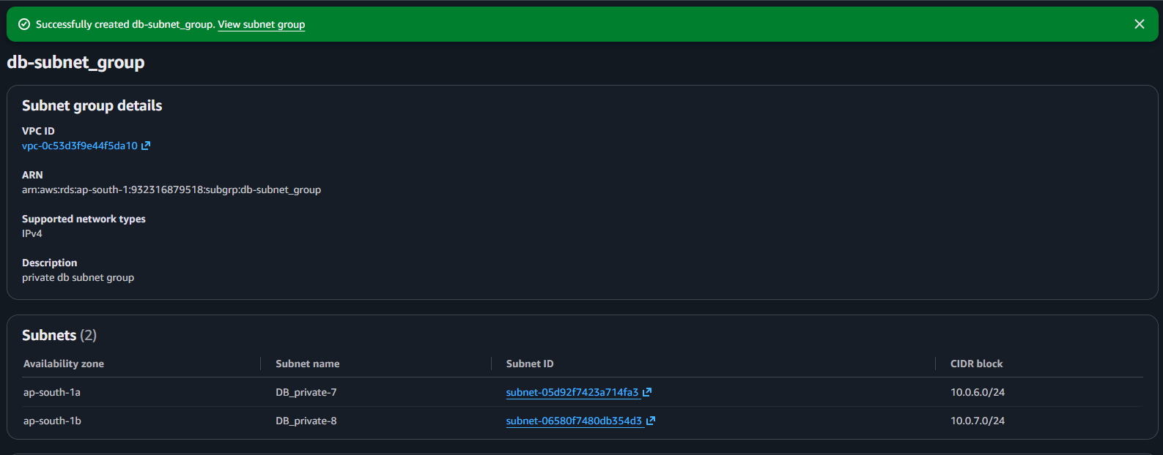

STEP 10 : Create rds database.
private access ( in 1a region).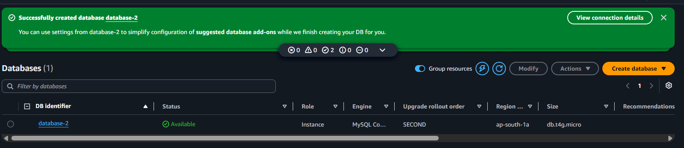

STEP 11 : Create keys in secrete manager and attach to database.
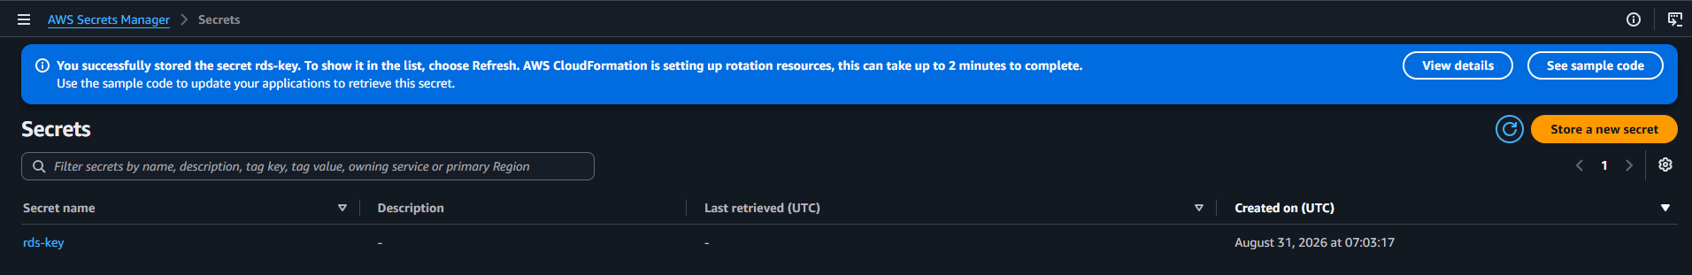

STEP 12 : Create read replica(in 1 b region). 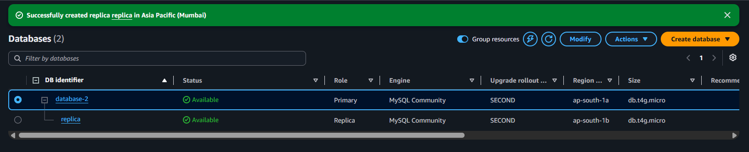
STEP 13 : Create redis cache for databse.(in 1b)
craete subnet group and a separate sg for cache.
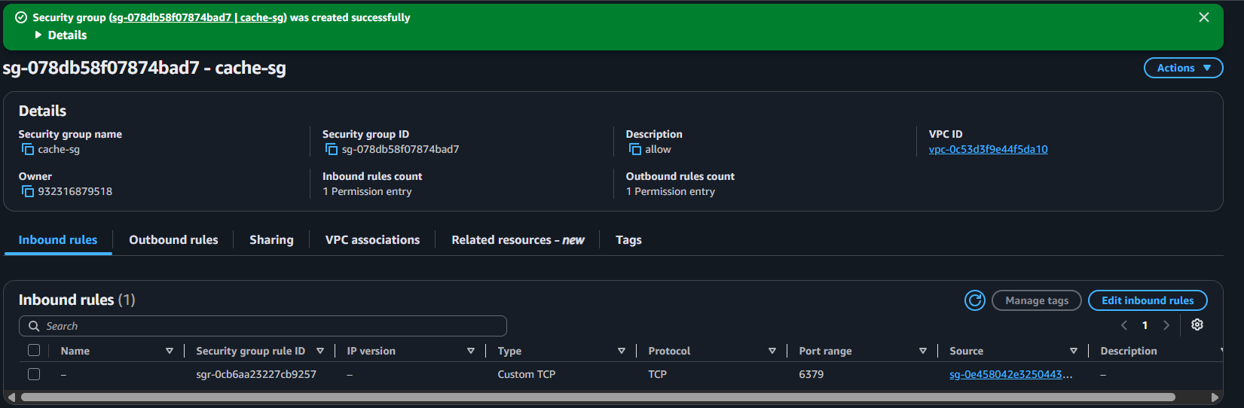
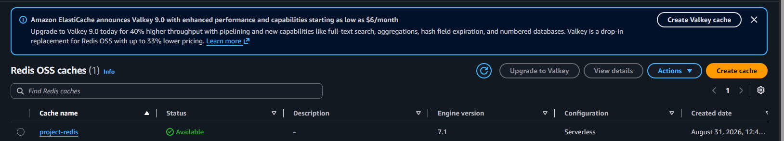
STEP 14 : Launch the instances , create an iam role for ssm and attach to instances.
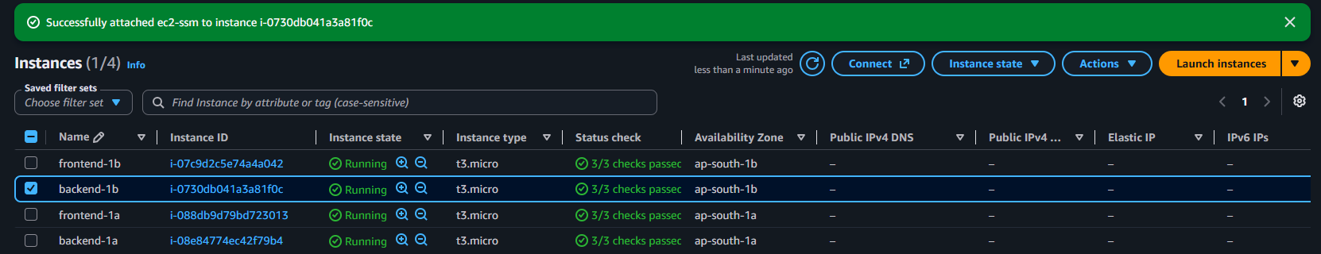

STEP 12 : Enable DHMC from system manager (system managersettingsenable).

STEP 13 : Connect to backed-1a and install Dynatrace one agent.
go to dynatarce infrastructure(select infrastructure , full stack and linux , click on install . copy the installation commands and paste in the server.)
wget -O Dynatrace-OneAgent-Linux-x86-1.343.102.20260826-151154.sh "https://bgq79633.live.dynatrace.com/api/v1/deployment/installer/agent/unix/default/latest?arch=x86" --header="Authorization: Api-Token dt0c01.LC6ITUVZ7JLBXOEEVWE7U6XA.JZKZVMOLHDTTEXIMUOHSCZHYCGMCEYQ772AV7BT2KS5RUOOBSRRBQP7455FXO7OM"

wget https://ca.dynatrace.com/dt-root.cert.pem ; ( echo 'Content-Type: multipart/signed; protocol="application/x-pkcs7-signature"; micalg="sha-256"; boundary="--SIGNED-INSTALLER"'; echo ; echo ; echo '----SIGNED-INSTALLER' ; cat Dynatrace-OneAgent-Linux-x86-1.343.102.20260826-151154.sh ) | openssl cms -verify -CAfile dt-root.cert.pem > /dev/null

/bin/sh Dynatrace-OneAgent-Linux-x86-1.343.102.20260826-151154.sh --set-monitoring-mode=fullstack --set-app-log-content-access=true

one agent is installed on the backed-1a server.
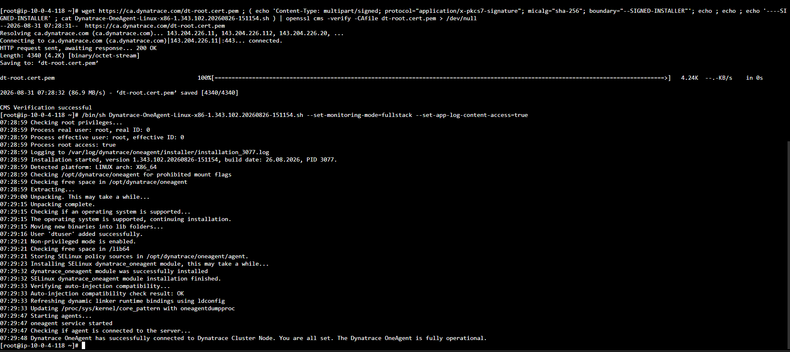

Commands:
Sudo su –
Git –version
git clone https://github.com/Goutham-id06/aws-ecomerce-Application-Multiple-services.git
ls
cd aws-ecomerce-Application-Multiple-services
ls
cd backend
dnf install -y python3-pip
source venv/bin/activate
pip install -r requirements.txt
python3 -m pip install --upgrade pip
now install db on server .
dnf install -y mariadb105
mysql -h database-2.cjmymywscfd4.ap-south-1.rds.amazonaws.com -P 3306 -u admin -p
show databases;
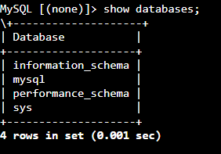

mysql -h database-2.cjmymywscfd4.ap-south-1.rds.amazonaws.com -P 3306 -u admin -p < test.sql
mysql -h database-2.cjmymywscfd4.ap-south-1.rds.amazonaws.com -P 3306 -u admin -p
show databases;
use cloud;
show tables;
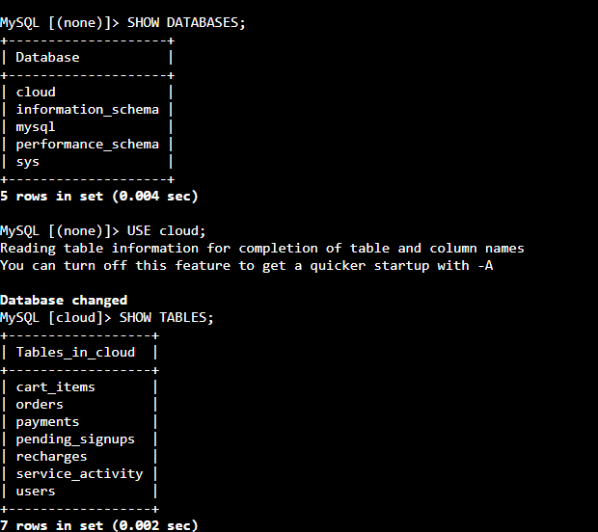
Ls -ls
Vi .env
(change database name and the password here)
pip install gunicorn
gunicorn --bind 0.0.0.0:5000 app:app
vi /etc/systemd/system/ecommerce-backend.service
[Unit]
Description=Ecommerce Flask Backend
After=network.target

[Service]
User=root
WorkingDirectory=/root/aws-ecomerce-Application-Multiple-services/backend
EnvironmentFile=/root/aws-ecomerce-Application-Multiple-services/backend/.env
ExecStart=/root/aws-ecomerce-Application-Multiple-services/backend/venv/bin/gunicorn --workers 2 --bind 0.0.0.0:5000 app:app
Restart=always
RestartSec=5

[Install]
WantedBy=multi-user.target
ls -l /etc/systemd/system/ecommerce-backend.service
systemctl enable --now ecommerce-backend
systemctl status ecommerce-backend

repeat the same process on backend-1b too.

STEP 14 : create target group and private load balancer for the backend servers .
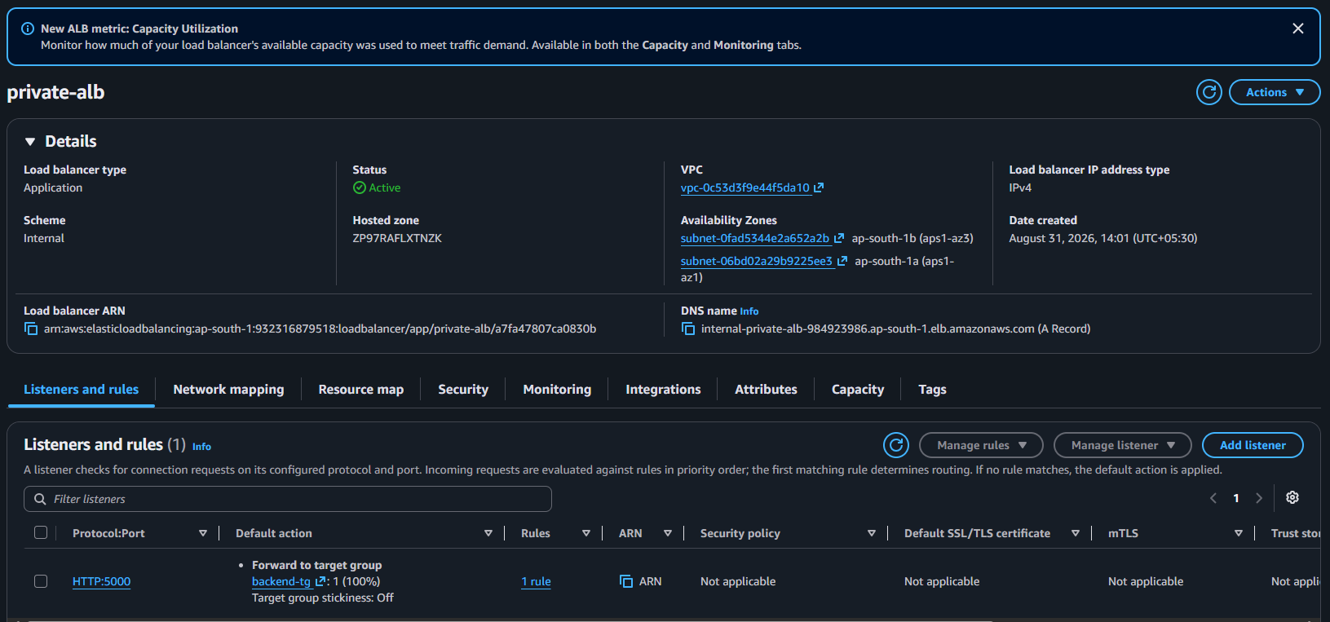

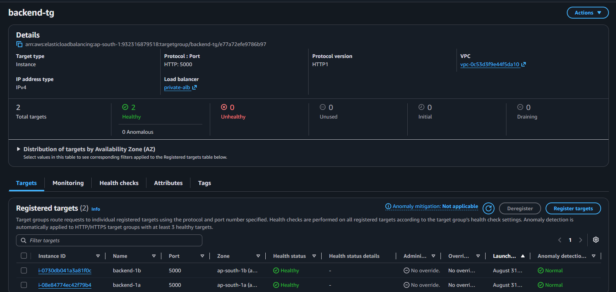

STEP 15 :Now create asg for backend-1a and backend-1b.
create ami for both servers ,create launch templates and then asg.
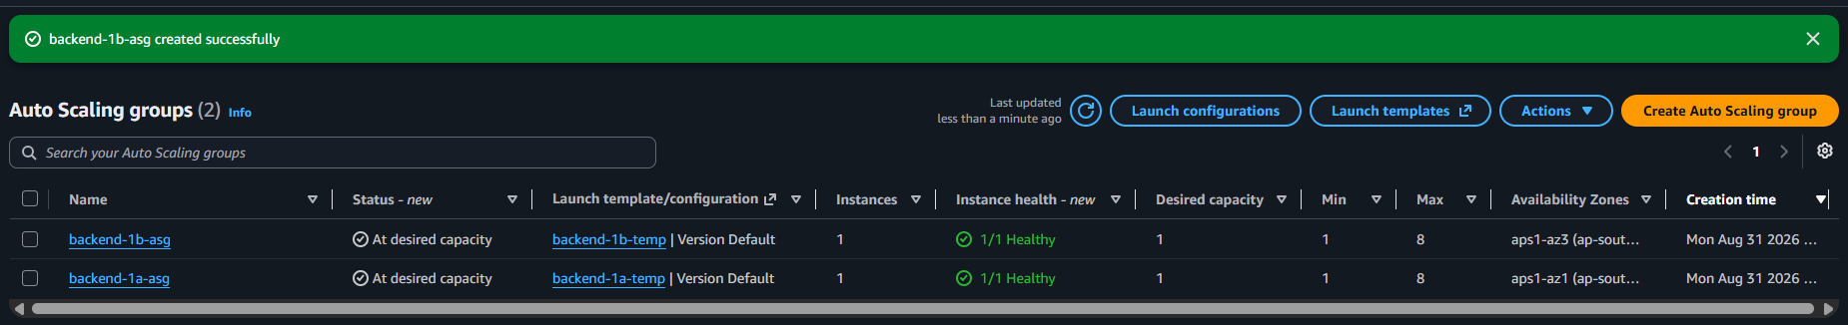

STEPP 16 : connect to frontend-1a and install oneagent .
wget -O Dynatrace-OneAgent-Linux-x86-1.343.102.20260826-151154.sh "https://bgq79633.live.dynatrace.com/api/v1/deployment/installer/agent/unix/default/latest?arch=x86" --header="Authorization: Api-Token dt0c01.LC6ITUVZ7JLBXOEEVWE7U6XA.JZKZVMOLHDTTEXIMUOHSCZHYCGMCEYQ772AV7BT2KS5RUOOBSRRBQP7455FXO7OM"

wget https://ca.dynatrace.com/dt-root.cert.pem ; ( echo 'Content-Type: multipart/signed; protocol="application/x-pkcs7-signature"; micalg="sha-256"; boundary="--SIGNED-INSTALLER"'; echo ; echo ; echo '----SIGNED-INSTALLER' ; cat Dynatrace-OneAgent-Linux-x86-1.343.102.20260826-151154.sh ) | openssl cms -verify -CAfile dt-root.cert.pem > /dev/null

/bin/sh Dynatrace-OneAgent-Linux-x86-1.343.102.20260826-151154.sh --set-monitoring-mode=fullstack --set-app-log-content-access=true

sudo yum update -y
sudo yum install -y git nginx
sudo systemctl start nginx
sudo systemctl enable nginx
sudo systemctl status nginx
git clone https://github.com/Goutham-id06/aws-ecomerce-Application-Multiple-services.git
cd aws-ecommerce-otp-authentication
cd frontend
ls
cp -r * /usr/share/nginx/html/
cp -r main/* /usr/share/nginx/html/
ls -l /usr/share/nginx/html/
sudo vi /etc/nginx/conf.d/google-store.conf
server {
listen 80;
server_name _;

root /usr/share/nginx/html;
index index.html;

location = /api {
proxy_pass http://internal-private-alb-984923986.ap-south-1.elb.amazonaws.com:5000/api;
proxy_http_version 1.1;
proxy_set_header Host $host;
proxy_set_header X-Real-IP $remote_addr;
proxy_set_header X-Forwarded-For $proxy_add_x_forwarded_for;
proxy_set_header X-Forwarded-Proto $scheme;
}

location /api/ {
proxy_pass http://internal-private-alb-984923986.ap-south-1.elb.amazonaws.com:5000/api/;
proxy_http_version 1.1;
proxy_set_header Host $host;
proxy_set_header X-Real-IP $remote_addr;
proxy_set_header X-Forwarded-For $proxy_add_x_forwarded_for;
proxy_set_header X-Forwarded-Proto $scheme;
}

location / {
try_files $uri $uri/ /index.html;
}
}

sudo nginx -t
sudo systemctl enable nginx
sudo systemctl restart nginx
sudo systemctl status nginx
Now configure with pager duty.
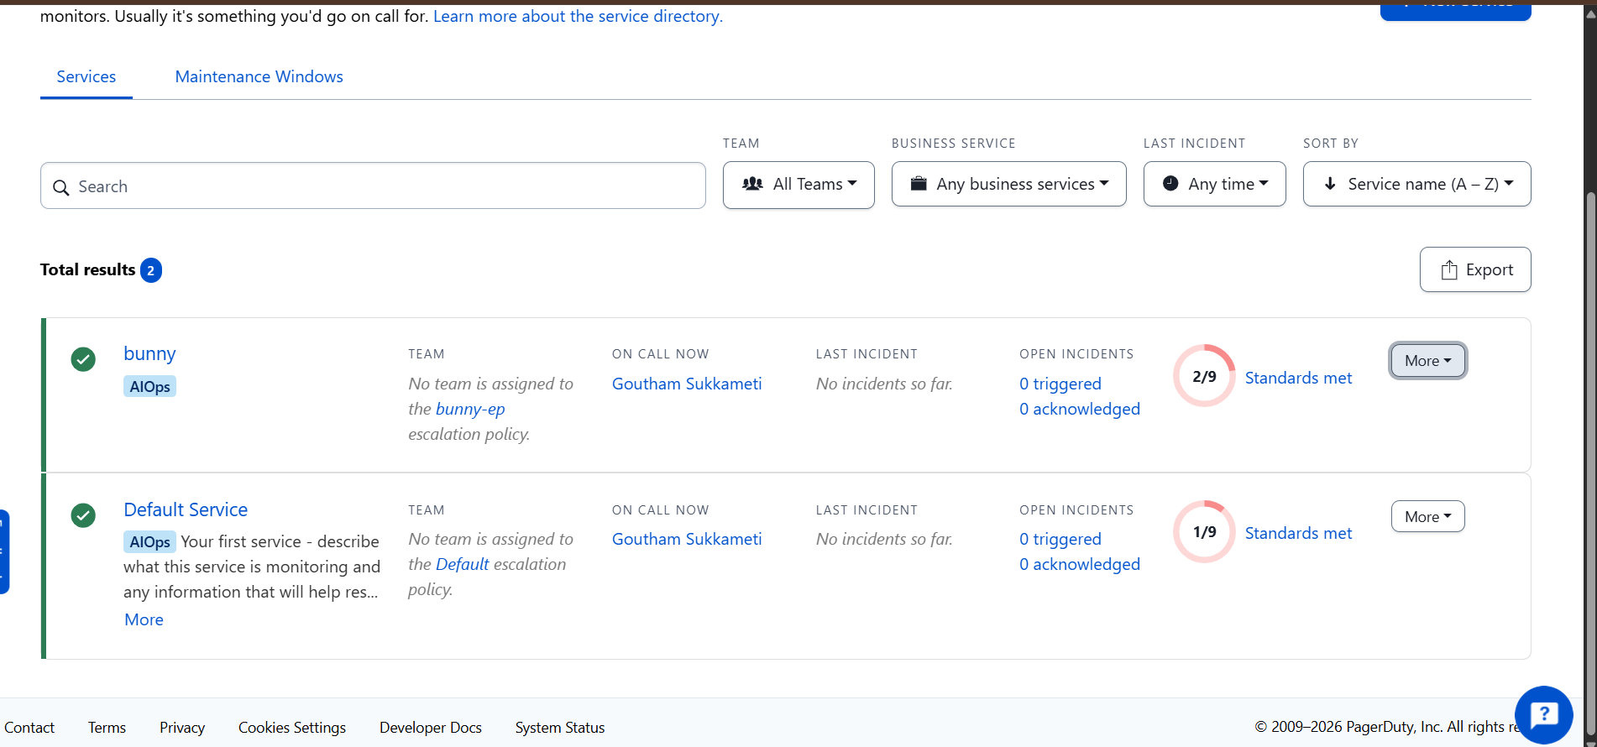
STEP 17 : Create asg for frontend servers.
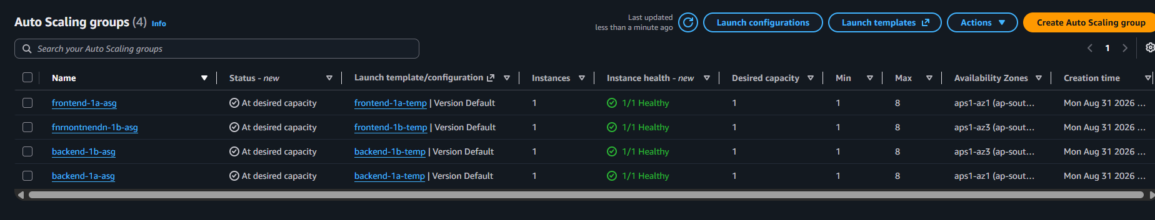

STEP 18 : Create public load balancer and tg for frontend.
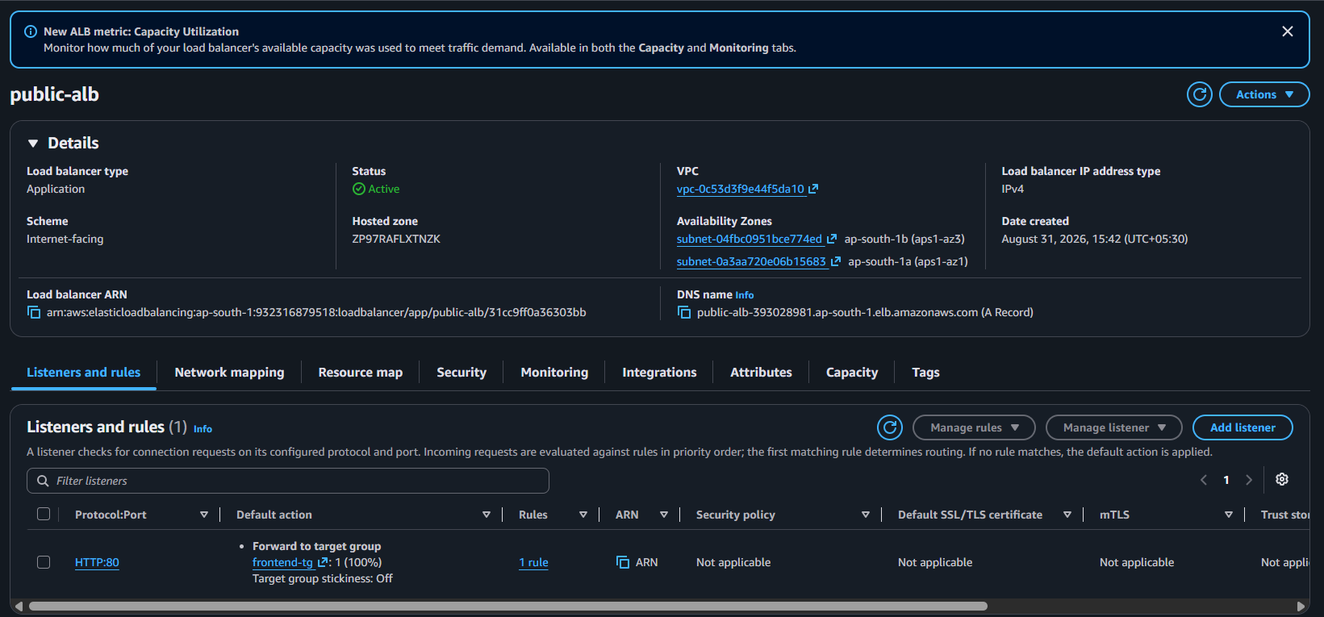

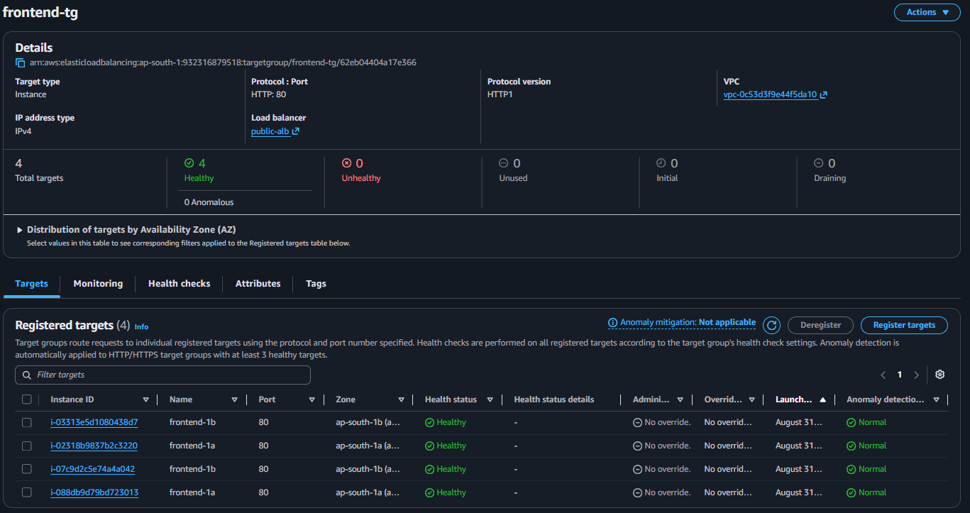

STEP 19 : Create cloudfront .(create https certificate for domain to access through browser).
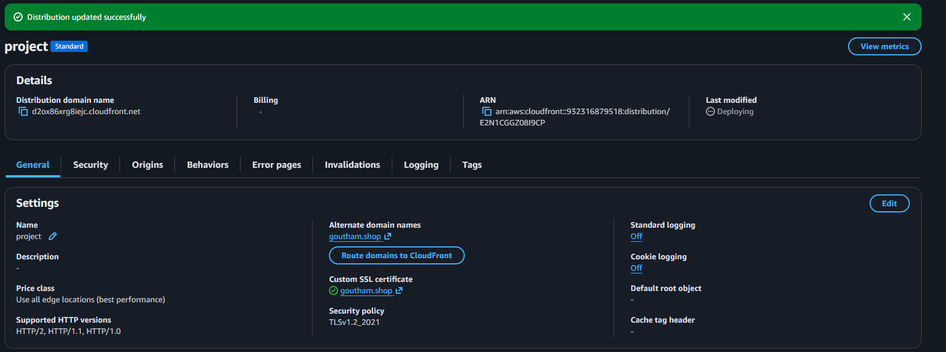

Now update public-lb listeners . 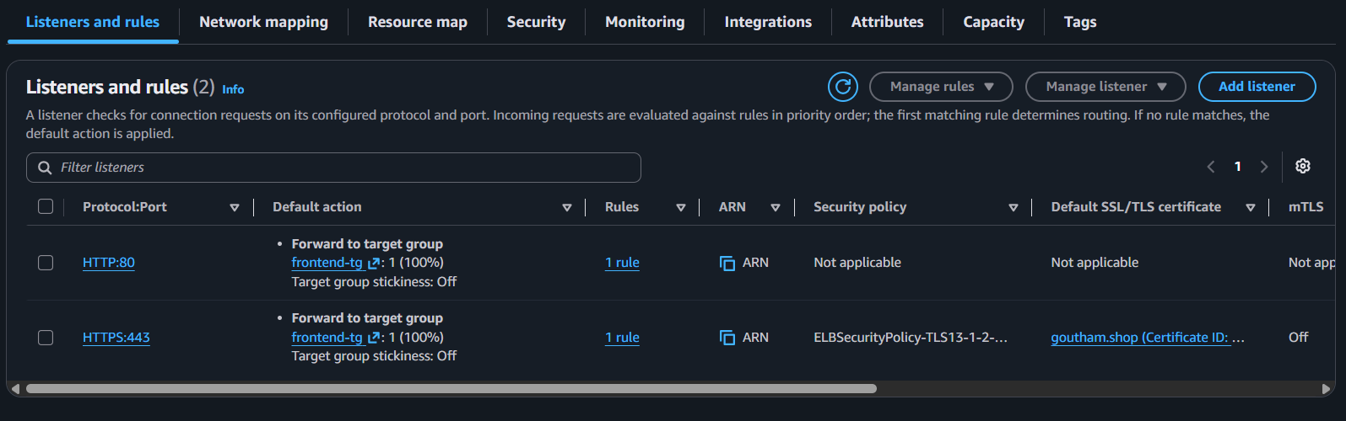

create origin , origin group and behavior . 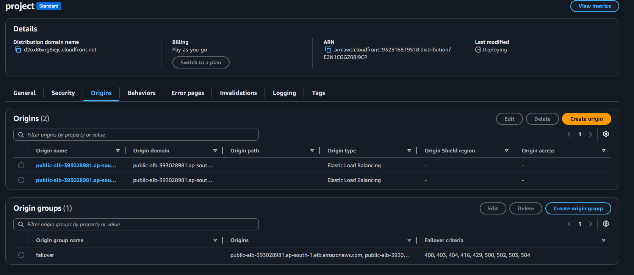

STEP 20 : Create a lambda function to invalidate cloudfront.
import boto3
import json

cloudfront = boto3.client("cloudfront")

DISTRIBUTION_ID = "E3BNZPFSP5OB3L"

def lambda_handler(event, context):

response = cloudfront.create_invalidation(
DistributionId=DISTRIBUTION_ID,
InvalidationBatch={
"Paths": {
"Quantity": 1,
"Items": [
"/*"
]
},
"CallerReference": context.aws_request_id
}
)

return {
"statusCode": 200,
"body": json.dumps({
"message": "CloudFront invalidation created",
"distribution_id": DISTRIBUTION_ID,
"invalidation_id": response["Invalidation"]["Id"]
})
}

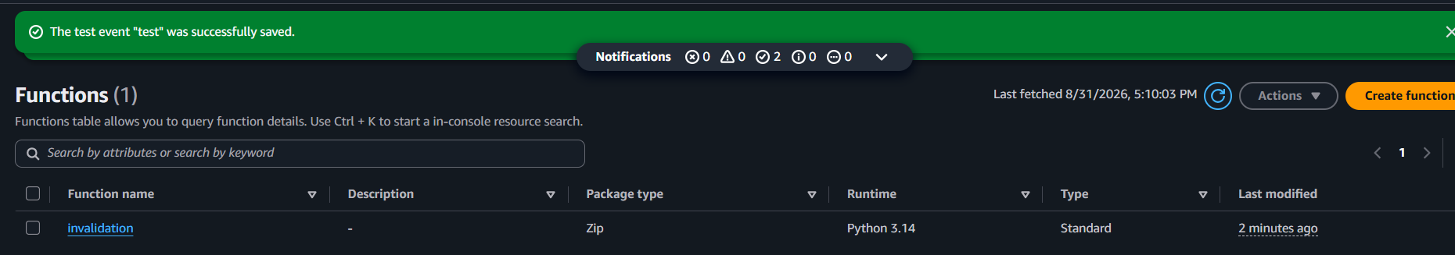
STEP 21 : Create an api gatway and attach to lambda.
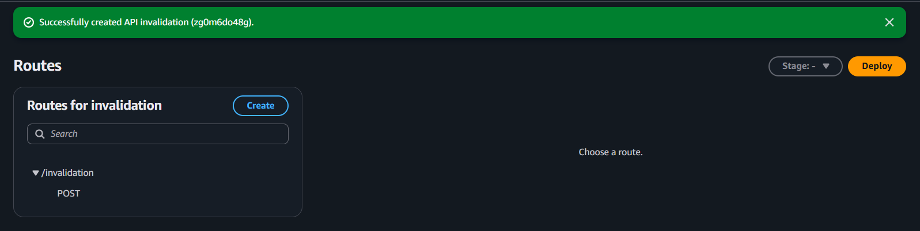
STEP 22 : Create eventbridge for lambda automation and create schedule of invocation .
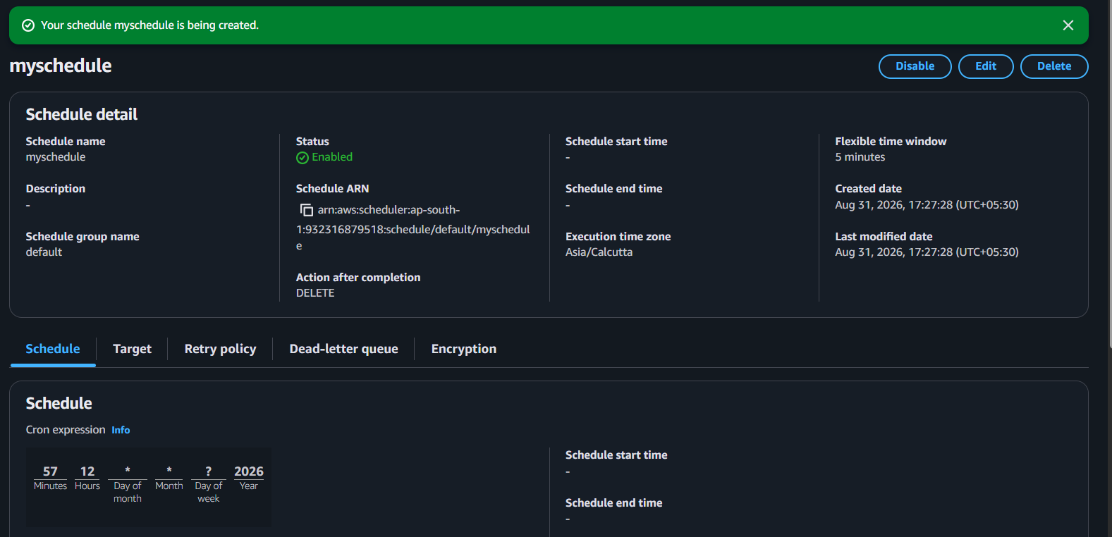

STEP 23 : Create kMS
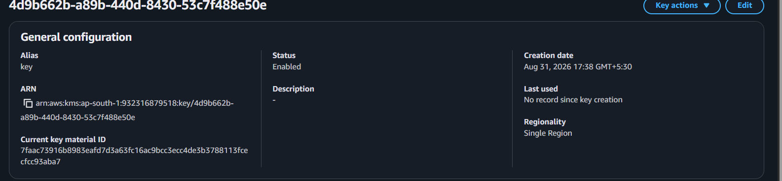
STEP 24 : Create an s3 bucket using kms keys.
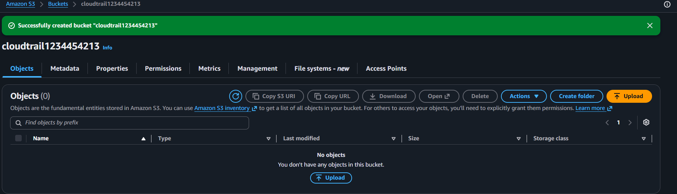

STEP 25 : Create cloudtrail to record data.
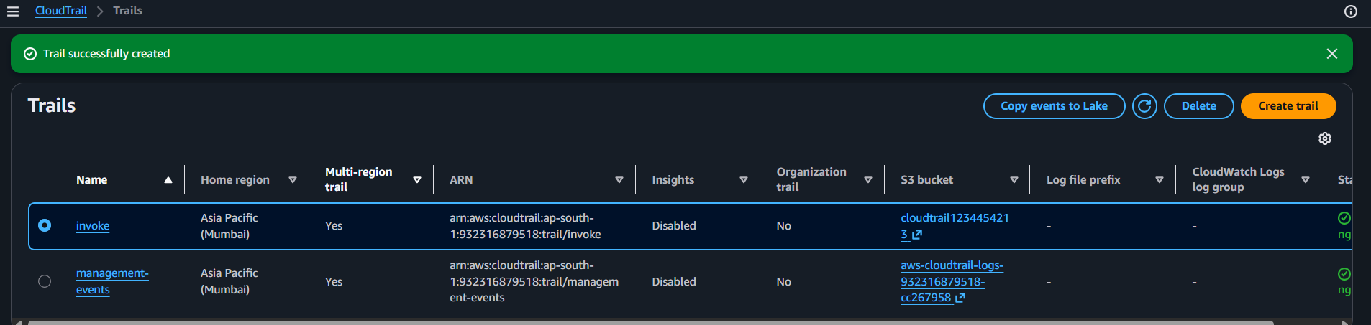

STEP 26 : Create route53 hostedzone and update the servernames in domain.
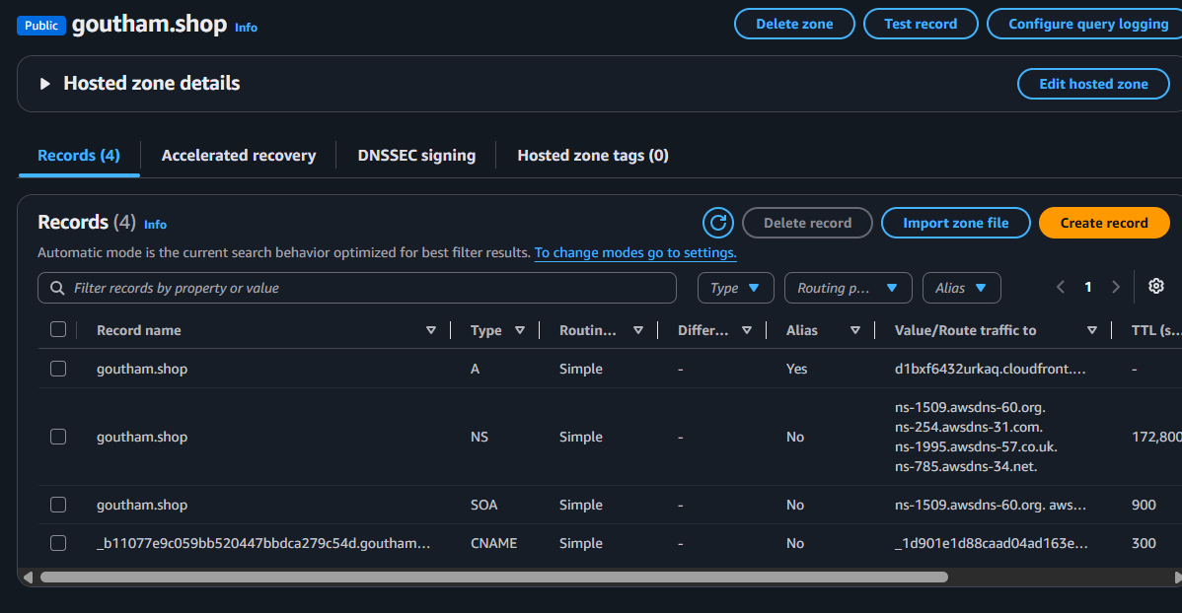

STEP 27 : Hit the domain in the browser.
