 

**Placement Empowerment Program**

***Cloud Computing and DevOps Centre***

Automate File Copying with a Script

Create a script to copy files from one folder to another automatically.

Name: Goutham K Department: EEE



**Introduction and Overview**

Copying file from one folder to another folder everyday takes a lot of time and becomes a repetitive task. So we can create a powershell script to automate this task. It will increase the overall efficiency and reduces time and complexity of this task.

**Objectives**

* Create a Script to Copy from one folder to another
* Automate the implementation of this task using task scheduler

**Importance**

* Reduce the workload by preventing the need to manually copy file from one folder to another
* Since the task is entirely automated , The chances of a mistake occurring is very low

**STEPS**

**STEP 1:** Create two folders as source folder and destination folder with the files to be copied in the source folder.



**STEP 2:** Open Notepad and write the script below and change the source and destination directories in the file and save it as .bat extension. 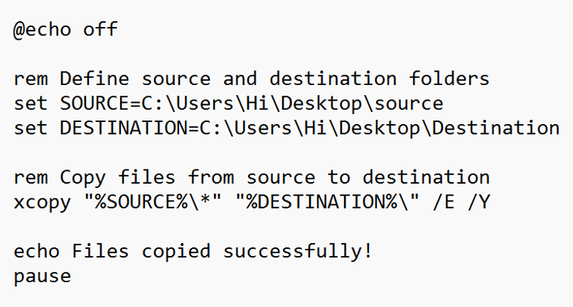

**STEP 3:** Press Win+R and type “taskshcd.msc” which will open thetask scheduler

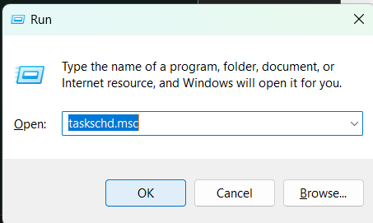

**STEP 5:** Right-Click the task scheduler and select create basic task.

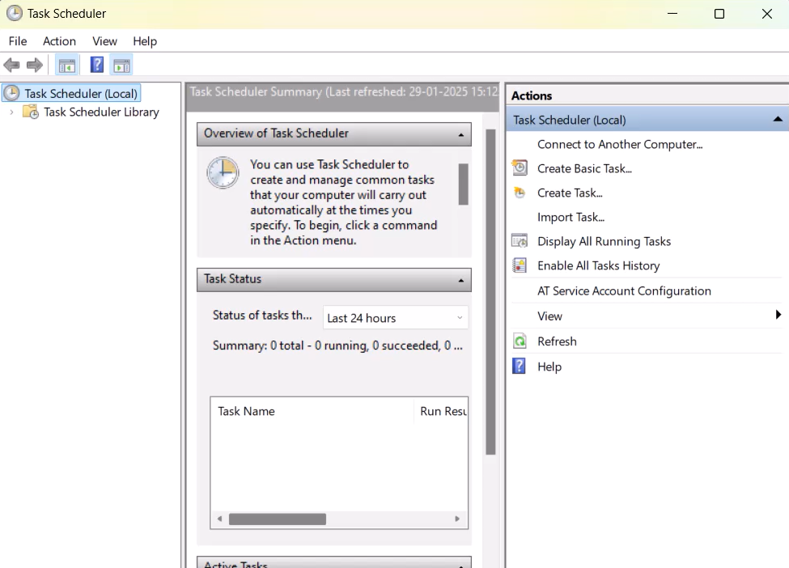

**STEP 6:** Provide a Name and Description for this automation task. 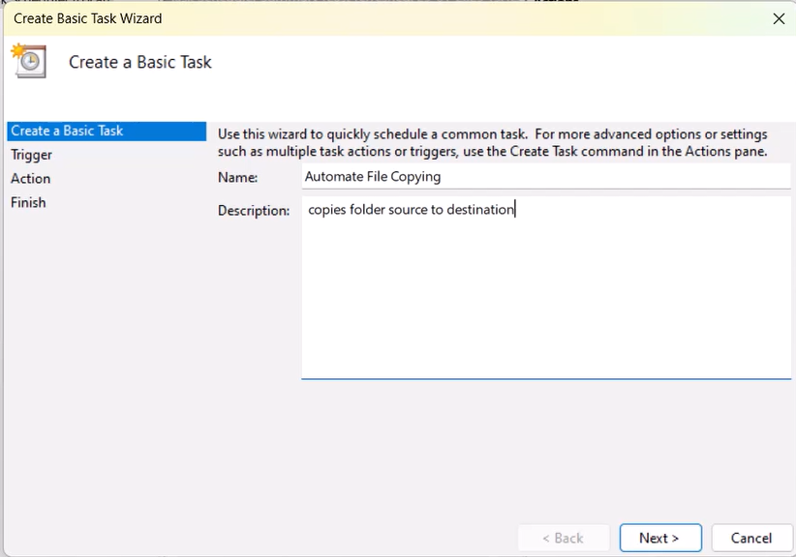

**STEP 7 :** Set a scheduled time and date to when the task should execute everyday within the trigger option. 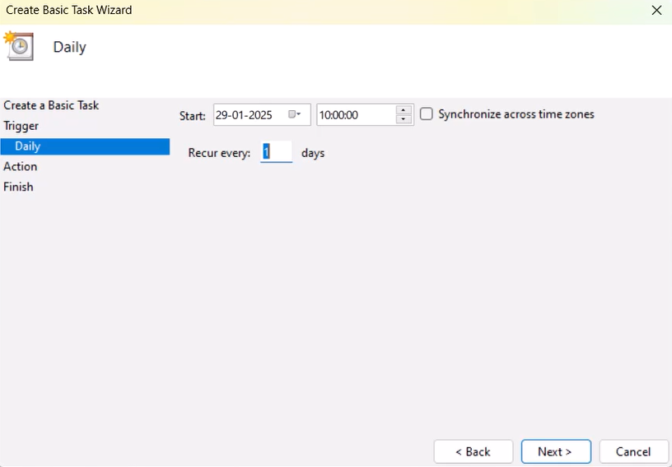

**STEP 8:** And Select Start a Program which confirms to the task scheduler that this task is supposed to start a program that is our script.

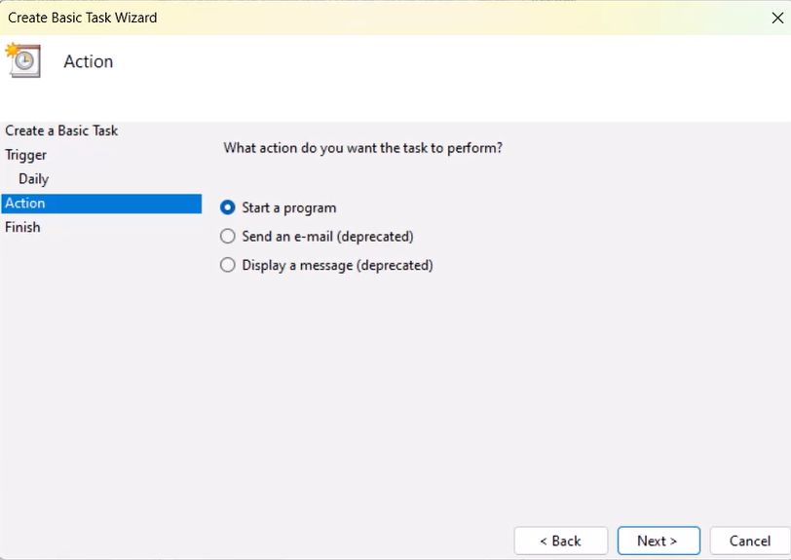

**STEP 9:** Now , select the file from the folder or paste the location path.

**STEP 10:** Select Finish and in the bottom right corner which will create the task .

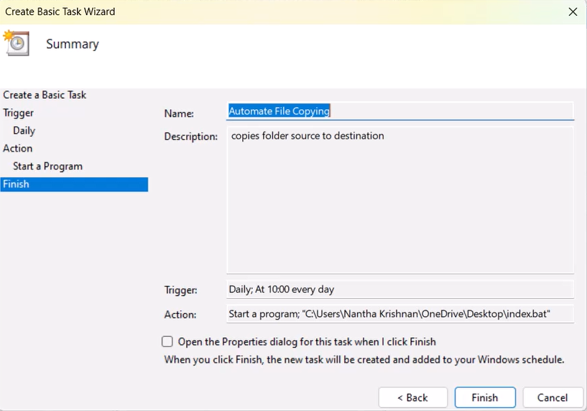**STEP 11:** To check whether the script is working. Right Click the Script Name and select Run to execute the task. 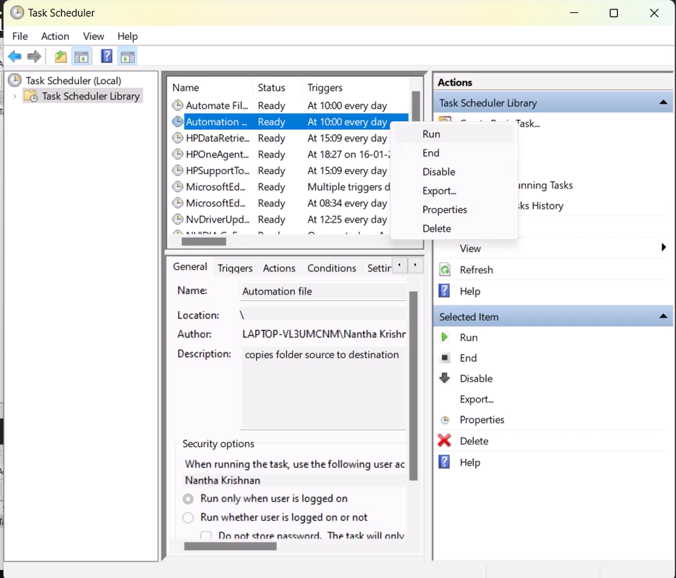

**STEP 12:** A Command Terminal will open ensuring that the files had been transferred successfully. 

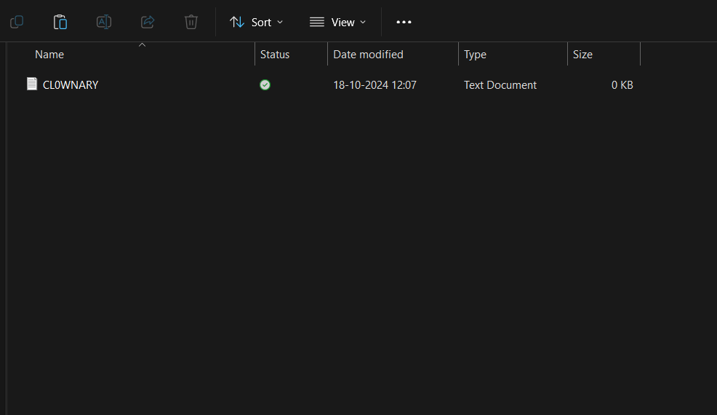

Outcome

By completing this Proof of Concept (PoC) of automating a task using Task Scheduler, you will:

1. Successfully set up an automated task that triggers on a schedule or when manually run.

2. Execute a batch script to copy files from a source folder to a destination folder automatically.

3. Understand how to use Task Scheduler to automate repetitive tasks in Windows.

4. Gain familiarity with task triggers, actions, and conditions in Task Scheduler.

5. Save time and ensure consistent execution of file operations without manual intervention.

6. Optionally test the task to verify that it runs as expected and achieves the desired outcome.

7. Enhance your workflow automation skills with practical hands-on experience.