 

**Placement Empowerment Program**

***Cloud Computing and DevOps Centre***

Set Up a Cloud-Based Monitoring Service Enable basic cloud monitoring (e.g., CloudWatch on AWS) View metrics like CPU usage and disk I/O for your cloud VM.

Name: Goutham K Department: EEE



**Introduction and Overview**

Cloud-based monitoring plays a vital role in modern infrastructure management by providing real-time insights into the performance and health of cloud resources. In this Proof of Concept (PoC), we will configure **Amazon CloudWatch** to monitor essential metrics for an **EC2 instance**, including **CPU utilization, disk I/O, and network traffic**. This implementation will help track system performance, detect potential bottlenecks, and set up alerts for proactive issue resolution, ensuring optimal resource utilization and uptime.

**Objective**

The goal of this project is to:

1. Understanding the basics of AWS CloudWatch and its monitoring capabilities.
2. Configuring CloudWatch to monitor essential EC2 metrics.
3. Gaining hands-on experience in proactive cloud resource management

**Importance of Cloud-Based Monitoring**

**Hands-On Learning:**  Provides practical exposure to cloud-based monitoring tools like AWS CloudWatch, helping you gain essential skills for real-world cloud infrastructure management.

**Proactive Resource Management**: Enables you to monitor system performance in real-time, identify performance issues, and take corrective actions before they impact end users.

**Foundation for Automation:** Lays the groundwork for automating monitoring processes, such as setting up alerts and scaling actions, which are critical for efficient cloud operations and DevOps practices.

**Step-by-Step Overview**

Step1:

Open the AWS Management Console. Navigate to the EC2 Dashboard.

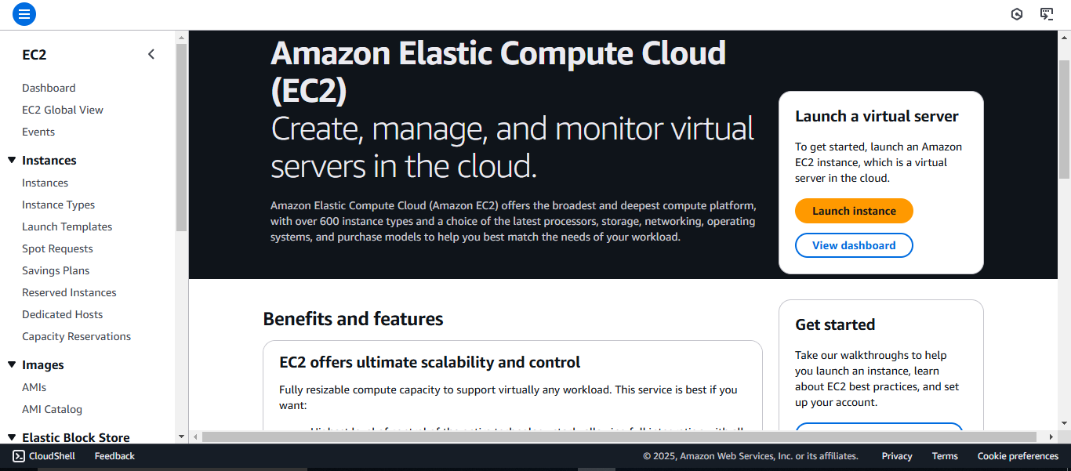

Step 2 :

Click Launch Instance, Configure the instance as needed:

Select an Amazon Machine Image (e.g., Amazon Linux or Ubuntu).

Choose an instance type (e.g., t2.Micro for free-tier eligibility)

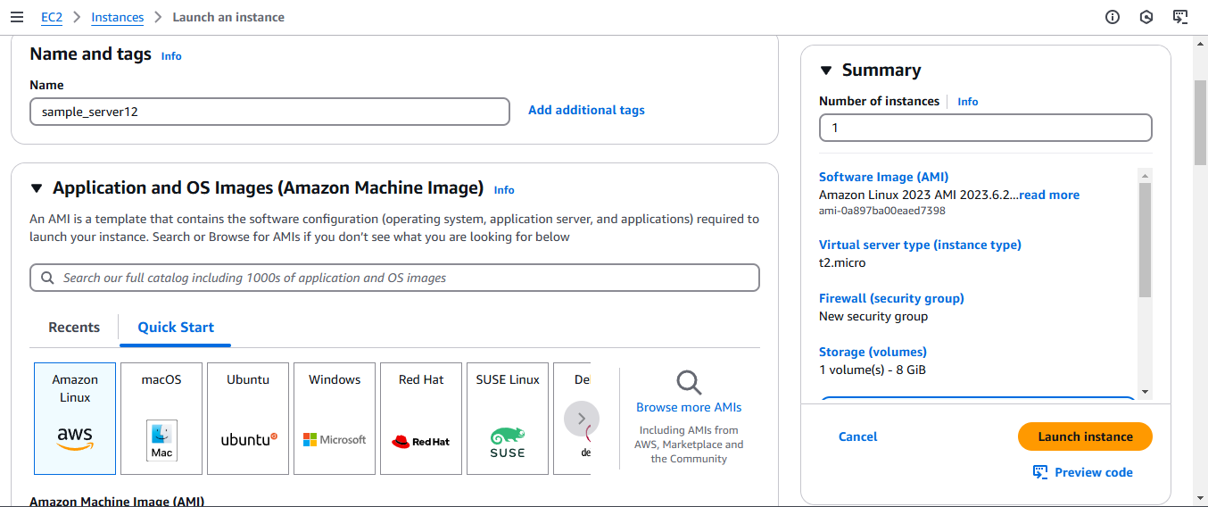

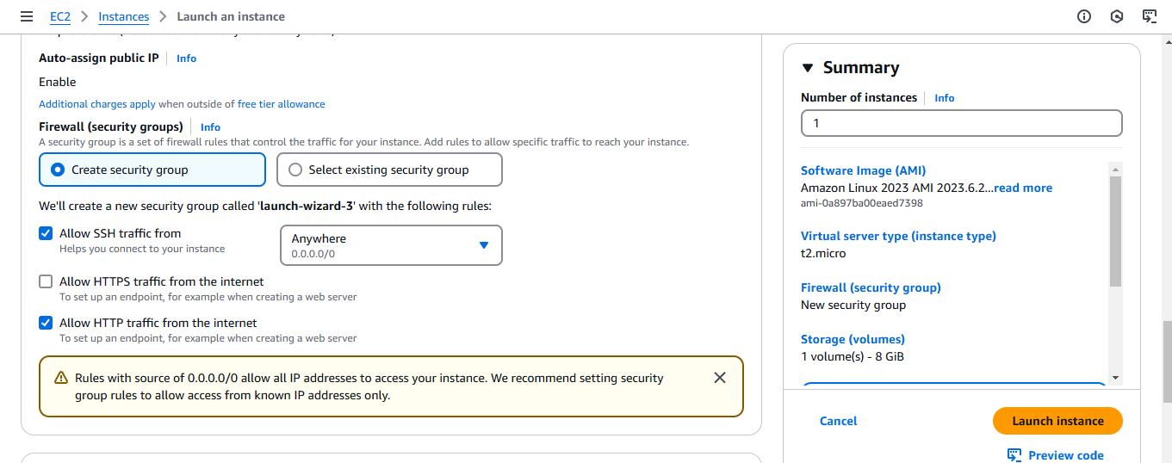

Step 3:

Configure the security group to allow necessary ports (e.g., SSH, HTTP, etc.).

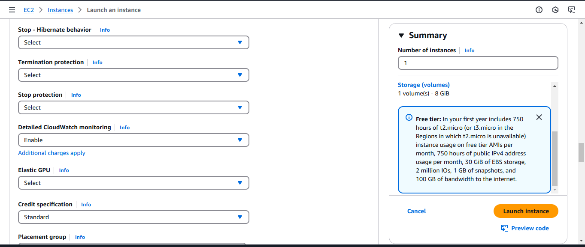

Step 4:

Launch the instance, While launching the EC2 instance:

Under the "Advanced Details" section, ensure that the CloudWatch monitoring option is enabled.

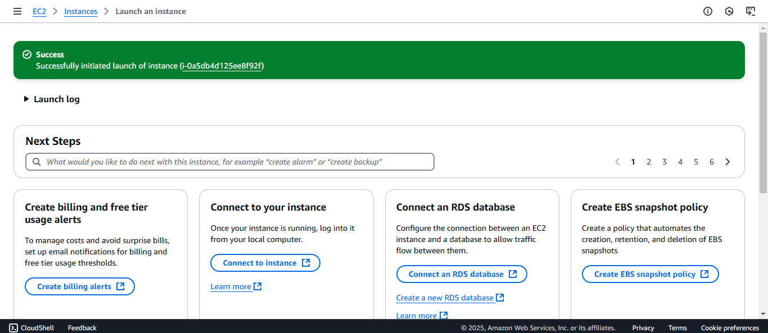

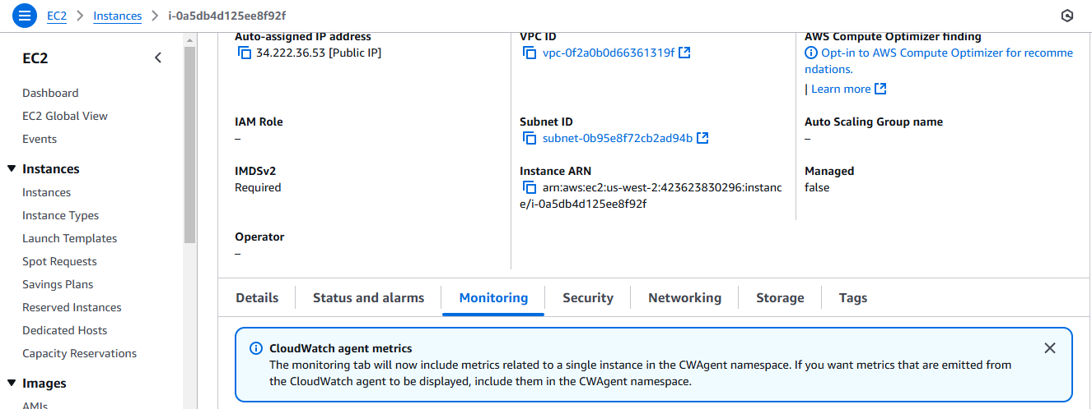

Step 5:

Open the CloudWatch Dashboard, On the CloudWatch Dashboard, navigate to Metrics on the left-hand menu.

Click All Metrics and choose the EC2 namespace.

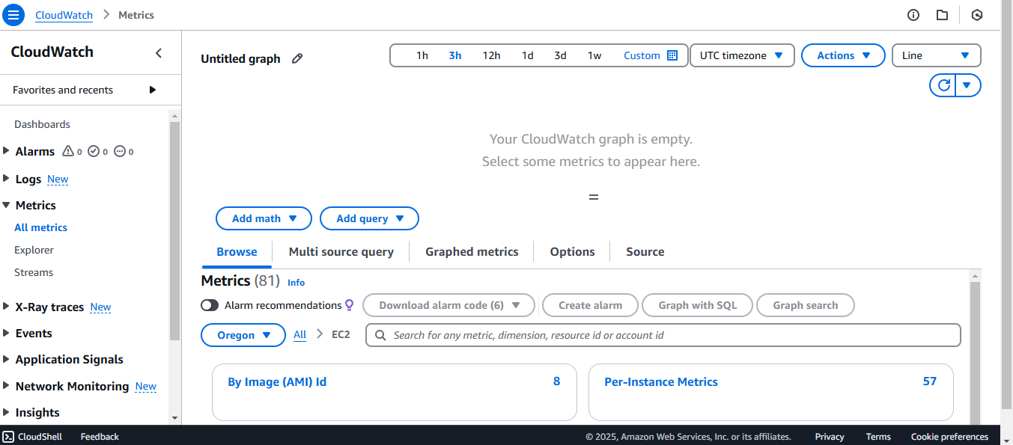

Step 6:

Select metrics like:

CPUUtilization (CPU usage in percentage).

DiskReadBytes and DiskWriteBytes (disk I/O activity).

Network In and Network Out (network data transfer).

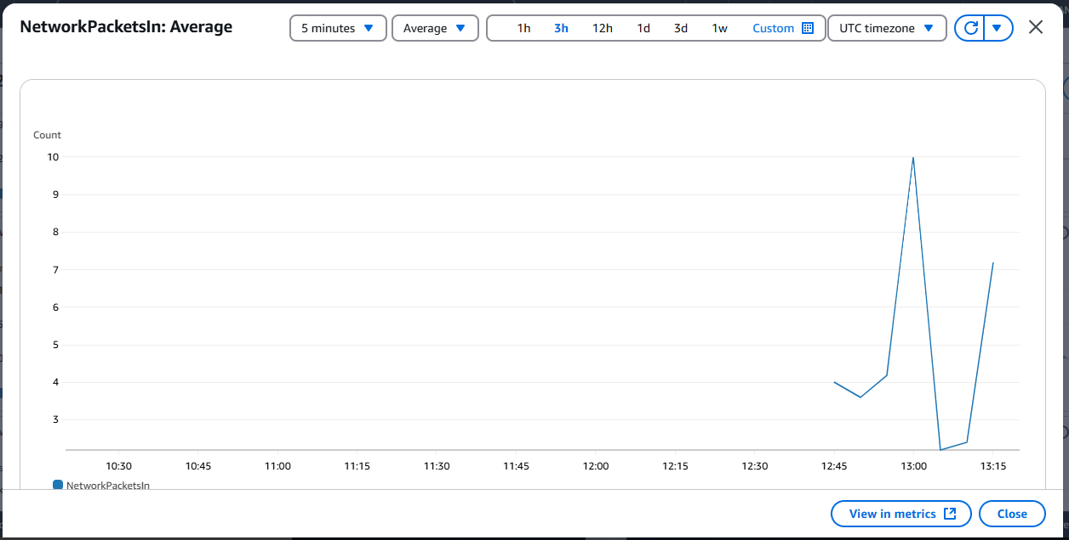

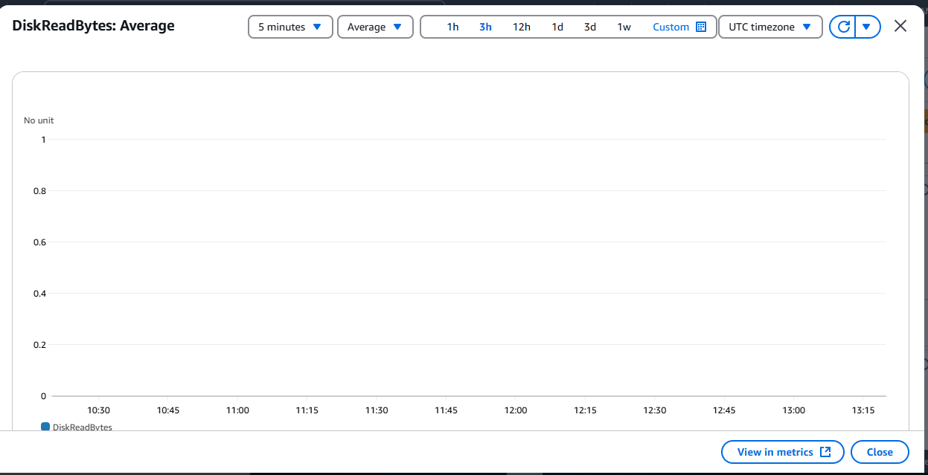

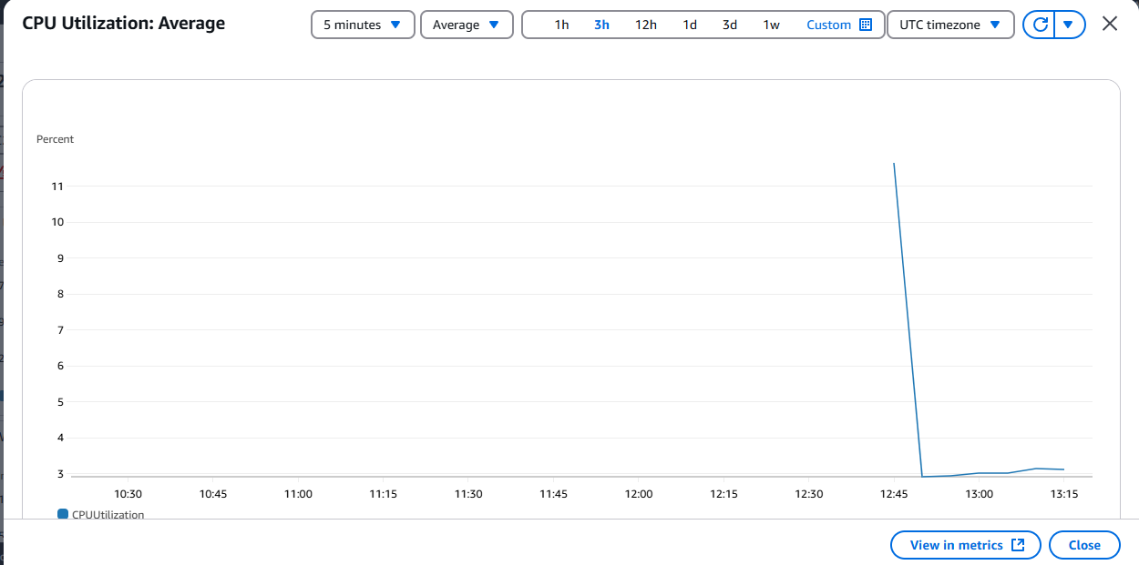

**Expected Outcome**

By completing this POC, you will:

1. Successful setup of AWS CloudWatch to monitor key metrics like CPU usage, disk I/O, and network traffic for an EC2 instance.
2. Creation of a custom CloudWatch dashboard for real-time performance tracking.
3. Improved understanding of cloud monitoring and proactive resource management.