 

**Placement Empowerment Program**

***Cloud Computing and DevOps Centre***

**Set Up a Private Network in the Cloud:**

Create a Virtual Private Cloud (VPC) with subnets for your instances. Configure routing for internal communication between subnets.

Name: Goutham K Department: EEE



**Introduction and Overview**

In AWS, a Virtual Private Cloud (VPC) allows you to launch resources in a virtual network that you define. Setting up a private network within AWS is an essential step to ensure the security and proper segmentation of your cloud infrastructure. This task involves creating a VPC, subnets for your instances, and configuring routing for internal communication between subnets.

**Objectives**

* Set up a Virtual Private Cloud (VPC) in AWS.
* Create public and private subnets within the VPC.
* Configure routing to enable communication between internal subnets.

**Importance**

* **Network Segmentation:** Dividing your network into public and private subnets ensures better security by isolating resources.
* **Traffic Routing:** Configuring routing tables allows traffic to flow between subnets, facilitating communication within your network.
* **Enhanced Security:** By isolating resources in private subnets, you reduce the surface area for potential attacks while maintaining necessary internal communications.
* **Best Practice:** This architecture aligns with best practices for cloud network design, ensuring scalable and secure deployment of resources.

**STEPS:**

**STEP 1: Create a Virtual Private Cloud (VPC)**

* Log in to the AWS Management Console.
* Navigate to the **VPC Dashboard** and click **Create VPC**.
* Configure the following:
* **CIDR Block**: Choose an appropriate CIDR block for your VPC, such as 10.0.0.0/16 .
* **Specify the Subnet CIDR Blocks**: Follow a structured patter to easily add more subnets when needed.

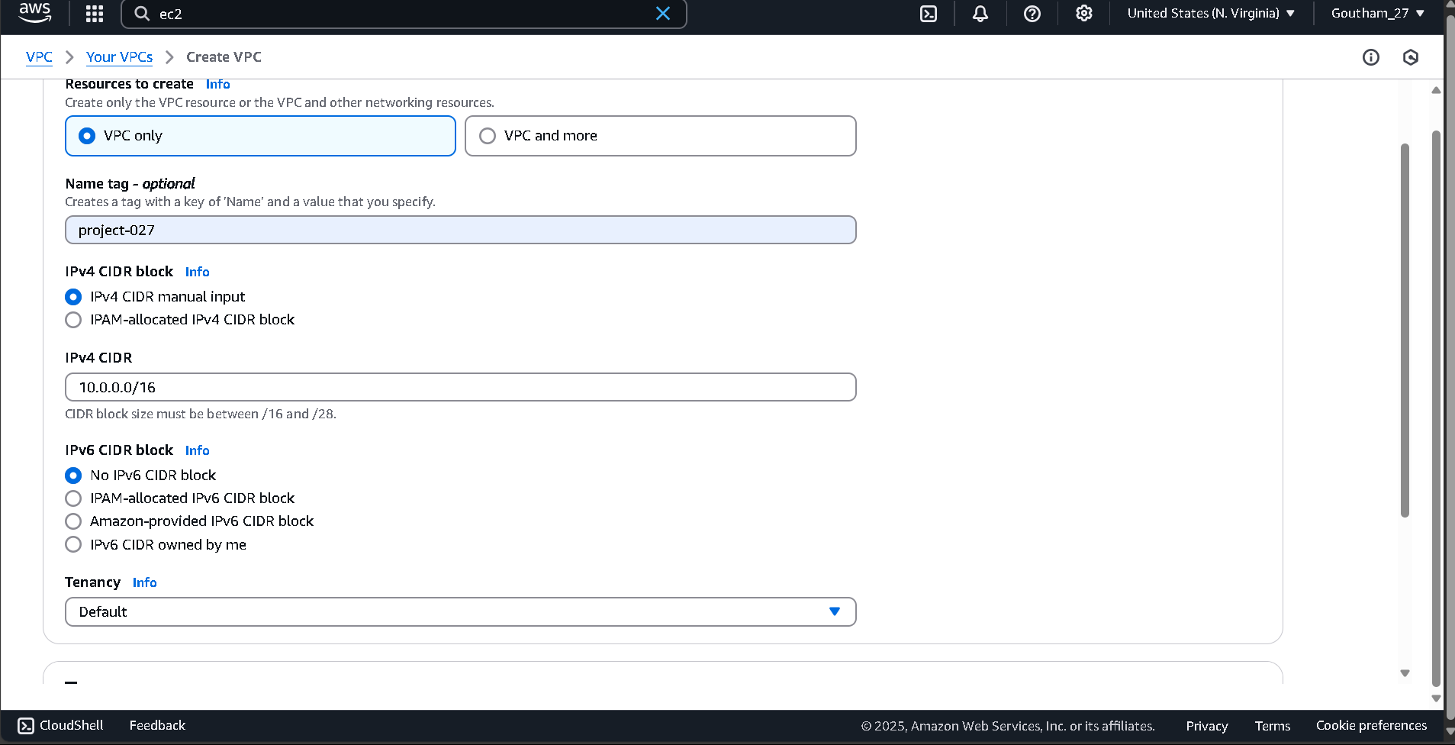

* **DNS Resolution**: Enable if required to ensure instances can resolve domain names.
* **DNS Hostnames**: Enable if required to allow instances to have hostnames.
* Click **Create** to create your VPC.

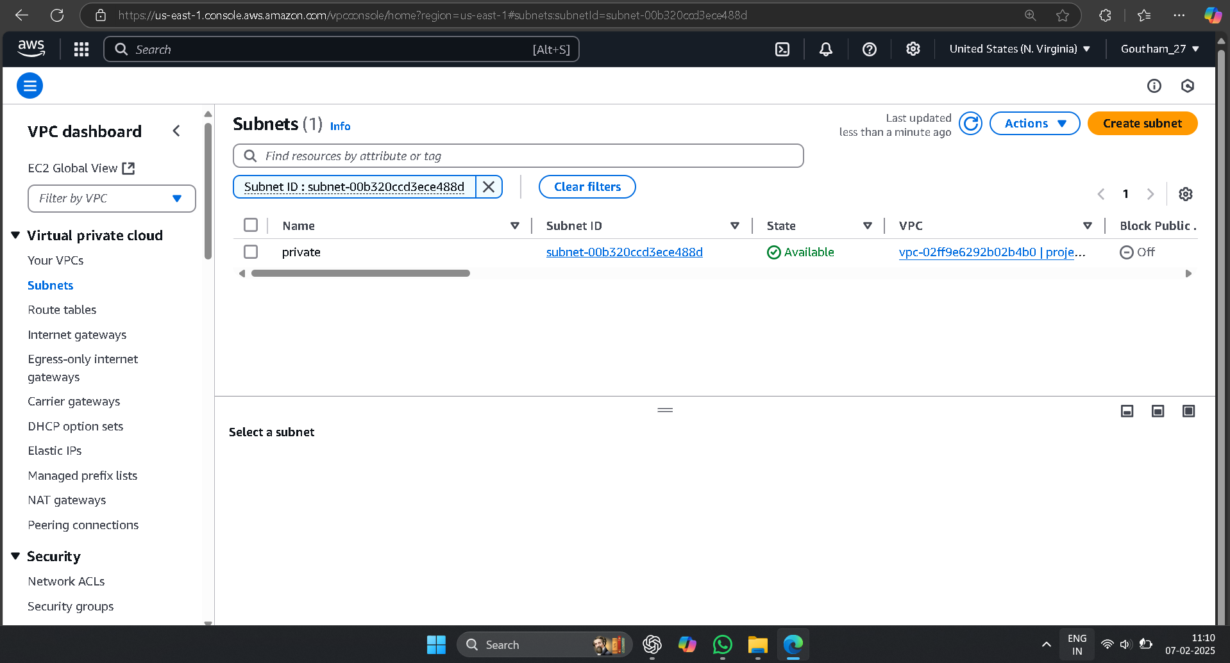**STEP 2: Create Subnets**

* Navigate to the Subnets section under the VPC dashboard and click Create Subnet.

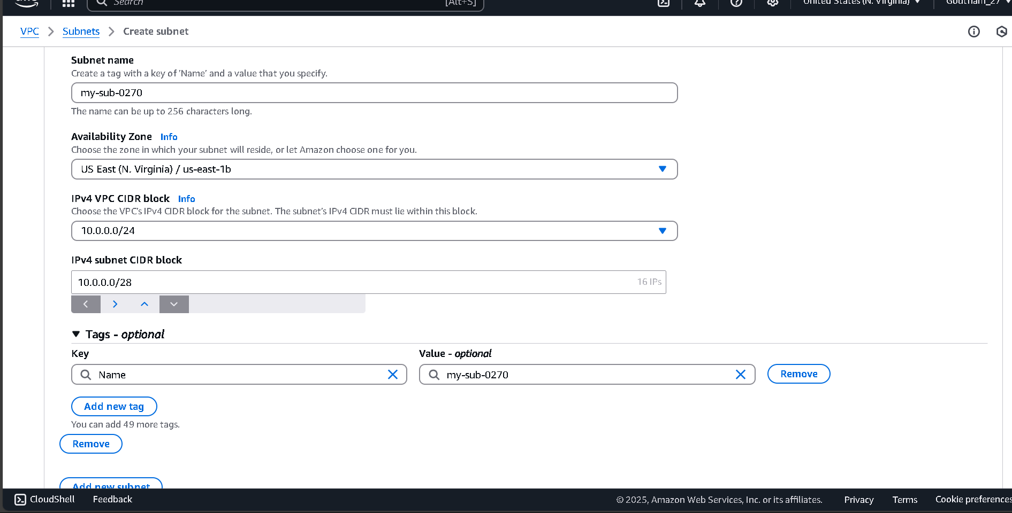

* Create the following private subnets within your VPC:
* Private Subnet 1: CIDR block 10.0.96.0/20 in us-east-1c.
* Private Subnet 2: CIDR block 10.0.112.0/20 in us-east-1c.

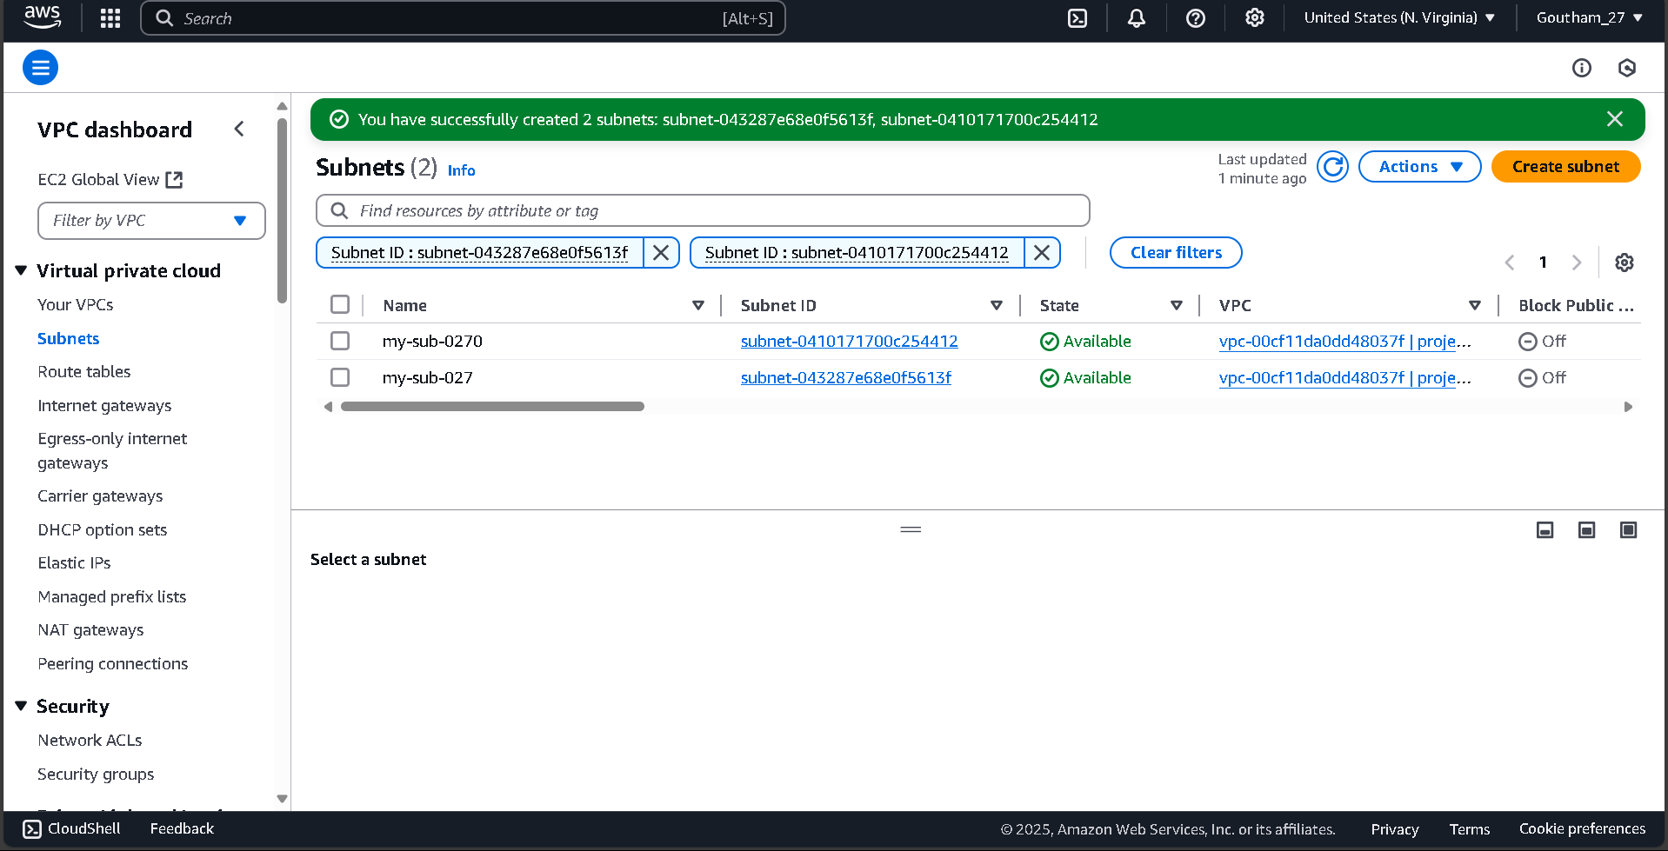

These two private subnets are specifically created for internal communication between instances in these subnets.

**STEP 3: Create Route Table for Internal Routing**

* Go to the Route Tables section of the VPC dashboard and click Create Route Table.

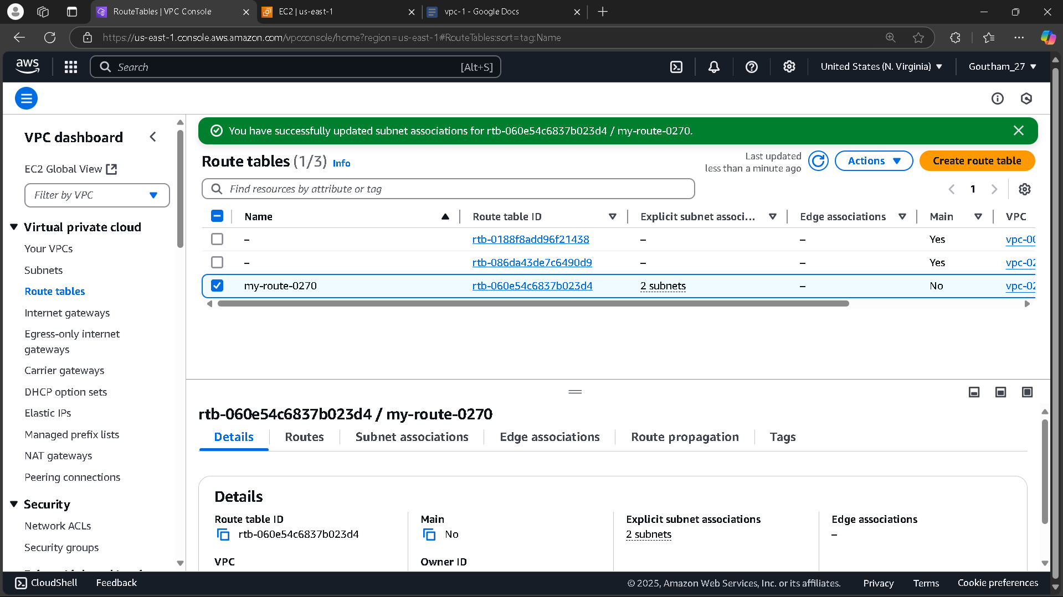

* Name the route table, for example, "Internal-Route-Table" to distinguish it from any public routing tables you might create.

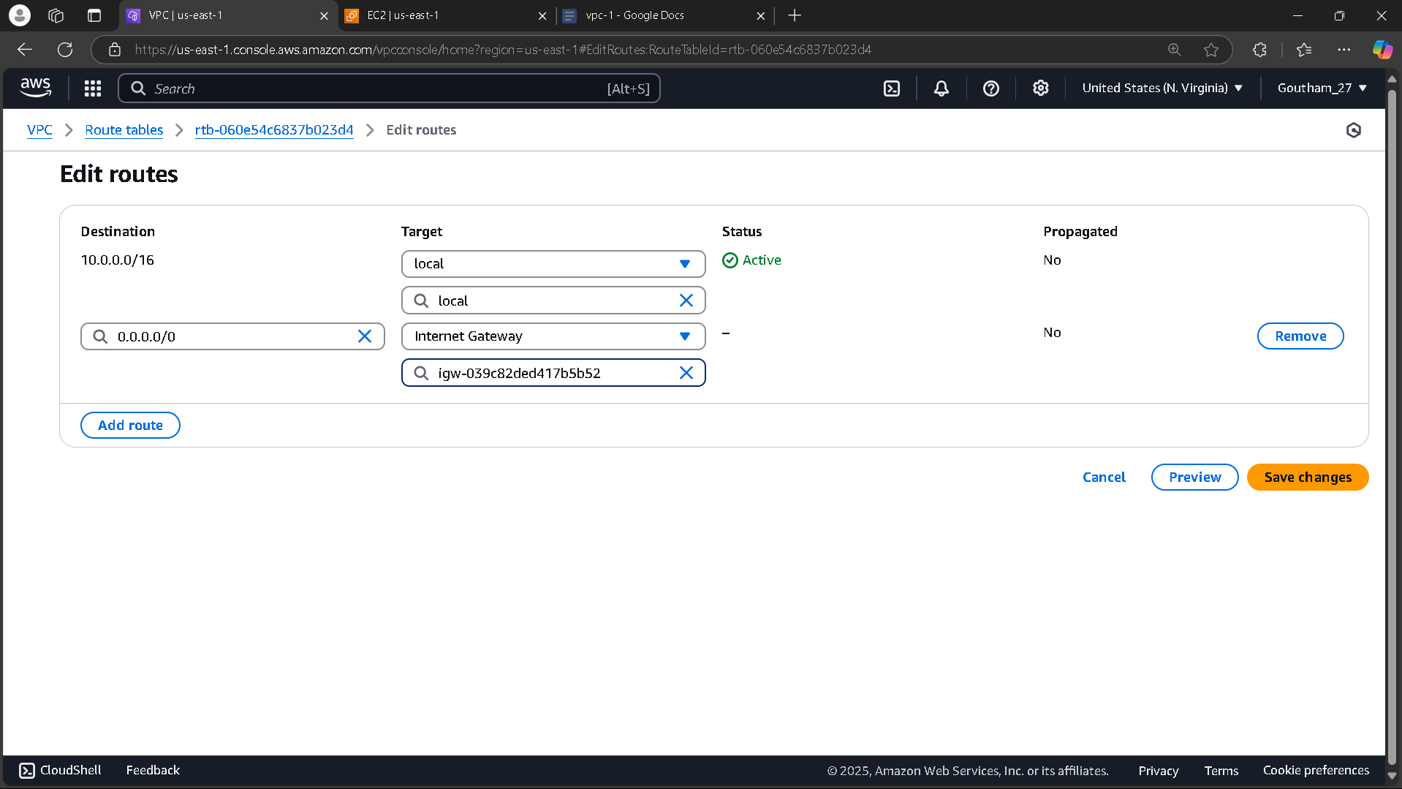

* Under the Routes tab, ensure that the route table has only internal routes, meaning no routes to the internet (this is critical for keeping the subnets private).
* Click Create to create the route table.

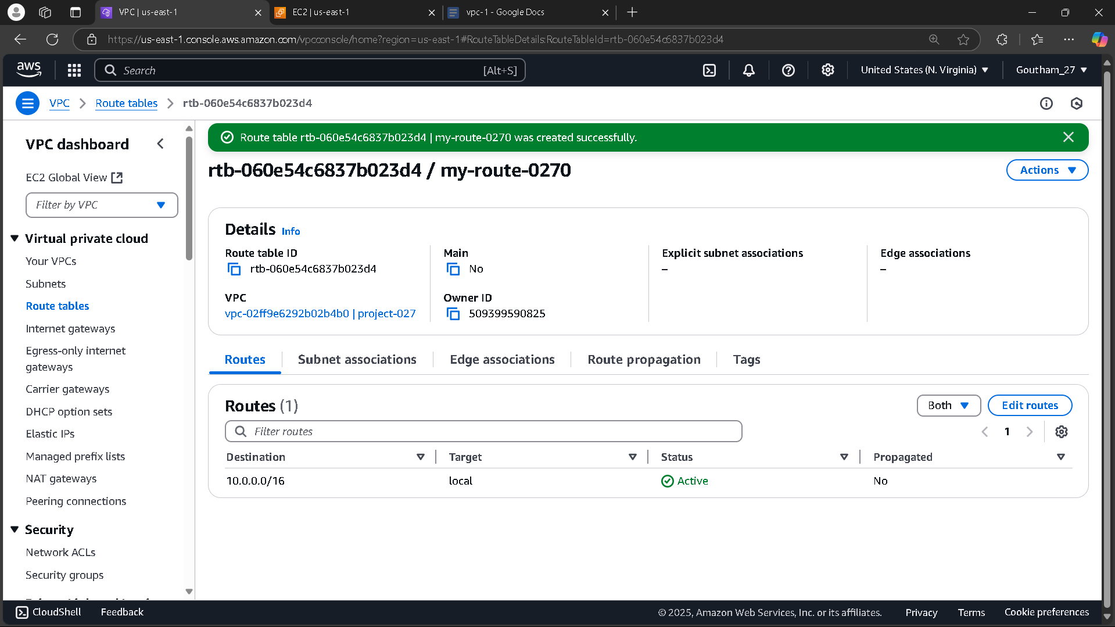

**STEP 4: Associate Subnets with the Route Table**

* Navigate to the Subnet Associations tab of the newly created route table.
* Click Edit Subnet Associations and select the two private subnets created in Step 2 (10.0.96.0/20 and 10.0.112.0/20).

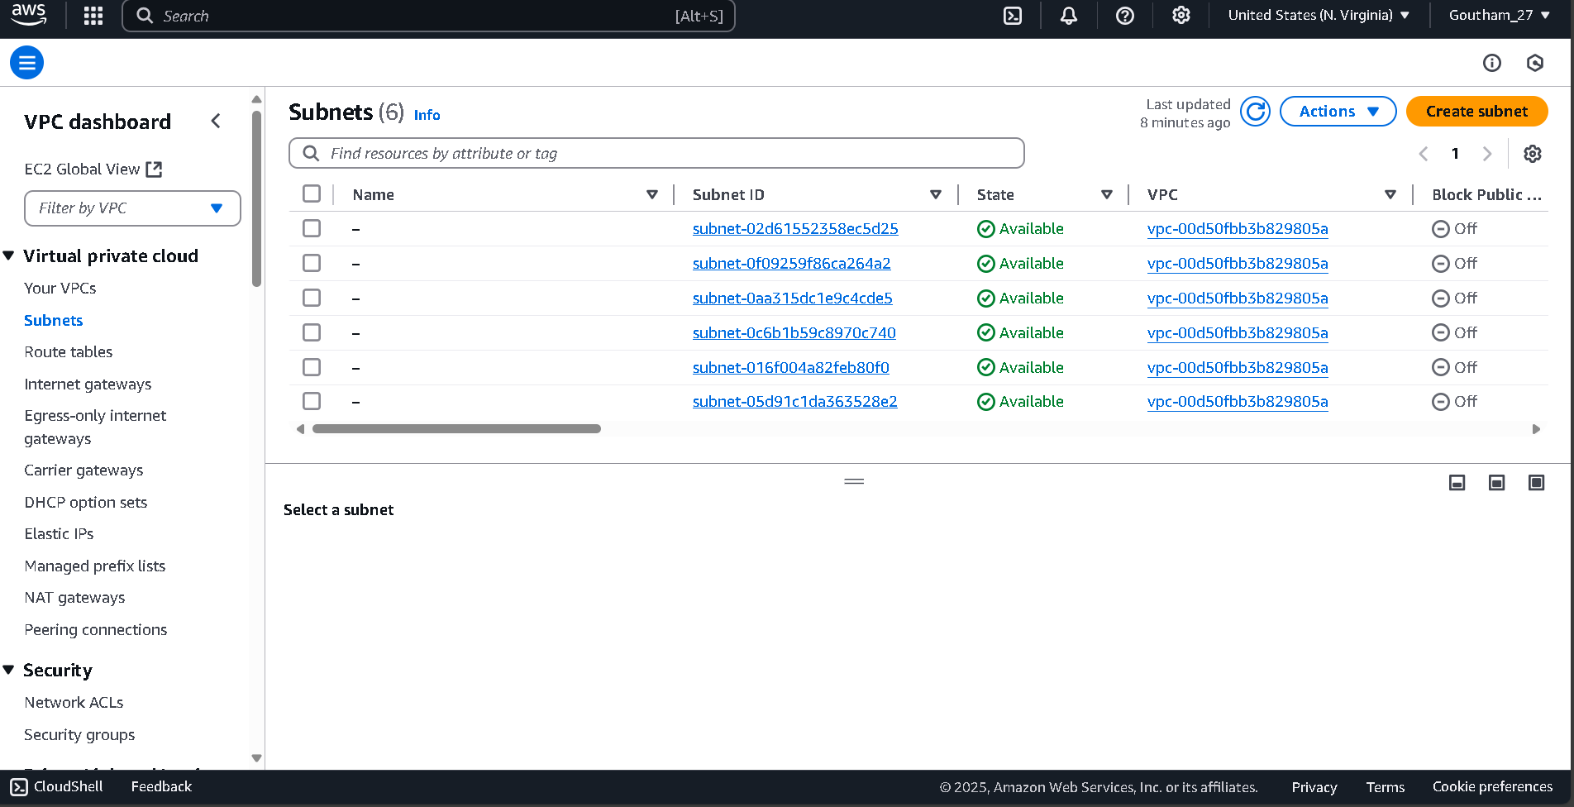

* Click Save to apply the route table to the private subnets. This ensures that traffic between these subnets is routed internally within the VPC**.**