**Exercise 1: Control Structures**

**Scenario 1:** The bank wants to apply a discount to loan interest rates for customers above 60 years old.

* + **Question:** Write a PL/SQL block that loops through all customers, checks their age, and if they are above 60, apply a 1% discount to their current loan interest rates.

**Scenario 2:** A customer can be promoted to VIP status based on their balance.

* + **Question:** Write a PL/SQL block that iterates through all customers and sets a flag IsVIP to TRUE for those with a balance over $10,000.

**Scenario 3:** The bank wants to send reminders to customers whose loans are due within the next 30 days.

* + **Question:** Write a PL/SQL block that fetches all loans due in the next 30 days and prints a reminder message for each customer.

**Scenario 1:**

DECLARE

CURSOR loan_cur IS

SELECT l.LoanID, l.InterestRate, c.DOB, c.Name

FROM Loans l

JOIN Customers c ON l.CustomerID = c.CustomerID;

v_age NUMBER;

BEGIN

FOR loan_rec IN loan_cur LOOP

v_age := FLOOR(MONTHS_BETWEEN(SYSDATE, loan_rec.DOB)/12);

IF v_age > 60 THEN

UPDATE Loans

SET InterestRate = InterestRate - 1

WHERE LoanID = loan_rec.LoanID;

DBMS_OUTPUT.PUT_LINE('Applied discount to ' || loan_rec.Name ||

'''s loan: ' || loan_rec.InterestRate ||

'% -> ' || (loan_rec.InterestRate - 1) || '%');

END IF;

END LOOP;

COMMIT;

END;

/

OUTPUT:

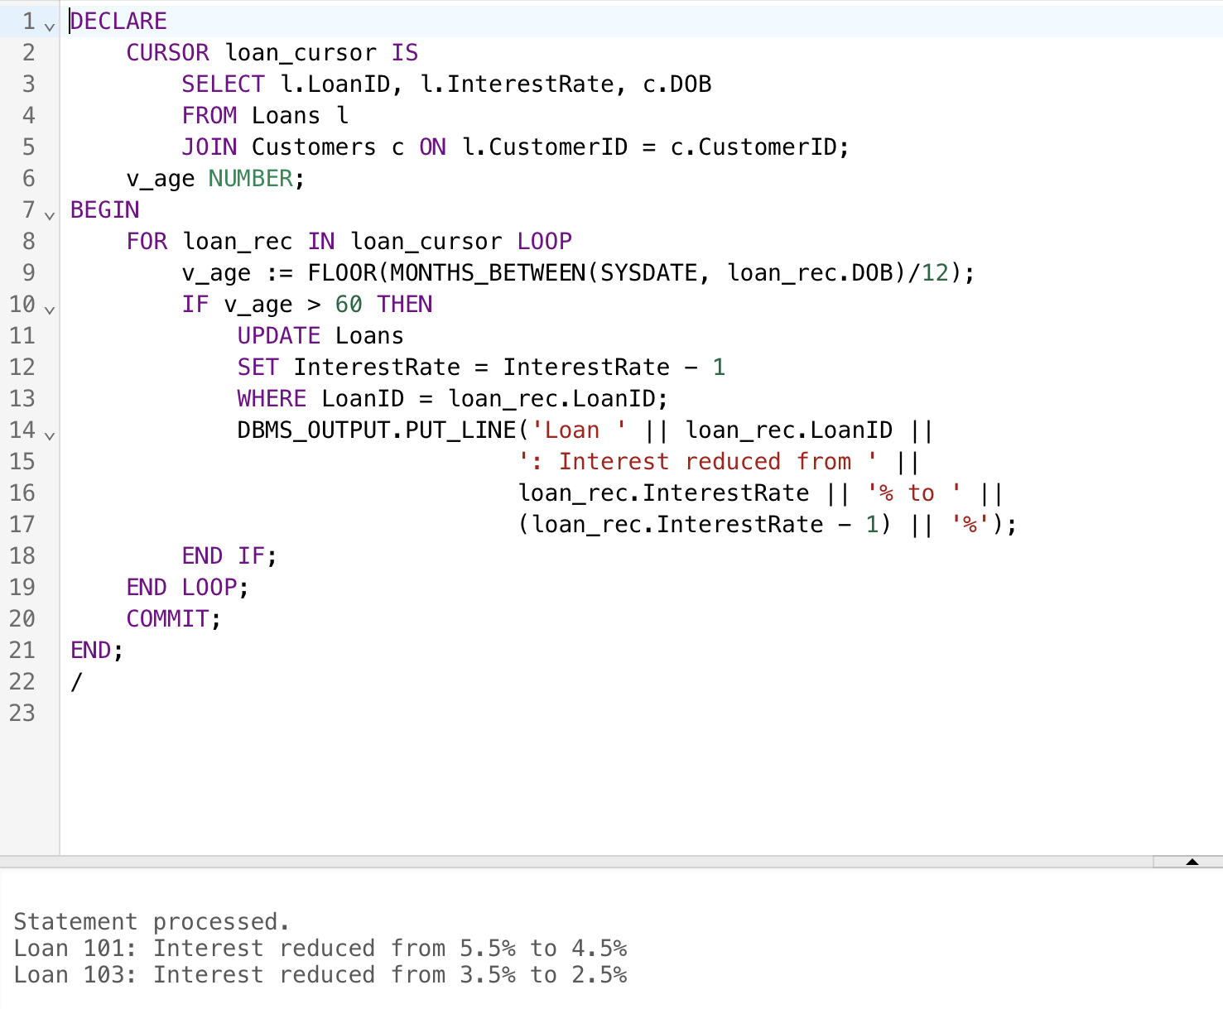

**Scenario 2:**

ALTER TABLE Customers ADD IsVIP VARCHAR2(5) DEFAULT 'FALSE';

BEGIN

FOR cust_rec IN (SELECT CustomerID, Name, Balance FROM Customers)

LOOP

IF cust_rec.Balance > 10000 THEN

UPDATE Customers

SET IsVIP = 'TRUE'

WHERE CustomerID = cust_rec.CustomerID;

DBMS_OUTPUT.PUT_LINE('VIP Status: ' || cust_rec.Name ||

' (Balance: $' || cust_rec.Balance || ')');

END IF;

END LOOP;

COMMIT;

END;

/

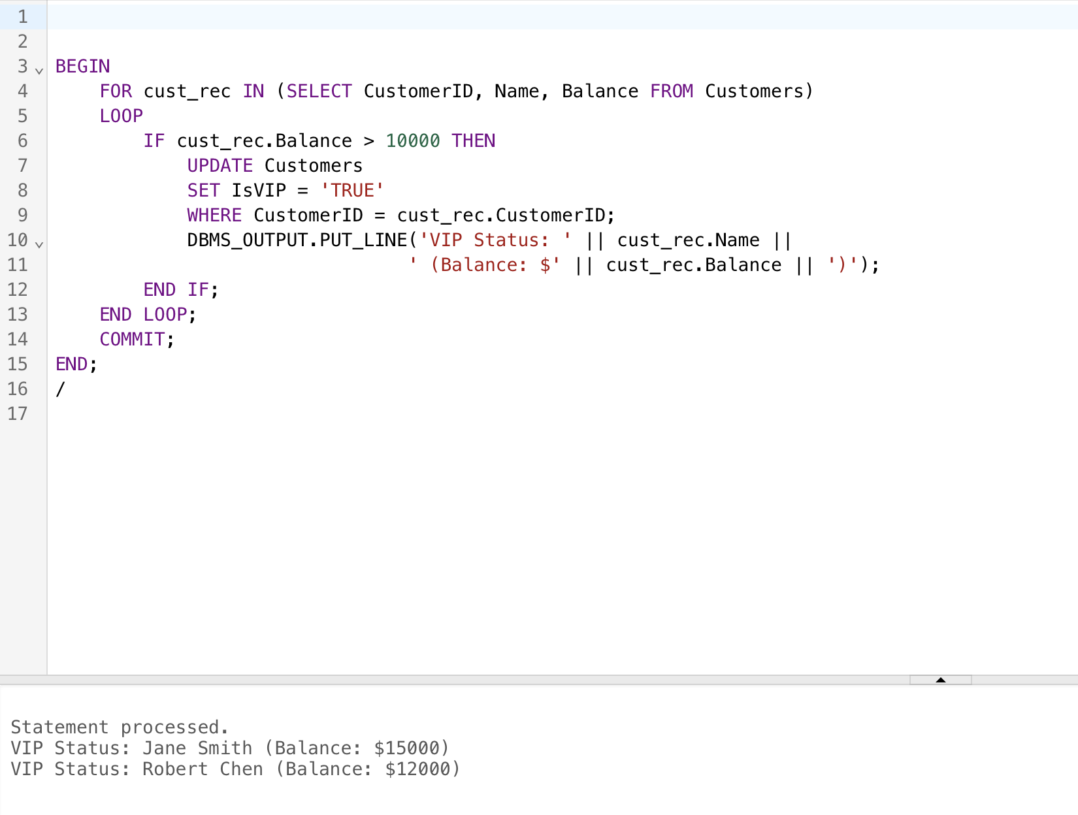

**Scenario 3:**

DECLARE

CURSOR loan_due IS

SELECT l.LoanID, c.Name, l.EndDate

FROM Loans l

JOIN Customers c ON l.CustomerID = c.CustomerID

WHERE l.EndDate BETWEEN SYSDATE AND SYSDATE + 30;

BEGIN

FOR rec IN loan_due LOOP

DBMS_OUTPUT.PUT_LINE('Reminder: ' || rec.Name ||

', Loan #' || rec.LoanID ||

' due on ' || TO_CHAR(rec.EndDate, 'YYYY-MM-DD'));

END LOOP;

END;

/

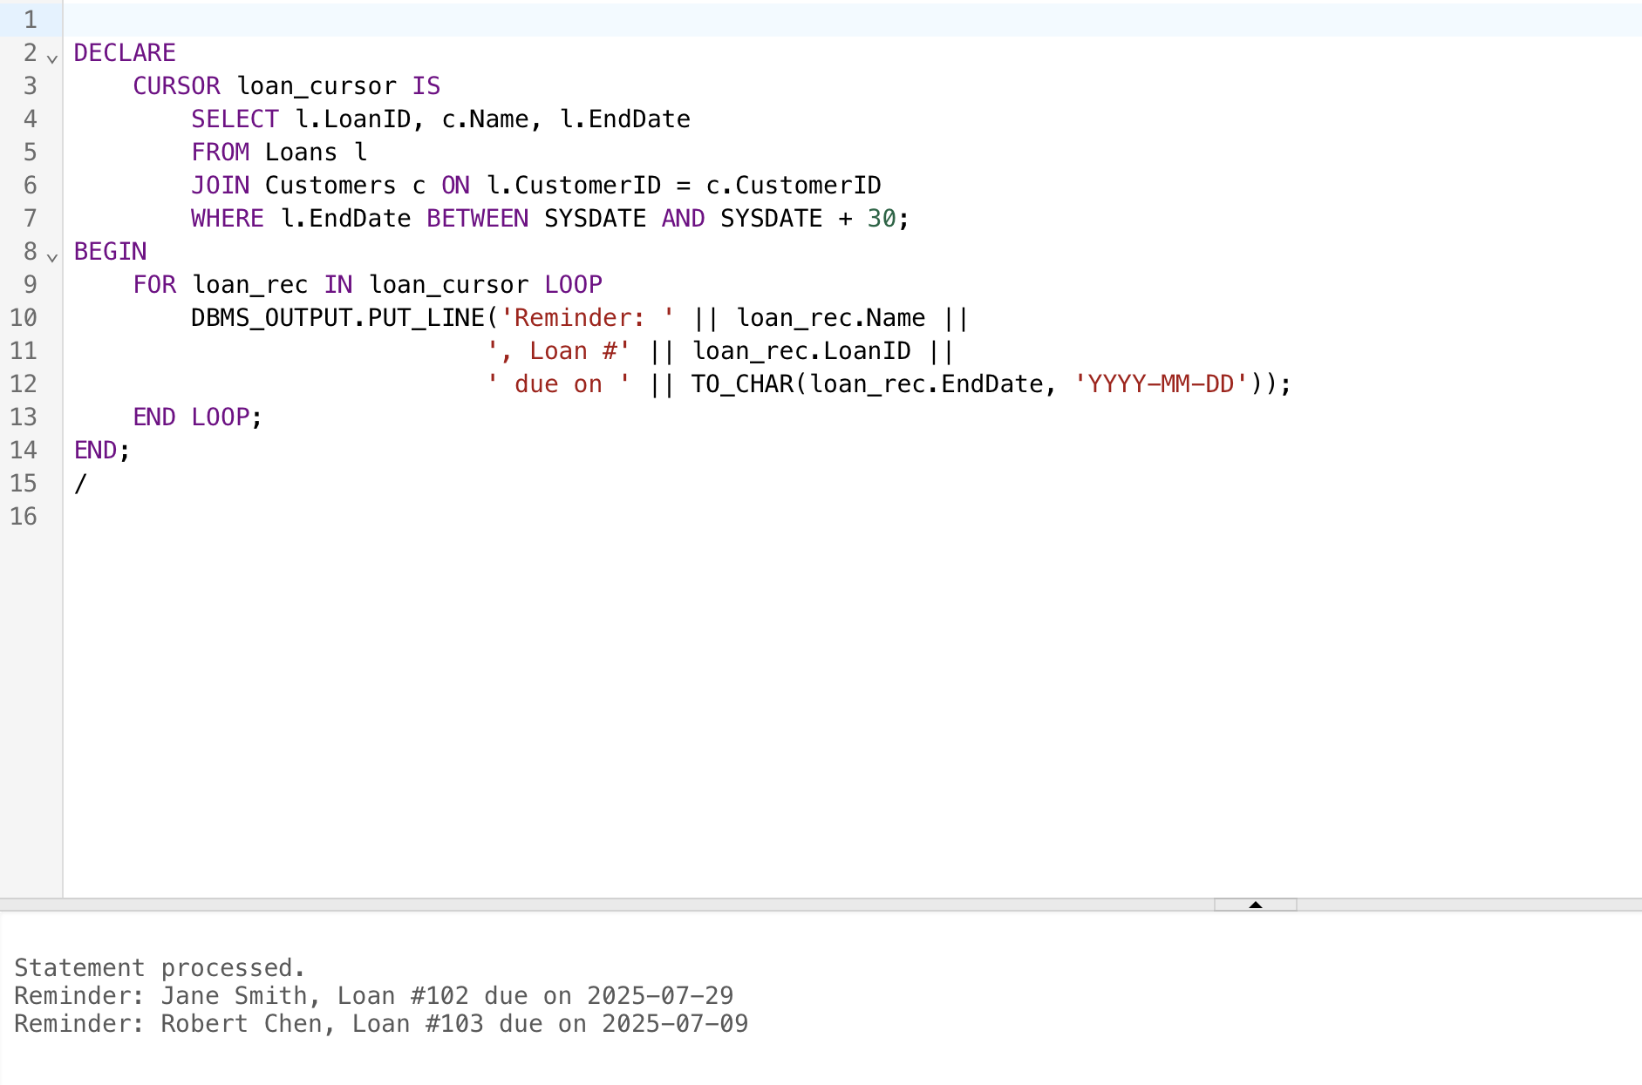

**Exercise 3: Stored Procedures**

**Scenario 1:** The bank needs to process monthly interest for all savings accounts.

* + **Question:** Write a stored procedure **ProcessMonthlyInterest** that calculates and updates the balance of all savings accounts by applying an interest rate of 1% to the current balance.

**Scenario 2:** The bank wants to implement a bonus scheme for employees based on their performance.

* + **Question:** Write a stored procedure **UpdateEmployeeBonus** that updates the salary of employees in a given department by adding a bonus percentage passed as a parameter.

**Scenario 3:** Customers should be able to transfer funds between their accounts.

* + **Question:** Write a stored procedure **TransferFunds** that transfers a specified amount from one account to another, checking that the source account has sufficient balance before making the transfer.

*-- Exercise 3: Stored Procedures*

*-- Scenario 1: Monthly Interest*

CREATE OR REPLACE PROCEDURE ProcessMonthlyInterest AS

BEGIN

UPDATE Accounts

SET Balance = ROUND(Balance * 1.01, 2)

WHERE AccountType = 'Savings';

DBMS_OUTPUT.PUT_LINE('Applied 1% interest to savings accounts');

COMMIT;

END;

/

*-- Scenario 2: Employee Bonus*

CREATE OR REPLACE PROCEDURE UpdateEmployeeBonus(

p_dept VARCHAR2,

p_bonus_percent NUMBER

) AS

BEGIN

UPDATE Employees

SET Salary = Salary * (1 + p_bonus_percent/100)

WHERE Department = p_dept;

DBMS_OUTPUT.PUT_LINE(p_bonus_percent || '% bonus applied to ' || p_dept || ' department');

COMMIT;

END;

/

*-- Scenario 3: Fund Transfer*

CREATE OR REPLACE PROCEDURE TransferFunds(

p_from_acc NUMBER,

p_to_acc NUMBER,

p_amount NUMBER

) AS

v_balance NUMBER;

v_from_exists NUMBER;

v_to_exists NUMBER;

BEGIN

SELECT COUNT(*) INTO v_from_exists FROM Accounts WHERE AccountID = p_from_acc;

SELECT COUNT(*) INTO v_to_exists FROM Accounts WHERE AccountID = p_to_acc;

IF v_from_exists = 0 THEN

RAISE_APPLICATION_ERROR(-20002, 'Source account does not exist');

ELSIF v_to_exists = 0 THEN

RAISE_APPLICATION_ERROR(-20003, 'Target account does not exist');

END IF;

SELECT Balance INTO v_balance

FROM Accounts

WHERE AccountID = p_from_acc;

IF v_balance < p_amount THEN

RAISE_APPLICATION_ERROR(-20001, 'Insufficient funds');

END IF;

UPDATE Accounts SET Balance = Balance - p_amount

WHERE AccountID = p_from_acc;

UPDATE Accounts SET Balance = Balance + p_amount

WHERE AccountID = p_to_acc;

DBMS_OUTPUT.PUT_LINE('Transferred $' || p_amount || ' from account ' ||

p_from_acc || ' to ' || p_to_acc);

COMMIT;

END;

/

*-- Test Execution*

SET SERVEROUTPUT ON;

*-- Test Exercise 1 Outputs*

BEGIN

DBMS_OUTPUT.PUT_LINE('--- Exercise 1 Outputs ---');

END;

/

*-- Test Exercise 3 Procedures*

BEGIN

DBMS_OUTPUT.PUT_LINE('--- Testing ProcessMonthlyInterest ---');

ProcessMonthlyInterest();

FOR acc IN (SELECT * FROM Accounts WHERE AccountType = 'Savings')

LOOP

DBMS_OUTPUT.PUT_LINE('Account ' || acc.AccountID || ': $' || acc.Balance);

END LOOP;

DBMS_OUTPUT.PUT_LINE('--- Testing UpdateEmployeeBonus ---');

UpdateEmployeeBonus('HR', 10);

FOR emp IN (SELECT * FROM Employees WHERE Department = 'HR')

LOOP

DBMS_OUTPUT.PUT_LINE(emp.Name || ': $' || emp.Salary);

END LOOP;

DBMS_OUTPUT.PUT_LINE('--- Testing TransferFunds ---');

DBMS_OUTPUT.PUT_LINE('Before transfer:');

DBMS_OUTPUT.PUT_LINE('Account 1001: $' || (SELECT Balance FROM Accounts WHERE AccountID = 1001));

DBMS_OUTPUT.PUT_LINE('Account 1002: $' || (SELECT Balance FROM Accounts WHERE AccountID = 1002));

TransferFunds(1001, 1002, 500);

DBMS_OUTPUT.PUT_LINE('After transfer:');

DBMS_OUTPUT.PUT_LINE('Account 1001: $' || (SELECT Balance FROM Accounts WHERE AccountID = 1001));

DBMS_OUTPUT.PUT_LINE('Account 1002: $' || (SELECT Balance FROM Accounts WHERE AccountID = 1002));

END;

/

OUTPUT:

