NAME: ADEPU GOUTHAM SRI BHARGAV
ID NO: 2403A510C4
BATCH: 05

Q1: E-Commerce Sector – Web Frontend Development
Scenario: In the E-commerce sector, a company faces a challenge related to web frontend development.
Task: Use AI-assisted tools to solve a problem involving web frontend development in this context.
Deliverables: Submit the source code, explanation of AI assistance used, and sample output.

Prompt Used
Create a modern, responsive, and visually appealing product price calculator webpage for an e-commerce company using HTML, CSS, and JavaScript.

Source Code
<!-- ecommerce_calculator.html -->
<!DOCTYPE html>
<html lang="en">
<head>
<meta charset="UTF-8">
<meta name="viewport" content="width=device-width, initial-scale=1.0">
<title>SmartCart - Price Calculator</title>
<style> body {
font-family: 'Poppins', sans-serif;
background: linear-gradient(135deg, #f6d365, #fda085); display: flex;
align-items: center; justify-content: center; height: 100vh;
margin: 0;
}
.card { background: #fff; padding: 30px;
border-radius: 16px;
box-shadow: 0 8px 20px rgba(0, 0, 0, 0.2); text-align: center;

width: 350px;
animation: fadeIn 0.8s ease;
}
h2 { color: #ff6600; } select, input, button {
width: 100%; padding: 12px; margin-top: 10px;
border: 1px solid #ccc; border-radius: 8px; font-size: 15px;
}
button {
background: #ff6600; color: white;
font-weight: bold; cursor: pointer; border: none; transition: 0.3s ease;
}
button:hover { background: #cc5200; transform: scale(1.05);
}
#result {
margin-top: 20px; font-weight: bold; font-size: 18px; color: #333;
}
@keyframes fadeIn {
from { opacity: 0; transform: translateY(20px); } to { opacity: 1; transform: translateY(0); }
}
</style>
</head>
<body>
<div class="card">
<h2>🛒 SmartCart</h2>
<label for="product">Select Product:</label>
<select id="product">
<option value="1000">Smartphone - ₹1000</option>
<option value="1500">Headphones - ₹1500</option>
<option value="2000">Smartwatch - ₹2000</option>

</select>

<label for="quantity">Enter Quantity:</label>
<input type="number" id="quantity" min="1" placeholder="Enter quantity">

<button onclick="calculateTotal()">Calculate Total</button>
<div id="result"></div>
</div>

<script>
function calculateTotal() {
const price = parseInt(document.getElementById("product").value); const quantity =
parseInt(document.getElementById("quantity").value);

if (!quantity || quantity <= 0) { alert("Please enter a valid quantity!"); return;
}

const total = price * quantity; document.getElementById("result").innerText = `Total Price:
₹${total}`;
}
</script>
</body>
</html>

AI Assistance Used
AI (ChatGPT GPT-5) was used to design the webpage structure, improve UI aesthetics using CSS, and optimize JavaScript functionality for real-time calculations.

Sample Output
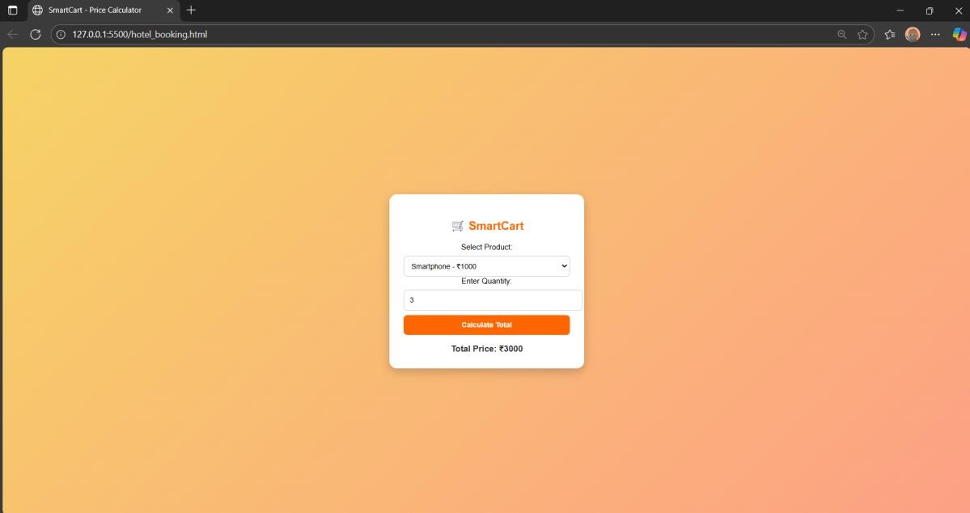
Example Interaction:

- Product: Smartwatch (₹2000)
- Quantity: 3
Output:

Total Price: ₹6000

Observation:
The webpage dynamically calculates total price, has a modern UI, and demonstrates AI-assisted frontend design for e-commerce applications.

Q2: Agriculture Sector – Data Structures with AI
Scenario: In the Agriculture sector, a company faces a challenge related to data structures with AI.
Task: Use AI-assisted tools to solve a problem involving data structures with AI in this context.
Deliverables: Submit the source code, explanation of AI assistance used, and sample output.

Prompt Used
Write a Python program using data structures (dictionary and lists) and AI logic to analyze crop yields, calculate average yield, and recommend the best performing crop.

Source Code

def analyze_crop_yields(crop_data): avg_yields = {}
for crop, yields in crop_data.items(): avg_yields[crop] = sum(yields) / len(yields)
best_crop = max(avg_yields, key=avg_yields.get) print("\n=== Crop Yield Analysis ===")
for crop, avg in avg_yields.items():
print(f"{crop}: Average Yield = {avg:.2f} tons/hectare") print(f"\n🌾 Recommended Crop: {best_crop} (Highest Avg Yield:
{avg_yields[best_crop]:.2f})") return best_crop

def ai_decision_support(best_crop): suggestions = {
"Rice": "Best for high rainfall areas.", "Wheat": "Ideal for dry, cool climates.", "Maize": "Grows best in moderate climate.",
"Sugarcane": "Requires warm weather and irrigation."
}
return suggestions.get(best_crop, "No suggestion available.")

if name == " main ": crop_data = {
"Rice": [4.5, 4.8, 5.0, 4.9],
"Wheat": [3.2, 3.4, 3.6, 3.5],
"Maize": [5.5, 5.7, 5.8, 5.9],
"Sugarcane": [4.2, 4.4, 4.3, 4.5]
}
best_crop = analyze_crop_yields(crop_data)
print(f"🤖 AI Suggestion: {ai_decision_support(best_crop)}")
AI Assistance Used
AI (ChatGPT GPT-5) helped in designing the logic, improving readability, and adding contextual recommendations for crops based on calculated yield.

Sample Output
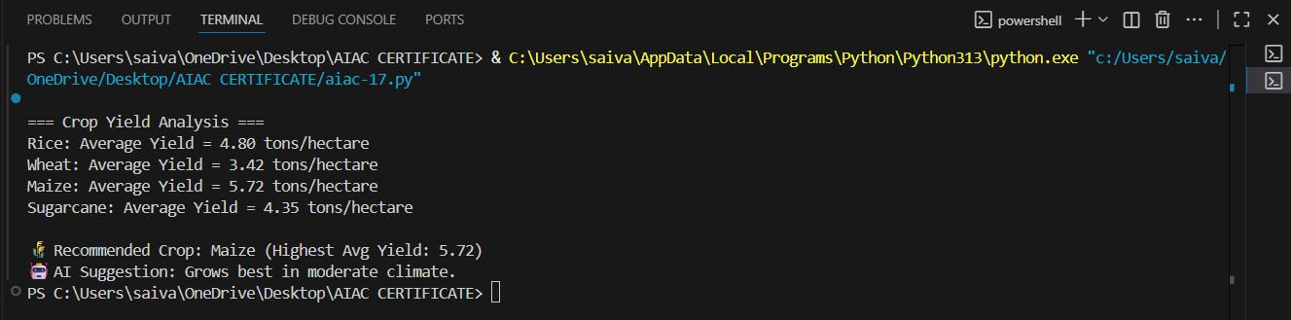

Observation
The program demonstrates how data structures and AI logic can enhance agricultural decision-making based on performance analysis.

