AI Assisted coding
Lab Test - 1
Name: Adepu Goutham Sri Bhargav Id: 2403A510C4
Batch: 05 Date: 01-09-2025
Q1. Zero-shot Classification [5M]
• Scenario: Classify tweets into “Positive,” “Negative,” or “Neutral.”
• Task 1: Write a zero-shot prompt to classify sentiment without any examples.
• Task 2: Create a scenario where an AI assistant needs to help a student solve math problems.
Task - 1:
Prompt:
“Classify the following tweet as “Positive,” “Negative,” or “Neutral” based on its sentiment using a python Code.”
Tweet: "I just got a new job and I’m so excited!"”
Code Generated:
def classify_tweet_sentiment(tweet):
positive_words = ["excited", "happy", "love", "great", "good", "cool", "amazing", "wonderful", "joy", "awesome", "fantastic", "best", "success"]
negative_words = ["sad", "angry", "bad", "hate", "terrible", "upset", "disappointed", "worst", "fail", "awful", "horrible", "problem"]

tweet_lower = tweet.lower()

if any(word in tweet_lower for word in positive_words):
return "Positive"
elif any(word in tweet_lower for word in negative_words):
return "Negative"
else:
return "Neutral"

tweet = input("Enter a tweet to classify its sentiment: ")
sentiment = classify_tweet_sentiment(tweet)
print(f'Tweet: "{tweet}"\nSentiment: {sentiment}')

Code Image:
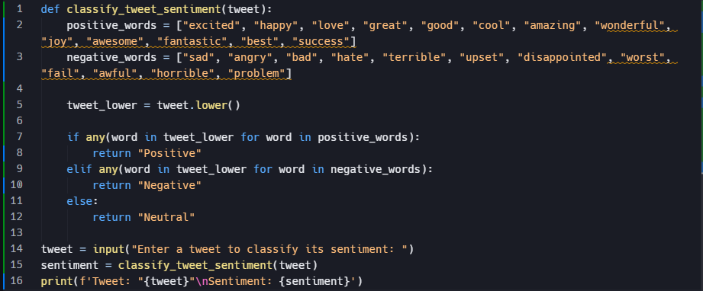

Output:
- Positive tweet
- Negative tweet
- Neutral tweet

Observation:
- The program attempts by checking for keywords related to positive and negative emotions.
- For the input tweet: "I just got a new job and I’m so excited!"
- the algorithm finds the word “excited” in the positive word list.
- Since positive words are detected and no negative words appear, the classifier correctly predicts: Positive
Task – 2:
Prompt Without Context:
“Help the student solve the following math problem:
"What is 7 multiplied by 8?" using c programming language”
Code Generated:
#include <stdio.h>
int main() {
int a, b, result;
printf("Enter the first number: ");
scanf("%d", &a);
printf("Enter the second number: ");
scanf("%d", &b);
result = a * b;
printf("What is %d multiplied by %d?\n", a, b);
printf("Answer: %d\n", result);
return 0;
}
Code Image:
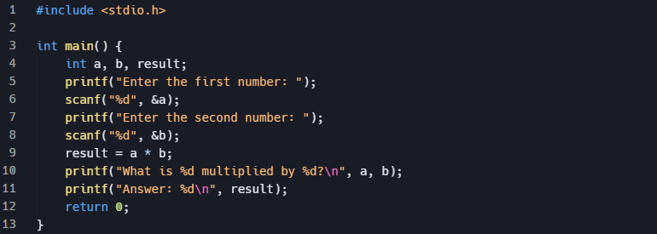

Output:
Prompt With detailed Context:
“You are an AI assistant helping a 6th-grade student with math homework. The topic is multiplication, and the difficulty level is basic.”
Code Generated:
#include <stdio.h>

int main() {
int a = 7, b = 8, result;
printf("You are a 6th-grade student learning multiplication.\n");
printf("Let's solve: What is %d multiplied by %d?\n\n", a, b);
printf("Step 1: Write the numbers: %d and %d.\n", a, b);
printf("Step 2: Multiply them together.\n");
printf("%d x %d = ", a, b);
result = a * b;
printf("%d\n", result);
printf("So, %d multiplied by %d equals %d.\n", a, b, result);
printf("Multiplication means adding %d eight times: ", a);
for(int i = 1; i <= b; i++) {
printf("%d", a);
if(i < b) printf(" + ");
}
printf(" = %d\n", result);
printf("Great job!\n");
return 0;
}

Code Image:
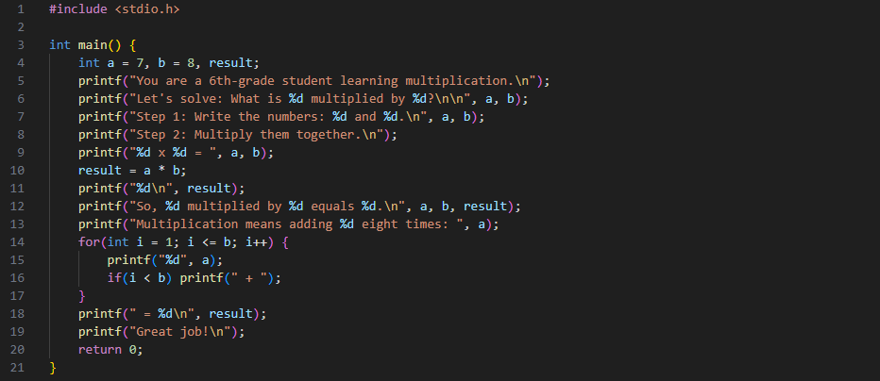

Output:
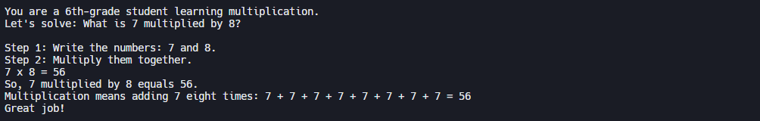

Observation:
The code solves 7 x 8 step by step and gives the correct final answer 56.

Task – 2:
Q2. One-shot vs Few-shot [5M]
Task 1: Write:
o A one-shot prompt (give 1 example of classification).
o A few-shot prompt (give 3–4 examples).
Task 2: Compare outputs on the same set of tweets and explain the difference.

One-shot Prompt:
“Classify the following tweet as “Positive,” “Negative,” or “Neutral.”
Example:
Tweet: "I love sunny days!"
Sentiment: Positive
Now classify this tweet:
Tweet: "I just got a new job and I’m so excited!"”
Code Generated:
def classify_tweet(tweet):
# One-shot example
example_tweet = "I love sunny days!"
example_sentiment = "Positive"

# Basic keyword-based classification
positive_words = ["excited", "happy", "love", "great", "good", "amazing", "wonderful", "joy", "awesome", "fantastic", "best", "success"]
negative_words = ["sad", "angry", "bad", "hate", "terrible", "upset", "disappointed", "worst", "fail", "awful", "horrible", "problem"]

tweet_lower = tweet.lower()
if any(word in tweet_lower for word in positive_words):
return "Positive"
elif any(word in tweet_lower for word in negative_words):
return "Negative"
else:
return "Neutral"

# Example from prompt
print('Tweet: "I love sunny days!"')
print('Sentiment:', "Positive")

# Now classify the new tweet
tweet = "I just got a new job and I’m so excited!"
print(f'Tweet: "{tweet}"')
print('Sentiment:', classify_tweet(tweet))

Code Image:
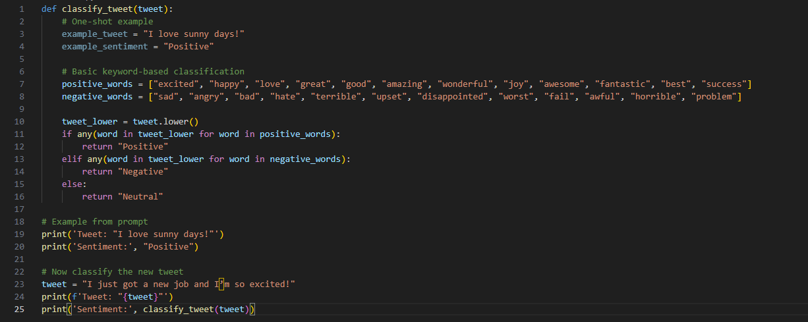
Output:
Few-shot prompt:
“Classify the following tweets as “Positive,” “Negative,” or “Neutral.”
Examples:
Tweet: "I love sunny days!"
Sentiment: Positive
Tweet: "I am feeling very sad today."
Sentiment: Negative
Tweet: "It might rain later."
Sentiment: Neutral
Tweet: "The food was terrible."
Sentiment: Negative
Now classify this tweet:
Tweet: "I just got a new job and I’m so excited!"
give me the code”
Code Generated:
# Few-shot examples
examples = [
("I love sunny days!", "Positive"),
("I am feeling very sad today.", "Negative"),
("It might rain later.", "Neutral"),
("The food was terrible.", "Negative")
]

for ex_tweet, ex_sentiment in examples:
print(f'Tweet: "{ex_tweet}"')
print(f'Sentiment: {ex_sentiment}\n')

# Classification function
positive_words = ["excited", "happy", "love", "great", "good", "amazing", "wonderful", "joy", "awesome", "fantastic", "best", "success"]
negative_words = ["sad", "angry", "bad", "hate", "terrible", "upset", "disappointed", "worst", "fail", "awful", "horrible", "problem", "food was terrible"]

def classify_tweet(tweet):
tweet_lower = tweet.lower()
if any(word in tweet_lower for word in positive_words):
return "Positive"
elif any(word in tweet_lower for word in negative_words):
return "Negative"
else:
return "Neutral"

# Now classify the new tweet
new_tweet = "I just got a new job and I’m so excited!"
print(f'Tweet: "{new_tweet}"')
print('Sentiment:', classify_tweet(new_tweet))

Code Image:
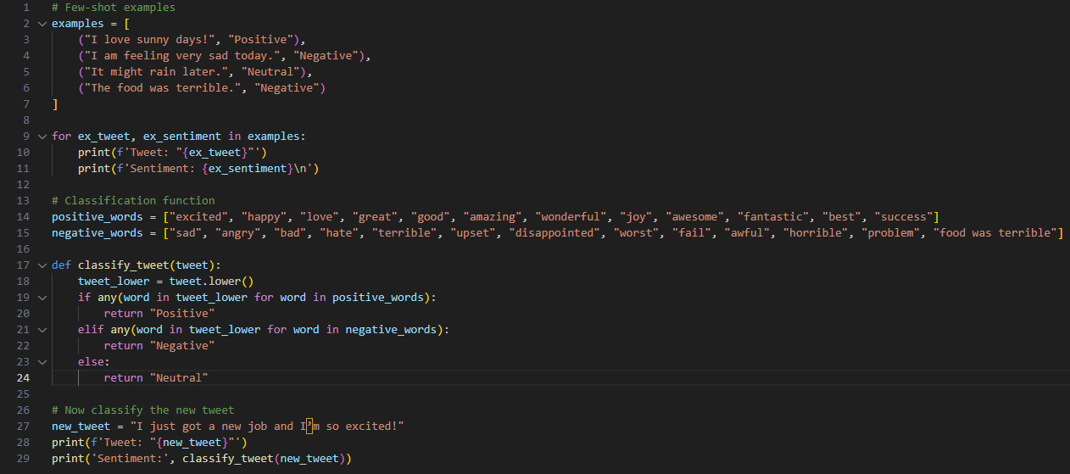
Output:
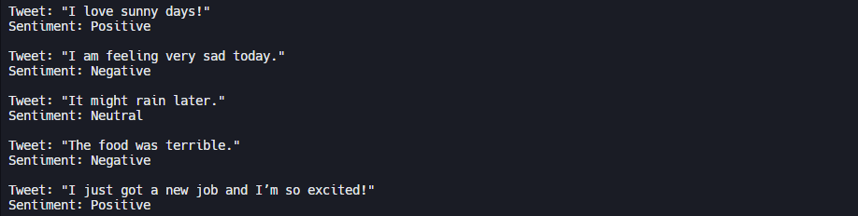
Observation:
One-shot: Limited context, less accurate for varied inputs.
Few-shot: More examples, better accuracy and generalization.

