Name: Goutham Chandrappa, ID: 1226130895
Design optimization Project 2
This project is aimed at determining the Optimum solution by making use of widely used industry recognized software- - ANSYS, for simplicity the project is separated into Three separate parts(1,2,3,), DOEs and response surfaces provide all the information required to achieve simulation-driven product development. Once the variation of product performance with respect to design variables is known, it becomes easy to understand and identify the changes required to meet requirements for the product. After response surfaces are created, we can analyse and share results using curves, surfaces, and sensitivities that are easily understood. The results obtained can be used at any time during the development of the product without requiring additional simulations to test a new configuration.

- MODEL ANALYSIS.
- OPTIMIZATION OF MODEL.
- CONCLUSION.

- Modal analysis:
The flowchart is shown in the figure below which is for the brake disc optimization, this also includes static structural analysis, modal analysis, and transient thermal analysis.
The required modal is already prepared in the ANSYS, the design variable of the brake disc optimization is brake disc thickness (p1, brake disc outer diameter (p2) and inner diameter of the brake disc (p3).

This Above figure shows the flow chart for ANSYS MODEL OPTIMIZATION .
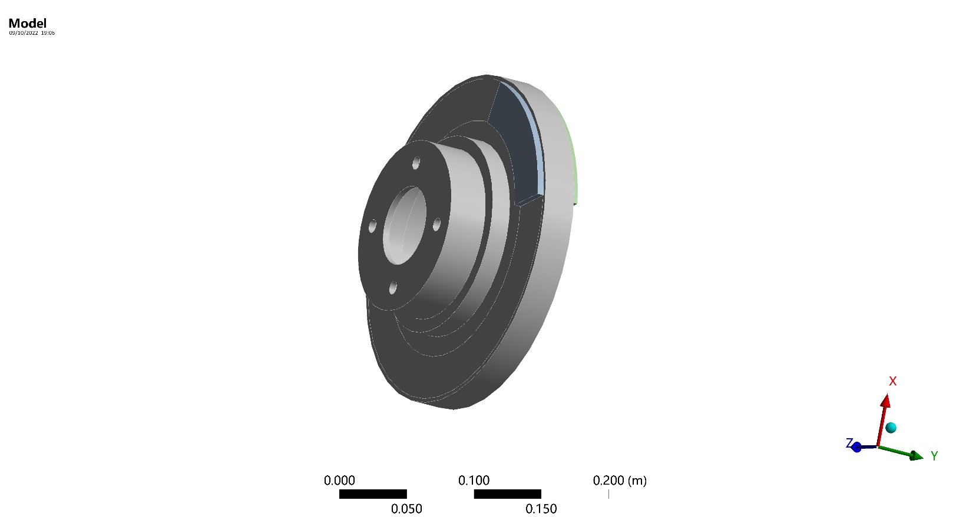
The above figure shows the Brake disc model prepared using the ANSYS Software.

- Structural analysis: This implemented after loading the constraint and stress for the break disc, the rotational velocity of the break disc is set as 250rad/sec on the x-axis and simultaneously constraining the brake pads on the X and Z axis besides revolted joint is applied for the inner diameter of the disc, which is in contact with the shaft.
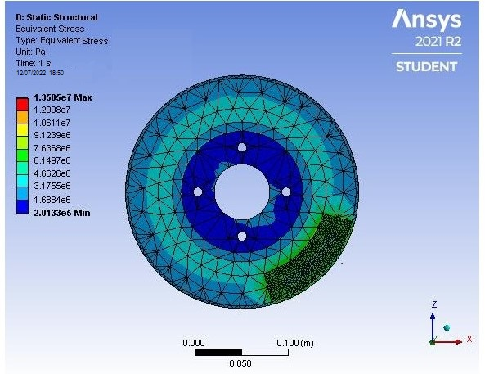

The above figure shows static structural analysis of the break disc model.

- Modal analysis: The modal analysis is implemented to determine the disc nature frequency after having the total deformation
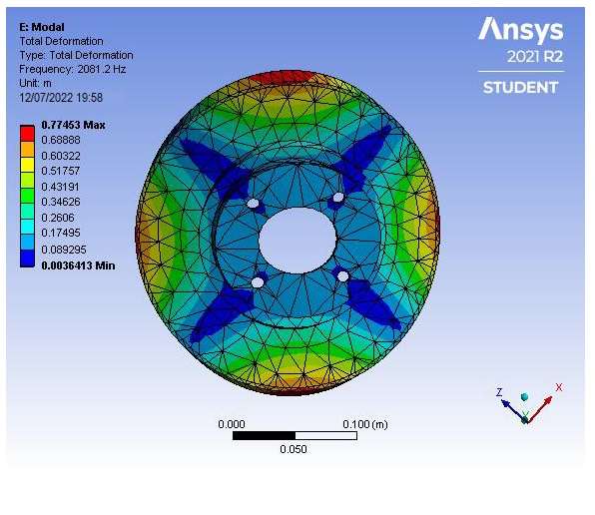

The above figure explains the modal analysis for the starting conditions,
Therefore, from the above figure we can notice that the natural frequency of the break disc is 2081.2 Hz, and the the maximum deformation is .775 m.

- Thermal analysis: Thermal analysis is performed in order to observe the maximum temperature rise after the braking operation is done, the initial temperature of the disc is given as 35 degrees Celsius, convection is applied on all the surfaces of the model. And Heat flux of 1.539 x 10*6 is applied on both the surfaces of the break disc

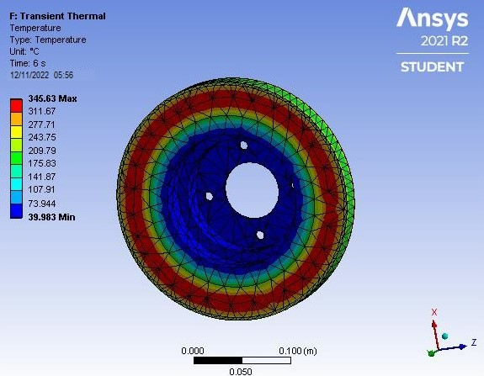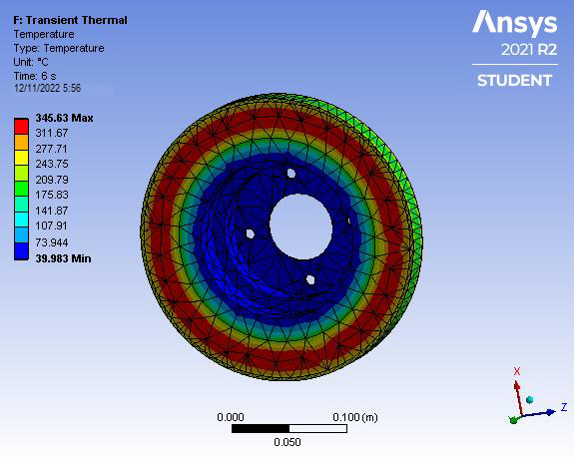
The above figure represents the THERMAL ANALYSIS of the brake disc model also,
From the figure we can observe that the maximum temperature is 354.63 degree Celsius,

- Model optimization: Since we have the initial analysis for the structural , modal, and thermal , the relationship between the design variable is known, the design variables are continuous, Now we will implement DOE and ANSYS build-in optimized method tom find the optimum solutions when the objective function is the stress, volume, frequency and the temperature of the disc brake.

DESIGN OF THE EXPERIMENT: Describes the relationship between the design variables and the performance of the product using Design of Experiments (DOEs) and Response surfaces. DOEs and response surfaces provide all the information required to achieve simulation-driven product development. After response surfaces are created, we can analyse and share results using curves, surfaces, and sensitivities that are easily understood. The results obtained can be used at any time during the development of the product without requiring additional simulations to test a new configuration. After the design of experiments process, we obtain various combinations of design variables and the corresponding output response.

Latin Hypercube Sampling (LHS) DOE method:
This DOE method avoids clustering samples, and the points are randomly generated in a square grid across the design space, but no two points share the same value. That is, no point shares a row or a column of the grid with any other point. In this study, Full Quadratic Samples property is used to generate the samples, so that a full quadratic model is formed.

The above figure depicts the LHS DOE Points.

Response Surface:
Response Surface Optimization: This system draws its information from its own Response Surface cell and so is dependent on the quality of the response surface. The available optimization methods are Screening, MOGA, NLPQL, and MISQP, which all use response surface evaluations rather than real solve.
In this project, only response surface optimization is performed and MOGA, MISQP optimization methods are used.

After DOE, a response surface is generated for all the design variables and the corresponding
output response through neural network, which the number of cells is 3. Also,
4 we set up 4 verification points. The goodness of fit plot for the structural analysis is
shown below,

The above picture depicts the goodness of fit plot for the output response.

Besides, we also show the sensitivity analysis as below. We can find the optimum
solutions through ANSYS build-in optimization method after actuating structural, modal
and thermal analysis for the brake disc.

Mixed-Integer Sequential Quadratic Programming (MISQP):
MISQP (Mixed-Integer Sequential Quadratic Programming) is a mathematical optimization algorithm as developed by Oliver Exler, Thomas Lehmann and Klaus Schittkowski (NLPQL). This method solves Mixed-Integer Non-Linear
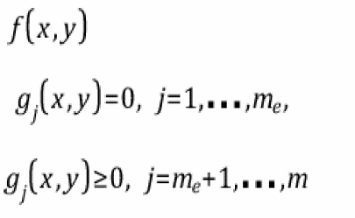
Programming (MINLP) of the form:

Minimize:

Subject to:

Problem functions are evaluated only at integer points and never at any fractional values in between.
MISQP solves MINLP by a modified sequential quadratic programming (SQP) method. After linearizing constraints and constructing a quadratic approximation of the Lagrangian function, mixed-integer quadratic programs are successively generated and solved by an efficient branch-and-cut method. The algorithm is stabilized by a trust region method as originally proposed by Yuan for continuous programs. Second order corrections are retained. The Hessian of the Lagrangian function is approximated by BFGS updates subject to the continuous and integer variables. MISQP is able to solve also non-convex nonlinear mixed-integer programs.

The above picture depicts the local sensitivity analysis

Figure 9 shows the response curve of stress (y-axis) with respect to the design variables
(P1, P2, P3, x-axis).

Fig : stress sensitivity analysis.

shows the response curve of volume (y-axis) with respect to the design variables (P1, P2, P3, x-axis).

Fig: Volume sensitivity analysis

Figure 11 shows the response curve of frequency (y-axis) with respect to the design variables (P1, P2, P3, x-axis).

Fig : frequency sensitivity analysis.

Figure 12 shows the response curve of temperature (y-axis) with respect to the design
variables (P1, P2, P3, x-axis).

Fig: temperature sensitivity analysis

Conclusion
This project firstly completes three analysis for the brake disc including structural, modal and thermal and then implements DOE with neural network to obtain optimum solutions for the objective function, which is the stress , volume, frequency and temperature of the brake disc. Through the analysis, we can find that the volume of the brake disc is reduced from 0.00099667 m3 to 0.00093871 m3, which volume reduction is 5.82 %. The comparison between initial and final design variables (output response) is shown in Table 2.

