|  |  |
| --- | --- |
| Welcome to Word  Instructions you can edit, share, and print | Microsoft Word logo |

Unlike old-school user guides, this doc is yours to tailor exactly for your needs. Reading it will teach you some basics about Word, but this document isn’t just for reading. It’s for editing too, so you can learn by doing.

For practice using Word features, watch for Try it text in red throughout this document.

|  |  |
| --- | --- |
| Learn Word with this interactive template | **Time saver:** If you’ve only got a minute and you want to see how this works, watch this Video: [Welcome to Word](https://www.microsoft.com/en-us/videoplayer/embed/RE1FGlM). |

# Write eloquently, with a little help

Word automatically checks spelling and grammar, and marks misspelled words with a red squiggly underline. Grammatical glitches get a blue double underline.

Try it: Put your cursor at the end of this paragraph, and hit Enter to start a new paragraph. Write a sentence with some spelling or grammatical mistakes, and press Enter to finish the paragraph.

Right-click the text that’s marked with underlines, or Press F7. Choose a suggestion to correct the mistakes.

Count on Word to count your words

Try it: Hit return after this line and type some words.

The status bar at the bottom of the window keeps a running count of the number of words in the document.

Example of word count displayed in the status bar

# Save this for later, access it anywhere

When you save this document in OneDrive, you’ll be able to open it anywhere: on your computer, tablet, or phone. Your changes will be saved automatically.

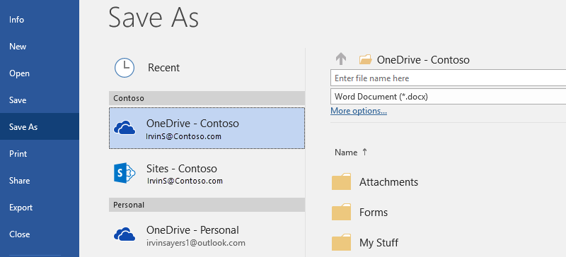

Try it: Select **File** > **Save As**, and then select OneDrive and give this document a name.

If you sign in to Office 365 on another device, this document will be in your list of recent files. You can pick up where you left off… even if you left the document open on the computer you’re using now.

Share and collaborate

With this document saved in OneDrive, you can share it with others. They don’t even need Word to open it.

Try it: Select **Share**, and send a link to this document. (keyboard shortcut – Alt+F+Z or Alt+Z+S)

You can send the link by typing someone’s email address or by copying the link and pasting it into a message or chat. If you want them to read the document but not edit it, set their permission to view-only.

If they don’t have Word, the document will open in their web browser, in Word Online.

# Add visuals with pictures from the web

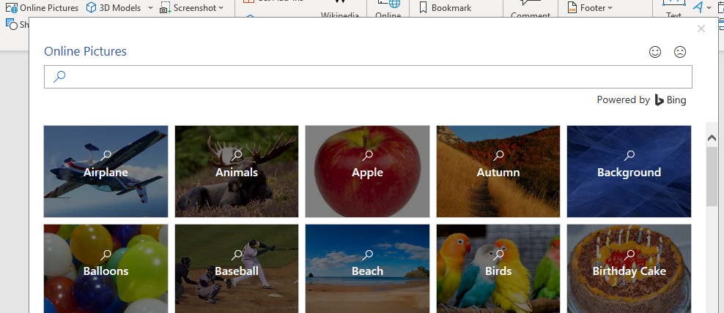

Word works with Bing to give you access to thousands of pictures you can use in your documents.

Try it: Hit enter after this line to make a blank line:

1. With your cursor in the blank space above, go to the Insert tab, select **Online Pictures**, and then search for something, like puppy clip art.
2. Select the picture you want, and select **Insert**.

# Make your meaning more visual by formatting text

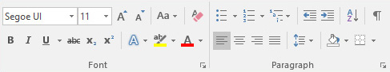

To format text, select it, and then select a button in the **Font** or **Paragraph** area on the Home tab.

Try it: Select text in the lines below and choose formatting options so that the text is an example of the formatting it’s describing:

|  |  |
| --- | --- |
| Bold command icon | Bold (keyboard shortcut: Ctrl+B) |
| Italics command icon | Italic (keyboard shortcut: Ctrl+I) |
| Highlight command icon | Highlight |
| Font color command icon | Font color |
| Bullets command icon | Bullets |
| Numbering command icon | Numbering |

**Pro tip:** If you selected whole words for this exercise, did you notice that Word popped up a little toolbar, with the font formatting options?

|  |  |
| --- | --- |
| Contextual toolbar with commands for formatting text | Between that and keyboard shortcuts like Ctrl+B and Ctrl+I, you save time by not having to go up to the Home tab all the time. |

Make magic: use Heading styles

The heading for this part (“Make magic: use Heading styles”) looks the same as the other headings in this document, but it’s not as useful. It’s formatted with *font settings* (font, size, and color), while the other headings are formatted with a *Heading style* (Heading 1, to be exact).

|  |  |
| --- | --- |
| Heading showing expand/collapse button | See the little triangle when you mouse over those other headings?  You can collapse and expand everything under a heading, like an outline. But this one’s not working. Let’s fix it. |

Try it: Apply the **Heading 1** style:

1. Put your cursor somewhere in the heading above (“Make magic: use Heading styles”) – don’t select anything.
2. On the **Home** tab, find **Styles**, and select **Heading 1** (keyboard shortcut Ctrl+Alt+1).

Ta-da! Now it looks like a heading, and acts like one too.

Give your doc an instant makeover

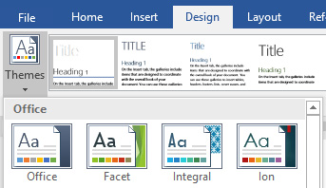

Style sets and themes let you completely change the look of your document in an instant. They work best when your document is formatted with styles (so it’s good that we fixed that Heading style, above).

Try it: Explore style sets and themes:

1. On the **Design** tab, select **Themes**, and choose a theme from the drop-down.  
   Notice that the gallery of style sets updates to reflect the theme you picked.
2. Select any theme you like from the drop-down and click to apply.

Just for fun

If you have a little more time, give these a try.

Try it: Find and replace

Press **Ctrl+H** and use Find/Replace to replace all the instances of Try it with I tried it.

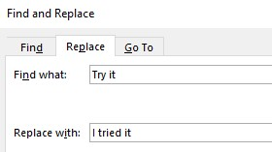

Try it: Wrap text around pictures

|  |  |
| --- | --- |
| Some of the pictures in this document are placed beside a paragraph of text. Try exploring text wrapping: Select the picture here, go to **Format** > **Wrap Text**, and use the up/down arrow keys to move between the options for a preview of the results. | Example of text wrapping around a picture |

Get help with Word

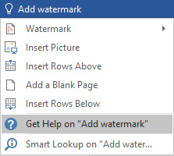

The **Tell me** search box takes you straight to commands and Help in Word.

Try it: Get help:

1. Go to **Tell me what you want to do** at the top of the window.
2. Type what you want to do.

For example, type:

* **Add watermark** to quickly get to the watermark command.
* **Help** to go to Word help.
* **Training** to see the list of Word training courses.
* **What’s new** for a list of the most recent updates to Word

[](https://go.microsoft.com/fwlink/?linkid=854192)