Student Performance Analysis - Week 2 Update
Completed:
- Loaded dataset into SQLite
- Imported student-mat.csv into student_math table
- Executed SQL queries to analyze distributions

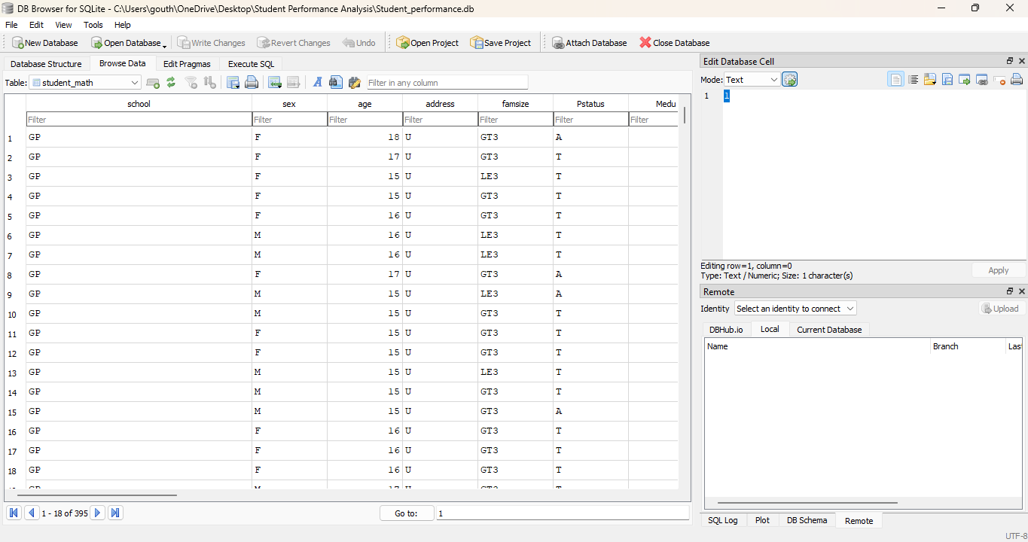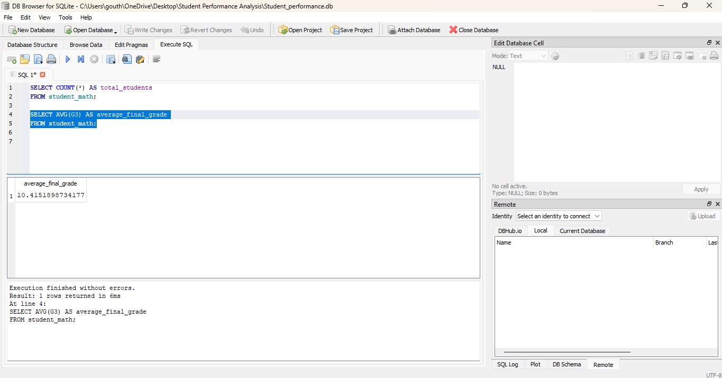

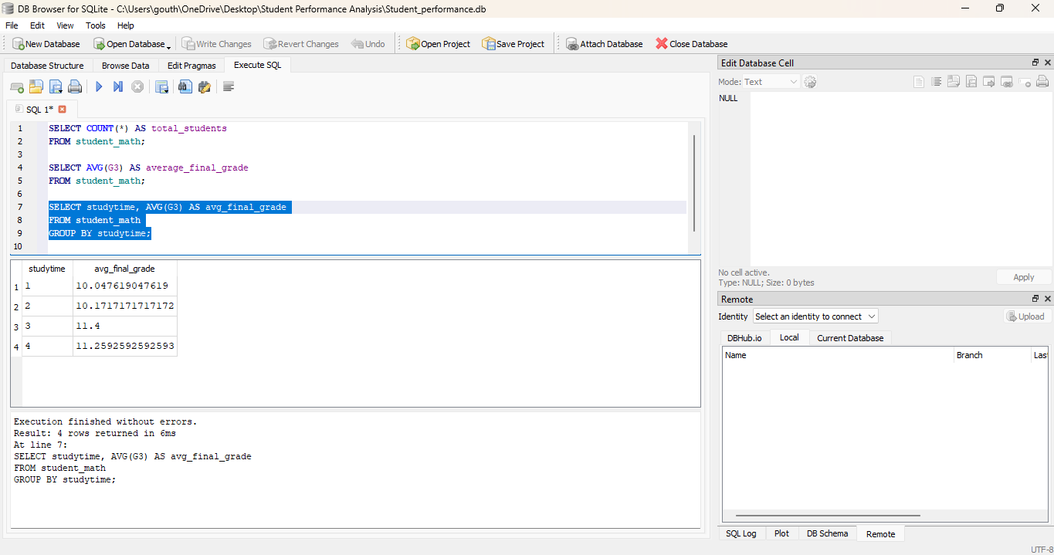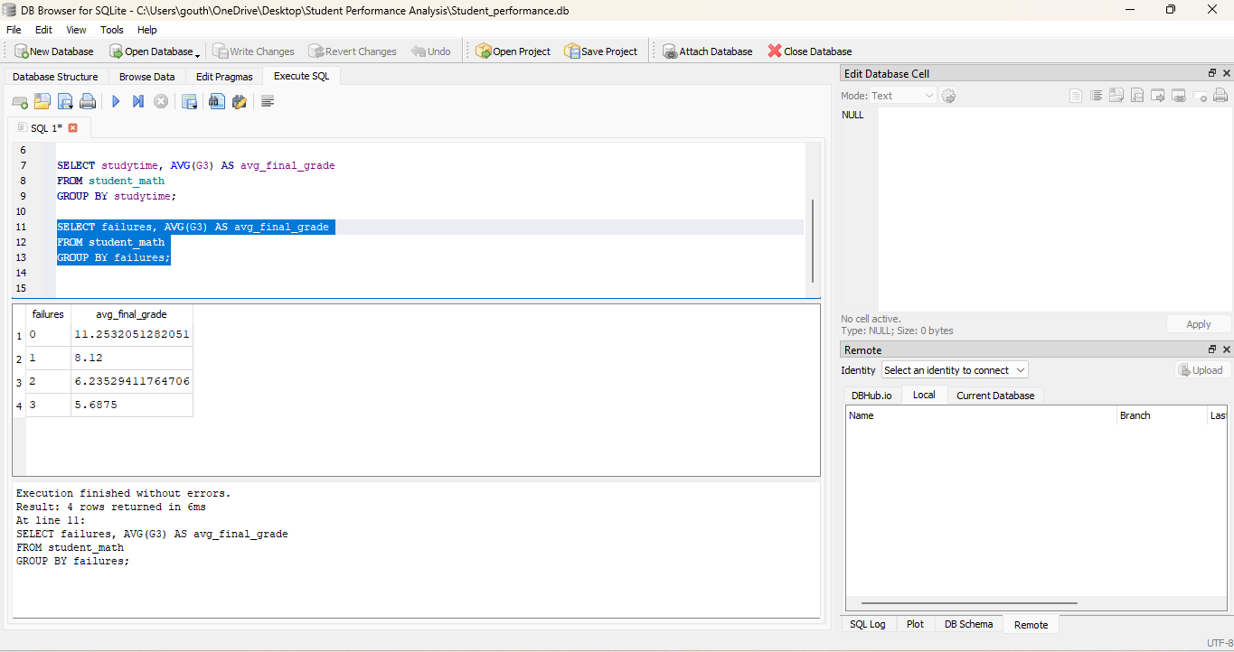

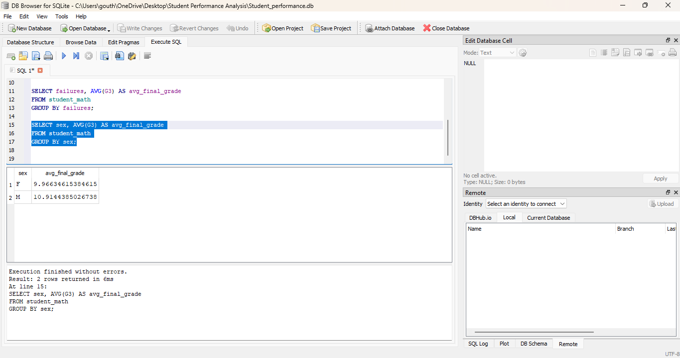

Key Findings:
- Dataset contains 395 student records.
- SQL queries were executed successfully.
- Initial exploration indicates study time and failures may influence final grades.

Next Steps:
- Continue SQL analysis.
- Perform Python EDA.
- Create Tableau visualizations.

