**PREDICTIVE ANALYTICS**

**Internal-1: Chatbot Development**

**INTRODUCTION**

A chatbot is a software or computer program that **simulates human conversation or "chatter" through text or voice interactions**.

At the most basic level, a chatbot is a computer program that simulates and processes human conversation (either written or spoken), allowing humans to interact with digital devices as if they were communicating with a real person.

Users in both business-to-consumer (B2C) and business-to-business (B2B) environments increasingly use chatbot virtual assistants to handle simple tasks. Contrary to the popular belief that a chatbot's main benefit is just answering queries and offering customer support, chatbots can provide value-driven, contextual support that can assist businesses significantly. An AI chatbot uses the data to provide a personalized experience to the users.

**CHATBOT FOR A BEAUTY PARLOUR**

**Name of the chatbot:** beautyparlourbot

**Objective:**

The current “beautyparlourbot” is a chatbot that I have developed for booking the appointments online hassle free.

* To book an appointment without going to the parlour
* To know the list of services that the parlour offers
* To schedule the time at which they want to avail the offer
* To know about the prices and discounts on the services

**Tool used:** Google Dialogflow

**Terminology**

1. *Agent:* A Dialogflow CX agent is a virtual agent that handles concurrent conversations with your end-users. It is a natural language understanding module that understands the nuances of human language. Dialogflow translates end-user text or audio during a conversation to structured data that your apps and services can understand. You design and build a Dialogflow agent to handle the types of conversations required for your system.

A Dialogflow agent is similar to a human call center agent. You train them both to handle expected conversation scenarios, and your training does not need to be overly explicit.

1. *Intent:* An intent categorizes an end-user's intention for one conversation turn. For each agent, you define many intents, where your combined intents can handle a complete conversation. When an end-user writes or says something, referred to as an end-user expression, Dialogflow matches the end-user expression to the best intent in your agent. Matching an intent is also known as intent classification.
2. *Follow-up intents:* A follow-up intent is a child of its associated parent intent. When you create a follow-up intent, an output context is automatically added to the parent intent and an input context of the same name is added to the follow-up intent. A follow-up intent is only matched when the parent intent is matched in the previous conversational turn. You can also create multiple levels of nested follow-up intents.
3. *Entity:* Each intent parameter has a type, called the entity type, which dictates exactly how data from an end-user expression is extracted.

Dialogflow provides predefined system entities that can match many common types of data. For example, there are system entities for matching dates, times, colors, email addresses, and so on. You can also create your own custom entities for matching custom data. For example, you could define a vegetable entity that can match the types of vegetables available for purchase with a grocery store agent.

**Overview:**

**Flow Process of the chatbot:**

Bot asks for the confirmation and the user confirms it

Bot responds to the user and ends the conversation

**Screenshots of the chat between bot and the user:**

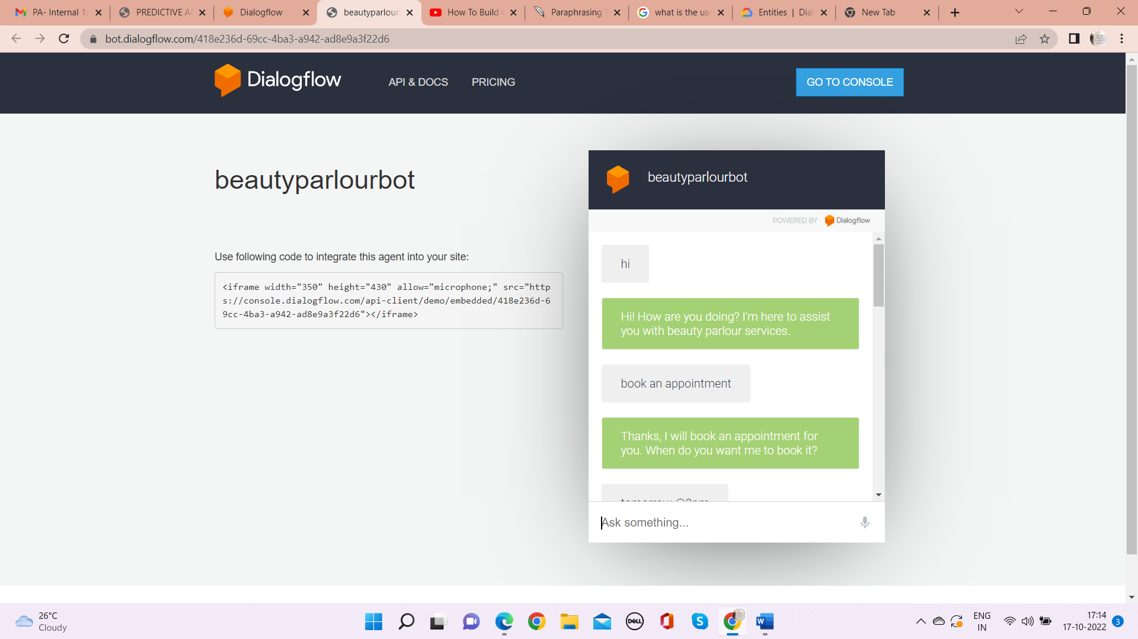

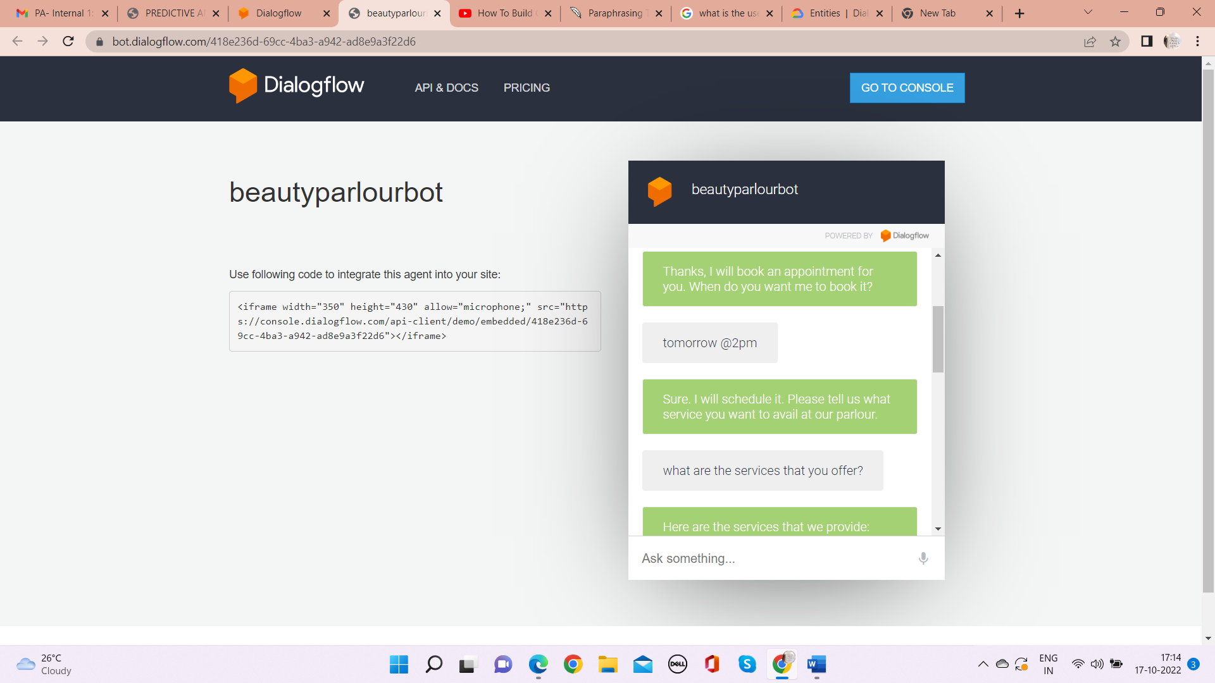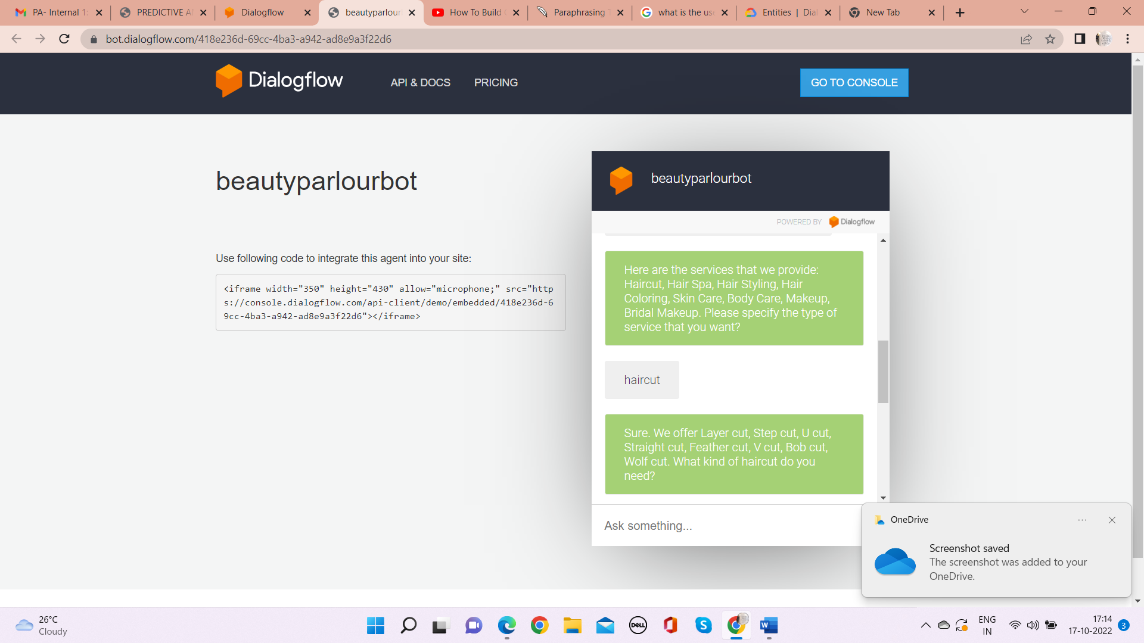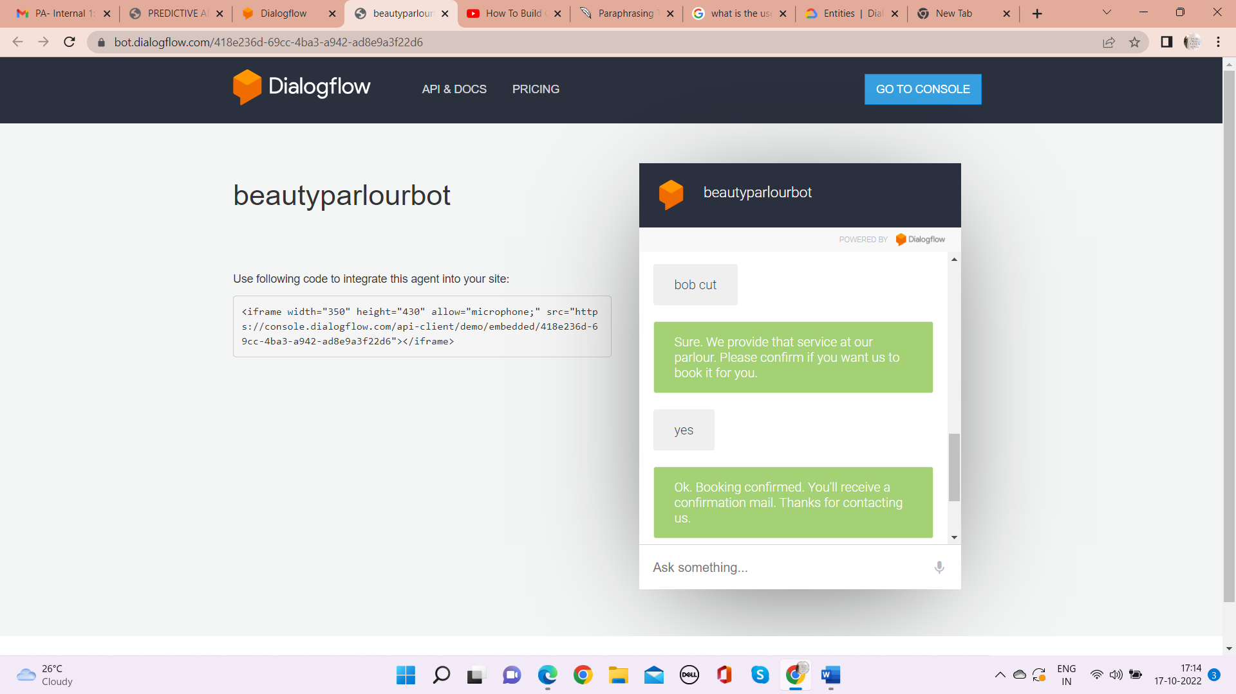

I’ve created welcome intent and 7 different intents for each service that the parlour provies.

I’ve also created 2 follow-up intents for each service intent that I’ve developed.

Total no. of intents I’ve created: 13

Total no. of follow-up intents I’ve created: 7

**Chatbot:**

<https://bot.dialogflow.com/418e236d-69cc-4ba3-a942-ad8e9a3f22d6>

**Conclusion:**

From my perspective, chatbots or smart assistants with artificial intelligence are dramatically changing businesses. There is a wide range of chatbot building platforms that are available for various enterprises, such as e-commerce, retail, banking, leisure, travel, healthcare, and so on. Chatbots can reach out to a large audience on messaging apps and be more effective than humans. They may develop into a capable information-gathering tool in the near future.